Homework 3 SVM

Yawen Zhang

1. I have used the Sklearn implementation of SVM and used them in this analysis.

2. I set C = 0.01, 0.01, 0.1, 1, 10 and 100 and choose two kernels: linear and RBF.

1) **For linear kernel**, as C $↑$, Margin (M) $↓$, Number of support vectors for each class $↓$, both Train and Hold-out data prediction accuracy $↑$, also, computing time $↑$. When C is larger than 0.01, the accuracy of train data is higher than hold-out data, as an indicator of overfitting.

2) **For RBF kernel** (gamma = 1/n_features), as C $↑$, Number of support vectors for each class $↓$, both Train and Hold-out data prediction accuracy $↑$, and, computing time $↓$. When C is larger than 1, the accuracy of train data is higher than hold-out data.

3) **By comparing linear and RBF kernel**, as the picture shows: given the same C, linear kernel computes much faster than RBF kernel, and RBF kernel tends not to overfitting. When C is larger than 0.1, RBF has a better performance than linear with higher perdiction accuracy for hold-out data. A special feature is that when C is smaller than 0.1, the performance of RBF drops significantly.

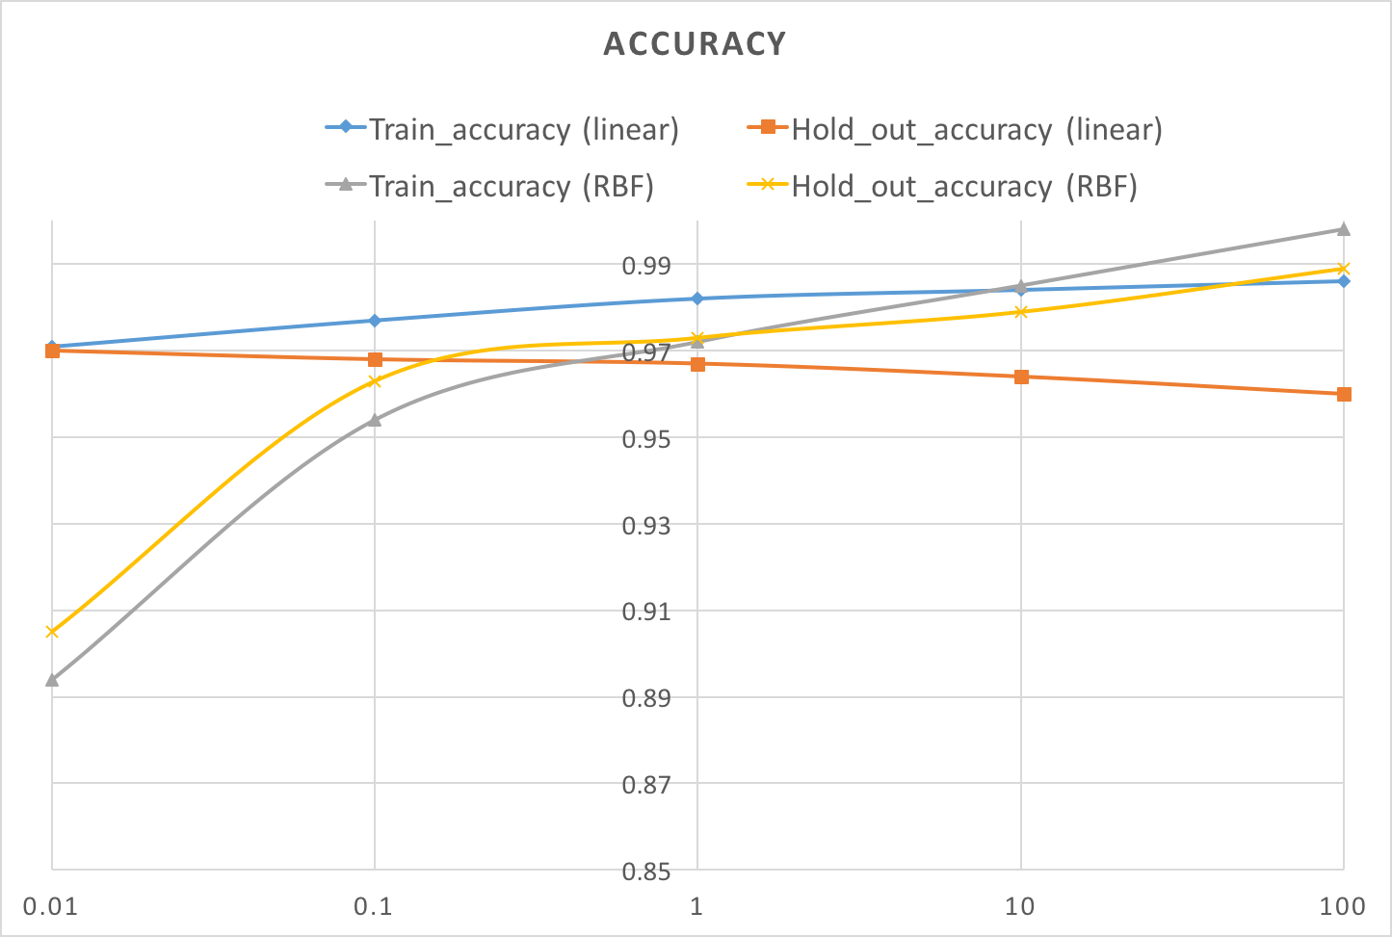

3. I set C = 0.01 with linear kernel, examples of support vectors are as follows.

 