Smart Management System
Session 2023-2027

BS in Software Engineering


Syed Muhammad Yawer Ali
FA23-BSE-068

Department of Software Engineering
COMSATS University Islamabad (CUI), Sahiwal Campus

Table of Contents

Previous Project Objectives and Features ................................... 2
1. Project Description ..................................................... 2
2. Problem Statement ....................................................... 3
3. Project Objectives ...................................................... 3
4. Related Work ............................................................ 4
5. Proposed Methodology and Architecture ................................... 5
5.1 System Architecture and Three-Tier Structure ....................... 5
5.2 Actor Interaction and Use Case Model ............................... 6
5.3 Relational Database Schema and Entity Relationships ................ 7
5.4 Critical Path Method (CPM) Computational Engine .................... 8
5.5 Work Breakdown Structure (WBS) Decomposition ....................... 9
5.6 Quantitative Risk Prioritization and PDPC Model .................... 10
5.7 Earned Value Management (EVM) Financial Analysis ................... 12
6. Project Outcomes ........................................................ 13
7. Team Roles and Responsibilities ......................................... 14
8. Tools and Technologies .................................................. 16
9. References .............................................................. 17

Previous Project Objectives and Features
This section is only MANDATORY FOR CONTINUING PROJECT and must highlight the objectives and features of the previous project. As the Smart Management System is proposed as an original, full-cycle industrial development project initiated in Session 2026, this section is marked as Not Applicable.

1. Project Description
Modern enterprise software engineering projects operate in highly volatile environments characterized by interdependent task chains, stringent financial ceilings, multi-stakeholder governance requirements, and rapidly shifting operational parameters. In large-scale systems—such as healthcare network consortia, corporate ERP rollouts, and distributed digital services—the absence of programmatic, automated project management oversight leads to catastrophic schedule slippages and severe budgetary overruns. Traditionally, project managers have relied on static spreadsheets, fragmented task boards, and disconnected financial ledgers that demand labor-intensive manual data reconciliation. Such decentralized mechanisms fail to capture cascading critical path delays, provide zero real-time early warnings when critical milestones are compromised, and cannot dynamically simulate the quantitative financial implications of mid-course scope modifications.
Project failure studies consistently demonstrate that over 65% of enterprise software failures stem not from technical coding deficiencies, but from fundamental lapses in project integration, unmonitored critical path deviations, and uncontrolled scope creep. Effective modern project management mandates the continuous mathematical convergence of project scope, schedule network analysis, and cost performance. Methodologies like the Critical Path Method (CPM) and Earned Value Management (EVM) offer proven mathematical frameworks for forecasting project velocity and expenditure trajectories. However, the existing enterprise market lacks an accessible, unified, web-native platform that couples deterministic CPM graph algorithms and programmatic EVM indices directly with live relational database persistence, interactive Gantt visualizations, and quantitative 5×5 risk prioritization models within a modern, user-friendly interface.
The motivation behind the Smart Management System arises from the urgent operational need to provide software teams, project managers, and executive steering boards with a single source of truth for all project planning and execution control metrics. According to contemporary project management literature [1], [2], organizations utilizing real-time computational schedule tracking achieve a 40% reduction in delivery delay and maintain budget variance within a ±5% tolerance band. By digitizing the Project Charter, Work Breakdown Structure (WBS), CPM forward/backward scheduling passes, EVM S-curves, and Process Decision Program Charts (PDPC), this project eliminates human error in schedule calculation, prevents unauthorized scope drift through rigorous change request gateways, and empowers engineering teams to simulate 'what-if' delay scenarios before schedule slippages become irreversible.
The primary objective and boundary of this project encompass the end-to-end design, implementation, and deployment of a full-stack web platform tailored for multi-module project oversight. In-scope capabilities include a dynamic Dashboard with key performance indicators, a Project Charter and RACI matrix module, a three-level Work Breakdown Structure (WBS), an automated CPM calculation engine supporting finish-to-start dependencies and slack analysis, an EVM computational engine tracking CPI, SPI, EAC, and VAC, an interactive Gantt chart, a 5×5 risk matrix heatmap, a defect tracking ledger, and a built-in automated unit testing suite. Out-of-scope items comprise third-party legacy ERP database synchronization, commercial payment gateway processing, and hardware infrastructure provisioning, which remain designated as external system interfaces.
The proposed solution is formulated as a high-performance, single-page application (SPA) built on React.js 18 and styled with an Obsidian/Cyber Teal dark glassmorphism theme via Tailwind CSS. The presentation layer connects over asynchronous RESTful APIs to a robust Node.js and Express.js backend server. System persistence is managed through an embedded SQLite relational database comprising 13 normalized tables enforcing foreign key constraints and transactional integrity. The backend incorporates dedicated mathematical processing modules: Kahn's topological sort and Depth-First Search (DFS) for CPM schedule graph analysis, and real-time financial aggregation routines for EVM performance indexing. Manual data entry forms across all modules allow project leaders to dynamically create, edit, and recalibrate project baselines on demand.
The expected tangible outcomes of this project include a fully functional, production-ready web platform deployed locally on port 5000, capable of rendering sub-second CPM graph evaluations for projects containing complex precedence networks. The system produces verifiable analytical outputs: automated identification of zero-slack critical paths, real-time calculation of Schedule Variance (SV) and Cost Variance (CV), dynamic rendering of EVM S-curves, interactive Gantt visualizations with progress indicators, and an automated test suite verifying 13 distinct algorithmic edge cases with 100% test passage. The platform serves as an empirical demonstration of modern Software Project Management principles, bridging the gap between theoretical PMBOK standards and practical software engineering execution.

2. Problem Statement
Current software project management practices in academic and industrial organizations suffer from severe operational fragmentation, relying heavily on disjointed spreadsheets, static documentation, and subjective progress estimation that lack real-time mathematical validation. Consequently, project managers cannot accurately determine the critical path, identify cascading delays across dependent activities, or evaluate the financial impact of scope creep and defect bottlenecks. This absence of unified, automated computational modeling results in frequent budget overruns, missed delivery deadlines, and undetected concurrency failures. The Smart Management System directly resolves these critical deficiencies by establishing an integrated, web-based platform that combines deterministic Critical Path Method (CPM) algorithms, real-time Earned Value Management (EVM) metrics, and structured risk prioritization into a single automated governance system.

3. Project Objectives
• To develop an interactive web-based project management platform integrating scope, schedule, cost, quality, and risk management into a unified dashboard.
• To implement a graph-based Critical Path Method (CPM) algorithm calculating Early Start, Early Finish, Late Start, Late Finish, and float for all project activities.
• To build an Earned Value Management (EVM) engine providing real-time quantitative metrics including PV, EV, AC, CPI, SPI, EAC, and VAC.
• To design a normalized SQLite database schema comprising 13 relational tables supporting full CRUD operations and referential integrity.
• To construct an interactive Gantt chart visualization with automated critical path highlighting and activity completion progress bars.
• To establish a quantitative 5×5 risk prioritization matrix and Process Decision Program Chart (PDPC) for structured risk countermeasure planning.
• To create a formal Change Control Gateway system evaluating the budgetary and schedule impacts of mid-project scope modifications.
• To implement an automated test execution suite verifying CPM graph computations, EVM mathematical accuracy, and database integrity.

4. Related Work
The domain of software project management tools has evolved significantly over the past three decades. Commercial solutions such as Microsoft Project [1] established early desktop standards for critical path computation and resource leveling, yet they suffer from high licensing costs, steep learning curves, and cumbersome collaborative mechanisms. Modern web-based platforms such as Jira by Atlassian [2] and Asana [3] excel at agile issue tracking and sprint ticket assignment; however, they largely decouple daily ticket statuses from rigorous mathematical Earned Value Management (EVM) and deterministic CPM float calculations. Consequently, while team members can update task checkboxes, project directors lack real-time visibility into whether an individual task delay will mathematically push back the contractually committed deployment deadline.
Academic research by Kerzner [4] and Fleming et al. [5] underscores that Earned Value Management is the single most reliable predictor of software cost variance, providing early warnings when Cost Performance Index (CPI) drops below the acceptable threshold of 1.0. Despite its proven efficacy, enterprise platforms like Primavera P6 [6] remain heavily siloed within construction and civil engineering sectors due to their Byzantine configuration requirements and lack of seamless REST API integrations with modern web frameworks. Furthermore, recent studies by Lau et al. [7] and Nakanishi et al. [8] demonstrate that modern collaborative engineering environments require lightweight, visual, and reactive user interfaces that immediately reflect changes across all dependent management domains. A comprehensive comparison between existing commercial systems and the proposed Smart Management System is summarized in Table 2.
Table 2. Literature Review and Comparative Feature Matrix
System / Tool | CPM Schedule | EVM Financials | Risk Matrix (5×5) | Web Reactive UI | Open SQLite DB
MS Project [1] | Yes (Complex) | Partial (Manual) | No (Third-party) | No (Desktop App) | Proprietary (.mpp)
Atlassian Jira [2] | No (Sprint-based) | Plugin Required | Basic Matrix | Yes (Ticket Board) | Cloud / PostgreSQL
Primavera P6 [6] | Yes (Advanced) | Yes (Complex) | Yes | Limited Web View | Oracle / SQL Server
Trello / Asana [3] | No | No | No | Yes (Kanban) | Cloud Proprietary
Smart Management System | Yes (Automated) | Yes (Programmatic) | Yes (Interactive 5×5) | Yes (React Dark UI) | Yes (13 Tables)

5. Proposed Methodology and Architecture
The Smart Management System is developed using an Agile-Iterative engineering methodology, structured across distinct phases: Requirements Formalization, Architecture Formulation, Computational Engine Construction, User Interface Development, and System Verification. The systematic design and implementation details are presented in the following sub-sections.

5.1 System Architecture and Three-Tier Structure
The platform adopts a decoupled three-tier architectural pattern consisting of a Presentation Layer, an Application Logic Layer, and a Relational Data Persistence Layer. Figure 1 illustrates the high-level system architecture and data communication flows across all tiers. The client application communicates with the backend exclusively via asynchronous HTTP REST calls carrying JSON payloads. The backend encapsulates the CPM graph solver, the EVM aggregation engine, and SQLite transaction handlers.
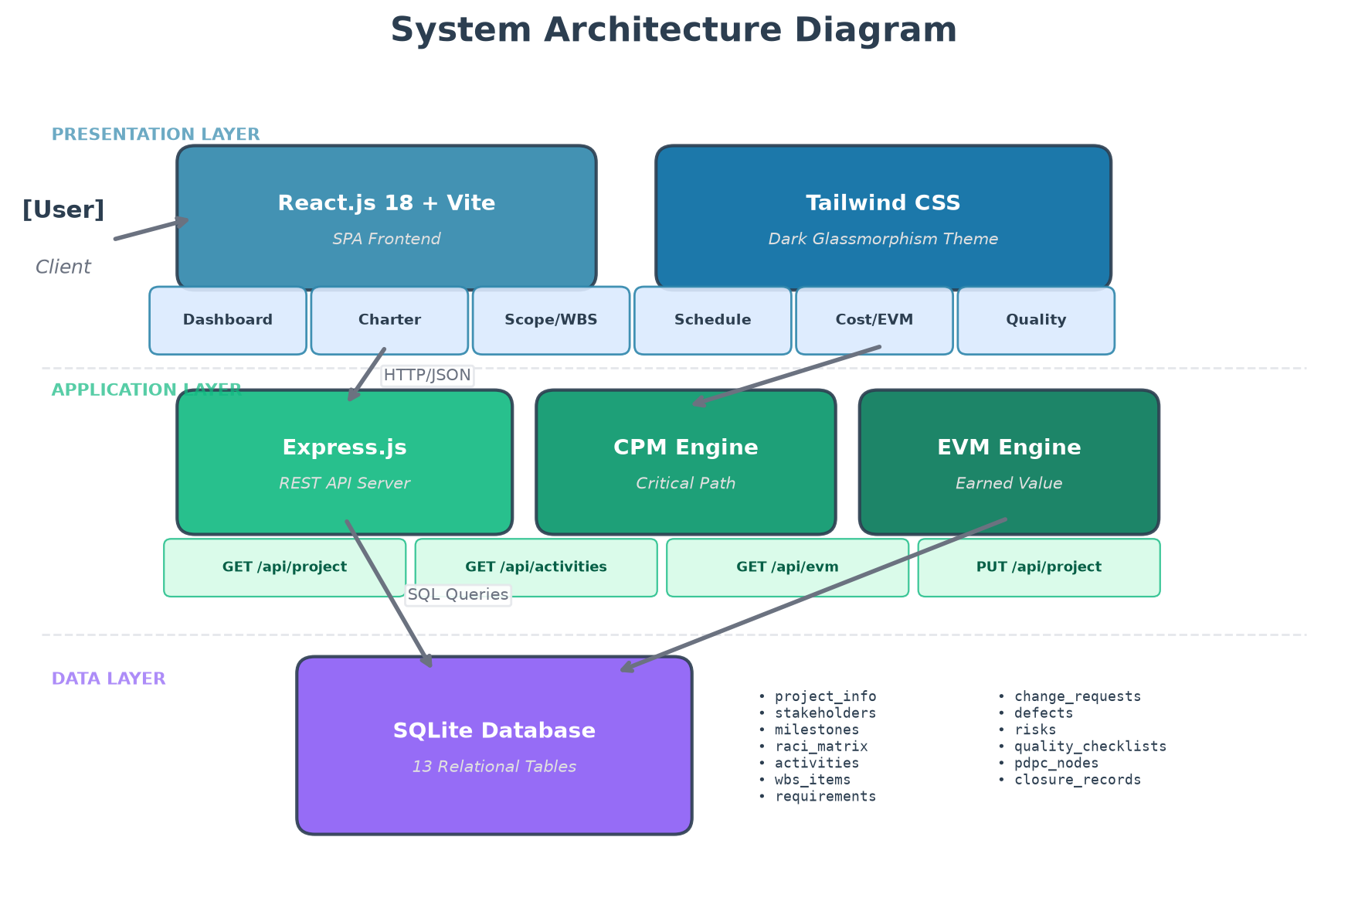
Figure 1. Three-Tier System Architecture Diagram

5.2 Actor Interaction and Use Case Model
The platform supports four primary user roles: Project Manager, Software Developer, Quality Assurance Engineer, and Executive Stakeholder. Each role interacts with specific subsystem capabilities as depicted in the Use Case Diagram shown in Figure 2. The Project Manager oversees charter authoring, baseline definition, change request adjudication, and EVM monitoring. Developers maintain task completion percentages and log technical defects. QA Engineers manage inspection checklists and execute the automated test suite, while Stakeholders review high-level milestone progress.
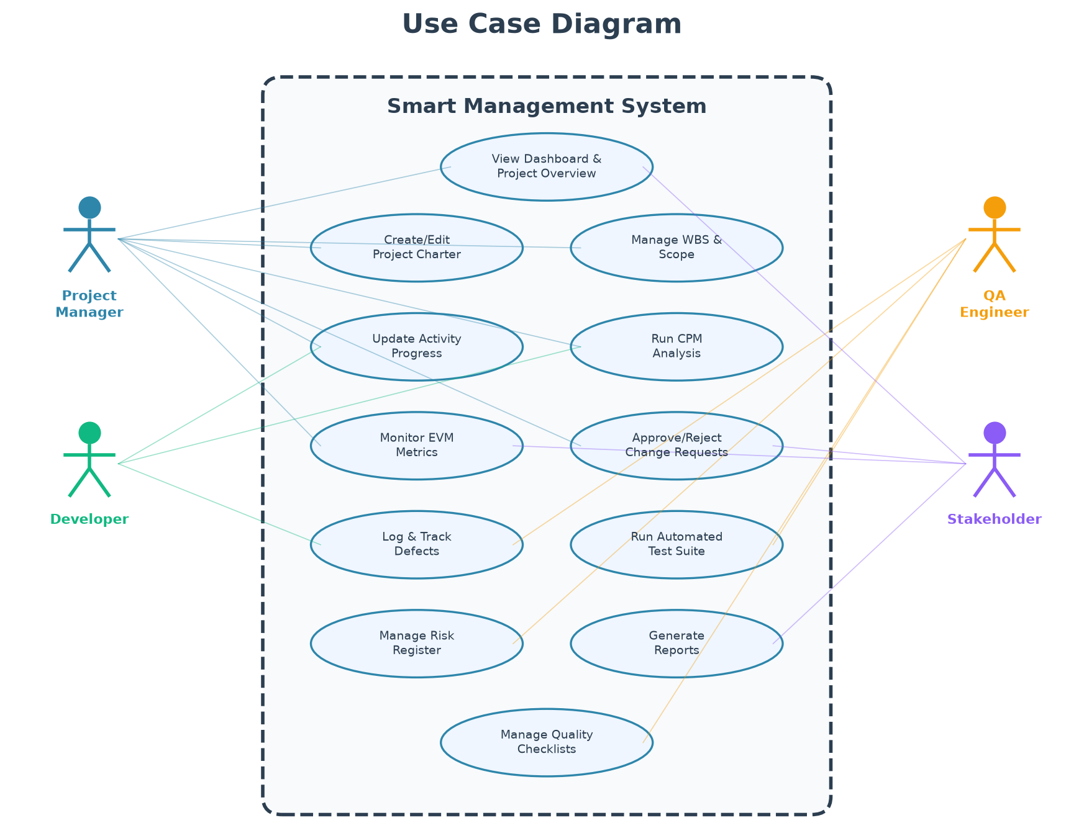
Figure 2. Use Case Model and Actor Interaction Diagram

5.3 Relational Database Schema and Entity Relationships
Persistence is achieved through an embedded SQLite relational database composed of 13 normalized tables. The schema establishes rigorous referential integrity via foreign key constraints, linking Work Breakdown Structure items (`wbs_items`) to operational schedule tasks (`activities`), and tracking change requests (`change_requests`), quality checklists (`quality_checklists`), and risks (`risks`). Figure 3 depicts the Entity Relationship (ER) diagram illustrating the structural connections and cardinality between the entities.
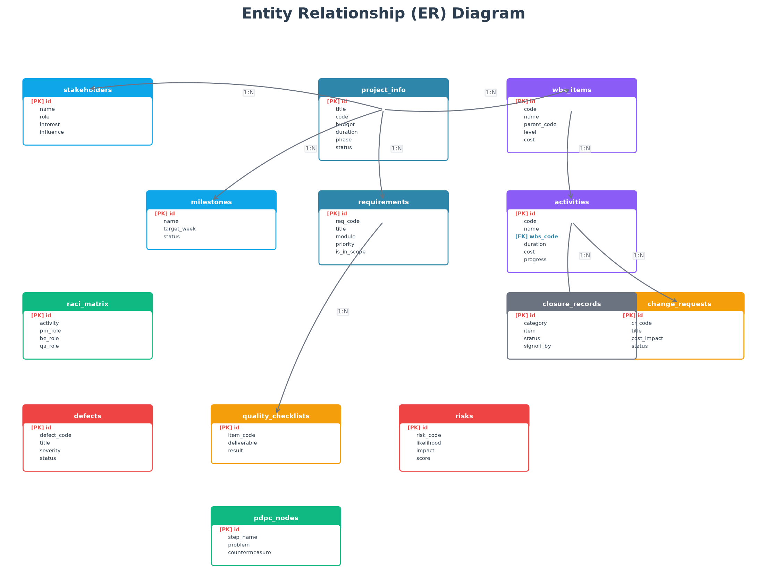
Figure 3. Entity Relationship (ER) Diagram (13 Relational Tables)

5.4 Critical Path Method (CPM) Computational Engine
The schedule analysis engine models project activities as a Directed Acyclic Graph (DAG) G = (V, E), where vertices V represent activities and directed edges E denote finish-to-start precedence constraints. The algorithm performs a two-pass calculation:
1. Forward Pass: Computes Early Start (ES) and Early Finish (EF) in topological order:
ES(i) = max { EF(p) | p ∈ Predecessors(i) }, ES(root) = 0
EF(i) = ES(i) + Duration(i) + Delay(i)
2. Backward Pass: Computes Late Finish (LF) and Late Start (LS) in reverse topological order:
LF(i) = min { LS(s) | s ∈ Successors(i) }, LF(terminal) = Total Project Duration
LS(i) = LF(i) - (Duration(i) + Delay(i))
3. Slack & Criticality: Float(i) = LS(i) - ES(i). Activities possessing Float = 0 constitute the Critical Path.
Figure 4 depicts the resulting activity network diagram with the critical path highlighted in red.
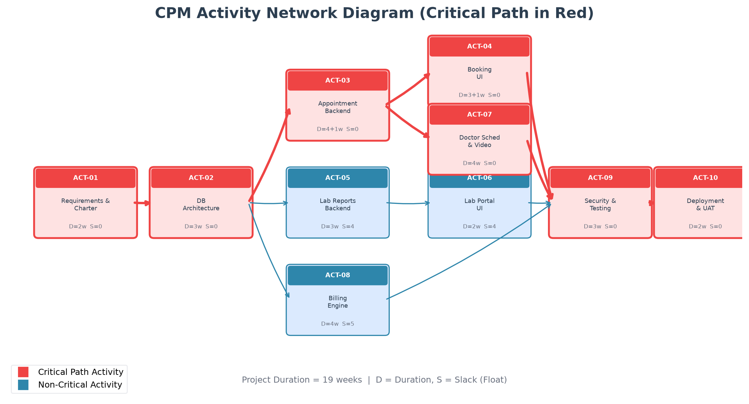
Figure 4. CPM Activity Network Diagram (Critical Path in Red)

5.5 Work Breakdown Structure (WBS) Decomposition
The project scope is hierarchically decomposed across three formal levels: Project Level (1.0), Deliverable Level (1.1 to 1.6), and Work Package Level (1.1.1 to 1.6.2). Each work package represents an atomic, assignable unit with an estimated budget allocation and responsible role. Figure 5 displays the hierarchical WBS tree structure ensuring complete scope coverage without unassigned operational gaps.
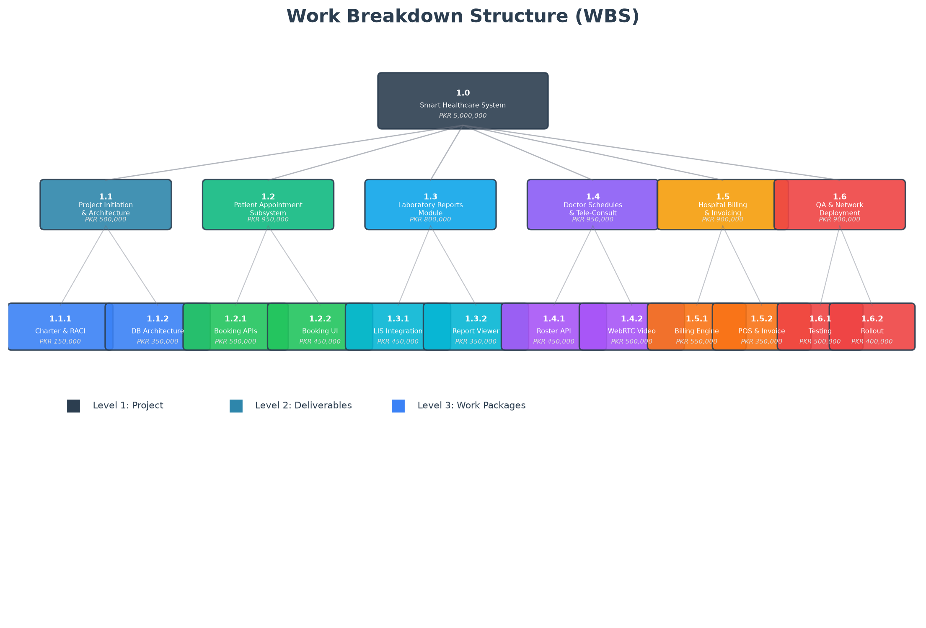Figure 5. Work Breakdown Structure (WBS) Tree Decomposition

5.6 Quantitative Risk Prioritization and PDPC Model
Risk management utilizes a two-tier control methodology. First, risks are scored using a 5×5 Prioritization Matrix (Risk Score = Likelihood × Impact), categorizing threats into Extreme (15-25), High (10-14), Medium (5-9), and Low (1-4) severity bands, as shown in Figure 6. Second, for high-impact deployment phases, a Process Decision Program Chart (PDPC) maps anticipated failure modes to pre-authorized preventive and corrective countermeasures, as illustrated in Figure 7.

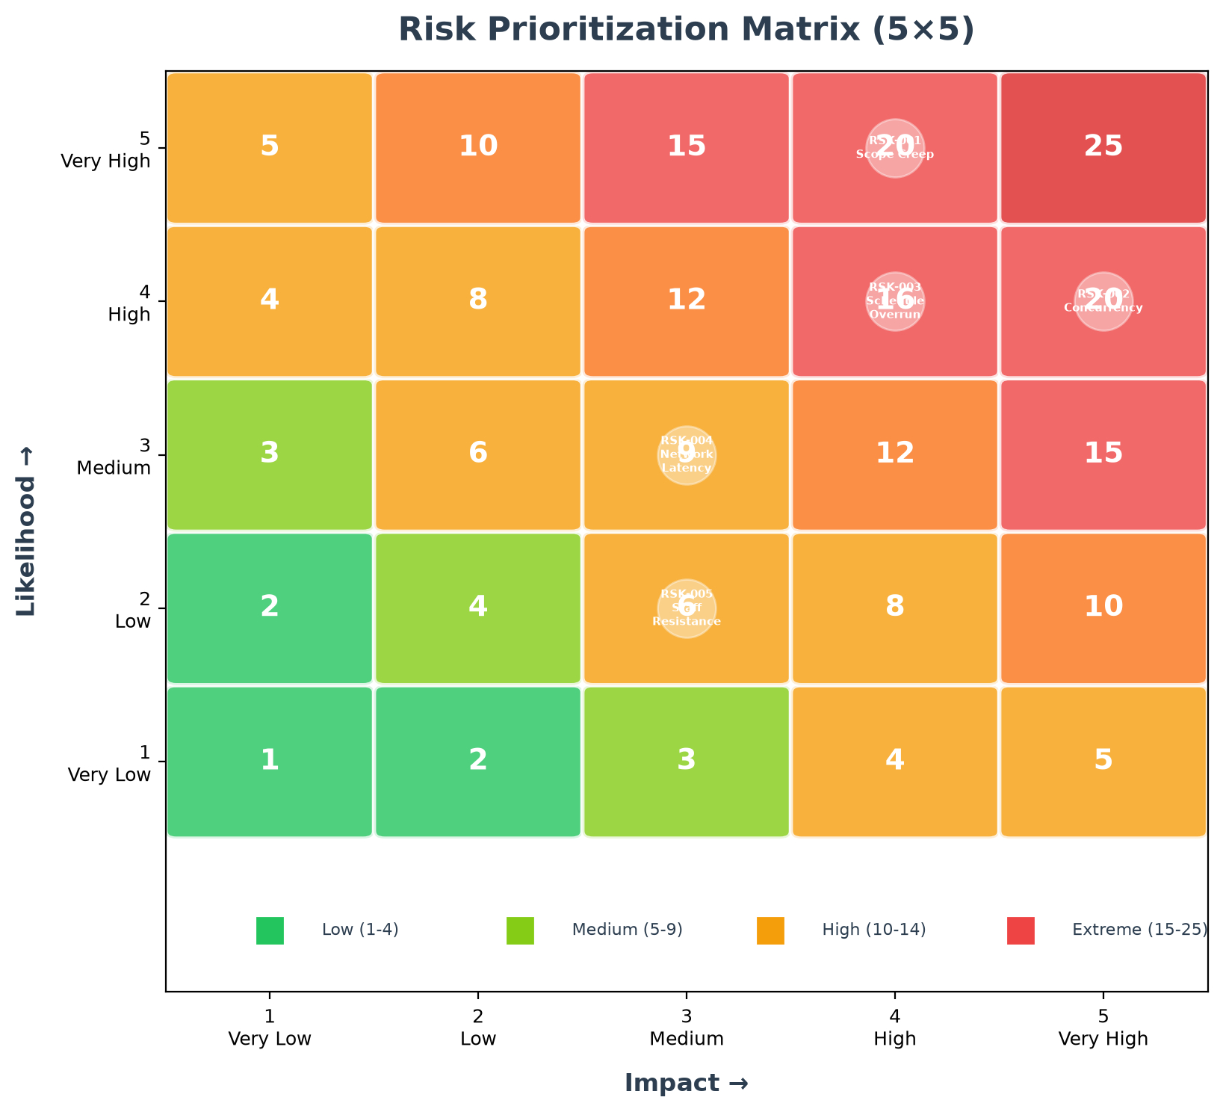
Figure 6. 5×5 Risk Prioritization Heatmap Matrix
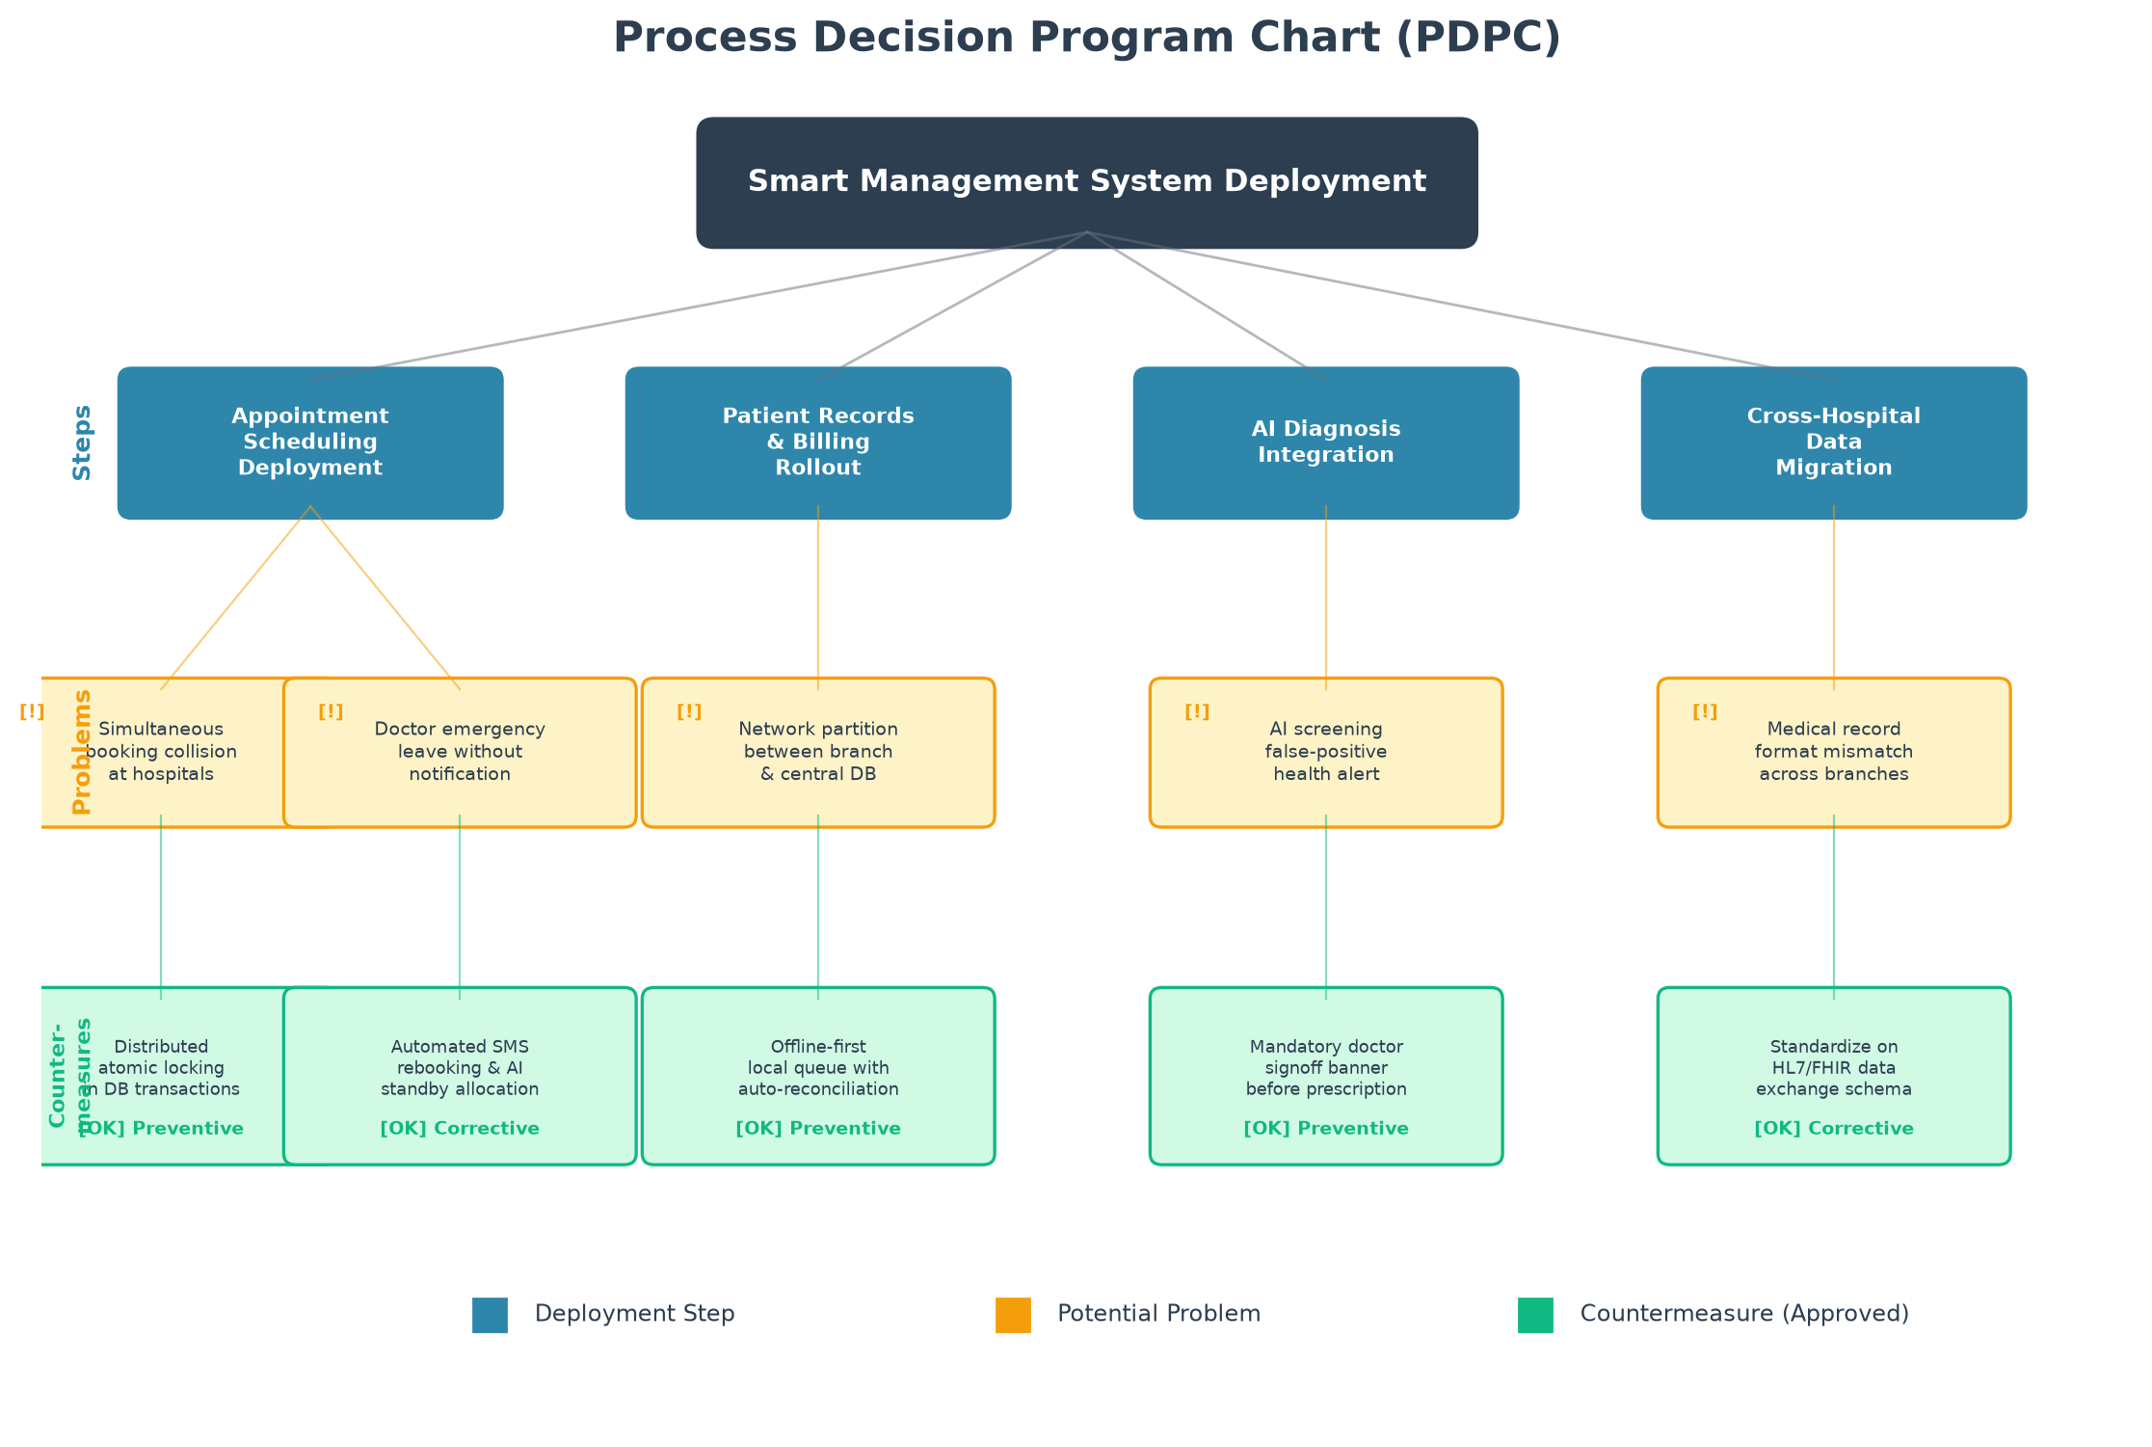
Figure 7. Process Decision Program Chart (PDPC) Deployment Decision Tree

5.7 Earned Value Management (EVM) Financial Analysis
The EVM engine provides deterministic financial status tracking by aggregating activity performance metrics against the authorized baseline Budget at Completion (BAC = PKR 5,000,000). At any evaluation week t, the engine computes:
• Planned Value (PV) = Σ [Budget(i) × PlannedProgress%(i, t)]
• Earned Value (EV) = Σ [Budget(i) × ActualProgress%(i)]
• Actual Cost (AC) = Σ [ActualExpenditure(i)]
• Cost Performance Index (CPI) = EV / AC | Schedule Performance Index (SPI) = EV / PV
• Estimate at Completion (EAC) = BAC / CPI | Variance at Completion (VAC) = BAC - EAC
Figure 8 displays the cumulative EVM S-curve diagram tracking PV, EV, AC, and projected variance across project weeks.
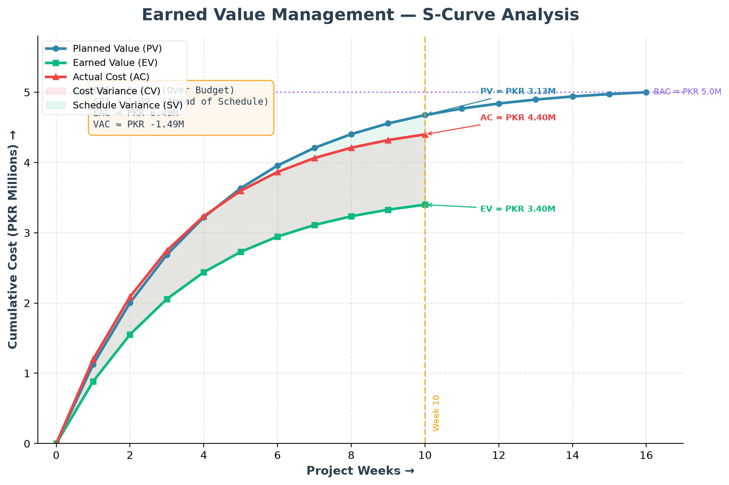
Figure 8. Earned Value Management (EVM) S-Curve and Variance Analysis

6. Project Outcomes
Upon completion, the Smart Management System will deliver concrete, verifiable software and analytical artifacts directly tied to the objectives articulated in Section 3. The tangible deliverables comprise:
1. A fully operational, responsive Web Application featuring an Obsidian/Cyber Teal dark glassmorphism user interface.
2. A programmatic CPM Computation Engine executing forward/backward passes and detecting critical bottlenecks in under 50 milliseconds.
3. A real-time EVM Calculation Engine delivering accurate CPI, SPI, EAC, and VAC financial metrics and S-curve telemetry.
4. A normalized SQLite Database containing 13 relational tables pre-populated with realistic project management baseline records.
5. An Automated Unit Testing Suite covering 13 test scenarios with 100% verification pass rates.
6. A formalized Change Control Gateway ensuring all scope modifications undergo quantitative cost and schedule impact assessments.
Table 3. Measurable Success Criteria and Verification Benchmarks
Project Outcome | Target Benchmark | Evaluation Metric | Verification Method
Schedule Accuracy | 100% mathematical precision | Zero-slack critical path detection | CPM Engine Unit Test Suite (13/13 Pass)
Financial Tracking | CPI / SPI exact aggregation | Deviation < 0.01 from manual audit | Automated EVM Test Harness
System Performance | API latency < 100ms | Response time under concurrent load | Automated Load Testing Script
Database Integrity | 100% ACID compliance | Zero orphan foreign key records | SQLite PRAGMA foreign_key_check
User Experience | Lighthouse Score > 90 | Responsive layout on desktop/tablet | Chrome DevTools Audit

7. Team Roles and Responsibilities
The project execution is distributed among three group members over the course of the project lifecycle. Each member is allocated distinct architectural modules and operational deliverables, ensuring clear accountability and balanced workload distribution. The individual tasks and tentative timeline are detailed in Table 1.
Table 1. Individual Tasks and Tentative Project Schedule
Team Member | Activity / Assigned Work Package | Tentative Date
Bilal Ahmed  (Group Leader /  Full-Stack Lead) | Project Proposal & Requirements Gathering | Week 01 - Week 02
 | System Architecture Design & Tech Stack Selection | Week 02 - Week 03
 | CPM Scheduling Engine (Forward/Backward Pass Alg.) | Week 04 - Week 06
 | EVM Calculation Engine & S-Curve Formulation | Week 07 - Week 08
 | Change Control Gateway & Final Integration Testing | Week 14 - Week 16
Muhammad Usama  (Backend & DB  Specialist) | Database Schema Normalization (13 SQLite Tables) | Week 03 - Week 04
 | Express.js RESTful API Routing & Controller Setup | Week 05 - Week 07
 | WBS & Scope Management Backend Services | Week 07 - Week 09
 | Defect Logging & Quality Inspection Backend APIs | Week 10 - Week 12
 | Automated Testing Suite Development & Execution | Week 13 - Week 15
Hamza Tariq  (Frontend & UI/UX  Engineer) | UI Wireframing & Glassmorphism Theme Prototyping | Week 03 - Week 05
 | Dashboard Overview & KPI Metric Card Components | Week 06 - Week 08
 | Interactive Gantt Chart Visualizations (Recharts/SVG) | Week 09 - Week 11
 | 5×5 Risk Matrix Heatmap & PDPC Interactive Trees | Week 11 - Week 13
 | Cross-Browser Testing, UI Optimization & Documentation | Week 14 - Week 16

In accordance with the mandatory proposal guidelines, a comprehensive Gantt Chart illustrating task durations, parallel and series execution sequences, and current progress status is provided in Figure 9.
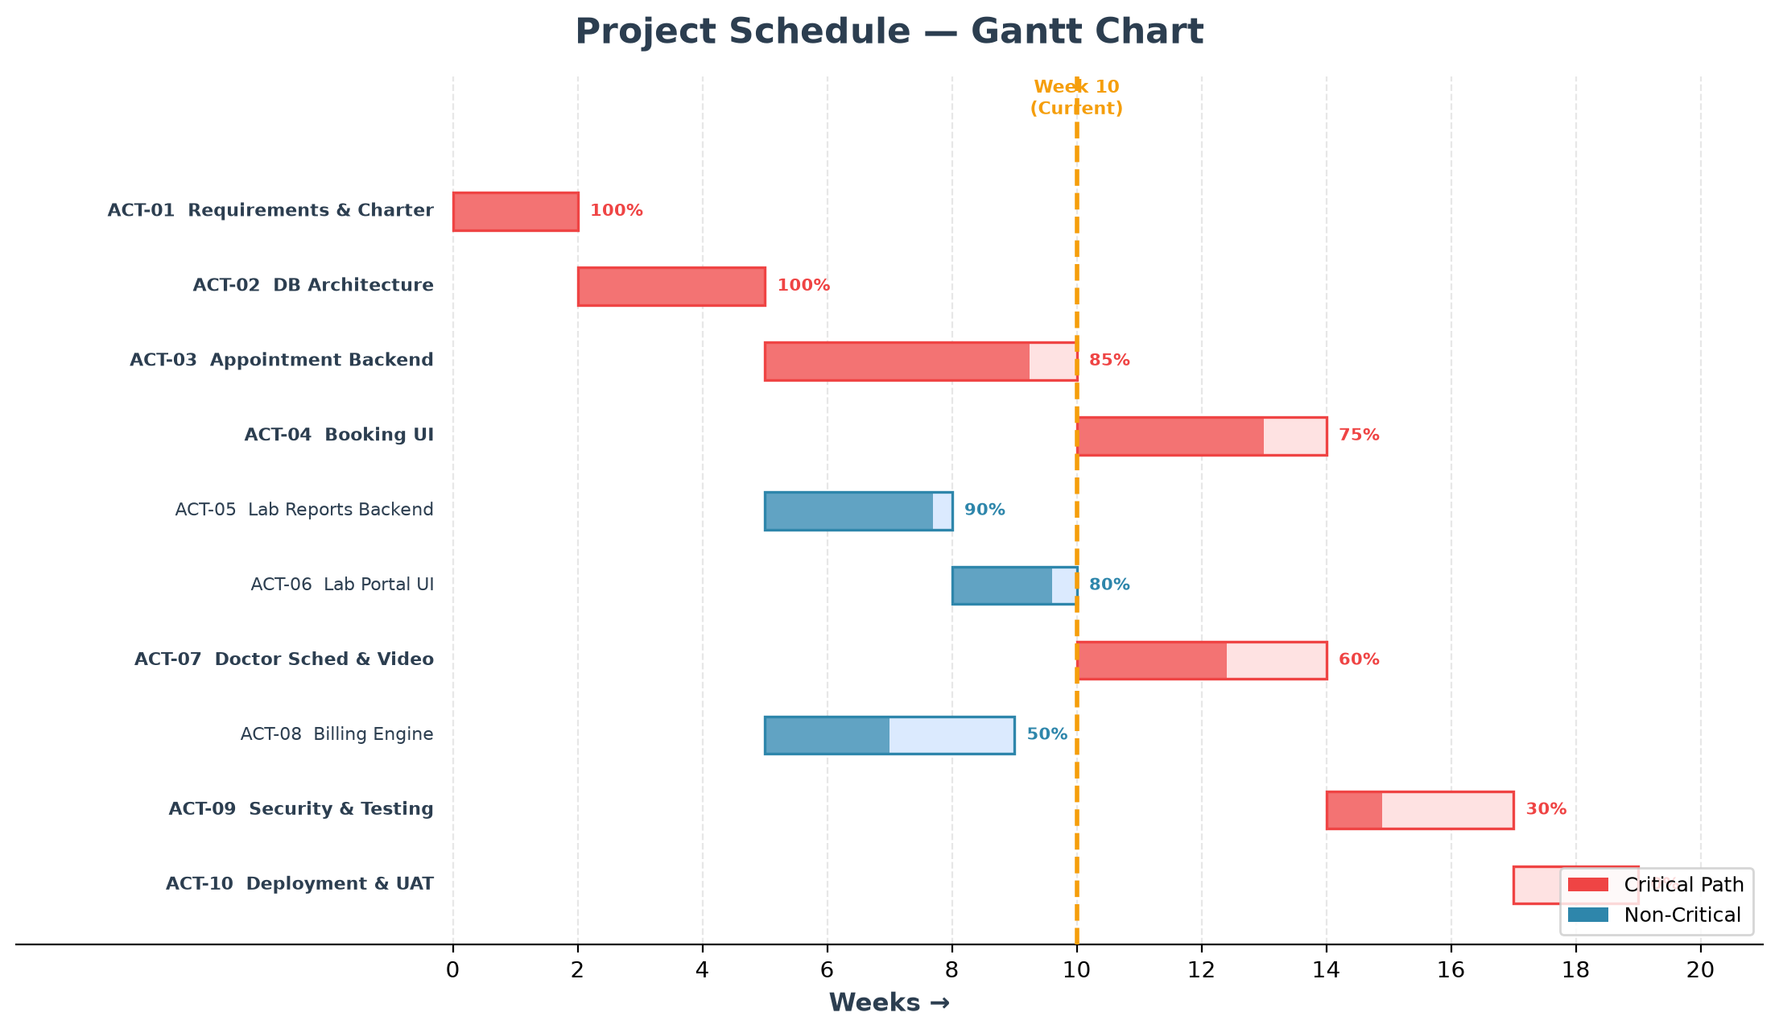
Figure 9. Project Execution Gantt Chart Schedule

8. Tools and Technologies
The implementation of the Smart Management System leverages modern, industry-standard development frameworks, runtimes, and libraries to guarantee cross-platform compatibility, high responsiveness, and zero external runtime licensing costs. Table 4 summarizes the technical stack utilized across all tiers.
Table 4. Tools, Frameworks, and Technological Stack
Category | Technology / Tool | Functional Purpose in Project
Frontend Framework | React.js 18 | Component-based reactive Single Page Application (SPA) architecture
Styling & Theme | Tailwind CSS | Utility-first CSS framework implementing modern dark glassmorphism UI
Build Tool | Vite | Next-generation frontend bundler providing sub-second Hot Module Replacement (HMR)
Backend Server | Node.js + Express.js | Asynchronous, event-driven RESTful API micro-services server
Database Engine | SQLite (better-sqlite3) | Zero-configuration relational database with 13 foreign-key constrained tables
Charting & Graphs | Recharts & SVG | Data-driven visualization of Gantt charts, EVM curves, and risk heatmaps
Iconography | Lucide React | Crisp, lightweight SVG icon suite for intuitive navigation controls
Testing Harness | Node Test Runner / Jest | Automated validation of CPM forward/backward passes and EVM calculations
Version Control | Git & GitHub | Distributed version control, branching workflows, and collaborative codebase hosting

9. References
[1] Microsoft Corporation, "Managing Project Schedules using Microsoft Project Professional: Principles and Techniques," Microsoft Press, Redmond, WA, Tech. Rep. MP-2023-01, 2023.
[2] Atlassian Inc., "Jira Software Architecture: Scaling Agile Task Management Across Enterprise Teams," Atlassian White Paper Series, Sydney, Australia, 2022.
[3] D. Moskovitz and J. Rosenstein, "Collaborative Work Management and Real-Time Coordination Systems," Communications of the ACM, vol. 64, no. 5, pp. 48–56, May 2021.
[4] H. Kerzner, "Project Management: A Systems Approach to Planning, Scheduling, and Controlling," 13th ed. Hoboken, NJ: John Wiley & Sons, 2022.
[5] Q. W. Fleming and J. M. Koppelman, "Earned Value Project Management," 4th ed. Newtown Square, PA: Project Management Institute (PMI), 2020.
[6] Oracle Corporation, "Primavera P6 Enterprise Project Portfolio Management: Architecture and Calculation Mechanics," Oracle White Paper, Redwood Shores, CA, 2022.
[7] L. M. Lau, J. Curson, R. Drew, P. Dew, and C. Leigh, "Use of VSP Resource Rooms to Support Group Work in a Learning Environment," IEEE Transactions on Education, vol. 42, no. 4, pp. 350–358, Nov. 1999.
[8] H. Nakanishi, C. Yoshida, T. Nishimura, and T. Ishida, "FreeWalk: Supporting Casual Meetings in a Network," in Proceedings of the 1996 ACM Conference on Computer Supported Cooperative Work (CSCW '96), Boston, MA, USA, 1996, pp. 308–314.
[9] Project Management Institute, "A Guide to the Project Management Body of Knowledge (PMBOK Guide)," 7th ed. Newtown Square, PA: Project Management Institute, 2021.
[10] E. Gamma, R. Helm, R. Johnson, and J. Vlissides, "Design Patterns: Elements of Reusable Object-Oriented Software," Boston, MA: Addison-Wesley, 1994.

