**Post**

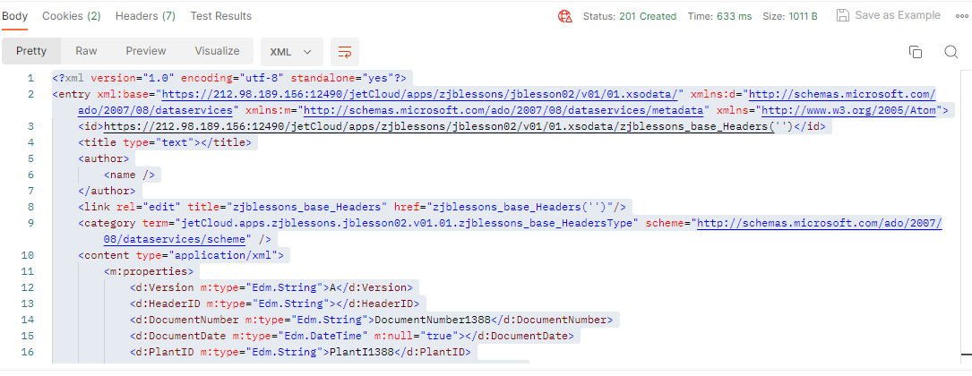

<?xml version="1.0" encoding="utf-8" standalone="yes"?>

<entry xml:base="https://212.98.189.156:12490/jetCloud/apps/zjblessons/jblesson02/v01/01.xsodata/" xmlns:d="http://schemas.microsoft.com/ado/2007/08/dataservices" xmlns:m="http://schemas.microsoft.com/ado/2007/08/dataservices/metadata" xmlns="http://www.w3.org/2005/Atom">

    <id>https://212.98.189.156:12490/jetCloud/apps/zjblessons/jblesson02/v01/01.xsodata/zjblessons_base_Headers('')</id>

    <title type="text"></title>

    <author>

        <name />

    </author>

    <link rel="edit" title="zjblessons_base_Headers" href="zjblessons_base_Headers('')"/>

    <category term="jetCloud.apps.zjblessons.jblesson02.v01.01.zjblessons_base_HeadersType" scheme="http://schemas.microsoft.com/ado/2007/08/dataservices/scheme" />

    <content type="application/xml">

        <m:properties>

            <d:Version m:type="Edm.String">A</d:Version>

            <d:HeaderID m:type="Edm.String"></d:HeaderID>

            <d:DocumentNumber m:type="Edm.String">DocumentNumber1388</d:DocumentNumber>

            <d:DocumentDate m:type="Edm.DateTime" m:null="true"></d:DocumentDate>

            <d:PlantID m:type="Edm.String">PlantI1388</d:PlantID>

            <d:PlantText m:type="Edm.String" m:null="true"></d:PlantText>

            <d:RegionID m:type="Edm.String" m:null="true"></d:RegionID>

            <d:RegionText m:type="Edm.String" m:null="true"></d:RegionText>

            <d:Description m:type="Edm.String">Description2003</d:Description>

            <d:Created m:type="Edm.DateTime" m:null="true"></d:Created>

            <d:CreatedBy m:type="Edm.String">D1B0238362</d:CreatedBy>

            <d:CreatedByFullName m:type="Edm.String">Grishilov Vladislav</d:CreatedByFullName>

            <d:CreatedByAvatar m:type="Edm.String" m:null="true"></d:CreatedByAvatar>

            <d:Modified m:type="Edm.DateTime" m:null="true"></d:Modified>

            <d:ModifiedBy m:type="Edm.String" m:null="true"></d:ModifiedBy>

            <d:ModifiedByFullName m:type="Edm.String" m:null="true"></d:ModifiedByFullName>

            <d:ModifiedByAvatar m:type="Edm.String" m:null="true"></d:ModifiedByAvatar>

            <d:IntegrationID m:type="Edm.String" m:null="true"></d:IntegrationID>

        </m:properties>

    </content>

</entry>

**Patch**

