YAWL Interface D – Developer Guide

Document Control

Date | Author | Version | Change
1st June 2005 | Guy Redding | 1.0 | Initial Draft

This document is not intended for users of the YAWL system. It is a technical overview of Interface D and is intended for people interested in the development of YAWL.

Interface D is used to connect the YAWL Work List Handler to external (3rd party) applications. As work item info is checked in and out of the work list, Interface D is used to forward the work item data to 3rd party applications. It is the responsibility of application integration developers to create their own customised/personalised adaptors for each 3rd party application that can appropriately deal with data received from YAWL.

Interface D is a HTTP wrapper, found in YAWL as part of the package au.edu.qut.yawl.engine.interfce, that is capable of sending either a GET or POST request to an application. Interface D is responsible for the following actions:

- Establishes a connection to an application found at a URL.
- Sets optional parameters on a HTTP request.
- Adds an optional message body.
- Sends the HTTP request as either a GET or POST.

Interface D is currently used to manage interaction between the YAWL Work List and a 3rd party application called YAWLXForms that dynamically creates and displays forms for work items in YAWL. This serves as an example implementation of Interface D (see Figure 1) that will have its functionality explained.

To create a form, the Work List creates a list of “instructions” and sends them to the YAWL engine to create a XML Schema for the given work item, which is saved as a temporary file. An XML instance is generated from the schema which is also saved as a temporary file. The instance contains any input data that exists in the work item.

The Work List creates an Interface D connection to the YAWLXForms web application, which can exist in a location other than on the localhost. Interface D is used to send the temporary schema and instance data files to YAWLXForms. Interface D then sends a command request from the Work List to YAWLXForms to generate a form. When this is complete, the YAWL Work List redirects to the newly created form that is displayed to the user. The submission of XML data posted from YAWLXForms to the Work List is received by a servlet found at au.edu.qut.yawl.forms.YAWLFormServlet. This servlet can be customised as desired to meet any additional requirements for the submission of data received by other 3rd party applications and it does not form part of Interface D.

It is important to note that checking in and checking out of work items is done separately to Interface D, since checking items in and out of the engine involves Interface B. This is done to ensure that Interface D is not dependant upon any other YAWL interface, making it resilient to change in these other interfaces.

The code that implements Interface D for YAWLXForms is found in the following locations in YAWL:

au.edu.qut.yawl.worklist.WorkItemProcessor.java
au.edu.qut.yawl.worklist._LaunchCase.jsp
au.edu.qut.yawl.worklist._WorkItemProcessor.jsp

Additionally, the code used to generate the XML schema and instance destined for YAWLXForms is found in the SchemaCreator and InstanceBuilder classes from the au.edu.qut.yawl.forms package.

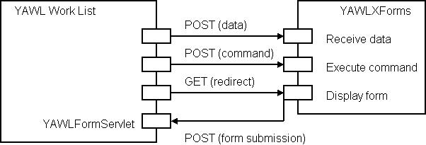

Figure 1. YAWLXForms implementation using Interface D

