YAWL Engine
User Manual

Beta – 7 Release



Document Control

Date | Author | Version | Change
25 Aug 2004 | Sean Kneipp | 0.1 | Initial Draft
30 Aug 2004 | Sean Kneipp | 1.0 | Final Draft
4 Feb 2005 | Guy Redding | 1.1 | Added YAWL XForms details
4 Feb 2005 | Lachlan Aldred | 1.2 | Updated Issues & 3rd-Party Software Acknowledgements
12/04/2005 | Lachlan Aldred | 1.3 | Updated troubleshooting section.
22/12/2005 | Michael Adams | 1.7 | Updated for Beta 7 Version.  Document version brought in line with Release Version

Contents

Document Control ii
Getting Started 1
Overview 1
Launching the YAWL Engine 1
The YAWL Workspace 2
Key YAWL Pages 2
YAWL Administration 3
Loading a YAWL specification 3
Launching a YAWL Specification 4
Unloading a YAWL Specification 5
Data Elements of a Case 6
Data Perspective 6
Providing Data for the Case Using a Form 6
Providing Data for the Case Using XML 7
How to Input the Data Using XML 8
Work Items 9
Viewing Available Work 9
Checking Out Available Work 9
Saving Detailed Information for a Work Item 10
Submitting a Work Item 12
Creating a New Instance of a Work Item 12
Suspending a Work Item 13
Managing Users 14
Managing Roles 15
Creating Charts and Tables 16
Step 1: 17
Step 2: 17
Step 3: 19
Known Issues 21
Engine (yawl.war) 21
Worklist (worklist.war) 21
Web Service Invoker (wsInvoker.war) 21
YAWL XForms Processor (YAWLXForms.war) 21
Troubleshooting 22
Third–Party Software Acknowledgements 23
Acknowledgements 26

Getting Started

Overview

Before you jump straight into the YAWL Engine and start testing your favourite workflows, you will need to make sure that the Tomcat web-service has been started. YAWL is a browser-based web application that requires a server jsp environment, such as Apache Tomcat.
For full instructions on starting the Tomcat service, or obtaining the Apache Tomcat software, please consult the YAWL Installation Manual.

Launching the YAWL Engine

      - Open up your web browser.
      - Type the following address into the address line and press enter (see Fig.2.):
http://localhost:8080/worklist.

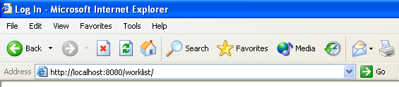
Fig.2. Navigate to the YAWL Log In webpage

      - The YAWL Log In screen will be displayed
      - Log in with the following details (case sensitive):
UserID: admin
Password: YAWL

The YAWL Workspace

Key YAWL Pages
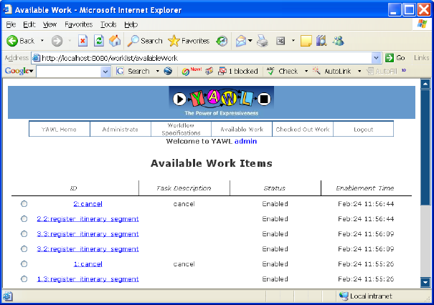

Fig.3. YAWL Workspace

Key YAWL Pages
The separate pages of the browser-based application, representing the different functions of the YAWL Engine:
- YAWL Home
- Administrate
- Workflow Specifications
- Available Work
- Checked Out Work
- Logout

YAWL Administration

Loading a YAWL specification

In additional to a graphical syntax, the YAWL language has an XML syntax. The runtime environment requires this YAWL XML syntax. To load a YAWL specification:
      - Navigate to the Administrate page:
http://localhost:8080/worklist/admin.
      - In the Manage Specifications section of the page, Browse for a YAWL specification (.xml file) and choose Open.
The installation package for YAWL contains a number of sample YAWL specifications (XML files). The specification used throughout this document refers to the “makeTrip3.XML” file.
      - Click on Upload.
      - You should now see the details of your specification. Fig.4.
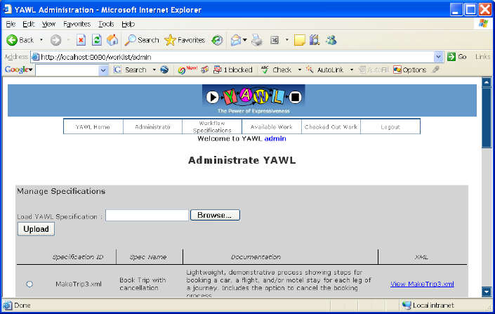
Fig.4. Upload YAWL Specification

Launching a YAWL Specification

In order to kick-off the workflow specification, you need to ‘launch a case’. To launch a YAWL specification that has already been uploaded into the YAWL Engine:
      - Navigate to the Workflow Specifications page:
http://localhost:8080/worklist/viewSpecifications.
      - In the Active YAWL Specifications section of the page, choose the specification to launch.
      - Click on the Launch Case button. Fig.5.
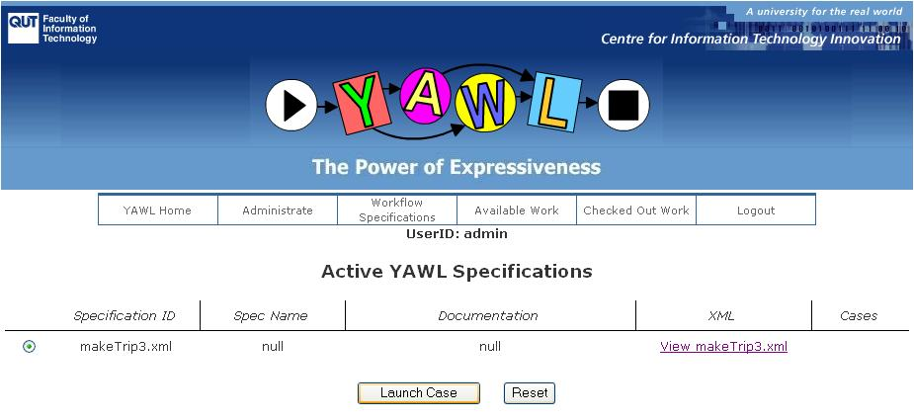
Fig.5. Launching the Case
      - Then in the following Launch Case section of the page, click on the Start Case button. Fig.6.
Depending on the specification loaded, you may be required to launch the case with specific information for data elements. For more information on providing data throughout the case, consult the Data Elements of a Case section of this manual.
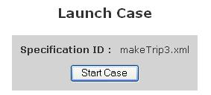
Fig.6. Starting the Case
      - You will then see a confirmation screen to indicate that a case has been launched with a specific identification number.

Unloading a YAWL Specification

You can remove a YAWL specification so that it is no longer available to be started. To remove a specification:
      - Navigate to the Administrate page:
http://localhost:8080/worklist/admin.
      - In the Manage Specifications area of the Content Pane, choose the specification to remove.
      - Click on the Unload Specification button.

Data Elements of a Case

Data Perspective

Although the initial focus of YAWL was on control flow, it has been extended to offer full support for the data perspective. It is possible to define data elements and use them for conditional routing, for the creation of multiple instances, for exchanging information with the environment, etc. Most of the existing workflow management systems use a propriety language for dealing with data. YAWL is one of the few languages that completely relies on XML-based standards like XPath and XQuery.

Providing Data for the Case Using a Form
During certain activities of a YAWL Case, you may be required to provide some information for data elements that have been established in the XML specification. Requests for data can occur when “Launching a Case” or when editing “Checked Out Work” items.
Fig.8. depicts a request for data form for multiple data elements, while performing an edit of a “Checked Out Work” item. The red star next to a field indicates that input is required for that field. The form submits data back to YAWL only when all data in the forms is valid.
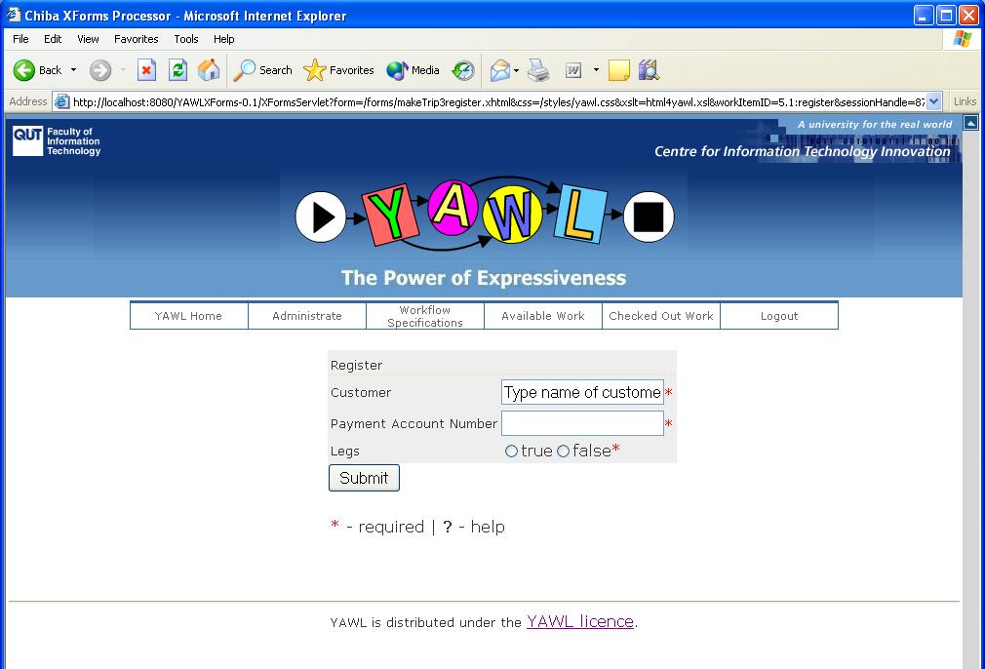
Fig.8. Request for Data using a Form

Providing Data for the Case Using XML
It is also always possible to enter data using XML. This method of user input is useful if data input using a form has failed for any reason. Fig. 9 is the XML input page. To get to this page click the link for the work item ID on the Checked Out Work Items page (Fig. 12) instead of selecting the radio button for a Work Item and clicking the Edit Work Item button.
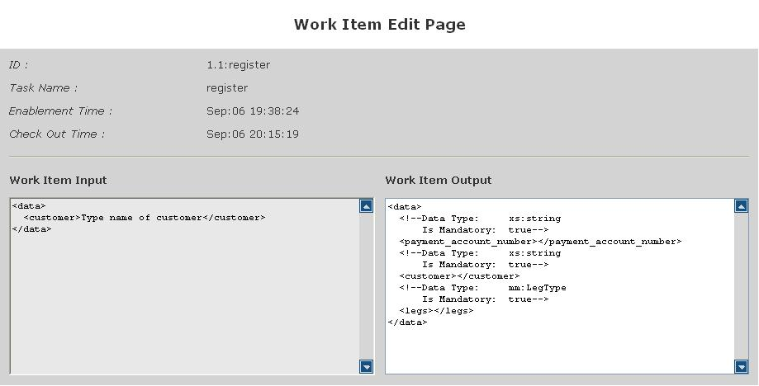
Fig. 9 Request for Data using XML

How to Input the Data Using XML
The structure of the request for data follows the XML format of opening and closing “tags”. The data is entered between the open and close tags that refer to that data element.
In the “makeTrip3.xml” specification, the example below (Fig. 10.) depicts a request to enter the name of the customer going on a trip, for the customer data element.
- Firstly the data tag is opened.
- Then the Data Type tag (or comments tag) is opened to let the user know the details of the data required.
- The Data Type tag is requesting a string variable from the user and the information required is Mandatory. The tag is closed.
- Then the customer tag is opened, referring to the data element to store the information.
- The user then enters the customer name within the customer tags.
- Finally the data tag is closed.
The Data Type tag
- Open
- Data Type
- Mandatory?
- Close

<data>
<!--Data Type: xs:string
The data tags
- Open
- Close
Is Mandatory: true-->
<customer>Mr John Smith</customer>
</data>
“My data”

Fig. 10. Inputting the Data
Work Items

Viewing Available Work

Alternate user accesses to the YAWL Engine can be created through the Administrator. To create a new user access:
- Navigate to the Available Work page:
http://localhost:8080/worklist/availableWork.
- All available work items will be listed, according to the specification loaded. Work items can be related back to a specific instance of a case, through their case number. Fig.11.

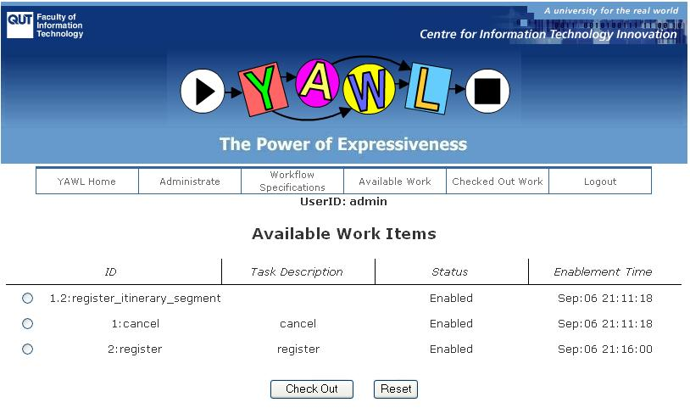

Fig. 11. Available Work Items

Checking Out Available Work

When a person is ready to start working on an available work item, the item is “Checked Out”.
- Navigate to the Available Work page:
http://localhost:8080/worklist/availableWork.
- Click on the radar button next to the work item and click the button “Check Out”

Saving Detailed Information for a Work Item

While a person is working on an item that has been “Checked Out”, specific details may be required to be saved against that item.
Information saved against a work item can be used to launch other YAWL cases or provide data for other interfacing systems. For more information on providing data in work items, consult the Data Elements of a Case section of this manual.
- Navigate to the Checked Out Work page:
http://localhost:8080/worklist/checkedOut.
- Click on the radar button next to the work item and click the button “Edit Work Item” Fig.12.
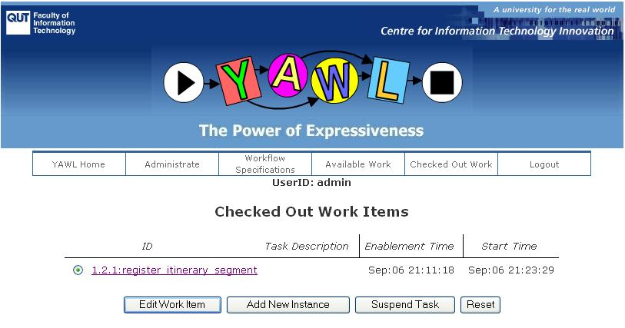
Fig. 12. Checked Out Work Items
- Enter any required data using a form for the data elements that have been requested, in the Work Item Output section of the page and click Save Work Item. Fig.13.
- Alternatively, click on the link for the Work Item ID to enter any required data for the requested data elements using XML. Fig. 14.
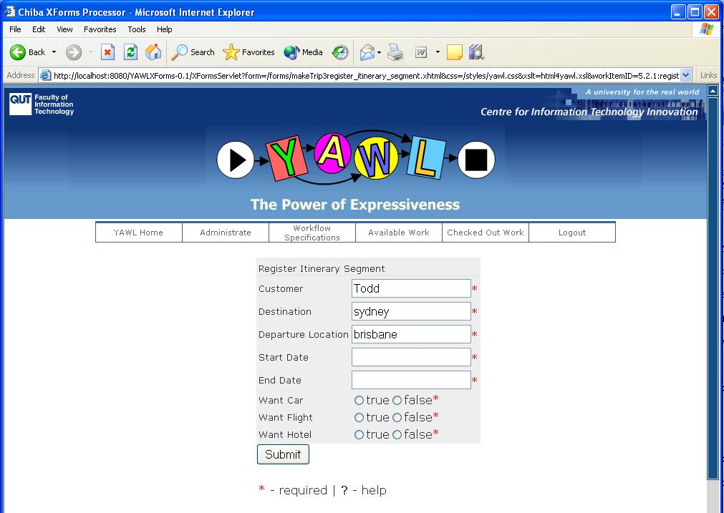
Fig 13. Work Item Edit Page Using a Form

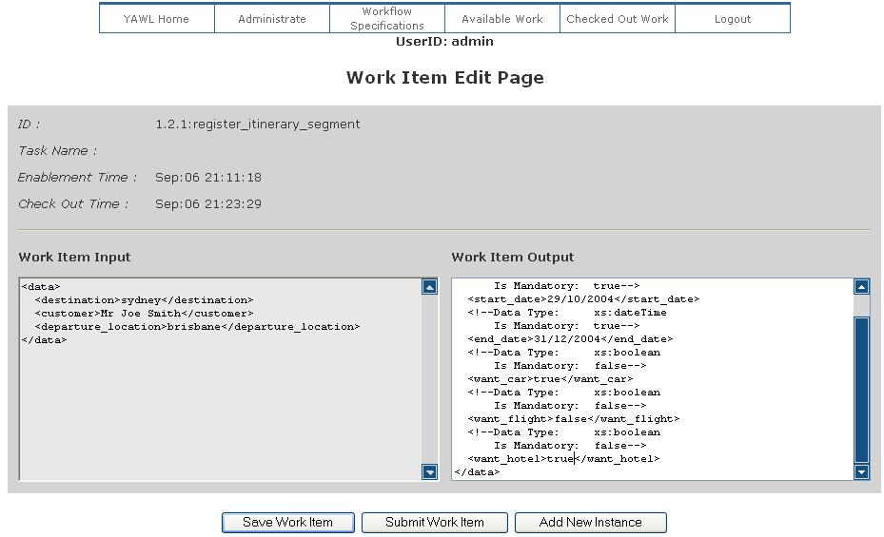

Fig. 14. Work Item Edit Page Using XML

Submitting a Work Item

Once a work item has been completed, it must be submitted for the token to be advanced in the workflow.
- Navigate to the Checked Out Work page:
http://localhost:8080/worklist/checkedOut.
- Click on the radar button next to the work item and click the button “Edit Work Item” Fig.12.
- Enter any required data for the data elements that have been requested in the Work Item Output section of the page. Fig.13, 14.
- Click on the Submit Work Item button.

Creating a New Instance of a Work Item

If the specification supports it, new instances of a work item can be created as an item is “checked out”, reflecting multiple instance tasks in the workflow.
The current example specification, “makeTrip3.xml” does not contain any multiple instance tasks, so instructions below refer to the specification “MakeMusic.XML”.
- Navigate to the Available Work page:
http://localhost:8080/worklist/availableWork.
- Check Out a work item that supports multiple instance creation.
The “MakeMusic.XML” specification contains a multiple instance task on the work item “Write a Song”.
- Navigate to the Checked Out Work page:
http://localhost:8080/worklist/checkedOut.
- Click on the radar button next to the work item and click the button “Add New Instance” Fig.12.
- Enter any required data for the data elements that have been requested and click on Create Instance. Fig.15.
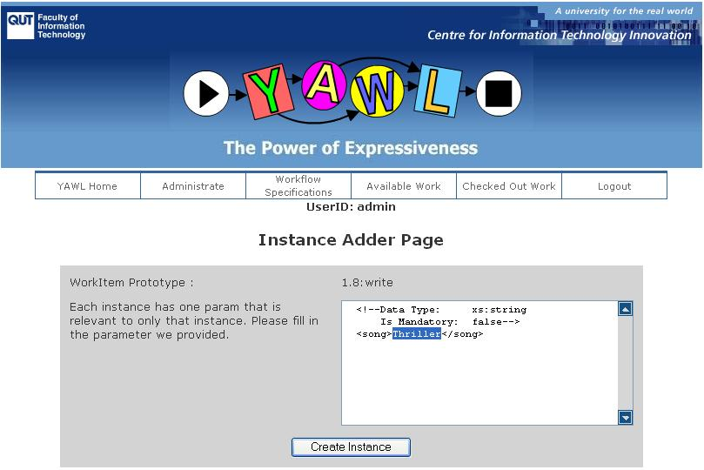

Fig.15. Creating a New Instance of a Work Item

Your new instance of the Work Item will be now be listed as Available Work.

Suspending a Work Item

Work items that have been “checked out” to a person, can be returned to the available work items. All data that has been saved for that work item remains intact.
- Navigate to the Checked Out Work page:
http://localhost:8080/worklist/checkedOut.
- Click on the radar button next to the work item and click the button “Suspend Task” Fig.12.

Managing Users

Alternate user accesses to the YAWL Engine can be created through the Administrator.
To create a new user access:
- Navigate to the Administrate page: http://localhost:8080/worklist/admin.
- Click on “Edit Organisational Model”.
- Select “Resources” from the menu on the top.
- To delete a user, choose the user ID from the box “Select Human ResourceID” and press delete.

To add a user:
- Choose the “—New User—“ item from the box “Select Human ResourceID” and then enter all required details for this user into the fields.
- Click “update resource”.

To assign user roles.
- Select a role from the column on the left hand side.
- Use the right-pointing arrow to move the selected role to the column on the right hand side.

To remove user roles:
- Select a role from the column on the right hand side.
- Use the left-pointing arrow to move the selected role to the column on the left hand side.
- Select Updates roles by resource when complete. The resource is then set to have the roles which are on the list on the right hand side.
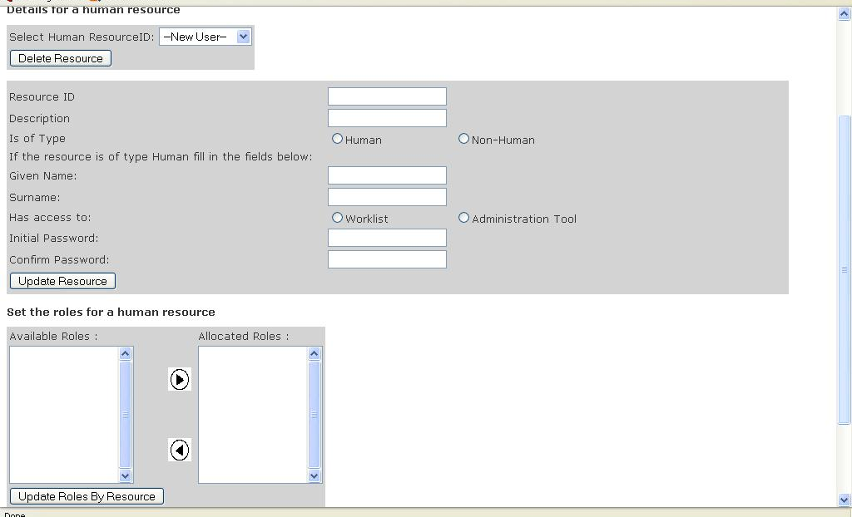
Figure 16: Managing Users

Managing Roles

Alternate user accesses to the YAWL Engine can be created through the Administrator.
To create a new role assignment:
- Navigate to the Administrate page: http://localhost:8080/worklist/admin.
- Click on “Edit Organisational Model”
- Select “Roles” from the menu on the top.

To delete a role, select the rolename from the “select role” list, and click delete.

To create a role, enter the rolename in the list at “Role” and click add role.

To assign resources to roles:
- Select a resource from the column on the left hand side.
- Use the right-pointing arrow to move the selected resource to the column on the right hand side.

To remove resource assignments to roles:
- Select a resource from the column on the right hand side.
- Use the left-pointing arrow to move the selected resource to the column on the left hand side.
To record the update in the system, press “Updates Resources by Role”. The role is then allocated to the resources which are on the list on the right-hand side.

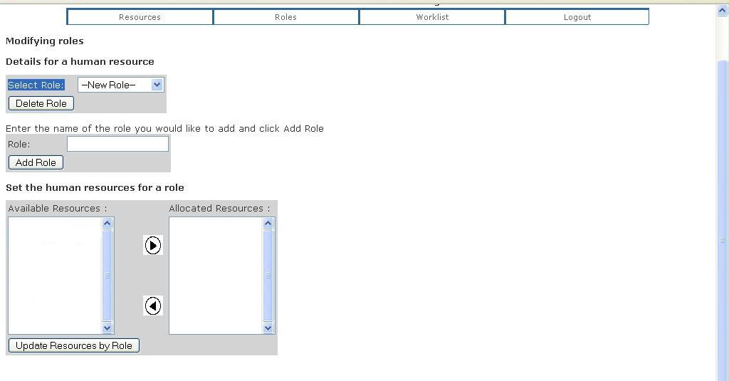
Figure 17: Managing Roles

Creating Charts and Tables

Charts and tables can be created by administrators in order to display reports of executions of previous cases and tasks. The chart building tool builds queries towards the database and displays results. Several different views can be created in order to compare the efficiency of different resources, tasks, and cases.

This tool requires that database persistence is switched on otherwise it will be marked as unavailable.

The chart building tool consists of three parts.
- Step 1: The initial set up
- Step 2: Adding filters
- Step 3: Displaying the results

Step 1:
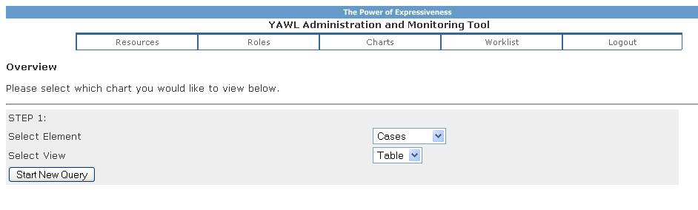
The first step is used to define the portion of the database which the queries will be performed over, as well as the type of view the result will be displayed as. The screen is shown in the figure above.

Queries may either be performed over Cases or Work-items. Case queries are used to examine how long cases took to execute, how many has executed etc. Work-item queries return similar results but regarding tasks instead. For example, it can display the number of tasks completed in each specification, or how long each tasks took to execute.

The view can be selected as either table, or chart. If a chart is selected, then the type of chart can be specified later.

After selecting these two elements, the “Start New Query” button can be pressed, and Step 2 is shown.

Step 2:

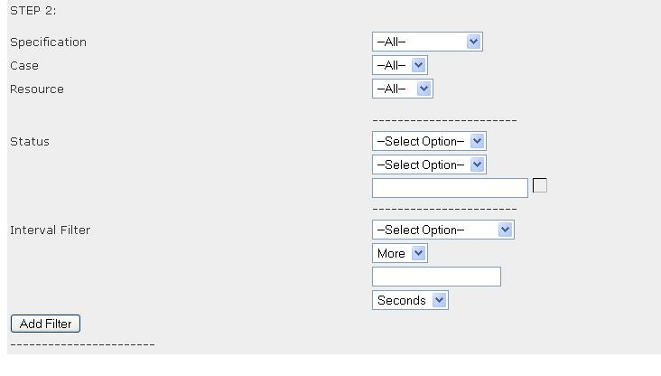

During the second step it is possible to add filters to the queries. Several types of filters can be added as shown in the Figure above.

A specification filter is inserted to restrict the results to a single specification. The list of specifications which can be filtered on, is provided from the database. The case filter is used to specify which case id the filtering should be made over. The resource filter specifies that results should only be returned if they relate to a particular resource (e.g. human user). Work-item queries have one addition filter, being a task name.

The status filter can be used to specify that a certain case was in a particular state, after or before a particular time. The time is specified by selecting the icon on the right hand side of the text field. A calendar pops up, and the time can be selected here.

The interval filter is used to specify that only cases which took more or less then a particular length of time is returned. For example, cases which took more than 7 days are returned. Administrators can select the interval of their choice, if it is more or less, the length of time, and the granularity of the time specified. The granularity can be seconds, minutes, hours, days, months or years.

For cases the interval specified is always started-completed. For work-items three intervals can be selected. These are either enabled, started, or completed. The relationship between these is shown below:
Enabled
Started
Completed
Work items become enabled when it is ready for execution. When it is checked out, it goes into the started state. Then when it is checked back in it is in the completed state. There are therefore three intervals which can be queried upon.
- Enabled-Started
- Enabled-Completed
- Started-Completed

After a filter has been created, the “add filter” button is pressed. This stores the filter in the system until the administrator requests that a chart or table is to be created. There must always be at least one filter, which could be an empty filter (i.e. nothing specified on any fields).

The administrator can create several filters, in which case the union of the results of all filters will be displayed. For example if the administrator wanted to display results from two specifications, then two filters must be added, one for each specification. If an empty filter is specified, then all results will be displayed regardless of what other filters are added. To restart the query mechanism and to remove all previously created filters, the “create query” button from step 1 must be pressed.

After all filters have been added, the admin may proceed to step 3.

Step 3:

In step 3, the developer specifies what elements should be viewed as part of the result set. Depending on whether a chart or table was selected as a view in step 1, different screens are shown.

Chart:

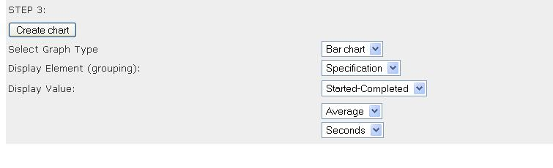

The chart screen lets administrators create results as a bar chart or a pie chart. Results can be grouped based on specifications, resources, or case ids (or task id in case of a work-item query). It the case id (or task id) is chosen, then no grouping is made. The value selected here is the value for the x-axis of a bar-chart.

Then a display value can be selected, which is either an interval or a count. This is the y-axis in the bar chart.

If a grouping is selected, then the average of these is calculated and displayed.

Finally the granularity for displaying the intervals can be selected.

When the chart is ready for display, the “Create Chart” button is pressed. This causes the screen to be updated with the display of the chart.
(NOTE: if the proper chart is not shown, press the refresh button and it should be updated).

Table:
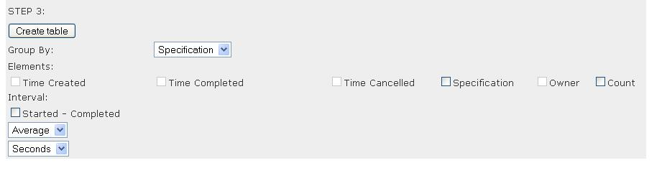
When creating table, the principles are the same, except that all elements to be displayed are ticked off on the screen. Different elements are shown depending on if it is a work-item query or a case query. Groupings can be made, in which case the developer can not show items which do not have aggregate functions. If grouping is made by specification, then only the count and intervals can be shown. If no grouping is selected, all elements except count are available, but no average is calculated.

When the table is ready to be created, the “Create Table” button can be pressed. This will create the table, and display a link to the table in the top of the screen.

Known Issues

Engine (yawl.war)

Worklist (worklist.war)

Web Service Invoker (wsInvoker.war)
- The web service invoker does not support sending call back addresses to an asynchronous web service.
- The web service invoker component is not able to invoke web services with complex data types as their parameters.

YAWL XForms Processor (YAWLXForms.war)
- All fields seen on the forms are editable. This means that input parameters on a form are editable. Input parameters should not be editable.
- Currently forms cannot be generated for schemas that contain enumerated types.

Troubleshooting

Error in Uploading a Specification
When uploading a specification, the YAWL Engine performs three different sets of validation for the specification. Please check that your specification passes the following three validations:
- Schema Validation
- XML Validation
- YAWL Engine Application Validation.
This validation is particular to the YAWL application and can represent inconsistencies in the workflow, for example, if a task is defined in the specification but doesn’t appear between the input and output condition.

Specification with an identical id.
This error occurs when you are uploading a specification that has already been uploaded into the engine. If you have made changes to the specification and want to upload a newer version, then unload the existing specification before uploading the newer version.

Third–Party Software Acknowledgements

(a) Software developed by the JDOM Project (http://www.jdom.org/),
JDOM Beta 9, Copyright © 2000-2003 Jason Hunter & Brett McLaughlin. All rights reserved. This software is subject to the terms of the licence available at http://www.jdom.org/.

(b) Software developed by the Apache Software Foundation (http://www.apache.org/) (Xerces2 Java Parser 2.6.0 Release) (http://xml.apache.org/xerces2-j/index.html), Copyright © 1999-2003 The Apache Software Foundation. All rights reserved. This software is subject to the terms of the licence available at http://xml.apache.org/.
Web Services Invocation Framework 2.0.- Release (http://ws.apache.org/wsif/), Copyright © 1999-2003 The Apache Software Foundation. All rights reserved. This software is subject to the terms of the licence available at http://xml.apache.org.

(c) The Saxon version 7 XLST Processor from Michael Kay (http://saxon.sourceforge.net/). This software is subject to the Mozilla Public License Version 1.0 and may not be used except in compliance with that License (a copy is available at http://www.mozilla.org/MPL/). The source code version of this software is available under the terms of that License.

(d) Chiba XForms processor version 0.9.9, available at http://sourceforge.net/projects/chiba/

(e) XSD and EMF (source available at http://www.eclipse.org/xsd)
XSD and EMF are made available under the Common Public License:
Common Public License Version 1.0
THE ACCOMPANYING PROGRAM IS PROVIDED UNDER THE TERMS OF THIS COMMON PUBLIC LICENSE ("AGREEMENT"). ANY USE, REPRODUCTION OR DISTRIBUTION OF THE PROGRAM CONSTITUTES RECIPIENT'S ACCEPTANCE OF THIS AGREEMENT.
1. DEFINITIONS
"Contribution" means:
a) in the case of the initial Contributor, the initial code and documentation distributed under this Agreement, and
b) in the case of each subsequent Contributor:
i) changes to the Program, and
ii) additions to the Program;
where such changes and/or additions to the Program originate from and are distributed by that particular Contributor. A Contribution 'originates' from a Contributor if it was added to the Program by such Contributor itself or anyone acting on such Contributor's behalf. Contributions do not include additions to the Program which: (i) are separate modules of software distributed in conjunction with the Program under their own license agreement, and (ii) are not derivative works of the Program.
"Contributor" means any person or entity that distributes the Program.
"Licensed Patents " mean patent claims licensable by a Contributor which are necessarily infringed by the use or sale of its Contribution alone or when combined with the Program.
"Program" means the Contributions distributed in accordance with this Agreement.
"Recipient" means anyone who receives the Program under this Agreement, including all Contributors.
2. GRANT OF RIGHTS
a) Subject to the terms of this Agreement, each Contributor hereby grants Recipient a non-exclusive, worldwide, royalty-free copyright license to reproduce, prepare derivative works of, publicly display, publicly perform, distribute and sublicense the Contribution of such Contributor, if any, and such derivative works, in source code and object code form.
b) Subject to the terms of this Agreement, each Contributor hereby grants Recipient a non-exclusive, worldwide, royalty-free patent license under Licensed Patents to make, use, sell, offer to sell, import and otherwise transfer the Contribution of such Contributor, if any, in source code and object code form. This patent license shall apply to the combination of the Contribution and the Program if, at the time the Contribution is added by the Contributor, such addition of the Contribution causes such combination to be covered by the Licensed Patents. The patent license shall not apply to any other combinations which include the Contribution. No hardware per se is licensed hereunder.
c) Recipient understands that although each Contributor grants the licenses to its Contributions set forth herein, no assurances are provided by any Contributor that the Program does not infringe the patent or other intellectual property rights of any other entity. Each Contributor disclaims any liability to Recipient for claims brought by any other entity based on infringement of intellectual property rights or otherwise. As a condition to exercising the rights and licenses granted hereunder, each Recipient hereby assumes sole responsibility to secure any other intellectual property rights needed, if any. For example, if a third party patent license is required to allow Recipient to distribute the Program, it is Recipient's responsibility to acquire that license before distributing the Program.
d) Each Contributor represents that to its knowledge it has sufficient copyright rights in its Contribution, if any, to grant the copyright license set forth in this Agreement.
3. REQUIREMENTS
A Contributor may choose to distribute the Program in object code form under its own license agreement, provided that:
a) it complies with the terms and conditions of this Agreement; and
b) its license agreement:
i) effectively disclaims on behalf of all Contributors all warranties and conditions, express and implied, including warranties or conditions of title and non-infringement, and implied warranties or conditions of merchantability and fitness for a particular purpose;
ii) effectively excludes on behalf of all Contributors all liability for damages, including direct, indirect, special, incidental and consequential damages, such as lost profits;
iii) states that any provisions which differ from this Agreement are offered by that Contributor alone and not by any other party; and
iv) states that source code for the Program is available from such Contributor, and informs licensees how to obtain it in a reasonable manner on or through a medium customarily used for software exchange.
When the Program is made available in source code form:
a) it must be made available under this Agreement; and
b) a copy of this Agreement must be included with each copy of the Program.
Contributors may not remove or alter any copyright notices contained within the Program.
Each Contributor must identify itself as the originator of its Contribution, if any, in a manner that reasonably allows subsequent Recipients to identify the originator of the Contribution.
4. COMMERCIAL DISTRIBUTION
Commercial distributors of software may accept certain responsibilities with respect to end users, business partners and the like. While this license is intended to facilitate the commercial use of the Program, the Contributor who includes the Program in a commercial product offering should do so in a manner which does not create potential liability for other Contributors. Therefore, if a Contributor includes the Program in a commercial product offering, such Contributor ("Commercial Contributor") hereby agrees to defend and indemnify every other Contributor ("Indemnified Contributor") against any losses, damages and costs (collectively "Losses") arising from claims, lawsuits and other legal actions brought by a third party against the Indemnified Contributor to the extent caused by the acts or omissions of such Commercial Contributor in connection with its distribution of the Program in a commercial product offering. The obligations in this section do not apply to any claims or Losses relating to any actual or alleged intellectual property infringement. In order to qualify, an Indemnified Contributor must: a) promptly notify the Commercial Contributor in writing of such claim, and b) allow the Commercial Contributor to control, and cooperate with the Commercial Contributor in, the defense and any related settlement negotiations. The Indemnified Contributor may participate in any such claim at its own expense.
For example, a Contributor might include the Program in a commercial product offering, Product X. That Contributor is then a Commercial Contributor. If that Commercial Contributor then makes performance claims, or offers warranties related to Product X, those performance claims and warranties are such Commercial Contributor's responsibility alone. Under this section, the Commercial Contributor would have to defend claims against the other Contributors related to those performance claims and warranties, and if a court requires any other Contributor to pay any damages as a result, the Commercial Contributor must pay those damages.
5. NO WARRANTY
EXCEPT AS EXPRESSLY SET FORTH IN THIS AGREEMENT, THE PROGRAM IS PROVIDED ON AN "AS IS" BASIS, WITHOUT WARRANTIES OR CONDITIONS OF ANY KIND, EITHER EXPRESS OR IMPLIED INCLUDING, WITHOUT LIMITATION, ANY WARRANTIES OR CONDITIONS OF TITLE, NON-INFRINGEMENT, MERCHANTABILITY OR FITNESS FOR A PARTICULAR PURPOSE. Each Recipient is solely responsible for determining the appropriateness of using and distributing the Program and assumes all risks associated with its exercise of rights under this Agreement, including but not limited to the risks and costs of program errors, compliance with applicable laws, damage to or loss of data, programs or equipment, and unavailability or interruption of operations.
6. DISCLAIMER OF LIABILITY
EXCEPT AS EXPRESSLY SET FORTH IN THIS AGREEMENT, NEITHER RECIPIENT NOR ANY CONTRIBUTORS SHALL HAVE ANY LIABILITY FOR ANY DIRECT, INDIRECT, INCIDENTAL, SPECIAL, EXEMPLARY, OR CONSEQUENTIAL DAMAGES (INCLUDING WITHOUT LIMITATION LOST PROFITS), HOWEVER CAUSED AND ON ANY THEORY OF LIABILITY, WHETHER IN CONTRACT, STRICT LIABILITY, OR TORT (INCLUDING NEGLIGENCE OR OTHERWISE) ARISING IN ANY WAY OUT OF THE USE OR DISTRIBUTION OF THE PROGRAM OR THE EXERCISE OF ANY RIGHTS GRANTED HEREUNDER, EVEN IF ADVISED OF THE POSSIBILITY OF SUCH DAMAGES.
7. GENERAL
If any provision of this Agreement is invalid or unenforceable under applicable law, it shall not affect the validity or enforceability of the remainder of the terms of this Agreement, and without further action by the parties hereto, such provision shall be reformed to the minimum extent necessary to make such provision valid and enforceable.
If Recipient institutes patent litigation against a Contributor with respect to a patent applicable to software (including a cross-claim or counterclaim in a lawsuit), then any patent licenses granted by that Contributor to such Recipient under this Agreement shall terminate as of the date such litigation is filed. In addition, if Recipient institutes patent litigation against any entity (including a cross-claim or counterclaim in a lawsuit) alleging that the Program itself (excluding combinations of the Program with other software or hardware) infringes such Recipient's patent(s), then such Recipient's rights granted under Section 2(b) shall terminate as of the date such litigation is filed.
All Recipient's rights under this Agreement shall terminate if it fails to comply with any of the material terms or conditions of this Agreement and does not cure such failure in a reasonable period of time after becoming aware of such noncompliance. If all Recipient's rights under this Agreement terminate, Recipient agrees to cease use and distribution of the Program as soon as reasonably practicable. However, Recipient's obligations under this Agreement and any licenses granted by Recipient relating to the Program shall continue and survive.
Everyone is permitted to copy and distribute copies of this Agreement, but in order to avoid inconsistency the Agreement is copyrighted and may only be modified in the following manner. The Agreement Steward reserves the right to publish new versions (including revisions) of this Agreement from time to time. No one other than the Agreement Steward has the right to modify this Agreement. IBM is the initial Agreement Steward. IBM may assign the responsibility to serve as the Agreement Steward to a suitable separate entity. Each new version of the Agreement will be given a distinguishing version number. The Program (including Contributions) may always be distributed subject to the version of the Agreement under which it was received. In addition, after a new version of the Agreement is published, Contributor may elect to distribute the Program (including its Contributions) under the new version. Except as expressly stated in Sections 2(a) and 2(b) above, Recipient receives no rights or licenses to the intellectual property of any Contributor under this Agreement, whether expressly, by implication, estoppel or otherwise. All rights in the Program not expressly granted under this Agreement are reserved.
This Agreement is governed by the laws of the State of New York and the intellectual property laws of the United States of America. No party to this Agreement will bring a legal action under this Agreement more than one year after the cause of action arose. Each party waives its rights to a jury trial in any resulting litigation.

Acknowledgements

This documentation includes feedback from Lachlan Aldred and Marlon Dumas, Queensland University of Technology.

