How to Manipulate Data in YAWL



Document Control

Date | Author | Version | Change
25 July 2005 | Chun Ouyang | 0.1 | Initial Draft
05 Aug 2005 | Chun Ouyang | 0.2 | 1. Revised with comments from Arthur, Lindsay and Lachlan; and  2. Included two MakeTrip examples
07 Nov 2005 | Chun Ouyang | 0.3 | 1. Revised with comments from Lachlan; and  2. Included testing results of all examples from YAWL Editor 1.3 and Engine Beta 6
20 Nov 2005 | Chun Ouyang | 0.4 | 1. Added figures from Lachlan’s slides on “Introduction to the YAWL System” for examples of data representation, data typing, data transfer and data-based conditional routing; and  2. Added the error scenario of invalid XQuery associated with composite tasks

Contents

Document Control ii
YAWL Data Perspective 1
Introduction 1
Data Visibility 1
Data Transfer 2
Data-related Issues 4
Illustrative Examples 7
Example 1: Credit Rating Process 7
Example 2: Simple Make Trip Process 12
Example 3: Make Trip Process with Multiple Instance Composite Tasks 16
References 24
Acknowledgements 24

YAWL Data Perspective

Introduction
YAWL was initially designed with a focus on the control flow, and has been extended to offer full support for the data perspective [3]. Compared to most of the existing workflow management systems which use a propriety language for dealing with data, YAWL completely relies on XML-based standards like XPath [7] and XQuery [8]. This document provides some insights into data manipulation in YAWL, in terms of data visibility (defining data elements), data transfer (passing data between workflow components and exchanging information with the environment), data related issues such as data-based conditional routing and handling of multiple instance data. Readers are assumed to have knowledge of YAWL and its supporting tools: the YAWL engine [4] and the YAWL editor [5].

Data Visibility
In YAWL, data are represented as XML documents. Error: Reference source not found depicts an example of a YAWL net specifying a simple booking trip process. The data at the net level are written in an XML document with a root element named PerformBooking, while the data at the task level are written in an XML document for each task.
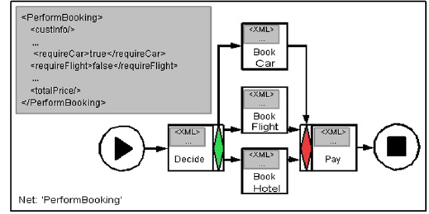
- A YAWL net “PerformBooking” and its data representation.
Next, data elements are stored in variables. There are: net variables for storing data that need to be accessed and/or updated by tasks in a net, and task variables for storing data that needs to be accessed and/or updated only within the context of individual execution instances of a task. Note that the task variables of a composite task are conceptually the net variables of the corresponding subnet.
YAWL applies strong data typing. Data types are defined using XML Schema. By default, the YAWL Editor provides a number of basic XML Schema data types for variable definition. There are: boolean, string, double (including decimal), long (integer), date (in the format of yyyy-mm-dd) and time (hh:mm:ss). Based on the above, the users can also supply their own XML Schema to define more complex data types. Fig. 2 shows the XML schema of a user-defined data type for element “CustInfo” which consists of both customer name and target start date for the booking trip process depicted in Error: Reference source not found.
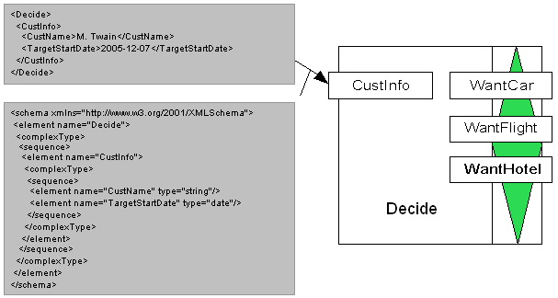
- XML schema of a user-defined data type for “CustInfo”.
Data usage is also part of the variable definition. There are: input and output variables, input only or output only variables, and local variables. In general, data are written to input variables and read from output variables. Local data usage is applicable to net variables only. The local (net) variables are used to store data that can be manipulated only internally within the scope of the corresponding net.
Finally, a net variable may be assigned an initial value at design time. Further details will be given in the next section on data transfer.
In the YAWL Editor Manual [5], the subsections of “Updating Data Type Definitions”, “Net decomposition Detail / Updating Net Variables”, “Task Decomposition Detail / Updating Task Variables” under Section “Advanced Specification Features” illustrate how to define variables in the YAWL Editor.

Data Transfer

Internal and External Data Transfers
YAWL supports data passing between variables, which can be considered internal data transfer, and data interaction between a process and its operating environment (i.e. workflow engine users and web services), which can be considered external data transfer.
Internal data transfer is always conducted between nets and their tasks (which themselves may or may not be composite) using XQueries [8]. Note that YAWL does not support direct data passing between tasks. This is because each task variable is local to the task that the variable belongs to, i.e., it is not accessible by other tasks. Assume task A and task B in net N. To pass data from task A (e.g. variable Va) to task B (e.g. variable Vb), an appropriate net variable of N (e.g. Vn) must be available to convey data from Va to Vb. In the YAWL editor, each task can be assigned an input parameter and/or an output parameter which define internal data transfer associated with that task. Input Parameters use an XQuery to extract the required information from a net variable and pass such information to the corresponding task variable, while output parameters define data passing in the opposite direction. Considering the process depicted in Fig. 1, Fig. 3 shows an example of passing the customer information from the net level to the task level (task “Decide”).
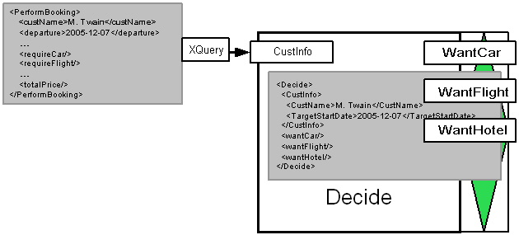
- An example of data transfer from net “PerformBooking” to task “Decide”.
External data transfer does not apply to any local variable or any variable of a composite task. This is because the local variables cannot be observed externally, and the variables of composite tasks serve as intermediate variables for passing data from the higher level to the lower level of a process and vice versa (e.g. between a net and the tasks in its subnets). When data are required from the external environment at run time, either a web form will be generated requesting the data from the user or a web service will be invoked that can provide the required data.

Valid and Invalid Data Transfers
To ensure correct data transfer, YAWL defines a set of transfer rules for variables of different data usage. Each input variable, except those associated with the top-level net (root net), must have data supply from the corresponding net variables (which could be a single net variable or an aggregation of any number of net variables), via input parameter definition. An input variable of the top-level net is either assigned an initial value at design time (data assignment), or gets data supply from the environment (e.g. a user input) once an execution of the net is started. Each output variable, except those associated with composite tasks, requests data supply from the environment once the corresponding net or task is executed. An output variable associated with a composite task gets data supply from the net data in its subnet, via output parameter definition. Otherwise, output variables are used to supply data (in internal data transfers).
Input and output variables are a combination of the above two variables, and local variables are neither input nor output variables. No (internal) data transfers are allowed between local variables of nets and their subnets and no (external) data transfers are allowed between local variables and the external environment.
In the YAWL Editor Manual [5], the subsection “Adding / Updating Task Parameters” under Section “Advanced Specification Features” illustrates how to pass data between variables in the YAWL Editor. Three things are worth noting:
- The YAWL Editor supports disabling invalid data transfers between variables in the parameter definition for each task. E.g., it is not possible to define data passing between local variables, or to set more than one input/output parameters on a single variable associated with a task.
- In the YAWL editor, by running the specification validation, the user can check whether or not the necessary data transfers are missing. E.g., if an input variable (V-in) of a task (T) does not have any data supply, the validation result will indicate that “there exists an input parameter (V-in) in (task) T that is not mapped to by this task”.
- When specifying XQueries in the parameter definitions of a task, the YAWL editor may automatically generate an engine-compatible XQuery or indicate whether a user-defined XQuery has valid or invalid syntax (by displaying the query in green or red). The semantics validation of XQueries is performed at run time by the YAWL engine. A semantic error may result in Schema Validation Problem and the execution of the process cannot be continued.

Data-related Issues

Data-based Conditional Routing
When tasks have XOR or OR splits, which branch to choose is determined by conditions associated with branches. These conditions are boolean expressions that involve data within the process. The data may determine the evaluation results of the conditions and therefore influence the operation of the process.
In YAWL, the branching conditions are specified as XPath [7] boolean expressions in the flow detail for tasks with XOR or OR splits. The branches (flows) whose conditions (predicates) evaluate to true will be executed by the YAWL engine. Also, for each task with XOR or OR split, there is always a default flow that will be taken if none of the other flow predicates evaluate to true. We consider separately the tasks with XOR splits and the tasks with OR splits.
As an example, Fig. 4 shows the XPath expression, which is specified at task “Decide”, for choosing the branch of “Book Car” in the “PerformBooking” process depicted in Fig. 1.
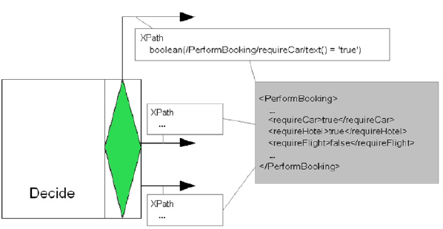
- XPath expression for choosing the branch of “Book Car” at task “Decide”.
For a task with XOR split, all (conditional) flows are specified in a list, and their predicates are evaluated in the same order as they are present in the list. Since an XOR split allows only one flow to be chosen, once the engine reaches a flow predicate that evaluates to true, the corresponding flow will be chosen and the rest of the list will be not be evaluated. However, if the engine reaches the bottom of the list, the bottom-most flow will always be chosen as the default, and it is not necessary to evaluate the predicate associated with that flow. Therefore, the default flow of a task with XOR split is similar to the concept of an “otherwise” clause defined in most programming languages.
For a task with an OR split (e.g. the task “Decide” in Fig. 4), all flows with their predicates are also present in a list. However, an OR split requires that all flows whose predicates evaluate to true are taken. Therefore, the engine will evaluate all flow predicates, and only if none of them evaluate to true will the bottom-most flow be taken as the default (despite the false evaluation result of its predicate).
In the YAWL Editor Manual [5], the subsection “Updating Flow Detail” under Section “Advanced Specification Features” illustrates how to specify flow predicates for tasks with XOR or OR splits in the YAWL Editor two things are worth noting:
- Only net variables are allowed to be used in specifying flow predicates. This is because the flow evaluation for a task with XOR or OR split is conducted after completing the execution of the task, and for such an operation at net-level the task variables are not accessible.
- Similarly to the XQuery validation, the syntax validation of XPath expressions can be performed in the YAWL editor. The semantics validation is however a different matter. As YAWL applies only XPath boolean expressions for specifying flow detail, an XPath boolean expression with invalid semantics may evaluate to false, and as a result the execution of the process will still continue. In such a case, the users need to validate their YAWL specification against the desired system behaviour by themselves.

Multiple Instance Data
There are two categories of data associated with multiple instance tasks. One is the task attribute data which define the maximum and the minimum number of instances allowed as well as the threshold value. The other is the multiple instance data which are specific to individual execution instances of tasks within a single workflow case [3]. Below we describe how to handle multiple instance data in YAWL.
YAWL supports both the designated multiple instance tasks and the isolation of data elements between task instances. However, the handling of multiple instance data is far from trivial. Data at the higher level needs to be split over the instances and after completion of the instances aggregated to data elements at the higher level [2]. A set of four types of XQueries may be used to pass multiple instance data between different levels. These are: the accessor query for manipulating the overall multiple instance data before the unique values are split out (to individual execution instances); the splitter query for separating the unique values from the overall multiple instance data and passing a unique value to each instance; the instance query for transforming the XML document returned on completion of an instance to a form that is suitable for aggregation; and the aggregate query for finally generating an overall result and passing the result to the higher level on completion of the multiple instance task.
In the YAWL Editor Manual [5], the subsection “Setting Multiple Instance Queries” under Section “Advanced Specification Features” illustrates how to specify multiple instance data manipulation in the YAWL editor, and Section “Illustrative Examples” includes a simple Multiple Instance Task Example describing how four types of XQueries are specified in the example.

Illustrative Examples

Below are three illustrative examples which cover the aforementioned data perspective of YAWL. The first example is the revised version of the “Credit Rating Process” given in [6]. The next two examples are the first two “Make Trip Processes” that can be found in [2].

Example 1: Credit Rating Process
This is a simple process that provides credit rating service. When running this process, the client (user) is asked to provide his/her social security number. The process takes the number and returns credit rating. There are two situations. If the client’s social security number starts with 0, a fault reporting “Bankruptcy” will occur. Otherwise, a credit rating (e.g. 560) will be given. From the above, the data associated with this process are: 1) client’s social security number (ssn), 2) credit rating (560), and 3) fault (“Bankruptcy”).

YAWL Specification
Fig. 5 shows the YAWL net specifying the above credit rating process. There are three labelled tasks: “ReceiveSSN” for requesting social security number from the client; “ReportFault” for reporting “Bankruptcy” fault; and “DecideRating” for providing the credit rating 560. There is also an unlabelled task, which has an XOR join and is used to ensure the soundness of the net.

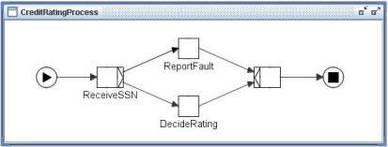
- The “CreditRatingProcess” net
Fig. 6 shows three net variable definitions for the “CreditRatingProcess” net. All are defined as local variables in order to avoid any data interaction with the external environment at the net level. Also, both rating and fault are assigned an initial value.
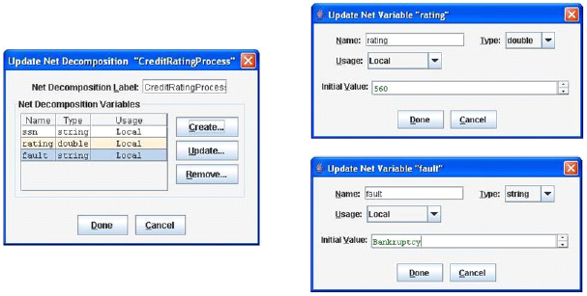
- Net variable definitions
Fig. 7 shows the parameter definition of task ReceiveSSN. It can be observed that this task has an output only variable called ssn. This variable requests social security number from the client, and as specified in the output parameter definition, it then passes the data to net via XQuery “{/ReceivedSSN/ssn/text()}”, which can be generated automatically by pressing XQuery content only button.

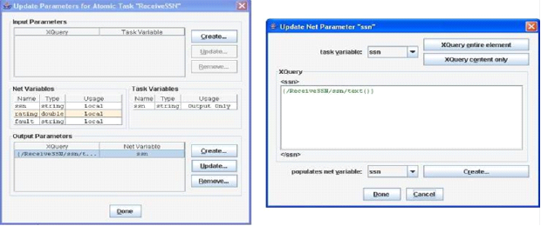
- Parameter definition for task ReceiveSSN
Fig. 8 shows the flow definition at task ReceiveSSN. The predicate for the flow leading to task ReportFault is “starts-with(/CreditRatingProcess/ssn/text(),‘0’)”. It returns true if the string conveyed by variable ssn starts with zero. Otherwise, the flow leading to task DecideRating will be taken. Since the flow evaluation is performed from the top-most flow to bottom-most flow at run time, the bottom-most flow will be used as the default. The query “/CreditRatingProcess/ssn/text()” can be automatically generated by pressing XPath Expression button,.

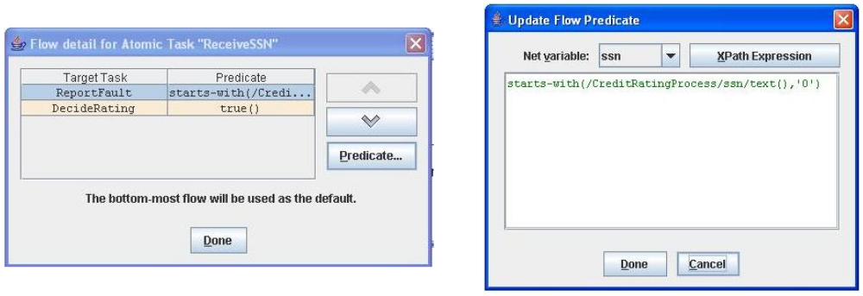
- Flow definition at task ReceiveSSN
Fig. 9 shows the parameter definition for task ReportFault. The variable fault is used to carry the fault information (“Bankruptcy”). It is defined as input only because the fault information is only used for client notification upon execution of the task.

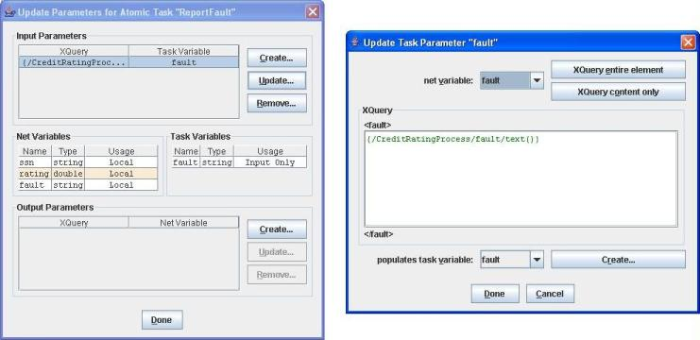
- Parameter definition for task ReportFault
Fig. 10 shows the parameter definition for task DeceideRating. Similarly, the input only variable rating is defined to convey the credit rating (560) that is only used for client notification upon execution of the task.

Now we have finished the design of the credit rating process, and can export it for deployment in the YAWL engine. We firstly conduct a syntax validation for the net. If the validation result indicates that “No design-time engine problems were founded in this specification”, the net is then exported to the engine file (XML document), which can be deployed (uploaded) in the engine and executed by launching a case.
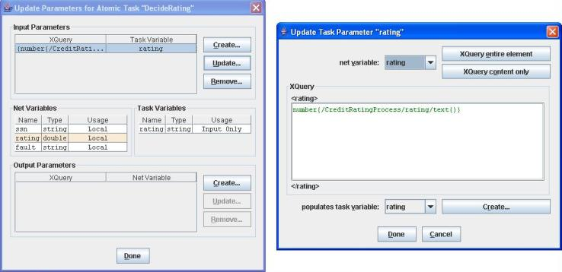
- Parameter definition for task DecideRating
The above YAWL specification is both syntactically and semantically well formed, and can be run through without any problem in the engine. Now we introduce some error into the above specification to see what error we will encounter via design-time or run-time validation. These errors are considered to be common when designing (especially large) YAWL specifications.

Error 1: Missing Data Supply for Input Variable
Assume that we forget to specify the mapping from net variable fault to task variable fault in the input parameter definition for task ReportFault (see Fig. 11). This results in two syntax errors after validation of the “CreatRatingProcess” specification, as shown in Fig. 11.

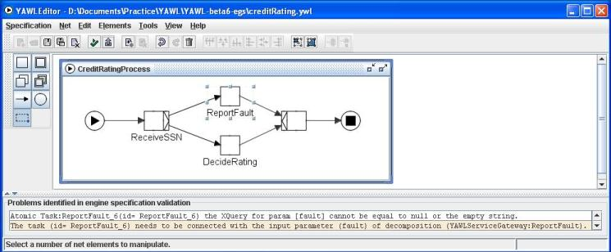
- An invalid specification with missing data supply for an input variable

Error 2: XQuery with Invalid Semantics
Assume that we use XQuery “/ReceiveSSN/ssn” but not “/ReceiveSSN/ssn/text()” in the output parameter definition for task ReceiveSSN (see Fig. 12). This modified mapping is incorrect because it pass “<ssn> social security number </ssn>” from task variable ssn to net variable ssn. However, the mapping has a valid syntax (because both variables are strings) and thus can pass the syntax validation in the YAWL editor. While at run time, after the user submits his/her social security number (task ReceiveSSN), an error page as shown in Fig. 12 will appear, indicating a failure in validating an XQuery used. Also, the executed credit rating process is halted.

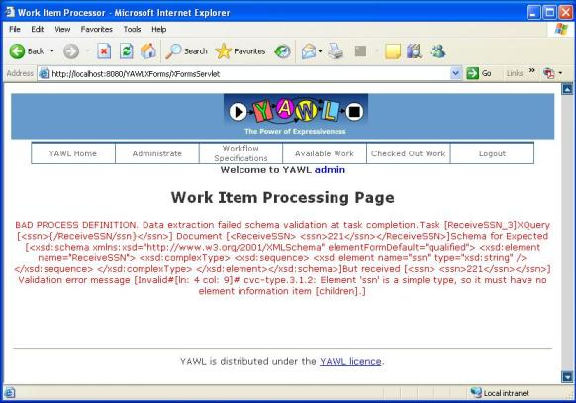
- An error indication of invalid semantics of an XQuery used in the specification

Example 2: Simple Make Trip Process
This process provides a trip booking service. When running this process, the user is first asked to register for the trip. The registration information includes: customer name, trip start date, trip end date, the need of booking flight, hotel, and/or car, and customer’s payment account number. After the registration, the booking tasks may be executed in parallel according to user’s requirement, and the booking details are also provided in each executed task. After all booking tasks complete, the user is then asked to make the payment for the trip, and the process ends.

YAWL Specification
Fig. 13 shows the YAWL net specifying the above simple make trip process. The net is hereafter referred to as simple “make trip” net. There are five labelled tasks: “register” for registering for the trip; “pay” for making payment; and the other three tasks for making the corresponding bookings. The task “register” is with an OR split construct, and the task “pay” with an OR join construct.

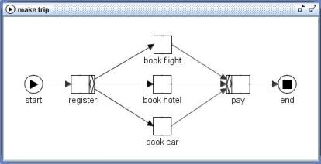
- The simple “make trip” net
Fig. 14 shows the data type definitions in the simple “make trip” net. There are two new data types: tripRegistrationType comprising information of trip start date (startDate), trip end date (endDate), the need of booking flight (want_flight), hotel (want_hotel) and/or car (want_car), and customer’s payment account number (payAccNumber); and dateType comprising information of year, month and day, e.g., both startDate and endDate are indeed of dateType.

Fig. 15 shows the net variables definitions for the simple “make trip” net. All are defined as local variables. The variable “registrInfo” is of tripRegistrationType, and the others are of string type. Also, the variable “customer” has an initial value of “Type name of customer” (as an indication for customer to enter his/her name).
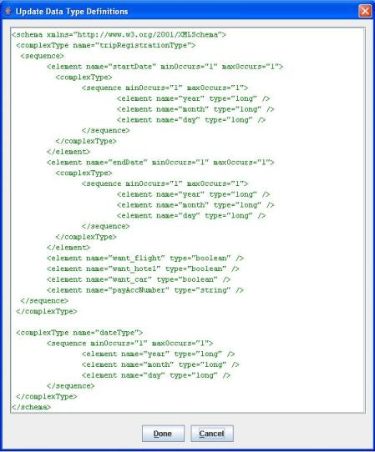
- Updated data type definitions

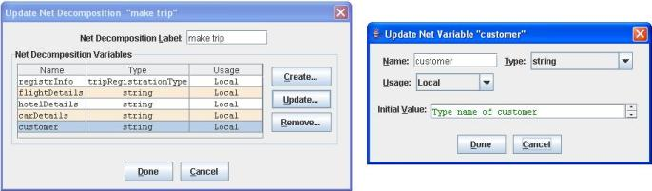
- Net variable definitions
Fig. 16 shows the parameter definition of task “register” with two task variables. The input & output variable customer gets customer’s name, and then passes it to the net. The output only variable registrInfo requests registration information from the customer, and then passes the data to the corresponding net variable via XQuery “{/register/registrInfo/*}”.
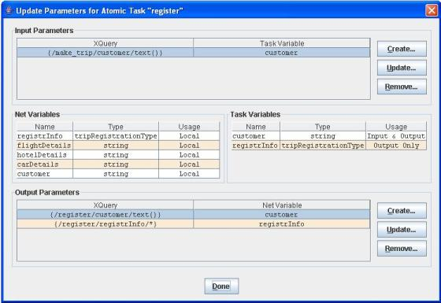
- Parameter definition for task “register”
Fig. 17 shows the flow definition at task “register”. The predicate for the flow leading to task “book flight” is “/make_trip/registrInfo/want_flight=`true’”. Similarly, the predicate associated with flow leading to task “book hotel” or “book car” is to determine whether the variable want_hotel or want_car has a boolean value of “true” or “false”. Note that this flow definition is defined with an OR split, so that any number of the booking tasks can be taken.
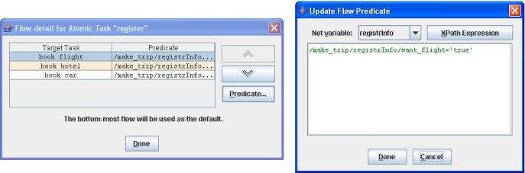
- Flow definition at task “register”
Fig. 18 shows the parameter definition of task “book flight” with four task variables. The three input only variables get data from the net via appropriate XQueries. Note that both startDate and endDate get data from the net variable registrInfo. There is one output only variable called flightDetails, which requires the information from the customer, such as his/her preferable airlines or even an exact flight number. Also, the parameter definition of task “book hotel” or “book car” is specified in a similar way, except that the output only variable is hotelDetails or carDetails.
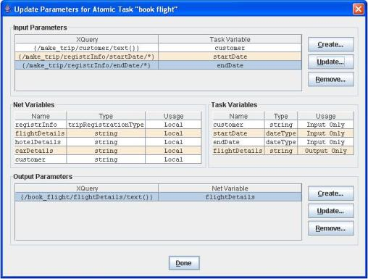
- Parameter definition for task “book flight”
Fig. 19 shows the parameter definition of task “pay” with five task variables. These are all input only variables and they get data correspondingly from those net variables with the same names.
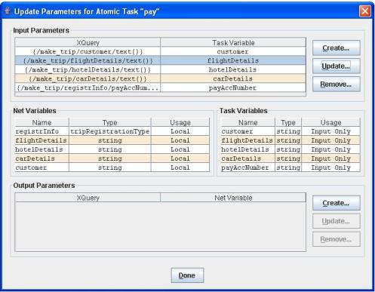
- Parameter definition for task “pay”

Example 3: Make Trip Process with Multiple Instance Composite Tasks
This process provides a booking service for a trip that has several legs. For each leg, the same simple make trip process in the previous example will be executed. As a result, we obtain a more complicate make trip process by involving a multiple instance composite task for execution of the simple make trip process for each leg. Also, the customer is provided with a subtotal of the payment for each leg, and the subtotals for all the legs in the trip will be calculated into a total payment at the end of the process.

YAWL Specification
Fig. 20 shows the YAWL net specifying the above make trip process. There are two nets: the root net called “make trip” and the subnet specifying details for the composite task “do itinerary segment”, which is basically the simple “make trip” net in the previous example.
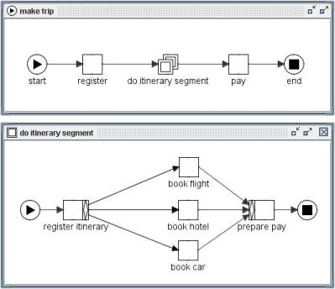
- The “make trip” net with a multiple instance composite task “do itinerary segment” and the corresponding subnet
Below, we list the data type definitions in the above “make trip” net. There are four new (user-defined) data types. The itineraryType contains a list of itinerarySegments, each of which comprises information of departure location, destination, startDate, endDate, flightDetails, hotelDetail, carDetails, and subtotal. The legsType is a set of legs of legType, which provides the information of departure location and destination. Finally, the serviceType specifies the need of booking flight, hotel and/or car (as alternative to the previous example, we group these needs together this time).
<schema xmlns="http://www.w3.org/2001/XMLSchema">
<complexType name="itineraryType">
<sequence>
<element name="itinerarySegment" minOccurs="1" maxOccurs="unbounded">
<complexType>
<sequence minOccurs="1" maxOccurs="1">
<element name="departure_location" type="string" />
<element name="destination" type="string" />
<element name="startDate" type="date" />
<element name="endDate" type="date" />
<element name="flightDetails" type="string" />
<element name="hotelDetails" type="string" />
<element name="carDetails" type="string" />
<element name="subTotal" type="double" />
</sequence>
</complexType>
</element>
</sequence>
</complexType>
<complexType name="legsType">
<sequence>
<element name="leg" minOccurs="1" maxOccurs="unbounded">
<complexType>
<sequence minOccurs="1" maxOccurs="1">
<element name="departure_location" type="string" />
<element name="destination" type="string" />
</sequence>
</complexType>
</element>
</sequence>
</complexType>
<complexType name="legType">
<sequence minOccurs="1" maxOccurs="1">
<element name="departure_location" type="string" />
<element name="destination" type="string" />
</sequence>
</complexType>
<complexType name="serviceType">
<sequence minOccurs="1" maxOccurs="1">
<element name="want_flight" type="boolean" />
<element name="want_hotel" type="boolean" />
<element name="want_car" type="boolean" />
</sequence>
</complexType>
</schema>
Fig. 21 shows the net variable definitions for the above “make trip” net. There are three new variables, itinerary, legs, and subtotals, as compared to the previous simple “make trip” net.
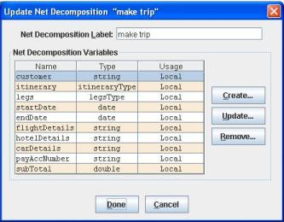
- Net variable definitions
Fig. 22 shows the parameter definition of task “register”. There are three task variables, customer, legs, and payAccNumber, with appropriate input or output parameter definition. Fig. 23 shows the parameter definition of task “pay”. There are four variables which are all input only variables. Note that the variable total gets data from a sum of subTotals from the net, as shown in Fig. 24. The XQuery function sum() calculates a total sum of subTotals from each itinerary segment.
[Note] A pair of curly brackets is NEEDED for enclosing the whole query expression. This is a new feature in the YAWL editor 1.3. If you miss the pair of curly brackets, the resulting specification is most likely to have run-time errors.
- Parameter definition for task “register”
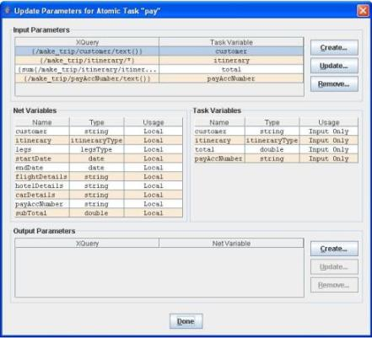
- Parameter definition for task “pay”
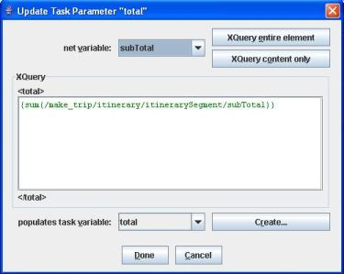
- Input parameter definition of variable total as a sum of subTotals
Fig. 25 shows the parameter definition of the multiple instance composite task “do itinerary segment”. There are nine task variables, which are also the net variables of the subnet of this task. All except serviceRequired are input & output variables conveying data between root net and the subnet. The variable serviceRequired contains information only used within the subnet, and is therefore defined as local variable. Also, the input parameter definition for variable leg and the output parameter definition for variable itinerary are both determined by the corresponding task instance queries (see below).
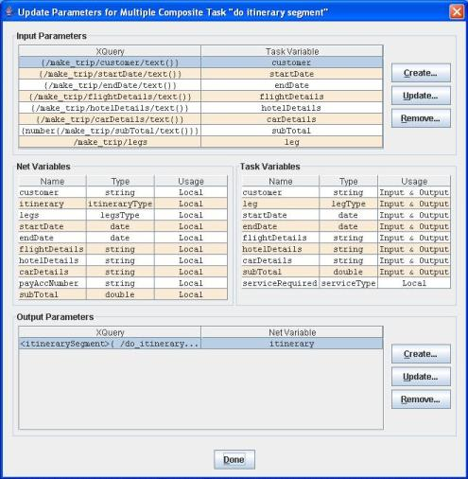
- Parameter definition of task “do itinerary segment”
Fig. 26 shows the instance details for task “do itinerary segment”. The left window titled Bounds is for specifying the task attribute data, i.e. the maximum and minimum number of instances allowed and the threshold value. The right window titled Queries is for defining the multiple instance data specific to individual execution instances of task “do itinerary segment” for each leg within one itinerary (i.e. a single process instance). There are four queries. Firstly, an accessor query manipulates the overall data carried by root net variable legs before the data is split out to each individual leg. This query determines the input parameter definition for variable leg. Secondly, a splitter query separates the unique values from the overall data carried by variable legs, and passes a unique value to variable leg associated with each instance. The data returned on completion of an instance is an XML document. Thirdly, an instance query transforms such an XML document to a form that is suitable for aggregation of data to the higher level, i.e. the root net “make trip”. This query determines the output parameter definition for root net variable itinerary. Finally, an aggregate Query generates an overall result and passes the data to variable itinerary on completion of all instances of task “do itinerary segment” within a single itinerary.
The subnet of task “do itinerary segment” specifies the simple “make trip” process in the previous example (Example 2: Simple Make Trip Process). Thus, we do not go into every detail, but provide the parameter definitions associated with tasks “register itinerary”, “book flight” and “prepare pay” in Fig. 27 to Fig. 29, respectively. The parameters for the other two tasks “book hotel” and “book car” are defined in a similar way to those of task “book flight”. Note that since the variable subTotal is of double type, the XQuery function number() is used to extract data from the variable.
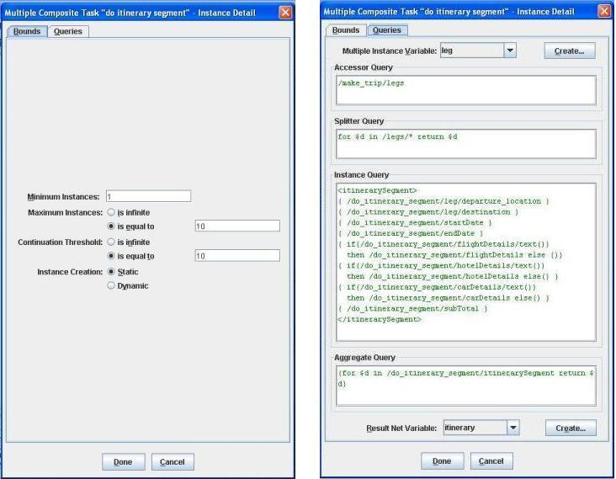
- Instance details for task “do itinerary segment”
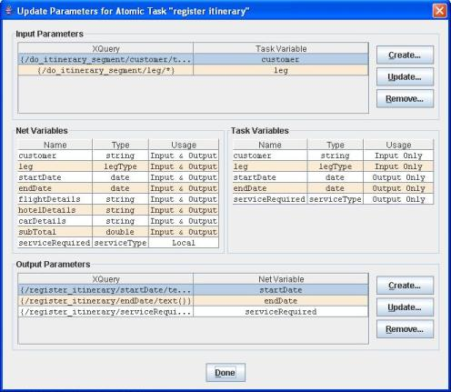
- Parameter definition for task “register itinerary”
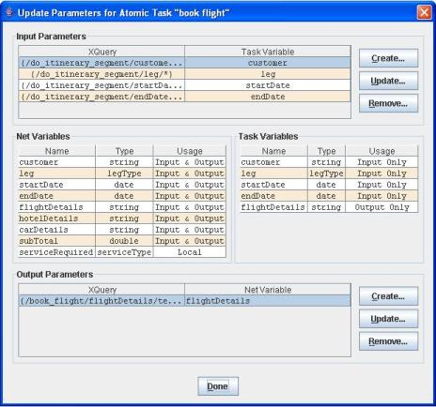
- Parameter definition for task “book flight”
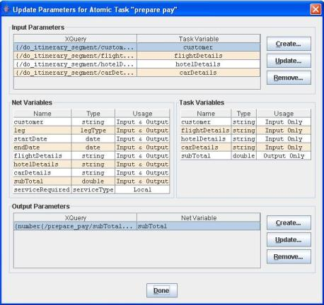
- Parameter definition for task “prepare pay”

Error 3: Invalid XQuery associated with Composite Tasks
In Example 1: Credit Rating Process, Error 2: XQuery with Invalid Semantics includes an example of an erroneous process that contains an atomic task with an invalid XQuery expression in its output parameter definition. The error can be detected at run time and is prompted to the user via the browser. Below, we assume an invalid XQuery with the (multiple instance) composite task “do itinerary segment” in Example 3: Make Trip Process with Multiple Instance Composite Tasks.

As mentioned before, one of the new features in YAWL editor 1.3 is that it requires a pair of curly brackets to enclose the XQuery expression in parameter definitions. Assume that in the input parameter definition of variable subTotal for task “do itinerary segment” (see Fig. 25), we deliberately drop the pair of curly brackets enclosing the XQuery “number(make_trip/subTotal/text())”. The resulting specification can pass the syntax validation in the YAWL editor, but cannot go through at the run-time. When detecting an invalid XQuery associated with a composite task, the YAWL engine generates the corresponding error indication and directly output it to the Console (rather than to the browser). The Console output is recorded in the standard log file for Tomcat (which can be found in the “log” directory under CATALINA_HOME). With the persistence mode switched on, such error indication can be also found in the warning table in the linked database. For example, Error: Reference source not found shows part of the log file that includes an error indication for the above invalid XQuery for the parameter definition of variable subTotal at task “do itinerary segment” (see the highlighted sentence).

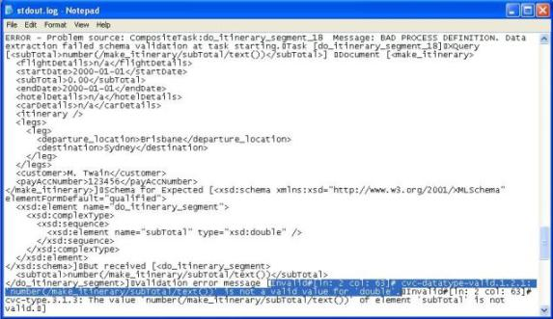
- Error indication for invalid XQuery in the parameter definition of variable subTotal at task “do itinerary segment”

References

    - W.M.P. van der Aalst and A.H.M. ter Hofstede. YAWL: Yet Another Workflow Language. Information Systems, 30(4):245-275, 2005.
    - W.M.P. van der Aalst, L. Aldred, M. Dumas, and A.H.M. ter Hofstede. Design and Implementation of the YAWL System. In A. Persson and J. Stirna, editors, Proceedings of the 16th International Conference on Advanced Information Systems Engineering (CAiSE'04), volume 3084 of Lecture Notes in Computer Science, Springer-Verlag, Berlin, 2004.
    - N. Russell, A.H.M. ter Hofstede, D. Edmond, and W.M.P. van der Aalst. Workflow Data Patterns. QUT Technical Report, FIT-TR-2004-01, Queensland University of Technology, Brisbane, 2004.
    - L. Aldred. YAWL Engine User Manual. Beta 5 Release. 12 April 2005.
    - L. Bradford. YAWL Editor 1.3 User Manual. Release 1.3. 2005.
    - Oracle BPEL Process Manager: Quick Start Guide. 10g Release 2. May 2005.
    - XML Path Language (XPath) 1.0. W3C Recommendation, 16 Nov 1999.
    - XQuery 1.0: An XML Query Language. W3C Working Draft, 04 April 2005.

Acknowledgements

Queensland University of Technology

Lachlan Aldred

Lindsay Bradford

A/Prof Arthur ter Hofstede

starts-with(string, string) is a boolean function defined in XPath. It returns true if the first argument string starts with the second argument string, and otherwise returns false.

