Worklet Selector
Custom YAWL Service

Installation Manual

Beta – 7 Release




Document Control

Date | Author | Version | Change
11 Dec 2005 | Michael Adams | 0.1 | Initial Draft

Preface

This manual contains instructions for installing the Worklet Dynamic Process Selection Custom Service for YAWL.

Contents

Document Control ii
Preface ii
Welcome to the YAWL Worklet Service 1
What is a Custom YAWL Service? 1
What is the YAWL Worklet Service? 1
Obtaining the Latest Version of the Worklet Service 2
The YAWL Project 3
YAWL Architecture 3
Requirements & Installation 4
Software Requirements 4
Worklet Installation Package 4
Installation 4
Appendix A: The Rules Editor 7
Third–Party Software Acknowledgements 8

Welcome to the YAWL Worklet Service

What is a Custom YAWL Service?

An important point of extensibility of the YAWL system is its support for interconnecting external applications and services with the workflow execution engine using a service-oriented approach. This enables running workflow instances and external applications to interact with each other in order to delegate work or to signal the creation of workitems or a change of status of existing workitems.
Custom YAWL services interact with the YAWL engine through XML/HTTP messages via certain endpoints, some located on the YAWL engine side and others on the service side. Custom YAWL services are registered with the YAWL engine by specifying their location, in the form of a “base URL”. Once registered, a custom service may send and receive XML messages to and from the engine.
More specifically, Custom YAWL services are able to check-out and check-in workitems from the YAWL engine. They receive a message when an item is enabled, and therefore can be checked out. When the custom yawl service is finished with the item it can check it back in, in which case the engine will set the work item to be completed, and proceed with the execution.

What is the YAWL Worklet Service?

The Worklet Dynamic Process Selection Service for YAWL provides the ability to substitute a workitem in a YAWL process with a dynamically selected "worklet" - a discrete YAWL process that acts as a sub-net for the workitem and so handles one specific task in a larger, composite process activity.
An extensible repertoire (or catalogue) of worklets is maintained. Each time the service is invoked for a workitem, a choice is made from the repertoire based on the data within the workitem, using a set of rules to determine the most appropriate substitution.
The workitem is checked out of the YAWL engine, then the selected worklet is launched as a separate case. The data inputs of the original workitem are mapped to the inputs of the worklet. When the worklet has completed, its output data is mapped back to the original workitem, which is then checked back into the engine, allowing the original process to continue.
Worklets can be substituted for atomic tasks and multiple-atomic tasks. In the case of multiple tasks, a worklet is launched for each child workitem. Because each child workitem may contain different data, the worklets that substitute for them are individually selected, and so may all be different.
The repertoire of worklets can be added to at any time, as can the rules base used for the selection process. Thus the service provides for dynamic ad-hoc change and process evolution, without having to resort to off-system intervention and/or system downtime.
More detailed information describing the service and its use can be found in the Worklet Service User Manual.

Obtaining the Latest Version of the Worklet Service

As new versions of the Worklet Service are released to the public, they will be available for download at the YAWL website:
http://www.citi.qut.edu.au/yawl
Developers interested in obtaining the source code for the Worklet Service (and Rules Editor), can download the files from here:
http://sourceforge.net/projects/yawl

The YAWL Project

For more information and progress on the YAWL project, visit the YAWL Homepage on Queensland University of Technology’s Centre for Information Technology Innovation website:
http://www.citi.qut.edu.au/yawl

YAWL Architecture
The following image depicts the interaction between components of the YAWL Engine.
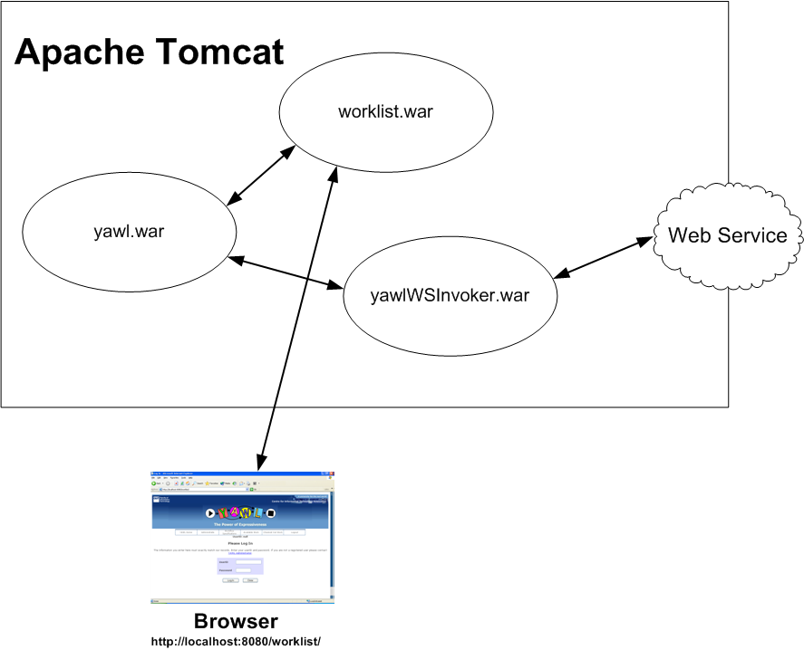

Requirements & Installation

Software Requirements

The Worklet Service requires the YAWL Engine Beta 7 version or higher. All other software requirements are as per the requirements of the YAWL Engine.

Worklet Installation Package

Within the YAWL web release YAWL-Beta-7-Executable-WebServer-Version.zip there is a file called workletSelector.war – this is the worklet web application component. In addition to the custom service files, workletSelector.war contains a file called workletRespository.zip, which contains a required set of file directories where worklets are stored, logs are written to and so on.

Installation
Open workletSelector.war in an unzipping tool (e.g. WinZip). Locate and extract the workletRespository.zip to a temporary directory.

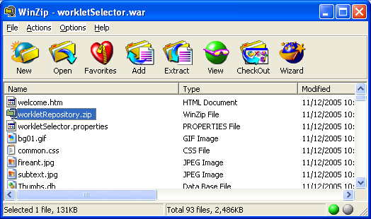
First, the repository should be installed. This needs to be done first because you need to let the service know where to find it (i.e. the path to the repository). The repository stores various components needed for the successful operation of the service. The repository has this structure:
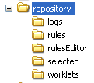
- The logs folder is where the service writes log files during its operation. In particular, the workletSelector.log contains a description of all stages of each operation. The eventLog.csv file logs key events of the service. All are plain text files.
- The rules folder contains the sets of rules using during the selection process. Rules files have an XML format. Each YAWL specification that uses the service will have a corresponding rules file of the same name, except with an extension of xrs (XML rule set).
- The rulesEditor folder contains a tool that allows you to add rules to a rule set for a specification (see Appendix A for more details).
- The selected folder contains a set of files, in XML format, that are essentially log files that capture the results of each selection process. These files have an xws extension (XML Worklet Selection). These files are used by the rules editor to enable easy addition of new rules for a specification.
- The worklets folder contains the worklet specification files. These files are YAWL specifications that are run as substitutes for workitems as required.
Several of the folders contain examples.
To install the repository, simply extract the contents of workletRepository.zip to a folder of your choice. If you choose to install it to C:\Worklets, it will make the next stage of the process a little easier.
Once the repository is installed, reopen the workletSelector.war file in an unzip tool.
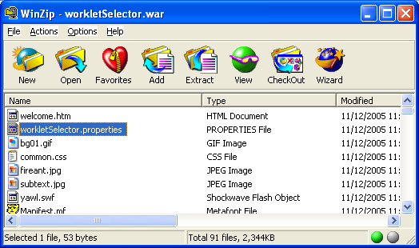

Find and open the file workletSelector.properties in a text editor. It contains one line:
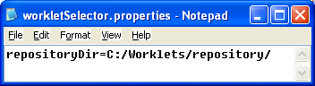
Change the path to where you installed the repository. Save and close the text editor. Your unzipping tool may ask you if you want to update the changed file – answer ‘Yes’. If not, copy the changed file into the war file.
Once that is done, copy the workletSelector.war file to the webapps directory of your Tomcat installation.
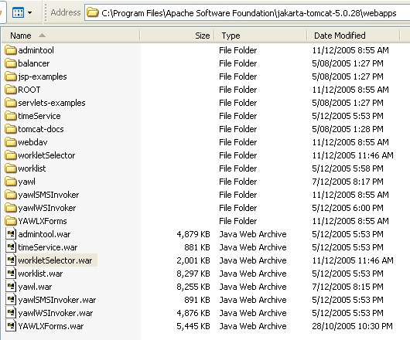

If Tomcat is not running, start it now. The service will automatically be installed.
Finally, the service needs to be registered with the YAWL engine. Login to YAWL’s Administrate page as an administrator, then go to the Register New YAWL Service section at the bottom of the page (see the YAWL installation manual for details). Enter the following details:
- YAWL Service URI: http://localhost:8080/workletSelector/ib
- Service Documentation: Worklet Dynamic Process Selection Service
Then click on Add YAWL Service:
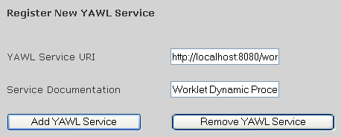
Congratulations – the Worklet Service installation is complete!

Appendix A: The Rules Editor

The Rules Editor allows for the addition of new rules to the rule sets of specifications. It is a .NET based application, so has the following requirements:
- Operating System: Windows 98SE or better
- The Microsoft .NET framework (any version). If you don’t have the framework installed, it can be downloaded from Microsoft.
The Rules Editor tool can be found in the rulesEditor folder of the worklet repository. It can be run directly from there – no further installation is required.
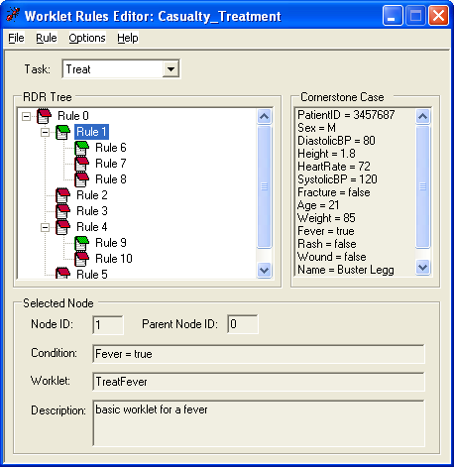
For more details on the Rules Editor and how to use it, refer to the Rules Editor User Manual.

Third–Party Software Acknowledgements

(a) Software developed by the JDOM Project (http://www.jdom.org/),
JDOM Beta 9, Copyright © 2000-2003 Jason Hunter & Brett McLaughlin. All rights reserved. This software is subject to the terms of the licence available at http://www.jdom.org/.

(b) Software developed by the Apache Software Foundation (http://www.apache.org/) (Xerces2 Java Parser 2.6.0 Release) (http://xml.apache.org/xerces2-j/index.html), Copyright © 1999-2003 The Apache Software Foundation. All rights reserved. This software is subject to the terms of the licence available at http://xml.apache.org/.
Web Services Invocation Framework 2.0.- Release (http://ws.apache.org/wsif/), Copyright © 1999-2003 The Apache Software Foundation. All rights reserved. This software is subject to the terms of the licence available at http://xml.apache.org.

(c) The Saxon version 7 XLST Processor from Michael Kay (http://saxon.sourceforge.net/). This software is subject to the Mozilla Public License Version 1.0 and may not be used except in compliance with that License (a copy is available at http://www.mozilla.org/MPL/). The source code version of this software is available under the terms of that License.

(d) Chiba XForms processor version 0.9.9, available at http://sourceforge.net/projects/chiba/

