**1.**

**·** what is git: git is a free and open source distributed version control system designed to handle projects with speed and efficiency.

· help: display help information about Git

branch: list, create, or delete branches

merge: combine the work from two different branches together

tag: create, list, delete or verify a tag object

commit: a commit in a git repository records a snapshot of all the files in the directory. “git commit” makes changes to the repository and saves them as a comit

init: create an empty Git repository or reinitialize an existing one

push: upload the changes to a specified remote

add: add file contents to the index

log: show commit logs

clone: create local copies of remote repositories

checkout: switch branches or restore working tree files

pull: fetch remote changes and then merge them

diff: show changes between commits, commit and working tree

fetch: fetch data from a remote repository

reset: reset current HEAD to the specified state

**2.**

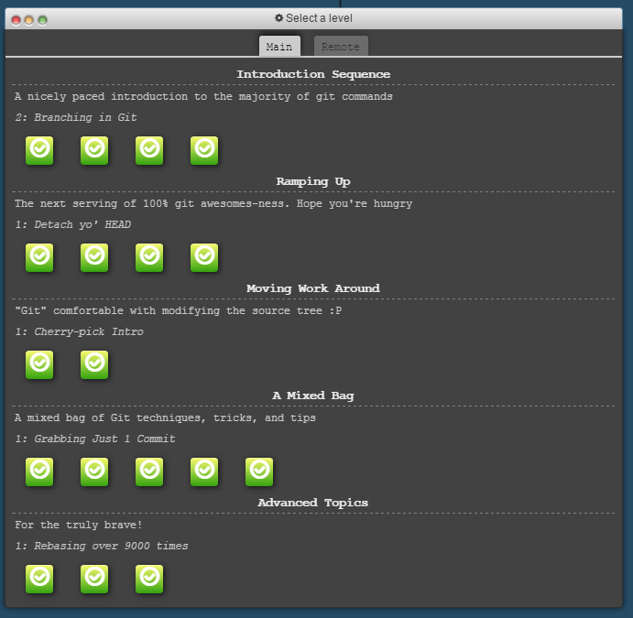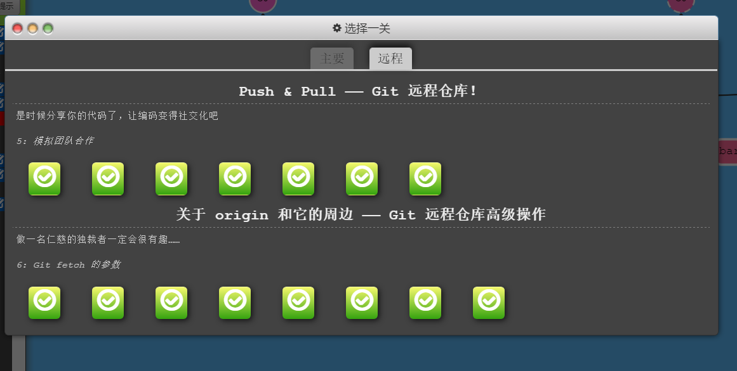

**3.**

3.1 • Read rsync manpage:

man rsync

• Create an exact copy of the directory /usr/src into the directory /usr/src_orig :

rsync –av /usr/src /usr/src_orig

• Create an exact copy of the Minix 3 directory /usr/src_orig into your Linux system, using rsync and ssh (note that the ssh server must be activated under Linux):

ssh minix

exit

rsync –av minix:/usr/src_orig /home/cyx/ve482/lab3/usr/src_orig

3.2

• Read the manpages of diff and patch:

man diff

man patch

• Using the diff command, create a patch corresponding to your changes in homework 2:

diff -uN /usr/src/ /usr/src_orig/src/ > ~/ve482/patchfile

• Retrieve your patch on your Linux system

rsync –av minix:~/ve482/patchfile /home/cyx/ve482

• Apply your patch to the copy of /usr/src_orig on your Linux system:

cd /home/cyx/ve482/lab3/usr/src_orig

patch –p0 < /home/cyx/ve482/patchfile

• Revert the patch

patch –p0 -R < /home/cyx/ve482/patchfile