**Environment:**

This project is based on VS2010 , Qt Creator 5.2.0, and openCV2.4.11.

The operating system is Windows 8.1

To run the source code, you need download and install these software and configure the environment.

1. install VS2010 or higher version
2. install Qt Creator 5.2.0 or higher version
   1. Download qt-windows-opensource-5.2.0-msvc2010_opengl-x86-offline.exe

You can find the installation package in http://download.qt.io/archive/

If you use higher version of Visual Studio to compile your C++ code, you should download the corresponding QT Library.

* 1. Run the exe file to install Qt Creator
  2. Increase environment variable

Create a new environment variable :QTDIR ,

Value: D:\QT\5.2.0\msvc2010_opengl\bin; (corresponding to your installation path)

1. Configure the openCV library 2.4.11
   1. Download opencv-2.4.11.exe

You can find the installation package in <http://opencv.org/downloads.html>

* 1. Run the exe file to install openCV library in your computer
  2. Increase environment variable

In the existing environment variable path,

Add a new value of it: D:\opencv\build\x86\vc10\bin;(corresponding to your installation path and your VS version)

1. Configure library path in this project
   1. Open qt5hw.pro by Qt Creator
   2. Edit qt5hw.pro

Change INCLUDEPATH (corresponding to your opencv installation path)

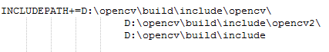

Change LIBS (corresponding to your opencv version and installation path)

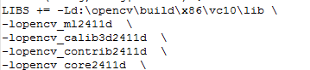

1. Run code in Qt Creator

**About writing rule**

Refer to the folder “ Writing Rule”, for letter “m” and “h” we use 2 stroke. And for digits “1” and “9”, we write it as below.

