AS1_Report

102062221 史芳瑜

* **Screenshot**

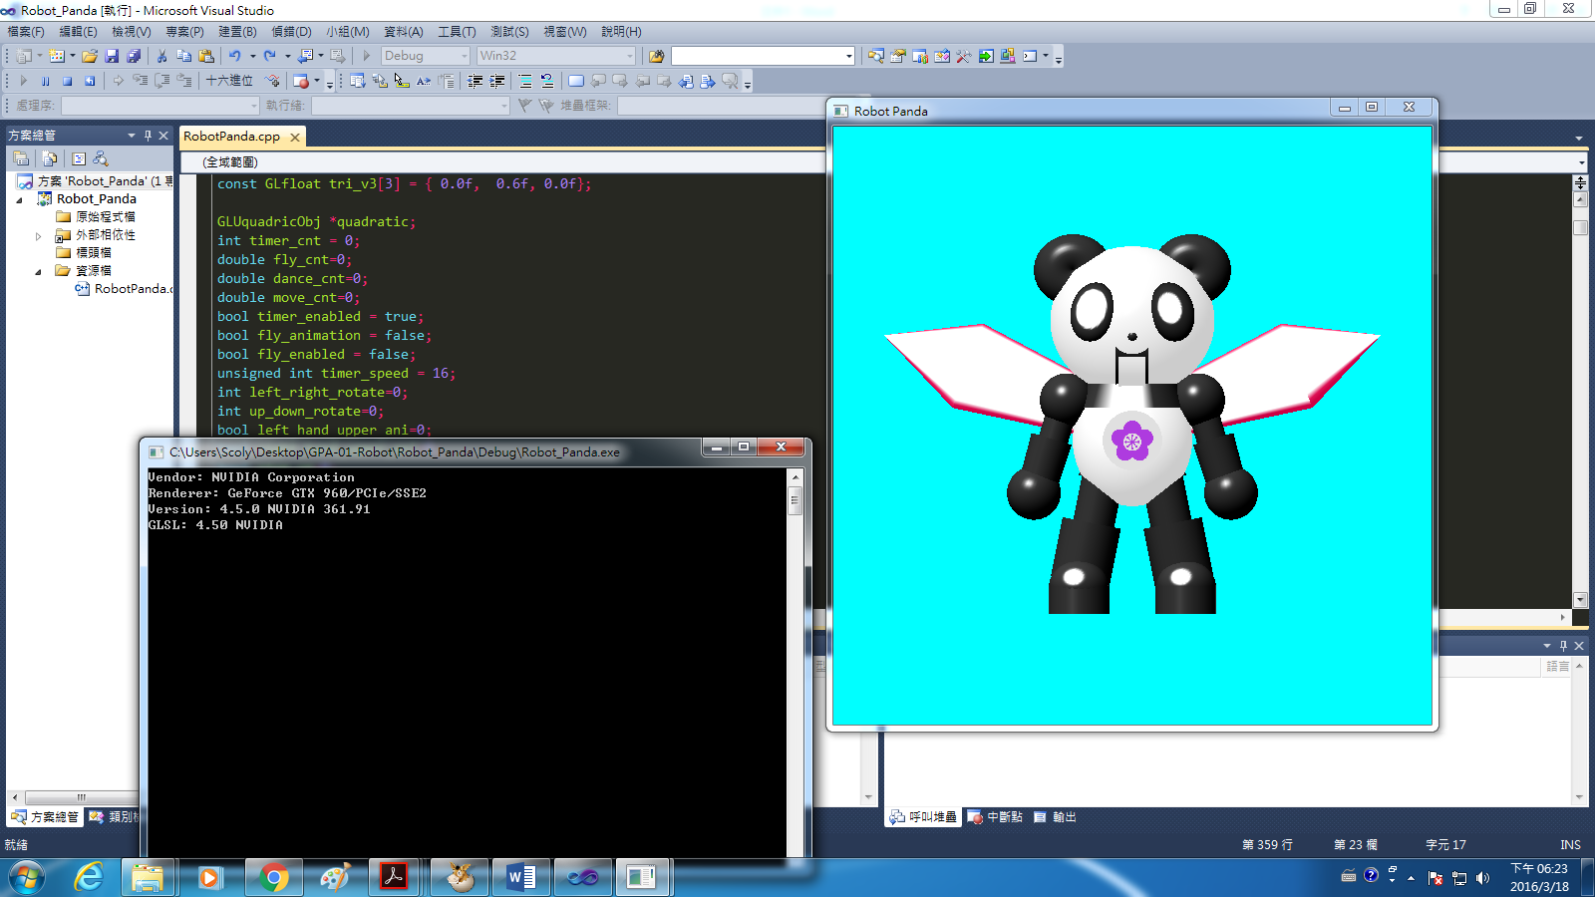

* **README**

Manipulate:

Control the position of the robot by ADWS

Control the rotation of the robot by ⭡⭣⭠⭢

Open the menu by right click on the window

Menu:

Center: Center the robot

Animation:

Fly: Fly

Dance: Dance

Stop: Stop the animation

Exit: Leave the program

Note1: The rocket would beam out energy while flying

Note2: Changing animations would stop the current animation

Note3: Before starting animations, the robot would press the button in front of him.

Using Visual Studio 2010

* **Part Relation Diagram**

BUTTON

ROCKET

RIGHT

WING

LEFT

WING

TORSO

HEAD

LEFT

UPPER

ARM

LEFT

LOWER

ARM

RIGHT

UPPER

ARM

RIGHT

LOWER

ARM

ROOT

LEFT

UPPER

LEG

LEFT

LOWER

LEG

LEFT

SOLE

RIGHT

UPPER

LEG

RIGHT

LOWER

LEG

RIGHT

SOLE