Table of Contents

Analysing and visualising weird family trees 1

Analysing family trees 1

Visualising family trees 2

Displaying family trees & incestual connections 2

Joining partnerships across hierarchies 2

Double-lining sibling relationships w/ a legend 3

Repetitions of partner names, e.g. Zeus 4

Adding captions to tree segments to solidify relationships 4

Adding loops to keep the hierarchy but also demonstrate interweaving 4

Conclusion from research 5

Complexities 5

Examples of weird family trees 5

Different types of family across cultures 7

Ancient History 7

Incest 7

Different definitions of “family” 7

Modern Day 8

Incest 8

Different definitions of “family” 9

TODO: 10

Questions at the end of this: 11

Family Relationships Across Cultures

# Analysing and visualising weird family trees

## Analysing family trees

(Ways to determine algorithmically how to code family trees and dags with family trees)

Java - <https://www.codeproject.com/Articles/531953/Family-Tree>

Coding a Directed Acyclic Graph <http://www.allisons.org/ll/AlgDS/Graph/DAG/>

## Visualising family trees

Expand this

(Artistic ways of representing family trees (the context))

For testing purposes: <https://gephi.org/> - an Open Graph Visualisation Platform

Using legends to display different relationships

Using images directly from Google images for the different nodes?

## Displaying family trees & incestual connections

### Joining partnerships across hierarchies

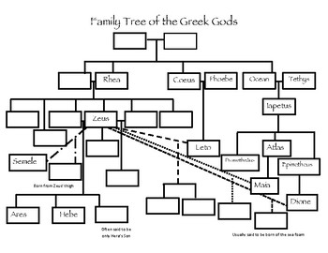

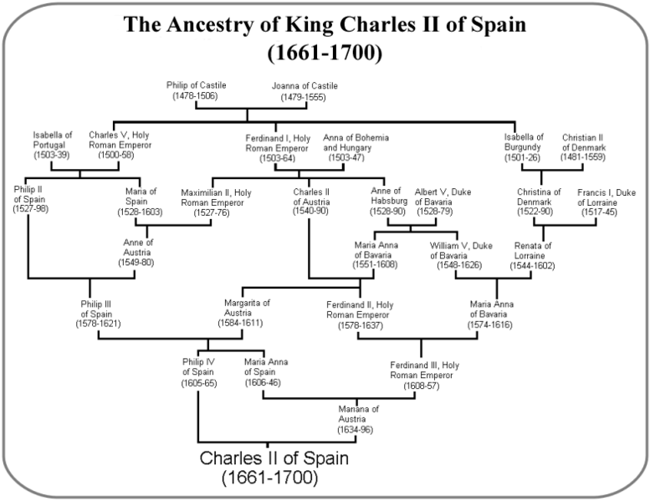

**Pros**: Classic family tree structure

**Cons**: Difficult to determine e.g. cousins vs granddaughters + hierarchies

Good example of when we need an algorithm

### Double-lining sibling relationships w/ a legend

**Good:** Legends ensure clarity

**Bad:** Double-lines indicating sibling/incestuous marriage are simplistic, but difficult to code – what if there is one sibling that has been involved with more than two of their siblings? The line will be convoluted to draw. + difficulties showing relationships between half siblings

### Repetitions of partner names, e.g. Zeus

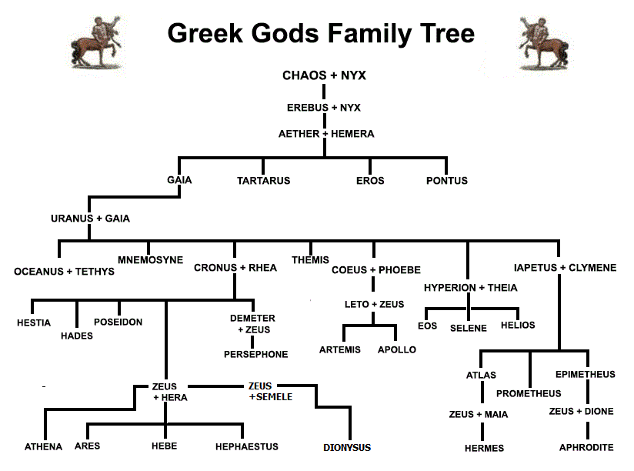

**Good**: Clear partnerships, not as messy

**Bad**: Repetition of names, can be frustrating to track

The above diagram is based on relationships over time – generational structure (y-axis)

As some figures are immortal, they will appear throughout and in multiple generational structures.

### Adding captions to tree segments to solidify relationships

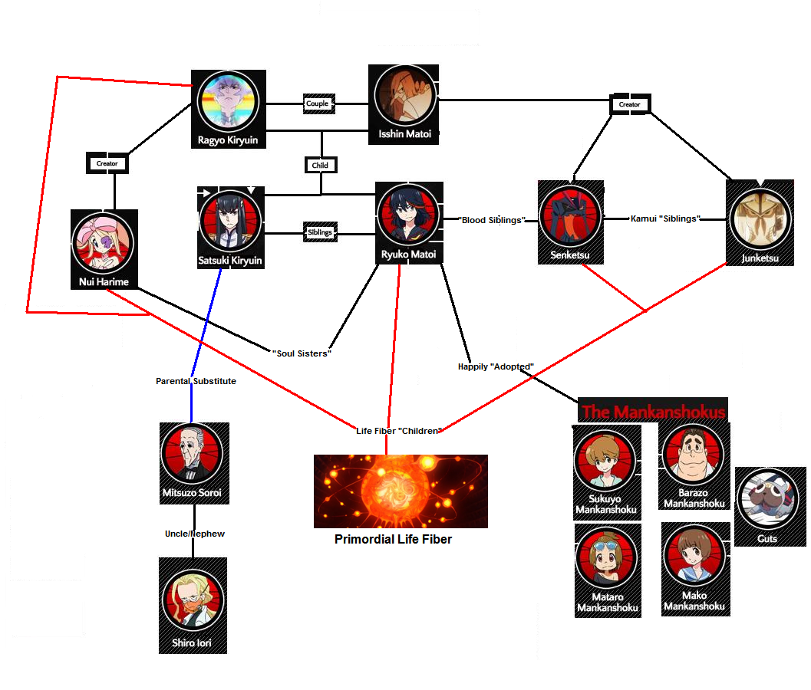

**Good**: Makes relationships between direct family members clear

**Bad**: Can be convoluted to code – parent + grandparent + great-grandparent depending on the levels of incest.

Consider using anime shows as examples of weird family trees.

Social vs biological father in Greek myths (not 2 parents)

### Adding loops to keep the hierarchy but also demonstrate interleaving

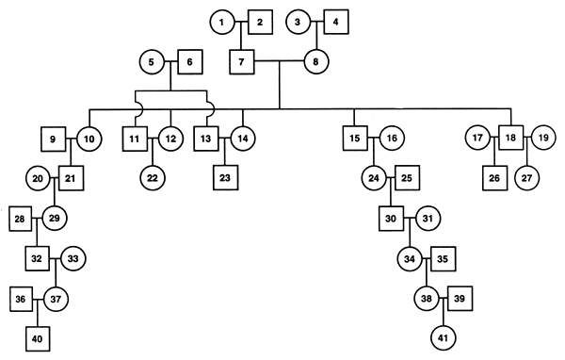

**Good**: Visually appealing, generational jumps

**Bad**: Difficult to code overlaps.

Depending on the type of family tree (and the content of the family tree to be generated), this shouldn’t be a problem. If height is large then not so easy.

Strobing, animations, dynamic graph generation and interactiveness / movement.

Multiple different views of the same generational “chunks” (e.g. front-elevation, side-elevation, views of a house plan).

## Conclusion from research

* **Use a directed acyclic graph (DAG). Deals with cycles in the graph and removes the requirement of a single root (tree structure)**
* DAGs can also represent collections of events and their influence on each other, either in a probabilistic structure such as a [Bayesian network](https://en.wikipedia.org/wiki/Bayesian_network) or as a record of historical data such as [family trees](https://en.wikipedia.org/wiki/Family_tree)
* **Can be structured top-down to maintain “family tree” appearance**
* **Add a legend for clarity**

## Complexities

* Could be extremely complex and too messy if the graph requires a comprehensive view of e.g. all Greek god relationships.
  + Will need to confirm what kind of graph would be shown and
  + how much of the relationships are shown (e.g. only Zeus’ direct descendants? Descendants to depth of 5? Ancestors?)
  + Need to determine what the user wants to see from the graphs – just the relationships?
  + Something to ask Greta
  + Not so much “Show me the relationships that Zeus has” but focus on the heroes. Show parts that are not generally available easily on the internet.
  + E.g. the regional, Apollodorus information, not readily available.
  + These are the interesting questions!
  + Greta will suggest a place to start. ☺
* Would need to be scalable and responsive as the graph could become unwieldy if large.
* No existing user research on different types of family trees and different layout effectiveness/intuitiveness
* **How to address couplings in DAGs?**
  + If we make the nodes tuples it would make children connections clearer, but it would require repetition of names in tuples. Wouldn’t establish a clear lineage.
  + If we separate the nodes into two separate parent nodes, then would make sibling connections / incest clearer but could be too big and unwieldy if required to put lot of info in the graph
  + If we make the notes separate but highlight in a different color or line size explicit incestuous relationships (e.g. between siblings, or between grandparent and grandchild). Clearly shows the weird relationships, but could be difficult to code the different lines.
  + **Create an algorithm for incestuous connections**

# Examples of weird family trees

* King Charles II of Spain



* Ancient Egypt (King Tut) for the sake of monarchy preservation

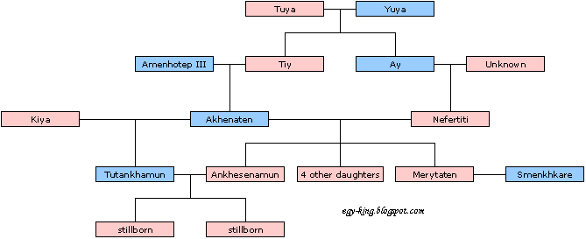

* Charles Darwin, married his first cousin Emma

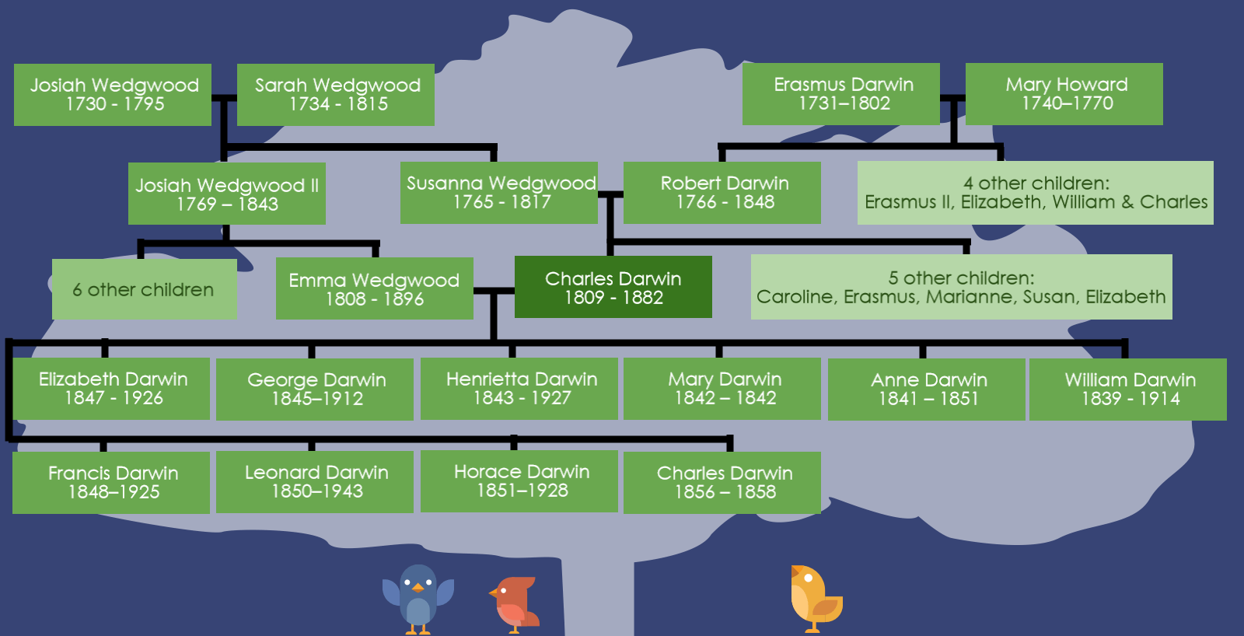

+ The idea of kinship as also “family”. Friendships in modern times (referring to each other as defacto family, “she’s like a sister to me”), or slaves included as part of the family in Ancient Rome.

+ adoption? Esp. adopting people of the same generation as a “successor”

Creating a few principles and seeing how they address the complex issues.

# Different types of family across cultures

## Ancient History

### Incest

King Tut, as a preservation of monarchy / ensuring pure-blooded lineage.

“The Risk and Rewards of Royal Incest”

<https://www.nationalgeographic.com/magazine/2010/09/tut-dna-dobbs/#close>

* “Royal incest, notes historian Joanne Carando, was "not only accepted but even encouraged" in Hawaii as an exclusive royal privilege.”
* “while virtually every culture in recorded history has held sibling or parent-child couplings taboo, royalty have been exempted in many societies, including ancient Egypt, Inca Peru, and, at times, Central Africa, Mexico, and Thailand.”
* “According to Stanford University classics professor Walter Scheidel, one reason is that "incest sets them apart." Royal incest occurs mainly in societies where rulers have tremendous power and no peers, except the gods. Since gods marry each other, so should royals. Incest also protects royal assets. Marrying family members ensures that a king will share riches, privilege, and power only with people already his relatives.”

### Different definitions of “family”

The Ancient Roman family was a complex social structure based mainly on the [nuclear family](https://en.wikipedia.org/wiki/Nuclear_family), but could also include various combinations of other members, such as extended family members, household slaves, and freed slaves. Ancient Romans had different names to describe their concept of family, including "familia" to describe the nuclear family and "domus" which would have included all the inhabitants of the household.

* Bradley, Keith R. *Discovering the Roman Family: Studies in Roman Social History*. New York: Oxford University Press, 1991

It was a paternal society, with young girls married at ~13yo Shelton, Jo-Ann. *As the Romans Did: A Sourcebook in Roman Social History*. 2nd ed. New York: Oxford University Press, 1998.

Since the mortality rate of children in Ancient Rome was so high, many parents needed to adopt.

Shelton, Jo-Ann. *As the Romans Did: A Sourcebook in Roman Social History*. 2nd ed. New York: Oxford University Press, 1998.

Wikipedia – history of the family (to read) <https://en.wikipedia.org/wiki/History_of_the_family>

The origin of family paper: <https://www.jstor.org/stable/349449?seq=1#page_scan_tab_contents>

The Old Testament in Christianity - Polygamy <https://www.jw.org/en/bible-teachings/questions/polygamy-bible-view/>, <https://www.biblestudytools.com/topical-verses/polygamy-in-the-bible/>

Should we show who are concubines/mistresses/wives/partners/girlfriends? Distinguish them in the family tree?

## Modern Day

### Incest

Sexual relations with first-degree relatives (i.e. parent or sibling) is universally forbidden. *The Tapestry of Culture: An Introduction to Cultural Anthropology*, Ninth Ed., Abraham Rosman, Paula G. Rubel, Maxine Weisgrau, 2009, AltaMira Press, p. 101

Chimpanzees attempting to make with their mothers [Incest not so taboo in nature](http://www.livescience.com/2226-incest-taboo-nature.html) Livescience, retrieved 29 January 2012

bed bugs, in contrast to most other insects, tolerate incest and are able to genetically withstand the effects of inbreeding quite well ["Insect Incest Produces Healthy Offspring"](http://www.laboratoryequipment.com/news/2011/12/insect-incest-produces-healthy-offspring). 8 December 2011.

“According to Gaiarbau, the main Aboriginal informant for the work of University of Queensland anthropologist Lindsey Page Winterbotham, marriage in traditional times in southeast Queensland, prior to the onset of colonisation, was arranged between the parents and senior Elders in their tribe with assistance from the maternal uncle, the Mother’s Brother. Other close family members might also be involved. Each stage of the marriage arrangement was determined by a set of rules that guided families through the complex process. The parents knew in advance who their sons and daughters could and could not marry. Exceptions to this would be in the case of elopement which did often happen and could involve punishment and/or forgiveness if the couple returned to their community (Winterbotham 34). In most of the tribal groups of southeast Queensland marriages were arranged between different moieties of the same tribe often involving a union between cross-cousins. This could only happen if the man and woman were from a different section or totem group. Exogamous marriage was also practised and this involved both men and women marrying outside of their moiety, again depending on the specific rules that operated for the group”

<http://www.easa-australianstudies.net/files/4.1.7%20Jeanie%20Bell.pdf>

### Different definitions of “family”

<https://scholarworks.gvsu.edu/cgi/viewcontent.cgi?article=1061&context=orpc>

Family values in different cultures

“statistics showing that at least 10% of adult women in Zimbabwe are in polygamous marriages by choice.” “Unlike with polygamy in the old days, in our days women who are in polygamous marriages choose to have their own homes and own lives separate from that of their sister wives.” <https://www.thestandard.co.zw/2019/07/07/modern-day-society-embracing-polygamy/> - unconventional

[Polygamy](https://en.wikipedia.org/wiki/Polygamy) is legal in 58 out of nearly 200 sovereign states, the vast majority of them being [Muslim-majority countries](https://en.wikipedia.org/wiki/Muslim-majority_countries) situated in Africa and Asia. In most of these states, [polygyny](https://en.wikipedia.org/wiki/Polygyny) is allowed and legally sanctioned. [Polyandry](https://en.wikipedia.org/wiki/Polyandry) is illegal in virtually every state in the world. The rest of the sovereign states do not recognize [polygamous marriages](https://en.wikipedia.org/wiki/Polygamy).

<https://en.wikipedia.org/wiki/Legality_of_polygamy>

Polyamory in modern society <https://vestnik.socio.msu.ru/jour/article/view/398?locale=en_US>

Family = identity and kinship in indigenous communities <http://www.workingwithindigenousaustralians.info/content/Practice_Implications_5_Fafmily_and_Kinship.html>

Traditional marriage and family in indigenous Australian communities “The persistence of Aboriginal kinship and marriage rules in Australia: Adapting traditional ways into modern practices” - [http://www.easa-australianstudies.net/files/4.1.7%20Jeanie%20Bell.pdf](http://www.easa-australianstudies.net/files/4.1.7%20Jeanie%20Bell.pdfin)

(More) Indigenous Australian definitions of family and marriage: <https://aifs.gov.au/publications/archived/3539>

Native American polygamy relations paper <https://lawdigitalcommons.bc.edu/cgi/viewcontent.cgi?referer=https://www.google.com/&httpsredir=1&article=1015&context=twlj>

“She’s like a sister to me” “She’s like family”

Invention of godparents (how to visualise this in a family tree?)

Homosexuality, transsexuality in family trees (is this something that should be addressed?)

Could research more on different values in family relationships e.g. whether certain cultures are more paternal, children’s level of dependence on parents, overall family closeness in Chinese vs European families. However since this doesn’t directly affect the layout of the family tree, is not really necessary, and as such should only be used as background information for the e.g. introduction of the thesis.

* + - A really good paper about family relationships <https://scholarworks.gvsu.edu/cgi/viewcontent.cgi?article=1061&context=orpc>

# TODO:

* Using the existing data model / datums, conduct logic operations that reverse relationships
  + e.g. “Y is son/daughter/child of X”, create new data point “X is father/mother/parent of Y”
* Extrapolate datums for other contexts
  + E.g. “Y is father of Z” and “Z is mother of X” => “Y is grandfather of X”
* Perhaps physically write a logic operation for these operations using COMP1600? – DAGs and DCGs and tree structures.

# Questions at the end of this:

* What “extent” of the family tree would we be visualising? Under what contexts would we need to generate graphs?
  + Graphs would be highly complex if height > e.g. 10.
* How should I approach doing a User Evaluation in this context?
  + Determine what people would want to see graphs of?
  + What tree structures would they be familiar with / understand intuitively.
  + Few ways
    - Discuss with experts, do qualitative research with feedback and iteratively define
    - Come up with some questions & bits of the family tree we want to ask questions about
      * Intuitiveness
      * Two types of users: General population, classicists who know the family tree and able to ask specific questions

# Before Week 5 meeting

* A list of the problem cases – from Greta by Monday/Tuesday
* Data from the Epitome – from Greta (won’t be final data but useful for reference), csv
* Lightning talk presentation for thesis in 2 weeks
* Look at the existing tools (&play around with them) and what they’re ca­­­­pable of
  + Github
  + JS graph visualisation libraries
  + Could generate a prototype
* Work on the workshop stuff from Week 5 seminar