Camtasia

makes it simple to record and create professional-looking videos

Introduction

Camtasia is a screen recording software. The application is quick to learn and easy to use. It gives you everything you need to make a high-quality video. Record anything on your computer screen – websites, software, video calls, or PowerPoint presentations. You can create Video tutorials, Presentation recordings, Video lessons, Meeting recordings and more.

Usage

If you often make videos out of PowerPoint presentations, you can now import PowerPoint slides directly into Camtasia and quickly edit them to match audio narration.

* Add PowerPoint Slides to a Camtasia Project

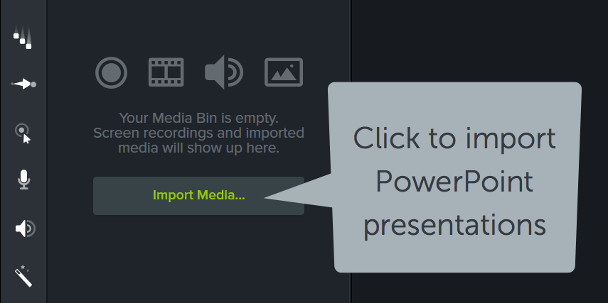First, make sure that PowerPoint is closed. Then click the *Import Media* button and choose your PowerPoint file. Camtasia converts each slide into an image (PNG) and adds it to the media bin. Drag slides to timeline and edit them like any other media in a project.

* Drag a Presentation to Camtasia

If you are using Camtasia on Windows, you can add a PowerPoint presentation by clicking and dragging it into Camtasia. Add it directly to the *Media Bin* or *Timeline* by dragging to either one.

If you add the presentation to the *Timeline*, each slide is added in order and set to the default image duration.

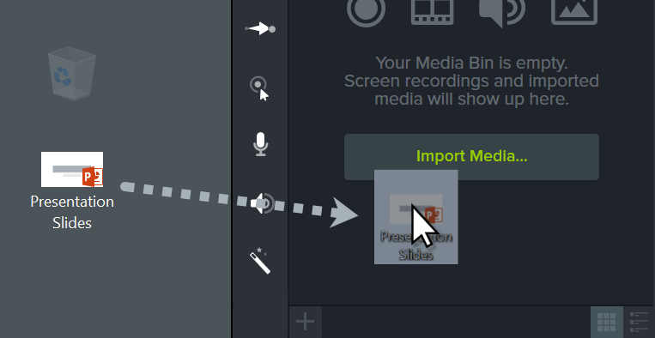

* Default Slide Duration

To change the default slide duration, go to *Edit > Preferences* and then choose the *Timing* tab. Set the “Images” option to the desired duration and click *OK*.

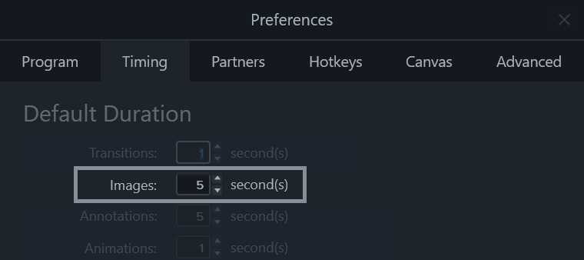

* Ripple Move

With your presentation on the timeline, use ripple move to create space in between slides to fine tune their timing. To do this, hold shift, then click and drag.

This moves all of the media to the right of a clip, which allows you to extend the slide and provide yourself more time for narration.

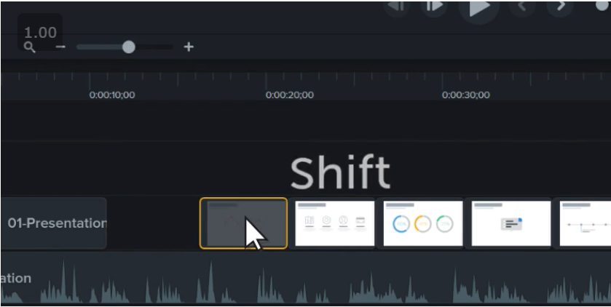

Conclusion

In conclusion if you want to record anything on your screen, drag and drop text or add effects, Camtasia is the perfect application for you.