Assembly instructions (MALM)

Contents

1. **Preparation steps (Part 1)3**
2. Introduction3
3. Necessary tools3
4. Preparation3
5. Safety information3
6. **Assembly steps (Part 24**
7. Hardware and accessories4
8. Pre-assembly instruction4
9. Assembly instruction5
10. Preparation steps (Part 1)
11. Introduction

This technical documentation provides information about how to assemble 2-drawer chest MALM. The product can be used as a nightstand. The drawers are with pull-out-stop mechanism and holds about five pairs of folded pants or 10 T-shirts. The designer of the product is IKEA.

1. Necessary tools

* Phillips screwdriver
* Slotted screwdriver
* Pencil
* Hammer

Important! The required or recommended tools for assembly are not supplied with the product.

1. Preparation

Make sure you get all the necessary tools. Read each step of the documentation carefully. It is very important that each step of instruction is performed in the correct order. If the steps below are not followed in sequence, assembly difficulties will occur. Make sure all parts are included. Work in spacious area, preferably on a carpet, near the place the unit will be used. Use the tools carefully and gentle, if you don’t want to damage the parts.

1. Safety information

The product contains small components, please ensure that they are kept away from children. Move your new furniture and his parts carefully only with two people. Never push, drag or pull the product. For help with assembly, identifying parts, product information or to order parts, please contact seller.

1. Assembly steps (Part 2)
2. Hardware and accessories

* A - Spare part - 8 Pcs
* B - Cam-Lock Screw - 20 Pcs
* C - PVC Dowel - 20 Pcs
* D - Minifix - 20 PCs
* E - Drawer Rail Screw - 12 Pcs
* F - Plastic Pin - 4 Pcs
* G – Nails – 1 Pcs
* H – Floor protector – 4 Pcs
* I – Drawer Slide – 2 Pcs

1. Pre-assembly

Step 1

Place the left and right boards on the ground. Then tight 4 Cam-Lock Screws (B) with the Phillips screwdriver on the left board and after that 4 Cam-Lock Screws (B) on the right board (as shown).

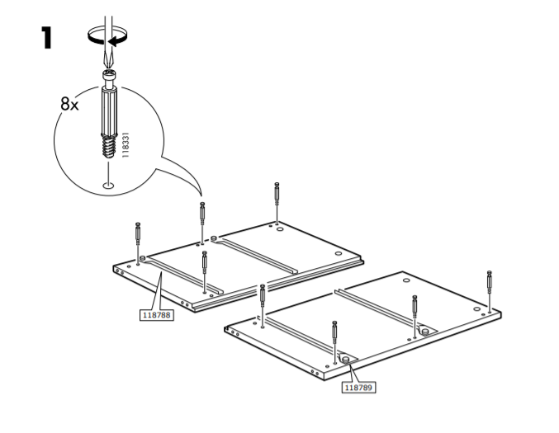

Step 2

Insert the Floor protectors (H) to the bottom of the boards, using hammer to gently tap them in.

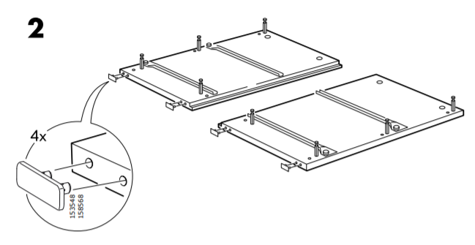

1. Assembly instruction

Step 3

Insert PVC dowels (C) to the bottom and top of the four long narrow boards. After that place and fix the long boards onto left board of the chest by inserting the dowels onto the non-thru holes at the long boards.

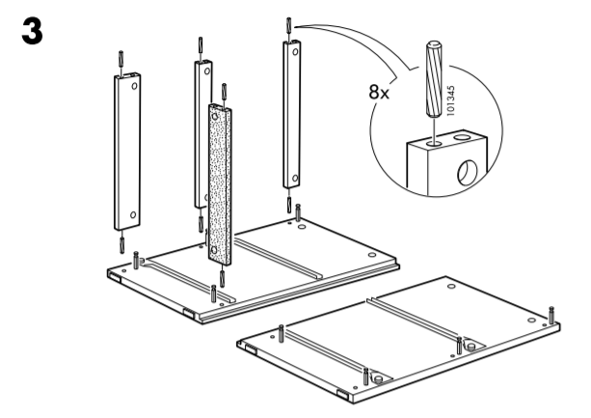

Step 4

Insert one minifix (D) in the four long boards with the flat mark facing up ward. Then tight it with the slotted screwdriver.

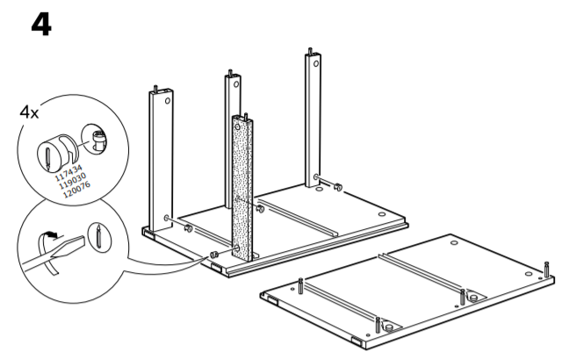

Step 5

Place and fix the right board with the other construction. Carefully insert the dowels onto the non-thru holes.

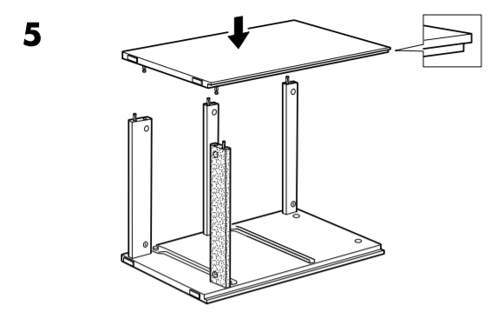

Step 6

Carefully rotate the furniture face down and tight the minifix in the long boards.

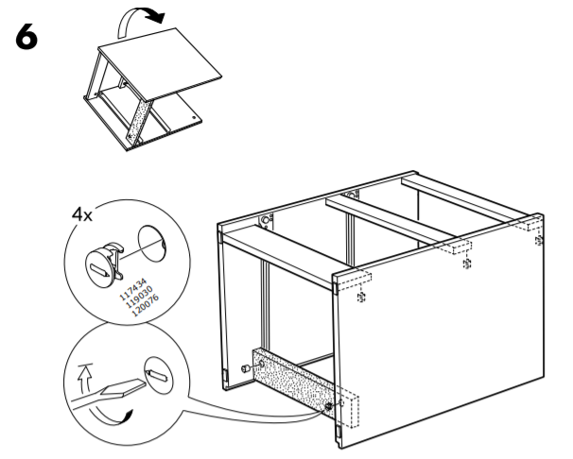

Step 7

Tight 4 Cam-Lock Screws (B) with the Phillips screwdriver on the inside of the surface board (as shown).

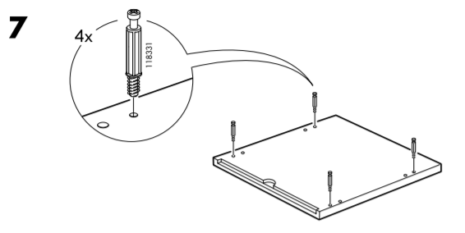

Step 8

Insert 4 PVC dowels (C) to the top of the left and right boards. Then place and fix the surface board with the other construction, carefully. The front of the surface should not have a protruding edge.

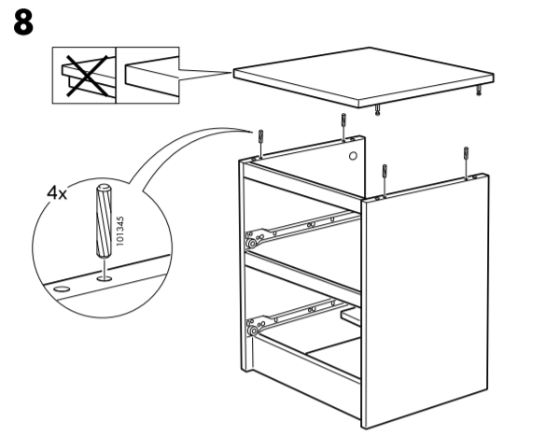

Step 9

Insert two minifixes (D) in the upper part of the left board with the flat mark facing up ward. Do the same for the right board. Then tight the four minifixes with the slotted screwdriver.

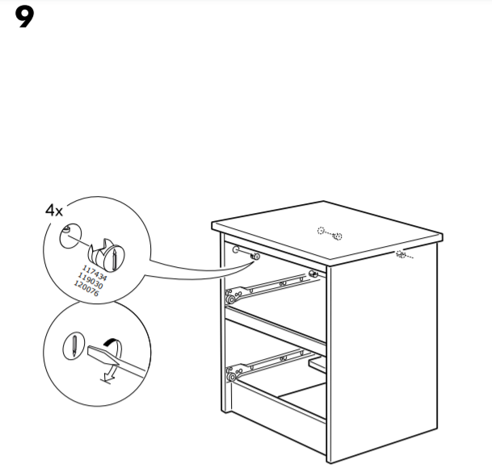

Step 10

Place the plywood on the back of the construction. After that fix one Nail (G) in the top-left angle of the plywood, using Hammer.

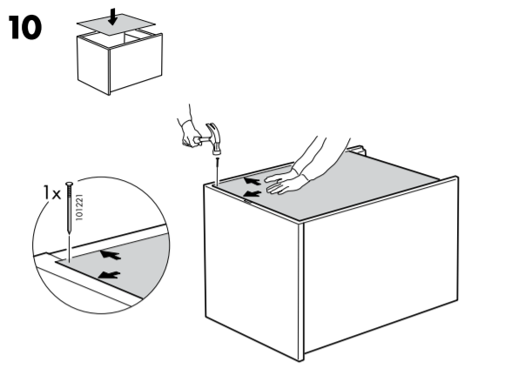

Step 11

Fix a Nail (G) in the top-right angle of the plywood, using Hammer.

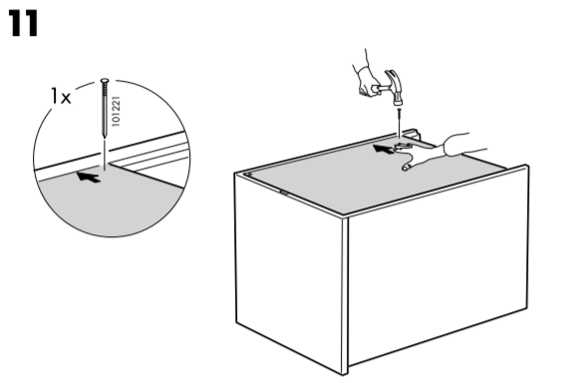

Step 12

Fix a Nail (G) in the bottom-left angle of the plywood, using Hammer.

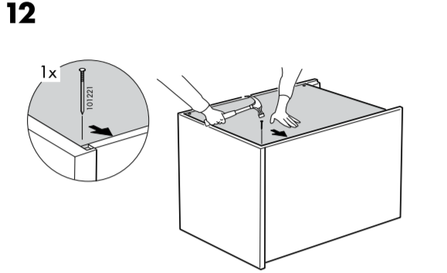

Step 13

Fix a Nail (G) in the bottom-right angle of the plywood, using Hammer. And after that fix the rest Nails (G) into the surface’s edges, using Hammer again.

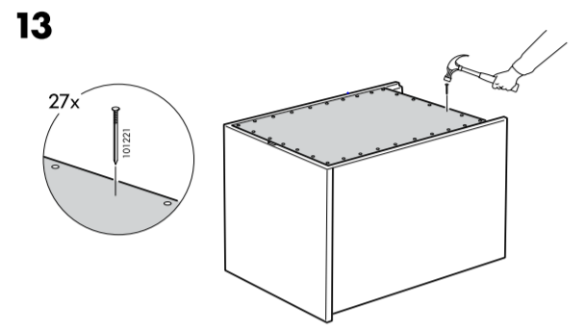

Step 14

Place the front board of the drawer on the ground. Then tighten 4 Cam-Lock Screws (B) to the board, using Phillips screwdriver (as shown).

Step 15

Insert 4 PVC dowels (C) to the front side of the left and right drawer’s boards. Then place and fix the side boards with the front panel, carefully.

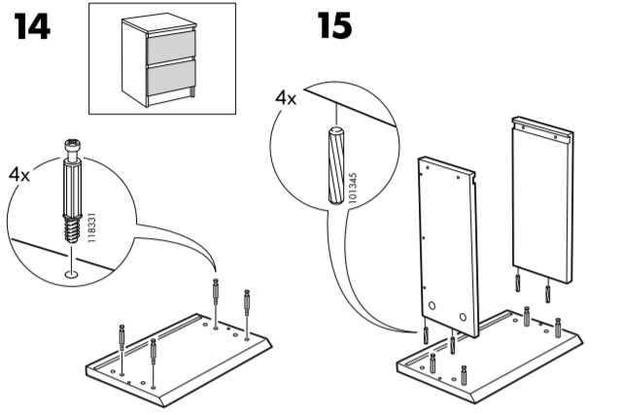

Step 16

Insert two minifixes (D) in the left drawer’s board. Do the same for the right board. Then tight the four minifixes with the slotted screwdriver.

Step 17

Place and fix the plywood in the bottom of the drawer, carefully. There are furrows in the boards, where the plywood has to stand.

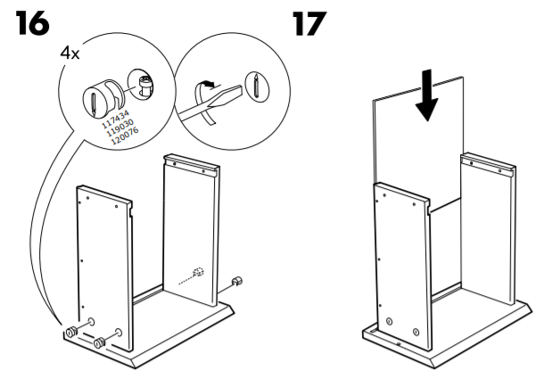

Step 18

Add the back board of the drawer carefully. There are furrows, where the board has to stand.

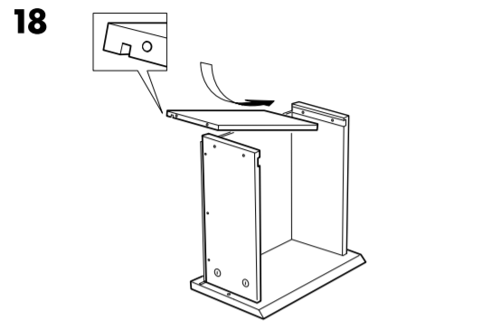

Step 19

If step 18 is executed correctly, you can easily nail the spare parts (A) in the back of the drawer with hammer, as shown. After that gentle nail the Plastic pins (F) on the inside of the front drawer’s board.

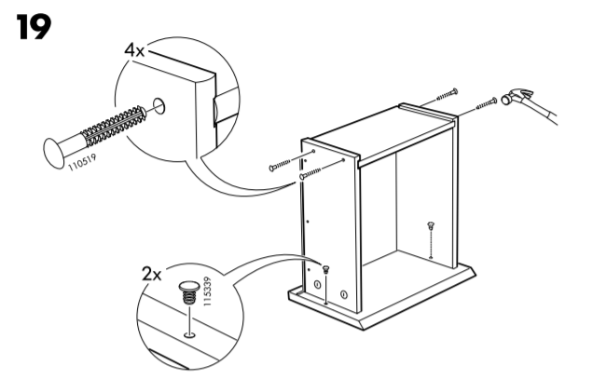

Step 20

Place the drawer slides (I) at the predrilled holes on the left and right drawer’s boards as shown. Then tighten the drawer slide (I) with 3 Drawer Rail Screws (E).

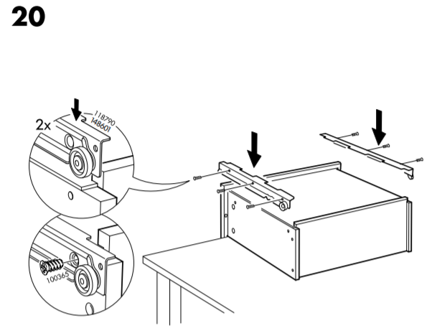

Step 21

When the drawer is ready, you just place it in the chest. The method is movement from bottom to top. The rollers at drawer slide at both side of drawers are to go into the track of the slide at each side panel. After that do the same procedure for the second drawer.

