**IAAS (infrastructure-as-a-service) for public and private clouds.**

OpenStack’s Compute (Nova)

OpenStack’s Network (Neutron)

**REQUIREMENTS**

Required packages: (centos7)

* virt-manager, qemu-kvm, qemu-img
* libvirt, libvirt-python, python-virtinst, libvirt-client
* libvirtd on startup

(minimum)

Controller/Compute Node (4GB ram,1vCPU,40GB root disk)

Network Node(2GB ram, 1vCPU,40GB root disk)

Ceph1(admin node) 4GB ram, 1vCPU,30GB root disk, 30GB root disk, 100GB data disk

Ceph2(mon node) 2GB ram, 1vcPU, 30 GB root disk, 100GB data disk

Ceph3(osd node) 4GB ram, 1vCPU, 30GB root disk, 100GB data disk

**(on controller and network node)**

* systemctl stop NetworkManager firewalld postfix
* systemctl disable NetworkManager firewalld postfix
* systemctl mask NetworkManager
* (disable selinux)
* yum update
* Add all nodes to /etc/hosts entries
* Setup ntp

(if centos)

* yum install <https://www.rdoproject.org/repos/rdo-release.rpm>
* yum install -y centos-release-openstack-queens

(if redhat)

subscription-manager repos –disable=*

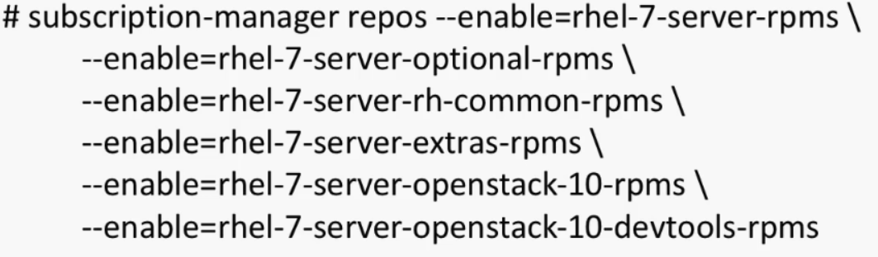

**(ceph nodes)**

subscription-manager repos –disable=*





systemctl enable firewalld && systemctl start firewalld

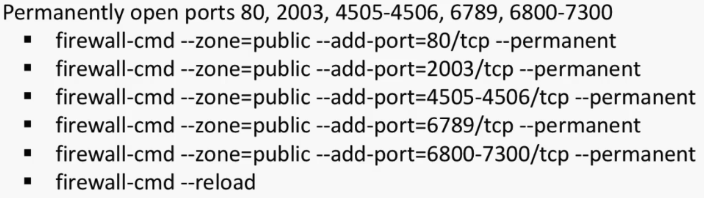

* configure ntp
* create ceph user and add to wheel group

/home/ceph/ceph-config

* passwordless login between ceph nodes
* yum install epel-release ansible git -y

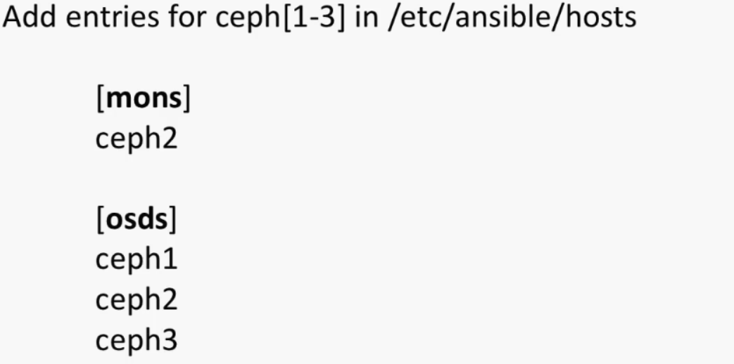

**INSTALLATION**

**(on controller node)**

yum -y install openstack-packstack

packstack --gen-answer-file=/root/answers.txt

vi /root/answers.txt

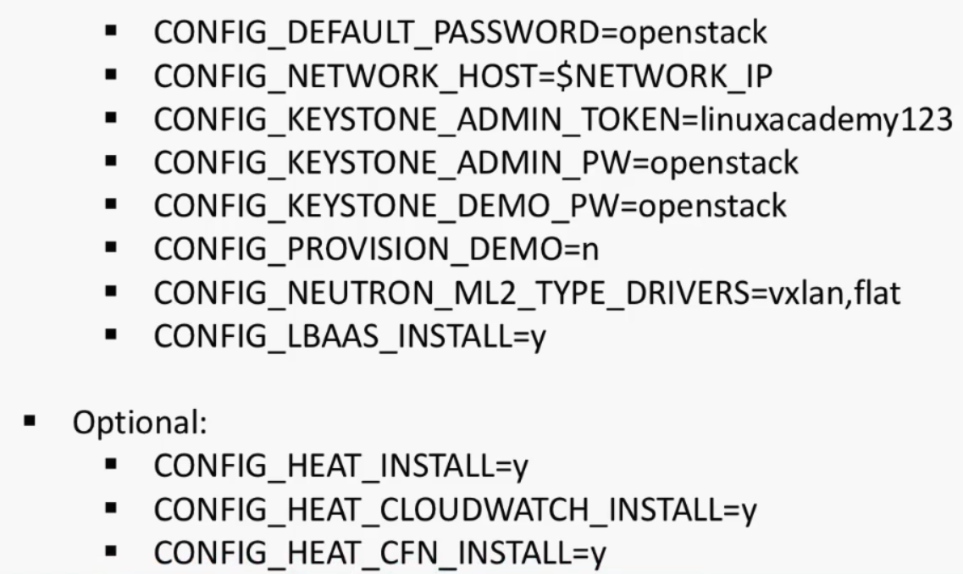

CONFIG_NTP_SERVERS= 0.tr.pool.ntp.org

packstack --answer-file=/root/answers.txt

<http://192.168.1.30/dashboard>

username: admin

password: openstack

**(on ceph1-admin node)**

git clone <https://github.com/ceph/ceph-ansible>

(testing ansible) ansible all -m ping