**JENKINS**

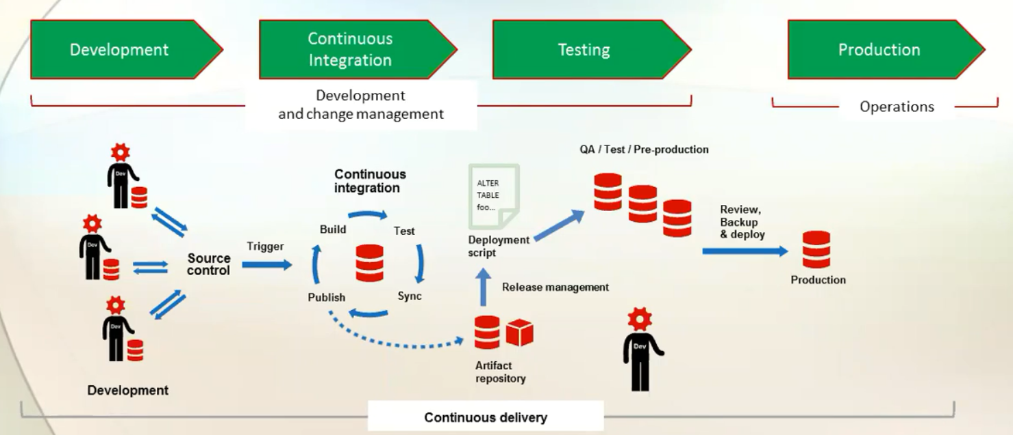

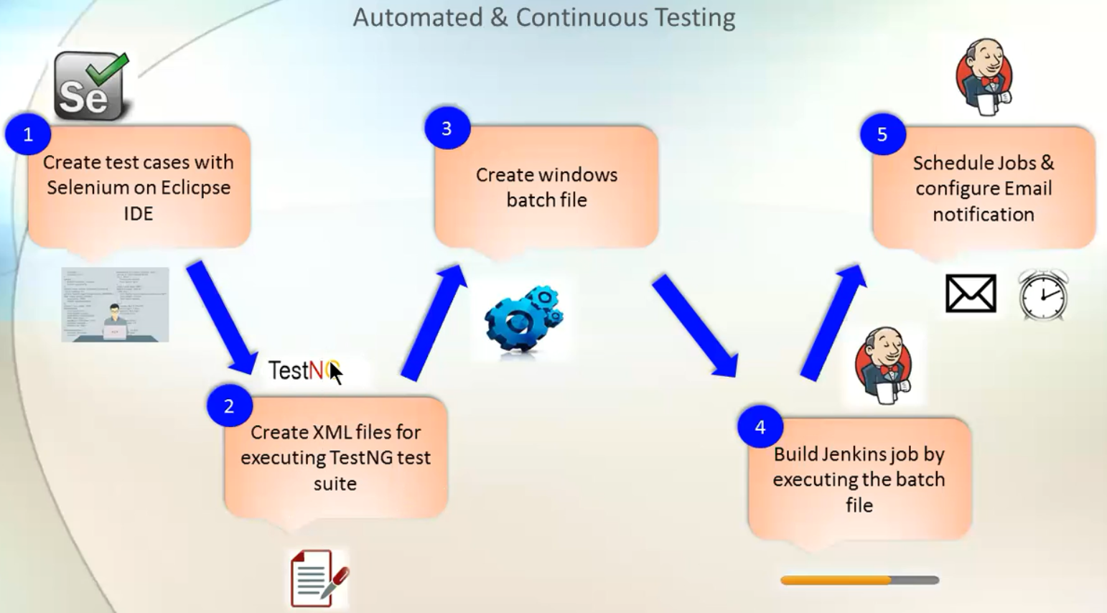

(Linux installation)

yum install java-1.8.0-openjdk

java -version

openjdk version "1.8.0_242"

OpenJDK Runtime Environment (build 1.8.0_242-b08)

OpenJDK 64-Bit Server VM (build 25.242-b08, mixed mode)

yum install -y git

git --version

[root@centos1 ~]# git config --global user.name yaydog23

[root@centos1 ~]# git config --global user.email yaydog@gmail.com

cat .ssh/id_rsa.pub

<https://github.com/settings/keys>

new ssh key

wget -O /etc/yum.repos.d/jenkins.repo <https://pkg.jenkins.io/redhat/jenkins.repo>

[root@centos2 ~]# cat /etc/yum.repos.d/jenkins.repo

[jenkins]

name=Jenkins

baseurl=http://pkg.jenkins.io/redhat

gpgcheck=1

rpm --import <https://pkg.jenkins.io/redhat/jenkins.io.key>

yum install jenkins -y

systemctl start Jenkins

systemctl enable jenkins

<http://localhost:8080>

[root@centos2 ~]# netstat -tulpn | grep java

tcp6 0 0 :::8080 :::* LISTEN 14393/java

cat /var/lib/jenkins/secrets/initialAdminPassword

>>INSTALL SUGGESTED PLUGINS

**GIT PROJECT (/root/project/)**

mkdir -p /root/project

git init

git add FilePermission.ps1 (git add . > for all files)

git commit -m "v1" FilePermission.ps1

(change code and add new files)

git diff FilePermission.ps1

git add FilePermission.ps1

git commit -m "v2" FilePermission.ps1

git log (shows commits and changes)

git log --oneline

(create repository on github name:deneme)

git remote add origin https://github.com/yaydog23/deneme.git

git push -u origin master

(getting repository from github)

git clone <https://github.com/yaydog23/deneme.git>