Server pull data from Exporters (agents)

**SERVER INSTALLATION (192.168.1.10)**

useradd -M -r -s /bin/false Prometheus

mkdir /etc/prometheus /var/lib/prometheus

wget <https://github.com/prometheus/prometheus/releases/download/v2.23.0/prometheus-2.23.0.linux-amd64.tar.gz>

tar xzf prometheus-2.23.0.linux-amd64.tar.gz

cp /root/prometheus-2.23.0.linux-amd64/prometheus /usr/local/bin

cp /root/prometheus-2.23.0.linux-amd64/promtool /usr/local/bin

cp -r /root/prometheus-2.23.0.linux-amd64/consoles /etc/prometheus

cp -r /root/prometheus-2.23.0.linux-amd64/console_libraries /etc/prometheus

cp /root/prometheus-2.23.0.linux-amd64/prometheus.yml /etc/prometheus/prometheus.yml

chown prometheus:prometheus /usr/local/bin/prometheus

chown prometheus:prometheus /usr/local/bin/promtool

chown -R prometheus:prometheus /etc/prometheus

chown prometheus:prometheus /var/lib/prometheus

vi /etc/systemd/system/prometheus.service

[Unit]

Description=Prometheus Time Series Collection and Processing Server

Wants=network-online.target

After=network-online.target

[Service]

User=prometheus

Group=prometheus

Type=simple

ExecStart=/usr/local/bin/prometheus --config.file /etc/prometheus/prometheus.yml --storage.tsdb.path /var/lib/prometheus --web.console.templates=/etc/prometheus/consoles --web.console.libraries=/etc/prometheus/console_libraries

[Install]

WantedBy=multi-user.target

systemctl daemon-reload

systemctl enable prometheus

systemctl start prometheus

reloading the configuration without restart

killall -HUP prometheus

IP: 9090

/etc/prometheus/consoles/mygraph.html

IP:9090/consoles/graph.html

**PUSH GATEWAY INSTALLATION (192.168.1.10)**

useradd -M -r -s /bin/false pushgateway

wget <https://github.com/prometheus/pushgateway/releases/download/v1.3.0/pushgateway-1.3.0.linux-amd64.tar.gz>

tar xvfz pushgateway-1.3.0.linux-amd64.tar.gz

cp pushgateway-1.3.0.linux-amd64/pushgateway /usr/local/bin

chown pushgateway:pushgateway /usr/local/bin/pushgateway

vi /etc/systemd/system/pushgateway.service

Wants=network-online.target

After=network-online.target

[Service]

User=pushgateway

Group=pushgateway

Type=simple

ExecStart=/usr/local/bin/pushgateway

[Install]

WantedBy=multi-user.target

systemctl daemon-reload

systemctl enable pushgateway

systemctl start pushgateway

curl <http://IP:9091/metrics>

vi /etc/prometheus/prometheus.yml



verify

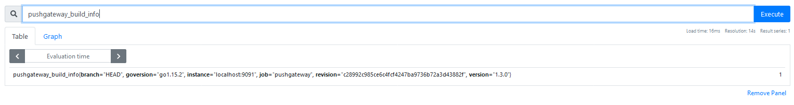

(recording rules)

mkdir -p /etc/prometheus/rules

vi /etc/prometheus/prometheus.yml

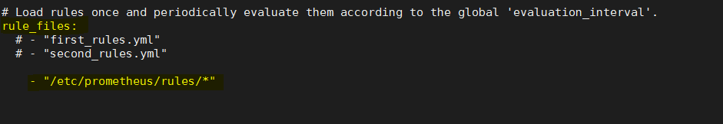

systemctl restart prometheus

vi /etc/prometheus/rules/linux_server_rules.yml

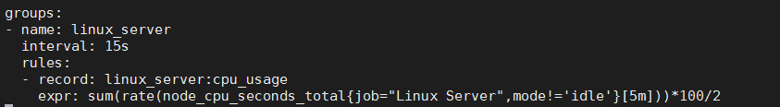

**!burdaki job isimi** /etc/prometheus/prometheus.yml job ismiyle aynı olmalıdır

**ALERT MANAGER INSTALLATION-SERVER (192.168.1.10)**

useradd -M -r -s /bin/false alertmanager

wget <https://github.com/prometheus/alertmanager/releases/download/v0.21.0/alertmanager-0.21.0.linux-amd64.tar.gz>

tar xvfz alertmanager-0.21.0.linux-amd64.tar.gz

cp alertmanager-0.21.0.linux-amd64/alertmanager /usr/local/bin

cp alertmanager-0.21.0.linux-amd64/amtool /usr/local/bin

chown alertmanager:alertmanager /usr/local/bin/alertmanager

chown alertmanager:alertmanager /usr/local/bin/amtool

cp alertmanager-0.21.0.linux-amd64/alertmanager.yml /etc/alertmanager/

chown -R alertmanager:alertmanager /etc/alertmanager/

chown alertmanager:alertmanager /var/lib/alertmanager

mkdir -p /etc/amtool

vi /etc/amtool/config.yml

alertmanager.url: <http://localhost:9093>

vi /etc/systemd/system/alertmanager.service

[Unit]

Description=Prometheus AlertManager

Wants=network-online.target

After=network-online.target

[Service]

User=alertmanager

Group=alertmanager

Type=simple

ExecStart=/usr/local/bin/alertmanager --config.file /etc/alertmanager/alertmanager.yml --storage.path /var/lib/alertmanager

[Install]

WantedBy=multi-user.target

systemctl daemon-reload

systemctl enable alertmanager

systemctl start alertmanager

vi /etc/prometheus/prometheus.yml

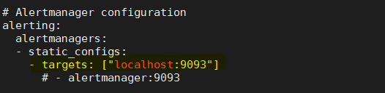

(general status)

<http://localhost:9093>

(checking alerts)

<http://localhost:9090/alerts>

(creating alert rule)

vi /etc/prometheus/prometheus.yml

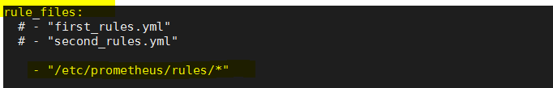

vi /etc/prometheus/rules/my-alerts.yml

groups:

- name: example alert

rules:

- alert: server down

expr: up{job="linux server"} == 0

for: 10m

labels:

severity: critical

annotations:

summary: down

waits 10minute then start alarm

syntax check: promtool check rules /etc/prometheus/rules/my-alerts.yml

**EXPORTER INSTALLATION-CLIENT (192.168.1.11)**

wget <https://github.com/prometheus/node_exporter/releases/download/v1.0.1/node_exporter-1.0.1.linux-amd64.tar.gz>

cp node_exporter-1.0.1.linux-amd64/node_exporter /usr/local/bin

chown node_exporter:node_exporter /usr/local/bin/node_exporter

vi /etc/systemd/system/node_exporter.service

[Unit]

Description=Prometheus Node Exporter

Wants=network-online.target

After=network-online.target

[Service]

User=node_exporter

Group=node_exporter

Type=simple

ExecStart=/usr/local/bin/node_exporter

[Install]

WantedBy=multi-user.target

systemctl daemon-reload

systemctl enable node_exporter

systemctl start node_exporter

test: curl localhost:9100/metrics

vi /etc/prometheus/prometheus.yml

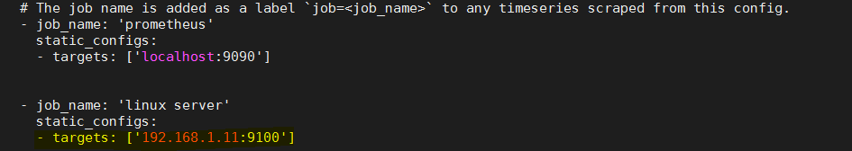

Querying via API

curl localhost:9090/api/v1/query?query=node_cpu_seconds_total

**APACHE EXPORTER (on client)**

useradd -M -r -s /bin/false apache_exporter

wget https://github.com/Lusitaniae/apache_exporter/releases/download/v0.8.0/apache_exporter-0.8.0.linux-amd64.tar.gz

tar xvfz apache_exporter-0.8.0.linux-amd64.tar.gz

cp apache_exporter-0.8.0.linux-amd64/apache_exporter /usr/local/bin

chown apache_exporter:apache_exporter /usr/local/bin/apache_exporter

vi /etc/systemd/system/apache_exporter.service

[Unit]

Description=Prometheus Apache Exporter

Wants=network-online.target

After=network-online.target

[Service]

User=apache_exporter

Group=apache_exporter

Type=simple

ExecStart=/usr/local/bin/apache_exporter

[Install]

WantedBy=multi-user.target

systemctl daemon-reload

systemctl enable apache_exporter.service

systemctl start apache_exporter.service

**(on server)**



**GRAPHANA INSTALLATION (192.168.1.12)**

vi /etc/yum.repos.d/grafana.repo

[grafana]

name=grafana

baseurl=https://packages.grafana.com/oss/rpm

repo_gpgcheck=1

enabled=1

gpgcheck=1

gpgkey=https://packages.grafana.com/gpg.key

sslverify=1

sslcacert=/etc/pki/tls/certs/ca-bundle.crt

yum install epel-release

yum install grafana fontconfig freetype* urw-fonts -y

systemctl enable grafana-server.service

systemctl start grafana-server

IP:3000

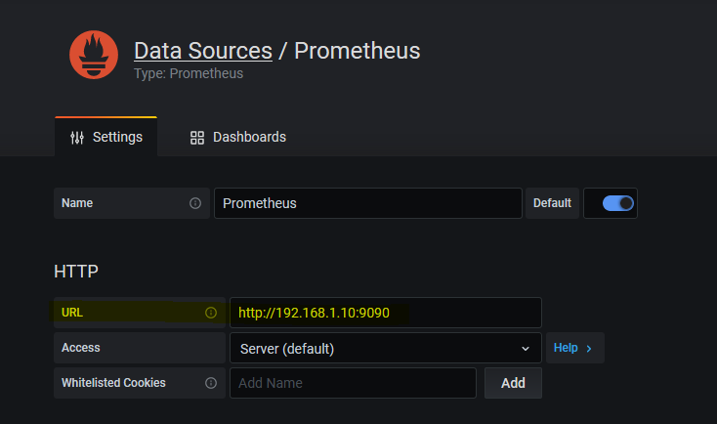

(add zabbix to grafana)

grafana-cli plugins install alexanderzobnin-zabbix-app

(enable zabbix plugin)

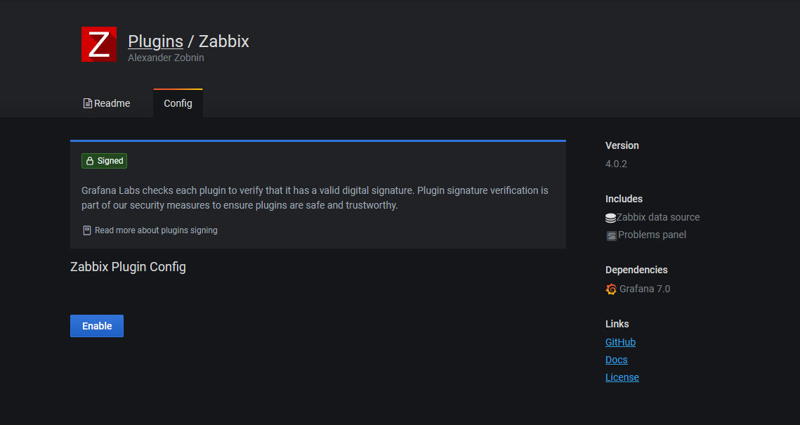

Add as datasource

http://Your-Zabbix-ServerIP/zabbix/api_jsonrpc.php