**Assignment #2**

**110503507林亞誼**

**1.編譯結果**



Figure 1: Compile file

**2.執行結果**

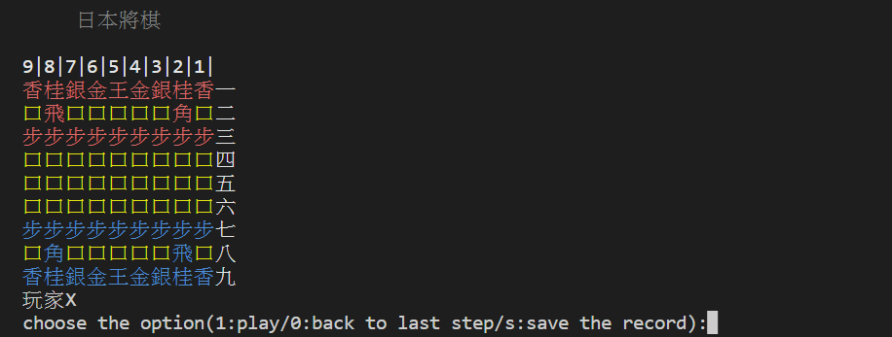

Figure 2: X player Initial site

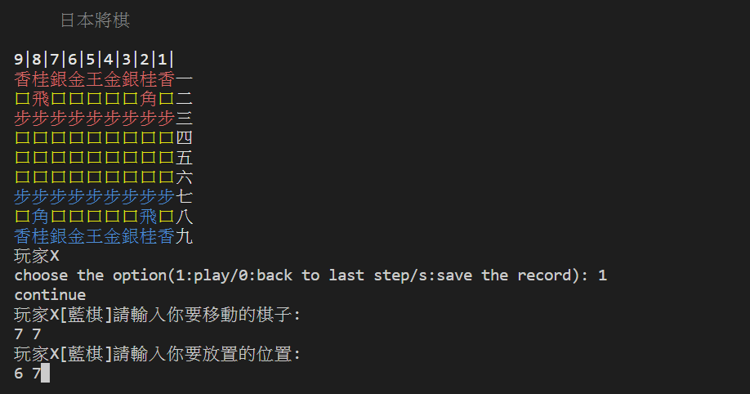

Figure 3: X player input 1 to play and move the piece

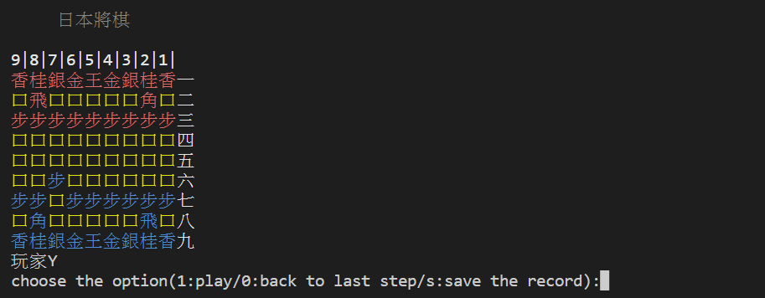

Figure 4: Y player Initial site

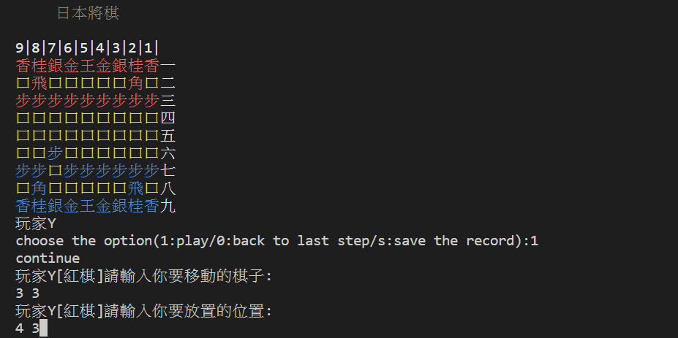

Figure 5: Y player input 1 to play and move the piece

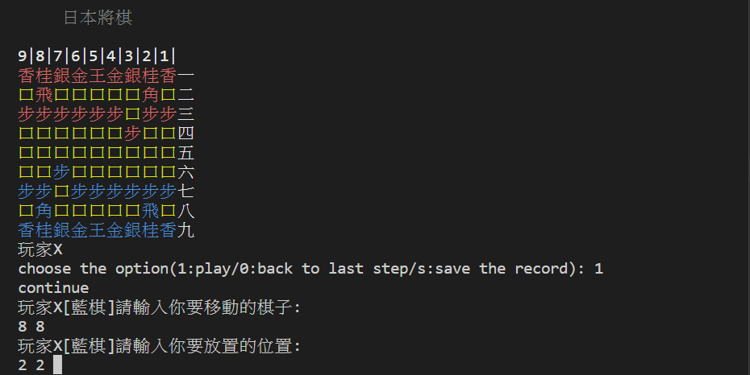Figure 6: X player capture Y player piece

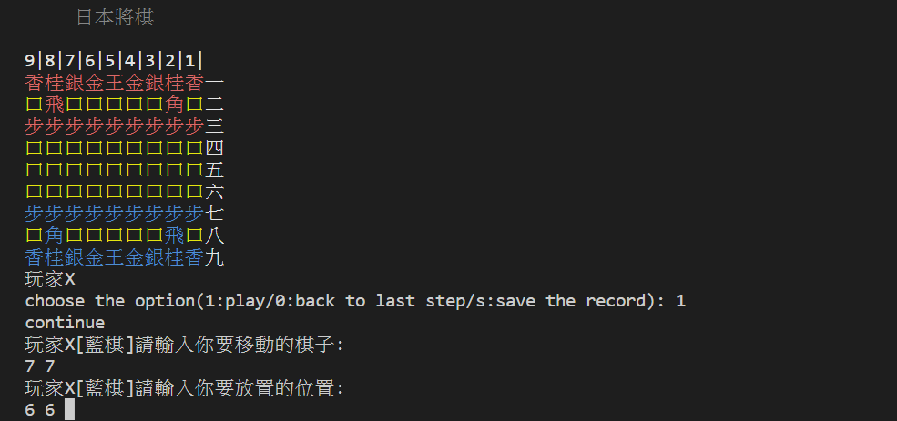

Figure 7: when X player enter wrong

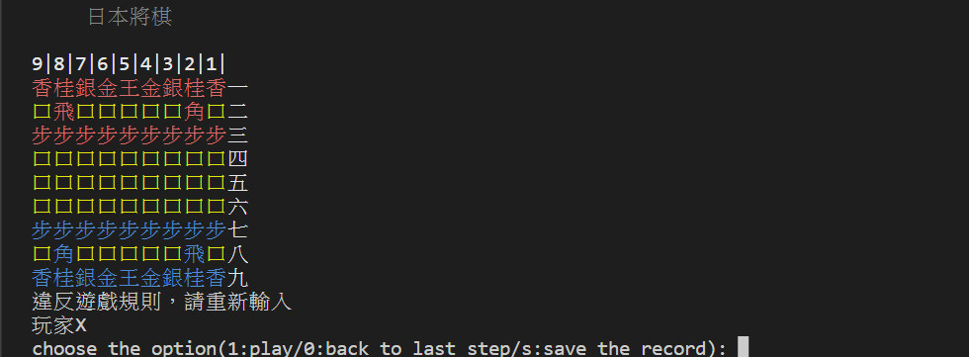

Figure 8: X player should input numbers again

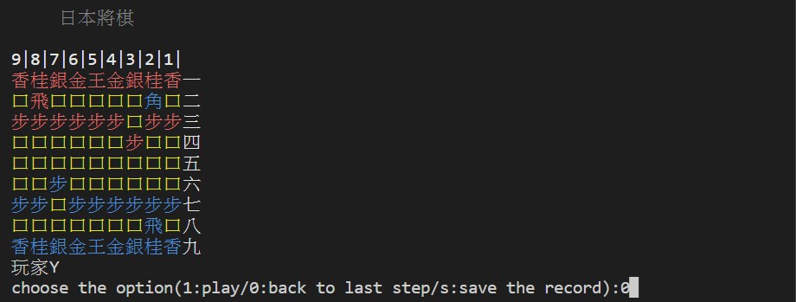

Figure 9: Y player enter 0 to go back to last step

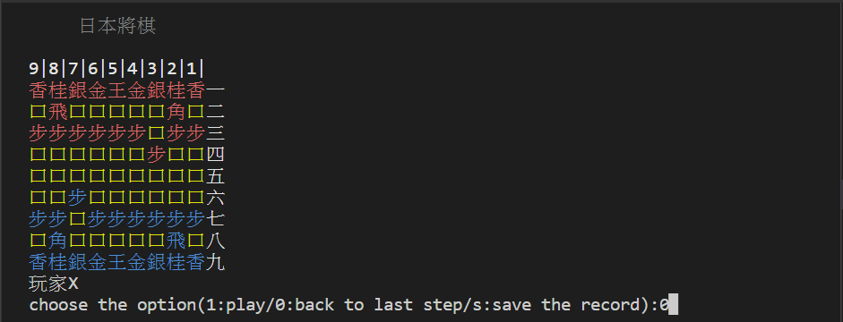 Figure 10: X player enter 0 to go back to last step

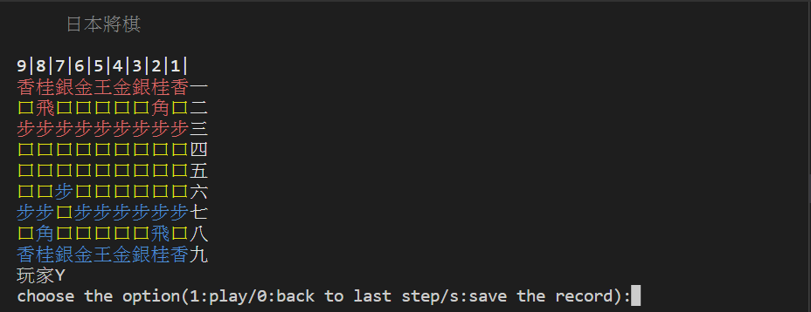

Figure 11: Pawn of Y player returns to initial place

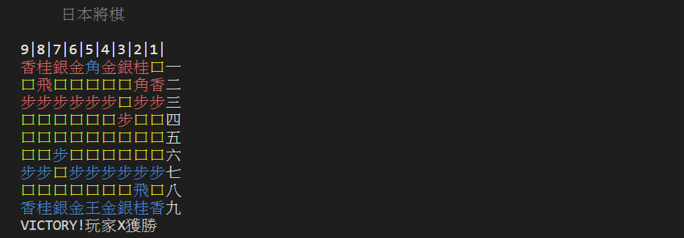

Figure 12: X player win the game

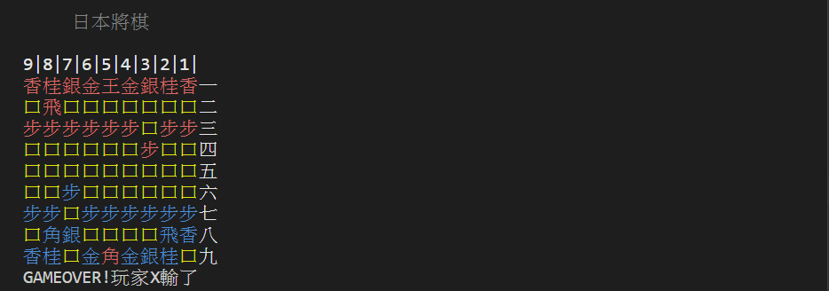

Figure 13: X player lose the game

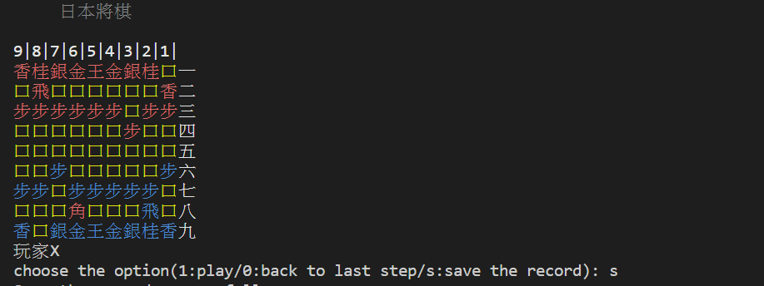

Figure 14: Once we input s, it would save the record in a file

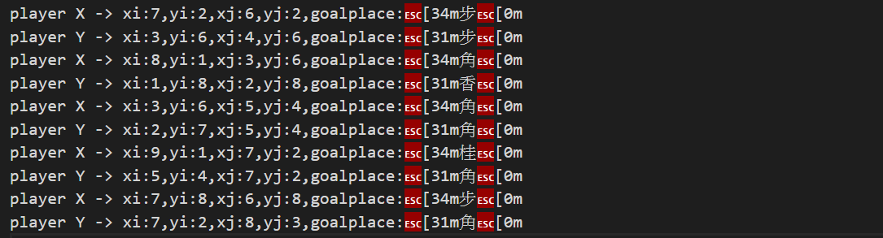

Figure 15: The record would be printed on record.txt

**<將棋棋子規則>**

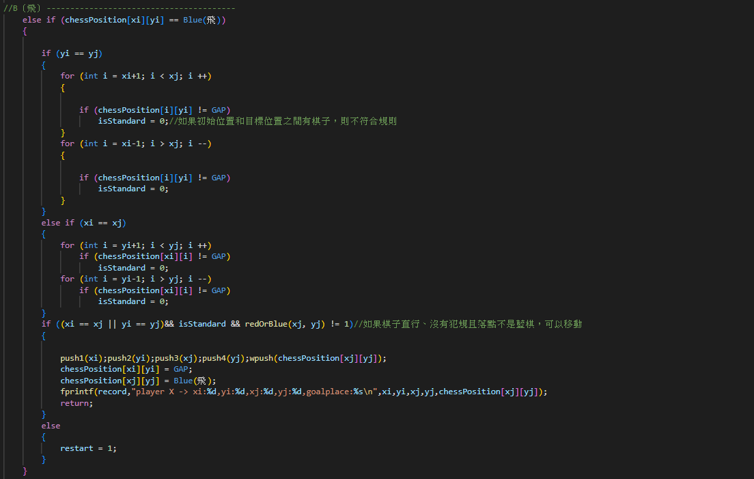 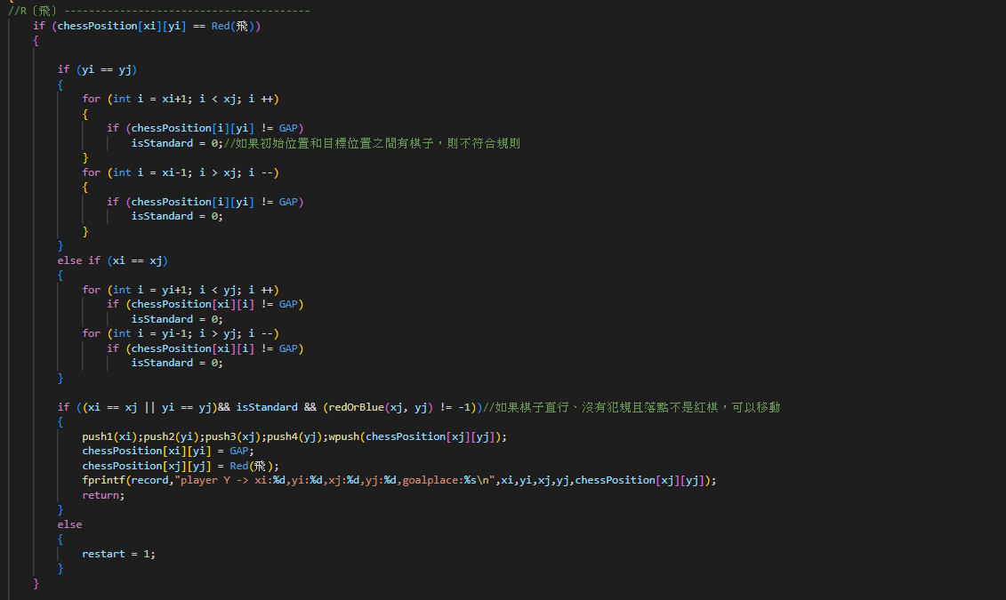

Figure 16: [飛] 可到上下左右的任何1格

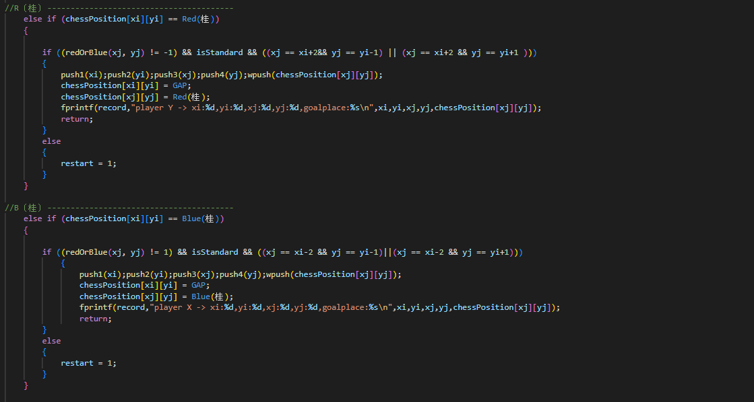

Figure 17: [桂] 每次走右上格或左上格對上之1格

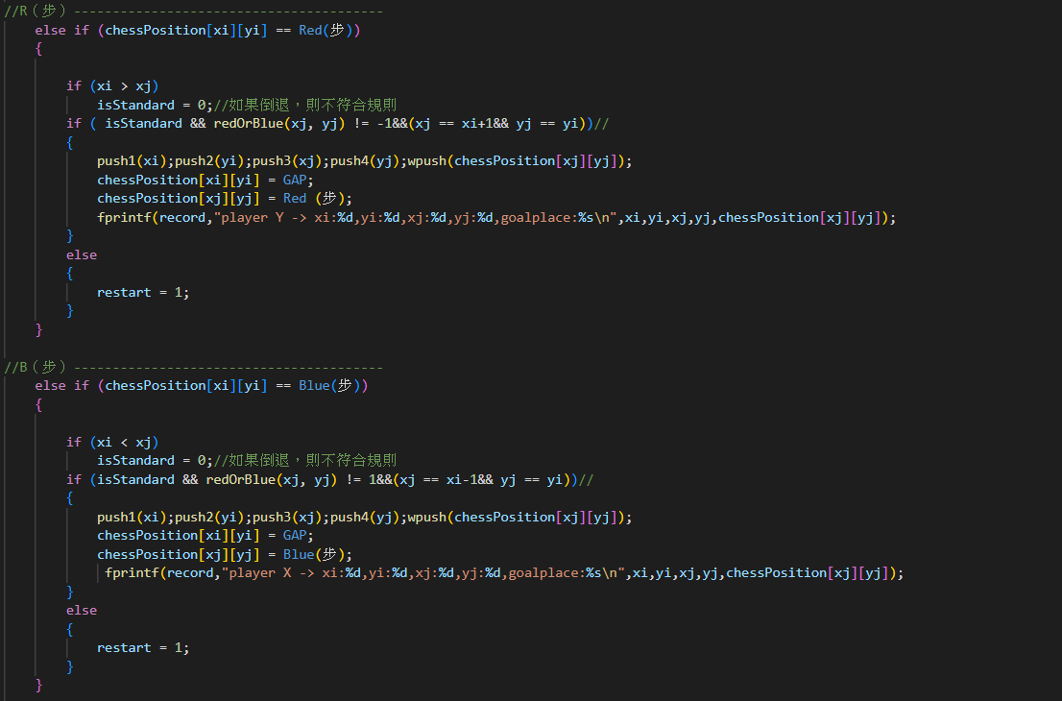

Figure 18: [步] 每次只可向前1格，不能後退

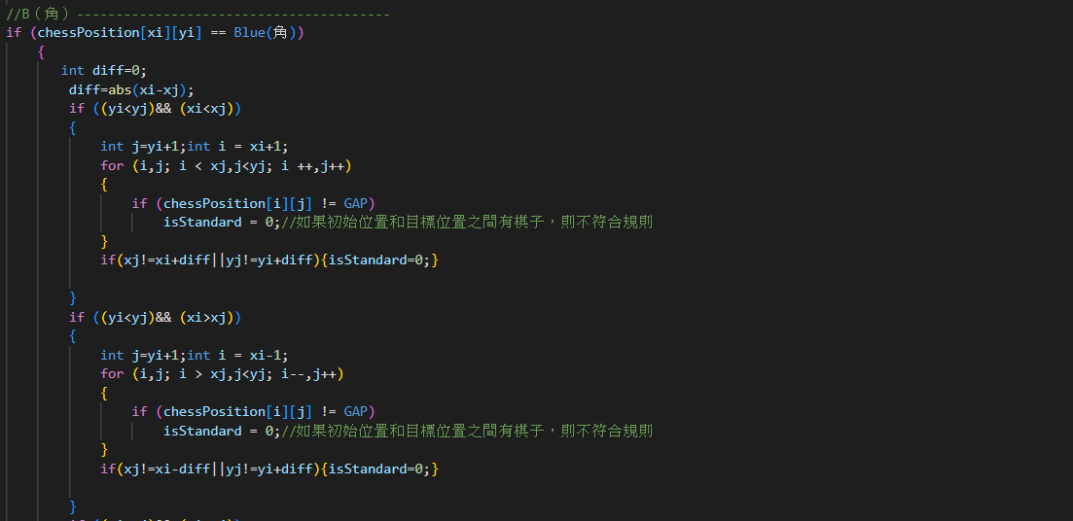

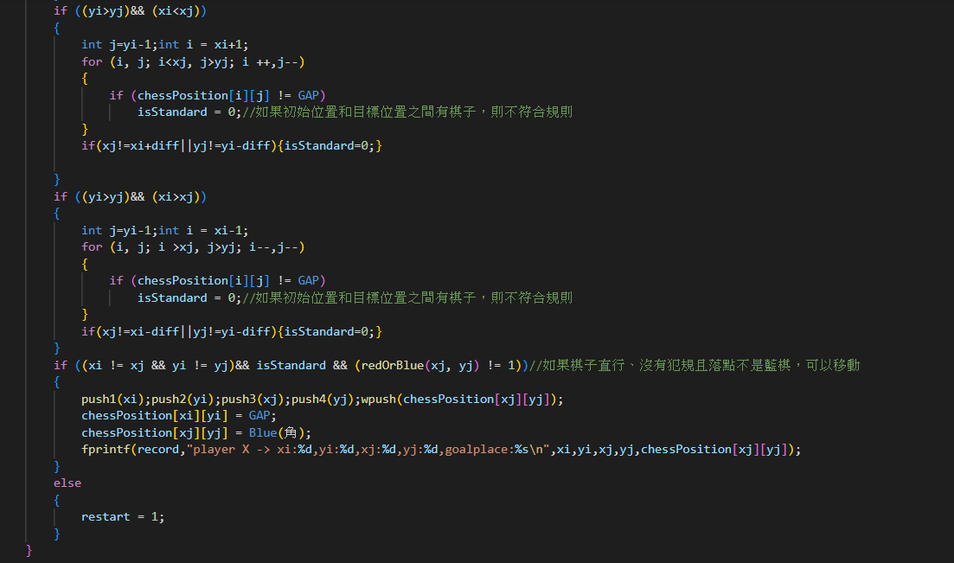

Figure 19: [角] 每次可到對角的任何1格(英文字母「X」方向)

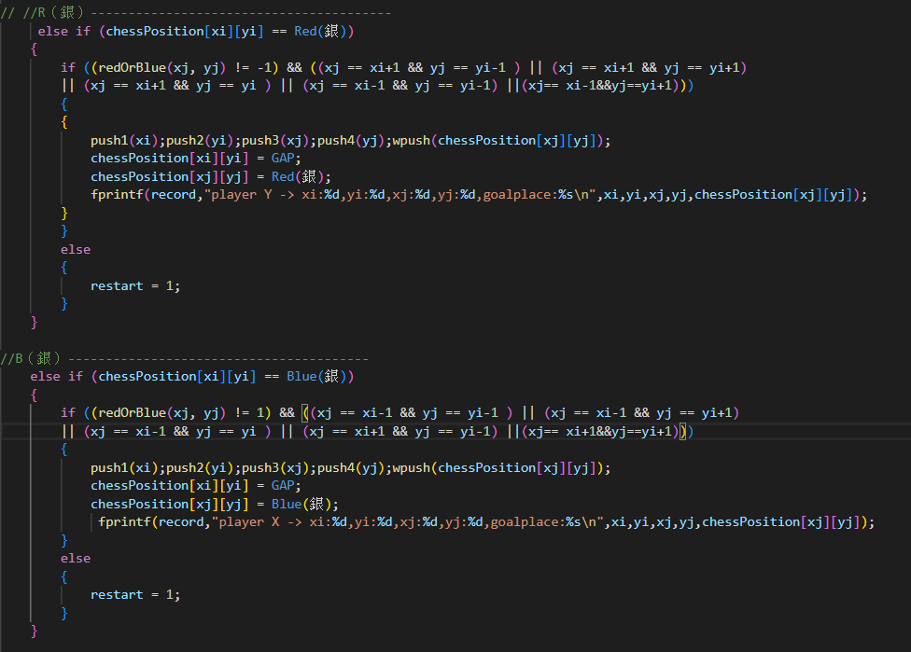

Figure 20: [銀] 每次走前面、右上、右下、左上、左下1格

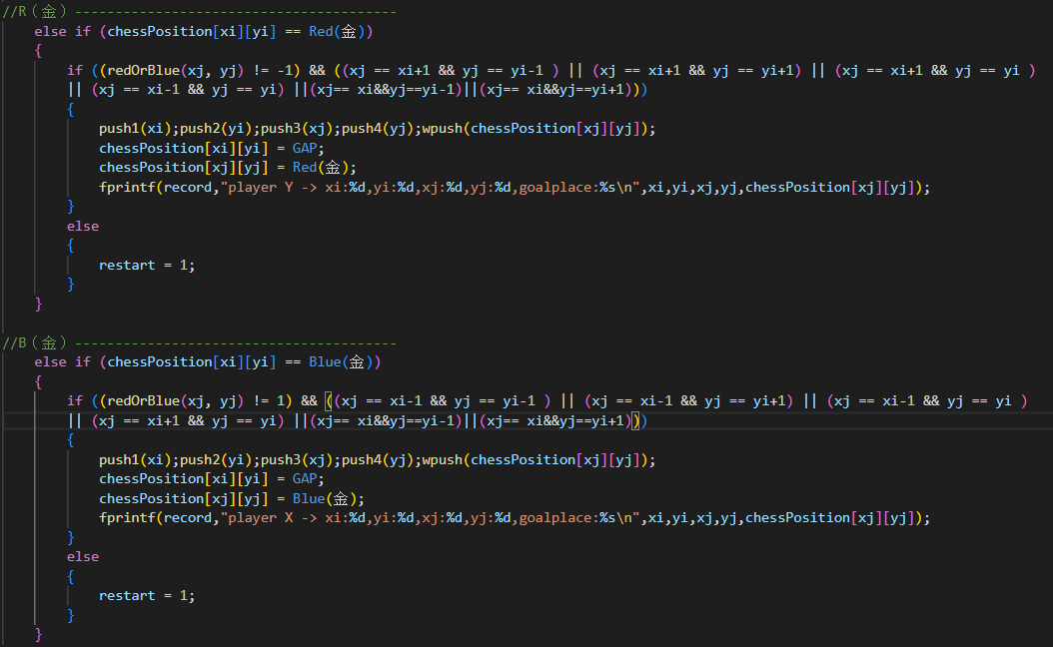

Figure 21: [金] 每次行前面、右上、右面、左上、左面、下面1格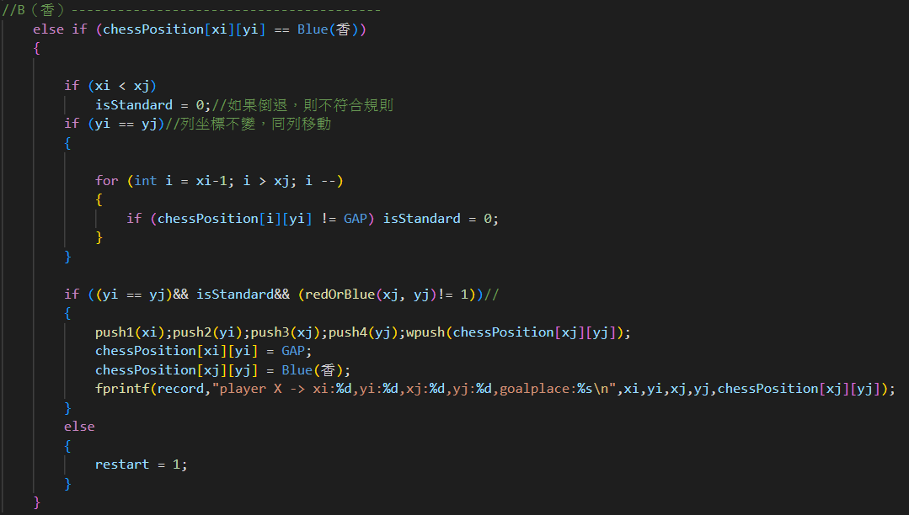

Figure 22: [香] 每次可向前行任1格，但不能後退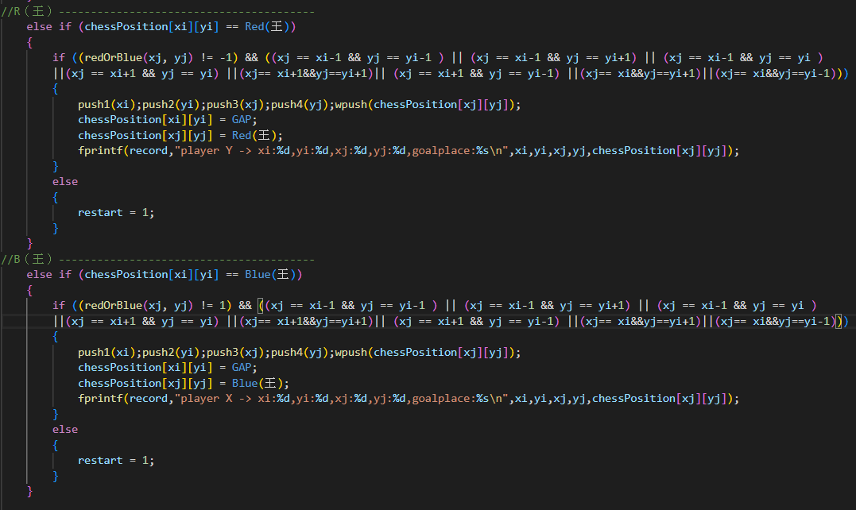

Figure 23: [王] 向前面、右上、右面、右下、左上、左面、左下、下面1格

**3.規則**

當使用者輸入1，可以決定下一步的位置，(先輸入[段(行)]的數值，再輸入[筋(列)]的數值) 確定要移動的棋子後，在決定放置的位置。如果輸入錯誤，會顯示違反遊戲規則，使用者需要再輸入一次。 若使用者輸入0，可進行悔棋。悔棋可連續執行，直到回到第一手。輸入s會儲存從頭到此的下棋資料到record.txt。若其中一方將對方的王被吃掉，遊戲即結束。

**4.參考資料**

(1) https://markdown.tw/

(2) <https://shogi.hk/Gameplay-of-Japanese-Chess-Shogi/>

(3) <https://lakesd6531.pixnet.net/blog/post/332858496-%5B%E8%B3%87%E6%96%99%E7%B5%90%E6%A7%8B%5D%E7%94%A8c%E8%AA%9E%E8%A8%80%E8%A3%BD%E4%BD%9C%E5%A0%86%E7%96%8A%28stack%29>

(4) <https://www.796t.com/content/1546926841.html>

(5) <https://www.delftstack.com/zh-tw/howto/c/read-file-c/>

**5. GITHUB連結**

<https://github.com/yayi1213/Cherry/tree/main/110503507_assignment_2>