Configuring VRF-lite

Cisco CCNP Lab 6

Mason and Hoffman – Period 6-8

Jeffrey Zhang

Purpose

The purpose of this lab is to configure virtual routers within real routers through the use of the VRF-lite protocol. We would use these routers to pass different networks within these routers without any cross-traffic between the networks.

Background

In topologies that require a massive amount of routing devices, or in money-strapped situations that limit the budget of available routers within a network, VRF protocol is the best solution to the current problem. VRF is a protocol that enables virtual routers to exist within physical routers. These virtual routers could be assigned to sub-interfaces within the 2 physical ports on the router. VRF-lite is a watered-down version of the default VRF package. It would use less resources to maintain and less computing power to process it throughout the topology.

Lab Summary

In this lab, we configured 2 layer-3 switches and 3 Cisco 2901 routers. Through the cisco routers, we virtualized 3 more cisco routers through the use of the VRF-lite protocol.

On the routers we enabled VRF-lite with the “ip vrf left” and “ip vrf right” commands, as well as stating which ports were to utilize the vrf protocol to route virtual traffic. In the two screenshots below, there are two physical ports being connected to 4 “routers”. The second one shows that traffic does not leak through to the other router within the router.

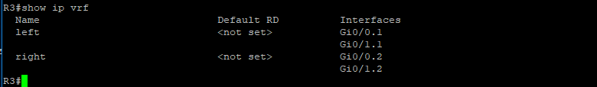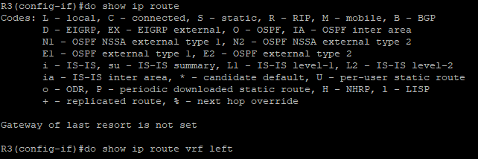

On the Layer-3 switches, we enabled trunking and set the two networks within their own separate VLANs, as well as enabling VRF-lite on the switches as well. The screenshots below demonstrate that traffic could not be detected locally within the two networks.

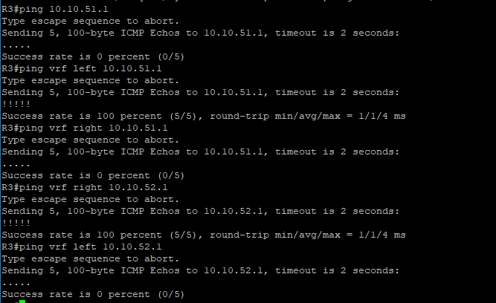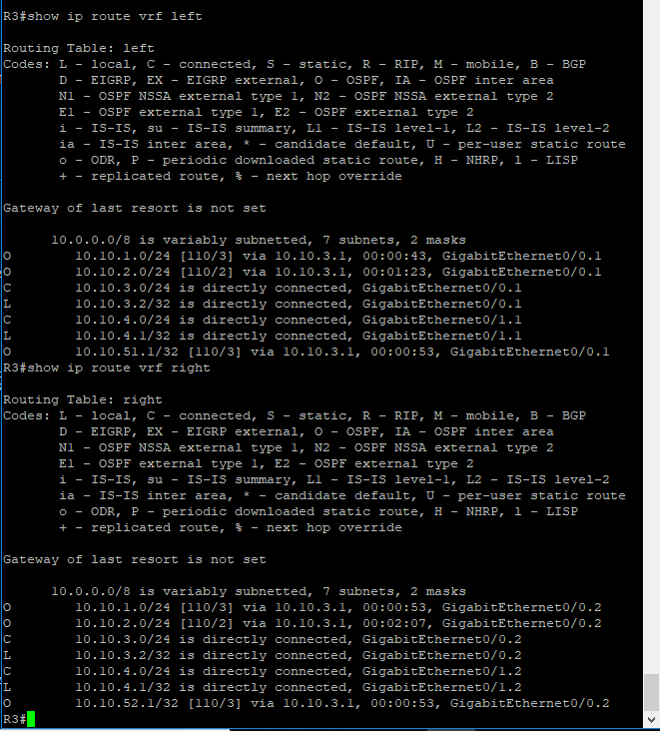

Configurations

Below are the router configurations for the 3 routers used within the topology.

hostname R1

boot-start-marker

boot-end-marker

no aaa new-model

memory-size iomem 10

ip cef

ip vrf left

ip vrf right

no ipv6 cef

multilink bundle-name authenticated

voice-card 0

license udi pid CISCO2901/K9 sn FTX1704Y038

license accept end user agreement

license boot module c2900 technology-package securityk9

license boot module c2900 technology-package uck9

vtp domain cisco

vtp mode transparent

redundancy

interface Loopback1

no ip address

interface Loopback2

description left

ip vrf forwarding left

ip address 10.10.51.1 255.255.255.0

interface Loopback3

description right

ip vrf forwarding right

ip address 10.10.52.1 255.255.255.0

interface Embedded-Service-Engine0/0

no ip address

shutdown

interface GigabitEthernet0/0

no ip address

duplex auto

speed auto

interface GigabitEthernet0/0.1

encapsulation dot1Q 2

ip vrf forwarding left

ip address 10.10.1.1 255.255.255.0

interface GigabitEthernet0/0.2

encapsulation dot1Q 3

ip vrf forwarding right

ip address 10.10.1.1 255.255.255.0

interface GigabitEthernet0/1

no ip address

duplex auto

speed auto

interface GigabitEthernet0/1.1

encapsulation dot1Q 2

ip vrf forwarding left

ip address 10.10.2.1 255.255.255.0

interface GigabitEthernet0/1.2

encapsulation dot1Q 3

ip vrf forwarding right

ip address 10.10.2.1 255.255.255.0

interface Serial0/0/0

no ip address

shutdown

clock rate 2000000

interface Serial0/0/1

no ip address

shutdown

clock rate 2000000

router ospf 2 vrf left

network 10.10.1.0 0.0.0.255 area 0

network 10.10.2.0 0.0.0.255 area 0

network 10.10.3.0 0.0.0.255 area 0

network 10.10.4.0 0.0.0.255 area 0

network 10.10.51.0 0.0.0.255 area 0

router ospf 3 vrf right

network 10.10.1.0 0.0.0.255 area 0

network 10.10.2.0 0.0.0.255 area 0

network 10.10.52.0 0.0.0.255 area 0

ip forward-protocol nd

no ip http server

no ip http secure-server

control-plane

mgcp profile default

gatekeeper

shutdown

line con 0

line aux 0

line 2

no activation-character

no exec

transport preferred none

transport output pad telnet rlogin lapb-ta mop udptn v120 ssh

stopbits 1

line vty 0 4

login

transport input all

scheduler allocate 20000 1000

end

Router 2:

hostname R2

boot-start-marker

boot-end-marker

no aaa new-model

memory-size iomem 5

ip vrf left

ip vrf right

ip cef

no ipv6 cef

multilink bundle-name authenticated

voice-card 0

license udi pid CISCO2901/K9 sn FTX15208075

license accept end user agreement

license boot module c2900 technology-package securityk9

license boot module c2900 technology-package uck9

vtp domain cisco

vtp mode transparent

redundancy

interface Embedded-Service-Engine0/0

no ip address

shutdown

interface GigabitEthernet0/0

no ip address

duplex auto

speed auto

interface GigabitEthernet0/0.1

encapsulation dot1Q 2

ip vrf forwarding left

ip address 10.10.2.2 255.255.255.0

interface GigabitEthernet0/0.2

encapsulation dot1Q 3

ip vrf forwarding right

ip address 10.10.2.2 255.255.255.0

interface GigabitEthernet0/1

no ip address

duplex auto

speed auto

interface GigabitEthernet0/1.1

encapsulation dot1Q 2

ip vrf forwarding left

ip address 10.10.3.1 255.255.255.0

interface GigabitEthernet0/1.2

encapsulation dot1Q 3

ip vrf forwarding right

ip address 10.10.3.1 255.255.255.0

interface Serial0/0/0

no ip address

shutdown

clock rate 2000000

interface Serial0/0/1

no ip address

shutdown

clock rate 2000000

interface GigabitEthernet0/1/0

no ip address

shutdown

duplex auto

speed auto

router ospf 2 vrf left

network 10.10.1.0 0.0.0.255 area 0

network 10.10.2.0 0.0.0.255 area 0

network 10.10.3.0 0.0.0.255 area 0

router ospf 3 vrf right

network 10.10.2.0 0.0.0.255 area 0

network 10.10.3.0 0.0.0.255 area 0

ip forward-protocol nd

no ip http server

no ip http secure-server

control-plane

mgcp profile default

gatekeeper

shutdown

line con 0

line aux 0

line 2

no activation-character

no exec

transport preferred none

transport input all

transport output lat pad telnet rlogin lapb-ta mop udptn v120 ssh

stopbits 1

line vty 0 4

login

transport input all

scheduler allocate 20000 1000

end

Router 3:

hostname R3

boot-start-marker

boot-end-marker

no aaa new-model

memory-size iomem 10

ip vrf left

ip vrf right

ip cef

no ipv6 cef

multilink bundle-name authenticated

voice-card 0

license udi pid CISCO2901/K9 sn FTX1520806V

license accept end user agreement

license boot module c2900 technology-package securityk9

license boot module c2900 technology-package uck9

vtp domain cisco

vtp mode transparent

redundancy

interface Embedded-Service-Engine0/0

no ip address

shutdown

interface GigabitEthernet0/0

no ip address

duplex auto

speed auto

interface GigabitEthernet0/0.1

encapsulation dot1Q 2

ip vrf forwarding left

ip address 10.10.3.2 255.255.255.0

interface GigabitEthernet0/0.2

encapsulation dot1Q 3

ip vrf forwarding right

ip address 10.10.3.2 255.255.255.0

interface GigabitEthernet0/1

no ip address

duplex auto

speed auto

interface GigabitEthernet0/1.1

encapsulation dot1Q 2

ip vrf forwarding left

ip address 10.10.4.1 255.255.255.0

interface GigabitEthernet0/1.2

encapsulation dot1Q 3

ip vrf forwarding right

ip address 10.10.4.1 255.255.255.0

interface Serial0/0/0

no ip address

shutdown

clock rate 2000000

interface Serial0/0/1

no ip address

shutdown

clock rate 2000000

interface GigabitEthernet0/1/0

no ip address

shutdown

duplex auto

speed auto

router ospf 2 vrf left

network 10.10.1.0 0.0.0.255 area 0

network 10.10.2.0 0.0.0.255 area 0

network 10.10.3.0 0.0.0.255 area 0

network 10.10.4.0 0.0.0.255 area 0

router ospf 3 vrf right

network 10.10.3.0 0.0.0.255 area 0

network 10.10.4.0 0.0.0.255 area 0

ip forward-protocol nd

no ip http server

no ip http secure-server

control-plane

mgcp profile default

gatekeeper

shutdown

line con 0

line aux 0

line 2

no activation-character

no exec

transport preferred none

transport input all

transport output lat pad telnet rlogin lapb-ta mop udptn v120 ssh

stopbits 1

line vty 0 4

login

transport input all

scheduler allocate 20000 1000

end

These are the configurations for the two Layer-3 switches:

Switch 1:

hostname S1

boot-start-marker

boot-end-marker

enable password cisco

no aaa new-model

system mtu routing 1500

ip vrf forwarding

ip vrf left

ip vrf right

vtp mode transparent

spanning-tree mode pvst

spanning-tree extend system-id

vlan internal allocation policy ascending

vlan 2

name forleft

vlan 3

name forright

interface Loopback1

description lo1 for right

ip address 10.10.1.2 255.255.255.0

interface FastEthernet1/0/1

switchport trunk encapsulation dot1q

switchport mode trunk

interface FastEthernet1/0/2

description left computer

switchport access vlan 2

switchport mode access

ip vrf forwarding left

interface FastEthernet1/0/3

description right computer

switchport access vlan 3

switchport mode access

ip vrf forwarding right

interface FastEthernet1/0/4

interface FastEthernet1/0/5

interface FastEthernet1/0/6

interface FastEthernet1/0/7

interface FastEthernet1/0/8

interface FastEthernet1/0/9

interface FastEthernet1/0/10

interface FastEthernet1/0/11

interface FastEthernet1/0/12

interface FastEthernet1/0/13

interface FastEthernet1/0/14

interface FastEthernet1/0/15

interface FastEthernet1/0/16

interface FastEthernet1/0/17

interface FastEthernet1/0/18

interface FastEthernet1/0/19

interface FastEthernet1/0/20

interface FastEthernet1/0/21

interface FastEthernet1/0/22

interface FastEthernet1/0/23

interface FastEthernet1/0/24

interface GigabitEthernet1/0/1

interface GigabitEthernet1/0/2

interface GigabitEthernet1/1/1

speed auto 1000

interface GigabitEthernet1/1/2

speed auto 1000

interface Vlan1

ip address 10.10.100.2 255.255.255.0

ip http server

ip http secure-server

logging esm config

line con 0

line vty 0 4

password cisco

login

line vty 5 14

password cisco

login

line vty 15

login

end

Switch 2:

hostname S2

boot-start-marker

boot-end-marker

no aaa new-model

system mtu routing 1500

ip routing

ip vrf forwarding

ip vrf left

ip vrf right

ipv6 unicast-routing

vtp domain CCNP

vtp mode transparent

crypto pki trustpoint TP-self-signed-2713494272

enrollment selfsigned

subject-name cn=IOS-Self-Signed-Certificate-2713494272

revocation-check none

rsakeypair TP-self-signed-2713494272

crypto pki certificate chain TP-self-signed-2713494272

certificate self-signed 01

3082023E 308201A7 A0030201 02020101 300D0609 2A864886 F70D0101 04050030

31312F30 2D060355 04031326 494F532D 53656C66 2D536967 6E65642D 43657274

69666963 6174652D 32373133 34393432 3732301E 170D3933 30333031 30303031

30315A17 0D323030 31303130 30303030 305A3031 312F302D 06035504 03132649

4F532D53 656C662D 5369676E 65642D43 65727469 66696361 74652D32 37313334

39343237 3230819F 300D0609 2A864886 F70D0101 01050003 818D0030 81890281

81009BE2 8164D5C1 CE8ADF3F 758136AF 07F2C129 80437482 16738A83 3C23CCD2

7D2EE757 5D9A0C19 3D86AF43 AE4BA7D9 81753266 B2EBB61F 0A58FEDD A58F54BD

1C302E46 D3CFA6B4 7E369A0C F1A135D8 2138DF1F 9BAEC6A1 2B3FB789 0AAD0ED6

0FF2B84D 2F504145 BDB4090A 11021DF5 230C37EC 5F559570 ED3C36DF 5AF1AE3A

A1810203 010001A3 66306430 0F060355 1D130101 FF040530 030101FF 30110603

551D1104 0A300882 06537769 74636830 1F060355 1D230418 30168014 C813BF6D

1DE44158 9BCBE0C0 B63EB6ED 96392FC6 301D0603 551D0E04 160414C8 13BF6D1D

E441589B CBE0C0B6 3EB6ED96 392FC630 0D06092A 864886F7 0D010104 05000381

81004922 4995B417 4AC4BF17 60A9A39A 3BD46687 D3F34386 829038A5 720D6B74

4061FF23 018D9930 4B99CC76 1E87FEA7 8AA66CD5 54737004 230E0D54 967C55A9

3F63BE05 F2AAECA2 C3B6E5C6 0230C953 E10CF307 A4344E07 142B9B2B E1AAA60D

32A74EAE 44AC853C 5D3BD24D AF1A31A6 F0509FBF 73481C17 F0BB11EA 9991F40A 3FCF

quit

spanning-tree mode pvst

spanning-tree extend system-id

vlan internal allocation policy ascending

vlan 2

name twoforleft

vlan 3

name threeforright

interface Loopback2

description lo2 for left

ip address 10.10.4.2 255.255.255.0

interface FastEthernet1/0/1

switchport trunk encapsulation dot1q

switchport mode trunk

interface FastEthernet1/0/2

description left computer

switchport access vlan 2

switchport mode access

ip vrf forwarding left

interface FastEthernet1/0/3

description right computer

switchport access vlan 3

switchport mode access

ip vrf forwarding right

interface FastEthernet1/0/4

interface FastEthernet1/0/5

interface FastEthernet1/0/6

interface FastEthernet1/0/7

interface FastEthernet1/0/8

interface FastEthernet1/0/9

interface FastEthernet1/0/10

interface FastEthernet1/0/11

interface FastEthernet1/0/12

interface FastEthernet1/0/13

interface FastEthernet1/0/14

interface FastEthernet1/0/15

interface FastEthernet1/0/16

interface FastEthernet1/0/17

interface FastEthernet1/0/18

interface FastEthernet1/0/19

interface FastEthernet1/0/20

interface FastEthernet1/0/21

interface FastEthernet1/0/22

interface FastEthernet1/0/23

interface FastEthernet1/0/24

interface GigabitEthernet1/0/1

interface GigabitEthernet1/0/2

interface GigabitEthernet1/1/1

speed auto 1000

interface GigabitEthernet1/1/2

speed auto 1000

interface Vlan1

ip address 10.10.101.1 255.255.255.0

shutdown

ip http server

ip http secure-server

logging esm config

line con 0

line vty 0

password cisco

login

line vty 1 4

login

line vty 5 15

login

end

Problems

We first encountered issues when we began to configure our sub-interfaces and traffic would still leak through to the physical router. We fixed the issue through researching the issue online and finding a fix. We also had issues converting a switchport mode to “trunk” from “access” on a layer 3 switch. We alleviated this issue by issuing the command “switchport trunk encapsulation dot1q”.

Conclusion

This lab aims to teach us how to configure VRF-lite protocol onto existing physical routers to route traffic under virtual router(s). This protocol could be useful within a tight-budget topology, or space-critical areas.