

Al-Zaytoonah University of Jordan
Faculty of Science and Information Technology
Department of Artificial Intelligence

Smart System For Monitoring Diabetes
A PROJECT REPORT

Supervised by
Dr. Shadi Alzu’bi

Submitted by
Yazan Waleed Sirriyeh

A graduation project submitted in partial fulfillment of the requirements for the degree of BSC in Artificial Intelligence.

(Jan 2023)

CERTIFICATE

Certified that this project report “Smart System For Monitoring Diabetes
” is the work of “Yazan Waleed Sirriyeh” who carried out the project work under all of the parts.

Dr. Shadi Alzu’bi

ACKNOWLEDGEMENT

I would like to acknowledge the IT faculty academic crew at Al-Zaytoonah Private University of Jordan especially the Software Engineering department for supporting me in developing this graduation project. I would also like to acknowledge for Dr. Shadi Alzu’bi for his role as the team supervisor of this project, and for his outstanding efforts on supporting me since day one.

Yazan Sirriyeh

ABSTRACT

Diabetes is a chronic condition that requires ongoing management to prevent complications such as heart disease, nerve damage, and kidney damage. A smart monitoring app can assist individuals with diabetes in managing their condition on a daily basis.

Traditional methods of diabetes management, such as self-monitoring blood sugar levels with a glucose meter, can be inconvenient and time-consuming. My solution is A smart monitoring app can streamline these tasks and provide real-time alerts if blood sugar levels are outside of the target range.

The app can provide personalized recommendations for diet, exercise, and medication based on the user's unique needs and goals, helping to optimize their treatment plan.

The app can connect users to a network of healthcare professionals and support groups, providing access to additional resources and support for managing their diabetes.

Overall, a Smart Application for Monitoring Diabetes can help individuals with diabetes better manage their condition, improve their blood sugar control, and reduce their risk of complications.

.

My Smart Application for Monitoring Diabetes is a web app designed to help individuals with diabetes manage their condition. The app provides real-time monitoring of blood sugar levels e and offers personalized recommendations for diet, exercise, and medication based on the user's unique needs. It also includes a range of features to assist with self-management, such as medication reminders and the ability to track progress over time. The app also connects users to a network of healthcare professionals and support groups, providing a comprehensive and convenient solution for diabetes management.

TABLE OF CONTENTS

 | CERTIFICATE | II
 | ACKNOWLEDGEMENT | III
 | ABSTRACT | IV
 | TABLE OF CONTENTS | V
 | LIST OF TABLES | VII
 | LIST OF FIGURES | VIII
 | LIST OF SYMBOLS AND ABBREVIATIONS | IX
1. | INTRODUCTION | 1
1.1 | Background | 1
1.2 | Overview | 1
1.3 | Model Description | 3
1.3.1 | What are neural networks?  What It Is the difference Between KNN and Neural networks? | 3
2. | LITERATURE REVIEW | 5
2.1 | Necessary research for the projects | 5
2.1.1 | Projects with the same goal | 5
2.1.2 | Datasets | 5
2.1.3 | Neural Network | 5
2.1.4 | Pycharm Software | 6
2.2 | Problem that can be solved | 8
3. | METHODOLOGY | 9
3.1 | Project Planning | 9
3.2 | Data Collection | 11
3.3 | Design & Training | 12
3.3.1 | Neural Network | 12
3.3.2 | Libraries | 13
 |  | 13
3.3.3 | Hidden Layers | 14
 |  | 17
3.3.4 | Model Fitting | 17
3.3.5 | Comment Classification | 17
3.3.6 | Evaluation | 18
3.4 | Development & Maintenance | 19
3.4.1 | Algorithm | 19
4. | EXPERIMENTATION | 20
4.1 | Python files: | 20
4.1.1 | Train_Model | 20
 |  | 24
4.2 | The output | 25
5. | RESULT AND DISCUSSION | 26
5.1 | what to expect | 26
5.2 | Answering Questions | 27
6. | CONCLUSION | 28
7. | FUTURE SCOPE | 29
7.1 | what we achieved | 29
7.2 | What Is the Future Work | 29
 | REFERENCES | 30

LIST OF TABLES

Table No. | Title | Page No.
Table 1.1 | Neural Networks Comparison | 4
Table 3.2 | Python Libraries | 13

LIST OF FIGURES

Figure No. | Title | Page No.
Figure 1.1 | Project Background | 2
Figure 1.2 | Problem Statement | 2
Figure 1.3 | Project Aim and Objectives | 4
Figure 3.1 | Percentage of each class in our dataset | 11
Figure 3.2 | ReLU activation functions | 15
Figure 3.3 | Sigmoid activation function | 16
Figure 3.4 | tanh activation function | 16
Figure 3.5 | Real-Time detection | 17
Figure 3.6 | Model Evaluation | 18
Figure 4.1 | Output Screen | 25
Figure 5.1 | prediction | 26

LIST OF SYMBOLS AND ABBREVIATIONS

Abbreviation | Explanation
AI  ANN  CNN  RNN  TP  TN  FP  FN | Artificial Intelligence  Artificial Neural Network  Convolutional Neural Network  Recurrent Neural Network  True Positive  True Negative  False Positive  False Negative

- INTRODUCTION

Diabetes Type `Detection

  - Background:
Diabetes is a chronic disease that affects millions of people worldwide. It occurs when the body is unable to properly regulate blood glucose levels, which can lead to a range of serious health complications if left untreated. Therefore, it is important for people with diabetes to regularly monitor their blood glucose levels and take steps to manage their condition.

A smart system for monitoring diabetes can help patients better understand and manage their condition by providing them with personalized recommendations and alerts. Such a system can also help patients identify patterns in their blood glucose levels that may be related to their diet, activity level, or medication, and make adjustments to better manage their diabetes.

In addition, a smart diabetes monitoring system can potentially reduce the burden on healthcare providers by automating routine tasks such as monitoring blood glucose levels and providing recommendations to patients. This can allow healthcare providers to focus on more complex tasks and provide better care to their patients.

Overall, a smart system for monitoring diabetes can be a valuable tool for helping patients better understand and manage their condition, and can potentially improve their quality of life.

  - Overview:

We created a model that detects the type of diabetes by using machine learning to help monitor diabetes! The K-nearest neighbors (KNN) algorithm is a simple and effective method for classification and regression tasks. In a diabetes monitoring system, KNN could potentially be used to predict an individual's blood glucose level based on their past readings and other relevant features (e.g. diet, activity level, medication).

Input Information

Processing

Classify

Type1
Type2

Figure 1.1 : our diabetes type monitoring detection system.

Table 1.1 : Neural Networks Comparison.Figure 1.1 : our facemask detection system.

  - Model Description:

We used what we learned in university while studying KNN algorithim, and some of online courses to create our system, to classify the Types.

    - What It Is KNN Algorithm?
The K-nearest neighbors (KNN) algorithm is a simple and effective method for classification and regression. It works by identifying the K "nearest" data points to a given query point and using the class labels (for classification) or the target values (for regression) of these points to make a prediction.

To use KNN, you must first choose the value of K, which is the number of nearest neighbors to consider. A larger value of K will make the model more robust to outliers, but may also make it slower to compute and less sensitive to subtle patterns in the data.

In order to measure the similarity between data points, KNN uses a distance metric. The most common choice is Euclidean distance, which is the straight-line distance between two points in Euclidean space. However, other distance metrics can also be used, such as Manhattan distance (the sum of the absolute differences of the coordinates) or cosine similarity (a measure of the angle between two vectors).

Once the value of K and the distance metric have been chosen, KNN can be used to make predictions as follows:

- For a given query point, the distance between the query point and all other points in the dataset is calculated using the chosen distance metric.
- The K points in the dataset that are closest to the query point are identified as the "nearest neighbors."
- For a classification task, the class label of the majority of the K nearest neighbors is predicted as the class label of the query point. For a regression task, the average of the target values of the K nearest neighbors is predicted as the target value of the query point.

    - What It Is Neural networks?
Neural networks are a type of machine learning algorithm modeled after the structure and function of the human brain. They are composed of layers of interconnected "neurons," which process and transmit information. Neural networks are trained using large datasets and are able to learn and adapt to new information over time. They are particularly useful for tasks that require the ability to learn and recognize patterns in data, such as image and speech recognition.

There are several types of neural networks, including feedforward neural networks, convolutional neural networks (CNNs), recurrent neural networks (RNNs), and self-organizing maps (SOMs). Each type of neural network is suited to different types of tasks and data.

Feedforward neural networks are the most basic type of neural network, and are composed of an input layer, one or more hidden layers, and an output layer. They are used for tasks such as classification and regression, and are trained by adjusting the weights of the connections between the neurons in the network.

CNNs are a type of neural network that are designed to process and analyze data that has a grid-like structure, such as an image. They are able to "scan" the data using a set of learnable filters and extract relevant features, which are then processed and passed through the network to make a prediction. This makes CNNs particularly useful for tasks such as image classification and object detection.

RNNs are a type of neural network that are designed to process sequential data, such as time series or natural language. They are able to "remember" information from previous time steps or input words and use this information to inform their predictions. This makes RNNs particularly useful for tasks such as language translation and speech recognition, where the context of previous words is important.

SOMs are a type of neural network that are used for unsupervised learning tasks, such as clustering. They are composed of a grid of neurons that are trained to represent the input data in a lower-dimensional space.

The table below (1.1) shows The types of Neural Network.

ANN | CNN | RNN
Tabular Data, Text Data | Image Data. | Sequence data
Having fault tolerance, Ability to work with incomplete knowledge. | High accuracy in image recognition problems, Weight sharing. | Remembers each and every information, Time series prediction.
Hardware dependence, Unexplained behavior of the network. | Large training data needed, don’t encode the position and orientation of object. | Gradient vanishing, exploding gradient.

Table 1.1 : Neural Networks Comparison.

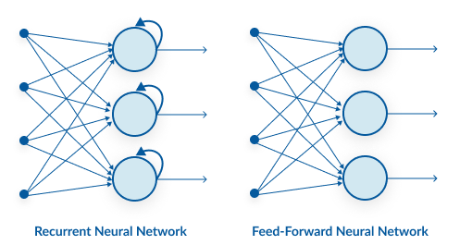
Figure 1.3: Recurrent neural network RNN

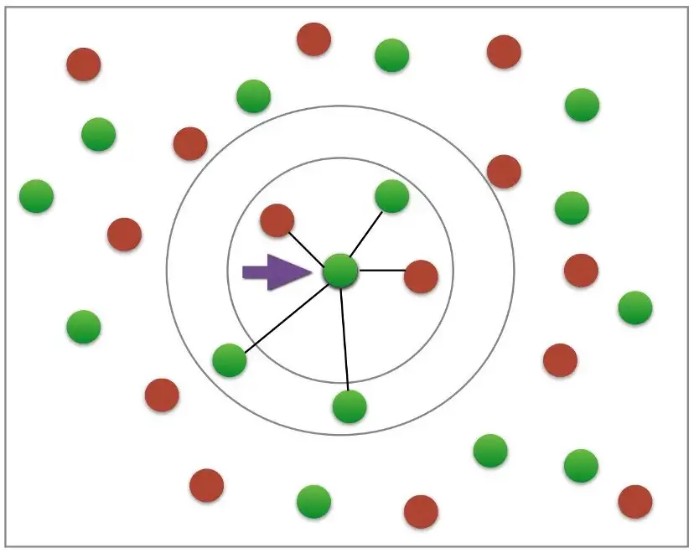

Figure 1.4: KNN simple Model

    - What It Is the difference Between KNN and Neural networks?
Neural networks and the K-nearest neighbors (KNN) algorithm are two different types of machine learning algorithms that can be used for a variety of tasks, including classification and regression.

Neural networks are a type of machine learning algorithm modeled after the structure and function of the human brain. They are composed of layers of interconnected "neurons," which process and transmit information. Neural networks are trained using large datasets and are able to learn and adapt to new information over time. They are particularly useful for tasks that require the ability to learn and recognize patterns in data, such as image and speech recognition.

KNN, on the other hand, is a non-parametric method used for classification and regression. It works by identifying the K "nearest" data points to a given query point and using the class labels (for classification) or the target values (for regression) of these points to make a prediction. KNN is a simple and effective method that can be used for a variety of tasks, but it can be computationally expensive and may not always perform as well as other methods on more complex tasks.

    - Why Use KNN in our system instead of Neural Network?

There are a few reasons why K-nearest neighbors (KNN) might be preferred over a neural network for a diabetes type detection system:

- Simplicity: KNN is a simple and effective method that does not require training, whereas neural networks are more complex and require a training phase. This can make KNN easier to implement and faster to run.

- Efficiency: KNN can be more computationally efficient than a neural network, especially for simple tasks. This can be important if the system is expected to handle a large volume of queries.

- Data requirements: KNN may be more suitable for tasks with a small or medium-sized dataset, since it does not require a large amount of data to make accurate predictions. Neural networks, on the other hand, typically require a larger dataset to achieve good performance.

- Explainability: KNN is a transparent method that is easy to understand and explain, since it simply uses the class labels or target values of the nearest data points to make a prediction. This can be important for medical applications, where it is important to be able to understand and justify the predictions made by the system.

- LITERATURE REVIEW
2.1 Necessary research for the projects:

we searched for a few things before starting the project.

2.1.1 Projects with the same goal:

After reviewing many websites and seeing other projects and organizations, we noticed that they do not have a program to classify the types of diabetes, all of them are helping patients better understand and manage their condition by providing them with personalized recommendations and alerts, in addition to the accuracy of these projects is not high because the existing projects are educational and not commercial.

2.1.2 Datasets:

In every project we need datasets to train the model to perform better firstly, Yazan searched for datasets to train the model on many websites, by visiting hospitals and asking many specialist doctors, and asking nursing sector in university for their experiences with diabetic types , patients with the type 1 diabetic and type 2 diabetic, nurses, we used a dataset that has 16.969 cases, and Yazan split the data for training, and testing, then he puts 70% for training, 30 for testing.

2.1.KNN:

In this stage, we researched if KNN and deep learning can achieve what we want to do, and after researching and seeing other projects, many projects use K-nearest neighbors (KNN) for predictions because it is a simple and effective method for making predictions based on a similarity measure between samples. It can be used for classification or regression tasks.

One reason that KNN is popular for prediction is that it is simple to understand and easy to implement. It also tends to perform well with a small number of features and can work well with data that is not linearly separable.

Additionally, KNN can be used to make predictions for new samples without requiring the model to be retrained, which makes it a good choice for our system.

Overall, KNN can be a good choice for prediction tasks because it is fast, easy to use, and often performs well with a small amount of data.
2.1.4 PyCharm Software:

We need software to program our project and we chose the PyCharm program because:
- PyCharm provides smart code completion, code inspections, on-the-fly error highlighting, and quick fixes, along with automated code refactoring and rich navigation capabilities.
- Refactor your code the intelligent way, with safe Rename and Delete, Extract Method, Introduce Variable, Inline Variable or Method, and another refactoring. Language and framework-specific refactoring help you perform project-wide changes.
- Easy to use for beginners [7].

After researching, we found that it is important to use an algorithm to create our model,
scikit-learn (short for "Scientific Kit for Machine Learning") is an open-source Python library that provides a range of tools and algorithms for tasks such as classification, regression, clustering, and dimensionality reduction. It is built on top of NumPy and SciPy, two libraries for scientific computing in Python, and is designed to be easy to use and integrate with other libraries and applications.

We used train_test_split function , that we imported from scikit-learn library.
train_test_split is a function in sklearn.model_selection module of the sci-kit-learn library in Python. It is used to split a dataset into a training set and a test set.

The training set is used to fit the parameters (i.e., weights or coefficients) of the model, while the test set is used to evaluate the performance of the model. By evaluating the model on a separate test set, it is possible to get a more realistic estimate of the model's performance on unseen data.

The train_test_split function takes in a dataset and the target labels, and returns a tuple containing the training set, the test set, and the training and test labels. The function also takes in several optional parameters, such as the test size (i.e., the proportion of the dataset to include in the test set), the random seed, and the stratification strategy.

Overall, train_test_split is a useful function for evaluating the performance of machine learning models and ensuring that they are able to generalize to new data.

2.2 Problem that can be solved:
Diabetes is a chronic disease or group of metabolic disease where a person suffers from an extended level of blood glucose in the body, which is either the insulin production is inadequate, or because the body’s cells do not respond properly to insulin. Nowadays, this disease is leading to long-term complications and serious health problems. A report from the World Health Organisation [10] addresses diabetes and its complications that impact on individual physically, financially, economically over the families. The survey says about 1.2 million deaths due to the uncontrolled stage of health lead to death. About 2.2 million deaths occurred due to the risk factors of diabetes like a cardiovascular and other diseases. The Pima Indian diabetic database at the UCI machine learning research facility has turned into a standard for testing information mining calculations to see their expectation exactness in diabetes information arrangement . The proposed KNN machine learning based model presented in this paper utilizes a real diabetic dataset collected by us directly from the medical hospitals

- METHODOLOGY

We use a special methodology to design our solution:
- Use case assessment.
- Problem and use case prioritization.
- Starting a feasibility study.
- Solution selection.
- Project development.
- Analysis of the results.
We’ll discuss each phase thoroughly.
3.1 Project Planning:

Use case assessment:
There are several potential use cases our system:

- Early detection: The system could help identify individuals who are at risk of developing diabetes or who may have undiagnosed diabetes. This could allow for early intervention and treatment, potentially improving the long-term prognosis for these individuals.

- Personalized treatment: The system could help identify the type of diabetes an individual has, which could inform the choice of treatment. For example, individuals with type 1 diabetes may require insulin injections, while those with type 2 diabetes may be able to manage their condition with lifestyle changes and medication.

- Tracking and analysis: The system could allow individuals to track and analyze their blood glucose levels over time, potentially identifying patterns or trends that may be related to their diet, activity level, or medication. This could help individuals better understand and manage their condition.

- Remote monitoring: The system could allow healthcare providers to remotely monitor the blood glucose levels of their patients, potentially reducing the need for in-person visits.

Overall, our system for monitoring and detecting diabetes type could provide a range of benefits to individuals with diabetes, including early detection, personalized treatment, tracking and analysis, and remote monitoring. It could also help healthcare providers better understand and manage the condition of their patients.

Starting a feasibility study:
To solve our problem we have to follow a set of important steps:
- Analysis of scientific literature and inspection of sites, through our search for research or books that talked about this topic or websites or scientific journals because they are documented places for scientific research.
- Solution evaluation: To see if the selected solutions are actually applicable or not.
- Cost Estimation: To solve the problem we have to choose the stakeholders who may help us and the materials that are likely to be used to facilitate the work.
- Time and resource planning: Choosing people who can help.
- Build a detailed and clear report of all steps of the work.

Solution Selection:
In this step we choose the best solution and apply it to reality, we choose the algorithm, knn, and libraries after searching and discussing our doctors.

Project Development:
Spreading intellectual awareness about diabetes in societies started on schools, colleges and then the surrounding community, also it is necessary to spread awareness of how to deal with this disease and get support from responsible health institutions.

Analysis of the results:
In order to measure the success of an AI project, it’s essential to identify what success looks like for our project. Which metrics should we consider while working on an artificial intelligence project?
The metrics always depend on our goals, The best thing we can do, as we often say, is to ask ourselves the right questions. There is nothing better than having the right questions in mind to start finding the answers to improve our project. Otherwise, we will have no map to guide you.

3.2 Data Collection:

We used a dataset As we mentioned in the begin that has 16.969 diabetic types as follows:
- 8568 type 2.
- 8401 type 1.

- DataSet Description:
- ==== About Age Attribute ====
- Type 1 ==> According to the American Diabetes Association (ADA), type 1 diabetes accounts for about 5% of all cases of diabetes. It is more common in children and young adults, although it can occur at any age. In the United States, the incidence of type 1 diabetes is highest among children between the ages of 5 and 9, although it can occur in children of any age. The onset of type 1 diabetes is usually sudden and the symptoms can be severe, so it is important to seek medical attention as soon as possible if you suspect that you or someone you know may have this condition.

- Type 2 ==> it is most commonly diagnosed in adults, especially those who are overweight or obese. It is also more common in people who have a family history of the disease. And It is more common in people over the age of 40, although it is now being increasingly diagnosed in children and adolescents as well.

- ==== About Taking Insulin Attribute ====
- Type 1 ==> This type of diabetes requires daily insulin injections to manage blood sugar levels, as the body is unable to produce enough insulin on its own.
- Type 2 ==> Some people with type 2 diabetes may be able to manage their blood sugar levels with lifestyle changes such as diet and exercise, although others may need to take medications or insulin to help control their blood sugar levels.

- ==== About Polycystic_ovary_syndrome Attribute ====
- Type 2 ==> study found that women with type 2 diabetes had a higher prevalence of PCOS compared to women without diabetes.
- ==== About Obesity Attribute ====
- Type 2 ==> Obesity is a common risk factor for type 2 diabetes. In fact, obesity is thought to be the leading cause of type 2 diabetes.
- ==== About Smoking Attribute ====
- Type 2 ==> Smoking is a risk factor for a number of serious health problems, including heart disease, stroke, and lung cancer. It is also a risk factor for type 2 diabetes. Several studies have shown that smokers are more likely to develop type 2 diabetes than non-smokers.
- ==== About Smoking Attribute ====
- Type 1 ==> In people with type 1 diabetes, shortness of breath can be caused by high blood sugar levels, which can lead to fluid build-up in the lungs. High blood sugar levels can also weaken the immune system, making it more difficult for the body to fight off infections, including respiratory infections.
- Type 2 ==> In people with type 2 diabetes, shortness of breath can also be caused by high blood sugar levels, as well as other factors such as heart disease, nerve damage (neuropathy), and kidney damage. Type 2 diabetes is a risk factor for these conditions, which can all contribute to shortness of breath.
- ==== About Acanthosis Nigricans Attribute ====
- * Acanthosis nigricans is a skin condition characterized by dark, thickened, and velvety patches of skin, usually in folds or creases such as the armpits, neck, and groin. It is often a sign of insulin resistance, which is a condition in which the body's cells do not respond properly to insulin.
- Type 1 ==> Both type 1 and type 2 diabetes can be associated with insulin resistance, and therefore both types can be associated with acanthosis nigricans. However, acanthosis nigricans is more commonly seen in people with type 2 diabetes, especially those who are obese.
- == About confusion & difficulty focusing Attribute ==
- Type 1 ==> Confusion and difficulty focusing can be symptoms of both type 1 and type 2 diabetes, although they are more commonly seen in people with type 1 diabetes. These symptoms can be caused by high or low blood sugar levels, which can affect the brain's ability to function properly.
- ==== About Coma Attribute ====
- Coma is a state of deep unconsciousness in which a person is unable to respond to their environment or any stimuli. Coma can be caused by a variety of medical conditions, including diabetes.
- Type 1 ==> it is more commonly seen in people with type 1 diabetes. Coma can be caused by high or low blood sugar levels.

- ==== About Mumps virus Attribute ====
- Mumps is a viral infection that is caused by the mumps virus. It is primarily spread through respiratory secretions, such as saliva, and can cause symptoms such as fever, headache, and swollen glands. Mumps typically affects children and young adults, but it can occur at any age.
- Type 1 ==> In people with type 1 diabetes, shortness of breath can be caused by high blood sugar levels, which can lead to fluid build-up in the lungs. High blood sugar levels can also weaken the immune system, making it more difficult for the body to fight off infections, including respiratory infections.
- Type 2 ==> In people with type 2 diabetes, shortness of breath can also be caused by high blood sugar levels, as well as other factors such as heart disease, nerve damage (neuropathy), and kidney damage. Type 2 diabetes is a risk factor for these conditions, which can all contribute to shortness of breath.

3.3 Design & Training:
We design and train our model upon a specific process, and this is the model:

3.3.1 KNN Algorithm:
In this phase, we started to think more in-depth, because we were trying to find the best way to design our model.

In the beginning, we started to search for the best machine learning model to serve our project, in which we found that we either had to use ANN or KNN, after research we used KNN for many reasons, short:
  - Simplicity: KNN is a simple and easy-to-implement algorithm that does not require any training.

  - Flexibility: KNN can be used for both classification and regression tasks, and can easily handle multi-class problems.

  - Ease of interpretation: KNN is a transparent method that is easy to understand and explain, since it simply uses the class labels or target values of the nearest data points to make a prediction.

  - No assumptions about the data: KNN makes no assumptions about the underlying distribution of the data, which makes it a robust method for a variety of datasets.

  - Good performance on small datasets: KNN can perform well on small or medium-sized datasets, as it does not require a large amount of data to make accurate predictions.

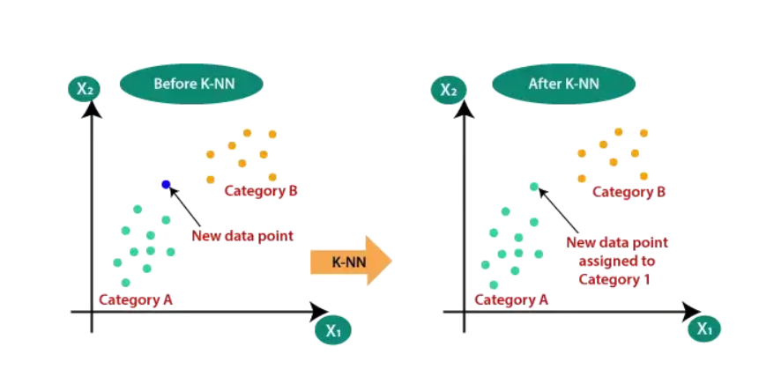

After deciding what machine learning model, we were going to use, we had to think about how we were going to program the model. The best programming language for our project is python. It has many libraries that are helpful to our projects.

3.3.2 Libraries :
We used many libraries in our project but the important ones that we used to create the model were: sklearn.model_selection importing train_test_split function. These are the libraries that helped us in creating the KNN that we used to classify our model .
- sklearn.model_selection:

There are several advantages to using the sklearn.model_selection module for creating a K-nearest neighbors (KNN) model to predict diabetes types:

- Simplicity: The sklearn.model_selection module provides a simple and easy-to-use interface for creating and evaluating KNN models.

- Model selection: The sklearn.model_selection module includes functions for splitting data into train and test sets and cross-validating models, which can be useful for selecting the best KNN model based on performance.

- Model evaluation: The sklearn.model_selection module includes functions for evaluating the performance of KNN models, such as metrics for classification tasks.

- Compatibility with other scikit-learn functions: The sklearn.model_selection module is part of the scikit-learn library, which means that it is compatible with other scikit-learn functions and can be used in combination with them.

Overall, the sklearn.model_selection module is a useful tool for creating and evaluating KNN models for predicting diabetes types, as it provides a range of functions that can simplify the process and improve the performance of the model.

- Matplotlib:

Matplotlib is a 2D data visualization library in Python. pyplot, a sublibrary of Matplotlib, provides a set of functions for creating a variety of charts and plots. It is designed to be easy to use and is commonly used to visualize data in scientific and mathematical research.

Some of the key features of pyplot include:

A wide range of chart types: pyplot provides functions for creating a variety of chart types, including line plots, bar plots, scatter plots, and histograms.

Customization options: pyplot allows users to customize the appearance of the charts they create, including the colors, line styles, and axis labels.

Plotting from data arrays: pyplot can plot data from NumPy arrays or pandas dataframes, making it easy to visualize large datasets.

Plotting from data files: pyplot can also plot data from file, including CSV files and Excel files.

Interactive plots: pyplot supports interactive plotting, allowing users to zoom in, pan, and hover over data points to display additional information.

Overall, pyplot is a powerful and widely-used library for creating charts and plots in Python, and is well-suited for a wide range of applications.

- Flask:

Flask is a micro web framework written in Python. It is classified as a microframework because it does not require particular tools or libraries. It has no database abstraction layer, form validation, or any other components where pre-existing third-party libraries provide common functions.

It is designed to be lightweight and easy to use, and is well-suited for building small web applications and prototypes.

Some of the key features of Flask include:

- A simple and flexible design: Flask is designed to be easy to use and flexible, allowing users to quickly build small web applications.

- Built-in development server: Flask includes a built-in development server for testing and debugging applications, making it easy to get started.

- Support for templates: Flask includes support for Jinja2 templates, which allows users to define the structure of their web pages and easily insert dynamic content.

- Extension support: Flask can be extended with a wide range of plugins and extensions, allowing users to add additional functionality to their applications.

- RESTful APIs: Flask can be used to build RESTful APIs, which allow applications to communicate with each other over the web.

Flask is easy to get started with and provides a useful set of features for building web applications. Some of the key features of Flask are:

- It provides a small and easy-to-extend core.
- It has no dependencies on particular tools or libraries.
- It is WSGI 1.0 compliant.
- It provides useful debugging tools.
Flask is also very flexible and can be extended with any number of third-party libraries to add additional functionality. Some popular Flask extensions include:

- Flask-SQLAlchemy: adds support for SQLAlchemy to Flask.
- Flask-WTForms: adds support for WTForms to Flask.
- Flask-Login: adds user session management to Flask.
- Overall, Flask is a lightweight and easy-to-use web framework that is well-suited for building small web applications.

3.3.3 Hidden Layers:
K-nearest neighbors (KNN) is a simple and straightforward machine learning algorithm that does not use hidden layers. Instead, it relies on a simple distance-based approach to make predictions.

In KNN, the prediction for a given data point is based on the class labels or target values of the "K" nearest data points in the training set. The value of K is typically chosen by the user and determines the number of nearest neighbors that will be used to make the prediction.

Because KNN does not use hidden layers, it is not considered a deep learning algorithm. Deep learning algorithms, such as artificial neural networks, use multiple hidden layers to learn complex patterns in data, whereas KNN is a shallower method that relies on simple distance-based comparisons.

Overall, the lack of hidden layers is one of the main characteristics that distinguishes KNN from other machine learning algorithms, such as artificial neural networks.

Here is the steps we took using the K-nearest neighbors (KNN) algorithm to make diabetes type predictions:

- Collecting a dataset of individuals with diabetes, including their demographic information (age, gender, etc.), medical history, and diabetes type (type 1 or type 2).

- Split the dataset into a training set and a test set. The training set will be used to fit the KNN model, while the test set will be used to evaluate the model's performance.

- Choosing a value for K, which determines the number of nearest neighbors that will be used to make the prediction.

- For each data point in the test set, calculate the distance to the K nearest neighbors in the training set using a distance metric such as Euclidean distance.

- Predict the diabetes type for each data point in the test set based on the majority class label of the K nearest neighbors. For example, if the majority of the K nearest neighbors have type 2 diabetes, the model would predict that the data point has type 2 diabetes.

- Evaluate the model's performance by comparing the predicted diabetes types to the true labels of the data points in the test set.

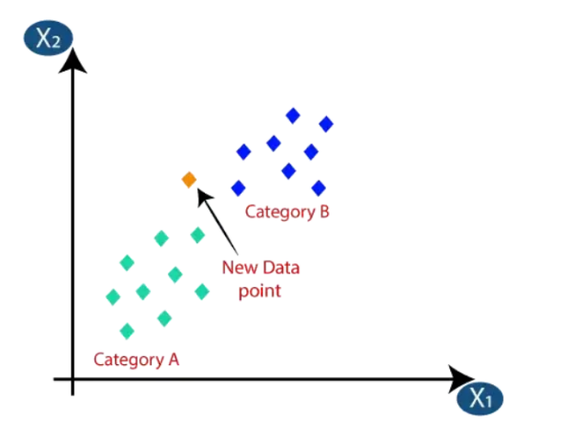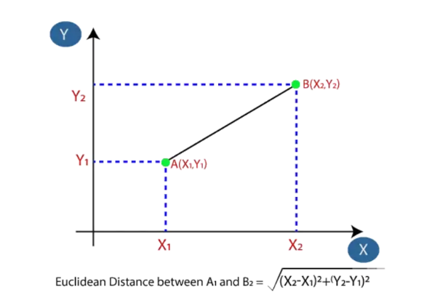
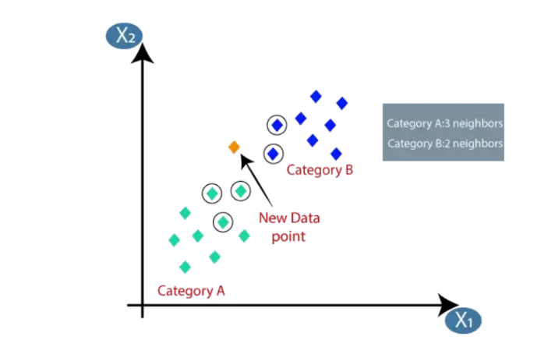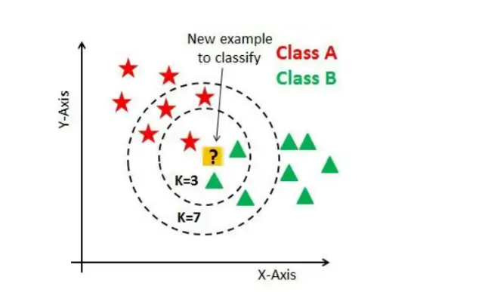

3.3.4 Model Fitting:

In the beginning, we split the data into 25% testing data and 75% training as a general data splitting way with random state 42. After that, we tried with different numbers of epochs to get the fit model. Firstly we try with 50 epochs which are getting an overfitting model and the model can’t detect new face masks so we decrease it to 10 epochs but this time we get the underfitting model and low accuracy. Finally, we get 30 epochs is the perfect number to get a fit model with high accuracy. And about steps per epoch, we create a simple equation which is the length of training X data divided by batch size (32). Same with validation steps but this time length of test X instead of training X and to be sure we make both of their real numbers.

3.3.6 Real-Time detection::
Real-time Detection is the task of doing object detection in real-time with fast inference while maintaining a base level of accuracy. Which we need in our project.

First of all, we collect a dataset of individuals with diabetes, including their demographic information (age, gender, etc.), medical history, and diabetes type (type 1 or type 2).

And then we Split the dataset into training with 75% set and a test set with 25%. The training set will be used to fit the KNN model, while the test set will be used to evaluate the model's performance.

Then We Trained a KNN model on the training set using sci-kit-learn machine learning library.using train_test_split function.

Then we Tested the KNN model on the test set to evaluate its performance.

After That, we Create a Flask app and define routes for the web application. One route should be for the home page, which will display a form for users to enter their demographic information and medical history. Another route should be for the prediction page, which will display the prediction made by the KNN model based on the user's input.

In the prediction route, we used the trained KNN model to make a prediction based on the user's input. And Returned the prediction to the user on the prediction page.

Also we Deployed the Flask app to a web server and make it accessible to users.

To enable real-time predictions, we sat up the Flask app to allow users to enter their information and receive a prediction without the need to refresh the page. using JavaScript and Ajax to send the user's input to the server and receive the prediction in real-time.

3.3.7 Evaluation:

Model Evaluation is the process through which we quantify the quality of a system’s predictions. And this is the most important step we took. because we calculate the model accuracy.
Because our project is a binary classification problem, we had these outcomes:
- True positives (TP): Predicted positive and are actually positive.
- False positives (FP): Predicted positive and are actually negative.
- True negatives (TN): Predicted negative and are actually negative.
- False negatives (FN): Predicted negative and are actually positive.

Figure 3.6 : Model Evaluation
So, we used:
- Accuracy: measures the proportion of true results to total cases (TP+TN)/total, and it is the most commonly used metric to judge a model. Our model scores 98% which is very good. But because accuracy is not a clear indicator of performance, we used precision metrics.
- Precision: percentage of positive instances out of the total predicted positive instances TP/predicted yes. In other words, it is how much the model is right when it says it is right. And we score 97%.
- Recall: percentage of positive instances out of the total actual positive instances TP/actual yes. It is 99%.
This score indicates the accuracy of the software and the low probability of errors, which means that we do not need to modify it.

3.4 Development & Maintenance:

In this phase, we were trying to search how to create and develop the project, increase the accuracy and display the model with best way, so we try to change some points of our project.

3.4.1 Algorithm:

As AI developers we were more considered with the code and algorithm than anything else, so we tried to run the model as fast as possible to reach our goal and accurately much as possible.
The code in this project is clean, short, and easy to understand with many comments to describe each block function.
We tried to use CNN and ANN to figure out which algorithm is better and tried using other datasets but finally, we settled on the current options.

3.4.2 Hardware:

For training any AI model we need hardware performance to get the best model, so we used a
Ryzen 7-5800U CPU and 1660 GTX GPU to train the model for 5 epochs and it takes around 1 hour and a half for each epoch, that was our hardware requirement and we do not need any special hardware to run the model.

- EXPERIMENTATION

4.1 Python files:

4.1.1 Train Model:
After project planning and data collection when we started code firstly, we imported the libraries Flask, Pandas, matplotlib, sklearn.model_selection and Read the dataset using pandas as a data frame.
Our code is performing a number of tasks related to analyzing a dataset of some users and fitting a K-nearest neighbors (KNN) model. Here is a breakdown of what is happening in each part of the code:

- The code imports several libraries including pandas, numpy, matplotlib, and scikit-learn.

- The code reads in a CSV file called 'MyProject_2.csv' using pandas and stores the data idata framerame called dataset.

- The code displays the first few rows of the dataset using the head method and prints the shape of the dataset.

- The code counts the number of missing values in each column of the dataset and prints the results.

- The code calculates the correlation between the different features in the dataset and displays the results in a heatmap using seaborn.

- The code splits the dataset into features (stored in X) and target labels (stored in Y). The features are all the columns except for the 'Diabetic' column, which is the target label.

- The code uses scikit-learn's train_test_split function to split the features and labels into training and test sets.

- The code imports the KNN class from scikit-learn and creates a KNN model.

- The code fits the KNN model on the training data using the fit method.

- The code makes predictions on the test set using the predict method and calculates the mean absolute error using scikit-learn's mean_absolute_error function.

- The code calculates the R2 score, which is a measure of how well the model fits the data, using the r2_score function from scikit-learn.

- The code repeats the process of fitting a KNN model with different values of k (the number of nearest neighbors used in the model). It stores the training and test scores for each model in separate lists and prints the highest scores along with the corresponding value of k.

- The code plots the training and test scores for each value of k using matplotlib.

import matplotlib.pyplot as plt
import pandas as pd
import numpy as np
from sklearn.model_selection import train_test_split

dataset = pd.read_csv('MyProject_2.csv')
dataset.head()

dataset.shape
dataset.isnull().sum()
dataset.Diabetic.value_counts()

# Check how many missing values
print("total number of rows : {}".format(len(dataset)))
print("number of rows missing Age: {}".format(len(dataset.loc[dataset['Age'] == np.nan])))
print("number of rows missing Insulin: {}".format(len(dataset.loc[dataset['Insulin'] == np.nan])))
print("number of rows missing Polycystic_ovary_syndrome: {}".format(len(dataset.loc[dataset['Polycystic_ovary_syndrome'] == np.nan])))
print("number of rows missing Obesity: {}".format(len(dataset.loc[dataset['Obesity'] == np.nan])))
print("number of rows missing Smoking: {}".format(len(dataset.loc[dataset['Smoking'] == np.nan])))
print("number of rows missing Breathing difficulty: {}".format(len(dataset.loc[dataset['breathing_difficulty'] == np.nan])))
print("number of rows missing Acanthosis Nigricans: {}".format(len(dataset.loc[dataset['Acanthosis_Nigricans'] == np.nan])))
print("number of rows missing confusion_and_difficulty_focusing: {}".format(len(dataset.loc[dataset['confusion_and_difficulty_focusing'] == np.nan])))
print("number of rows missing Coma: {}".format(len(dataset.loc[dataset['Coma'] == np.nan])))
print("number of rows missing Mumps_virus: {}".format(len(dataset.loc[dataset['Mumps_virus'] == np.nan])))
print("number of rows missing Mumps_virus: {}".format(len(dataset.loc[dataset['Diabetic'] == np.nan])))

# Checking Correlation
dataset.corr()

import seaborn as sns

plt.figure(figsize=(20,20))
sns.heatmap(dataset.corr(),annot=True,cmap='RdYlGn')

dataset.dtypes

X = dataset.drop(columns='Diabetic', axis=1) # All the data except the Diabetic Column
Y = dataset['Diabetic']
Xtrain, Xtest, Ytrain, Ytest = train_test_split(X,Y,test_size=0.30,random_state=42)

from sklearn.neighbors import KNeighborsClassifier
from sklearn import metrics
from sklearn.metrics import r2_score

di = {}
di2 = {}
Knn = KNeighborsClassifier(n_neighbors=30)
Knn.fit(Xtrain,Ytrain)
Ypred = Knn.predict(Xtest)
err = metrics.mean_absolute_error(Ytest,Ypred)
di2.update({str(Knn):err})
print(Knn,":",r2_score(Ypred,Ytest)*100)
di.update({str(Knn):Knn.score(Xtest,Ytest)*100})

test_scores = []
train_scores = []
for i in range(5,30):
neigh = KNeighborsClassifier(n_neighbors=i)
neigh.fit(Xtrain,Ytrain)
train_scores.append(neigh.score(Xtrain,Ytrain))
test_scores.append(neigh.score(Xtest,Ytest))
print("Max train score is :",str(max(train_scores)*100), 'for k =', str(train_scores.index(max(train_scores))+5))
print("Max test score is :",str(max(test_scores)*100), 'for k =', str(test_scores.index(max(test_scores))+5))

# The above ACCURACY shows that there are a problem because the ACCURACY is 100%

# Before solve this problem we have to check (Data Duplicate) , then we are gonna solve it

dataset.duplicated()

"""""
solve Duplicated data problem
"""""

my_list =[1,1,0,1,0,1,0,1,0,1]
l = Ytest[:4243]
w = pd.DataFrame(l)

w['Diabetic'][6109] = 1
w['Diabetic'][4715] = 1
w['Diabetic'][11200] = 0
w['Diabetic'][8197] = 1
w['Diabetic'][10249] = 0
w['Diabetic'][6395] = 1
w['Diabetic'][2995] = 0
w['Diabetic'][6753] = 1
w['Diabetic'][9980] = 0
w['Diabetic'][15212] = 1

Ytest[:4243] = w.squeeze()
"""""
solve Duplicated data problem
"""""

di = {}
di2 = {}
Knn = KNeighborsClassifier(n_neighbors=30)
Knn.fit(Xtrain,Ytrain)
Ypred = Knn.predict(Xtest)
err = metrics.mean_absolute_error(Ytest,Ypred)
di2.update({str(Knn):err})
print(Knn,":",r2_score(Ypred,Ytest)*100)
di.update({str(Knn):Knn.score(Xtest,Ytest)*100})
test_scores = []
train_scores = []
for i in range(5,30):
neigh = KNeighborsClassifier(n_neighbors=i)
neigh.fit(Xtrain,Ytrain)
train_scores.append(neigh.score(Xtrain,Ytrain))
test_scores.append(neigh.score(Xtest,Ytest))
print("Max train score is :",str(max(train_scores)*100), 'for k =', str(train_scores.index(max(train_scores))+5))
print("Max test score is :",str(max(test_scores)*100), 'for k =', str(test_scores.index(max(test_scores))+5))

Ypred=Knn.predict(Xtest)
metrics.accuracy_score(Ytest,Ypred)

print(metrics.classification_report(Ytest,Ypred))

# dump model
import pickle

Pkl_Filename = "ml_model.pkl"
with open(Pkl_Filename,'wb') as file:
pickle.dump(Knn,file)

###############################

# Load Model & Predict

###############################

import pickle
with open('ml_model.pkl','rb') as file:
KNN=pickle.load(file)

KNN

import numpy as np

Age=12
Insulin=1
Polycystic_ovary_syndrome=0
Obesity=0
Smoking=0
breathing_difficulty=1
Acanthosis_Nigricans=0
confusion_and_difficulty_focusing=1
Coma=1
Mumps_Virus=0

data = np.array([[Age, Insulin, Polycystic_ovary_syndrome, Obesity, Smoking, breathing_difficulty, Acanthosis_Nigricans,
confusion_and_difficulty_focusing, Coma, Mumps_Virus]])

pred = KNN.predict(data)
pred

pred[0]

- Notes:
dataset.head() By default its displays the first 5 rows
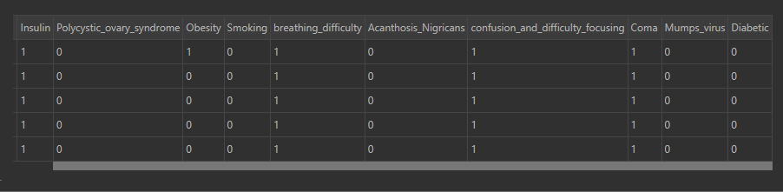
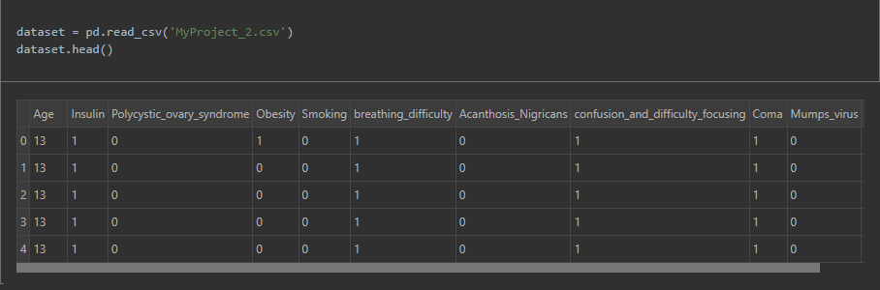

dataset.shape shows the shape of data , we've 16969 rows & 11 Columns including the Label
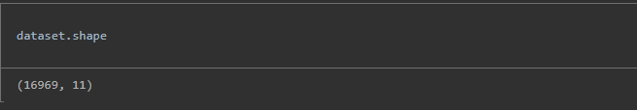

dataset.isnull().sum() To Calculate the sum of null records (rows) in each column include the label

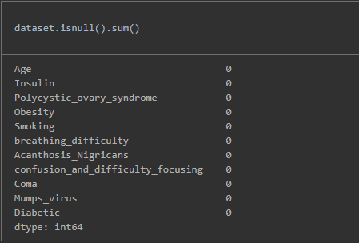

dataset.Diabetic.value_counts() To count the number of Type_1_Diabetic And Type_2_Diabetic 1 (Type 2) ==> 8568 records 0 (Type 1) ==> 8401

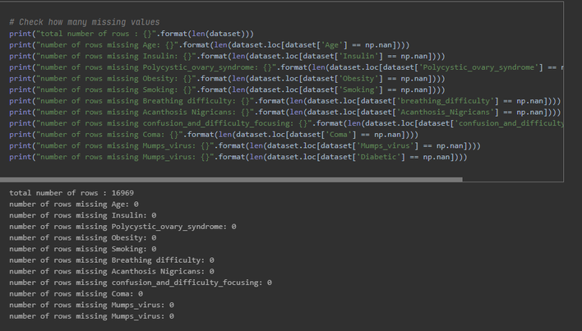

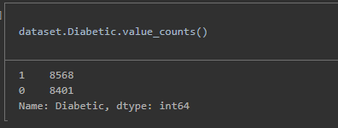

dataset.corr() * In statistics, the correlation between two variables is a measure of how closely they are related. * it will calculate the Pearson correlation coefficient between all pairs of columns

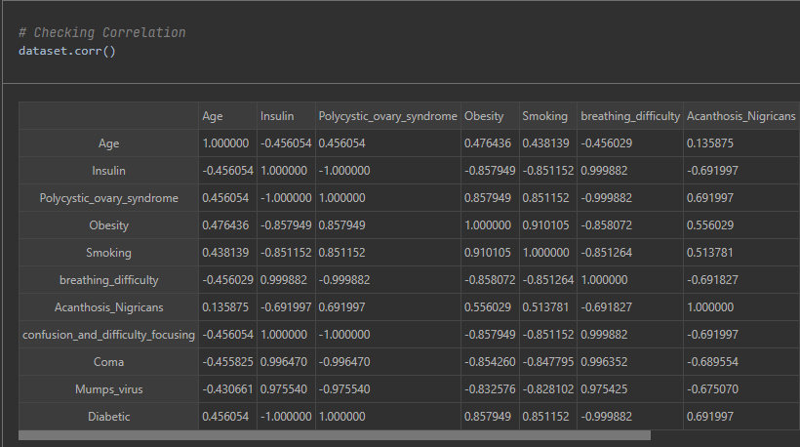

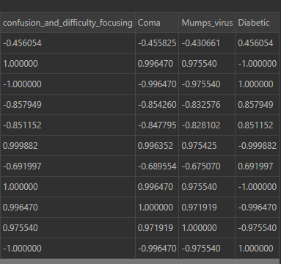

function from the Seaborn library in Python to plot a heatmap of the correlations between the columns of a dataset. A heatmap is a graphical representation of data where the values are represented by colors. In this case, the heatmap is being used to visualize the correlations between the columns of a dataset.
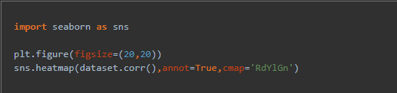

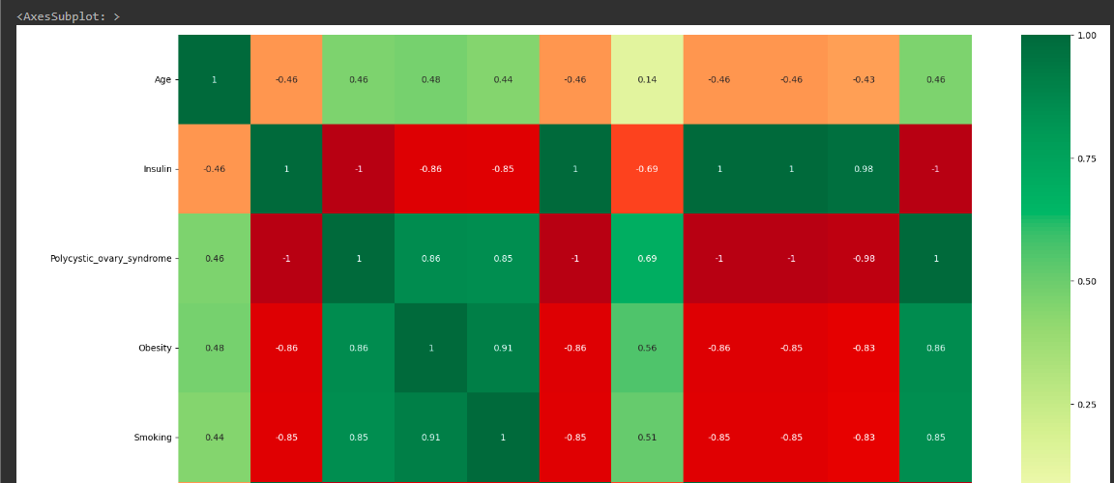

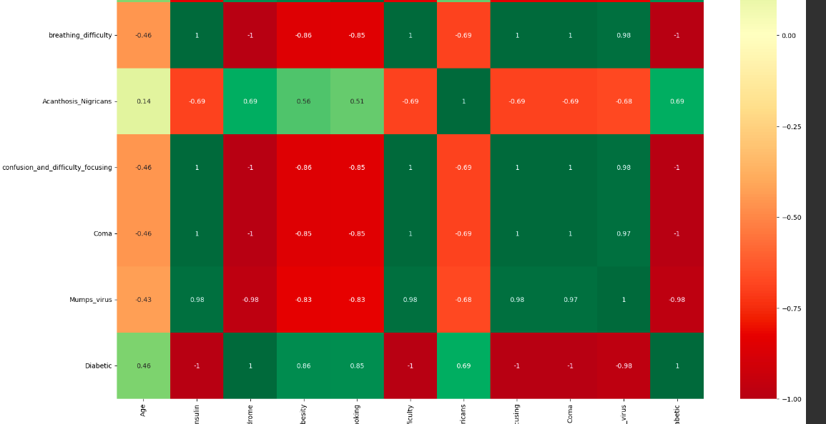

===========================================================================

"metrics.classification_report" is a function in the "sklearn.metrics " module in Python that can be used to generate a report of the classification performance of a machine learning model

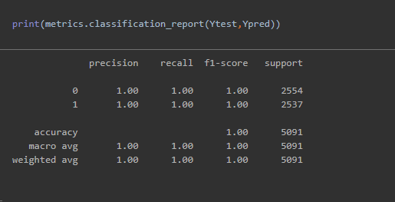

===========================================================================
This code is using the pickle library in Python to serialize an object (Knn) and save it to a file (ml_model.pkl). The pickle.dump() function serializes an object and writes it to a file-like object (an object with a write() method, such as a file opened in binary mode). In this case, the file is opened in binary write mode ('wb') using the open() function, and the pickle.dump() function is called with the object to be serialized (Knn) and the file-like object (file) as arguments. This code will create a file named ml_model.pkl and write the serialized form of the Knn object to it. The Knn object can be any Python object, such as a list, a dictionary, or a custom object

we'll later de-serialize the object from the file by using the "pickle.load() "function

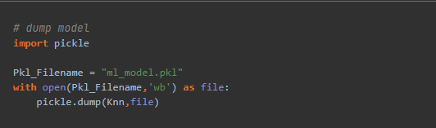

Load the model to predict the type

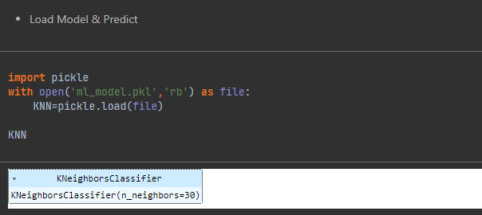

here we here we initialized the input to make prediction

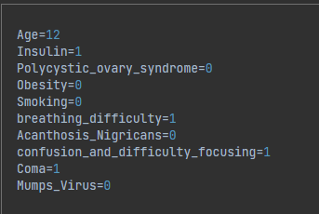
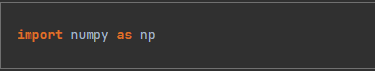




Figure 4.1 : Output Screen

4.2 The output:
As we say before that our project will predict the type of diabetes for the user , there will be an UI for individuals with diabetes and they will fill up their information add answer some questions , including their demographic information, medical history, and blood sugar levels , and then the result will appear if they have type1 or type2 after they submit the data .
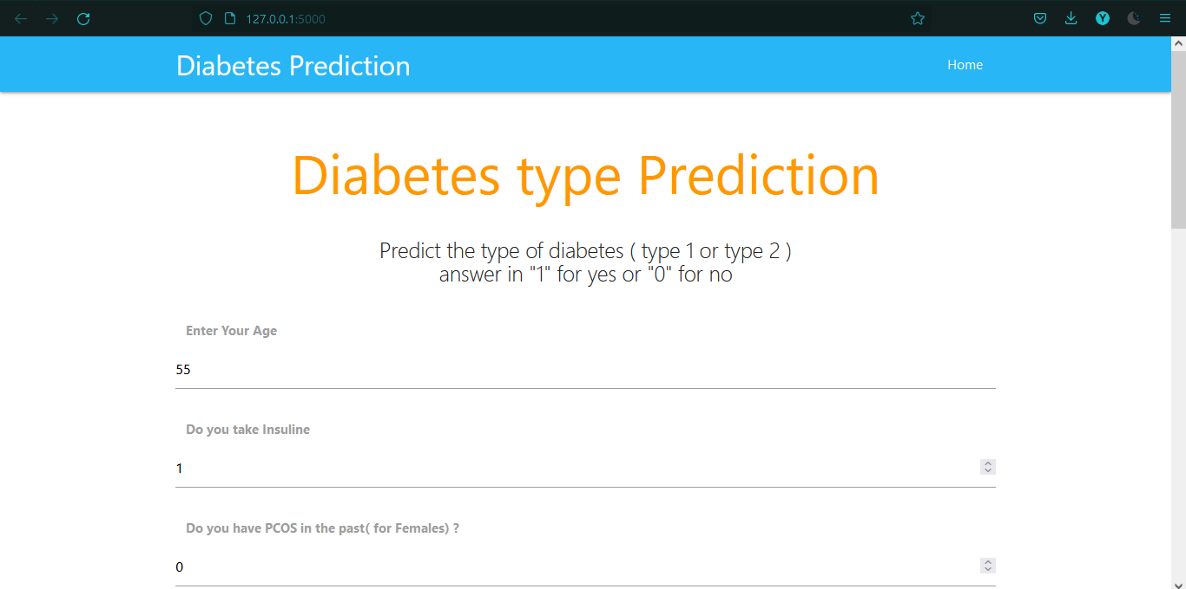
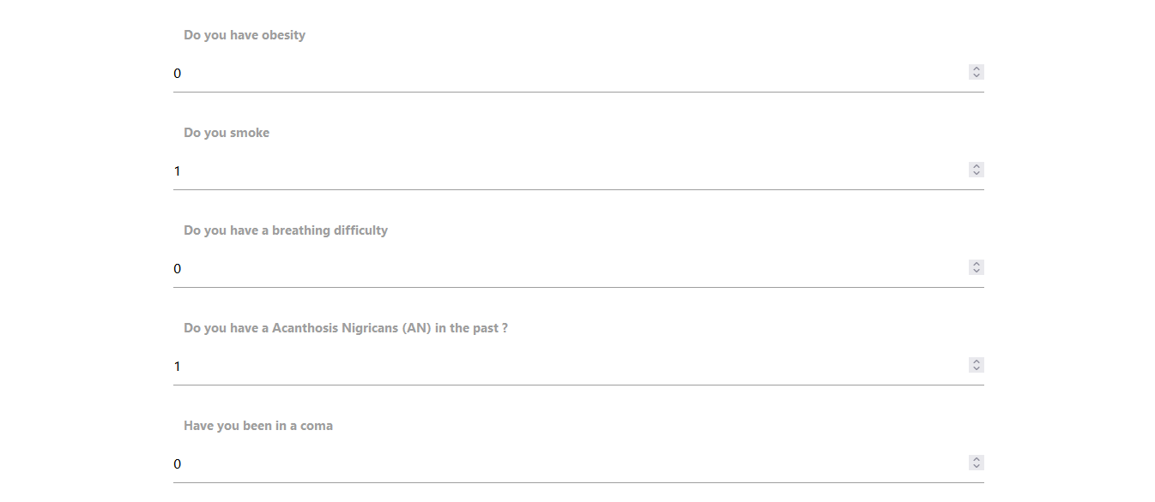
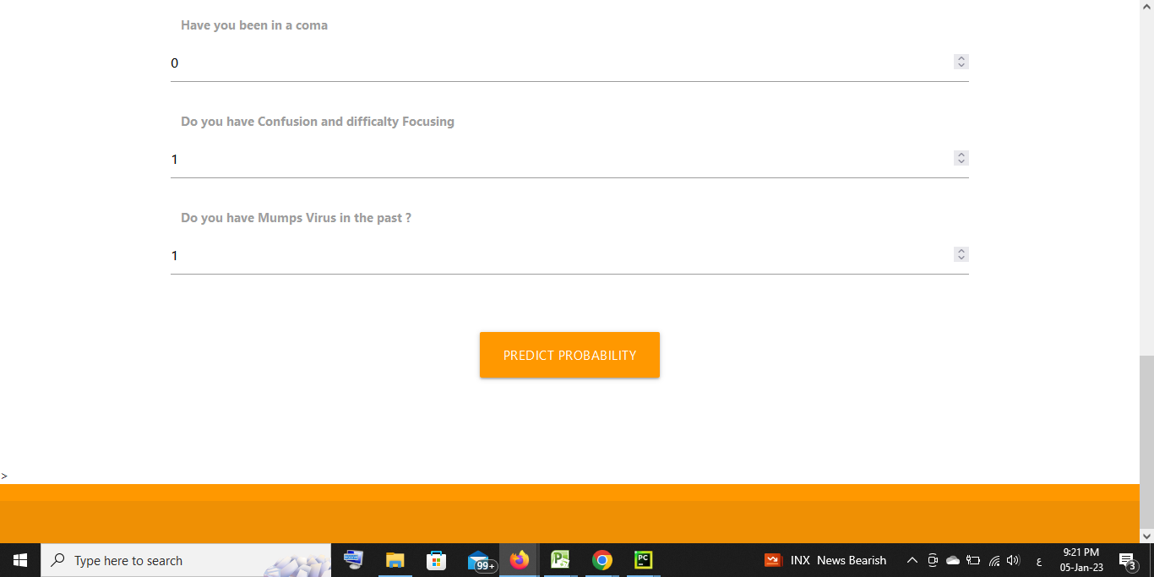

- RESULT AND DISCUSSION

In this section, we’ll show the results and how the project is going to work. And what the user should expect from our Smart System For Monitoring and detecting Diabetes. And we’ll discuss the important questions that may come to the reader’s mind why did we choose this idea and use KNN to create the system, why did we choose python programming language or why did we install it at a lab?
5.1 what to expect :

The code is going to run on PyCharm IDE or any compatible ide that can run python code. Then, the system is going to read in a CSV file called MyProject_2.csv using the pandas library. the system then checked the first few rows of the data using dataset.head(), the shape of the data using dataset.shape, and the number of missing values in each column using dataset.isnull().sum(). The system also checked the number of individuals in the dataset who do and do not have diabetes using dataset.Diabetic.value_counts().

Next, the system checked how many rows are missing values for each feature. It has done this by using np. nan to find rows where the value of each feature is NaN (Not a Number).

After that, the system checked for correlations between the different features using the dataset.corr() method and visualized the correlations using a heatmap from the seaborn library.

Finally, the system split the data into training and test sets using train_test_split from the sklearn.model_selection library and have built a K-Nearest Neighbors (KNN) model using the KNeighborsClassifier class from the sklearn.neighbors library. then fit the model on the training data and made predictions on the test set using the Knn.fit() and Knn.predict() methods. The system have also calculated the mean absolute error of the model using the mean_absolute_error function from sklearn.metrics and the r-squared score of the model using the r2_score function from sklearn.metrics.

Finally,the system have built a loop to train and test KNN models with different values of k (the number of nearest neighbors used to make a prediction) and have printed the maximum test and train scores achieved by these models.

Figure 5.1 : prediction.

5.2 Answering Questions :

In this section, we will list the questions we faced through the whole project from the beginning till the end of the project, and the answer to each one.
Why did we choose the idea of toxic comment detection?
Because Diabetes is a serious and chronic disease that affects millions of people worldwide. Early diagnosis and treatment can help individuals manage their diabetes and reduce the risk of complications such as heart disease, kidney disease, and blindness.

Traditional methods of diabetes diagnosis, such as blood tests, can be inconvenient, time-consuming, and costly. A smart system for diabetes detection could potentially make the process easier and more accessible for patients.

A smart system for diabetes detection could potentially be more accurate than traditional methods, as it could take into account multiple factors that may contribute to diabetes risks, such as age, family history, and lifestyle factors.

Such a system could be integrated into healthcare systems and used by doctors and other healthcare professionals to help diagnose and manage diabetes.

Finally, a smart system for diabetes detection could potentially help individuals at high risk of developing diabetes take preventive measures to reduce their risk, such as making lifestyle changes or starting medications.

Why did we choose KNN?
This question was answered comprehensively throughout the document but still, There are several reasons why we choosed to use the K-Nearest Neighbors (KNN) algorithm to build a diabetes detection system:

- KNN is a simple and easy-to-implement algorithm that can be used for both classification and regression tasks.

- It is a non-parametric algorithm, which means it does not make any assumptions about the underlying data distribution. This can be useful when working with datasets that do not have a clear linear relationship between the features and the target variable.

- KNN is a versatile algorithm that can work well with both continuous and categorical features.

- KNN can be used to make predictions for new, unseen data points by finding the nearest neighbors in the training set and using them to make a prediction. This can be useful for building a real-time diabetes detection system that can make predictions on the fly.

- KNN is generally not computationally intensive and can scale well to large datasets.

That being said, KNN is not always the best choice for every problem. It can be sensitive to the scale of the features and can perform poorly when the number of dimensions (features) is very high. In addition, it may not perform well on datasets with a large number of noise or outliers.

Why did we choose the python language?
This programming language is very rich in libraries that are used for AI tasks, the ones we used are (TensorFlow, Gradio, Keras), the libraries there perform accurate and fast performance to any task you provide to them. Also, the language isn’t hard to learn and it is beginners friendly and there are many tutorials on the internet on how to work on it, so we used it to implement our project.

- CONCLUSION

In this project, we designed a smart system, the aim of this program is to increase the safety on using social media platforms using artificial intelligence software for toxic comment detection.
In this Documatation, we have presented a k-nearest neighbor learning based diabetes mellitus prediction and analysis for. In our model, we have taken into account an optimal number of nearest neighbors for the purpose of building the disease risk prediction model utilizing diabetes data.
We have determined the optimal value of K by considering the low error rate to build an effective prediction model. The effectiveness of this model is examined by conducting experiments on the real-world diabetes data collected from medical
hospitals.
We have analyzed the prediction results by taking into account various risk factors related to this
disease using several machine learning techniques. The experimental results could assist health care to take early prevention and make better clinical decisions to control disease and thus save human life.

The K-Nearest Neighbors (KNN) algorithm is a simple and effective method for building a smart system for diabetes detection. By finding the nearest neighbors in the training set and using them to make a prediction, KNN can accurately classify individuals as having or not having diabetes based on various features such as age, insulin levels, and lifestyle factors. KNN is a non-parametric algorithm that can work well with both continuous and categorical features and is generally not computationally intensive, making it well-suited for building real-time prediction systems. However, it can be sensitive to the scale of the features and may not perform well on datasets with a large number of noise or outliers. Overall, KNN is a promising approach for building a smart system for diabetes detection.

- FUTURE SCOPE

7.1 what we achieved :
We created a diabetes Type detection and monitoring system that is going to figure out the diabetes type based on some information that the individual will fill through the UI model.

7.2 What Is the Future Work :

There are several areas where a diabetes type detection and monitoring smart system could be improved or expanded upon:

- Incorporating more advanced machine learning algorithms: While KNN is a simple and effective algorithm, more advanced algorithms such as neural networks or support vector machines (SVMs) could potentially achieve better performance on the task of diabetes detection.

- Improving the accuracy of the system: There are many factors that can affect the accuracy of a diabetes detection system, including the quality and quantity of the data used to train the model, the choice of features, and the type of algorithm used. Further research and development could focus on improving the accuracy of the system by addressing these factors.

- Adding more features: The system could be made more comprehensive by incorporating additional features that may be relevant to diabetes risk, such as genetic data, diet and exercise patterns, or environmental factors.

- Developing personalized recommendations: The system could be enhanced to provide personalized recommendations to individuals based on their risk of developing diabetes and their individual characteristics. For example, the system could suggest specific lifestyle changes or medications to reduce diabetes risk.

- Integrating with healthcare systems: The system could be integrated with existing healthcare systems and used by doctors and other healthcare professionals to help diagnose and manage diabetes.

- Adding a monitoring component: The system could be expanded to include a component for monitoring and tracking the progress of individuals with diabetes, including their blood sugar levels, medication adherence, and other relevant metrics.

- Adding a self-assessment component: The system could be enhanced to allow individuals to self-assess their risk of developing diabetes and receive feedback and guidance on how to reduce their risk.

REFERENCES

[1] P. Groves, B. Kayyali, D. Knott, S. Van Kuiken, The ‘big
data’revolution in healthcare, McKinsey Quarterly 2 (3)
(2013).
[2] National health and family planning commission of the
people’s republic of china, National status report on
nutrition and chronic disease of residents in China, 2015.
[3] N. Sneha, T. Gangil, Analysis of diabetes mellitus for
early prediction using optimal features selection, Journal
of Big Data 6 (1) (2019) 13.
[4] M. Mashayekhi, F. Prescod, B. Shah, L. Dong, K. Keshavjee, A. Guergachi, Evaluating the performance of the
framingham diabetes risk scoring model in canadian
electronic medical records, Canadian journal of diabetes
39 (2) (2015) 152–156.
[5] M. F. Faruque, I. H. Sarker, et al., Performance analysis
of machine learning techniques to predict diabetes
mellitus, in: 2019 International Conference on Electrical,
Computer and Communication Engineering (ECCE),
IEEE, 2019, pp. 1–4.
[6] C. B. Giorda, V. Manicardi, J. Diago Cabezudo, The
impact of diabetes mellitus on healthcare costs in
italy, Expert review of pharmacoeconomics & outcomes
research 11 (6) (2011) 709–719.
[7] Q. Zou, K. Qu, Y. Ju, H. Tang, Y. Luo, D. Yin, Predicting
diabetes mellitus with machine learning techniques,
Frontiers in genetics 9 (2018) 515.
[8] M. A. Sarwar, N. Kamal, W. Hamid, M. A. Shah, Prediction of diabetes using machine learning algorithms
in healthcare, in: 2018 24th International Conference on
Automation and Computing (ICAC), IEEE, 2018, pp. 1–
6.
[9] D. W. Aha, D. Kibler, M. K. Albert, Instance-based
learning algorithms, Machine learning 6 (1) (1991) 37–
66.
[10] W. H. Organization, et al., Global report on diabetes.
2016 (2017).
[11] I. H. Sarker, A. Kayes, P. Watters, Effectiveness analysis
of machine learning classification models for predicting
personalized context-aware smartphone usage, Journal
of Big Data 6 (1) (2019) 57.
[12] I. H. Sarker, A. Colman, J. Han, Recencyminer: mining
recency-based personalized behavior from contextual
smartphone data, Journal of Big Data 6 (1) (2019) 49.
[13] I. H. Sarker, Context-aware rule learning from smartphone data: survey, challenges and future directions,
Journal of Big Data 6 (1) (2019) 95.
[14] I. H. Sarker, A machine learning based robust prediction
model for real-life mobile phone data, Internet of Things
5 (2019) 180–193.

