COLOR PALETTE PICKER

Using event listeners in a loop

We are going to start building a color palette picker.

Lesson Objectives

1. Generate 150 divs (squares) each with their own random color.
2. Create a click handler on each square that will add a square with the same color as the clicked square to the right column.

Generate 150 divs (squares) each with their own random color.

* Add jQuery library

Create DOM elements:

<button id="generate">GENERATE</button>

<div id="container">

<div id="color-palette"></div>

<div id="my-palette"></div>

</div>

Grab them with jQuery:

const $colorPalette = $('#color-palette');

const $myPalette = $('#my-palette');

const $generate = $('#generate');

Write a function makePalette that will generate 150 squares with the class 'square' and append them to the color-palette div

const makePalette = () => {

for(let i = 0; i < 150; i++){

const $square = $('<div>');

$square.addClass('square');

$colorPalette.append($square);

}

}

//... bottom of file

makePalette();

Make it so each square will have a random color

const red = Math.floor(Math.random() \* 255);

const green = Math.floor(Math.random() \* 255);

const blue = Math.floor(Math.random() \* 255);

const color = 'rgb('+red+','+green+','+blue+')';

$square.css('background-color', color);

Should look like this:

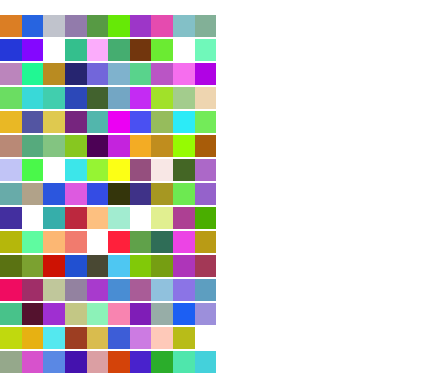

Add an event listener to the generate button that will run the makePalette function

$generate.on('click', makePalette);

Make it so the makePalette function will empty the previous palette of squares

const makePalette = () => {

$colorPalette.empty();

//...

}

Give each square an event listener whose addColor handler will (eventually) add the chosen square to the right column:

const makePalette = () => {

//...

$('.square').on('click', addColor);

}

* Make the addColor handler.
* First, it should console.log the background color of the square that was clicked:

const addColor = (event) => {

console.log($(event.currentTarget).css('background-color'));

}

* The addColor function should:
  + Make a new square
  + Give it a class of 'square'
  + Give it the clicked square's background color
  + Append to the 'my palette' right div

const addColor = (event) => {

const color = $(event.currentTarget).css('background-color');

const $square = $('<div>');

$square.addClass('square');

$square.css('background-color', color);

$myPalette.append($square)