

Palestine

An-Najah National University

Faculty of Information Technology

Computerized Information Systems

*دولـــــــــــــــة فلســـــــــــــطين*

*جامعة النـجـاح الـوطنـيـة*

*كليـة تكنولوجيا المعلومات*

*قسم نظم المعلومات المحوسبة*

**p**arty **p**lanning

*Students:*

* *yazan ayman – 11422193*
* *Mohammad amera-115*
* *Abdallah mashaqi-115*

***S****upervisor:*

**Dr. Emad Saadah**

*A project report submitted in partial fulfillment of the requirements   
for uml design course in Computer Information Systems department.*

*An-Najah National University*

*2018 / 2019*

**Actors of the system**

|  |  |  |
| --- | --- | --- |
| Actor | Actor type | Actor description |
| Party planners | Primary | Order management. This contains add special notes to the order, change the party place if the customer wants. The planner will receive notification from the server about the order state instead of going number of times to the manger. Moreover, the planner can be able to see all the current orders in the system. |
| accountant | Primary | Bill out. This set will allow the cashier to reserve an order, make discounts, divide the bill among customers, and review old orders. |
| following companies | Secondary | Order organization. This will allow the company to send notifications to the planner about the order state |
| Admin | Primary | Reports availability. This will provide the admin with different type of reports including profit, loss, top sold items, customer analysis.  Control users accounts. |
| Customer | Primary | Order online. This allows the customer to login to the customer page, this page provides the customer functionalities like open new order and add items to it. Also, the customer can reserve a date and submit the order. The customer will receive notification if the order accepted or rejected. |
| authorization Centre of cards | secondary |  |

**Static context diagram**

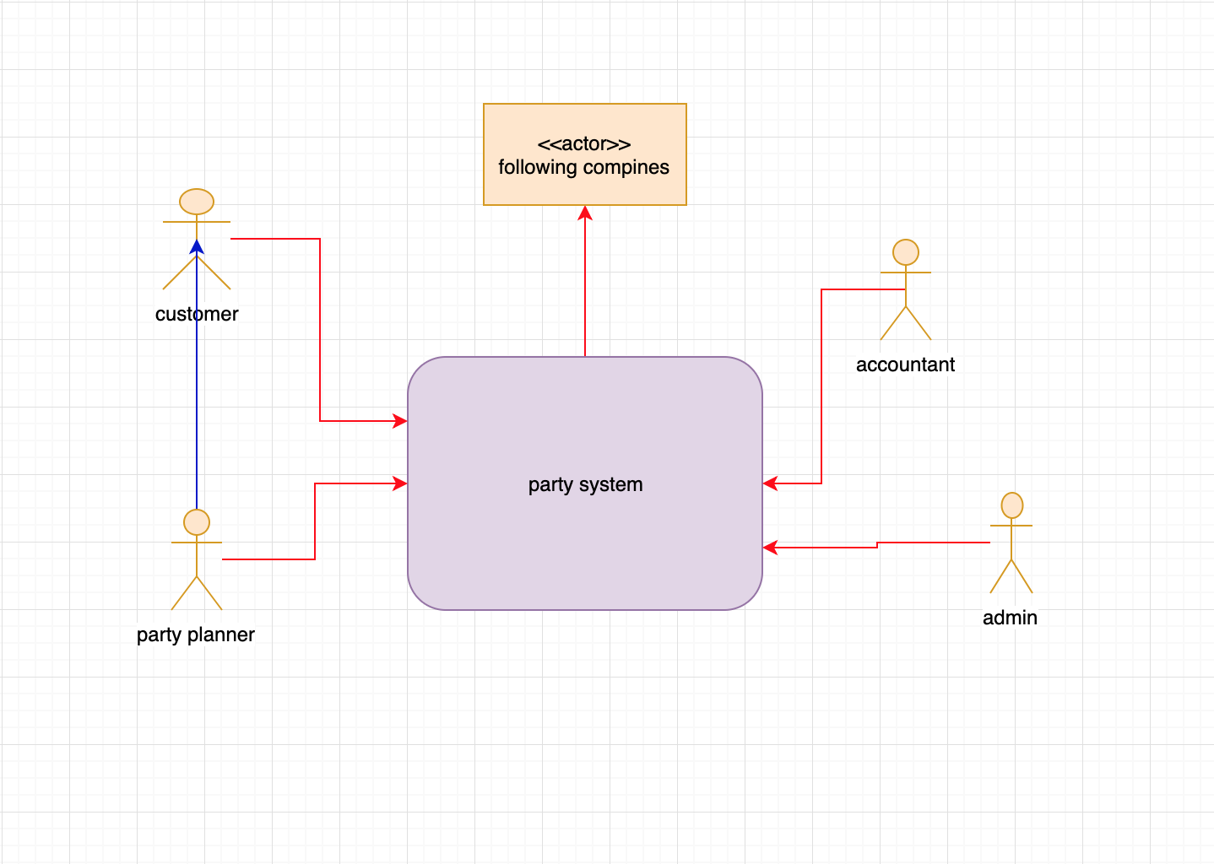

**Use case diagram & packages**

First we will identify use cases for every actor in the system :

* Planners:
* can delete an order by posting a report for the manger.
* Accept/ reject an order placed by a customer.
* Review order.

* Accountant
* print bill
* Following companies
* Had no access
* Admin
* create or delete employee account.
* see reports.

* Customer
* Submit a reserve.
* Review order.
* payment

**completed use case:**

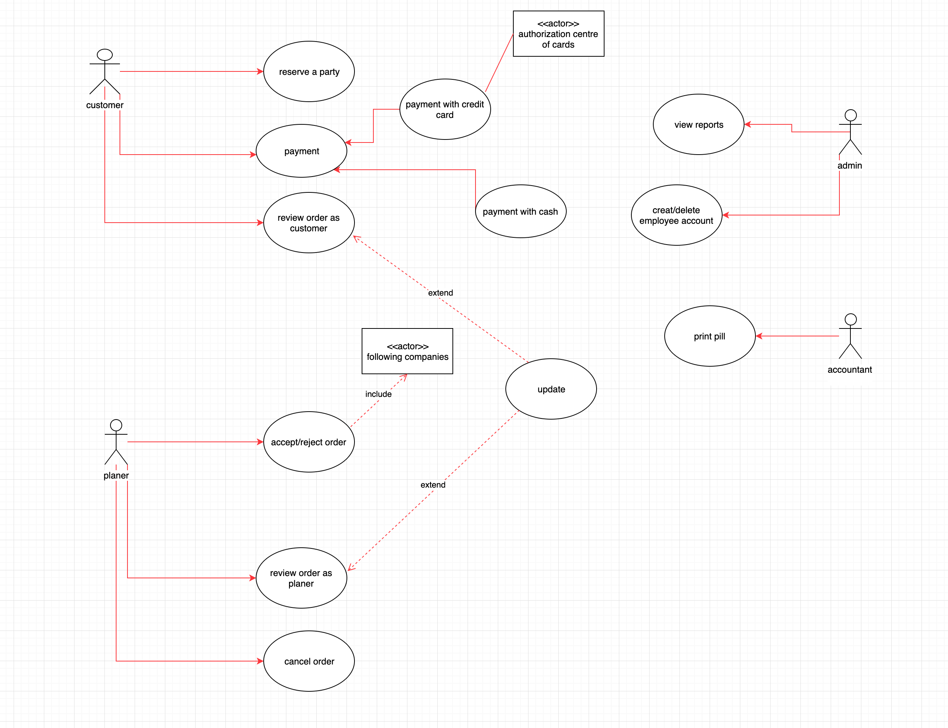

**Textual description:**

❖Identification summary :

Title: Submit a reserve

Summary: The customer can submit his/her order in the site after fill all the required information.

Actors: customer(primary ) .

Creation date: -/-/201-. data of update -/-/201-

❖ flow of events :

Preconditions :

1. The customer must be logged into his valid account.

2. The main page should displayed with all function the user need.

3. internet access.

Main success scenario :

|  |  |
| --- | --- |
| 1.The user selects “reserve a party ”button from website | 2.the system sure if that is a user or machine  By some way |
|  | 3. the system sure is a human and display a requirements |
| 4.the user selects a date that customer need | 5.the system check if the date is available |
|  | 6.the system agree for date and display a form of party to user |
| 7. the user fill that form (what user needed in party | 8.The system check if form is filling success (accurate data) |
|  | 9.the system show some option and requirements (number of chair , and DJ , etc.) |
| 10, the user can choose that option and send it to system | 11.the system take that information display all to user , and counting the total price |
| 12.the user can show the order or the reserved pill and look for price |  |

Alternative sequences :

1. If the customer has not fill the order completely.
2. At point4 the site will give an error message to the user

Errors sequences:

If the user keep having the same error it will be returned to the home page

Post conditions : -

A new reserve is added to the site.

--------------------------------------------------------------------

❖Identification summary :

Title: Update order

Summary The customer wants to update the submitted order and add special notes..

Creation date: -/-/201-. data of update -/-/201-

❖ flow of events :

Preconditions :

1. The customer must be logged into his valid account.

2. The user is already opened order and submitted it.

3. internet access.

Main success scenario :

|  |  |
| --- | --- |
| 1. The user select the “update ” button from website after post the order | 1. The system make sure that the time is update is in range (5-10) days |
|  | 1. Send the agree of update to user and display the requirements or option of party |
| 4.The user selects what he wants to change and update from requirements and send to system again | 5.the system check if all is available and check if correct data |
|  | 6 .the system send message about operation is success |
| 7.the user show the order again and make sure that all he want is change |  |

Alternative sequences :

Errors sequences:

Post conditions : -

The order is updated successfully.

❖Identification summary :

Title: Accept order

Summary: Accepts an order that has been submitted by a customer.

Actors: planer(primary ) .

Creation date: -/-/201-. data of update -/-/201-

❖ flow of events :

Preconditions :

1. A customer has submitted an order

Main success scenario :

|  |  |
| --- | --- |
| 1.when the customer prepared the order and finish it and the system received the order it send the order to planer | 2.the planer receive the order and check if the order is ready and open it |
|  | 3. the planer send the agree to system |
| 4.the customer receive the agree to order |  |

Alternative sequences :

Errors sequences:

If the customer has a black history with the company the order will be rejected.

Post conditions : -

The user will get notified that his order had been accepted.

❖Identification summary :

Title: payment

Summary: Close order and finalize payment by cash or visa card.

Actors: accountant(primary ) .

Creation date: -/-/201-. data of update -/-/201-

❖ flow of events :

Preconditions :

1. accountant select the order and it must contain items

Main success scenario :

|  |  |
| --- | --- |
| 1.the customer go to the accountant to pay for his/her order. | 2. the accountant check the order cost and check if the payment methods that customer choose |
| 3.Customer chose payment method. | 4.If credit card the accountant check if it valid or not and if cash the accountant ask the customer to pay |
| 5.the user put the amount of money that will pay | 5.the accountant check if the amount meet the cost of order |

Alternative sequences :

If the customer credit car is not working the accountant ask the customer to pay cash.

Errors sequences:

If the customer didn’t have cash or visa   
he/her must wright a cheque or draft

Post conditions : -

The order is closed and paid.

❖Identification summary :

Title View Report

Summary: provide the admin with different types of reports as needed.

Actors: Admin(primary ) .

Creation date: -/-/201-. data of update -/-/201-

❖ flow of events :

Preconditions :

1. logged in as Admin.

Main success scenario :

|  |  |
| --- | --- |
| 1. Admin login in the system | 2.the system required the id and password |
| 3.the admin put the id and password | 4.the system check if the id and password is valid and correct |
|  | 5.send the admin message about successfully |
| 6.the admin click on reports | 7.the system display the reports to admin |
|  | 8.the system ask admin to print report |

Alternative sequences:

If the user isn’t admin the system asks to logged in as admin.

Errors sequences:

logged in as planner/accountant.

**Sequence diagram:**

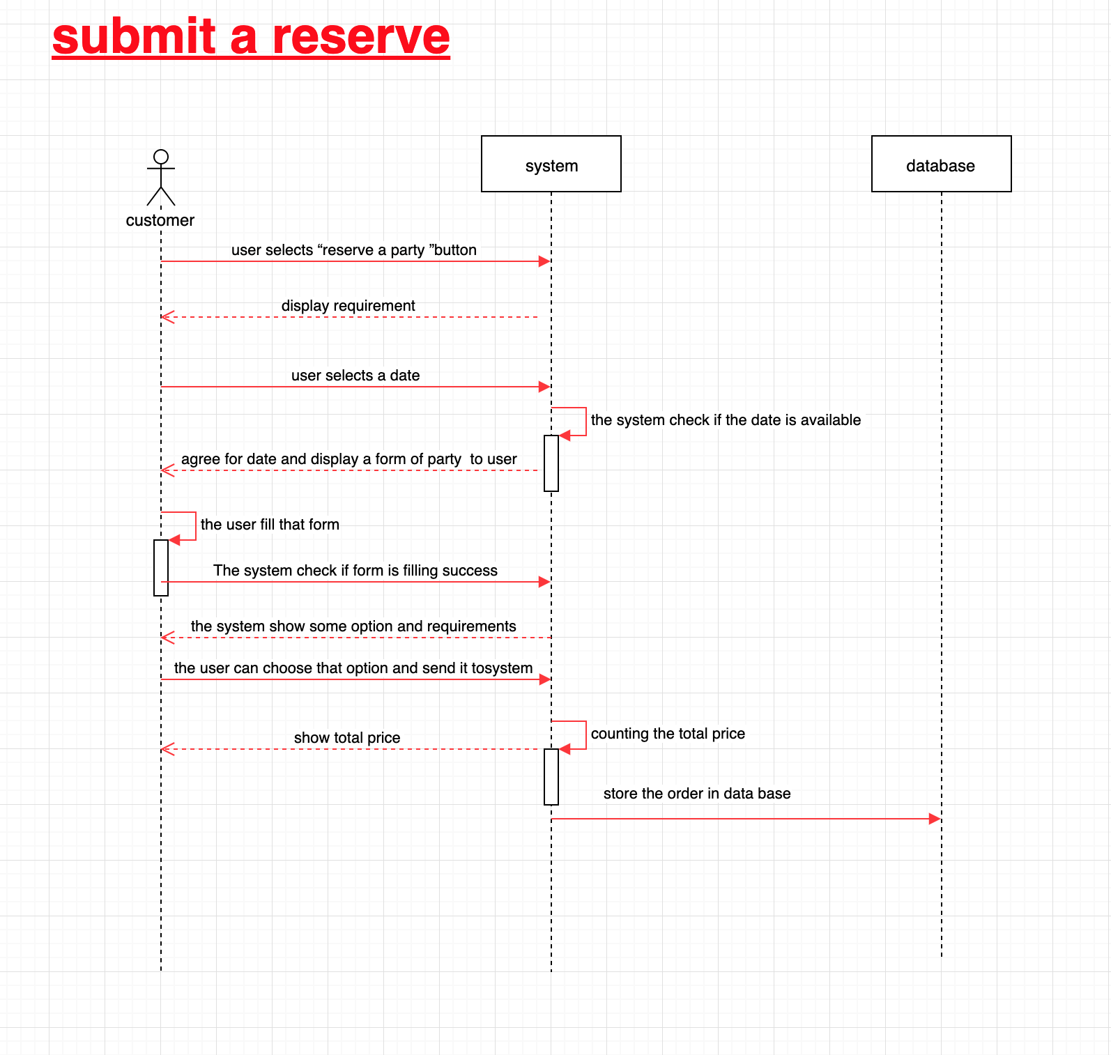

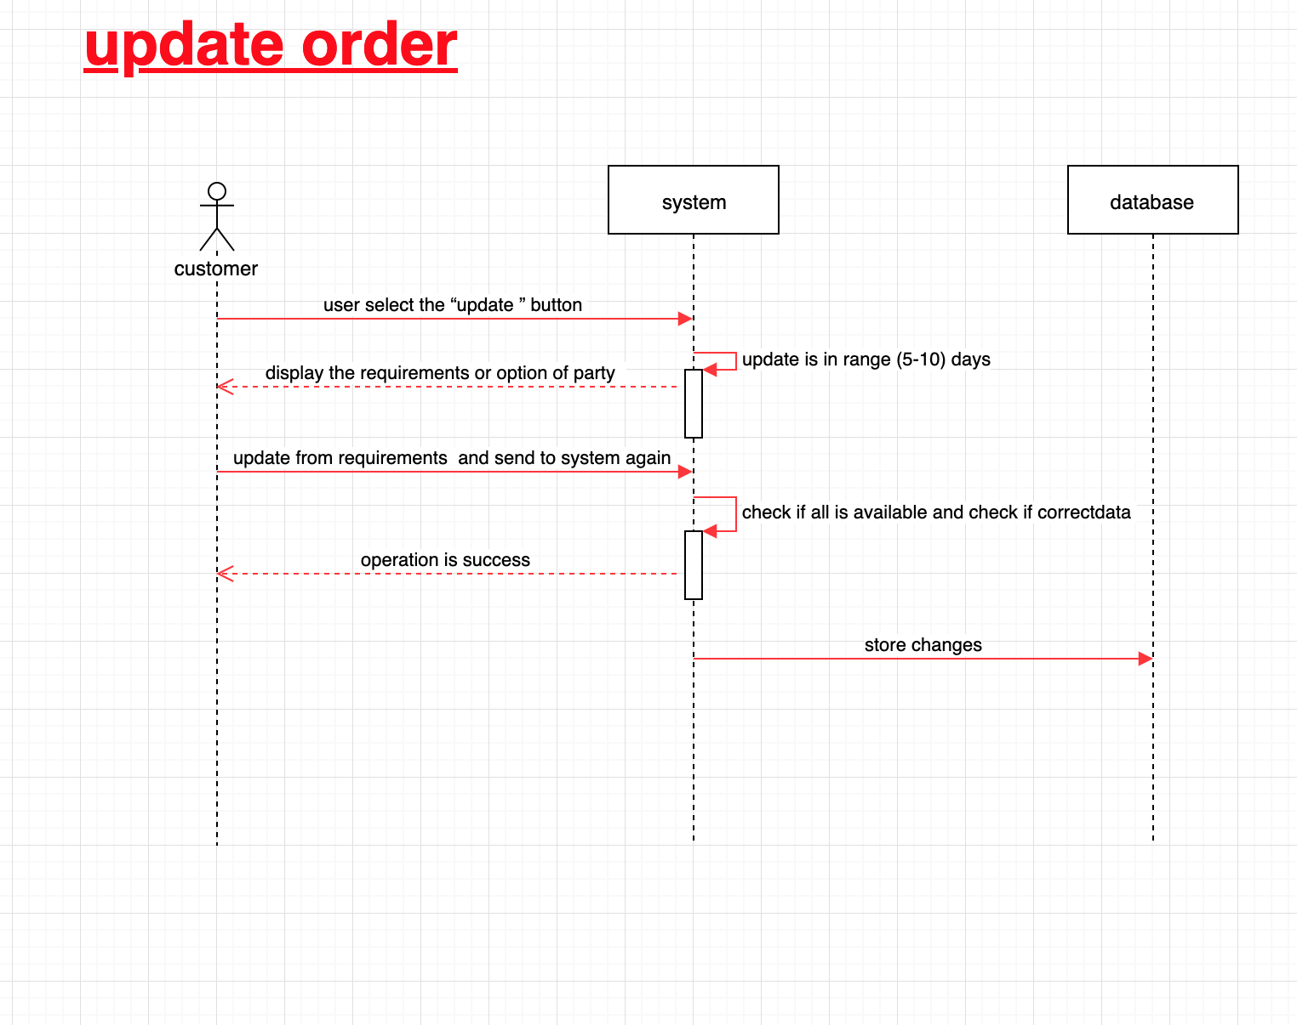

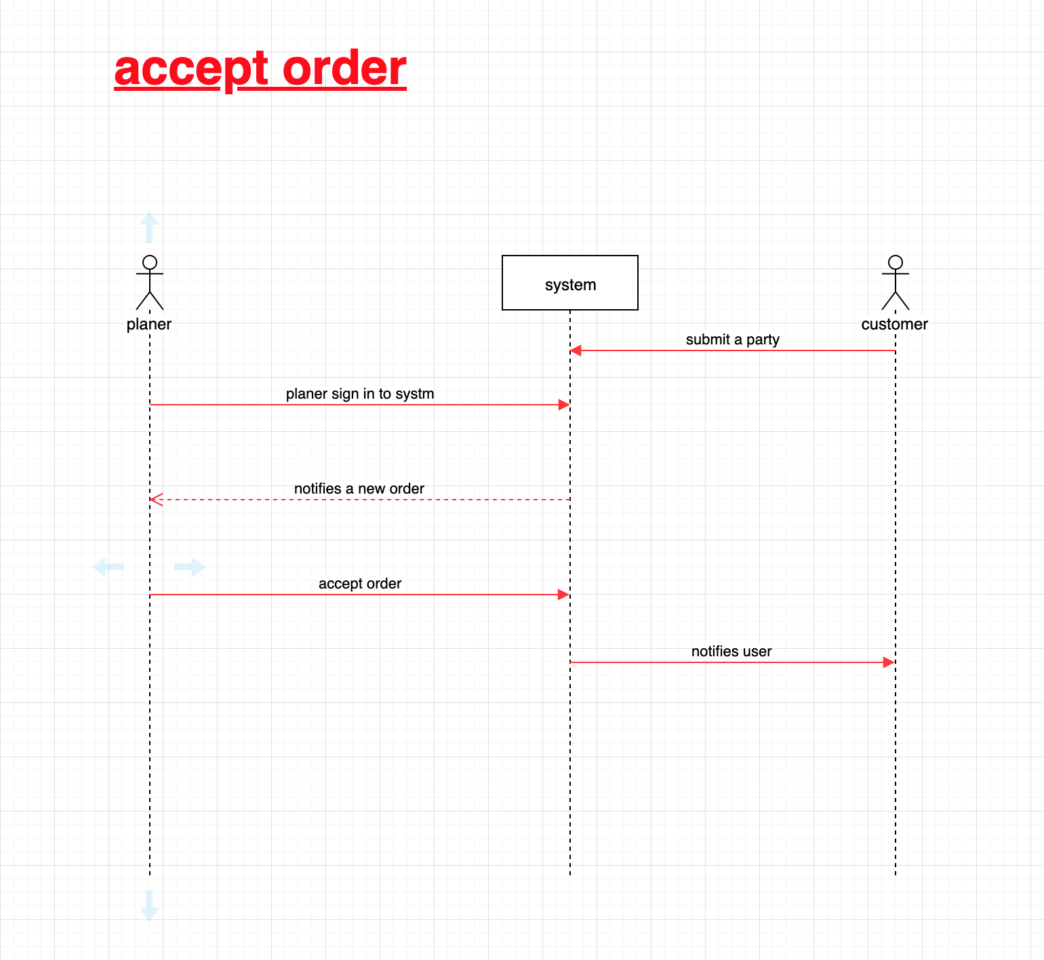

# **Screen%20Shot%202019-03-05%20at%208.57.16%20PM.png**

# 

**activity diagram**

