

**The Arab American University**

**Faculty of Engineering and Information Technology**

**Project Title**

**Library Noise Detection**

**By:**

**Aysar Wishahi-CSE-201610888**

**Yazan Jarrar-CSE-201610711**

**Yazan Khalaf-CSE-201611675**

**Supervisor:**

**Dr. Sami Awad**

**Date: July 2021**

**-**

Table of Contents

Declaration 4

Abstract 5

List of Tables 6

List of Figures 7

List of Abbreviations 8

Acknowledgement 9

Chapter 1: Introduction: 10

**1.1 Background and Motivation:** 10

**1.2 Aims and Objectives:** 11

**1.3 Problem Statement:** 11

**1.4 Contribution:** 11

Chapter 2: Literature Review: 12

**2.1 Overview:** 12

**2.2 Existing System:** 12

**2.2.1: Noise Detector with Automatic Recording System Using Arduino With the IoT** (noise-detector-automatic-recording-system, n.d.) 13

**2.2.2: Design and Construction of noise detector in Library** (design-and-construction-of-noise-detector-in-library, n.d.) 15

**2.2.3: Noise alarm** (ProjectCaseStudy-NoiseAlarm, n.d.) 16

**2.3 Summary:** 18

Chapter 3: System Analysis: 19

**3.1 Introduction:** 19

**3.2 Analysis of Existing Systems:** 19

**3.3 Requirements:** 20

**3.3.1 User Requirements:** 20

**3.3.2 System Requirements:** 20

**3.3.2.2 Non-Functional Requirements:** 21

**3.3.3 Noise Detection System Diagram:** 22

**3.4 Development Methodology:** 23

**3.4.1 Use Case Diagram:** 23

**3.4.2 Use Case Description:** 26

**3.4.3 Flowchart:** 27

**3.4.3.2 Device:** 29

**3.4.4 Activity Diagram:** 30

**3.4.5 Sequence Diagram:** 32

**3.4.6 Context Diagram:** 34

**3.5 Summary:** 34

Chapter 4: System Design and Solution: 35

**4.1 Introduction:** 35

**4.2 Class Diagram:** 36

**4.3 Software Component:** 38

**4.3.1 Software Description:** 38

**4.4 Hardware Components:** 38

**4.4.1 Hardware Description:** 39

**4.5 System Architecture and Algorithms:** 42

**4.6 Voice Loudness Levels:** 43

**4.7 Summary:** 43

Chapter 5: Conclusions and Future Work: 44

**5.1 Conclusion:** 44

**5.2 Future Work:** 44

References 45

# Declaration

This is to declare that the graduation project entitled (Library Noise Detection) under the supervision of (Dr. Sami Awad) is our own work and does not contain any unacknowledged work or material previously published or written by another person, except where due reference is made in the text of the report.

Date: July 2021

Graduation project’s students:

Name: Yazan Jarrar Signature: Jarrar

Name: Yazan Khalaf Signature: Khalaf

Name: Aysar Weshahi Signature: Weshahi

# Abstract

It is common for students and citizens to visit public or private libraries. The noise levels in libraries should be maintained as quiet (low) as possible. Sometime a noisy crowd would visit the library which may trigger the librarian to warn them of the noise level. Our system solves this problem for the librarians by installing sensor (detection) devices on tables that would indicate the level of noise of that table then represent the loudness level via LEDs which are placed on the device and warn the librarian by sending a notification via our mobile application. The application will run on mobile devices that use Android and IOS operating systems. The application will be programed using Flutter(dart) framework.

# List of Tables

Table 1:Compare devices 16

Table 2: Use Case Description 25

# List of Figures

Figure 1:pro-1a 13

Figure 2: pro-1b 13

Figure 3: pro-2 15

Figure 4:pro-3 16

Figure 5:Noise Detection System Diagram 22

Figure 6: Use Case Diagram 23

Figure 7: case 1 (visitor) 24

Figure 8: case 2 (Librarian) 25

Figure 9: case 3 (System) 25

Figure 10: Flowchart -Application 28

Figure 12:Activity Diagram for -App Notification 30

Figure 13:Activity Diagram for - Led Glow 31

Figure 14: Sequence Diagram for Send Device ID App 32

Figure 15: Sequence Diagram for Led Diagram 33

Figure 16: Context Diagram for Library Noise Alarm System 34

Figure 17: System 35

Figure 18: internal and external view 36

Figure 19: Class Diagram 37

Figure 20: Flutter 38

Figure 21: Arduino Uno 39

Figure 22: Wi-Fi Module 39

Figure 23: SD Card Module 40

Figure 24: SD Card 40

Figure 25: LED 41

Figure 26: Microphone (Sound Detection Sensor) Module 41

Figure 27: System Architecture and Algorithms-A 42

Figure 28: System Architecture and Algorithms-B 43

# 

# List of Abbreviations

AAUP Arab American University Palestine

CSE Computer Systems Engineering

LED Light Emitting Diode

# Acknowledgement

The owners of this senior project would like to express our sincerest appreciation and gratefulness to our supervisor, Dr. Sami Awad, for his encouragement, advice, direction, support, availability and patience during this endeavor. He has been a true source of knowledge and motivation for us over the past semester and we truly appreciate and value his efforts. For these reasons, Dr. Sami has earned our uttermost respect and gratitude. We will be forever grateful to him. We are also thankful to our beloved university, Arab American University of Palestine (AAUP) for the services and support that we received from its teachers and instructor, and for the knowledge and experience it gave us that shall lead us forward. We aim and hope to make you proud. Our deepest appreciation goes to our families who have been nothing but supportive and constantly encouraging and helpful. Thank you to our friends as well, for their support, enthusiasm, and for being there for us when we needed help. Thank you all for your support, encouragement, and friendships.

**Chapter One**

# Introduction:

## **1.1 Background and Motivation:**

The library is a place to study, research and read books it is supposed to be calm and not noisy so to keep it like that is part of the librarian's job. In 2019 the largest libraries in the world have a huge number of visitors for example (British Library with 1.75 million visitors per year, Library of Congress with 1.9 million visitors per year) (List_of_largest_libraries, n.d.)even in small libraries and small countries the number of visitors increased a lot in the past decade which makes it louder inside library than before.

Self-awareness is required but sometimes people don't have it or they don't be aware of their voice loudness level.

There is no successful solution for the loudness in libraries in Palestine.

Most of the systems that try to solve this problem are not very successful, the reason is that it does not give specific details of the direction of the noise (like the table number).

## **1.2 Aims and Objectives:**

The main objective of this system is to give the visitors and indicators of the loudness of their voices, make the librarian's job easier give the judgment of librarian more fairness and make the library a better place for study and reading.

This all will be achieved through and device that will be placed on every table that when some conditions are met will notify the librarian of the noisy table.

## **1.3 Problem Statement:**

In most libraries there is no noise detection system even in libraries that has one it is a big sensor placed on every hall cell and is wired connected to the librarian computer the problem is that this way is not flexible for librarian and sometimes the librarian does not know for sure the specific source of noise and does not give the visitors the ability to self-monitor their selves.

## **1.4 Contribution:**

We are researching the current existing Sound Alarm, to add to our system.

Our device will be placed on every table, it will have a sound sensor and three levels of sound loudness, there are three LEDS, each LED will glow to represent the loudness level that got exceeded, the first LED is the acceptable loudness, the second glows if a higher loudness level got exceeded, and if the third LED glow it will immediately notify the librarian’s phone.

**Chapter Two**

# Literature Review:

## **2.1 Overview:**

Many Existing Systems have been developed to provide sound alarming. However, there are limitations in what these systems provide, each system has its advantages and disadvantages, so we will show what distinguishes our system in upcoming sections.

## **2.2 Existing System:**

The most encouraging thing to start this idea is the lack of systems that are actually efficient. After some time of research, we found similar systems with ideas that are similar to the idea of our system but lacking basic features needed in the library.

**Existing systems:**

1. Noise Detector with Automatic Recording System Using Arduino With the IoT.
2. Design and Construction of noise detector in Library.
3. Noise Alarm.

### **2.2.1: Noise Detector with Automatic Recording System Using Arduino With the IoT** (noise-detector-automatic-recording-system, n.d.)

This uses a set of components that work together in order to achieve the goal of quiet and reasonably unobtrusive sound so the system use a noise detector that consists of the power of the Arduino and connect the Bluetooth with the app When your sound level crosses the threshold value, the Noise Detector device will buzz to notify about it and at the same time the app will start recording the sound and it will go on recording until the noise level comes down below the threshold level.

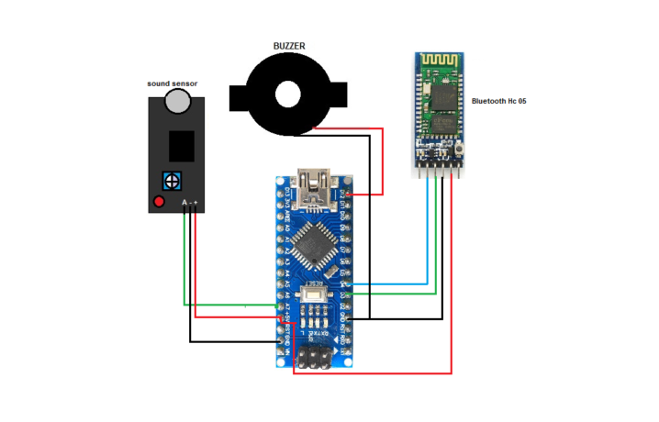

Figure 1:pro-1a

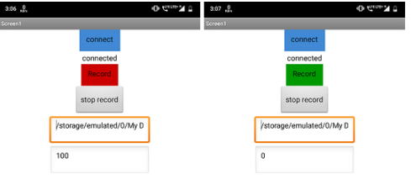

Figure 2: pro-1b

**Advantages:**

**1-** It can record voice for one minute and save it.

**2-** It is connected to the android device using an application wirelessly.

**Disadvantages:**

**1-** The distance between mobile and device should be small due to the Bluetooth connection.

**2-** Can’t connect more than one device due to Bluetooth limitations.

**3-** It has a buzzer so it’s annoying.

### **2.2.2: Design and Construction of noise detector in Library** (design-and-construction-of-noise-detector-in-library, n.d.)

This project is for the design and construction of the NOISE DETECTOR IN LIBRARY. This device is able to detect the noise, compare the intensity of louder sound, and hence producing the warning signal to the librarian. This system is very economical and helpful in maintaining peace in the library.

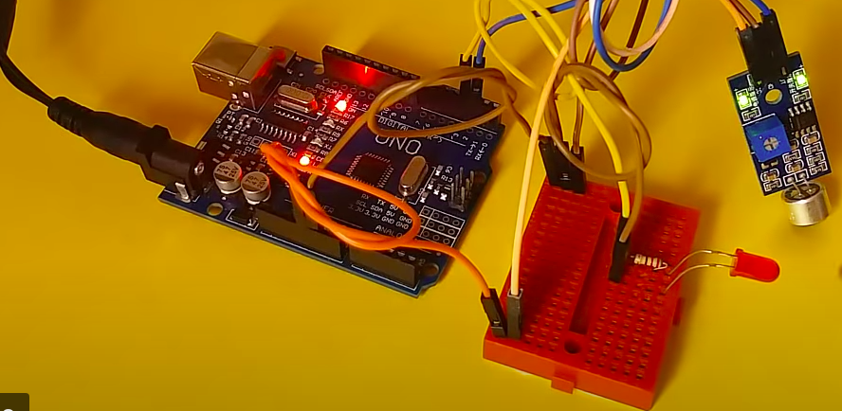**Advantages:**

Figure 3: pro-2

Figure 1:pro-2

**1-** It is simple.

**Disadvantages:**

**1-** It should be wired all through the library.

**2-** If there is a big number of devices it will take a big space like a wall of lids.

**3-** Librarian can’t moves around freely.

**4-** One level of indicator.

### **2.2.3: Noise alarm** (ProjectCaseStudy-NoiseAlarm, n.d.)

This project creates a visual noise detector, using LittleBits sensors to relay noise information via an Arduino board through to our Processing-based software system that will visually indicate when the noise has been detected.

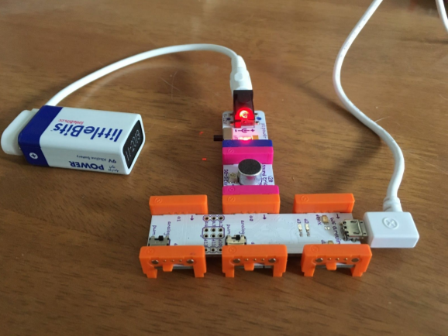

Figure 4:pro-3

**Advantages:**

**1-** It is simple.

**2-** Multiple levels of indicators.

**Disadvantages:**

**1-** It should be wired all through the library.

**2-** If there is a big number of devices it will take a big space like a wall of lids.

**3-** Librarian can’t moves around freely.

|  |  |  |  |  |
| --- | --- | --- | --- | --- |
| System/Feature | Existing  System 1 | Existing  System 2 | Existing  System 3 | Our  System |
| App |  |  |  |  |
| WIFI |  |  |  |  |
| Led indicators |  |  |  |  |
| Multiple levels of loudness |  |  |  |  |
| Support multiple devices |  |  |  |  |
| Bluetooth |  |  |  |  |

Table 1:Compare devices

## **2.3 Summary:**

In this chapter, we have looked up and discussed the existing systems which are similar to our system. We also showed the advantages and disadvantages of these systems.

We showed and studied the disadvantages in order to avoid them in our system and take advantage of the previous systems to implement in our system.

**Chapter Three**

# **System Analysis:**

## **3.1 Introduction:**

In this chapter we will explain the user requirements, system requirements (functional, non-functional), development Methodology (Use Case Diagrams, Activity Diagram, Sequence Diagram, Flow Chart, Context Diagram, and System Diagram) and we will explain system components and how it will be integrated into final system. We will divide our system into two main components:

1. The application.
2. The device (It is the micro controller and all components that will be added to it and it will be placed on the table).

## **3.2 Analysis of Existing Systems:**

We will try to get all benefits and discard weakness of existing systems we showed in chapter two.

WIFI over Bluetooth: because it is more reliable, has longer connection distance, can connect bigger number of devices.

LEDs and an application over sound alarm: it is not noisy and easier to librarian to know the sound source.

## **3.3 Requirements:**

### **3.3.1 User Requirements:**

1. The devices should be connected to the network wirelessly.
2. The librarian should get notified of the loud table via an application.
3. The librarian should be able change the number of the devices (Tables).
4. The library should be able to add new devices to new tables.
5. The library visitors should be able to see their voices loudness via LEDS placed on the devices.

### **3.3.2 System Requirements****:**

#### **3.3.2.1 Functional Requirements:**

1. The system should keep sensing voices continuously.
2. The system should be able stay working day and night (all the time).
3. The system should compare the detected voices to decide loudness level
4. The system should notify the librarian of the loud table via an application.
5. The system should display the voice loudness for the library visitors via LEDS.
6. The system should allow the librarian to change device number.
7. The system should be able to acquire the IP address from router DHCP to the devices.

### **3.3.2.2 Non-Functional Requirements:**

Non-functional requirements define the behavior, features, and general characteristics of the system.

1- Speed: Response time for the noise should not exceed 10 second.

2- Size: device size should be acceptable, small size is preferred to be placed on the desks.

3- Ease of use: the application should be easy enough for users to use without training and device easy to install.

4- Reliability: It should give the correct information about the table number that has level three loudness.

5- Cost: the system should be cheap because it needs multiple device one for each table

6- Portability: the librarian should be able move inside library freely and still get notification from devices.

### **3.3.3 Noise Detection System Diagram:**

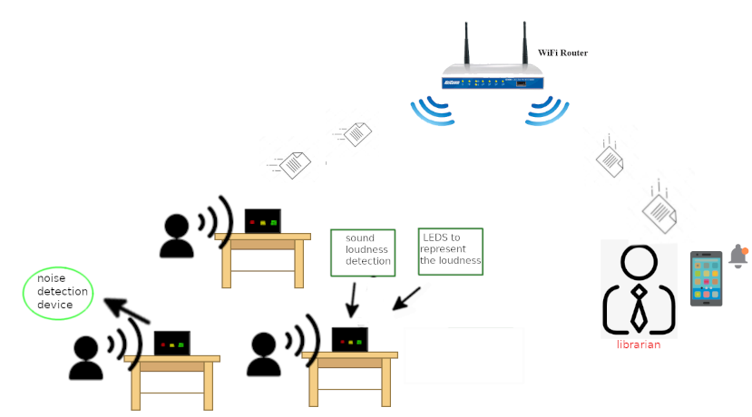

Figure 5:Noise Detection System Diagram

## **3.4 Development Methodology****:**

### **3.4.1 Use Case Diagram:**

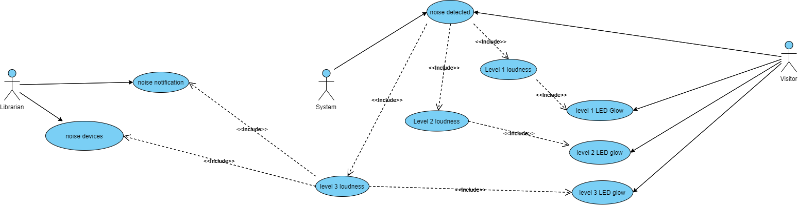

Figure 6: Use Case Diagram

## 

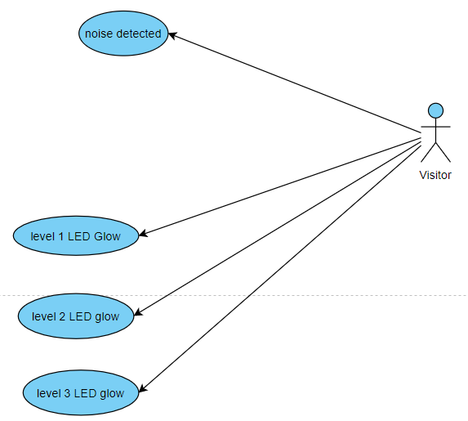

Figure 7: case 1 (visitor)

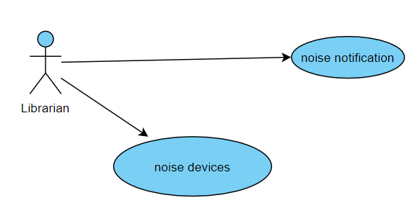

Figure 8: case 2 (Librarian)

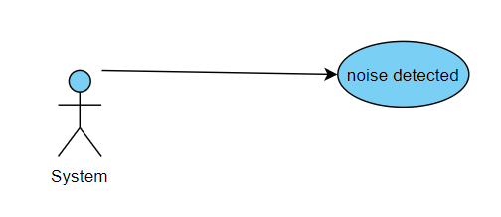

Figure 9: case 3 (System)

### **3.4.2 Use Case Description:**

|  |  |  |  |
| --- | --- | --- | --- |
| ***Use case*** | ***Actors*** | ***Type*** | ***Description*** |
| Noise notification | System | Primary and essential | System send notification to the user  in case the loudness is level 3 |
| Show noisy devices | Librarian | Primary and essential | The system should print all noisy devices on librarian app |
| Noise detected | System | Primary and essential | The system should monitor voices and determine what is the loudness level |
| Level 1 loudness | System | Secondary and essential | The system determines the next actions based on this use case |
| Level 2 loudness | System | Secondary and essential | The system determines the next actions based on this use case |
| Level 3 loudness | System | Secondary and essential | The system determines the next actions based on this use case |
| Level 1 LED Glow | System | Secondary and essential | The system will trigger the level 1 LED in case the loudness is level 1 |
| Level 2 LED Glow | System | Secondary and essential | The system will trigger the level 2 LED in case the loudness is level 2 |
| Level 3 LED Glow | System | Secondary and essential | The system will trigger the level 3 LED in case the loudness is level 3 |

Table 2: Use Case Description

### **3.4.3 Flowchart:**

Flowchart is a type of diagram that represents a workflow or process, and makes it easy to understand how system works.

#### **3.4.3.1 Application:**

Initialize the server

List all noisy devices on app screen

Check for notification

There is a notification

Add the noisy device of list

Read notification from device

Output notification for user of device number

YES

Figure 10: Flowchart -Application

### **3.4.3.2 Device:**

Connecting to Wi-Fi

Getting device name networks ssid and password from SD card

Voice input

Check loudness level

loudness level > 2

Loudness level > 1

Notify the app

Turn on level 3 LED

Loudness level> 0

Turn on level 2 LED

Turn on level 1 LED

NO

YES

YES

NO

YESS

NO

Figure 11:Flowchart- Device 1

### **3.4.4 Activity Diagram:**

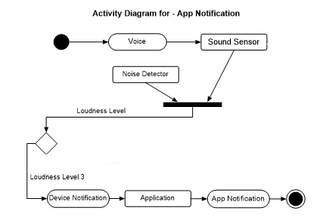

Figure 12:Activity Diagram for -App Notification



Figure 13:Activity Diagram for - Led Glow

### **3.4.5 Sequence Diagram:**

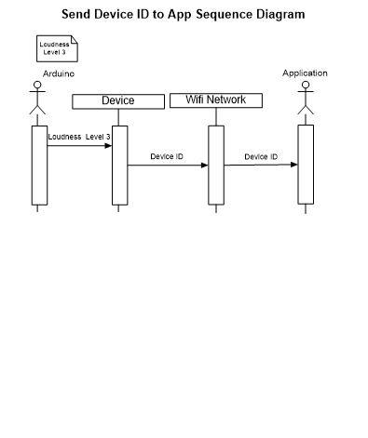

Figure 14: Sequence Diagram for Send Device ID App

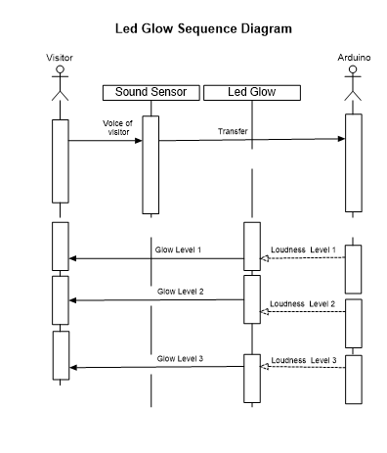

Figure 15: Sequence Diagram for Led Diagram

### **3.4.6 Context Diagram:**



Figure 16: Context Diagram for Library Noise Alarm System

## **3.5 Summary:**

In this chapter we showed requirements of our system (user requirement, functional requirements, non-functional requirements). Explained how the system will work and its components, all of that is showed through a Development Methodology’s (activity diagram, use case diagram, flowchart and sequence diagram).

**Chapter Four**

# System Design and Solution:

## **4.1 Introduction:**

In this chapter we will work on implementation of our system so we will head to achieve our system requirements that we described in chapter three to come with overall complete design of the system.

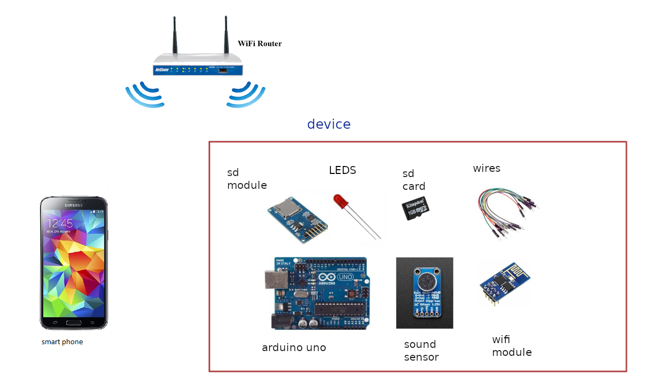

Figure 17: System

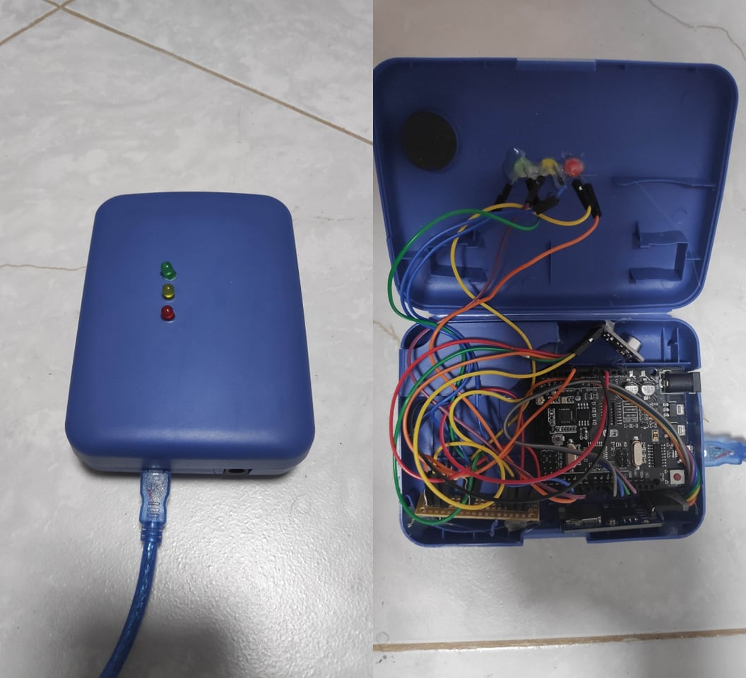

Figure 18: internal and external view

## **4.2 Class Diagram:**

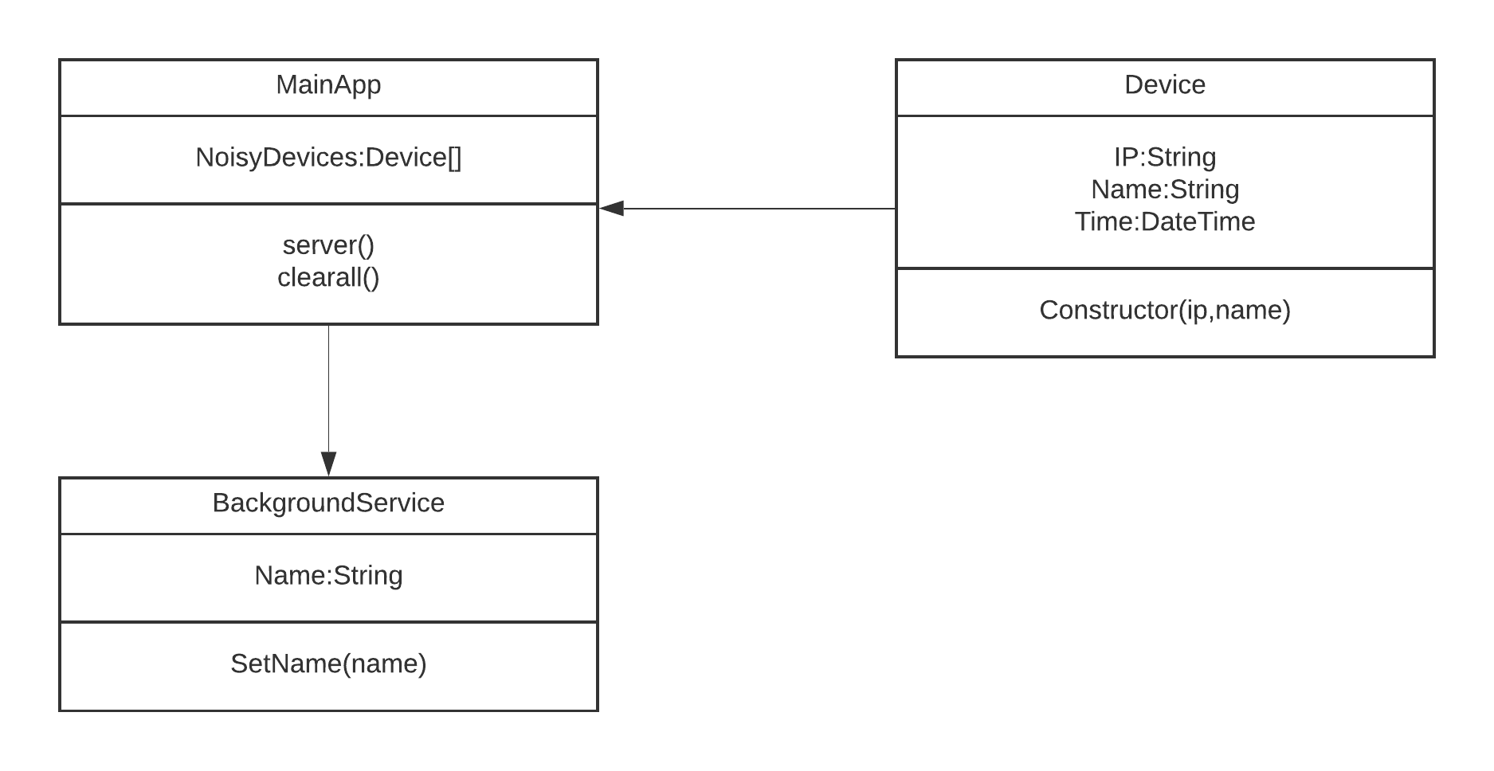

Figure 19: Class Diagram

## **4.3 Software Component:**

* **Flutter (Dart)**

### **4.3.1 Software Description:**

* **Flutter:** Offering cross-platform, native-like, and superior experiences, Flutter has emerged as one of the top choices for cross-platform app development. (we chosen flutter over other option because it is strongest cross platform for smart phone application programing).



Figure 20: Flutter

## **4.4 Hardware Components:**

* **Arduino Uno**
* **Wi-Fi Module**
* **SD Card Module**
* **SD Card**
* **LED**
* **Microphone Sound Detection Sensor Module**

### **4.4.1 Hardware Description:**

* **Arduino Uno:** Is an open-source microcontroller the board is equipped with sets of digital and analog input/output pins that may be interfaced to various expansion boards and other circuits and it can be programed using C++.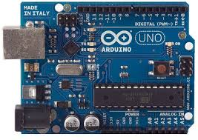

Figure 21: Arduino Uno

* **Wi-Fi Module: ESP8266** Self-contained SOC with integrated TCP/IP protocol that can give any Arduino access to Wi-Fi network.

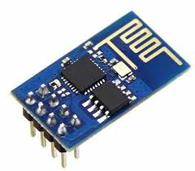

Figure 22: Wi-Fi Module

* **SD Card Module:** It is an interface to give ability to add SD Card to the Arduino.

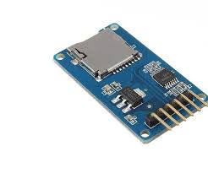

Figure 23: SD Card Module

* **SD Card:** It is a form of small non-volatile memory.



Figure 24: SD Card

* **LED:** Is a semiconductor light source that emits light.

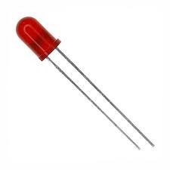

Figure 25: LED

* **Microphone (Sound Detection Sensor) Module: MX9814** It gives a measurement of how loud the sound is (max9814) we noticed that the range of db is not accurate and the maximum range is 80db not 60db .

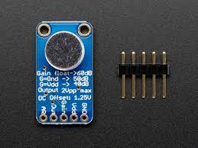

Figure 26: Microphone (Sound Detection Sensor) Module

## **4.5 System Architecture and Algorithms:**

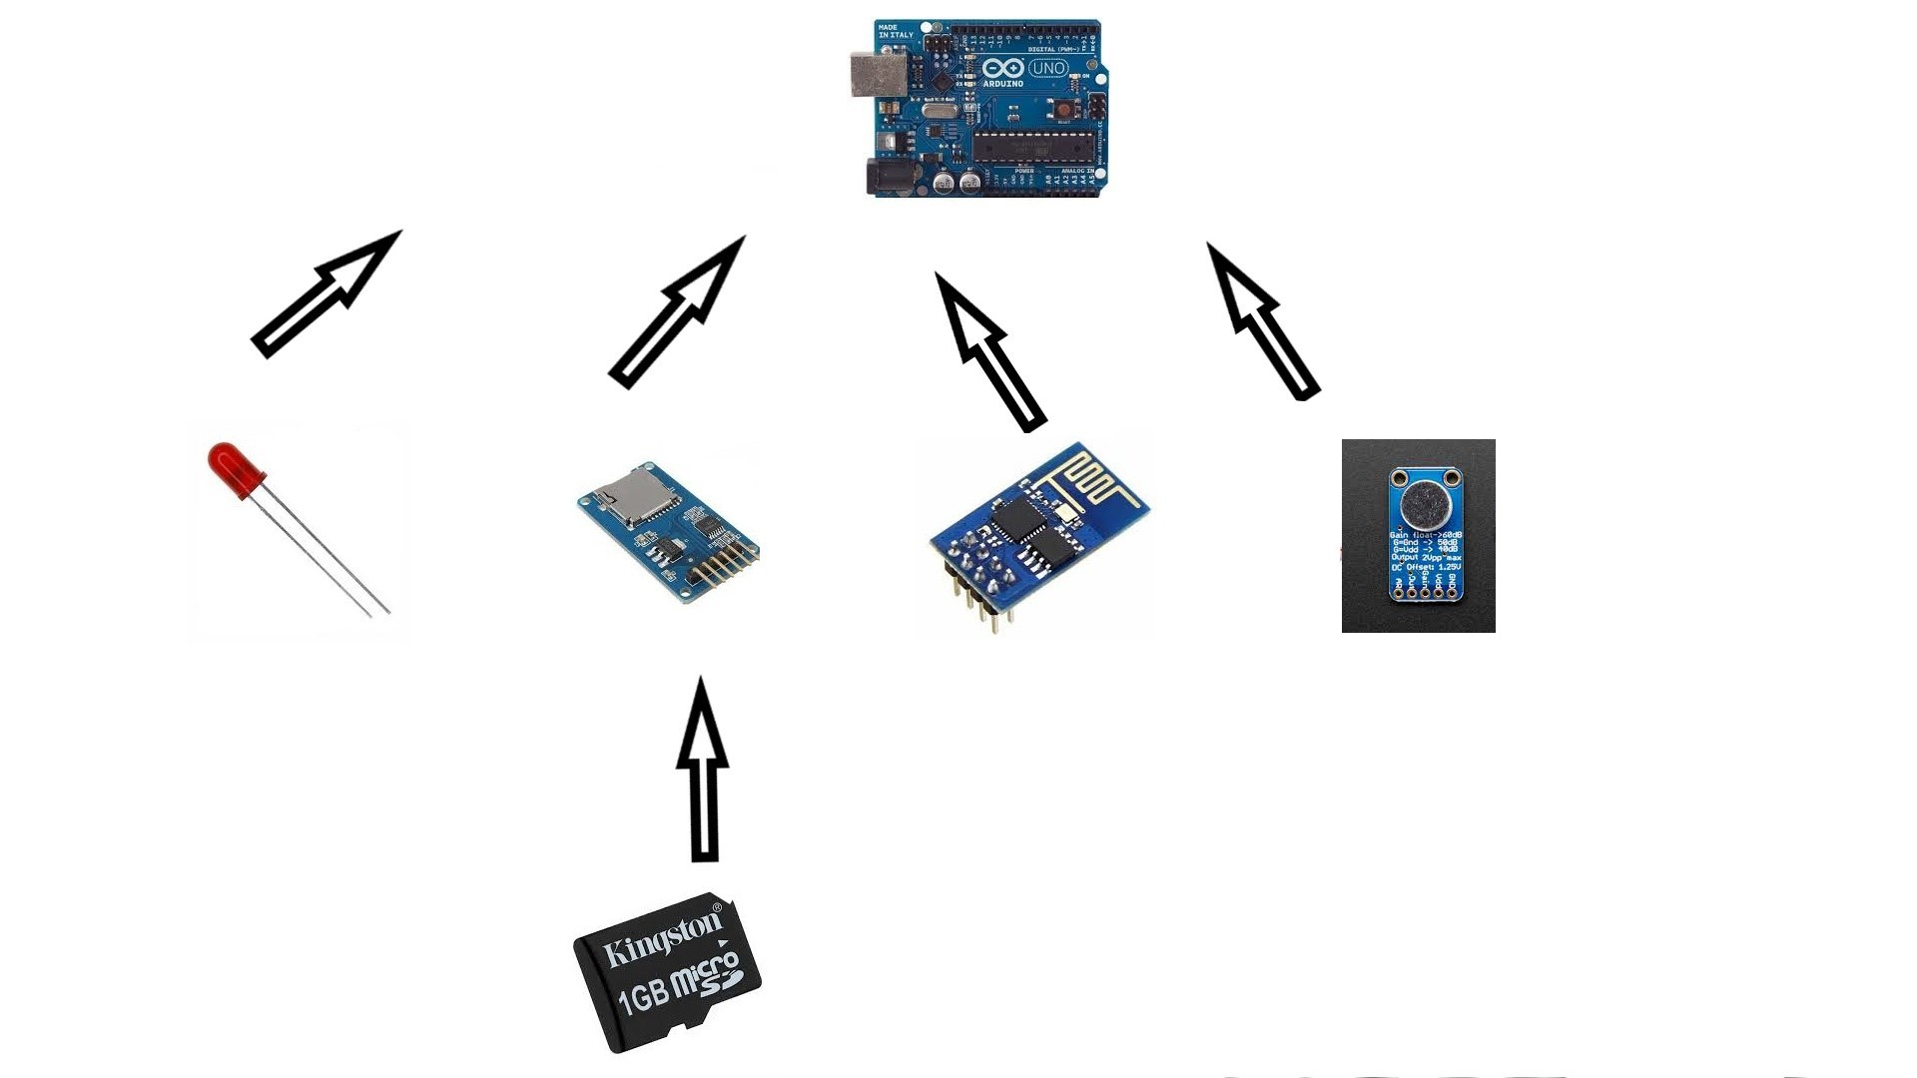

Figure 27: System Architecture and Algorithms-A

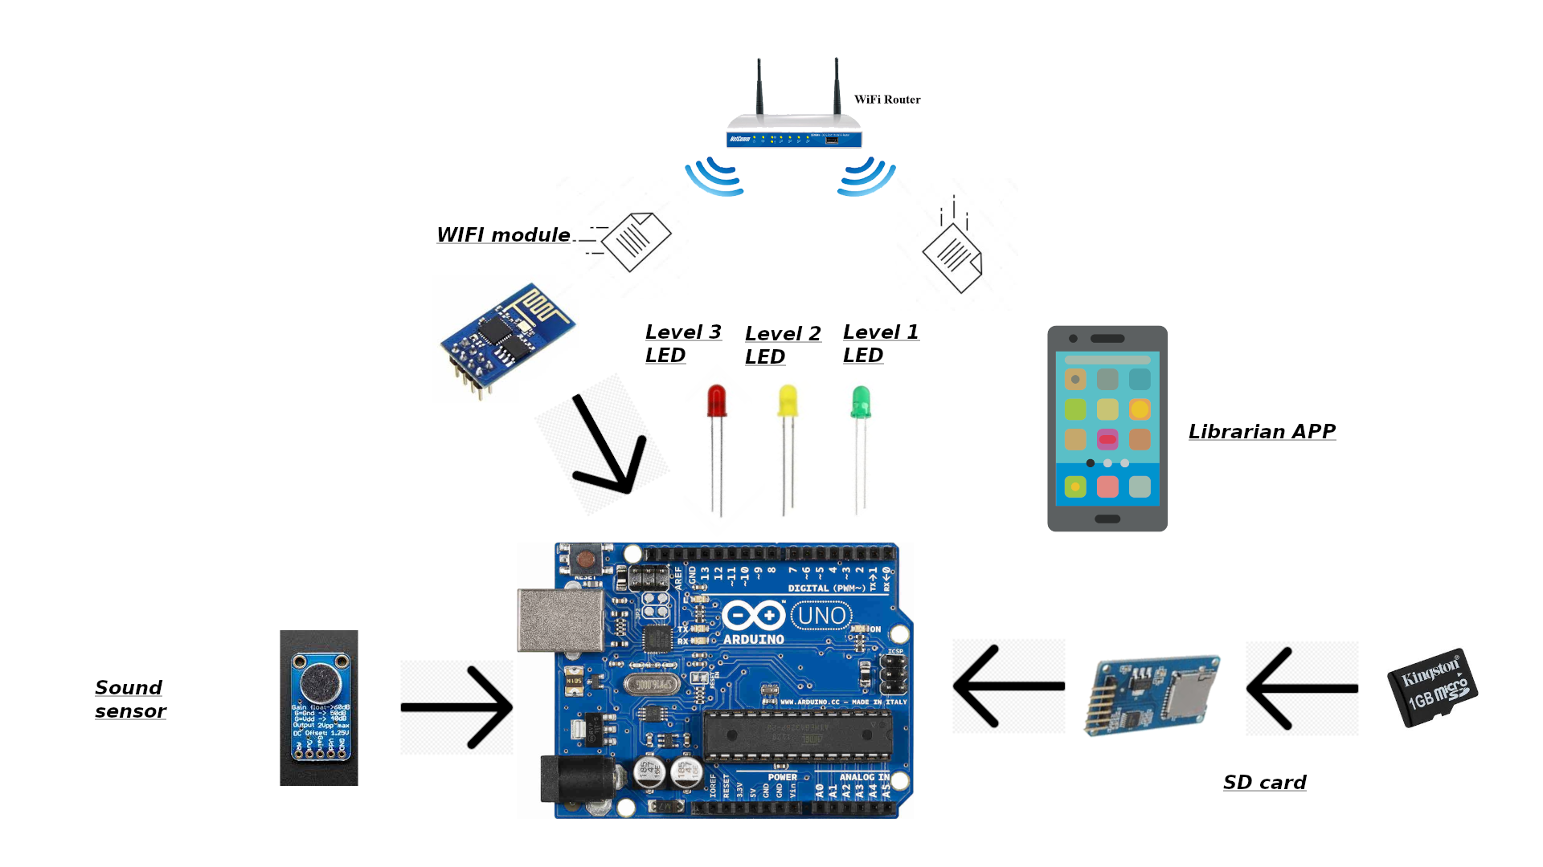

Figure : System Architecture and Algorithms-B

## **4.6 Voice Loudness Levels:**

In this section we will decide the loudness levels in real world value and represent them as Decibels.

Loudness Level:

* Level 1: 50 dB
* Level 2: 60 dB
* Level 3: 70 dB

## **4.7 Summary:**

In this chapter we explained the design of our system, we showed the class diagram for the application and talked about device components and what every single one of them will do.

**Chapter Five**

# Conclusions and Future Work:

## **5.1 Conclusion****:**

In this project, we have provided an initial design for a system that should help to keep library quiet for visitors so it provides a healthy learning atmosphere. Make the librarian job easier by adding IOT to his job, all of that will be achieved by our system that will give the visitors a self-monitoring by keep them in track of their voices loudness via LEDs and notify the librarian if the visitor got so noisy.

## **5.2 Future Work:**

1. Build the device with Wi-Fi 6 compatible module to decrease power consumption.
2. Add battery to the device to make the system truly wireless.

# References

(n.d.). Retrieved from https://cdn-shop.adafruit.com/datasheets/MAX9814.pdf

*design-and-construction-of-noise-detector-in-library*. (n.d.). Retrieved from https://hyclassproject.com/design-and-construction-of-noise-detector-in-library.html

*List_of_largest_libraries*. (n.d.). Retrieved from https://en.wikipedia.org/wiki/List_of_largest_libraries

*noise-detector-automatic-recording-system*. (n.d.). Retrieved from https://www.electronicsforu.com/electronics-projects/noise-detector-automatic-recording-system

*ProjectCaseStudy-NoiseAlarm*. (n.d.). Retrieved from https://csermoocs.adelaide.edu.au/library/ProjectCaseStudy-NoiseAlarm.pdf