**Chapter Two**

**Literature Review:**

**2.1 Overview :**

Many Existing Systems have been developed to provide sound alarming. However, there are limitations in what these systems provide, Each system has its advantages and disadvantages, so we will show what distinguishes our system in the next section.

**2.2 Existing System**

The most encouraging thing to start this idea is the lack of systems that are actually efficient.

After some time of research, we found similar systems with ideas that are similar to the idea of our system but lacking basic features needed in the library.

**1- Noise Detector with Automatic Recording System Using Arduino With The IoT**

**2- Design And Construction of noise detector in Library**

**3- Noise Alarm**

**2.2.1: Noise Detector with Automatic Recording System Using Arduino With The IoT** (noise-detector-automatic-recording-system)

This use a set of components that work together in order to achieve the goal of quiet and reasonably unobtrusive sound so we use a noise detector that consists of the power of the Arduino and connect the Bluetooth with the app When your sound level crosses the threshold value, the Noise Detector device will buzz to notify about it and at the same time the app will start recording the sound and it will go on recording until the noise level comes down below the threshold level.

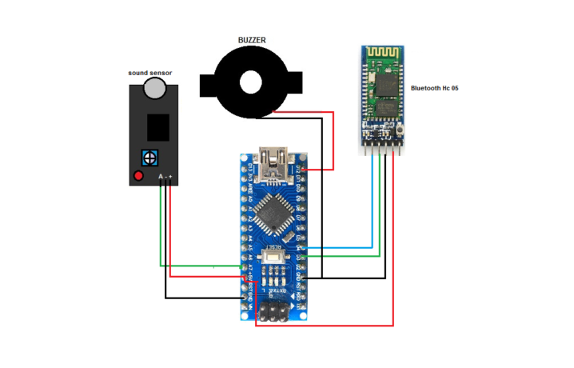

pro-1a

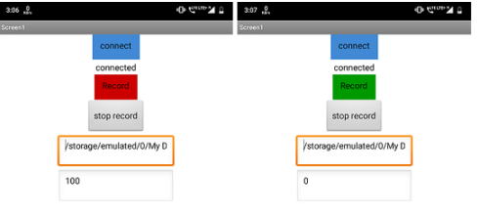

pro-1b

**advantages:**

**1-** it can record voice for one minute and save it.

**2-** it is connected to the android device using an application wirelessly.

**disadvantages:**

**1-** the distance between mobile and device should be small due to the Bluetooth connection.

**2-** cant connect more than one device due to Bluetooth limitations.

**3-** it has a buzzer so it’s annoying.

**2.2.2: Design And Construction of noise detector in Library** (design-and-construction-of-noise-detector-in-library)

This project is for the design and construction of the NOISE DETECTOR IN LIBRARY. This device is able to detect the noise, compare the intensity of louder sound, and hence producing the warning signal to the librarian. This system is very economical and helpful in maintaining peace in the library.

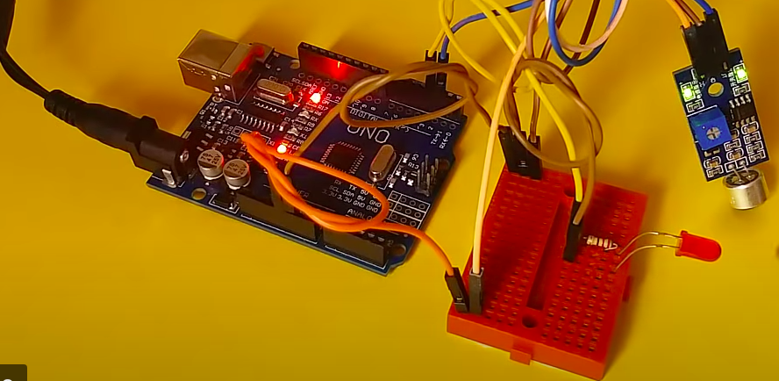pro-2

**advantages:**

**1-** It is simple.

**disadvantages:**

**1-** it should be wired all through the library.

**2-** if there is a big number of devices it will take a big space like a wall of lids.

**3-** librarian cant moves around freely.

**4-** one level of the indicator.

**2.2.3**: **Noise alarm** (ProjectCaseStudy-NoiseAlarm)

this project creates a visual noise detector, using LittleBits sensors to relay noise information via an Arduino board through to our Processing-based software system that will visually indicate when the noise has been detected.

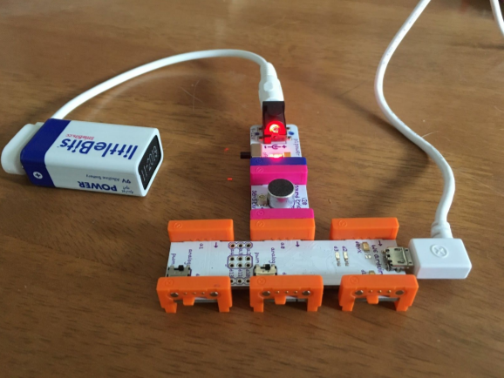

pro-3

**advantages:**

**1-** It is simple.

**2-** multiple levels of indicators.

**disadvantages:**

**1-** it should be wired all through the library.

**2-** if there is a big number of devices it will take a big space like a wall of lids.

**3-** librarian cant moves around freely.

|  |  |  |  |  |
| --- | --- | --- | --- | --- |
| System/ Feature | **Existing System**  **1** | **Existing System**  **2** | **Existing System**  **3** | **Our**  **System** |
| App |  |  |  |  |
| Wifi |  |  |  |  |
| Led indicators |  |  |  |  |
| Multiple levels of loudness |  |  |  |  |
| Support multiple devices |  |  |  |  |
| Bluetooth |  |  |  |  |

## 2.3 Summary

In this chapter, we have looked up and discussed the existing systems which are similar to our system. We also showed the advantages and disadvantages of these systems.

We showed and studied the disadvantages in order to avoid them in our system and take advantage of the previous systems to implement in our system.

# References

# 

*design-and-construction-of-noise-detector-in-library*. (n.d.). Retrieved from hyclassproject: https://hyclassproject.com/design-and-construction-of-noise-detector-in-library.html

*noise-detector-automatic-recording-system*. (n.d.). Retrieved from electronicsforu: https://www.electronicsforu.com/electronics-projects/noise-detector-automatic-recording-system

*ProjectCaseStudy-NoiseAlarm*. (n.d.). Retrieved from csermoocs.adelaide: https://csermoocs.adelaide.edu.au/library/ProjectCaseStudy-NoiseAlarm.pdf