**Chapter Three**

**System Analysis**

# **3.1 Introduction:**

In this chapter we will explain the user requirements, system requirements (functional, non-functional), development Methodology (Use Case Diagrams, Activity Diagram, Sequence Diagram, Flow Chart, and System Diagram) and we will explain system components and how it will be integrated into final system. We will divide our system into two main components

1. The application
2. The device(it is the arduino and all components will be added to it that will be placed on the table)

**3.2 Analysis of Existing Systems**

We will try to get all benefits and discard weakness of existing systems we showed in chapter two.

WIFI over Bluetooth : because it is more reliable ,has longer connection distance, can connect bigger number of devices.

LEDS and an application over sound alarm: it is not noisy and easier to librarian to know the sound source

**3.3 Requirements:**

**3.3.1 User Requirements:**

1. The devices should be connected to the network wirelessly.
2. The librarian should get notified of the loud table via an application.
3. The librarian should be able change the number of the devices (Tables) via the application.
4. The library should be able to add new devices to new tables.
5. The library visitors should be able to see their voices loudness via LEDS placed on the devices.

## 3.3.2 System Requirements:

**3.3.2.1 Functional Requirements:**

1. The system should keep sensing voices continuously.
2. The system should be able stay working day and night (all the time).
3. The system should notify the librarian of the loud table via an application.
4. The system should compare the detected voices to decide loudness level
5. The system should display the voice loudness for the library visitors via LEDS.
6. The system should allow to librarian to change device number via the application.
7. The system should be able to acquire the ip address from router DHCP to the devices.

**3.3.2.2 Non-Functional Requirements:**

Non-functional requirements define the behaviour, features, and general characteristics of the system.

1- Speed: Response time for the noise should not exceed 1 second

2- Size: device size should be acceptable, small size is preferred to be placed on the desks.

3- Ease of use: the application should be easy enough for users to use without training and device easy to install.

4- Reliability: It should give the correct information about the table number that has level three loudness.

5- Robustness: If there is a malfunction in the system, the system should work again after less than a minute.

6- Portability: the librarian should be able move inside library freely and still get notification from devices.

# 

# **3.3.3 Noise Detection System Diagram**

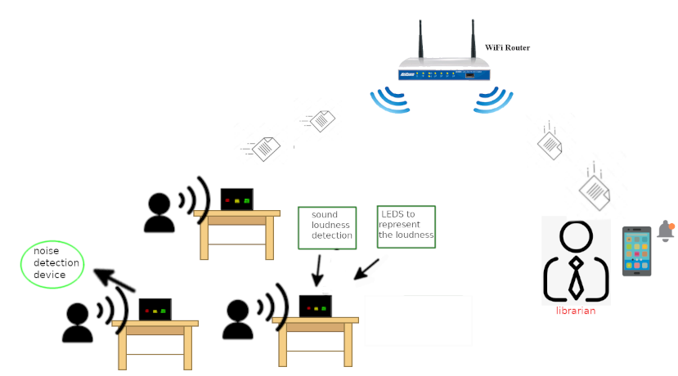

# **3.4 Development Methodology**

**3.4.1 Use Case Diagram**

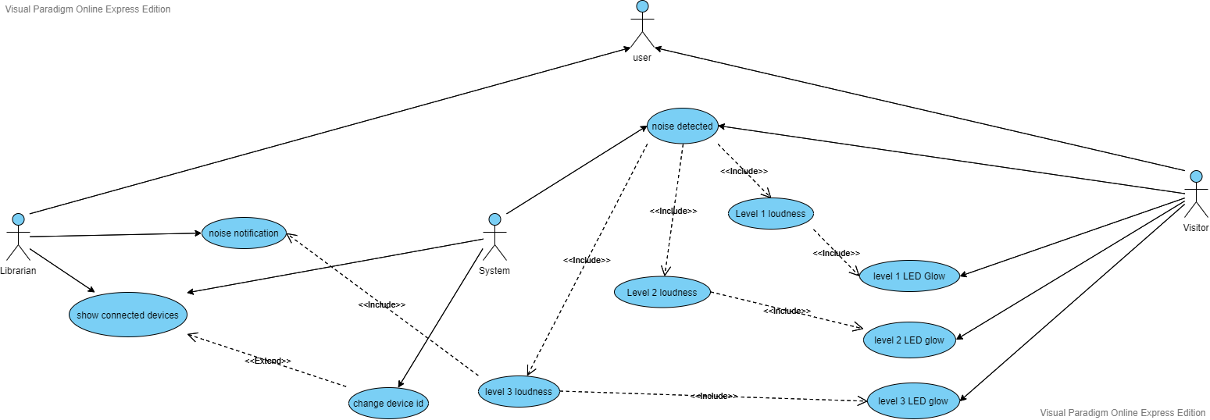

## 

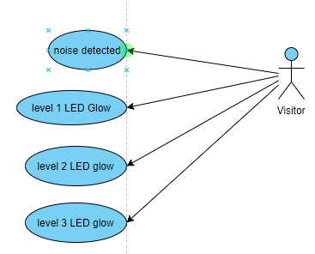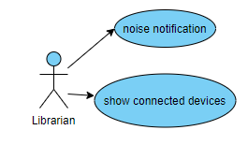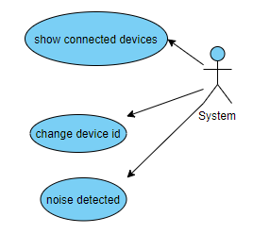

## 3.4.2 Use Case Description

|  |  |  |  |
| --- | --- | --- | --- |
| ***Use case*** | ***Actors*** | ***Type*** | ***Description*** |
| noise notification | System | Primary and essential | System send notification to the user  in case the loudness is level 3 |
| show connected devices | Librarian | Primary and essential | The system should fetch all devices connected to system to librarian app |
| change device id | Librarian | Secondary | The user is able to change devices id |
| noise detected | System | Primary and essential | The user should monitor voices and determine what it is loudness level |
| Level 1 loudness | System | Secondary and essential | The system determine the next actions based on this use case |
| Level 2 loudness | System | Secondary and essential | The system determine the next actions based on this use case |
| Level 3 loudness | System | Secondary and essential | The system determine the next actions based on this use case |
| level 1 LED Glow | System | Secondary and essential | The system will fire the level 1 LED in case the loudness is level 1 |
| level 2 LED Glow | System | Secondary and essential | The system will fire the level 2 LED in case the loudness is level 2 |
| level 3 LED Glow | System | Secondary and essential | The system will fire the level 3 LED in case the loudness is level 3 |

Table 2: Use case

**3.4.2 Flowchart**

Flowchart is a type of diagram that represents a workflow or process, and makes it easy to understand how system works

**3.4.2.1 Application**

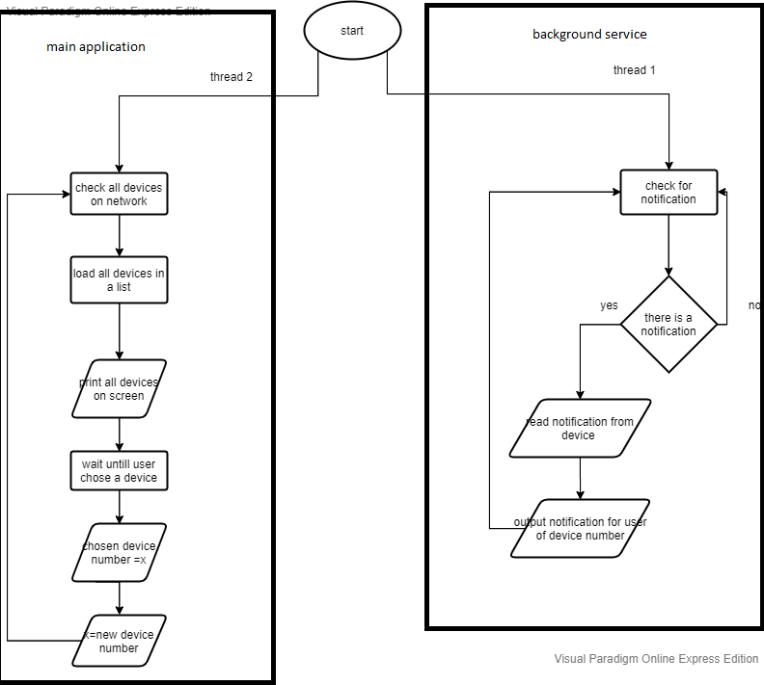

**3.4.2.2 Device**

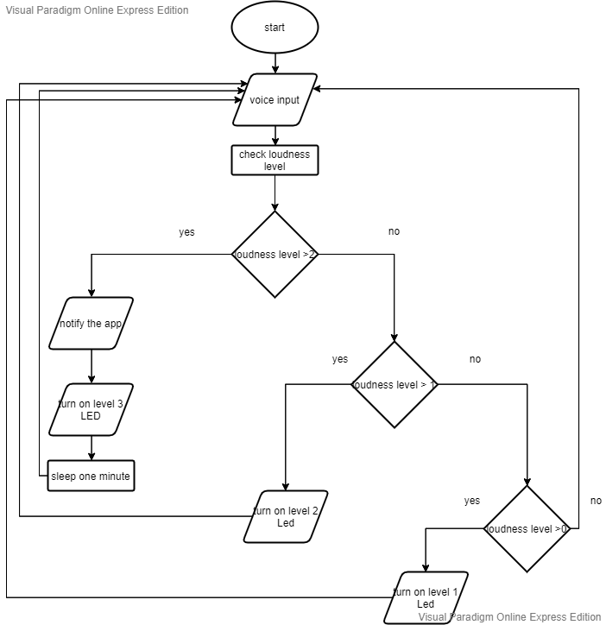

**3.4.3 Activity Diagram**

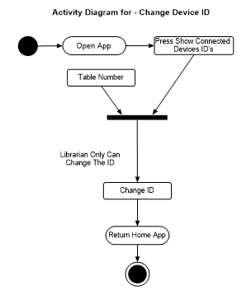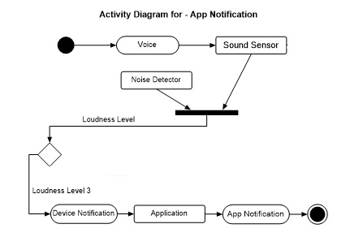



**3.4.4 Sequence Diagram**

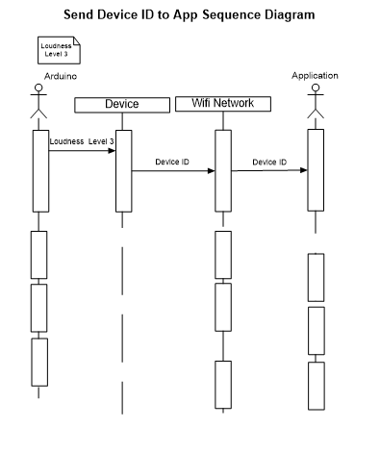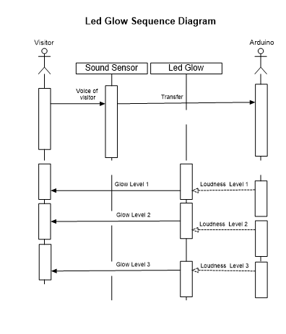



**3.4.5 Context Diagram**



**3.5 Summary**

In this chapter we showed requirements of our system (user requirement, functional requirements, non-functional requirements) and explained how the system will work and its components, all of that is showed through a Development Methodology’s (activity diagram, use case diagram, flowchart and sequence diagram)