**Chapter Four**

**System Design and Solution:**

**ـــــــــــــــــــــــــــــــــــــــــــــــــــــــــــــــــــــــــــــــــــــــــــــــــــــــــــــــــ**

**4.1 Introduction**

In this chapter we will work on designing our system so we will head to achieve our system requirements that we described in chapter three to come with overall complete design of the system.

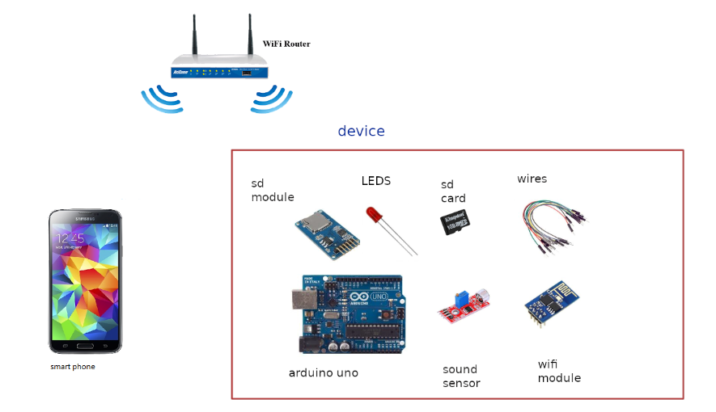

**4.2 Class Diagram**

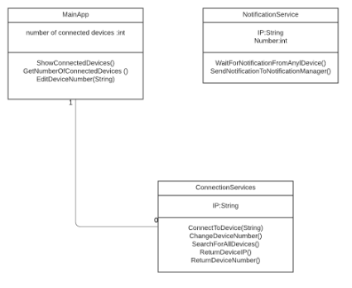

**4.3 Software Component**

* **Flutter(Dart)**

**4.3.1 Software Description**

* **Flutter:** Offering cross-platform, native-like, and superior experiences, Flutter has emerged as one of the top choices for cross-platform app development.(we chosen flutter over other option because it is strongest cross platform for smart phone application programing)



**4.4 Hardware Components**

* **Arduino Uno**
* **Wi-Fi Module**
* **SD Card Module**
* **SD Card**
* **LED**
* **Microphone Sound Detection Sensor Module**

**4.4.1 Hardware Description**

* **Arduino Uno:** is an open-source microcontroller The board is equipped with sets of digital and analog input/output pins that may be interfaced to various expansion boards and other circuits and it can be programed using C++.

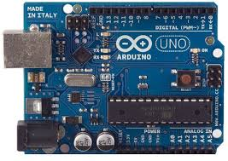

* **Wi-Fi Module:** self-contained SOC with integrated TCP/IP protocol that can give any arduino access to Wi-Fi network.

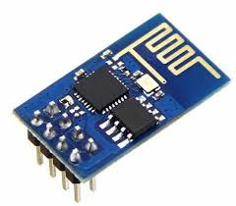

* **SD Card Module:** it is an interface to give ability to add SD Card to the arduino.

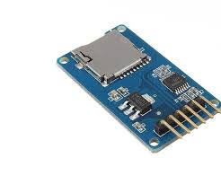

* **SD Card:** it is a form of small non-volatile memory.

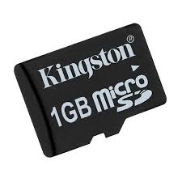

* **LED**:is a semiconductor light source that emits light

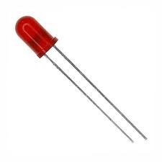

* **Microphone (Sound Detection Sensor) Module:** It gives a measurement of how loud a sound is.

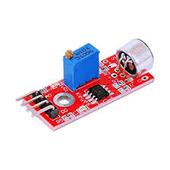

**4.5 System Architecture and Algorithms**

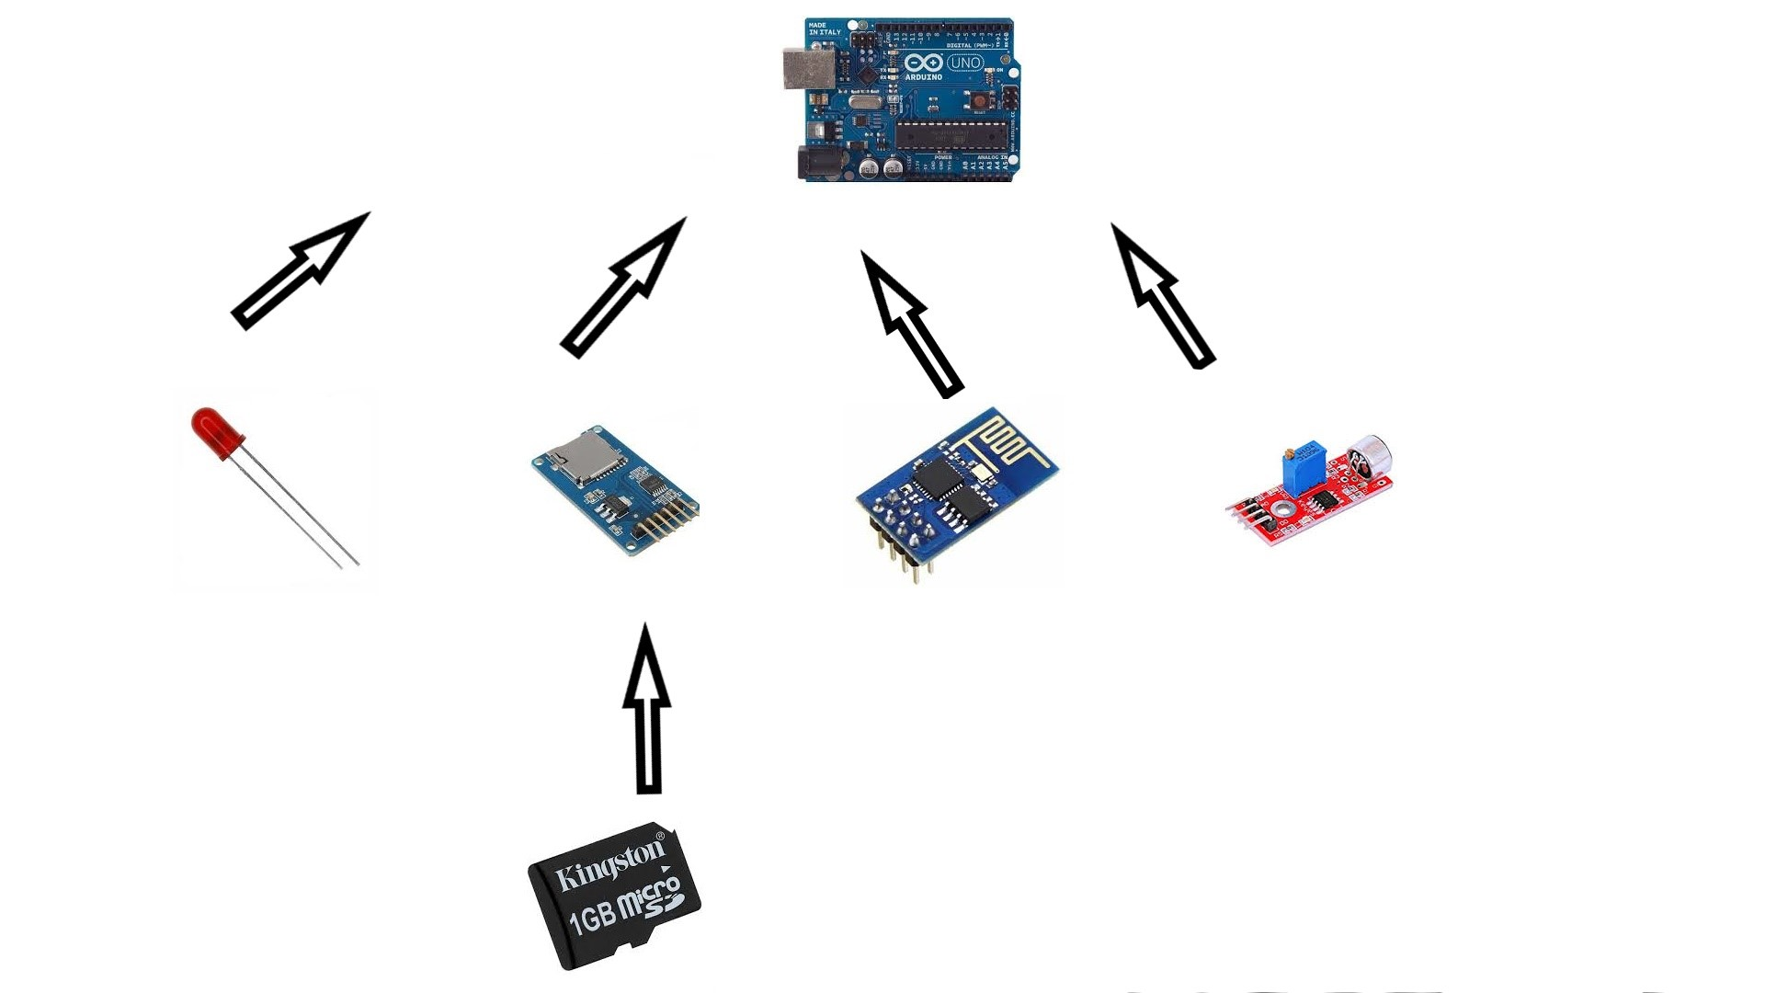

## **4.6 Summary**

In this chapter we explained the design of our system , we showed the class diagram for the application and talked about device components and what every single one of them will do.