Yazan Ahmad Jarrar ASS#2 12154165

Test error = 76.5%

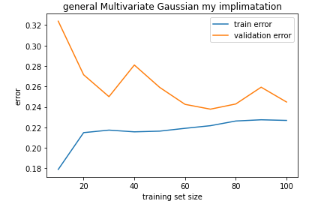

Test error = 75.7%

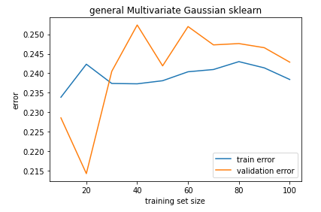

**Problem one:**

The tow results are quite the same the only big difference is in validation at the start and the reason for that might be that the sample data chosen are random so it might have that one algorithm has chosen a data that are more similar to the training data by coincidence and the other has chosen a data that are different from training data.

Test error = 76.7%

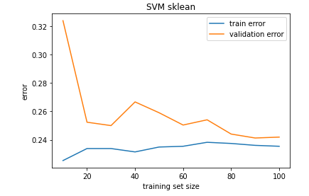

Test error = 74.5%

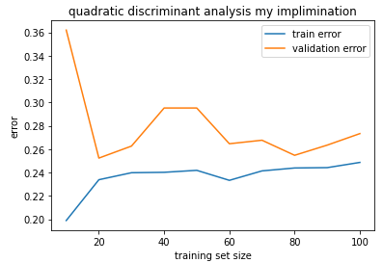

**Problem two:**

These tow results are almost the same in validation error, training error and test error but SVM is slightly better at all aspects.

**Conclusion:**

All algorithms gave a results close to each other’s with SVM as most accurate classifier but with downside that it is slow in training and Multivariate Gaussian classifier as fastest learner.