Yazan Jarrar Assignment 3 12154165

1)

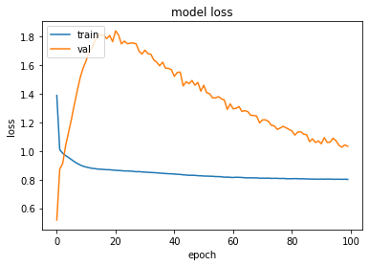

the equation is simple so at first epochs the model learned it then the model faced an overfitting state after that the model started learning again until the end

2)

The best model is the model with 2 hidden layers

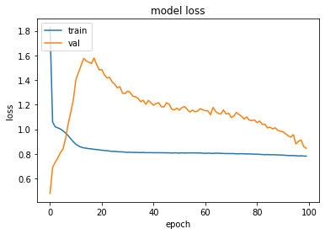

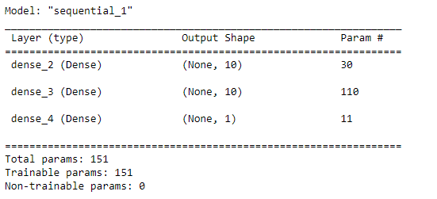

3)

a) Overfitting avoiding:

early stopping: stopped the model at first two epochs before overfitting problem

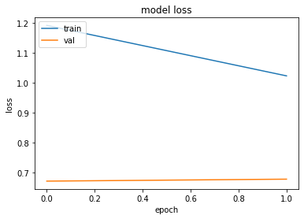

l1 regularization with λ = 0.5(I tried several values and this was the best)

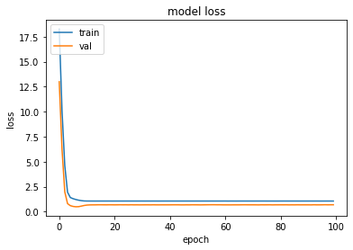

l1 regularization with λ = 0.5(I tried several values and almost all values gave a close results)

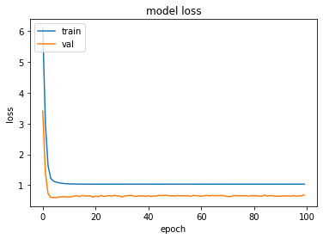

Max norm : made the model worst:

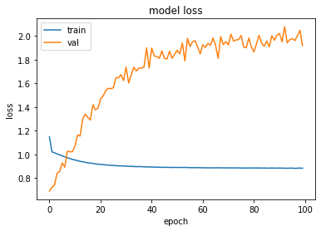

Dropout : at fixed the overfitting at the end

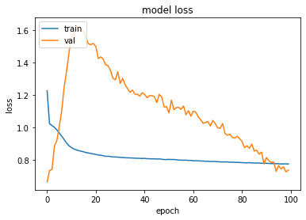

b) parameter initialization: didn’t affect the model because it is not facing vanishing gradient problem

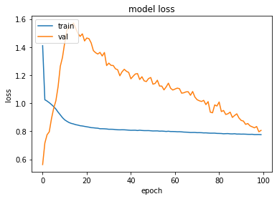

nonsaturating activation function:using relu activation function caused the model to stop learning properly and got in underffittng

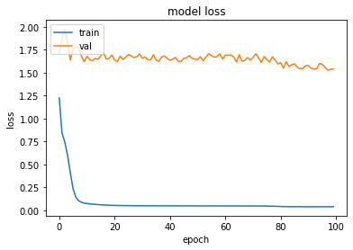

Batch normalization: it slowed down the model learning rate

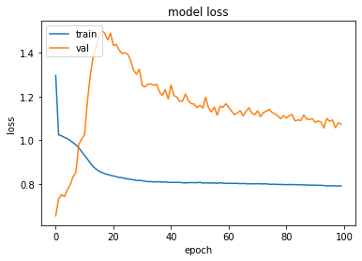

gradient clipping: using it caused to increase overfitting problem in this model

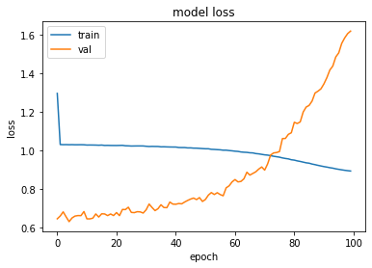

c)Sgd vs adam

Sgd : caused the model to overfit state

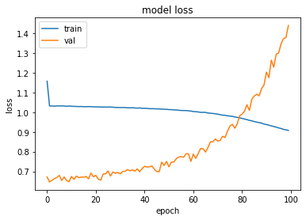

Adam : slowed down the learning

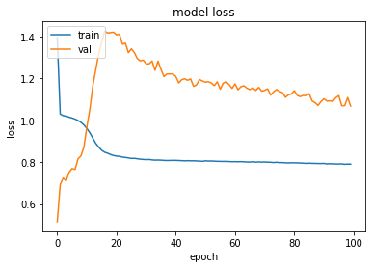

d) 5 neurons

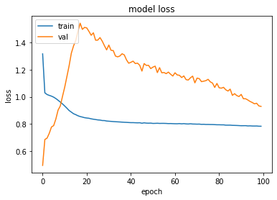

10 neurons



15 neurons : the model accuracy kept increasing by increasing the number of neurons

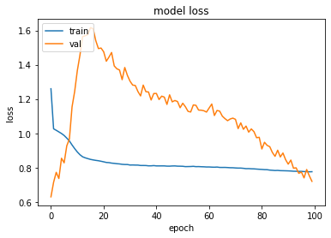

e)batch size 64



Mini batch 32

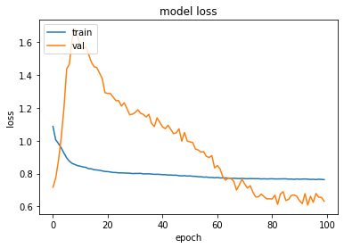

Mini batch 24 : the lower the mini batch the better to avoide overfitting on small dataset

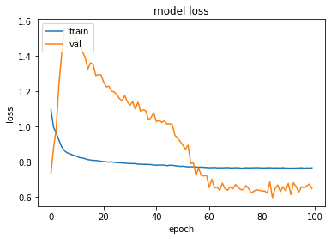

F) simoid



Linear: got in underfitting state

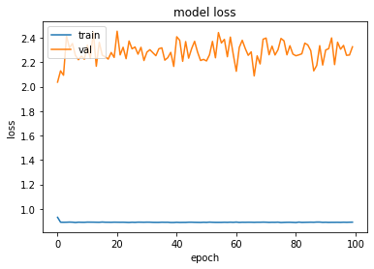

Tan h : at first it gave a better results then got into overfitting at epoch 20 because tan h learns faster than sigmoid

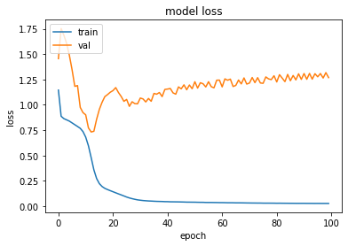

After all the tuning I got this model as the best model for this dataset

Optimizer: adam , epochs:20 , batch_size:64 , neurons:15,15,1

Activation function: tanh , l1 regularizer

