Self check: one pin is input and other is output. We want to check if the input we inserted is shown on the output. For example:
We used pin 0 as output and pin 16 as input. When toggling switch 4 it shows the expected output. We can do this to various pins changing on the code. (file : selected pin)
Initial state : only LD1 is on , all switches are off
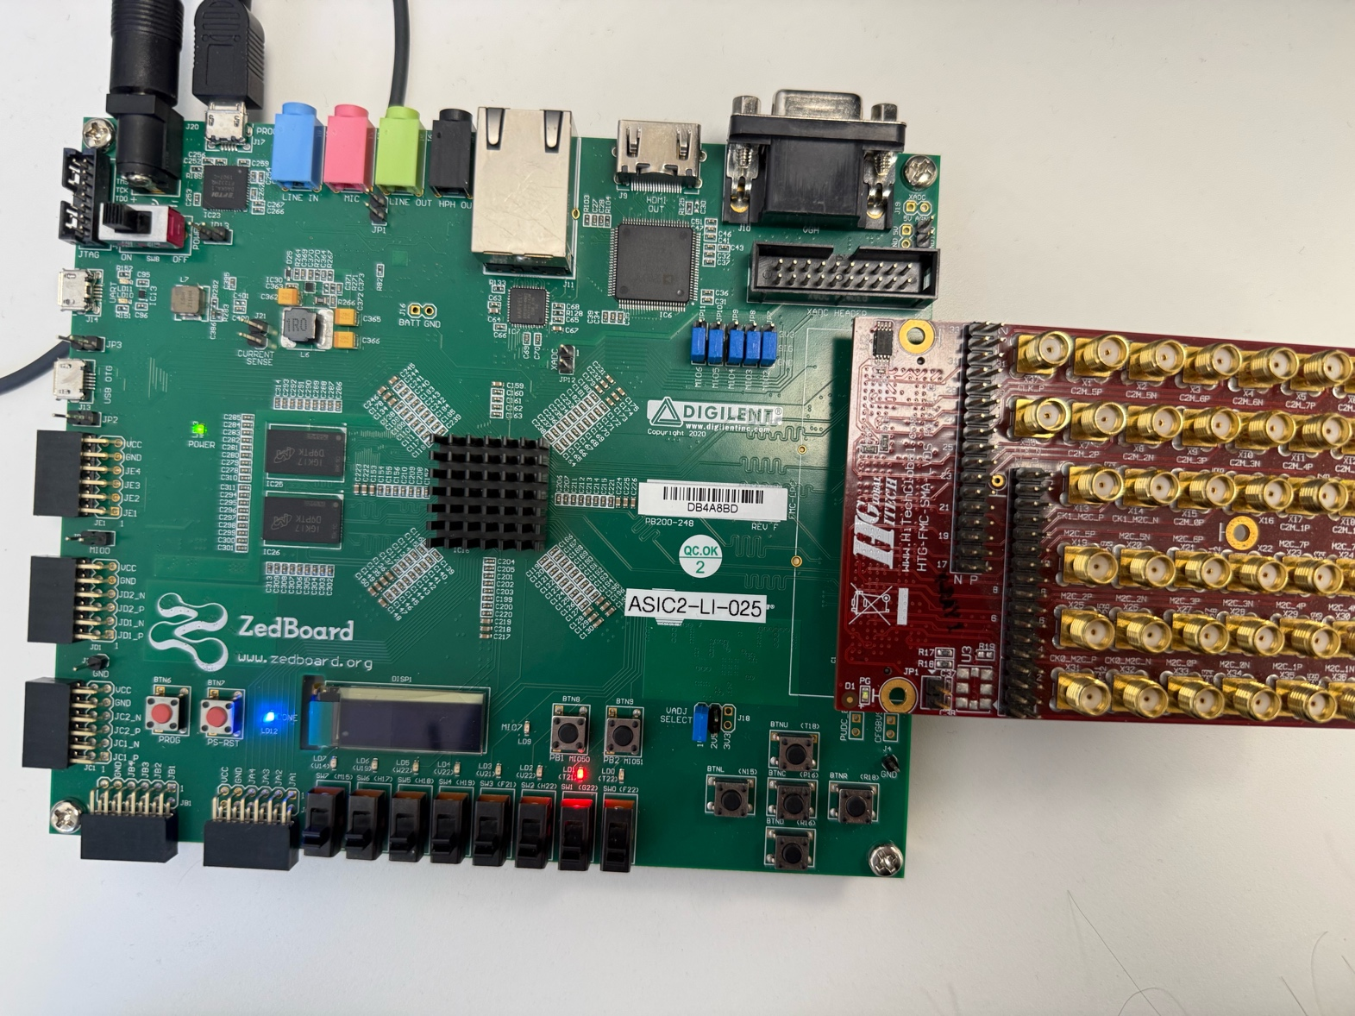

When connecting pin 0 and pin 16 with female to female jumper wires: LD2 is on and LD1 is off
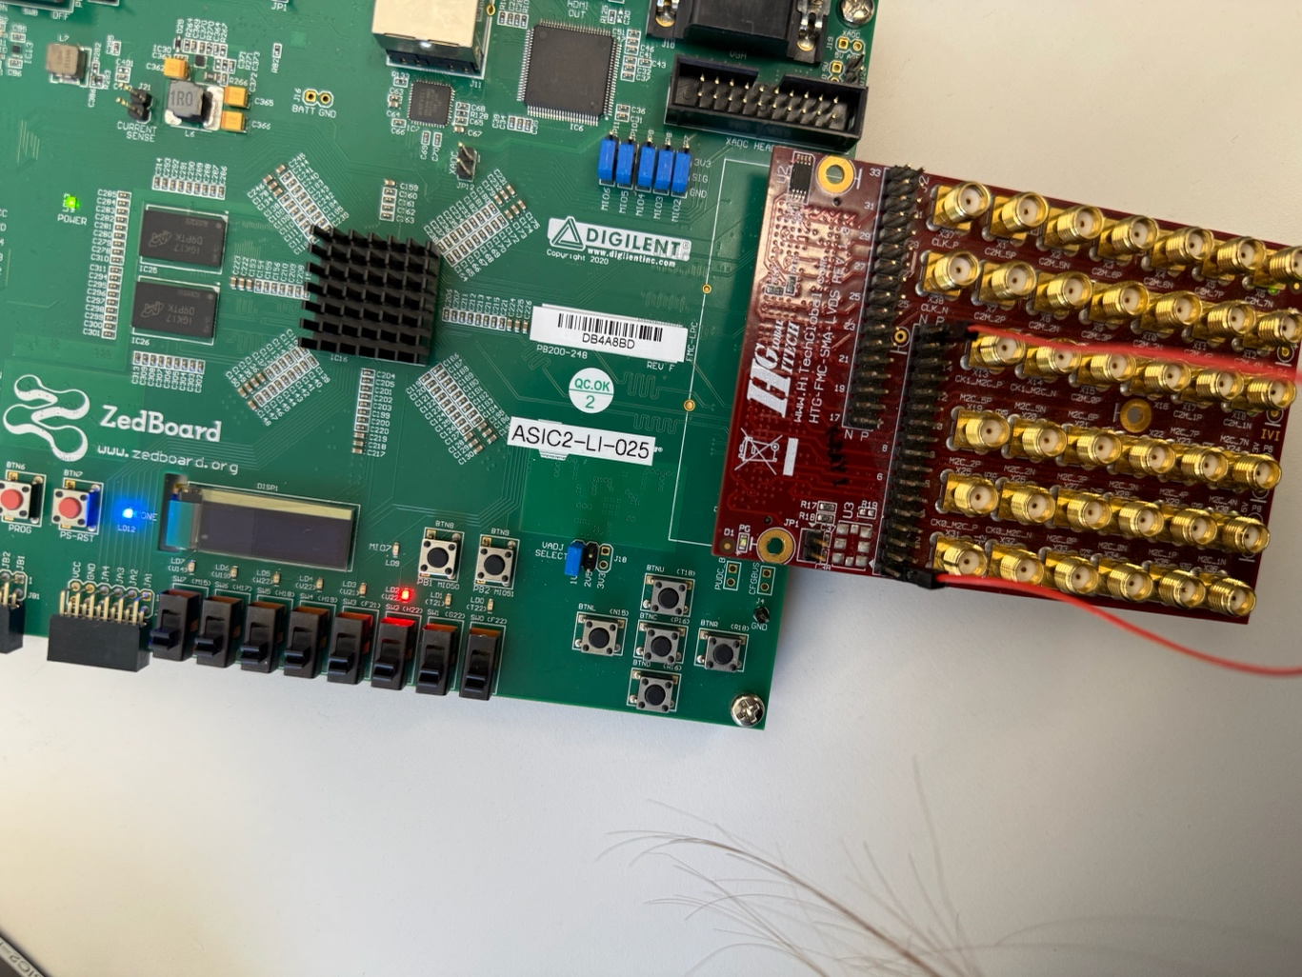

Turning switch 4 on : LD0,LD1,LD2 are on now. And this is as expected – we signed in the code to get this output and it gives the exact thing
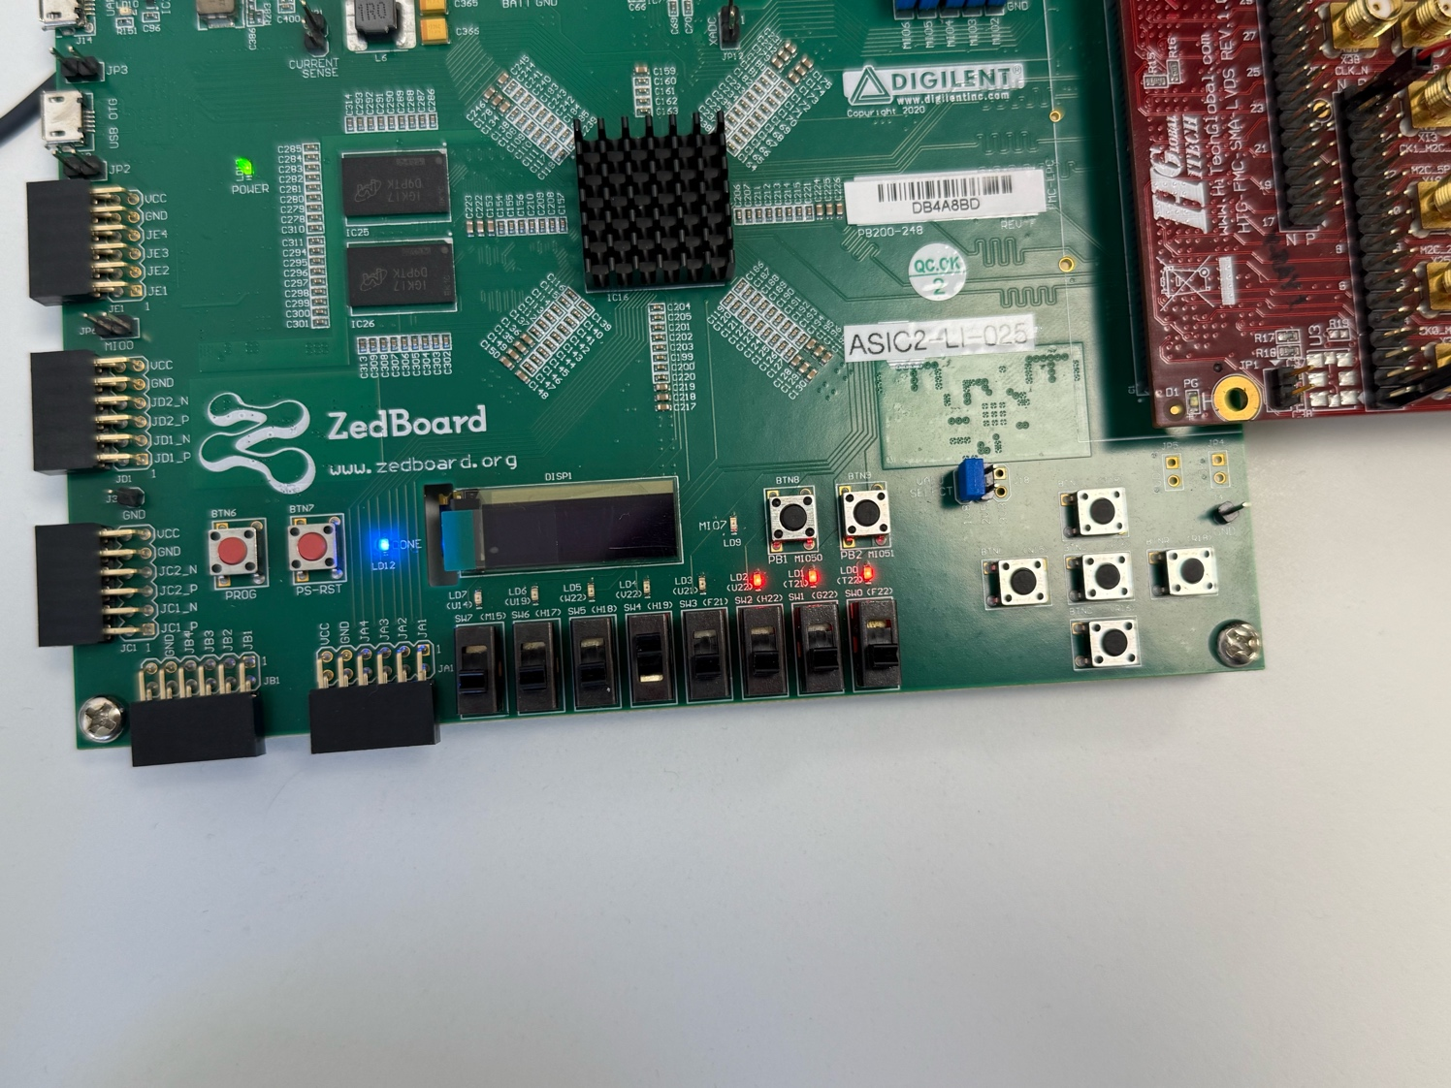

So for now, we only had the on-off process ‘1’,’0’.

Trying the pins with clock signal or any other signal that changes :duty cycle 50% , voltage 0v to 1.8 v, 1MHz
The same result as the previous situation

Now we tried with slower clock 100Hz so the multimeter can measure.
To make sure the code is correct and the pin 0 acting as an output and pin 16 as input is correct we connect the red prob from the multimeter to pin 0, and the black prob (COM) to the ground.
We connect both pin 0 and 16 via female to female jumper wires, so when we are in initial state the multimeter reads 0.000v
When we connect the pins together it statys on 0.000v as the switch 4 still off.
When we turn on switch 4 – it reads 0.899v that is correct, because we have duty cycle 50% and the voltage range is 0-1.8v so we expect reading 0.9v and this is what we got !
LD0,1,2 are on when switch 4 is on.
Only LD1 is on when pins are not connected
Only LD2 is on when pins are connected and switch 4 is off.
The whole process was SELF-CHECK !!
