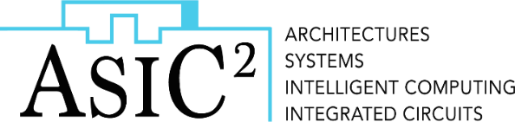
Taken !!

FPGA-Based Digital Signals Generation System for Y-Flash-Based Artificial Neural Network Analysis
Recently, several nonvolatile memory (NVM) technologies, such as NAND Flash, PCM, ReRAM, and STT-MRAM, have emerged as promising candidates for digital and analog in-memory computation. Tower’s Y-Flash NVM, fully compatible with standard CMOS process, can be used as a building block which can be used in many artificial neural networks (ANNs) applications owing its multilevel characteristic.
In this project, you will develop an experimental setup to write the weights of an ANN to a Y-Flash memory array. You will learn the FPGA environment and use it to develop an experimental setup for digital control signals.
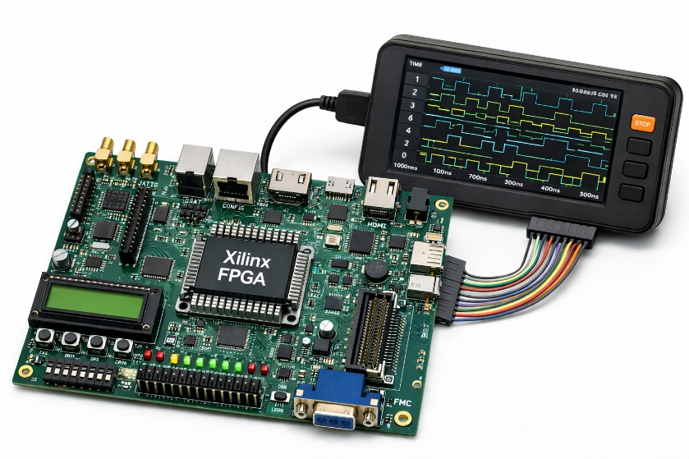
This project is part of the NEMO research project, where we aim to implement ultra-low-power ANN hardware accelerators.

Project Goals:
The goal of this project is to build a framework system that generates the digital control signals for using an FPGA platform.
The students will:
- Learn about emerging memory technologies and processing in memory for ANN hardware accelerators.
- Gain practical experience with FPGA platform combined with research purposes for experimental characterization.
Prerequisites:
- Courses: Electronic Circuits
- Programming: Python, Verilog / VHDL
For more information: ilan.l@technion.ac.il (Ilan Lipschutz)

