Appendix

2024-08-15

## Figure 1 - Normalized RMSE of Successive Imputations: MICE vs missForest

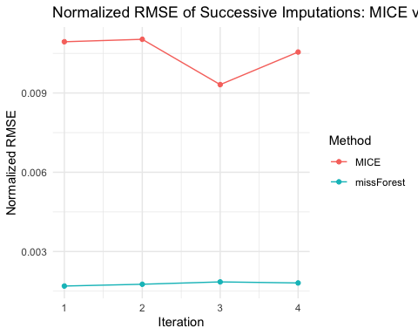

## Table 1 - Summary Stats Comparing Imputed vs. Original Data

| Statistic: 2019 Budget | Imputed | Original |
| --- | --- | --- |
| Min. | 0 | 0 |
| 1st Qu..25% | 812,458 | 780,958 |
| Median | 3,379,262 | 3,500,000 |
| Mean | 27,653,294 | 32,079,766 |
| 3rd Qu..75% | 17,948,947 | 20,000,000 |
| Max. | 6,476,471,967 | 6,476,471,967 |
| NA’s | 0 | 779 |

| Statistic: 2020 Budget | Imputed | Original |
| --- | --- | --- |
| Min. | 0 | 0 |
| 1st Qu..25% | 828,605 | 809,000 |
| Median | 3,465,179 | 3,617,880 |
| Mean | 25,776,958 | 29,699,647 |
| 3rd Qu..75% | 18,026,674 | 20,701,825 |
| Max. | 5,500,000,000 | 5,500,000,000 |
| NA’s | 0 | 780 |

| Statistic: 2021 Budget | Imputed | Original |
| --- | --- | --- |
| Min. | 0 | 0 |
| 1st Qu..25% | 960,919 | 1,414,839 |
| Median | 3,252,206 | 6,950,699 |
| Mean | 26,039,525 | 36,472,230 |
| 3rd Qu..75% | 16,651,818 | 25,817,561 |
| Max. | 5,400,000,000 | 5,400,000,000 |
| NA’s | 0 | 1,141 |

## Table 2 - Peaceful Analysis Pre Matching

| Variable | Control Mean | Treatment Mean | Control Std Dev | Treatment Std Dev | Control Percentage | Treatment Percentage |
| --- | --- | --- | --- | --- | --- | --- |
| Ideology | 0.13519 | 0.03546 | 0.23192 | 0.19109 | NA | NA |
| Percent Female | 0.50826 | 0.51026 | 0.04427 | 0.02556 | NA | NA |
| Percent Age 0-17 | 0.22362 | 0.21720 | 0.05783 | 0.04709 | NA | NA |
| Percent Age 18-34 | 0.22553 | 0.24557 | 0.07184 | 0.07808 | NA | NA |
| Percent Age 35-59 | 0.30285 | 0.30232 | 0.04996 | 0.04250 | NA | NA |
| Percent Age 60-74 | 0.16883 | 0.15979 | 0.05698 | 0.04485 | NA | NA |
| Percent Age 75+ | 0.07921 | 0.07510 | 0.04040 | 0.03098 | NA | NA |
| Percent Black | 0.12332 | 0.13019 | 0.18388 | 0.16114 | NA | NA |
| Percent White | 0.73338 | 0.68885 | 0.21669 | 0.19209 | NA | NA |
| Percent Hispanic | 0.12700 | 0.16399 | 0.16887 | 0.17802 | NA | NA |
| Percent Less Than High School | 0.02989 | 0.02946 | 0.02814 | 0.02293 | NA | NA |
| Percent Associates | 0.06202 | 0.05808 | 0.02647 | 0.01915 | NA | NA |
| Percent Bachelors | 0.11279 | 0.13325 | 0.06115 | 0.05917 | NA | NA |
| Percent Graduate/Professional | 0.06603 | 0.08747 | 0.05232 | 0.05809 | NA | NA |
| Percent Not in Labor Force | 0.31879 | 0.31027 | 0.08509 | 0.06688 | NA | NA |
| Median Household Income | 64974.35138 | 71316.25490 | 27736.76340 | 29241.06157 | NA | NA |
| Has Police Killing | NA | NA | NA | NA | 0.2917716 | 0.5393258 |

## Table 3 - Violent Analysis Pre Matching

| Variable | Control Mean | Treatment Mean | Control Std Dev | Treatment Std Dev | Control Percentage | Treatment Percentage |
| --- | --- | --- | --- | --- | --- | --- |
| Ideology | 0.13805 | -0.12890 | 0.21044 | 0.17804 | NA | NA |
| Percent Female | 0.50869 | 0.51015 | 0.04190 | 0.01339 | NA | NA |
| Percent Age 0-17 | 0.22286 | 0.21312 | 0.05718 | 0.03292 | NA | NA |
| Percent Age 18-34 | 0.22485 | 0.27931 | 0.07336 | 0.06331 | NA | NA |
| Percent Age 35-59 | 0.30256 | 0.30357 | 0.04970 | 0.03136 | NA | NA |
| Percent Age 60-74 | 0.16922 | 0.14397 | 0.05600 | 0.02377 | NA | NA |
| Percent Age 75+ | 0.08052 | 0.06004 | 0.03935 | 0.01493 | NA | NA |
| Percent Black | 0.11423 | 0.20300 | 0.17657 | 0.16127 | NA | NA |
| Percent White | 0.73989 | 0.57930 | 0.20935 | 0.15729 | NA | NA |
| Percent Hispanic | 0.13207 | 0.18253 | 0.17312 | 0.16222 | NA | NA |
| Percent Less Than High School | 0.02943 | 0.03205 | 0.02737 | 0.02076 | NA | NA |
| Percent Associates | 0.06170 | 0.05460 | 0.02567 | 0.01231 | NA | NA |
| Percent Bachelors | 0.11541 | 0.14483 | 0.06222 | 0.04681 | NA | NA |
| Percent Graduate/Professional | 0.06908 | 0.09746 | 0.05546 | 0.04508 | NA | NA |
| Percent Not in Labor Force | 0.32085 | 0.28371 | 0.08338 | 0.03689 | NA | NA |
| Median Household Income | 66537.97519 | 69700.01835 | 29012.14155 | 23187.94572 | NA | NA |
| Has Police Killing | NA | NA | NA | NA | 0.2936297 | 0.8853211 |

## Table 4 - DID Analysis Pre-Matching Peaceful

| Variable | Estimate | Std_Error | t_value | P_Value |
| --- | --- | --- | --- | --- |
| (Intercept) | 27282517.8 | 3311141 | 8.2396120 | 0.0000000 |
| peaceful_protest | 1633134.2 | 5951160 | 0.2744228 | 0.7837679 |
| time | 426970.7 | 4682661 | 0.0911812 | 0.9273513 |
| peaceful_protest:time | -6811589.9 | 8416211 | -0.8093416 | 0.4183466 |

## Table 5 - DID Analysis Pre-Matching Violent

| Variable | Estimate | Std_Error | t_value | P_Value |
| --- | --- | --- | --- | --- |
| (Intercept) | 15903075 | 2886380 | 5.5096962 | 0.0000000 |
| violent_protest | 94044189 | 8119322 | 11.5827642 | 0.0000000 |
| time | -2057120 | 4081957 | -0.5039543 | 0.6143096 |
| violent_protest:time | 2970950 | 11482455 | 0.2587383 | 0.7958449 |

## Table 6 - Peaceful Analysis Post-Matching

| Variable | Control Mean | Treatment Mean | Control Std Dev | Treatment Std Dev | Control Percentage | Treatment Percentage |
| --- | --- | --- | --- | --- | --- | --- |
| Ideology | 0.02916 | 0.03546 | 0.22664 | 0.19109 | NA | NA |
| Percent Female | 0.51078 | 0.51026 | 0.03776 | 0.02556 | NA | NA |
| Percent Age 0-17 | 0.21604 | 0.21720 | 0.05241 | 0.04709 | NA | NA |
| Percent Age 18-34 | 0.21795 | 0.21776 | 0.05663 | 0.05967 | NA | NA |
| Percent Age 35-59 | 0.30245 | 0.30232 | 0.04635 | 0.04250 | NA | NA |
| Percent Age 60-74 | 0.14783 | 0.14752 | 0.03965 | 0.03769 | NA | NA |
| Percent Age 75+ | 0.07239 | 0.07201 | 0.03463 | 0.02807 | NA | NA |
| Percent Black | 0.11916 | 0.11362 | 0.13497 | 0.12782 | NA | NA |
| Percent White | 0.13693 | 0.13368 | 0.15526 | 0.15509 | NA | NA |
| Percent Hispanic | 0.14103 | 0.14177 | 0.14194 | 0.13712 | NA | NA |
| Percent Less Than High School | 0.02835 | 0.02880 | 0.02408 | 0.02187 | NA | NA |
| Percent Associates | 0.23847 | 0.23748 | 0.04402 | 0.04112 | NA | NA |
| Percent Bachelors | 0.35974 | 0.35650 | 0.08489 | 0.07849 | NA | NA |
| Percent Graduate/Professional | 0.08181 | 0.08250 | 0.05170 | 0.05133 | NA | NA |
| Percent Not in Labor Force | 0.27058 | 0.26898 | 0.05809 | 0.04986 | NA | NA |
| Median Household Income | 0.57711 | 0.57716 | 0.11882 | 0.11794 | NA | NA |
| Has Police Killing | NA | NA | NA | NA | 0.5262172 | 0.5393258 |

## Table 7 - Violent Analysis Post-Matching

| Variable | Control Mean | Treatment Mean | Control Std Dev | Treatment Std Dev | Control Percentage | Treatment Percentage |
| --- | --- | --- | --- | --- | --- | --- |
| Ideology | -0.02023 | -0.12890 | 0.18426 | 0.17804 | NA | NA |
| Percent Female | 0.51007 | 0.51015 | 0.02367 | 0.01339 | NA | NA |
| Percent Age 0-17 | 0.22052 | 0.21312 | 0.04205 | 0.03292 | NA | NA |
| Percent Age 18-34 | 0.22962 | 0.24515 | 0.04383 | 0.04808 | NA | NA |
| Percent Age 35-59 | 0.30535 | 0.30357 | 0.03670 | 0.03136 | NA | NA |
| Percent Age 60-74 | 0.13931 | 0.13429 | 0.02765 | 0.02067 | NA | NA |
| Percent Age 75+ | 0.06268 | 0.05821 | 0.01973 | 0.01401 | NA | NA |
| Percent Black | 0.14063 | 0.17644 | 0.14602 | 0.12750 | NA | NA |
| Percent White | 0.17373 | 0.20167 | 0.17780 | 0.14191 | NA | NA |
| Percent Hispanic | 0.16293 | 0.15933 | 0.15067 | 0.12553 | NA | NA |
| Percent Less Than High School | 0.03135 | 0.03135 | 0.02489 | 0.01974 | NA | NA |
| Percent Associates | 0.23851 | 0.23217 | 0.03788 | 0.02638 | NA | NA |
| Percent Bachelors | 0.36230 | 0.37559 | 0.07538 | 0.06137 | NA | NA |
| Percent Graduate/Professional | 0.08147 | 0.09218 | 0.04706 | 0.04031 | NA | NA |
| Percent Not in Labor Force | 0.25403 | 0.24934 | 0.04125 | 0.02863 | NA | NA |
| Median Household Income | 0.58004 | 0.57699 | 0.10936 | 0.09776 | NA | NA |
| Has Police Killing | NA | NA | NA | NA | 0.7465596 | 0.8853211 |

## Figure 2 - Peaceful Analysis: Comparison of Means for Removed vs. Not Removed Rows

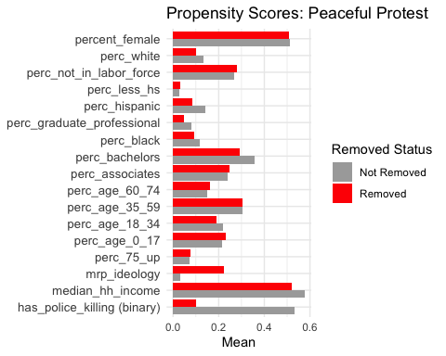

## Figure 3 - Violent Analysis: Comparison of Means for Removed vs. Not Removed Rows

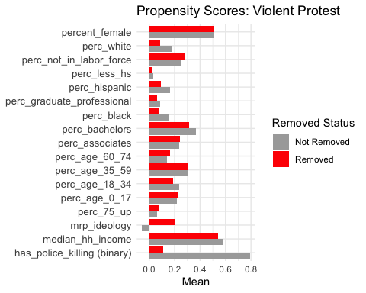

## Table 8 - DID Analysis Post-Matching Peaceful

| Variable | Estimate | Std_Error | t_value | P_Value |
| --- | --- | --- | --- | --- |
| (Intercept) | 25279775 | 3348511 | 7.5495580 | 0.0000000 |
| peaceful_protest | 3635877 | 4735509 | 0.7677902 | 0.4426543 |
| time | 737633 | 4735509 | 0.1557664 | 0.8762246 |
| peaceful_protest:time | -7122252 | 6697021 | -1.0634956 | 0.2876174 |

## Table 9 - DID Analysis Post-Matching Violent

| Variable | Estimate | Std_Error | t_value | P_Value |
| --- | --- | --- | --- | --- |
| (Intercept) | 34530984 | 7526876 | 4.5876912 | 0.0000047 |
| violent_protest | 75416279 | 13036932 | 5.7848179 | 0.0000000 |
| time | -1383459 | 10644611 | -0.1299681 | 0.8966017 |
| violent_protest:time | 2297290 | 18437006 | 0.1246021 | 0.9008481 |