WEEK 1 DATA ANALYST ASSIGNMENT
DATA ACQUISITION, CLEANING
AND PREPROCESSING
Online Retail II Transaction Dataset
Prepared by
Abu Yazdani
Data Analytics Learning Project | 2026 | GitHub: yazdani09/-online-retail-data-cleaning-python
Dataset source
UCI Machine Learning Repository - Online Retail II (Chen, 2012). DOI: 10.24432/C5CG6D. The notebook analysis uses the 525,461-record worksheet loaded from the downloaded Excel workbook.

Summary of the Work
In this Week 1 assignment, I worked with the Online Retail II dataset to practice the full data preparation process in Python. I first loaded the public dataset and checked what was actually inside it before changing anything. I then looked for missing values, duplicate records, unusual quantities and prices, and other entries that could affect later analysis. After investigating these issues, I applied only the cleaning rules that I could justify and created a separate sales dataset for analysis.
The UCI Online Retail II dataset is a real transactional dataset describing a UK-based non-store online retailer. The UCI documentation describes the data as multivariate, sequential, time-series and text data, with fields including invoice number, stock code, product description, quantity, invoice date, unit price, customer identifier and country. The full UCI resource contains more records than the worksheet used in this project; this report deliberately documents the exact local extract processed in the notebook rather than treating the local extract as the complete repository dataset. [1]
My loaded worksheet had 525,461 rows and 8 columns, covering 1 December 2009 to 9 December 2010. At the beginning I found several things that needed attention: 2,928 missing product descriptions, a large number of missing Customer IDs, 6,865 exact duplicate rows, negative quantities, three negative prices, zero-price records, and some very large quantity and price values.
I tried not to treat cleaning as simply deleting anything that looked unusual. My approach was to find a problem, inspect the affected rows, think about what those rows could mean in a real business, and only then decide what to do. This mattered especially for outliers. Some very high prices were actually postage, manual entries, bank charges, Amazon fees or adjustments. In the same way, some very large quantities were genuine bulk orders rather than typing mistakes.
After cleaning, 515,665 records remained in the cleaned dataset. An analysis-specific sales dataset, sales_df, was then created using positive quantities, positive prices and exclusion of clearly non-product stock codes. This produced 502,630 analysis-ready product-sales rows, representing 95.66% of the original records. The final sales dataset contained no duplicate rows, no zero or negative quantities, no zero or negative prices, and no negative calculated transaction amounts. Missing customer identifiers were intentionally retained because they do not prevent product, country, time and sales-amount analysis.
The figures below are the results I obtained from my notebook after the cleaning and preprocessing steps.

Key Results at a Glance
Measure | Result | Interpretation
Original records | 525,461 | Rows in the worksheet loaded into the notebook
Cleaned records | 515,665 | After exact duplicates, negative prices and missing descriptions were addressed
Analysis-ready sales rows | 502,630 | Positive-quantity, positive-price product transactions
Data retained | 95.66% | High retention; most source information was preserved
Unique products | 4,245 | Distinct stock-code values in sales_df
Known unique customers | 4,286 | Distinct non-missing Customer_ID values
Countries represented | 40 | Distinct country values
Aggregate transaction amount | 9,813,783.84 | Sum of Quantity × Price in sales_df; not a claim of net company revenue
Date range | 2009-12-01 to 2010-12-09 | Observed transaction period in the analyzed worksheet

Submission Improvement: Detailed Evidence and Cleaning Decision Log
The first version of this report explained the workflow, but it did not show enough of the actual evidence behind my decisions. I have added this section to make the work traceable: every major cleaning action below is tied to a count, an example observed in the notebook, and a reason for the decision. The goal was to avoid treating every unusual value as an error.

A. Comprehensive Cleaning Summary
Issue | Observed | Method | Decision | Specific justification
Exact duplicates | 6,865 (1.31%) | drop_duplicates() | Removed | The rows were exact copies across all columns. Keeping them would double-count transactions.
Missing Description | 2,928 (0.56%) | dropna(subset=["Description"]) | Removed | Product-level analysis needs a usable description. The missing-description records could not be reliably classified as normal product sales.
Missing Customer ID | 107,927 initially (20.54%) | No row deletion | Retained | Transactions still contain date, product, price, quantity and country. Deleting them would remove about one-fifth of the dataset.
Negative Price | 3 | Price >= 0 | Removed | All three were described as "Adjust bad debt" with large negative prices, so they were accounting adjustments rather than product sales.
Zero Price | 3,687 initially; 753 after missing-description removal | Investigate; exclude only from sales_df | Retained in cleaned_df | The rows mixed operational notes such as damages/missing with some positive-quantity product records, so blanket deletion was avoided.
Negative Quantity | 12,326 (2.35%) | Do not delete in cleaned_df; use Quantity > 0 for sales_df | Retained for traceability | Many negative rows were cancellation/return transactions. They may be useful for return analysis.
Non-product transactions | 2,592 (0.49%) | Exclude listed codes in sales_df | Separated from product sales | POSTAGE, DOTCOM POSTAGE, Manual, Bank Charges, AMAZON FEE and adjustments are not product unit sales.
Quantity IQR outliers | 57,870 (11.01%) | IQR investigation only | Retained unless filtered by sales rules | Large quantities can be genuine bulk orders; examples included 4,320 and 6,144 units.
Price IQR outliers | 35,273 (6.71%) | IQR investigation only | Retained unless non-product | The IQR upper bound was £8.65, but expensive legitimate items and non-product charges occur.

B. Specific Cleaning Decisions with Examples

B.1 Duplicate rows
The first duplicate check returned 6,865 exact duplicate rows out of 525,461 records. I used exact row duplication rather than assuming that repeated invoice numbers were duplicates. Multiple line items can legitimately share an invoice number, so invoice repetition alone would have been the wrong rule. After dropping exact duplicates, the dataset contained 518,596 rows and a second check returned zero duplicates.
Cleaning code used:
cleaned_df = cleaned_df.drop_duplicates()

B.2 Missing Description
The initial missing-value audit showed 2,928 missing Description values, equal to about 0.56% of the raw data. I inspected the corresponding records instead of filling the text with a made-up product name. The affected rows included zero-price records and operational-looking entries. Because the assignment is preparing transaction data for product and sales analysis, I removed those rows rather than inventing product labels.
Result: 518,593 rows remained after duplicate removal and negative-price removal; 515,665 remained after the missing Description rows were removed.
Cleaning code used:
cleaned_df = cleaned_df.dropna(subset=["Description"])

B.3 Missing Customer ID
Customer ID was missing in 107,927 raw records (20.54%). This was the largest missing-value issue. I decided not to remove these rows because the examples I inspected still contained valid transaction information, such as product code, description, quantity, price and country. For example, invoice 489525 contains "BLUE PULL BACK RACING CAR" at £0.55 even though the customer identifier is missing. The same applies to several line items on invoice 489548.
After the three negative-price adjustments and the 2,928 missing-description rows were removed, 104,902 Customer IDs were still missing in cleaned_df. The rows were retained in sales_df as well. This means customer-level analysis must use known Customer IDs, while product, date, country and revenue analysis can still use the full sales dataset.

B.4 Negative Quantity and cancellation/return logic
I found 12,326 rows with Quantity < 0. The sample contained invoice numbers such as C489449 and other cancellation-looking records. A direct check found 10,205 negative-quantity rows whose invoice-start check returned True for the cancellation prefix test, and a separate comparison for negative quantities not starting with C returned an empty result for the inspected condition. Because negative quantities can represent returns or cancellations rather than data-entry errors, I did not delete them from cleaned_df.
For the sales-analysis dataset, I used Quantity > 0. This turns the cleaned data into a positive-sales view while keeping the original return/cancellation information available in cleaned_df for future analysis.

B.5 Negative Price: three specific records
Only three raw rows had negative prices. All three were large negative values and were associated with the description "Adjust bad debt": -£53,594.36, -£44,031.79 and -£38,925.87. These values are not plausible unit prices for the products in this dataset and are clearly accounting-style adjustments. I therefore removed exactly those rows by retaining Price >= 0 rather than applying a broad high-value filter.
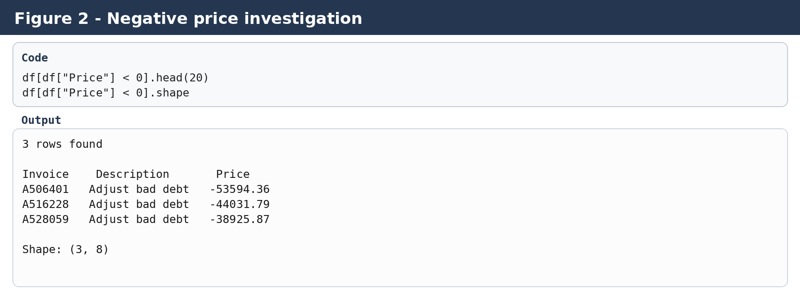
Figure 2. Evidence from the notebook showing the three negative-price adjustment records.

B.6 Extreme prices: why I did not delete all price outliers
The raw Price distribution was highly right-skewed. The IQR calculation gave Q1 = £1.25, Q3 = £4.21, IQR = £2.96 and an upper statistical bound of £8.65. This flagged 35,273 rows as price outliers. However, an outlier is not automatically an error.
I investigated values above £100 and, more specifically, above £1,000. The examples made the business meaning clear: POSTAGE appeared at £141; DOTCOM POSTAGE appeared at £647.19 and other high values; Manual entries reached £1,213.02, £8,985.60, £10,953.50 and even £25,111.09; Bank Charges reached £18,910.69; and AMAZON FEE reached £13,541.33. These are non-product financial or operational transactions. At the same time, a product such as ANTIQUE EDWARDIAN DRESSER appeared at £104.30, so simply deleting every price above £100 would also remove legitimate product transactions.
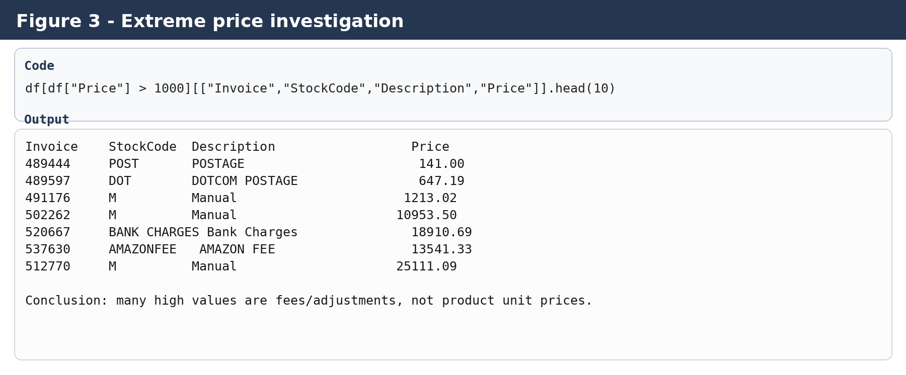
Figure 3. Examples used to distinguish genuine product values from fees and manual adjustments.

B.7 Zero-price records
The raw dataset contained 3,687 zero-price rows. Of these, 2,121 had negative quantity and 1,566 had positive quantity. There were 2,928 missing-description rows in the raw dataset and 3,656 of the raw zero-price records had no Customer ID. After removing missing descriptions, 753 zero-price rows remained in cleaned_df.
The remaining 753 rows were mixed. There were 459 positive-quantity records and 294 negative-quantity records. Only 31 had a Customer ID. Frequent descriptions included "damages", "damaged", "missing", "smashed", "given away", "MIA", "temp", "ebay sales" and "dotcom". Some other rows were recognizable product descriptions with customer IDs. Because of this mixture, I kept the records in cleaned_df for traceability but excluded Price == 0 from the positive-sales dataset.
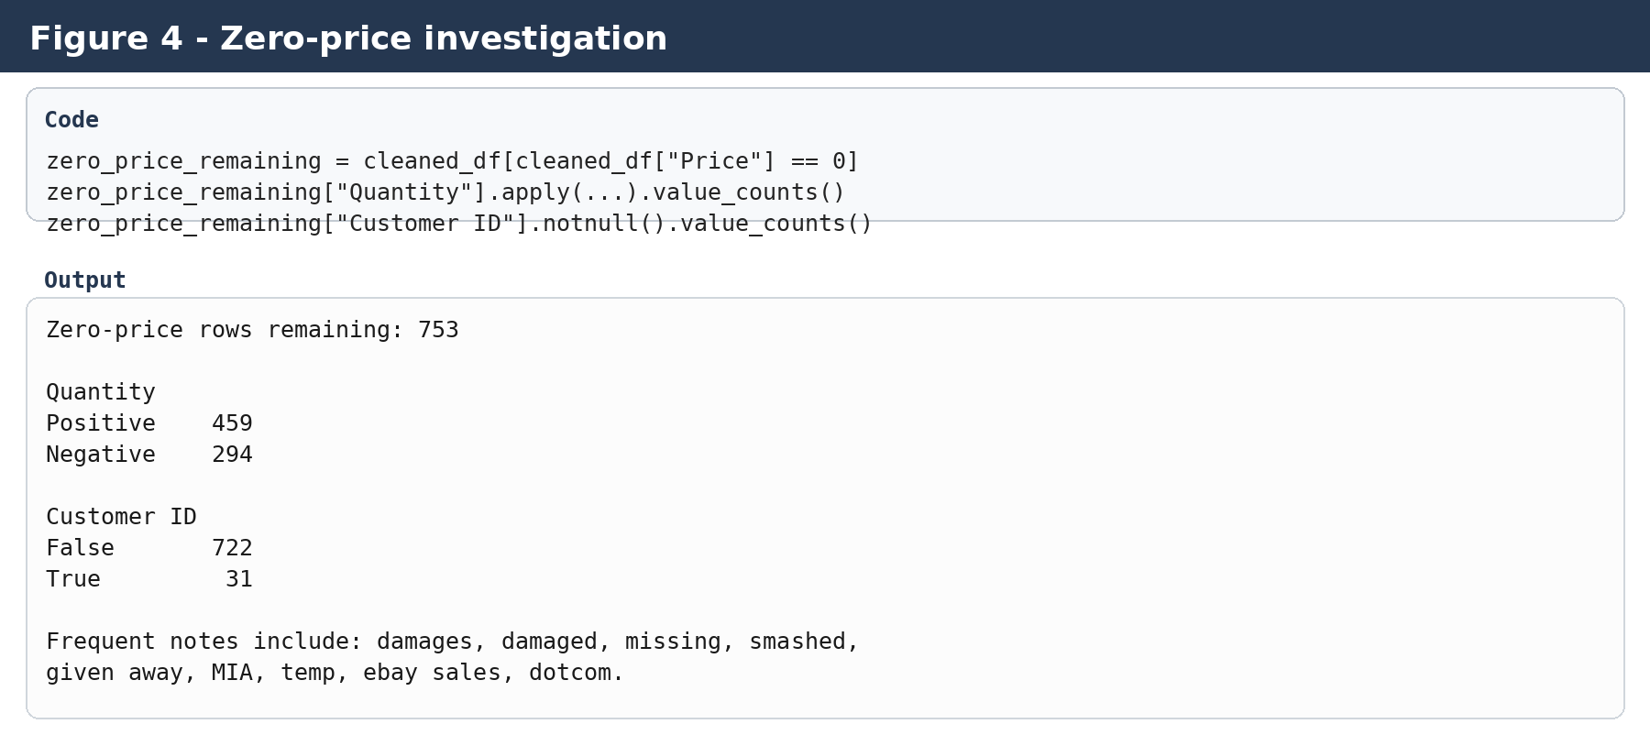
Figure 4. Evidence used to decide how zero-price records should be treated.

B.8 Quantity outliers
For Quantity, Q1 was 1, Q3 was 10, so the IQR was 9 and the upper IQR threshold was 23.5. This produced 57,870 statistical outliers. The split was 55,395 positive and 2,475 negative. Examples showed why automatic deletion would be unsafe: legitimate bulk transactions included quantities such as 4,320 and 6,144 units. Some very large negative values, however, appeared with descriptions such as lost, damaged, smashed, or as cancellation invoices. I therefore used business meaning and the later sales filter rather than deleting every IQR outlier.
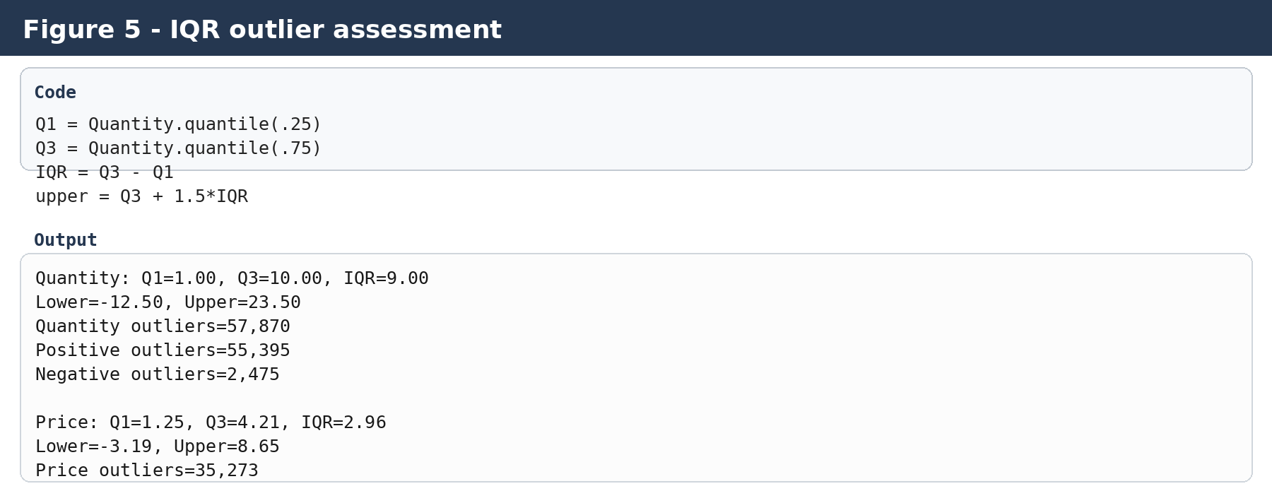
Figure 5. IQR calculations and outlier counts recorded in the notebook.

C. From cleaned_df to sales_df
A key change in the revised report is that I distinguish between a cleaned dataset and an analysis-specific dataset. cleaned_df preserves business records after the main data-quality actions. sales_df is intentionally narrower: Quantity must be positive, Price must be positive, and known non-product StockCodes are excluded. This avoids mixing product sales with returns, zero-value operational records and charges.
The filtering rule used was:
non_product_codes = ["POST", "DOT", "M", "BANK CHARGES", "AMAZONFEE", "ADJUST"]
sales_df = cleaned_df[(cleaned_df["Quantity"] > 0) &
(cleaned_df["Price"] > 0) &
(~cleaned_df["StockCode"].isin(non_product_codes))].copy()
Final stage | Rows | Interpretation
Original dataset | 525,461 | Input used for all initial quality checks
After exact duplicate removal | 518,596 | Duplicate rows removed
After negative-price removal | 518,593 | Three bad-debt adjustments removed
After missing Description removal | 515,665 | Product description required for the cleaned product view
sales_df | 502,630 | Positive-price, positive-quantity product-sales view

D. Final validation evidence
The final validation checks returned zero duplicate rows, zero negative quantities, zero zero-quantity rows, zero negative prices, zero zero-price records and zero negative TotalAmount values in sales_df. The final dataset retained 95.66% of the original records for positive product-sales analysis. TotalAmount was calculated as Quantity multiplied by Price, and Year, Month, Day and Hour were extracted from Invoice_Date.
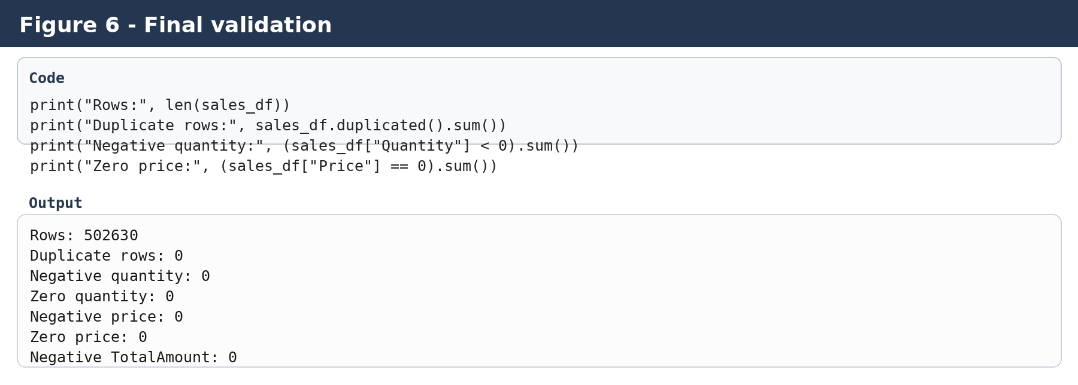
Figure 6. Final validation output from the notebook.
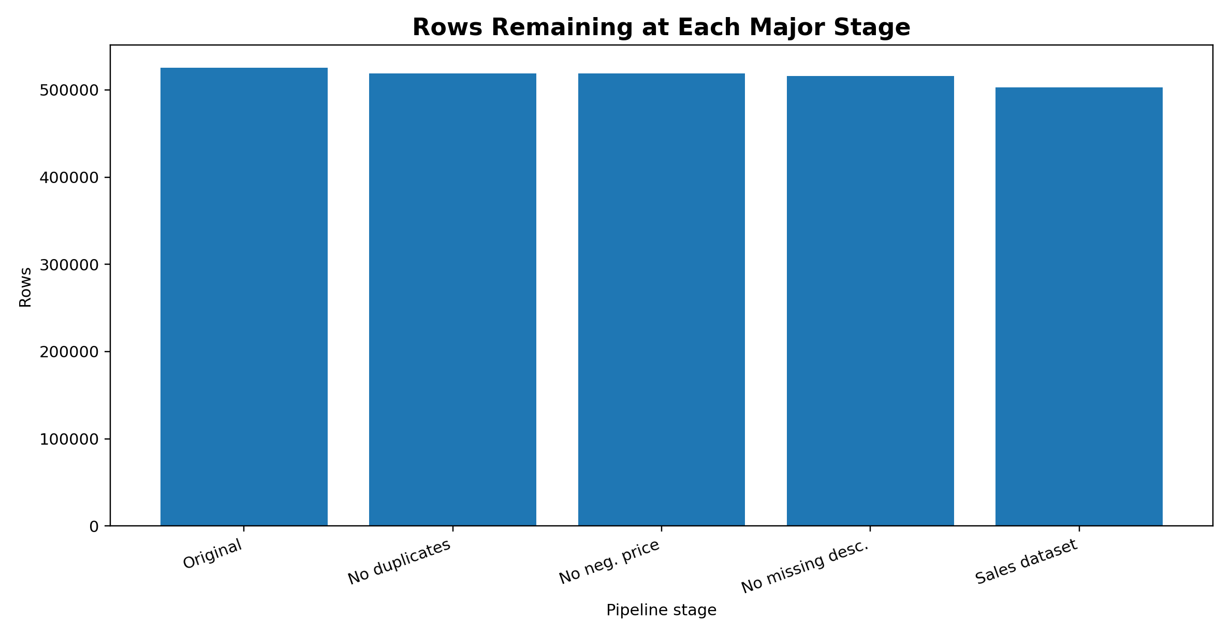
Figure 7. Rows remaining at each major stage of the cleaning and filtering pipeline.
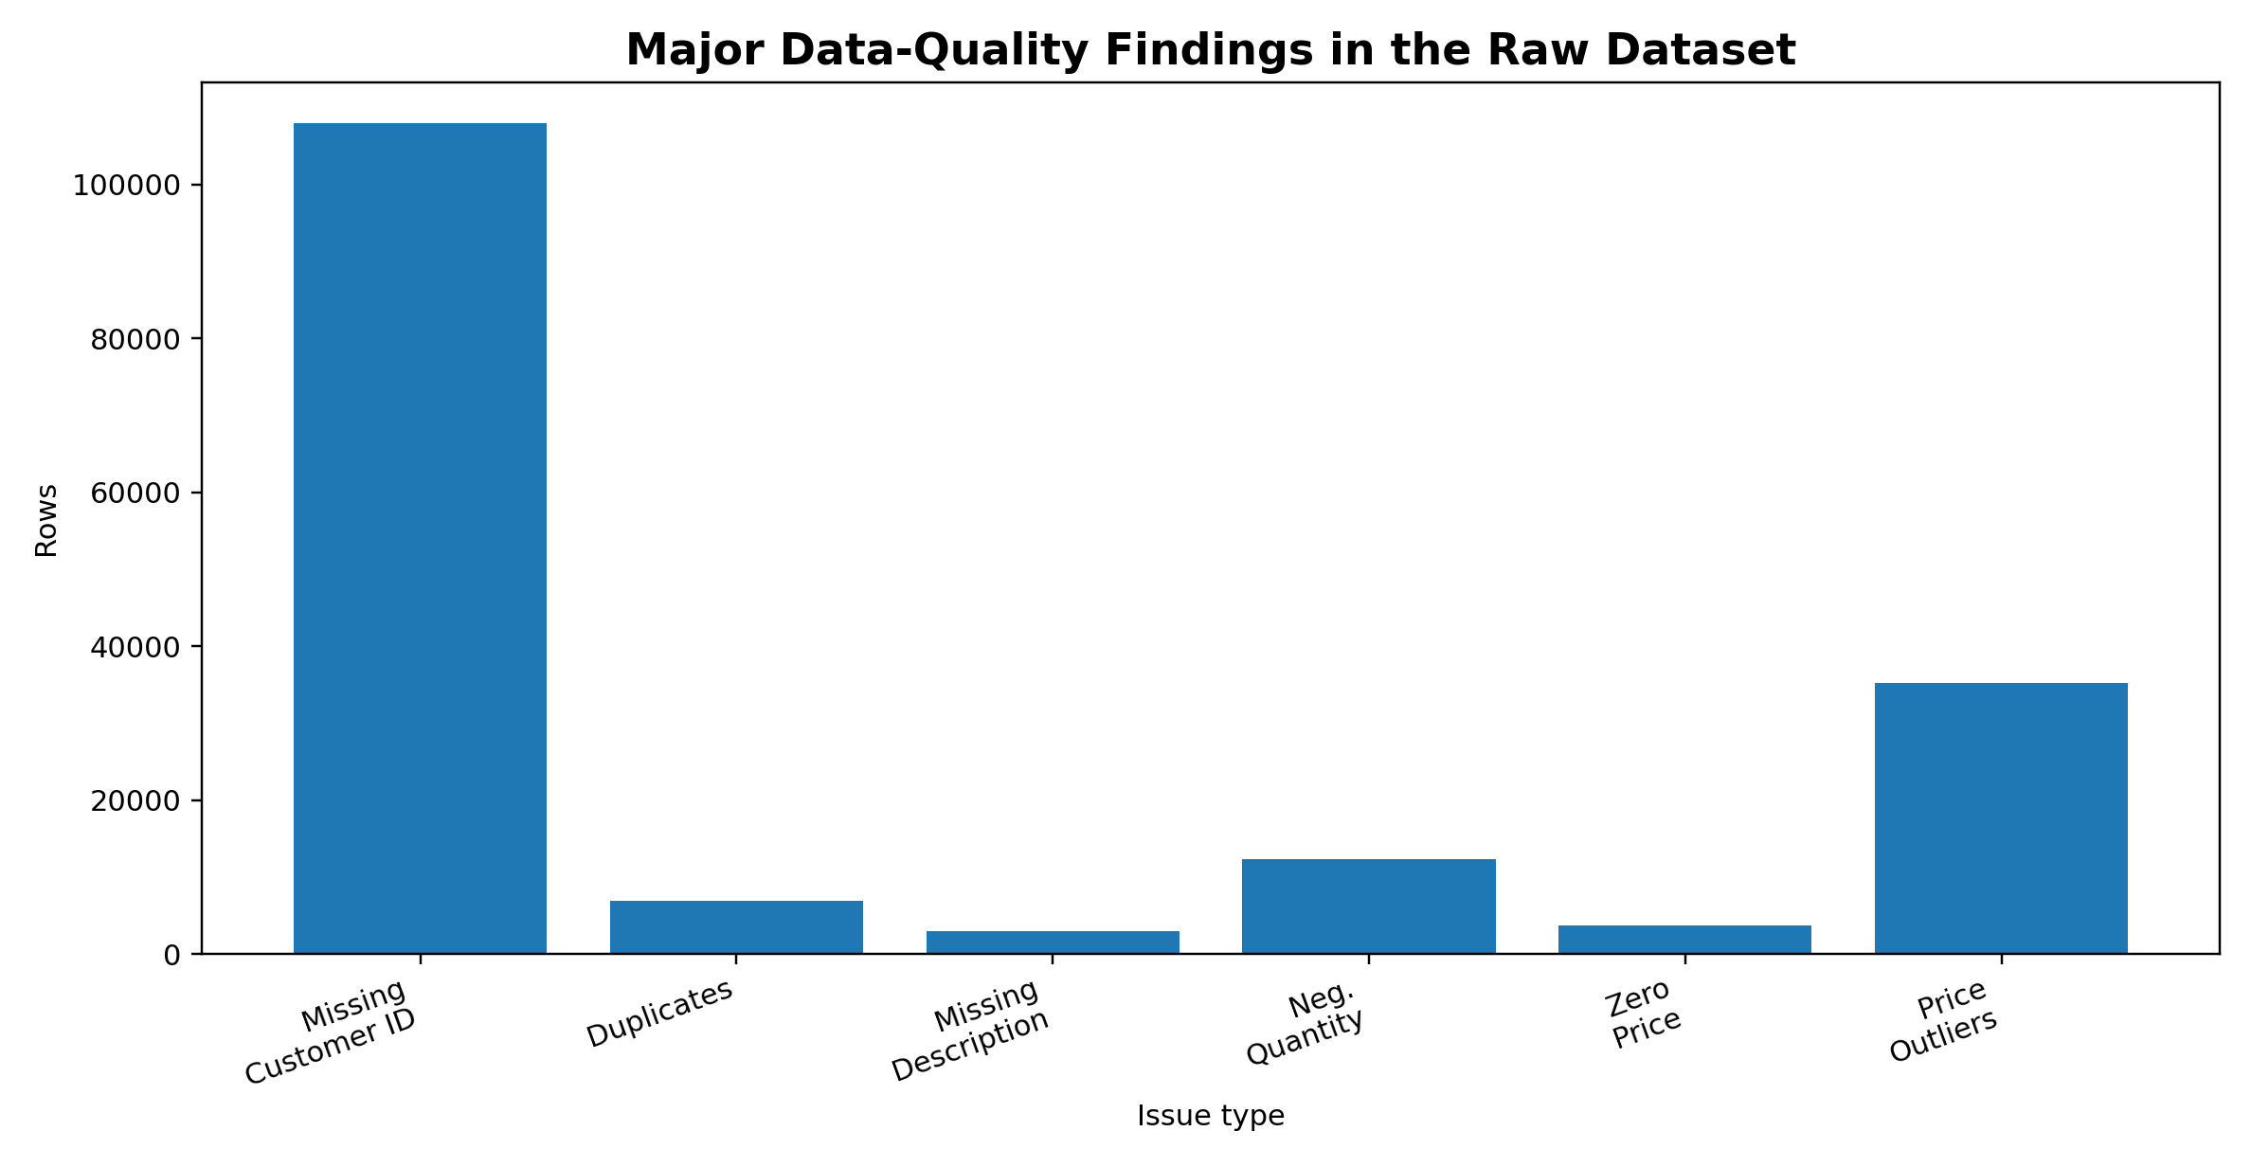
Figure 8. Major data-quality findings identified before cleaning. Values are counts of affected rows and are not additive because some issues overlap.

E. What changed in this resubmission
- Added specific row-level examples for negative prices, extreme prices, zero-price records, missing values and cancellations/returns.
- Added a comprehensive cleaning summary table showing the observed problem, method, action and justification.
- Added evidence figures based on the notebook outputs so the reviewer can see the actual counts and examples used in the decisions.
- Clarified the difference between cleaned_df and sales_df so that filtering for analysis is not confused with deleting raw business information.
- Added explicit before/after row counts, validation checks, and data-retention percentage.

Contents
1. Introduction and Assignment Context
2. Dataset Selection and Data Acquisition
3. Data Dictionary and Initial Dataset Understanding
4. Initial Data Exploration
5. Data Quality Assessment
6. Missing-Value Analysis and Treatment
7. Duplicate-Record Analysis and Treatment
8. Inconsistent and Erroneous Entries
9. Outlier Detection and Business-Context Investigation
10. Cleaning and Preprocessing Workflow
11. Creation of the Analysis-Ready Sales Dataset
12. Feature Engineering
13. Validation and Quality-Control Checks
14. Exploratory Analysis Prepared for Later Work
15. Impact of Preprocessing on Later Analysis
16. Challenges Encountered and Solutions
17. My Reflection and Best Practices
18. Conclusion and Final Remarks
References
Appendix A - Key Python Code
Appendix B - Report-Ready Findings Table
Submission Improvement: Detailed Evidence and Cleaning Decision Log

1. Introduction and Assignment Context

1.1 Purpose of the Assignment
The main purpose of this assignment was to learn how to take a public dataset and make it usable for analysis. I was expected not only to write Python code, but also to explain why I made each cleaning decision and what effect that decision could have on later analysis.
I followed a simple sequence throughout the notebook: get the data, understand it, look for quality problems, investigate those problems, clean what needed cleaning, create useful variables, validate the result, and save the final dataset.

1.2 Objectives
- Acquire a reliable public dataset suitable for data-analysis practice.
- Understand the dataset structure before modifying any values.
- Identify missing values, duplicates, inconsistent entries and unusual observations.
- Use both statistical methods and business context to evaluate potential outliers.
- Apply defensible cleaning rules while preserving legitimate information.
- Create an analysis-ready sales dataset with meaningful derived variables.
- Validate the cleaned data and document its impact on later analysis.

1.3 Analytical Principle
Core principle
Detect -> Investigate -> Decide -> Clean -> Validate. This principle prevented automatic deletion of unusual values and kept the cleaning decisions connected to the meaning of the business data.

2. Dataset Selection and Data Acquisition

2.1 Why Online Retail II Was Selected
I chose Online Retail II because it looks much closer to the type of messy business data an analyst may see in practice than a small, already-clean dataset. It contains numbers, text, dates and identifiers in the same file, and it also includes missing values, cancellations, operational records and highly skewed values.
According to the UCI documentation, the underlying business is a UK-based non-store retailer that mainly sells giftware, and many of its customers are wholesalers. [1]

2.2 Source and Reliability
I downloaded the dataset from the UCI Machine Learning Repository. I used the local Excel file in the project so that the same input could be loaded again and the results could be reproduced. The UCI page also provides the dataset description and variable definitions. [1]
Source item | Documented detail
Dataset | Online Retail II
Repository | UCI Machine Learning Repository
Creator | Daqing Chen
Dataset citation | Chen, D. (2012). Online Retail II [Dataset]. UCI Machine Learning Repository.
DOI | 10.24432/C5CG6D
License | Creative Commons Attribution 4.0 International (CC BY 4.0)
Local input used | online_retail_II.xlsx
Worksheet processed in notebook | 525,461 rows x 8 columns
Observed local date range | 1 Dec 2009 to 9 Dec 2010

2.3 Data Acquisition Code
import pandas as pd
import numpy as np
import matplotlib.pyplot as plt
import seaborn as sns
df = pd.read_excel("../dataset/online_retail_II.xlsx")
I kept the Excel file inside the project folder and loaded it with a relative path. This makes it easier to keep the notebook and the data together and rerun the work later.

3. Data Dictionary and Initial Dataset Understanding
Before making any changes, I went through the columns and checked what each one represented. Invoice and Stock Code are identifiers, Description and Country are text fields, Quantity is numeric, Invoice_Date is a date/time field, Price is numeric, and Customer_ID is another identifier. [1]
Column in notebook | Business meaning | Expected type | Role in analysis
Invoice | Transaction/invoice identifier; values beginning with C indicate cancellations in the UCI documentation | Text / identifier | Transaction grouping and cancellation investigation
Stock_Code | Product or item code | Text / identifier | Product grouping
Description | Product/item name | Text | Product interpretation
Quantity | Number of units in the transaction line | Integer | Volume analysis and sales calculation
Invoice_Date | Transaction date and time | Date/time | Time-based analysis
Price | Unit price in sterling | Floating-point numeric | Value calculation and price-quality checks
Customer_ID | Customer identifier; missing for many rows | Nullable integer | Customer-level analysis when available
Country | Customer country | Text / categorical | Geographical analysis

3.1 Project Structure
Week_1_Data_Cleaning_Project/
├── dataset/
│ └── online_retail_II.xlsx
├── notebook/
│ └── data_cleaning.ipynb
├── screenshots/
├── cleaned_data/
└── report/
I used the Jupyter notebook as the main record of my work. I kept the code, outputs, checks and charts there so that I could see how the dataset changed from the beginning to the final version. I also exported the analysis-ready data to CSV.

4. Initial Data Exploration

4.1 First Inspection
df.head()
df.shape
df.info()
df.isnull().sum()
My first check showed 525,461 rows and 8 columns. Most of the data types already made sense: Quantity was an integer, Price was numeric, and Invoice_Date was already a date/time value. Customer_ID appeared as float because that column contained missing values, which I corrected later using pandas nullable integers.

4.2 Initial Descriptive Statistics
Measure | Quantity | Price | Customer ID
Count | 525,461 | 525,461 | 417,534
Mean | 10.3377 | 4.6888 | 15,360.65
Minimum | -9,600.00 | -53,594.36 | 12,346
25th percentile | 1.00 | 1.25 | 13,983
Median | 3.00 | 2.10 | 15,311
75th percentile | 10.00 | 4.21 | 16,799
Maximum | 19,152 | 25,111.09 | 18,287

The descriptive statistics helped me see the first warning signs. Quantity had both negative and very large positive values. Price also had negative values and a very high maximum. Customer_ID had a large number of missing values, so I knew that column needed a different treatment from the numerical measures.

4.3 Country Distribution
The UK made up most of the records, followed by EIRE, Germany, France and the Netherlands. I did not treat this as an error because the dataset represents a UK retailer. A country being much more common than others does not mean the data are wrong.

5. Data Quality Assessment

5.1 Quality Issues Identified
Issue | Evidence from notebook | Initial interpretation
Missing Description | 2,928 rows | Small proportion; investigate whether these are useful product records
Missing Customer ID | 107,927 initially | Large proportion; do not delete blindly because other transaction fields remain usable
Exact duplicates | 6,865 rows | Likely repeated transaction lines; investigate and remove exact duplicates
Negative Quantity | 12,326 rows | Strongly associated with cancellations/returns and operational corrections
Negative Price | 3 rows | All were bad-debt accounting adjustments rather than normal product sales
Zero Price | 3,687 initially | Mixed operational records and some valid-looking zero-value transactions
Quantity IQR outliers | 57,870 rows | Statistical outliers; not automatically errors
Price IQR outliers | 35,273 rows | Many are postage, fees, manual entries or legitimate higher-priced items
Non-product transaction codes | 2,592 rows | Postage, manual, bank charges, Amazon fee and adjustment records

5.2 Missing-Value Percentages
Column | Initial missing count | Approx. percentage | Decision
Description | 2,928 | 0.56% | Remove missing-description rows for product-sales analysis
Customer ID | 107,927 | 20.54% | Retain; use only known IDs for customer-specific analysis
Other columns | 0 | 0% | No missing-value treatment required

5.3 Why One Rule Was Not Used for Every Problem
I did not use one cleaning rule for everything. A missing product description affects product analysis, while a missing Customer ID still leaves the transaction useful for many other analyses. A negative quantity may be a return, and a high price may be postage or a fee. Because the meanings are different, I handled the issues separately.

6. Missing-Value Analysis and Treatment

6.1 Missing Description
I found 2,928 rows where Description was missing. When I inspected those rows, they were tied to zero-price transactions and several unusual notes or incomplete-looking records. Since I wanted sales_df to support product-level analysis, I decided that keeping rows with no product description would make the dataset harder to interpret.
missing_description = df[df["Description"].isnull()]
print("Rows with missing Description:", len(missing_description))
missing_description[[
"Invoice", "StockCode", "Quantity", "Price", "Customer ID", "Country"
]].head(20)
cleaned_df = cleaned_df.dropna(subset=["Description"])
I removed those 2,928 rows. This was only a small part of the original dataset, and after removal there were no missing Description values left in cleaned_df. For this project, I considered that a reasonable trade-off because the affected rows were not useful for the main product-sales analysis.

6.2 Missing Customer ID
Customer_ID was missing quite often. It started with 107,927 missing values, and after the earlier cleaning steps there were 104,902 missing values in cleaned_df. Even in the final sales dataset, 102,924 Customer IDs were missing. I kept these transactions because I can still use them for product, country, quantity, time and transaction-value analysis.
I did not want to lose around one-fifth of the usable transactions just because the customer number was unavailable. For future customer-level work, I can simply use the rows where Customer_ID is known instead of changing or inventing customer identities.
sales_df["Customer_ID"] = sales_df["Customer_ID"].astype("Int64")
I changed Customer_ID to pandas Int64. This keeps IDs as whole numbers while still allowing missing values, so an ID such as 12346 is no longer displayed as 12346.0.

7. Duplicate-Record Analysis and Treatment

7.1 Detection
duplicate_count = df.duplicated().sum()
print("Duplicate rows:", duplicate_count)
I found 6,865 exact duplicate rows. Here I mean rows where every value is repeated. I did not remove rows simply because an invoice number appeared more than once, because one invoice can legitimately contain several different product lines.

7.2 Treatment
cleaned_df = cleaned_df.drop_duplicates()
print("Rows after removing duplicates:", len(cleaned_df))
print("Remaining duplicates:", cleaned_df.duplicated().sum())
After dropping the exact duplicates, 518,596 rows remained and the duplicate check returned zero. Removing them avoids counting the same transaction line more than once and protects later totals and counts from being inflated.
Decision rationale
Only exact duplicates were removed. The project did not attempt to remove similar-looking records or repeated invoice numbers because those may represent legitimate multiple line items within a transaction.

8. Inconsistent and Erroneous Entries

8.1 Negative Price Values
I found only three negative Price values. All three had StockCode B and the description “Adjust bad debt”. They looked like accounting adjustments rather than normal product sales, so I removed them for this sales-focused project.
Type | Count | Treatment
Negative Price | 3 | Removed
Negative Quantity | 12,326 initially | Retained in cleaned_df for context; excluded from sales_df
Zero Price | 3,687 initially; 753 after description cleaning | Retained in cleaned_df; excluded from sales_df
Non-product codes | 2,592 initially | Excluded from sales_df

cleaned_df = cleaned_df[cleaned_df["Price"] >= 0]
print("Negative prices remaining:", (cleaned_df["Price"] < 0).sum())

8.2 Negative Quantity Values
There were 12,326 negative-quantity rows. I checked the invoice values and found that 10,205 of them started with C, which is consistent with cancellation records in the dataset documentation. I therefore did not assume that every negative quantity was a mistake.
I kept those rows in cleaned_df so the cancellation and return information was not lost. When I created sales_df, I filtered to positive quantities so that the sales view contains actual positive sales only. This leaves the return information available for a future analysis.

8.3 Zero Quantity
After the positive-sales filter, there were no zero-quantity records in sales_df. This did not require a separate cleaning rule because the Quantity > 0 condition already removed them.

9. Outlier Detection and Business-Context Investigation

9.1 IQR Method
I used the IQR method to flag unusual numerical values. It gives lower and upper limits from Q1, Q3 and 1.5 times the IQR. I used it as a screening method, not as an automatic instruction to delete rows.
Q1 = df["Quantity"].quantile(0.25)
Q3 = df["Quantity"].quantile(0.75)
IQR = Q3 - Q1
upper_limit = Q3 + 1.5 * IQR
lower_limit = Q1 - 1.5 * IQR

9.2 Quantity Outliers
Statistic | Quantity
Q1 | 1.0
Median | 3.0
Q3 | 10.0
IQR | 9.0
Lower bound | -12.5
Upper bound | 23.5
IQR-flagged rows | 57,870
Positive outliers | 55,395
Negative outliers | 2,475

The IQR method marked 57,870 Quantity values as outliers, but I did not delete them. When I looked at examples, I found genuine bulk orders such as 4,320, 5,184 and 6,144 units, along with returns and operational corrections. This showed me that statistical outlier does not automatically mean incorrect data.

9.3 Price Outliers
Statistic | Price
Q1 | 1.25
Median | 2.10
Q3 | 4.21
IQR | 2.96
Lower bound | -3.19
Upper bound | 8.65
IQR-flagged rows | 35,273
Raw maximum | 25,111.09

When I inspected the high-price rows, many of the extreme values turned out to be POSTAGE, DOTCOM POSTAGE, Manual, Bank Charges, AMAZON FEE or Adjustment records. I also found a real product, ANTIQUE EDWARDIAN DRESSER, priced at 104.30. This is why I treated the IQR result as a warning signal rather than an error label.
Non-product type | Rows | Observed price range
POSTAGE | 862 | 0.50 to 850.00
DOTCOM POSTAGE | 735 | 0.00 to 1,081.70
Manual | 850 | 0.00 to 25,111.09
Bank Charges | 65 | 0.96 to 18,910.69
AMAZON FEE | 9 | 1.00 to 13,541.33
Adjustment records | 67 | 4.57 to 5,117.03

9.4 Outlier-Handling Principle
Key learning
An outlier is not automatically an error. Remove it only when there is sufficient evidence that it is invalid for the intended analysis. Otherwise, retain it or separate it into another analytical category.

10. Cleaning and Preprocessing Workflow

10.1 Cleaning Sequence
- Load the local Excel workbook into a pandas DataFrame.
- Inspect shape, data types, descriptive statistics and missing values.
- Investigate duplicates and identify exact duplicate rows.
- Investigate negative quantities and recognize cancellation/return behaviour.
- Investigate negative price values and remove accounting-only negative-price rows.
- Investigate zero-price rows using quantity, description and customer information.
- Investigate statistical outliers using IQR and business context.
- Create cleaned_df as a working copy rather than modifying the original df.
- Remove exact duplicates and missing product descriptions.
- Standardize important column names and convert Customer_ID to nullable Int64.
- Create TotalAmount and date/time features.
- Build sales_df as a separate analysis-specific dataset.
- Validate the final dataset and export the cleaned CSV.

10.2 Main Cleaning Code
cleaned_df = df.copy()
cleaned_df = cleaned_df.drop_duplicates()
cleaned_df = cleaned_df[cleaned_df["Price"] >= 0]
cleaned_df = cleaned_df.dropna(subset=["Description"])
sales_df = cleaned_df[
(cleaned_df["Quantity"] > 0) &
(cleaned_df["Price"] > 0) &
(~cleaned_df["StockCode"].isin([
"POST", "DOT", "M", "BANK CHARGES", "AMAZONFEE", "ADJUST"
]))
].copy()
The main idea here is that cleaned_df and sales_df do two different jobs. cleaned_df is my cleaned transaction-level base, while sales_df is the version I prepared specifically for positive-value product-sales analysis.

11. Creation of the Analysis-Ready Sales Dataset

11.1 Why a Separate Sales Dataset Was Created
I kept the cleaning stage separate from the analysis stage because not every transaction is a normal product sale. Returns, cancellations, postage, fees and manual entries can be useful in another project. For this assignment, I preserved the cleaned records and then applied sales-specific filters to create sales_df.
Stage | Rows | Change from previous stage
Original worksheet | 525,461 | -
After duplicate removal | 518,596 | 6,865 removed
After negative-price removal | 518,593 | 3 removed
After missing-description removal | 515,665 | 2,928 removed
Final sales_df | 502,630 | 13,035 filtered at analysis stage

sales_df contains 502,630 rows, so 95.66% of the original records were retained. The final reduction includes different filters that can overlap, such as negative quantities, zero prices and non-product codes, so those numbers should not be added together as separate totals.

11.2 Final Sales-Dataset Rules
- Quantity must be greater than zero.
- Price must be greater than zero.
- Clearly identified non-product stock codes are excluded.
- Missing Customer_ID is retained.
- TotalAmount is calculated as Quantity x Price.
- No duplicate rows remain after cleaning.

12. Feature Engineering

12.1 Total Transaction Amount
I created TotalAmount by multiplying Quantity by Price. This gives me the value of each transaction line and makes it possible to calculate product totals, monthly sales and other revenue-related measures later.
sales_df["TotalAmount"] = sales_df["Quantity"] * sales_df["Price"]

12.2 Date and Time Features
sales_df["Year"] = sales_df["Invoice_Date"].dt.year
sales_df["Month"] = sales_df["Invoice_Date"].dt.month
sales_df["Day"] = sales_df["Invoice_Date"].dt.day
sales_df["Hour"] = sales_df["Invoice_Date"].dt.hour
I added Year, Month, Day and Hour from Invoice_Date. This saves time later because I can group by these columns directly instead of extracting the same date parts again.

12.3 Standardized Column Names
sales_df = sales_df.rename(columns={
"Customer ID": "Customer_ID",
"InvoiceDate": "Invoice_Date",
"StockCode": "Stock_Code"
})
I changed names such as Customer ID and InvoiceDate to Customer_ID and Invoice_Date. Using underscores makes the columns easier to work with in Python and keeps the naming style consistent.

12.4 Index Reset
sales_df = sales_df.reset_index(drop=True)
Because several rows were removed, the original index had gaps. I reset the index so the final dataset starts again at 0 and runs sequentially.

13. Validation and Quality-Control Checks

13.1 Final Validation Code
print("Rows:", len(sales_df))
print("Columns:", len(sales_df.columns))
print(sales_df.isnull().sum())
print("Duplicate rows:", sales_df.duplicated().sum())
print("Negative quantity:", (sales_df["Quantity"] < 0).sum())
print("Zero quantity:", (sales_df["Quantity"] == 0).sum())
print("Negative price:", (sales_df["Price"] < 0).sum())
print("Zero price:", (sales_df["Price"] == 0).sum())
print("Negative TotalAmount:", (sales_df["TotalAmount"] < 0).sum())

13.2 Final Validation Results
Validation check | Result | Status
Rows in sales_df | 502,630 | Pass
Columns in sales_df | 14 | Pass
Missing Description | 0 | Pass
Duplicate rows | 0 | Pass
Negative quantity | 0 | Pass
Zero quantity | 0 | Pass
Negative price | 0 | Pass
Zero price | 0 | Pass
Negative TotalAmount | 0 | Pass
Customer_ID missing | 102,924 | Expected / retained

13.3 Final Data Types
At the end, the main numerical fields were stored as numeric types, Invoice_Date remained a date/time field, the text fields stayed as text, and Customer_ID was stored as nullable Int64. These types are suitable for the calculations I plan to do later.

13.4 Final Sales Summary Statistics
Measure | Quantity | Price | TotalAmount
Count | 502,630 | 502,630 | 502,630
Mean | 11.5534 | 3.442955 | 19.524867
Std. dev. | 87.5169 | 5.210647 | 65.812217
Minimum | 1 | 0.001 | 0.001
25th percentile | 1 | 1.25 | 4.20
Median | 3 | 2.10 | 10.20
75th percentile | 12 | 4.21 | 17.70
Maximum | 19,152 | 1,157.15 | 15,818.40

14. Exploratory Analysis Prepared for Later Work

14.1 Purpose of Exploratory Visualizations
After cleaning the data, I created a few basic charts to check the shape of the prepared data and to get an early view of sales patterns. The charts are not a replacement for cleaning; they are a useful check and a starting point for the next analysis phase.
Visualization | Purpose | Saved output
Monthly sales revenue | Identify seasonal and month-to-month transaction-value patterns | monthly_sales.png
Top 10 countries by sales | Compare geographic contribution to sales amount | top_countries_sales.png
Top 10 products by revenue | Identify products with the largest aggregate transaction amount | top_products_revenue.png
Transaction amount distribution | Inspect the distribution and skew of line-level transaction values | transaction_amount_distribution.png
Top 10 products by quantity | Identify volume leaders by units sold | top_products_quantity.png
Sales revenue by year | Compare observed annual periods | yearly_sales.png
Sales revenue by hour | Identify intraday transaction patterns | hourly_sales.png
Customer ID availability | Visualize known versus missing customer identifiers | customer_id_missing.png

14.2 Example Visualization Code
monthly_sales = sales_df.groupby("Month")["TotalAmount"].sum()
plt.figure(figsize=(10, 5))
monthly_sales.plot(kind="bar")
plt.title("Monthly Sales Revenue")
plt.xlabel("Month")
plt.ylabel("Total Sales Amount")
plt.tight_layout()
plt.show()
I generated the charts directly from the cleaned dataset in the notebook. I have not manually made up chart values; the plots are produced by the Python code and can be rerun from the notebook whenever needed.

15. Impact of Preprocessing on Later Analysis

15.1 Effect on Sales Metrics
The cleaning choices directly affect the numbers I will calculate later. Removing exact duplicates avoids counting the same row twice. Removing the three negative accounting prices keeps them from distorting the price analysis. Filtering out negative quantities and zero prices gives me a clearer population for positive sales and product comparisons.

15.2 Effect on Customer Analysis
Keeping missing Customer_ID values preserves useful sales information, but it also means that customer-level analysis has to use the records where an ID is available. For future RFM or segmentation work, I would either filter to known IDs or clearly report the unknown-customer share. I would not invent customer numbers.

15.3 Effect on Outlier-Sensitive Methods
I did not cap or winsorize all IQR outliers because the investigation showed that some extreme values were legitimate. If a later statistical or machine-learning task is sensitive to the skew, I could consider a transformation such as log1p or a justified business-based cap. I would only do that when the next analysis actually needs it.

15.4 Reproducibility
All of the main steps are recorded in the Jupyter notebook, and the cleaned CSV is saved in the project folder. This means I can rerun the process from the same source file and check the intermediate results instead of relying on memory.

16. Challenges Encountered and Solutions
Challenge | What happened | Solution / learning
Understanding negative quantities | Many negative quantities looked like errors at first. | Investigated invoice prefixes and context; recognized cancellations/returns and filtered them only for sales_df.
IQR flagged too many values | The standard 1.5 x IQR rule marked 57,870 quantity rows and 35,273 price rows. | Investigated extreme examples and separated statistical unusualness from business invalidity.
Extreme price values | Some prices exceeded £25,000. | Inspected descriptions and stock codes; found postage, manual, fees, bank charges and adjustments.
Missing Customer_ID | Over 20% of rows initially lacked customer IDs. | Retained records because other transaction fields remained useful.
Customer_ID stored as float | NaN forced the identifier into float64. | Converted to pandas nullable Int64.
Index gaps after filtering | Original row labels remained after deletions. | Reset index after final filtering.
Zero-price ambiguity | Some zero-price rows looked like adjustments, while others looked like valid special transactions. | Retained in cleaned_df and excluded from the analysis-specific sales_df.
Avoiding data loss | Aggressive cleaning could discard legitimate business events. | Separated cleaning from analysis-specific filtering and preserved the raw df.

16.1 Practical Lesson
The hardest part for me was not the pandas syntax itself. The more difficult part was deciding what a strange row actually meant. For example, a large price could be an expensive item, postage, a fee or an adjustment. Looking at the surrounding fields helped me make better decisions instead of deleting records just because they looked unusual.

17. My Reflection and Best Practices

17.1 What Was Learned
- I learned that data cleaning is mostly about making careful decisions, not just deleting rows.
- I learned to look at why a value is missing and how important that column is before deciding whether to remove or keep the row.
- I also learned that identifiers such as Customer_ID should not be treated like ordinary numerical measurements.
- An IQR outlier is only a flag. I need to check the business meaning before removing it.
- Keeping a cleaned base dataset separate from an analysis-specific dataset makes the work safer and more flexible.
- Validation after every major step is important because code can run successfully and still leave bad records behind.
- Writing down the reasoning is part of the analysis itself. Someone else should be able to follow my notebook and understand why I made the changes.

17.2 Best-Practice Checklist
Practice | Implemented in this project? | Evidence
Preserve original data | Yes | df kept unchanged; cleaned_df created as a copy
Inspect before cleaning | Yes | head, shape, info, describe, missing-value checks
Investigate before deleting | Yes | Duplicate, quantity, price and zero-price investigations
Use business context | Yes | Cancellation, postage, fees and adjustment analysis
Validate after cleaning | Yes | Duplicate, range and missing-value checks
Export analysis-ready data | Yes | online_retail_cleaned.csv
Document limitations | Yes | Local worksheet scope and missing Customer_ID caveat

17.3 Suggested Next-Phase Analysis
With sales_df ready, the next step would be to answer business questions such as which months performed best, which products generated the most sales, which countries contributed the most, and how frequently customers purchased. I would use the same cleaning definitions from this report so that the later results stay consistent.

18. Conclusion and Final Remarks
This assignment gave me hands-on practice with the full data-preparation process using Python and pandas. The Online Retail II data were useful because they contained the kinds of issues that made me stop and think about the meaning of the data, including missing values, duplicates, cancellations, unusual prices and quantities, and different transaction types.
I started with 525,461 records. After removing the 6,865 exact duplicates, the three negative-price accounting records and the 2,928 rows with missing descriptions, 515,665 rows remained in cleaned_df. I then created sales_df using the positive-sales rules and finished with 502,630 rows, retaining 95.66% of the original dataset.
One of the biggest lessons from this work was that unusual values are not automatically wrong. I checked the extreme quantity and price values and found genuine bulk orders as well as postage, fees, manual entries and other operational transactions. I kept the information that could be useful for other questions and filtered it only when creating the specific sales view.
The final sales dataset now includes TotalAmount, Year, Month, Day and Hour, and it passed the validation checks in the notebook. I can use this dataset as the starting point for the next stage of exploratory analysis and business insights.
Final outcome
The project retained 95.66% of source records in the analysis-ready sales view while eliminating the specific issues most likely to distort a positive product-sales analysis. The result is a defensible, reproducible and documented analytical dataset.

References
[1] Chen, D. (2012). Online Retail II [Dataset]. UCI Machine Learning Repository. DOI: 10.24432/C5CG6D. https://archive.ics.uci.edu/dataset/502/online+retail+ii
[2] Pandas documentation. pandas.DataFrame, missing-value handling, duplicate detection, data types and grouping operations. https://pandas.pydata.org/docs/
[3] Python Software Foundation. Python 3 Documentation. https://docs.python.org/3/
Access date for web resources: 6 October 2026.

Appendix A - Key Python Code

A.1 Imports and Loading
import pandas as pd
import numpy as np
import matplotlib.pyplot as plt
import seaborn as sns
df = pd.read_excel("../dataset/online_retail_II.xlsx")

A.2 Initial Exploration
df.head()
df.shape
df.info()
df.isnull().sum()
df.describe()

A.3 Duplicate Analysis
duplicate_count = df.duplicated().sum()
duplicate_percentage = (duplicate_count / len(df)) * 100
print("Duplicate rows:", duplicate_count)
print("Duplicate percentage:", duplicate_percentage)

A.4 Negative Quantity Investigation
negative_qty = df[df["Quantity"] < 0]
print(negative_qty.shape)
negative_qty[negative_qty["Invoice"].str.startswith("C") == False].head(20)

A.5 IQR Analysis
Q1 = df["Quantity"].quantile(0.25)
Q3 = df["Quantity"].quantile(0.75)
IQR = Q3 - Q1
upper_limit = Q3 + 1.5 * IQR
lower_limit = Q1 - 1.5 * IQR
quantity_outliers = df[
(df["Quantity"] < lower_limit) |
(df["Quantity"] > upper_limit)
]
print("Quantity outliers:", len(quantity_outliers))

A.6 Price Investigation
df[df["Price"] < 0].head()
df[df["Price"] == 0].head()
df[df["Price"] > 100].head(30)
df.nlargest(20, "Price")

A.7 Cleaning and Sales Dataset
cleaned_df = df.copy()
cleaned_df = cleaned_df.drop_duplicates()
cleaned_df = cleaned_df[cleaned_df["Price"] >= 0]
cleaned_df = cleaned_df.dropna(subset=["Description"])
non_product_codes = ["POST", "DOT", "M", "BANK CHARGES", "AMAZONFEE", "ADJUST"]
sales_df = cleaned_df[
(cleaned_df["Quantity"] > 0) &
(cleaned_df["Price"] > 0) &
(~cleaned_df["StockCode"].isin(non_product_codes))
].copy()

A.8 Preprocessing and Validation
sales_df = sales_df.rename(columns={
"Customer ID": "Customer_ID",
"InvoiceDate": "Invoice_Date",
"StockCode": "Stock_Code"
})
sales_df["Customer_ID"] = sales_df["Customer_ID"].astype("Int64")
sales_df["TotalAmount"] = sales_df["Quantity"] * sales_df["Price"]
sales_df["Year"] = sales_df["Invoice_Date"].dt.year
sales_df["Month"] = sales_df["Invoice_Date"].dt.month
sales_df["Day"] = sales_df["Invoice_Date"].dt.day
sales_df["Hour"] = sales_df["Invoice_Date"].dt.hour
sales_df = sales_df.reset_index(drop=True)
sales_df.to_csv("../cleaned_data/online_retail_cleaned.csv", index=False)

A.9 Final Validation
print("Rows:", len(sales_df))
print("Columns:", len(sales_df.columns))
print(sales_df.isnull().sum())
print("Duplicate rows:", sales_df.duplicated().sum())
print("Negative quantity:", (sales_df["Quantity"] < 0).sum())
print("Zero quantity:", (sales_df["Quantity"] == 0).sum())
print("Negative price:", (sales_df["Price"] < 0).sum())
print("Zero price:", (sales_df["Price"] == 0).sum())
print("Negative TotalAmount:", (sales_df["TotalAmount"] < 0).sum())

Appendix B - Report-Ready Findings Table
Topic | Finding | Final treatment / interpretation
Dataset size | 525,461 rows x 8 columns | Local worksheet used for this assignment
Exact duplicates | 6,865 | Removed
Negative price | 3 | Removed as accounting bad-debt adjustments
Missing Description | 2,928 | Removed for product-sales analysis
Missing Customer_ID | 104,902 after cleaning; 102,924 in sales_df | Retained; customer analysis limited to known IDs
Negative Quantity | 12,326 initially | Interpreted mainly as cancellations/returns; excluded from sales_df
Zero Price | 3,687 initially; 753 after description cleaning | Retained in cleaned_df; excluded from sales_df
Non-product rows | 2,592 initially | Excluded from sales_df using stock-code categories
Quantity IQR outliers | 57,870 | Investigated; not automatically removed
Price IQR outliers | 35,273 | Investigated; not automatically removed
Final cleaned dataset | 515,665 rows | Cleaned transactional base
Final sales dataset | 502,630 rows | Analysis-ready product-sales data
Retention | 95.66% | High data retention
TotalAmount sum | 9,813,783.84 | Aggregate amount for retained positive product-sales lines
Unique products | 4,245 | Distinct Stock_Code values
Known unique customers | 4,286 | Distinct non-missing Customer_ID values
Countries | 40 | Distinct Country values
Observed date range | 1 Dec 2009 - 9 Dec 2010 | Scope of local worksheet used

Appendix C - Submission Checklist
Requirement | Status
Acquire public dataset | Completed
Describe data collection | Completed
Initial exploration | Completed
Missing-value analysis | Completed
Duplicate analysis | Completed
Outlier analysis | Completed
Erroneous/inconsistent entry investigation | Completed
Cleaning and preprocessing code | Completed
Before/after comparison | Completed
Validation checks | Completed
Impact on later analysis | Completed
Challenges and solutions | Completed
Final cleaned CSV export | Completed
Notebook-generated charts | Prepared in notebook
Written report | Completed

