BUSINESS SALES
PERFORMANCE ANALYTICS
Future Interns — Task 1

Prepared by: Abu Yazdani
Tools: Python, Pandas, Matplotlib and Jupyter Notebook
Dataset: Sample Superstore Sales Dataset
1. Executive Summary
For this project, I worked with the Sample Superstore dataset to understand how the business was performing across regions, product categories and individual products. I used Python in a Jupyter Notebook to check the data, calculate key figures and create charts that make the results easier to understand.
The dataset contains 9,994 records and 21 columns, with order dates ranging from 3 January 2014 to 30 December 2017. Total sales were $2,297,200.86 and total profit was $286,397.02. The overall profit margin was 12.47%.
The West region recorded the highest sales and profit. Technology was the strongest category by both sales and profit, while Furniture had a much lower profit margin than the other categories. I also identified several products with negative total profit. These results point to areas the business could investigate further, especially product pricing, discounts and costs.

2. Project Objectives
- Understand overall sales and profit performance.
- Compare sales and profitability across regions and product categories.
- Review monthly sales over time.
- Identify high-selling products and products with the lowest profit.
- Present the findings through clear charts and practical recommendations.

3. Dataset and Tools
The file used for this analysis was Sample - Superstore.csv.xlsx. It contains order and shipping dates, customer and location details, product categories, sales, quantity, discount and profit fields. The data was loaded into Pandas from the Excel file.
I used Pandas for data inspection, grouping and calculations, and Matplotlib to create charts. The analysis was carried out in VS Code using a Jupyter Notebook.
Dataset detail | Result
Rows | 9,994
Columns | 21
Date range | 3 January 2014 – 30 December 2017
Unique orders | 5,009
Unique customers | 793

4. Data Quality Checks
Before analyzing the results, I checked the dataset for missing values, exact duplicate rows and several unusual values that could affect the calculations.
Check performed | Result
Missing values | 0
Exact duplicate rows | 0
Negative or zero sales | 0
Negative quantity | 0
Negative discounts | 0
Discounts above 100% | 0
Ship date earlier than order date | 0

These checks did not identify issues in the fields tested. This does not prove that every record is correct, but it gave me a reasonable starting point for the analysis. I kept negative profit values because they may represent genuine business losses and are important to the project.

5. Overall Business Performance
Key performance indicator | Result
Total sales | $2,297,200.86
Total profit | $286,397.02
Total quantity sold | 37,873
Unique orders | 5,009
Unique customers | 793
Overall profit margin | 12.47%
Average order value | $458.61
Average profit per order | $57.18

The average order value was calculated by dividing total sales by the number of unique orders. The average profit per order was calculated in the same way using total profit. These are overall averages; individual orders may perform very differently.

6. Regional Performance
The West region generated the highest sales at $725,457.82 and the highest profit at $108,418.45. The East region was second in sales, while Central had the lowest profit margin at 7.92%. South had the lowest sales but a higher margin than Central.
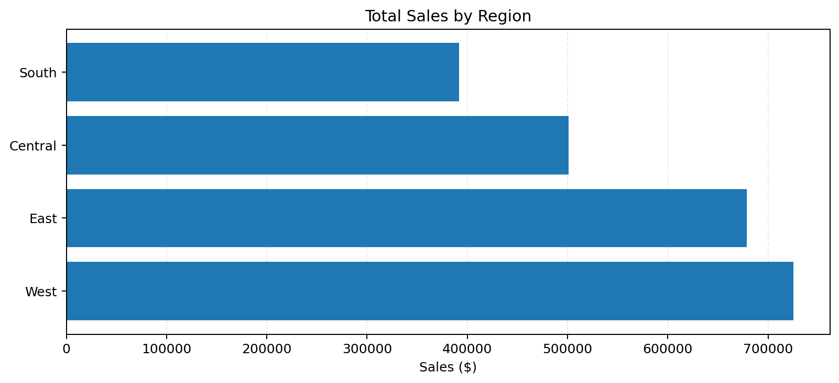
Region | Sales | Profit | Profit margin
West | $725,457.82 | $108,418.45 | 14.94%
East | $678,781.24 | $91,522.78 | 13.48%
Central | $501,239.89 | $39,706.36 | 7.92%
South | $391,721.90 | $46,749.43 | 11.93%

The Central region is worth a closer look. Reviewing its product mix, discounts and cost patterns could help explain why its margin is lower. The figures alone do not show the exact cause.

7. Product Category Performance
Technology had the highest sales, at $836,154.03, and the highest profit, at $145,454.95. Office Supplies generated $122,490.80 in profit. Furniture generated $741,999.80 in sales but only $18,451.27 in profit.
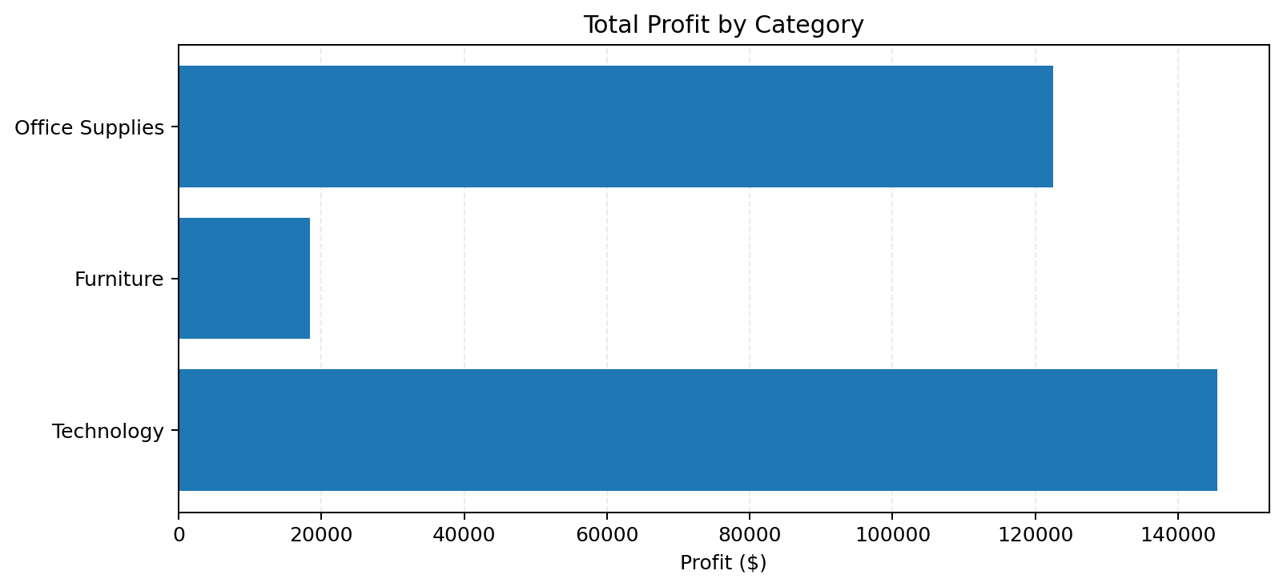
Category | Sales | Profit | Profit margin
Technology | $836,154.03 | $145,454.95 | 17.40%
Furniture | $741,999.80 | $18,451.27 | 2.49%
Office Supplies | $719,047.03 | $122,490.80 | 17.03%

Furniture's margin was approximately 2.49%, considerably lower than Technology at 17.40% and Office Supplies at 17.03%. I would investigate Furniture's discount levels and product-level results before making any pricing changes.

8. Product-Level Findings
The Canon imageCLASS 2200 Advanced Copier was the highest-selling product in the top-10 list, with $61,599.82 in sales and $25,199.93 in profit.
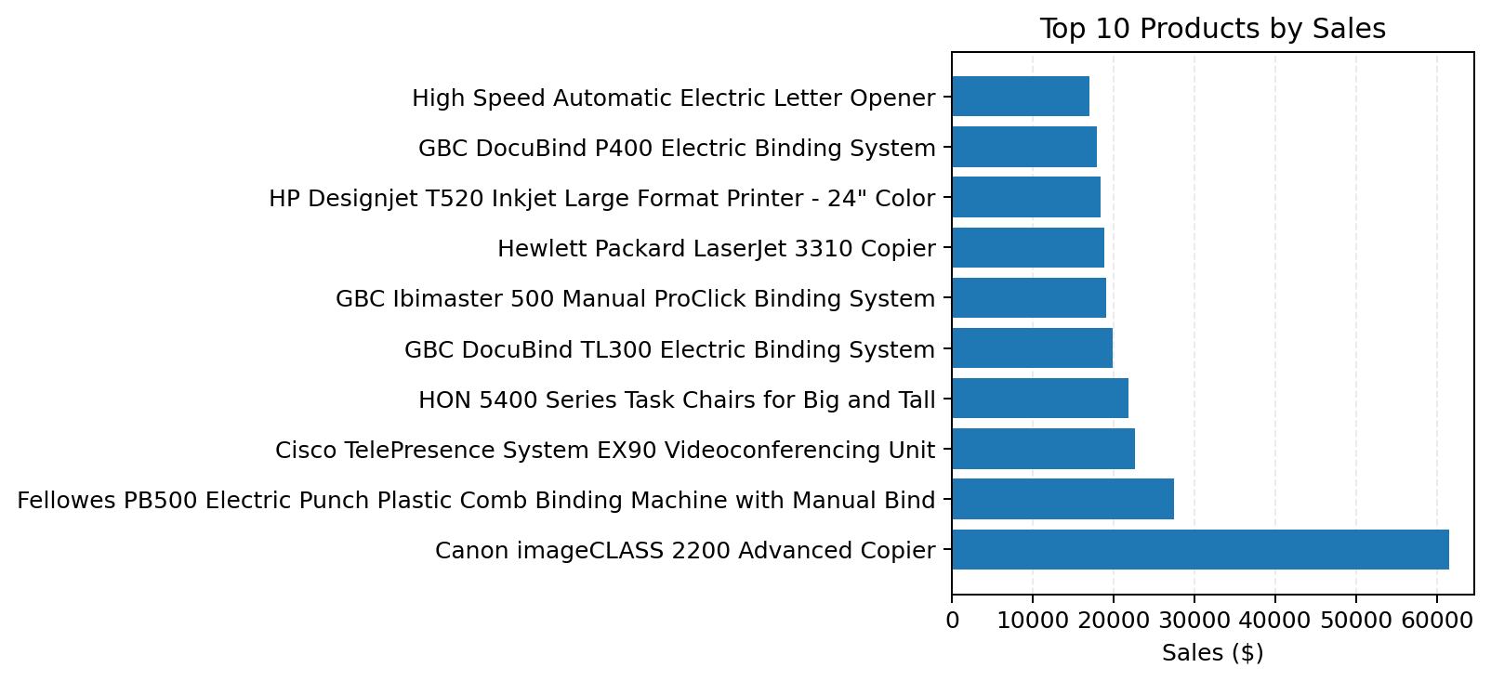
The loss-making product review found that the Cubify CubeX 3D Printer Double Head Print had the lowest total profit among the ten products shown, at -$8,879.97. The Lexmark MX611dhe Monochrome Laser Printer recorded -$4,589.97, and the Cubify CubeX 3D Printer Triple Head Print recorded -$3,839.99.
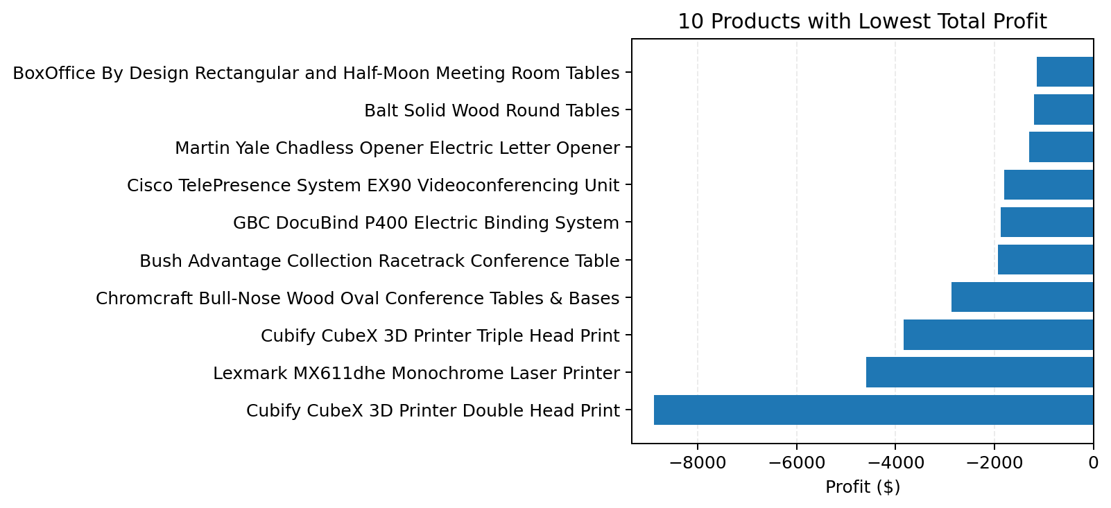
These products deserve further investigation, but negative profit alone does not tell us whether the cause was a discount, cost, return or another factor. More detailed transaction and cost information would be needed to confirm the reason.

9. Monthly Sales Trend
I grouped sales by order month and created a monthly sales trend chart covering 2014–2017. The chart is saved as monthly_sales_trend.png in the project's output folder. It can be used to inspect monthly peaks and dips. I have not stated a specific seasonal pattern here because that conclusion should be based on a careful review of the chart and the underlying monthly figures.
The monthly totals were also exported to CSV so they can be checked or reused in another visualization tool.

10. Recommendations
- Review Furniture profitability. Check discounts, costs and product-level margins to understand why sales are relatively high but profit is low.
- Investigate repeated product losses. Review transactions for the Cubify printers, Lexmark printer and other loss-making products before deciding whether to change prices or promotions.
- Study the Central region. Compare its product mix, discount patterns and profitability with the West and East regions.
- Track sales and profit together. A rise in sales does not always mean a rise in profit, so both measures should be reviewed regularly.
- Use monthly reporting. Monitor monthly sales and profit to spot changes early and compare performance over time.

11. Limitations
This project is based on the fields available in the supplied dataset. The analysis identifies patterns and areas to investigate, but it does not establish the causes of product losses or regional differences. I did not use external cost records, return details or additional customer information to explain those results. The dataset also ends in 2017, so it should not be treated as a picture of current retail performance.

12. Conclusion
This project gave me practical experience in loading a dataset, checking its quality, calculating business KPIs, grouping data for comparison and presenting results through charts. The main findings were that the West region led in sales and profit, Technology was the strongest category by profit, and Furniture had a much lower margin than the other categories. The product-level analysis also highlighted items that deserve a closer review because their total profit was negative.
Overall, the analysis provides a starting point for business decisions. The next step would be to investigate the reasons behind low margins and losses using more detailed discount, cost and transaction information.

13. Project Files
- sales_analysis.ipynb — notebook containing the analysis code.
- output/ — charts and exported summary tables.
- dataset/ — source dataset used for the analysis.
- README.md — project overview and instructions.

Prepared by Abu Yazdani | Future Interns — Task 1

