Classification Dataset Description
Machine Learning | Exercise 0 | Group 56
Yazdan ZandiyeVakili, Amir Saadati, Hani Esreb
We chose MembershipWoes (OpenML 44225, version 2) and Dermatology (UCI 33) because they differ in size, feature types, and number of classes. Both have missing values to handle before modelling [1, 2].
MembershipWoes has 10,362 records and 14 columns besides the target: five quantitative inputs, six nominal fields, two dates, and an ID. Dermatology has 366 patients and 34 inputs.

MembershipWoes
The target has two classes: 7,219 INFORCE records (69.67%) and 3,143 CANCELLED (30.33%). Age at issue ranges from 0 to 92 years, with median 46; additional members range from 0 to 3. Annual fees range from 0 to 10,100,000, with median 118,209.28. Observed income ranges from 9,996 to 999,999,996. The currency is not given. Four zero ages and terms up to 102 years need checking. Occupation and agent codes are categories; there are 4,317 agent codes.
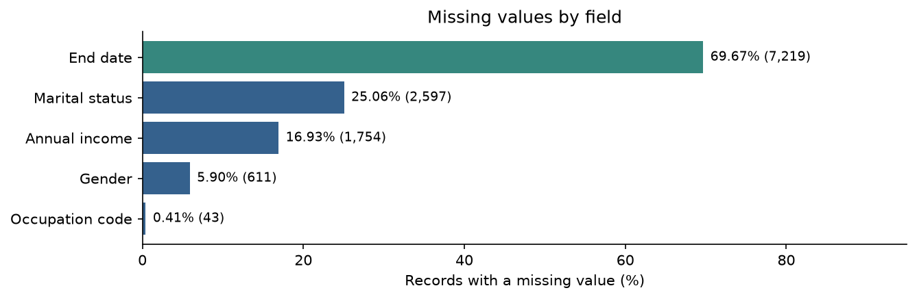
Figure 1. Missing values out of 10,362 records. Labels show percentages and counts.
At least one value is missing in 8,024 rows (77.44%). Every cancelled membership has an end date, while every in-force membership has none. This could give away the outcome. For advance prediction, we should leave out end date and its missing-value flag unless their timing is known. Removing the ID and end date leaves 12 possible inputs.
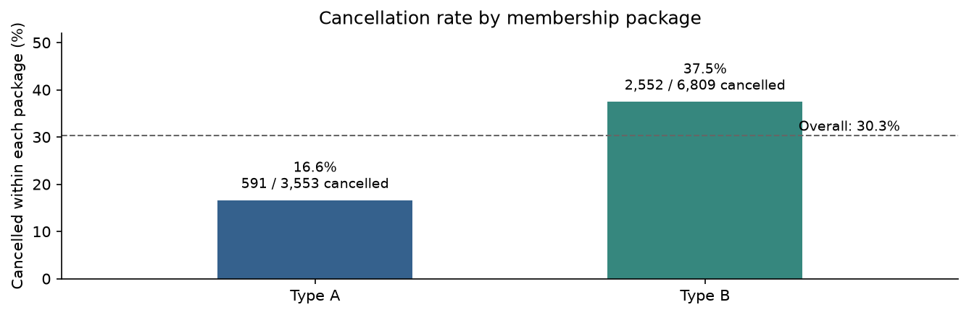
Figure 2. Cancellation rate within each package. Labels show cancelled and total records.
Cancellation rates are 16.63% for Type A and 37.48% for Type B. The groups may differ in other ways, so this does not show that package causes cancellation. Before modelling, we need to handle missing inputs, encode categories, and consider a transformation or scaling for fees and income.

Dermatology
There are 12 clinical inputs and 22 findings from skin samples. Thirty-two inputs are ordinal scores from 0 (absent) to 3 (largest degree). Their order matters, but the gaps need not be equal. Family history is binary nominal, age quantitative, and disease codes nominal [2].
The classes are psoriasis 112 (30.60%), seborrhoeic dermatitis 61 (16.67%), lichen planus 72 (19.67%), pityriasis rosea 49 (13.39%), chronic dermatitis 52 (14.21%), and pityriasis rubra pilaris (PRP) 20 (5.46%). The largest class is 5.6 times the smallest, so later evaluation needs stratified splits and results for each class.
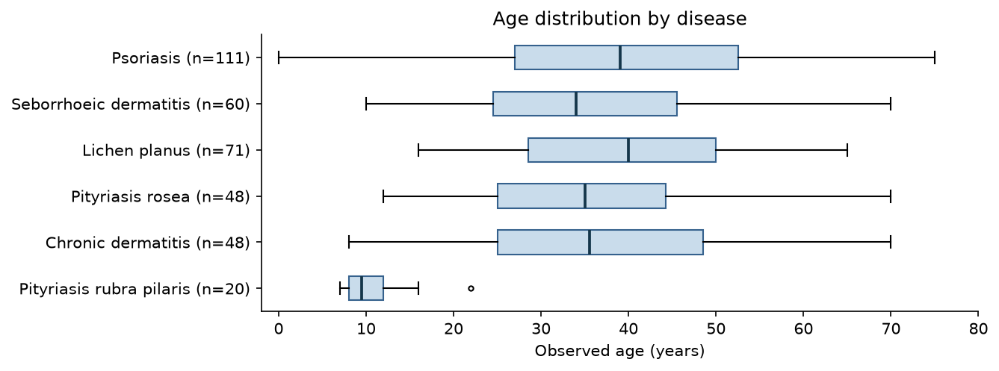
Figure 3. Ages by disease. Boxes show the middle 50% and medians; whiskers use 1.5 times the interquartile range. Eight missing ages are excluded; zero age is kept.
Only age has missing values: 8 out of 366 (2.19%). Observed ages range from 0 to 75 years, with median 35. PRP has median 9.5 years, compared with 34–40 for the other classes. This sample difference is not a diagnostic rule.
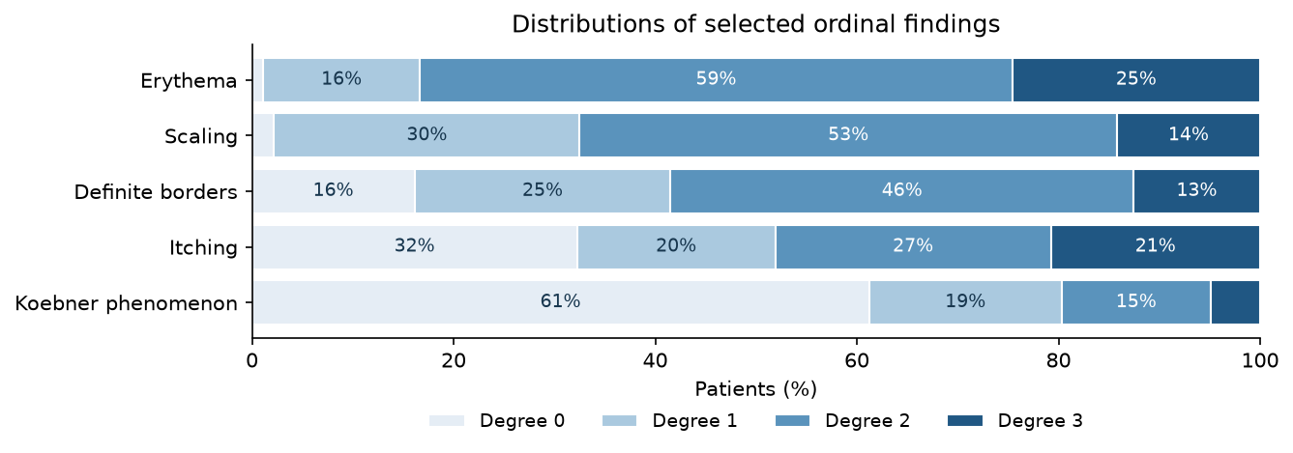
Figure 4. The first five clinical scores in source order. Each bar includes 366 patients; labels show rounded percentages for segments of at least 8%.
For the skin finding scaling, degree 2 is most common (53.28%). Family history is positive for 46 patients (12.57%). There are no duplicate rows. Keep scores ordered and fit age imputation or scaling on training data only. The skin-sample inputs would not be available from a clinical examination alone.

Sources and reproducibility
[1] OpenML. MembershipWoes, dataset 44225, version 2. https://www.openml.org/search?type=data&status=active&id=44225
[2] Ilter, N., & Guvenir, H. (1998). Dermatology [Dataset]. UCI Machine Learning Repository. https://doi.org/10.24432/C5FK5P
Sources accessed 24 October 2026. The notebooks contain the data checks, NumPy and pandas versions, and all analysis and plotting code. The figures come directly from their saved outputs.

