Comparative Evaluation of YOLO, Mask R-CNN, and Marker-Controlled Watershed for Automated Pill Counting
Yazed Aswad
Department of Computer Engineering, Abdullah Gül University
Kayseri, Turkey

Abstract--This project investigates automated pill counting in realistic images containing clutter, glare, touching pills, and varied lighting. Two established baselines, YOLO detection and Mask R-CNN instance segmentation, are compared with a proposed image-processing-centered method based on foreground prediction, center heatmaps, and marker-controlled watershed segmentation. To address comparison fairness, all three methods are evaluated on the same 175-image CountingPills test split. YOLO achieved the best count performance with MAE 0.0171 and exact count accuracy 0.9829. Mask R-CNN achieved MAE 0.2229 and exact count accuracy 0.8171 after training on CountingPills polygon-derived instance masks. The proposed method achieved MAE 0.3143 and exact count accuracy 0.7429. Although the proposed method did not outperform the baselines, it provides interpretable intermediate maps and explicit image-processing controls for studying under-counting and over-counting in touching-pill scenes.
Index Terms--pill counting, image processing, YOLO, Mask R-CNN, watershed segmentation, instance separation.
I. INTRODUCTION
Accurate pill counting is important in medication management, pharmacy verification, and assistive health applications. Manual counting can be slow and error-prone when pills are visually similar, clustered, partially overlapping, or photographed under uneven illumination. Image-based counting is attractive because a single camera image can provide both object count and visual evidence for later review.
The image-processing challenge is not only to detect pills, but also to handle realistic artifacts. Tray images may contain glare, scratches, shadows, transparent plastic boundaries, and fingers at the image border. Pills can touch each other or overlap, causing several physical objects to appear as one connected foreground region. A robust system must therefore handle both normal separated pills and difficult merged regions.
Recent medication and pill-counting systems often use deep object detectors. Sun et al. proposed a lightweight YOLOv8n-based pill-box detection and counting method for efficient deployment [1]. Nguyen et al. presented a multi-pill detection framework with multimodal fusion and compared against detectors including Faster R-CNN and YOLOv5 [2]. These studies motivate YOLO-style detection as a strong baseline. Mask R-CNN is also a natural baseline because it predicts object masks rather than only bounding boxes [3]. The MEDISEG dataset further supports segmentation-based evaluation by providing medication images with instance masks and realistic conditions [4].
The literature also shows why a comparison study is useful. Object detectors are fast and accurate when object boundaries are visually separable, but they do not expose much information about why a particular pill was missed. Instance segmentation methods provide richer object masks, but they still depend on the model learning one mask per physical object. Classical image-processing methods, including thresholding, morphology, connected-component labeling, distance transforms, and watershed segmentation, offer another viewpoint: they allow the counting process to be decomposed into visible intermediate steps. That decomposition is valuable in an image processing course because it connects modern learning-based prediction with traditional pixel-level operations.
The original proposal included detection, classification, and OCR. After professor feedback, the project was revised because such a pipeline would be incremental over existing YOLO and CNN systems. The revised project focuses on a clearer experimental question: how does a finalized image-processing-based instance separation module compare against two established pill-counting baselines? This makes the proposed method directly comparable with the two baselines while still being different from them in its counting mechanism.
This comparison is important because a single high accuracy number can hide different types of behavior. A detector may count correctly without producing an interpretable segmentation. A foreground segmenter may identify the pill region but fail to separate instances. A watershed method may split touching pills but may also over-split scratches or glare. By evaluating all three approaches, the project separates the question of detection accuracy from the question of image-processing-based instance separation.
The contribution of this work is a controlled comparison between two established baselines and a proposed image-processing-centered method. The proposed method is not intended to replace modern detectors. Instead, it tests whether foreground segmentation, center-marker extraction, morphology, and watershed segmentation can explicitly address touching-pill cases and provide interpretable failure analysis. The implementation code is intended to be released at the public repository URL cited in [5].
II. MATERIALS AND METHODS
A. Datasets
Two datasets were used. CountingPills is a YOLO-format dataset with one class, pill. It contains tray images with multiple pills, glare, scratches, and varied visual conditions. The local split contained 6450 training images with 22779 instances, 386 validation images with 2014 instances, and 175 test images with 842 instances. The original polygon labels were converted into bounding boxes for YOLO detection training. The same polygons were used to create foreground masks and Gaussian center heatmaps for the proposed method.
MEDISEG 3pills is a COCO-style instance segmentation dataset that was used during initial baseline development and is retained only as auxiliary context. The final Round-2 comparison does not use the MEDISEG result in the main table because the professor feedback emphasized that fair comparison requires the same dataset, split, and metric protocol.
The two datasets differ in visual domain and annotation style. CountingPills contains tray-centered images with plastic reflections, dark scratches, strong highlights, and sometimes fingers near the image border. MEDISEG contains medication images with instance masks that are useful for training and evaluating segmentation. This domain difference is important: a model that performs well on one dataset should not automatically be assumed to generalize to the other. For that reason, the final comparison reports the dataset used for each result rather than mixing all scores into one combined metric.
For CountingPills, the annotations were used in three compatible ways. The YOLO baseline used rectangular detection targets, so each polygon was converted to a bounding box. The Mask R-CNN baseline used the same YOLO polygon labels as instance masks, with one binary foreground class for pill instances. The proposed method used the polygons to build a foreground map and a Gaussian-like center heatmap, allowing the final comparison to use the same 175-image CountingPills test split for all methods.
TABLE I. DATASET SUMMARY
Dataset | Split / subset | Images | Instances / ann.
CountingPills | Train | 6450 | 22779
CountingPills | Validation | 386 | 2014
CountingPills | Test | 175 | 842
MEDISEG 3pills | All | 2333 | 4603

Fig. 1. Representative prediction and segmentation examples from the experiments.
B. Baseline 1: YOLO Detector
The YOLO baseline performs direct object detection. Its counting rule is simple: after confidence filtering and non-maximum suppression, each remaining bounding box is counted as one pill. This baseline is strong because it directly optimizes object localization and is robust for separated pills. In this project, YOLO was trained on the processed CountingPills detection labels.
YOLO is also an appropriate baseline because recent pill-counting papers use YOLO-family models for real-time counting. In this project, polygon annotations were converted into bounding boxes so that the detector was trained on clean detection labels. The final validation score was computed by comparing the number of predicted boxes with the ground-truth number of pills in each image.
The count estimate for an image I can be written as
N_YOLO(I) = |{b_i : conf(b_i) >= tau and b_i remains after NMS}|,
where b_i is a predicted bounding box and tau is the confidence threshold.
C. Baseline 2: Mask R-CNN
Mask R-CNN performs instance segmentation by predicting class labels, bounding boxes, and masks for object instances [3]. For counting, each accepted instance mask is counted as one pill. This makes Mask R-CNN a useful second baseline because it models object shape more directly than a bounding-box detector. In this project, Mask R-CNN was trained on the CountingPills training split using instance masks generated from the polygon annotations and evaluated on the same 175-image CountingPills test split used for YOLO and the proposed method. MEDISEG 3pills was used only during preliminary development and is not included in the final numerical comparison.
The Mask R-CNN baseline gives a stronger segmentation-oriented comparison than connected components alone. Its mask branch is trained to predict separate object masks, so successful counting does not require a post-processing algorithm to split one binary foreground blob. This is the main conceptual difference between Mask R-CNN and the proposed method: Mask R-CNN learns the instance separation inside the neural network, while the proposed method performs the final split through marker-controlled image processing.
The count estimate is
N_MRCNN(I) = |{m_i : score(m_i) >= tau}|,
where m_i is a predicted instance mask.
D. Proposed Method
The proposed method was designed to differ from both baselines. YOLO counts boxes and Mask R-CNN counts predicted instance masks. The proposed method instead predicts two dense maps and then uses classical image-processing operations to reconstruct instances. The foreground map estimates pill pixels, while the center heatmap estimates likely pill centers. These predictions are converted into object instances using thresholding, morphology, local-maxima extraction, non-maximum suppression, and marker-controlled watershed segmentation.

Fig. 2. Proposed Method pipeline.
The foreground mask is obtained by thresholding the foreground probability map P_f:
F(x,y) = 1 if P_f(x,y) >= theta_f, otherwise 0.
The center heatmap P_c is searched for local maxima. Candidate centers are retained if P_c(x,y) >= theta_c and then filtered by non-maximum suppression with minimum peak distance d. The resulting markers initialize watershed segmentation inside the foreground mask F. The predicted count is the number of accepted watershed regions after optional component filtering:
N_proposed(I) = |{R_k : area(R_k) >= A_min and R_k is accepted}|.
This strategy explicitly addresses occlusion and touching pills by replacing a single merged foreground component with multiple marker-guided regions. It also creates interpretable intermediate outputs: foreground probability, center heatmap, markers, and final separated regions.
The design choice is motivated by a common failure mode in pill images. If two pills touch, ordinary thresholding may produce one foreground component. Connected-component analysis would then count one object even though the correct answer is two. The proposed method tries to fix that failure by estimating the centers of the physical pills and using those centers as watershed markers. In this way, the center heatmap acts as an explicit occlusion-handling signal. The watershed step uses the foreground boundary to prevent the split from spreading into the background.
The foreground and center predictions were produced with a small U-Net-style model. The purpose of this network was not to compete with a large segmentation architecture, but to provide dense maps that could be interpreted by the image-processing stage. The final two-channel version predicts a foreground probability channel and a center heatmap channel. Training used a combined objective so that the model learned both pixel coverage and center localization. During inference, the two channels are separated and processed with deterministic operations.
Algorithm 1. Proposed Method Center-Marker Counting
1: Input: RGB image I
2: Output: Predicted pill count N
3: procedure PROPOSED_METHOD(I)
4: X <- ResizeNormalize(I)
5: Pf, Pc <- TinyUNet(X)
// foreground probability and center heatmap
6: F <- Threshold(Pf; theta_f = 0.5)
// binary pill foreground
7: F <- MorphClose(MorphOpen(F))
// remove noise and fill small holes
8: C <- LocalMaxima(Pc; theta_c = 0.35)
// candidate pill centers
9: M <- NMS(C; minDistance = 32)
// keep separated center markers
10: D <- DistanceTransform(F)
11: R <- Watershed(-D; markers = M, mask = F)
// split touching foreground regions
12: R <- FilterComponents(R; area >= A_min)
13: N <- Count(R)
14: return N
15: end procedure

E. Post-Processing
After the foreground and center maps are predicted, the proposed method uses deterministic post-processing to convert the dense outputs into countable instances. Morphological opening and closing are used to reduce small foreground artifacts and fill minor holes in pill regions. Component filtering is then applied after watershed segmentation to remove regions that are too small to represent a pill.
The post-processing stage is important because the proposed method does not directly output object boxes or instance masks. It must transform pixel-level predictions into a discrete set of pill regions. This stage is also where the method remains interpretable: errors can be inspected as foreground errors, missing center markers, over-splitting, under-splitting, or component-filtering mistakes.
F. Implementation Details
All experiments were organized as reproducible scripts. Separate training and evaluation scripts were created for YOLO, Mask R-CNN, and the proposed method. The scripts save outputs under experiment folders and write numerical summaries to CSV tables. This organization makes it possible to rerun a method, change a threshold, and regenerate the report tables without manually copying results.
The YOLO experiment used the CountingPills detection labels and evaluated count error from the number of predicted boxes. The Mask R-CNN experiment was retrained on CountingPills by converting each YOLO polygon label into an instance mask and bounding box. This change makes the main results a fair dataset-matched comparison across YOLO, Mask R-CNN, and the proposed method.
G. Fair Comparison Protocol
The Round-2 comparison was designed so that the main numerical table answers a single question: given the same CountingPills test images, which method produces the most accurate pill count? All three methods were evaluated on the identical 175-image CountingPills test split, and no MEDISEG result was included in the main comparison table. The ground-truth count for each image was computed from the CountingPills annotation file, so the evaluation target was independent of the model type.
The three methods used different prediction representations but the same final counting objective. YOLO produced a set of detection boxes after confidence filtering and non-maximum suppression; the count was the number of accepted boxes. Mask R-CNN produced instance-level mask predictions; the count was the number of accepted masks at score threshold 0.5. The proposed method produced a foreground map and center-marker map; the count was the number of watershed-separated regions remaining after thresholding, marker extraction, and component filtering.
This protocol separates model representation from counting performance. YOLO is allowed to use rectangular detections, Mask R-CNN is allowed to use instance masks, and the proposed method is allowed to use marker-controlled watershed, but all of them are judged by the same image-level count metrics: MAE, MSE, exact count accuracy, under-counting, and over-counting. This makes the comparison fairer than the earlier cross-dataset version because differences in dataset domain, annotation style, and test image count no longer drive the main result.
III. EXPERIMENTAL RESULTS
A. Evaluation Metrics and Parameters
Counting performance was evaluated using MAE, MSE, exact count accuracy, under-count rate, and over-count rate. MAE measures the average absolute count error, while MSE penalizes larger count errors more strongly by squaring the error. Exact count accuracy measures the fraction of images for which the predicted count equals the ground-truth count. The under-count rate is the fraction of images where the predicted count is lower than the ground truth, and the over-count rate is the fraction where the predicted count is higher.
MAE = (1/n) sum_i |N_i - Nhat_i|.
MSE = (1/n) sum_i (N_i - Nhat_i)^2.
UnderRate = (1/n)|{i : Nhat_i < N_i}|, OverRate = (1/n)|{i : Nhat_i > N_i}|.
The proposed method used foreground threshold theta_f = 0.5, center threshold theta_c = 0.35, and peak minimum distance d = 32 for the final CountingPills test result. These values define the final method used in the comparison table.
TABLE II. MAIN EXPERIMENT PARAMETERS
Experiment | Main parameters
YOLO | CountingPills test; confidence threshold 0.25; box count after NMS
Mask R-CNN | CountingPills test; polygon-derived  instance masks; score threshold 0.5
Proposed method | CountingPills test; theta_f=0.5; theta_c=0.35; peak distance=32

B. Main Numerical Comparison
TABLE III. MAIN COUNTING RESULTS
Method | n | MAE | MSE | Exact | Under | Over
YOLO detector | 175 | 0.0171 | 0.0171 | 0.9829 | 0.0057 | 0.0114
Mask R-CNN | 175 | 0.2229 | 0.3029 | 0.8171 | 0.0000 | 0.1829
Proposed method | 175 | 0.3143 | 0.4514 | 0.7429 | 0.1314 | 0.1257

The results show that YOLO was the strongest method on the shared CountingPills test split. Mask R-CNN was second, and the proposed method was third. This ordering is consistent across MAE, MSE, exact count accuracy, and the under-count/over-count rates. For this dataset, direct object-detection boxes were sufficient for counting most pills, while mask-based and watershed-based methods were more sensitive to segmentation quality and post-processing.
The numerical gap between YOLO and the proposed method on CountingPills is still large. YOLO achieved exact count accuracy 0.9829, Mask R-CNN achieved 0.8171, and the proposed method reached 0.7429. The proposed method also had a higher MSE than YOLO and Mask R-CNN, showing that its occasional larger count errors mattered more than one-pill mistakes alone. The proposed method therefore should be interpreted as an interpretable image-processing alternative rather than the best-performing counting model.
Fig. 3 provides a qualitative view of the shared-test protocol on one CountingPills image with ten annotated pills. All three methods produce the correct count in this example, but they do so through different visual evidence: YOLO marks detection boxes, Mask R-CNN marks instance regions, and the proposed method reconstructs separated regions from foreground and center-marker predictions. The figure is included to make the comparison concrete rather than only numerical.
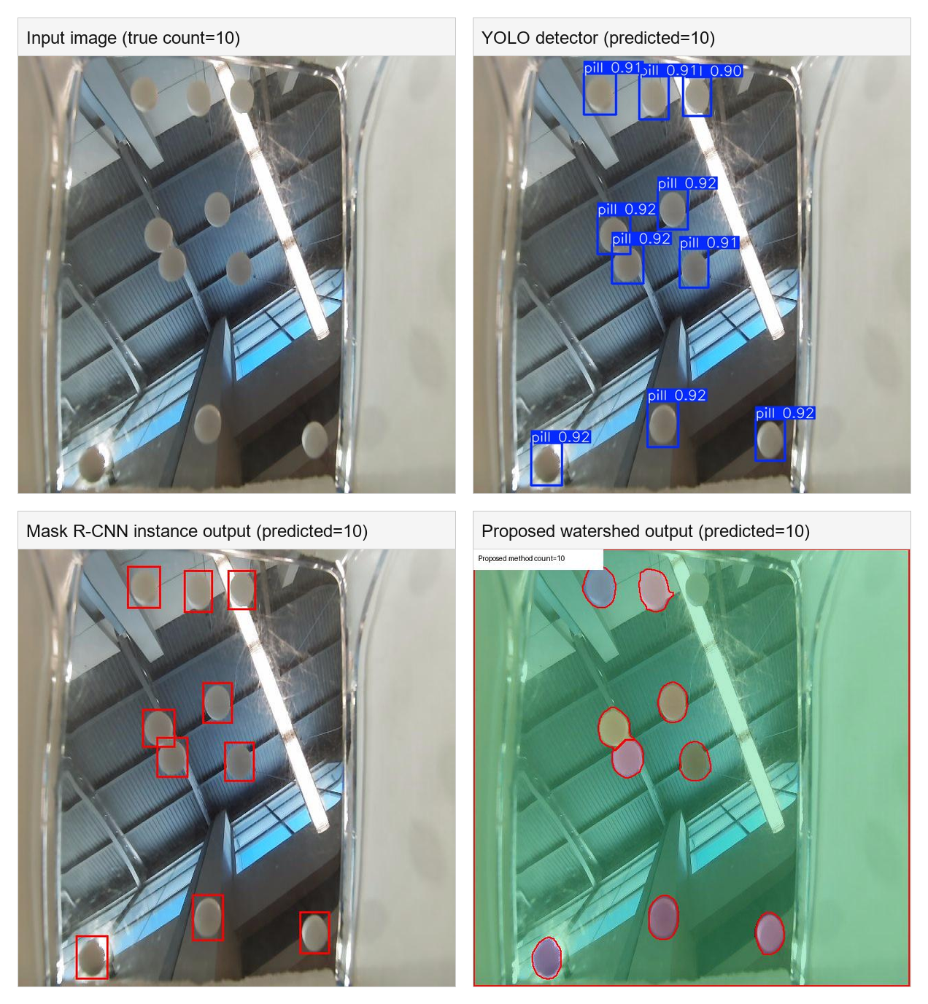
Fig. 3. Qualitative comparison on the same CountingPills test image. The panels show the input image, YOLO detector output, Mask R-CNN output, and proposed watershed output.
C. Parameter Sensitivity of the Proposed Method
A validation-only sensitivity study was performed for the three post-processing parameters that most directly affect instance reconstruction: the foreground threshold theta_f, center threshold theta_c, and local-maximum peak distance d. The foreground threshold theta_f converts the predicted foreground probability map into a binary pill mask; pixels with probability at or above theta_f are treated as possible pill pixels. The center threshold theta_c controls which peaks in the predicted center heatmap are accepted as possible pill centers. The distance parameter d is the minimum allowed spacing, in pixels, between accepted center peaks after non-maximum suppression. These accepted centers become watershed markers, so the values of theta_c and d directly control whether touching pills are split into separate regions or merged into one region. The test result in Table III was not retuned from this table; the purpose of the study is to explain behavior rather than to repeatedly search the test split.
TABLE IV. PROPOSED METHOD VALIDATION PARAMETER SENSITIVITY
Setting | theta_f | theta_c | d | MAE | Exact | Under | Over
Initial validation setting | 0.5 | 0.35 | 24 | 0.6425 | 0.6632 | 0.1632 | 0.1736
lower foreground threshold | 0.45 | 0.35 | 24 | 0.6451 | 0.6606 | 0.1632 | 0.1762
higher foreground threshold | 0.55 | 0.35 | 24 | 0.6399 | 0.6658 | 0.1632 | 0.1710
lower center threshold | 0.5 | 0.3 | 24 | 0.6839 | 0.6580 | 0.1269 | 0.2150
higher center threshold | 0.5 | 0.4 | 24 | 0.6399 | 0.6762 | 0.1813 | 0.1425
shorter peak distance | 0.5 | 0.35 | 16 | 0.8187 | 0.6062 | 0.1321 | 0.2617
longer peak distance | 0.5 | 0.35 | 32 | 0.5570 | 0.7021 | 0.1969 | 0.1010
The center threshold and peak distance had the largest practical effect. Lowering theta_c accepted weaker center peaks and reduced some under-counting, but it increased over-counting because false or duplicate centers created extra watershed markers. Increasing theta_c had the opposite effect: fewer markers reduced over-counting but made merged pills more likely to remain under-split. A shorter peak distance, d=16, produced the clearest over-counting behavior because nearby maxima inside one pill were allowed to survive. A longer peak distance, d=32, achieved the best validation MAE in this sweep by suppressing duplicate nearby markers, but it also increased the under-count rate because close pills can lose separate markers. The foreground threshold had little effect in the tested range from 0.45 to 0.55, which suggests that the main limitation was center-marker placement rather than foreground masking.
D. Representative Dense-Cluster Example
A dense CountingPills example was used to visually inspect the final proposed method. The image contains a compact group of pills, making it useful for showing why the method predicts center markers before watershed segmentation. In this example, the final proposed method recovered the correct count when peak distance was set to 24, and the YOLO baseline also recovered the correct count.
TABLE V. REPRESENTATIVE DENSE-CLUSTER EXAMPLE
Method/settings | Count
Proposed method, representative dense example | 13
YOLO baseline | 13
Ground truth | 13

E. Visual Interpretation
The visual outputs were useful for diagnosing errors. YOLO predictions were generally reliable on CountingPills because bounding boxes remained separable even in moderately dense clusters. Mask R-CNN produced instance-level predictions on CountingPills, but its tendency to generate extra masks resulted in over-counting on 32 test images. because the dataset provides instance masks that match the model objective. Visualizations from the proposed method were more revealing: the foreground map showed whether the model found pill pixels, the center heatmap showed whether the model found individual pill centers, and the final watershed overlay showed where the split succeeded or failed.
Several failure cases were observed. In tray images, scratches and glare sometimes appeared as foreground-like regions. Under-counting happened when neighboring pills had weak or missing center peaks, while over-counting happened when one pill produced multiple peaks or when an artifact produced a false peak. These observations explain why center-marker quality is important for the proposed method.
Fig. 4 shows one under-count and one over-count from the proposed method. The under-count occurs when pill evidence is weak or merged so that not enough center markers survive. The over-count occurs when a small number of pills generates too many accepted markers, causing watershed to split the foreground into extra regions.
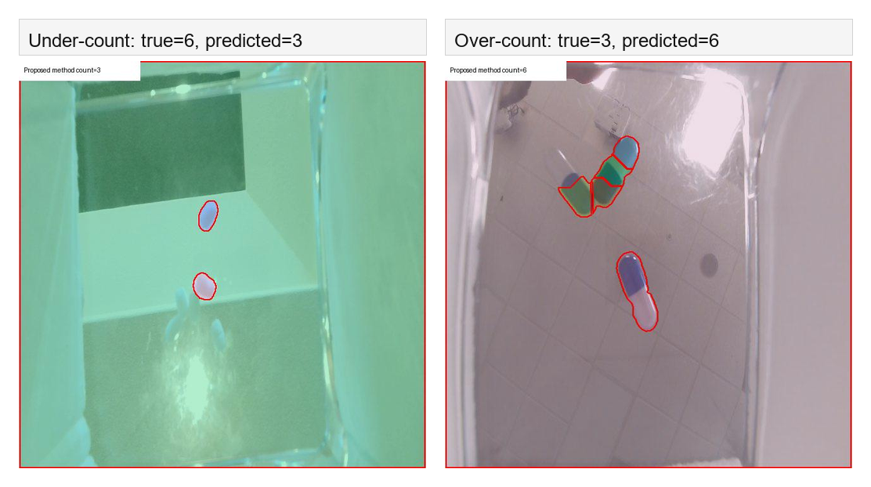
Fig. 4. Proposed method failure cases on CountingPills test images: under-counting from missed center markers and over-counting from extra markers.
F. Error Distribution Analysis
The per-image error distribution gives a more detailed view than MAE alone. YOLO produced exact counts for nearly every image, so its MAE was caused by only three one-pill errors. Mask R-CNN made no under-count errors in this run, but it over-counted 32 images, indicating that its dominant failure mode was extra mask predictions. The proposed method was more balanced but less stable: it under-counted 23 images and over-counted 22 images, with a few errors reaching three pills in magnitude.
TABLE VI. COUNTINGPILLS TEST ERROR DISTRIBUTION
Method | Exact | Under | Over | Largest errors
YOLO detector | 172 | 1 | 2 | -1 to +1
Mask R-CNN | 143 | 0 | 32 | 0 to +2
Proposed method | 130 | 23 | 22 | -3 to +3
This distribution supports the qualitative interpretation in Fig. 4. The proposed method has an explicit mechanism for separating touching pills, but the number of watershed markers must be correct. Too few accepted markers merge pills and cause under-counting; too many accepted markers split one pill or glare region into multiple regions and cause over-counting. This makes the method useful for image-processing analysis, while also explaining why its final accuracy remains below the detector baseline.
Why the proposed method fails differently: YOLO and Mask R-CNN make object-level decisions, so their counting errors usually come from missed detections, duplicate detections, or extra predicted masks. The proposed method instead makes pixel-level foreground and center-marker decisions before the final count exists. This means its failures are tied to image-processing reconstruction. If glare, shadows, or low contrast weaken the center heatmap, multiple touching pills can share one marker and become one watershed region. If scratches, highlights, or texture create extra local maxima, one pill can receive multiple markers and be split into several regions. Therefore, the proposed method is more interpretable because the failure can be traced to foreground, center, and watershed stages, but it is also more sensitive to threshold and marker-placement parameters than a direct detector.

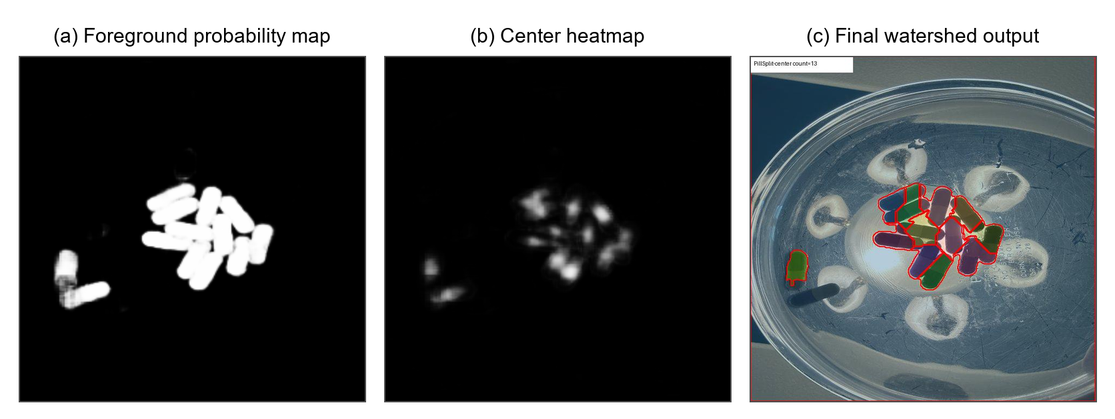

IV. DISCUSSION
The comparison study leads to an important interpretation: the proposed method should not be described as better than YOLO or Mask R-CNN overall. Under the training settings used in this study, YOLO and Mask R-CNN achieved lower counting error than the proposed method on the shared CountingPills test split. The proposed method's value is instead methodological and diagnostic. It shows how image-processing operations can be inserted after learned predictions to make touching-object separation explicit and interpretable.
This also addresses the professor's feedback about the original proposal being incremental over YOLO and CNN stacks. The revised proposed method does not simply add OCR or classification to a detector. It changes the counting mechanism: the final count is generated by marker extraction and watershed segmentation. OCR and classification can be future extensions for imprint reading and categorization, but they are not required for the core counting comparison in this version.
The main limitation is that the proposed method remains sensitive to center-marker quality and peak extraction parameters. Tray glare, scratches, and strong highlights can create false foreground regions or suppress true centers. In addition, the best method may vary by dataset domain. MEDISEG and CountingPills differ in imaging setup, annotation style, and visual artifacts, so a model trained on one domain does not necessarily transfer to the other.
The comparison also clarifies the role of categorization and OCR. The current project focuses on counting, because counting is the clearest way to compare the three methods. Pill categorization and imprint reading could be added after detection or segmentation by cropping each predicted instance and applying a classifier or OCR model. A confidence fusion formula could combine visual classification confidence and OCR confidence, for example S = alpha S_visual + (1-alpha) S_OCR. However, adding OCR before establishing reliable counting would make the project harder to evaluate. Therefore, OCR is discussed as future work rather than included in the final core pipeline.
A. Threats to Validity
Several threats to validity should be considered. First, the CountingPills Mask R-CNN experiment was trained for a limited one-epoch run because the goal of the revision was to establish a same-split comparison, not to exhaustively optimize every baseline. More training and threshold tuning could improve Mask R-CNN. Second, the proposed method was tuned on validation and then evaluated once on the test split; broader hyperparameter optimization could change the exact error rates.
Another limitation is that the proposed method uses center heatmaps derived from annotations. If annotations are noisy or if pills have unusual shapes, the center target may not fully represent the best marker for watershed. Future work could use skeletons, distance-transform peaks, or learned offset vectors instead of simple center heatmaps. The method could also be evaluated with cross-validation or on an external dataset to test generalization.
V. CONCLUSION
This project compared YOLO detection, Mask R-CNN instance segmentation, and the proposed marker-controlled watershed method for automated pill counting on a common CountingPills test split. YOLO achieved the best result, Mask R-CNN provided a stronger segmentation baseline than the original cross-dataset result, and the proposed method showed interpretable but more error-prone behavior.
Future work should include broader hyperparameter optimization, stronger center-heatmap architectures, instance-aware losses, cross-dataset training, and a controlled OCR or imprint-recognition module for categorization. A practical system could combine YOLO's strong detection accuracy with the proposed method's separation diagnostics for difficult clusters.
A more complete future system could use YOLO to quickly propose pill regions, the proposed method to analyze dense or suspicious clusters, and a classifier/OCR module to identify pill category and imprint. This hybrid design would use each method where it is strongest: YOLO for detection speed, watershed-based image processing for interpretable cluster splitting, and OCR/classification for medication identity. The current project provides the counting comparison needed before those additional modules are added.
VI. ACKNOWLEDGEMENTS
AI tools were used during project preparation to assist with planning, code organization, experiment scripting, result summarization, and report drafting. The experiments, interpretation, and final technical claims were reviewed and organized by the author. The implementation repository is cited as [5].
VII. REFERENCES
[1] W. Sun, X. Niu, Z. Wu, and Z. Guo, "Lightweight detection counting method for pill boxes based on improved YOLOv8n," Electronics, vol. 13, no. 24, Art. no. 4953, 2024, doi: 10.3390/electronics13244953.
[2] A. D. Nguyen et al., "High accurate and explainable multi-pill detection framework with graph neural network-assisted multimodal data fusion," arXiv:2303.09782, 2023. [Online]. Available: https://arxiv.org/abs/2303.09782
[3] K. He, G. Gkioxari, P. Dollar, and R. Girshick, "Mask R-CNN," in Proc. IEEE Int. Conf. Comput. Vis. (ICCV), 2017, pp. 2961-2969, doi: 10.1109/ICCV.2017.322.
[4] W. I. Chu, S. Hirani, G. Tarroni, and L. Li, "A dataset of medication images with instance segmentation masks for preventing adverse drug events," arXiv:2603.10825, 2026. [Online]. Available: https://arxiv.org/abs/2603.10825.
[5] Y. Aswad, "COMP430 automated pill counting implementation," GitHub repository, 2026. [Online]. Available: https://github.com/yazeedaswad/COMP430. Accessed: Jun. 16, 2026.

