AGU COMPUTER ENGINEERING
CAPSTONE PROJECT
FINAL REPORT
Imbalance-Aware CNN-Transformer for Intrusion Detection in Modern Network Traffic
by
Yazed Aswad
2211051078

SUMMARY
This project investigates imbalance-aware intrusion detection for modern network traffic. A CNN-Transformer model was implemented and evaluated on the UNSW-NB15 dataset using multiclass attack labels. The study compares the proposed model with MLP, Deep Autoencoder, and CNN-BiLSTM baselines under common preprocessing. Weighted cross entropy and focal loss were tested for class imbalance, and a preliminary UNSW-NB15 to NSL-KDD binary transfer experiment was added to examine cross-dataset behavior. Results show that the CNN-Transformer with weighted cross entropy is competitive with CNN-BiLSTM on UNSW-NB15, but it does not outperform the Deep Autoencoder or MLP baselines. The cross-dataset test confirms that generalization remains difficult. Deployment profiling shows that all models are compact, although the CNN-Transformer is slower at inference than simpler baselines.

INTRODUCTION
Network intrusion detection systems are important security mechanisms for identifying malicious traffic, scanning behavior, exploitation attempts, and other abnormal network events. As modern networks become larger and more heterogeneous, manually defined signatures alone are not sufficient for detecting new or evolving attacks. Machine learning and deep learning models have therefore become common in intrusion detection research because they can learn discriminative patterns from flow-level traffic features.
However, high benchmark accuracy can be misleading in intrusion detection. Many public datasets are highly imbalanced: benign traffic and frequent attack families dominate the samples, while rare attack categories appear only in small numbers. A model can therefore achieve high accuracy while still failing to detect minority attacks. Recent work on IDS class imbalance emphasizes that rare attacks are often the most important cases to detect, even though they are under-represented in training data [8]. For this reason, this project reports macro-F1, weighted-F1, and per-class precision and recall rather than relying only on accuracy.
A second challenge is dataset-specific bias. Recent cross-dataset studies show that models can perform very well when trained and tested on the same dataset, but degrade sharply when evaluated on traffic from a different dataset [7]. This suggests that some IDS models learn artifacts of a benchmark dataset instead of robust attack behavior. The present project therefore includes a preliminary cross-dataset binary transfer experiment from UNSW-NB15 to NSL-KDD.
The main goal of this project is to evaluate whether a lightweight CNN-Transformer architecture can improve imbalance-aware intrusion detection compared with prior deep-learning baselines. The proposed model combines a one-dimensional convolutional feature extractor with a Transformer encoder. The CNN layer is intended to capture local feature interactions, while the Transformer encoder uses self-attention to model broader dependencies across encoded flow features.
The contributions of this work are: (1) a reproducible preprocessing and training pipeline for UNSW-NB15, (2) implementation of the proposed CNN-Transformer IDS, (3) comparison against two prior-work-style baselines, Deep Autoencoder IDS and CNN-BiLSTM IDS, (4) evaluation of focal loss and weighted cross entropy for class imbalance, (5) preliminary binary cross-dataset evaluation from UNSW-NB15 to NSL-KDD, and (6) deployment-oriented profiling using parameter count, checkpoint size, and inference latency.

RELATED WORK
Autoencoder-based intrusion detection is a major line of deep IDS research. Farahnakian and Heikkonen proposed a deep autoencoder approach for intrusion detection, showing that compressed representations can be useful for modeling abnormal traffic [3]. Shone et al. also demonstrated the value of deep representation learning for network intrusion detection [4]. These studies motivate the Deep Autoencoder baseline used in this project.
Hybrid deep architectures combine different neural components to capture complementary patterns. CNN-based layers can learn local feature interactions, while recurrent layers such as LSTM or BiLSTM can model ordered dependencies. This project includes a CNN-BiLSTM baseline to represent this family of hybrid IDS approaches. Transformer-based IDS research has also grown recently. Tseng et al. evaluated Transformer-based multiclass intrusion detection for IoT traffic and reported strong results on CIC-IoT-2023 [6].
Dataset design and evaluation methodology are equally important. UNSW-NB15 was introduced by Moustafa and Slay as a modern benchmark for network intrusion detection [2]. CIC-IDS2017 is another widely used dataset with contemporary attack scenarios [5]. Reviews of IDS research identify persistent challenges including class imbalance, dataset bias, limited realism, and deployment constraints [1]. Cantone et al. further showed that cross-dataset generalization can collapse even when same-dataset results are strong [7].
Table 1. Comparison of related IDS approaches.
Approach | Main idea | Strength | Limitation
Deep Autoencoder IDS | Compressed representation plus classifier | Strong representation learning baseline | May learn dataset-specific reconstruction patterns
CNN-BiLSTM IDS | CNN feature extraction followed by bidirectional recurrent modeling | Strong hybrid deep baseline | Slower than simple feed-forward models
Transformer IDS | Self-attention over encoded feature tokens | Models broader feature dependencies | More complex and not always superior on tabular features
This project | 1D-CNN plus Transformer with imbalance-aware objectives | Tests accuracy, macro-F1, transfer behavior, and deployment profile | Current transfer test uses compact binary feature alignment

SYSTEM MODEL
The main experimental dataset is UNSW-NB15. The official training and testing CSV files were used. The training file contains 175,341 records and the testing file contains 82,332 records. A validation subset was created by taking 10% of the training split using stratified sampling. After preprocessing, the final split sizes were 157,808 training records, 17,533 validation records, and 82,332 test records.
The multiclass target is attack_cat, which contains ten classes: Analysis, Backdoor, DoS, Exploits, Fuzzers, Generic, Normal, Reconnaissance, Shellcode, and Worms. The binary label column was dropped for the multiclass experiment. Numerical features were standardized using training-set statistics, while the categorical features proto, service, and state were one-hot encoded. The processed multiclass representation has 194 features.
Table 2. UNSW-NB15 class distribution in the official train and test files.
Split | Class | Count | Percentage
Train | Normal | 56000 | 31.94
Train | Generic | 40000 | 22.81
Train | Exploits | 33393 | 19.04
Train | Fuzzers | 18184 | 10.37
Train | DoS | 12264 | 6.99
Train | Reconnaissance | 10491 | 5.98
Train | Analysis | 2000 | 1.14
Train | Backdoor | 1746 | 1.0
Train | Shellcode | 1133 | 0.65
Train | Worms | 130 | 0.07
Test | Normal | 37000 | 44.94
Test | Generic | 18871 | 22.92
Test | Exploits | 11132 | 13.52
Test | Fuzzers | 6062 | 7.36
Test | DoS | 4089 | 4.97
Test | Reconnaissance | 3496 | 4.25
Test | Analysis | 677 | 0.82
Test | Backdoor | 583 | 0.71
Test | Shellcode | 378 | 0.46
Test | Worms | 44 | 0.05

The preliminary cross-dataset experiment uses UNSW-NB15 for training and NSL-KDD KDDTest+ for testing. Because the two datasets do not share identical feature schemas or attack taxonomies, this experiment is binary: Normal versus Attack. A compact aligned feature representation with 18 features was used, including log duration, log source bytes, log destination bytes, protocol bucket, service bucket, and connection-state bucket.

Feature Alignment for Cross-Dataset Transfer
Cross-dataset transfer between UNSW-NB15 and NSL-KDD requires explicit feature alignment because the datasets were collected in different environments and use different feature names, attack labels, and extraction tools. A direct multiclass transfer would be unfair because UNSW-NB15 and NSL-KDD do not share the same attack taxonomy. Therefore, the cross-dataset experiment was converted to a binary Normal-versus-Attack task and only semantically comparable features were retained.
Table 3. Feature alignment used for UNSW-NB15 to NSL-KDD binary transfer.
Concept | UNSW-NB15 feature | NSL-KDD feature | Processing
Duration | dur | duration | log1p, standardization
Source bytes | sbytes | src_bytes | log1p, standardization
Destination bytes | dbytes | dst_bytes | log1p, standardization
Protocol | proto | protocol_type | bucket / one-hot
Service | service | service | shared categories + unknown
State / flag | state | flag | mapped to connection-state bucket

The numerical features were transformed with log1p to reduce the effect of extreme byte-count and duration values, then standardized using statistics computed from the UNSW-NB15 training data only. Categorical fields were mapped into shared buckets before one-hot encoding. This compact representation improves fairness across datasets, but it also removes many dataset-specific features. For this reason, the cross-dataset experiment should be interpreted as preliminary evidence of transfer behavior rather than a full feature-complete cross-dataset benchmark.

PROPOSED SOLUTION APPROACHES

Preprocessing Pipeline
The preprocessing pipeline first removes non-predictive or incompatible columns. For UNSW-NB15 multiclass experiments, id and label were removed, while attack_cat was used as the target. Numerical features were standardized, and categorical features were one-hot encoded. The same processed arrays were used for all models, ensuring that performance differences are caused by the model architecture or loss function rather than inconsistent preprocessing.
The end-to-end workflow is: raw UNSW-NB15 CSV files, data cleaning, label extraction, numerical scaling, categorical encoding, model training, validation by macro-F1, test evaluation, and result export. All scripts and configurations are included in the project repository. GitHub repository URL: https://github.com/yazeedaswad/COMP491.

Proposed CNN-Transformer
The proposed CNN-Transformer receives the encoded flow feature vector as input. A one-dimensional convolutional block first extracts local feature interactions. The resulting feature sequence is projected into Transformer token embeddings, positional embeddings are added, and a Transformer encoder applies multi-head self-attention. The encoded tokens are averaged and passed to a fully connected classifier. The best proposed configuration used 64 CNN channels, Transformer dimension 64, two Transformer layers, four attention heads, dropout 0.2, batch size 256, learning rate 0.001, and weighted cross entropy.
The proposed method differs from the Deep Autoencoder baseline because it is optimized directly for discriminative attack classification rather than reconstruction-based representation learning. It also differs from the CNN-BiLSTM baseline by replacing recurrent sequence modeling with Transformer self-attention. In the CNN-BiLSTM model, information passes through recurrent hidden states, while in the Transformer encoder each encoded feature position can attend directly to every other feature position. The intended advantage of the proposed design is therefore to combine local feature extraction from the CNN with global pairwise feature interaction from self-attention. This can be useful when attack behavior depends on relationships among distant traffic-flow features. At the same time, because UNSW-NB15 consists of engineered tabular flow features rather than a natural temporal sequence, the benefit of self-attention must be verified experimentally rather than assumed.
Weighted cross entropy was used to reduce bias toward majority classes. The loss can be written as L = -w_y log(p_y), where w_y is the class weight and p_y is the predicted probability of the correct class. Focal loss was also tested as an ablation using L = -w_y (1 - p_y)^gamma log(p_y), with gamma = 2.0.

Baseline Models
The Deep Autoencoder baseline uses an encoder to compress the feature vector into a latent representation, a decoder to reconstruct the input, and a classifier to predict the attack class from the latent vector. Its training objective combines classification loss with reconstruction loss, following the idea that useful IDS features can be learned through compressed representations.
The CNN-BiLSTM baseline uses a convolutional layer to extract local patterns and a bidirectional LSTM to process the feature sequence. The final hidden sequence is pooled and passed to a classifier. This model represents hybrid convolutional-recurrent IDS approaches. MLP baselines were also included as simple but strong tabular references.

PERFORMANCE EVALUATIONS
The models were implemented in Python using PyTorch. Data processing used pandas, NumPy, and scikit-learn-style transformations. Training used a CUDA-enabled GPU. Each experiment saved its best checkpoint according to validation macro-F1 and then evaluated the selected model on the test split. Metrics include accuracy, macro precision, macro recall, macro-F1, weighted-F1, and per-class precision, recall, and F1-score.
Table 4. Same-dataset UNSW-NB15 multiclass results.
Model | Accuracy | Macro-F1 | Weighted-F1
MLP, unweighted CE | 0.7516 | 0.4250 | 0.7547
MLP, weighted CE | 0.6513 | 0.4099 | 0.7093
Deep Autoencoder | 0.6698 | 0.4092 | 0.7153
CNN-BiLSTM | 0.5850 | 0.3798 | 0.6628
CNN-Transformer, focal loss | 0.5617 | 0.3132 | 0.6065
unsw_nb15_cnn_transformer_unweighted | 0.7449 | 0.3780 | 0.7497
CNN-Transformer, weighted CE | 0.6520 | 0.3800 | 0.7039
CNN-Transformer, tuned weighted CE | 0.6527 | 0.3733 | 0.7061

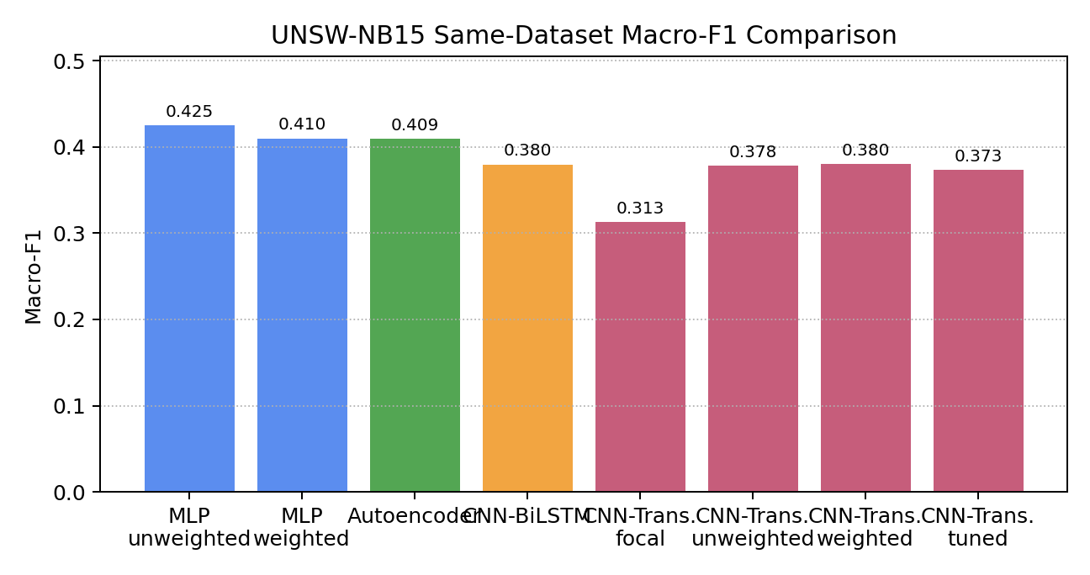
Figure 1. Same-dataset macro-F1 comparison on UNSW-NB15.
The best overall same-dataset model was the unweighted MLP, with 0.7516 accuracy, 0.4250 macro-F1, and 0.7547 weighted-F1. The strongest prior-work-style baseline was the Deep Autoencoder, with 0.4092 macro-F1. The proposed CNN-Transformer with weighted cross entropy achieved 0.3800 macro-F1, slightly above CNN-BiLSTM at 0.3798, but below the Deep Autoencoder and MLP baselines.
The CNN-Transformer likely underperformed the MLP because UNSW-NB15 is an engineered tabular flow dataset rather than a natural sequence dataset. The MLP directly learns nonlinear combinations of all input features without assuming that neighboring feature positions have special local meaning. In contrast, the CNN-Transformer treats the ordered feature vector as a sequence: the CNN assumes local neighborhoods among adjacent features, and the Transformer attends over feature tokens. This structure can be useful when feature order carries meaningful spatial or temporal relationships, but the UNSW-NB15 feature order is mostly a design artifact of the dataset. Therefore, the additional CNN and self-attention layers add complexity and latency without guaranteeing better class separation. This result supports the observation that, for engineered network-flow features, simpler tabular models can be highly competitive.
The loss-function ablation shows that weighted cross entropy is more effective than focal loss for the proposed architecture. The CNN-Transformer improved from 0.3132 macro-F1 with focal loss to 0.3800 macro-F1 with weighted cross entropy. A tuned weighted-CE variant slightly improved accuracy and weighted-F1 but reduced macro-F1, so the original weighted-CE model remains the best proposed variant under the primary imbalance-aware metric.
Table 5. CNN-Transformer ablation study on UNSW-NB15.
Ablation | Accuracy | Macro-F1 | Weighted-F1
Full CNN-Transformer, weighted CE | 0.6520 | 0.3800 | 0.7039
Remove CNN stage | 0.6513 | 0.4026 | 0.7049
Reduce Transformer to 1 layer | 0.5893 | 0.3074 | 0.6644
Replace weighted CE with focal loss | 0.5617 | 0.3132 | 0.6065

The architecture ablation provides an important result. Removing the CNN stage and using the Transformer encoder directly on projected feature tokens improved macro-F1 from 0.3800 to 0.4026. This suggests that the convolutional local-neighborhood assumption is not always helpful for engineered tabular flow features, where adjacent columns do not necessarily have semantic locality. Reducing the Transformer depth to one layer decreased macro-F1 to 0.3074, indicating that the self-attention depth contributes to performance. Replacing weighted cross entropy with focal loss also reduced macro-F1, confirming that the loss function is a major factor in imbalance-aware IDS performance.
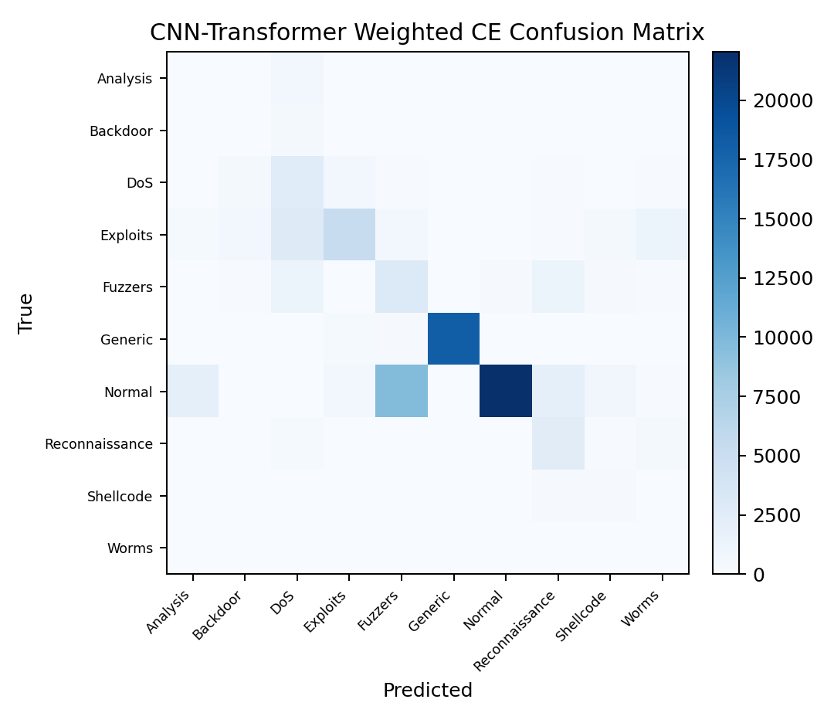
Figure 2. Confusion matrix for the proposed CNN-Transformer with weighted cross entropy.
Per-class results show that Generic traffic is detected very well by most models, while rare classes such as Analysis, Backdoor, Shellcode, and Worms remain difficult. Imbalance-aware training often increases rare-class recall but can reduce precision, causing additional false positives. This trade-off is central to practical IDS deployment.
Table 6. Per-class results for the proposed CNN-Transformer with weighted cross entropy.
Class | Precision | Recall | F1
Normal | 0.9883 | 0.5957 | 0.7434
Generic | 0.9973 | 0.9624 | 0.9795
Exploits | 0.7669 | 0.4716 | 0.5840
Analysis | 0.0000 | 0.0000 | 0.0000
Backdoor | 0.0354 | 0.0755 | 0.0482
Shellcode | 0.1056 | 0.4762 | 0.1728
Worms | 0.0156 | 0.7500 | 0.0306

The proposed model performs strongly on frequent classes such as Normal and Generic, but minority classes remain challenging. For example, Worms recall is relatively high, but precision is very low, which means many samples from other classes are incorrectly predicted as Worms. Analysis and Backdoor are especially weak. This confirms that weighted cross entropy reduces some majority-class bias but does not fully solve minority-class detection.
Table 7. Preliminary UNSW-NB15 to NSL-KDD binary transfer results.
Model | Accuracy | Macro-F1 | Weighted-F1
Deep Autoencoder | 0.2513 | 0.2480 | 0.2549
CNN-BiLSTM | 0.5518 | 0.5416 | 0.5321
CNN-Transformer, weighted CE | 0.4906 | 0.4401 | 0.4168

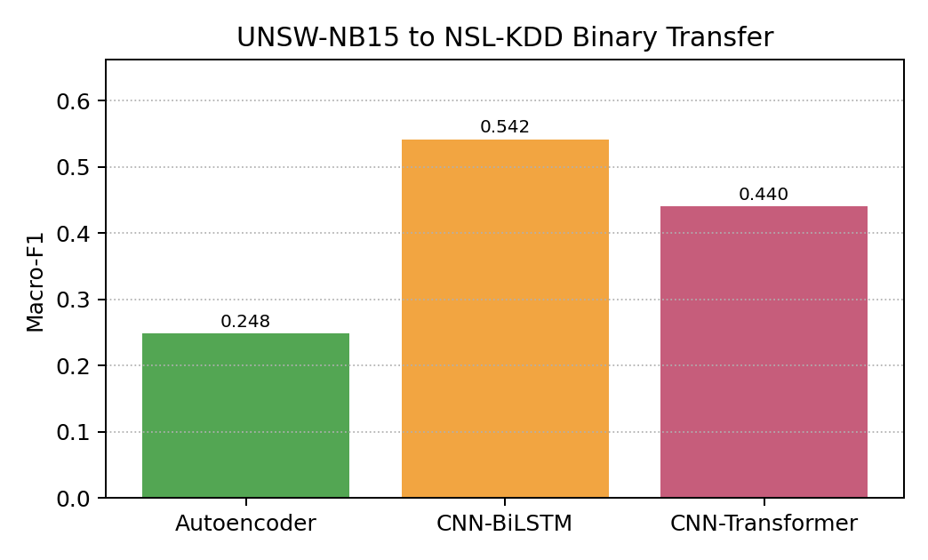
Figure 3. Binary cross-dataset macro-F1 for UNSW-NB15 to NSL-KDD transfer.
The cross-dataset experiment confirms that generalization is difficult. All models perform worse under UNSW-NB15 to NSL-KDD transfer than in same-dataset UNSW-NB15 evaluation. CNN-BiLSTM achieved the best transfer macro-F1 at 0.5416. The proposed CNN-Transformer reached 0.4401 macro-F1. It had high Normal recall but low Attack recall, indicating that it missed many NSL-KDD attacks. This result supports the literature claim that strong same-dataset performance does not guarantee robust cross-dataset behavior.
Table 8. Preliminary NSL-KDD to UNSW-NB15 binary transfer results.
Model | Accuracy | Macro-F1 | Weighted-F1
Deep Autoencoder | 0.4429 | 0.3278 | 0.2997
CNN-BiLSTM | 0.4505 | 0.3511 | 0.3254
CNN-Transformer, weighted CE | 0.4374 | 0.3570 | 0.3340

The reverse transfer direction gives a more favorable result for the proposed model. When trained on NSL-KDD and tested on UNSW-NB15, the CNN-Transformer achieved the highest macro-F1 and weighted-F1 among the three tested transfer models. The gain came mainly from improved Attack recall compared with the Deep Autoencoder and CNN-BiLSTM baselines. However, the absolute Attack recall remained low for all models, so this result should be interpreted as a limited advantage under difficult dataset shift rather than a complete solution to cross-dataset generalization.
Table 9. Deployment-oriented model profile on CUDA.
Model | Parameters | Checkpoint MB | Batch latency ms
MLP, unweighted CE | 43,274 | 0.173 | 0.829
MLP, weighted CE | 43,274 | 0.173 | 0.837
Deep Autoencoder | 76,428 | 0.299 | 1.134
CNN-BiLSTM | 76,106 | 0.297 | 2.889
CNN-Transformer, weighted CE | 118,027 | 0.465 | 15.221

Deployment profiling shows that all models are compact, with checkpoint sizes below 0.5 MB. However, the CNN-Transformer has the largest parameter count and the highest inference latency. The proposed model has 118,027 parameters and requires 15.221 ms per batch, while the CNN-BiLSTM requires 2.889 ms per batch and the Deep Autoencoder requires 1.134 ms per batch. Therefore, the current CNN-Transformer is compact in storage but less efficient at inference than the simpler baselines.

CONCLUSIONS
This project implemented and evaluated an imbalance-aware CNN-Transformer IDS on UNSW-NB15. It also compared the proposed model against Deep Autoencoder and CNN-BiLSTM baselines from prior IDS literature, along with MLP reference baselines. The results show that the CNN-Transformer with weighted cross entropy is competitive with CNN-BiLSTM on same-dataset UNSW-NB15 evaluation, but it does not outperform the Deep Autoencoder or MLP baselines. Weighted cross entropy is more stable than focal loss for the proposed model.
The project also confirms two important limitations in IDS research. First, class imbalance remains difficult: rare classes can be improved in recall, but precision often decreases. Second, cross-dataset transfer remains challenging: the preliminary UNSW-NB15 to NSL-KDD experiment showed a clear performance drop, and the proposed CNN-Transformer did not solve this issue. Finally, deployment profiling showed that the proposed model is small but slower than simpler baselines.
Future work should focus on better feature alignment, domain adaptation, threshold calibration, and model compression. Additional experiments on NSL-KDD and CIC-IDS2017 should also be performed when there is enough time to ensure fair feature mapping and evaluation. Overall, the main contribution is not a claim that the proposed architecture is universally best, but a careful empirical comparison showing where the CNN-Transformer helps, where it does not, and why robust IDS evaluation requires more than same-dataset accuracy.

ACKNOWLEDGEMENT OF AI TOOLS
AI tools were used to assist with code structuring, experiment organization, and document editing. All experimental results, interpretations, and final report content were reviewed and validated by me.

REFERENCES
[1] H. M. R. U. Rehman, S. Liaquat, M. J. Gul, M. Z. Jhandir, D. Gavilanes, M. M. Vergara, and I. Ashraf, "A systematic literature study of machine learning techniques based intrusion detection: Datasets, models, challenges, and future directions," Journal of Big Data, vol. 12, art. 264, 2025, doi: 10.1186/s40537-025-01323-2.
[2] N. Moustafa and J. Slay, "UNSW-NB15: A comprehensive data set for network intrusion detection systems (UNSW-NB15 network data set)," in Proc. Military Communications and Information Systems Conference (MilCIS), 2015, pp. 1-6, doi: 10.1109/MILCIS.2015.7348942.
[3] F. Farahnakian and J. Heikkonen, "A deep auto-encoder based approach for intrusion detection system," in Proc. 20th International Conference on Advanced Communication Technology (ICACT), 2018, pp. 178-183, doi: 10.23919/ICACT.2018.8323688.
[4] N. Shone, T. N. Ngoc, V. D. Phai, and Q. Shi, "A deep learning approach to network intrusion detection," IEEE Transactions on Emerging Topics in Computational Intelligence, vol. 2, no. 1, pp. 41-50, 2018, doi: 10.1109/TETCI.2017.2772792.
[5] I. Sharafaldin, A. H. Lashkari, and A. A. Ghorbani, "Toward generating a new intrusion detection dataset and intrusion traffic characterization," in Proc. 4th International Conference on Information Systems Security and Privacy (ICISSP), 2018, pp. 108-116, doi: 10.5220/0006639801080116.
[6] S.-M. Tseng, Y.-Q. Wang, and Y.-C. Wang, "Multi-class intrusion detection based on Transformer for IoT networks using CIC-IoT-2023 dataset," Future Internet, vol. 16, no. 8, art. 284, 2024, doi: 10.3390/fi16080284.
[7] M. Cantone, C. Marrocco, and A. Bria, "Machine learning in network intrusion detection: A cross-dataset generalization study," IEEE Access, vol. 12, pp. 144489-144508, 2024, doi: 10.1109/ACCESS.2024.3472907.
[8] V. Shanmugam, R. Razavi-Far, and E. Hallaji, "Addressing class imbalance in intrusion detection: A comprehensive evaluation of machine learning approaches," Electronics, vol. 14, no. 1, art. 69, 2025, doi: 10.3390/electronics14010069.

