

**King Abdulaziz University Faculty of Engineering**

**Computer Applications in IE – IE322**

**THE PROJECTS REPORT**

**User Referral System**

|  |  |  |
| --- | --- | --- |
| **Member** | **Name** | **#ID** |
| **1** | **Abdulaziz Ghaith** | **2239231** |
| **2** | **Yazeed Bohassan** | **2235779** |
| **3** | **Manaf al Jadani** | **2236702** |



**Yazeed Bohassan**

**Abdulaziz Gaith**

**Manaf al Jadani**

**Instructor: Dr. Atif Shahzad**

**Sections: GA**

User Referral System - Final Report

# 1. Introduction

The User Referral System is a C# Windows Forms application that allows users to register, log in, edit profiles, use referral codes, and view a leaderboard.

# 2. Objective

To create a modern referral tracking system using C#, SQLite, and Robinhood-inspired UI design.

# 3. Technologies Used

• C# (Windows Forms)  
• SQLite  
• Visual Studio  
• .NET Framework

# 4. System Features

• Login and Registration  
• Referral Code Generation and Tracking  
• Leaderboard with Highlighted Users  
• Editable User Profile  
• Clean Robinhood-Inspired Interface

# 5. Screenshots of Forms

## Login Form

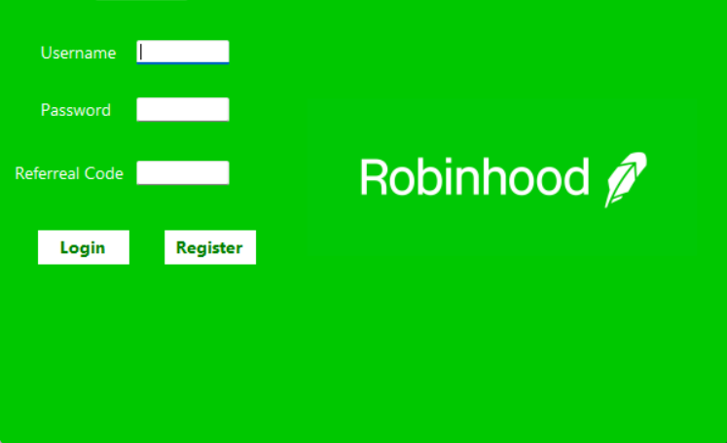

## Dashboard Form

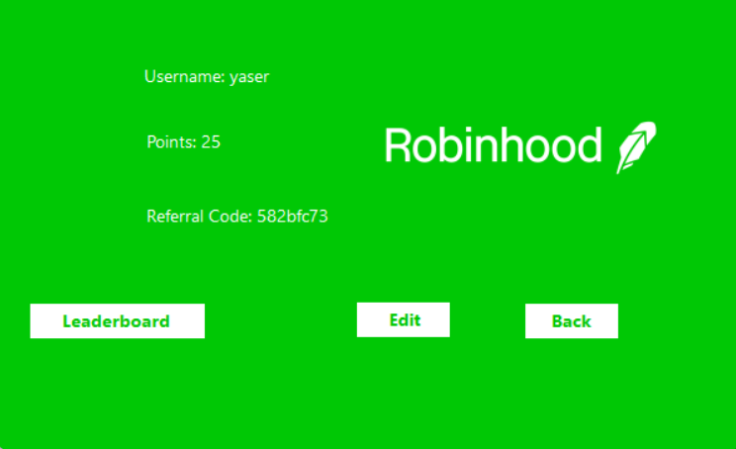

## Edit Profile Form

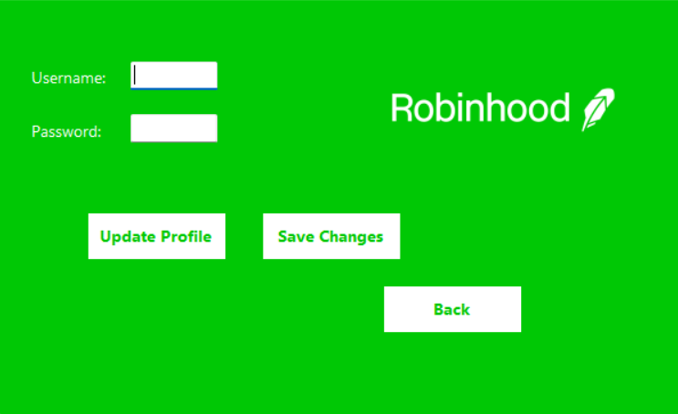

## Leaderboard Form

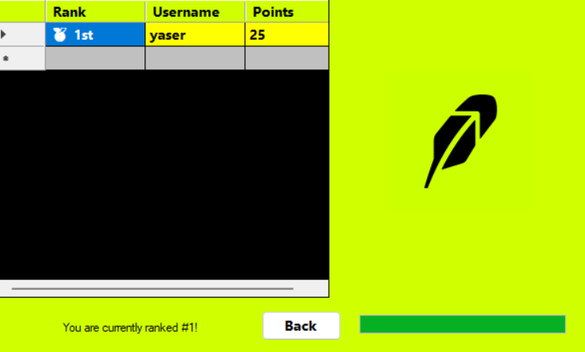

# 6. Sample Code Snapshots

## Form1.cs (Login & Registration)

﻿using System;

using System.Windows.Forms;

using System.Data.SQLite;

namespace UserReferralSystem

{

public partial class Form1 : Form

{

public Form1()

{

InitializeComponent();

}

private void btnLogin_Click(object sender, EventArgs e)

{

// Login logic with DB validation

}

private void btnRegister_Click(object sender, EventArgs e)

{

// Registration logic with referral code points

}

}

}

**Functions Used:** btnLogin_Click, btnRegister_Click

* **btnLogin_Click:** Authenticates user credentials and logs them in.
* **btnRegister_Click:** Handles registration, validates referral code, and adds user to the database.

## Form2.cs (User Dashboard)

﻿using System;

using System.Windows.Forms;

namespace UserReferralSystem

{

public partial class Form2 : Form

{

public Form2(string username)

{

InitializeComponent();

}

private void btnEditProfile_Click(object sender, EventArgs e)

{

// Opens Form3 for editing user profile

}

private void btnLeaderboard_Click(object sender, EventArgs e)

{

// Opens Form4 to view leaderboard

}

private void btnBack_Click(object sender, EventArgs e)

{

// Navigates back to login form

}

}

}

**Functions Used:** Form2_Load, btnEditProfile_Click, btnLeaderboard_Click, btnBack_Click

* **Form2_Load:** Loads user data including referral code and points.
* **btnEditProfile_Click:** Opens Form3 for editing username/password.
* **btnLeaderboard_Click:** Navigates to Form4 to view leaderboard.
* **btnBack_Click:** Returns to the login screen.

## Form3.cs (Profile Edit)

﻿using System;

using System.Windows.Forms;

using System.Data.SQLite;

namespace UserReferralSystem

{

public partial class Form3 : Form

{

public Form3(string username, string password, Form2 form2)

{

InitializeComponent();

}

private void btnSave_Click(object sender, EventArgs e)

{

// Updates username and password in database

}

private void btnBack_Click(object sender, EventArgs e)

{

// Returns to dashboard

}

}

}

**Functions Used:** btnSave_Click, btnBack_Click

* **btnSave_Click:** Executes SQL UPDATE for the username/password.
* **btnBack_Click:** Returns user to Form2 dashboard.

## Form4.cs (Leaderboard)

﻿using System;

using System.Data.SQLite;

using System.Drawing;

using System.Windows.Forms;

namespace UserReferralSystem

{

public partial class Form4 : Form

{

public Form4(string username)

{

InitializeComponent();

}

private void Form4_Load(object sender, EventArgs e)

{

// Load leaderboard data from DB

}

}

}

**Functions Used:** Form4_Load

* **Form4_Load:** Displays sorted user list by points and highlights the current user with a progress bar.

# 7. Conclusion

The **User Referral System** is a complete C# desktop application developed with WinForms and SQLite. It implements essential functionalities such as user authentication, registration with referral points, profile editing, and leaderboard ranking.

Key strengths:

* Clear and simple UI based on Robinhood branding.
* Functional features implemented across four forms.
* Code is modular and maintainable.

The application demonstrates practical database integration with UI navigation. It can serve as a foundation for more complex systems involving rewards, gamification, or referral programs.