Monitoring_PR_Project

ASL-1

2 epochs, batch size = 64, learning rate = 0.001, decay ratio=0.05, val_set= false.

ASL-2:

20 epoch, 0.001 learning rate, batch size = 32, decay ratio=0.05, val_set= false.

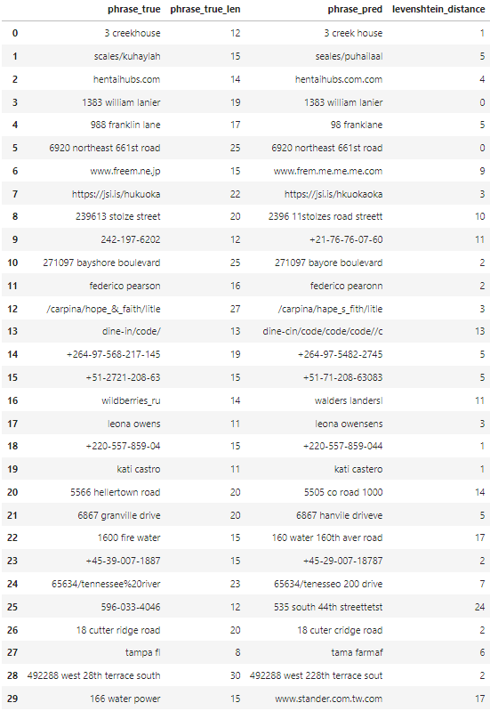

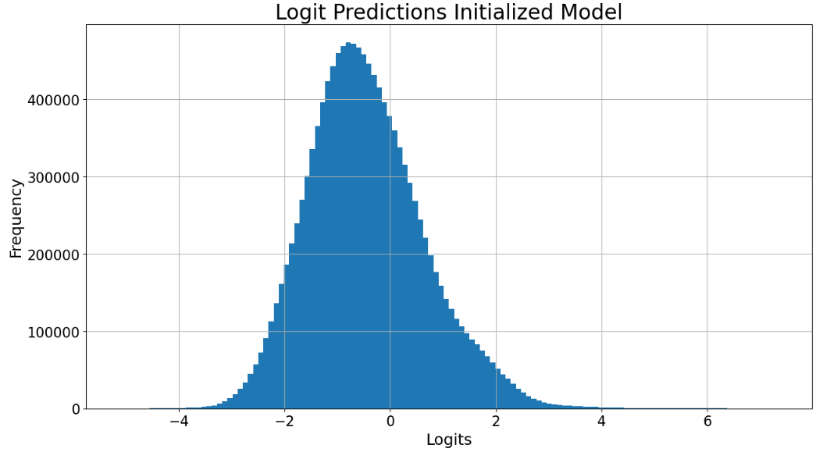

ASL-3:

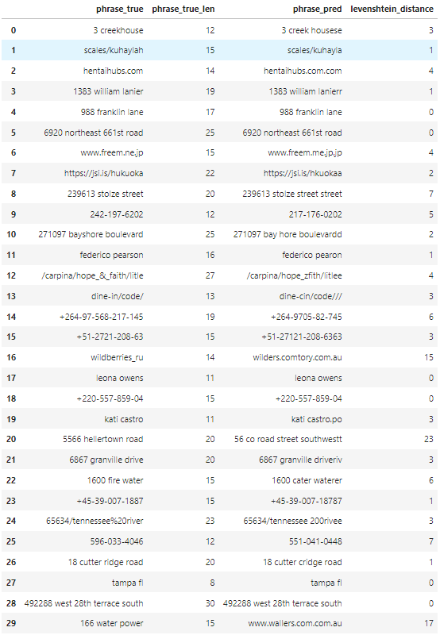

ASL-4:

