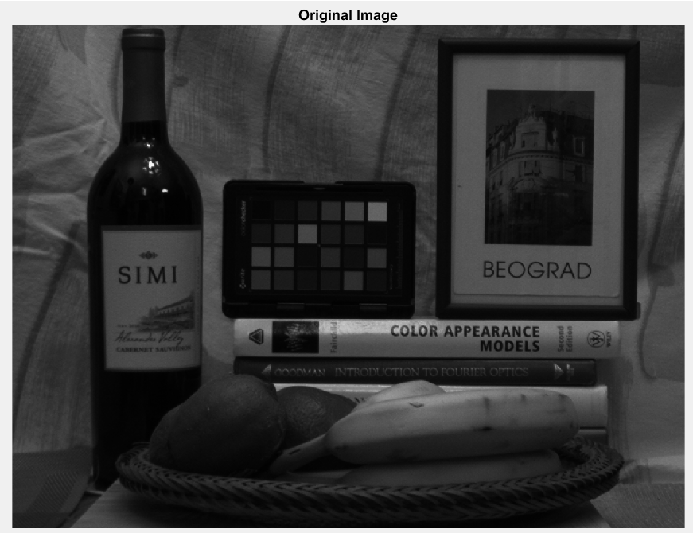

The figure below exhibits the Histogram of the given image.

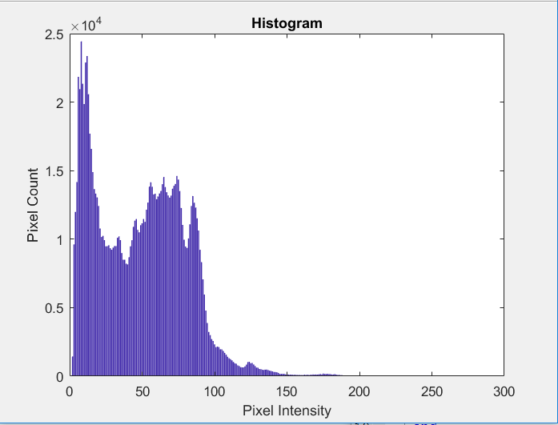

Based on the pixel intensity distribution exhibited on the Histogram above, it will be sensible to segment the image at Thresholds, T1=20 and T2 =50. Considering the objects of interest are either dark or whiter than the background, it is fair to conclude, the intensity interval [20,50] represents the background and the rest is taken to be the object of interest. Finally, the pixels within the interval is assigned 0 and every pixel outside the interval is assigned 255.

Comparing the original image versus the segmented, the provided image is obviously not ideal for thresholding. From the Histogram, it can be deduced that the peaks corresponding to the foreground and background have run together. Hence, simple thresholding couldn’t give good results.

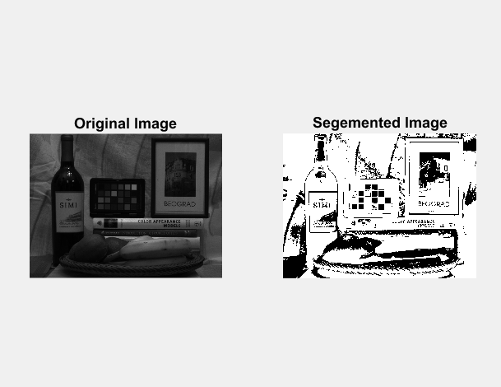

First, the CDF distribution is calculated using each pixel’s intensity frequency from the Histogram. By using the CDF, the lower and higher thresholds (c & d) were calculated to be 6 and 95, respectively.

As I understood, the goal of Contrast Stretching is to stretch the histogram of an image so that the full dynamic range of the image is filled. For an image of low contrast (such as the image given for this homework), the histogram is skewed. As a result, Contrast Stretching performed poorly in this case as shown in the figure below. However, if the Histogram was a nice bell curve distribution (Normal distribution), the results would have been significantly better.

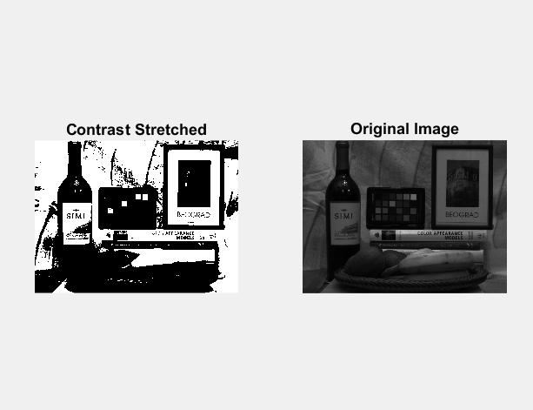

Gamma values used are 0.8 and 1.25 as indicated in the figure below. Using trial and error method it was determined that Gamma values much greater than 1 such as 2.2 over darkened the image while values much less than 1 seemed to bleach the image. Since computer monitors already perform gamma decoding (Image^ Gamma), for gamma greater than 1, it would make sense to perform gamma encoding using values 1/Gamma. Therefore, through trial and error, it was determined a value of Gamma =0.8 (1/1.25) seemed to produce an optimum image.

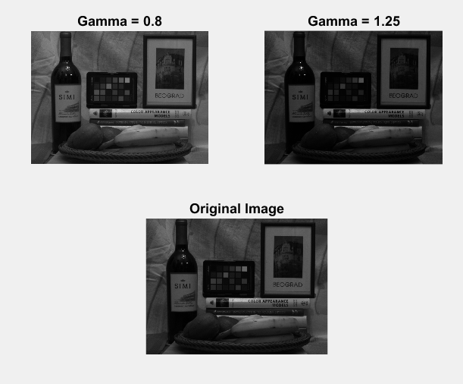

As it can be deduced from the figure below, the histogram equalized image has been contrast enhanced and its histogram has also been equalized. Histogram equalization has proved to be the method to enhance the contrast of the given image in this assignment.

