**HPM573 final project report**

Grace Sun (ys544), Haoran Zhuo (hz338) (in Alphabetic order)

**Public Health Significance**

Lung cancer is the leading cause of cancer-related deaths in the United States [1]. However, until recently, no method of screening had been shown to reduce mortality from lung cancer [2]. Among risk factors of lung cancer, tobacco smoking is the most important modifiable one. Smoke of cigarette contains at least 50 carcinogens, including polycyclic aromatic hydrocarbons (PAHs), aromatic amines, and other organic and inorganic compounds. It is estimated that up to 20% of all cancer deaths worldwide can be prevented by the elimination of tobacco smoking [3]. Never smokers are also susceptible to lung cancer. The overall global statistics estimate never smokers accounting for 25% of all lung cancer cases worldwide [3]. In order to ameliorate mortality rate of lung cancer, several screening interventions with criteria for high-risk population have been applied in for early diagnosis and therapy. The National Lung Screening Trial (NLST) showed that screening with low-dose computed tomography (LDCT) of the chest can reduce 20% lung-cancer mortality rate in patients at high risk for lung cancer [4]. LDCT has been recommended by several major medical-societies for patients with high risk of lung cancer. However, the cost-effectiveness of this screening intervention varied from vary favorable to unfavorable in previous studies [2].

Selection criteria might have significant influence on the cost-effectiveness of LDCT. NLST used a selection criteria for populations that only those with high risk (e.g., ≥30 pack-years of smoking and <15 years since quitting) are eligible for the screening test. Another research developed and validated a lung-cancer risk-prediction model by using data from former and current smokers in the Prostate, Lung, Colorectal and Ovarian (PLCO) Cancer Screening Trial control and intervention groups. After modifying this model and making it more applicable to NLST data, the new model (PLCOM2012) was more sensitive than the NLST criteria for lung-cancer detection.

We are interested in analyzing the cost-effectiveness of LDCT screening test for lung cancer based on PLCOM2012 selection criteria. Since the implementation of screening test would be a financial burden and bring huge impact to its incremental cost-effectiveness ratio (ICER), it would be necessary for policy makers to get general information on relatively good implementation method when deploying the lung cancer screening. No current research analyzed cost-effectiveness of PLCOM2012 criteria. Thus, we intend to assess the cost-effectiveness of LDCT with PLCOM2012 criteria by simulating and compare it the cost-effectiveness with general NLST criteria.

**Model assumptions**

Our project is based on several assumptions. First, the LDCT screening did not affect the mortality from causes other than lung cancer. Second, we assume observations in two study are independent. Third, all individuals in both studies would be regarded as alive if they don’t die until the last day of follow-up and would be considered for life-time horizon.

**Markov diagram**

In this model, we used five states to describe a participant prognosis. The population recommend with LDCT screening are those who have been long-time smoker with higher risk of lung cancer compared to the general population. The state A represents the healthy status. The stage B shows those who get a curative treatment. The state C are participants who came to late-stage of cancer and continued for non-curative treatment and the state D shows death from other causes. We also added the stage E to show death caused by other factors. The following shows the Markov diagram.

Well (high-risk smokers)

Death caused

by other factors

Curative treatment

Non-curative treatment

Death caused

by lung cancer

100

**Model parameters**

A previous study showed PLCOM2012 criteria had improved sensitivity 83.0% and a positive predictive value 4.0%, and specificity of 62.9%; whereas NLST criteria had sensitivity of 71.1%, positive predictive value 3.4%, and specificity of 62.7% [5]. we calculated the following table to show the results of screening test under NLST criteria and PLCOM2012 criteria.

(a) NLST criteria

|  |  |  |  |
| --- | --- | --- | --- |
|  | Lung cancer | No lung cancer | Total |
| Screening positive | 1.290 | 36.637 | 37.927 |
| Screening negative | 0.524 | 61.55 | 62.074 |
| Total | 1.814 | 98.187 | 100 |

(b) PLCOM2012 criteria

|  |  |  |  |
| --- | --- | --- | --- |
|  | Lung cancer | No lung cancer | Total |
| Screening positive | 1.515 | 36.360 | 37.875 |
| Screening negative | 0.310 | 61.814 | 62.124 |
| Total | 1.825 | 98.174 | 100 |

From literature we obtained the number of 1000 men and women smokers will die in the next 10 years [10].

(a) the number of 1000 men will die in the next 10 years from lung cancer and other causes, and calculated annual mortality rate

|  |  |  |  |  |  |
| --- | --- | --- | --- | --- | --- |
| in 1000 men in next 10 years | | |  |  | annual mortality rate |
| age | smoking status | Lung,,colon and prostate cancer death | all other causes combined | all death | other cause |
| 55 | Never smoker | 6 | 65 | 71 | 0.0067 |
| smoker | 38 | 140 | 178 | 0.0151 |
| 60 | Never smoker | 2 | 113 | 115 | 0.0120 |
| smoker | 67 | 189 | 256 | 0.0209 |
| 65 | Never smoker | 4 | 172 | 176 | 0.0189 |
| smoker | 102 | 263 | 365 | 0.0305 |
| 70 | Never smoker | 6 | 285 | 291 | 0.0335 |
| smoker | 132 | 379 | 511 | 0.0476 |
| 75 | Never smoker | 8 | 441 | 449 | 0.0582 |
| smoker | 135 | 532 | 667 | 0.0759 |

(b) the number of 1000 men will die in the next 10 years from lung cancer and other causes, and calculated annual mortality rate

|  |  |  |  |  |  |
| --- | --- | --- | --- | --- | --- |
| in 1000 women in next 10 years | | |  |  | annual statistical rate |
| age | smoking status | lung, colon and ovarian cancer death | all other causes combined | all death | other cause |
| 55 | Never smoker | 2 | 53 | 55 | 0.0054 |
| smoker | 30 | 80 | 110 | 0.0083 |
| 60 | Never smoker | 3 | 81 | 84 | 0.0084 |
| smoker | 47 | 120 | 167 | 0.0128 |
| 65 | Never smoker | 5 | 126 | 131 | 0.0135 |
| smoker | 63 | 178 | 241 | 0.0196 |
| 70 | Never smoker | 7 | 200 | 207 | 0.0223 |
| smoker | 71 | 264 | 335 | 0.0307 |
| 75 | Never smoker | 7 | 328 | 335 | 0.0397 |
| smoker | 71 | 392 | 463 | 0.0498 |

Since previous studies applied NLST and PLCOM2012 criteria for participants in both sexes, we used averaged number of death caused by other factors in men and women smokers to represent the number of death caused by other factors in the smoker population. We calculated the average number of death in the age group from 55 to 75, which is recommended for screening. We also calculate averaged number of death of groups aged from 55 to 64 and from 65 to 75 for further investigation into the effectiveness of screening tests among different age groups. In this project, we used 281.9 per 1000 person as the background mortality rate.

|  |  |  |  |
| --- | --- | --- | --- |
|  | Men | Women | average |
| 55-75 | 300.6 | 263.2 | 281.9 |
| 55-64 | 164.5 | 100 | 132.25 |
| 65-75 | 391.3333 | 278 | 334.6666667 |

In our model, all participants in Well status had annual cost of $1703 for screening test since they were smokers at high risk for lung cancer. Previous publications have showed lists costs of curative treatment and non-curative treatment items. We used $21532.6 for curative treatment and $51255 for non-curative treatment. The following figure shows how we calculated costs of each status.

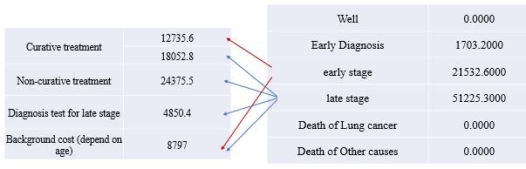

For utility, we assigned Well status as 1.0 and death as 0. Previous studies showed the utility of Curative Treatment is 0.77 and Non-curative as 0.46.

**Calculation of Markov matrix**

Our model was based on several simplification and assumption. We had four states which are: well, curative treatment, non-curative treatment and lung cancer death. We hypothesized that each participant would have the screening test, then got results as screening positive or negative. Those with true positive results would go for curative treatment, which has relatively lower cost and may cure early-state lung cancer. Statistics showed the mortality rate of lung cancer with early detection is 45%, and 95% for lung cancer without early detection. Thus, 55% of patients would survived and keep in the curative treatment. We hypothesize 45% of patients in the curative treatment state, who would finally die from lung cancer, would turn into the next state, non-curative state. Non-curative treatment had higher cost than curative state, and all patient in this state had 95% probability to die.

The calculated Markov matrix is as the following

(a) NLST

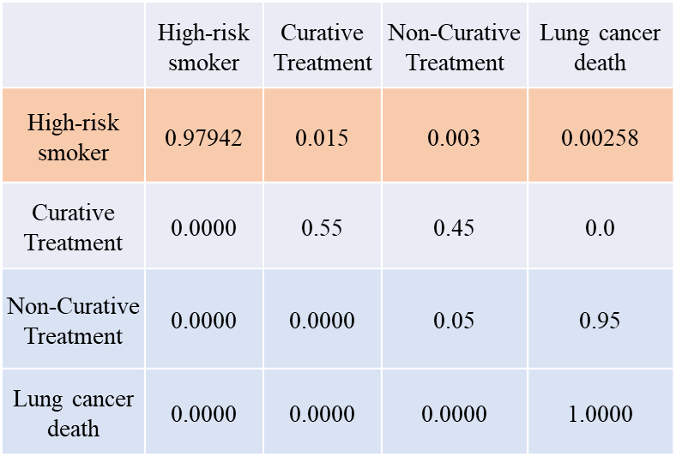

(b) PLCO

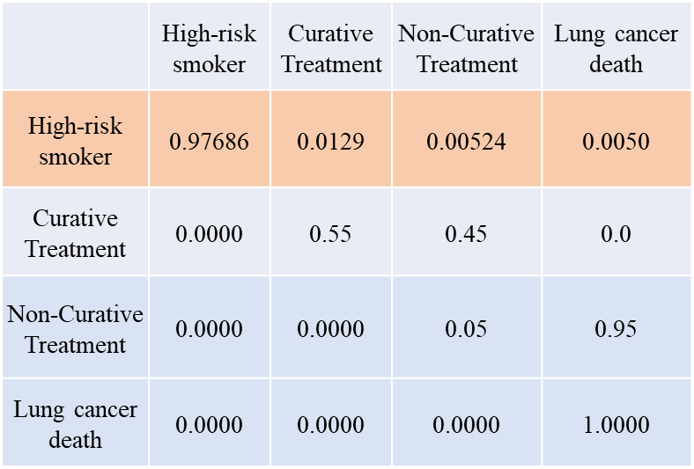

**Results**

*Results for smokers aged from 55 to 75*

First, we are interested in the difference of the mean survival time of simulated population under two different criteria. Compared to NLST criteria, population using PLCOM2012 had an average increase in survival time of 0.21 years out of 20 years’ simulation and the 95% confidence interval is (-0.07, 0.49). Since the lower bound of CI is less than 0, the result is not significant, indicating we might need bigger population to narrow down the 95% CI. In general, we got increased mean survival time for 20 years’ simulation if we choose PLCOM2012 instead of NLST. This is an expected result since we know the selection criteria of NLST is more sensitive in advance, which indicates PLCOM2012 can be a better selection criteria with less missing lung cancer cases and more positive predictive results.

For the results of cost comparison,  we saw little increase in health cost with discount rate of 3% in PLCOM2012 than NLST. The average increase in cost is $2,359, with 95% confidence interval of ($1,873, $2,844). Compared to the annual cost of lung cancer screening, treatment and other background cost, which in sum equals to around twenty-thousand dollars, the increase of cost using PLCOM2012 is quite small and satisfying.

For the results of utility comparison, we saw an increase a utility of 0.48 in population with PLCOM2012 criteria compared to NLST criteria, which 95% CI of (0.24, 0.72). This is a satisfying result since the utility of late stage of lung cancer is just 0.46, which is even lower than the increased utility, which indicates that PLCOM2012 did better job than NLST. The following figure shows the cost-effectiveness plane for NLST criteria and PLCOM2012 criteria. We observed PLCOM2012 criteria had a higher additional discounted cost than NLST criteria, while the slope of PLCOM2012 criteria is smaller than NLST criteria. Though PLCOM2012 criteria was more expensive than NLST.





Above figures shows results of cost-effective analysis. We observed the ICER of PLCOM2012 criteria compared to NLST is 4096 $/per life years. Thus, to sum up, PLCOM2012 criteria might be a better choice for the LDCT screening test, for the small number of ICER compared to the NLST, which indicates that we are able to achieve high increase in utility without sacrifice too much money.

*Results for Younger group*

We used the model to simulated the group aged from 65 to 74. The following table shows the result. Compared to the overall test result, we have similar conclusion for younger group. We observed average increase in survival time 0.21 (95%CI (-0.07, 0.49)), average increase in discounted cost and 95% confidence interval: $2,001 ($1,583, $2,418), and average increase in discounted utility and 95% confidence interval: 0.48 (0.24, 0.72). For cost-effective analysis, ICER for PLCO screening is $4161 /life years

|  |  |  |  |
| --- | --- | --- | --- |
|  | Mean survival time (95%CI) | Discounted cost (95% CI) | Discounted utility (95% CI) |
| NLST | 7.45 (7.34, 7.56) | $21,700 ($21,526, $21,874) | 7.61 (7.51, 7.70) |
| PLCO | 7.66 (7.54, 7.77) | $23,701 ($23,543, $23,859) | 8.09 (7.99, 8.19) |

*Results for older group*

We conducted the same analysis for smokers aged from 65 to 75. Compared to the overall test result, we also have similar conclusion for younger group. The result is shown in the following table. We found the result was similar to younger group, indicating the screening criteria showed little difference among different age groups. Average increase in survival time and 95% confidence interval was 0.21 (-0.07, 0.49). Average increase in discounted cost and 95% confidence interval: $1,937 ($1,529, $2,344) and average increase in discounted utility and 95% confidence interval was 0.48 (0.24, 0.72). The cost-effectiveness analysis showed PLCO screening has 4028 (95%CI 3261, 5344) ICER compared to NLST screening.

|  |  |  |  |
| --- | --- | --- | --- |
|  | Mean survival time (95%CI) | Discounted cost (95% CI) | Discounted utility (95% CI) |
| NLST | 7.45 (7.34, 7.56) | $21,349 ($21,179, $21,519) | 7.61 (7.51, 7.70) |
| PLCO | 7.66 (7.54, 7.77) | $23,286 ($23,132, $23,439) | 8.09 (7.99, 8.19) |

**Conclusion**

To sum up, we saw an increase in mean survival time and utility value in PLCOM2012 criteria simulated population compared to NLST criteria. Although there was an increase of cost in PLCOM2012 criteria, this increased cost compared to the total cost of each stage was small. Since the ICER value is quite satisfying, PLCOM2012 criteria might be a better choice for the LDCT screening test. Instead of following NLST, we are able to use PLCOM2012 criteria to achieve high increase in utility without sacrifice too much money. We also saw similar results in population of 55-64 and 65-75, while smaller ICER was observed in older age group. This indicates that PLCOM2012 criteria might be even better for old population.

However, our model has several limitations. First, we simplified the stage of lung cancer into two status, curative treatment and non-curative treatment, which will miss some detailed information of mortality rate in more detailed stages. And we also assume that people who get positive screening test will all first get into the curative stage. Also, we didn’t include sensitivity analysis since there were no uncertain variables in our model.

Reference

1. Siegel, R., Naishadham, D., & Jemal, A. (2012). Cancer statistics for hispanics/latinos, 2012. *CA: a cancer journal for clinicians*, *62*(5), 283-298.

2. Black, W. C., Gareen, I. F., Soneji, S. S., Sicks, J. D., Keeler, E. B., Aberle, D. R., ... & Gatsonis, C. (2014). Cost-effectiveness of CT screening in the National Lung Screening Trial. *New England Journal of Medicine*, *371*(19), 1793-1802.

3. Beckett, W. S. (1993). Epidemiology and etiology of lung cancer. *Clinics in chest medicine*, *14*(1), 1-15.

4. National Lung Screening Trial Research Team. (2011). Reduced lung-cancer mortality with low-dose computed tomographic screening. *New England Journal of Medicine*, *365*(5), 395-409.

5. Tammemägi, M. C., Katki, H. A., Hocking, W. G., Church, T. R., Caporaso, N., Kvale, P. A., ... & Berg, C. D. (2013). Selection criteria for lung-cancer screening. *New England Journal of Medicine*, *368*(8), 728-736.

6. Curl, P. K., Kahn, J. G., Ordovas, K. G., Elicker, B. M., & Naeger, D. M. (2015). Understanding Cost-Effectiveness Analyses: An Explanation Using Three Different Analyses of Lung Cancer Screening. *American Journal of Roentgenology*, *205*(2), 344-347.

7. Goulart, B. H., Bensink, M. E., Mummy, D. G., & Ramsey, S. D. (2012). Lung cancer screening with low-dose computed tomography: costs, national expenditures, and cost-effectiveness. *Journal of the National Comprehensive Cancer Network*, *10*(2), 267-275.

8. McMahon, P. M., Kong, C. Y., Bouzan, C., Weinstein, M. C., Cipriano, L. E., Tramontano, A. C., ... & Gazelle, G. S. (2011). Cost-effectiveness of computed tomography screening for lung cancer in the United States. *Journal of Thoracic oncology*, *6*(11), 1841-1848.

9. Villanti, A. C., Jiang, Y., Abrams, D. B., & Pyenson, B. S. (2013). A cost-utility analysis of lung cancer screening and the additional benefits of incorporating smoking cessation interventions. *PloS one*, *8*(8), e71379.

10. Woloshin, S., Schwartz, L. M., & Welch, H. G. (2008). The risk of death by age, sex, and smoking status in the United States: putting health risks in context. *Journal of the National Cancer Institute*, *100*(12), 845-853.

11. Kumar V, Cohen JT, van Klaveren D, Soeteman DI. (2018). Risk-Targeted Lung Cancer Screening: A Cost-Effectiveness Analysis. Ann Intern Med. 2018 Feb 6;168(3):161-169. doi: 10.7326/M17-1401. Epub 2018 Jan 2.