***BHARATHIYAR UNIVERCITY, COIMBATORE***

***GOVERNMENT ARTS COLLEGE, UDUMALPET***

***BSC COMPUTER SCIENCE***

***PROJECT TITLE: CRM APPLICATION FOR JEWEL MANAGEMENT***

*Role* *:* Developer

*Team Leader : Yazhuni S*

*yyazhu879@gmail.com*

*Team Members : Priyadharshini M*

*priyadharshini101020302gmail.com*

*Mohanapriya R*

*mohanapriya.r2005@gmail.com*

*Nadhiya G*

*nadhiyanagulan@gmail.com*

*Rashika G*

*rashikarashikag@gmail.com*

*Acadamic Year : 2025_2026*

*Mentor : Suguna Mam*

***ABSTRACT***

*The Jewel Management CRM Application is a could-based Salesforce solution built tomodernize jewelry business operations. It combines essential features such as customer management, product inventory, billing, and sales tracking into a single platform. By leveraging Salesforce tools like custom objects, record types workslows, and dasaboards, the system ensures accuracy, security, and mooth automation of day-of-day tasks. This project, crried out as part of the* ***B.SC Computer Science****, provide practical exposure to could application development and teamwork.*

*The solution not only improves effiency in handing jewellery transaction ut also supports decision-making through real-time reporting and analystics, offering a reliable and user-friendly approach to business management.*

***TEAM LEARNING OUTCOMES***

Learned how to customize Salesforce CRM.

Understood data modeling and database design.

Practiced application development and testing.

Used workflows, validation rules, and automation.

Improved teamwork and communication skills.

Experenced real-world business process handling.

***INTRODUCTION***

*Customer Relationship Management isused to maintain customer details and improve business activies. In jewelery shops, it is important to manage customers, stock, nilling, and sales correctly. Doing this manually takes more time and may cause mistakes.*

*To makes the process simple, we develped a* ***Jewel Management CRM Aplication*** *using Saesforce.*

*Store customer information*

*Manage product inventory*

*Generate bills and invoices*

*Track sales records*

*The system is easy to use, safe, and saves time. It also gives quick reports for better decision-making. Through this project, we got practical knowledge about CRM and could applications.*

***OBJECTIVES***

*To design a smart solution that simplifies jewelry shop operations*

*To safety store customer information and purchase details*

*To track inventory levels and avoid stock stock problems*

*To speed up billing and sales with automation*

*To give secure access for admin and staff with proper roles*

*To genetate useful reports and insights for business growth*

*To provide an easy-to-use system that saves time and reduces manual work.*

**SYSTEM REQUIREMENTS**

SOFTWARE USED

HARDWARE USED

***Software used:***

*Browser (Crome Edge)*

*Internet Connection*

***Hardware used:***

*Laptop with 4GB + RAM*

*Windows 10/11*

Handling and storing customer purchase history,preference, and details.

Offering customized jewellery designs and details.

**SALES AND MARKETING SUPPORTS**

helping in promotions, campaigns, and details.

**SYSTEM DESIGN**

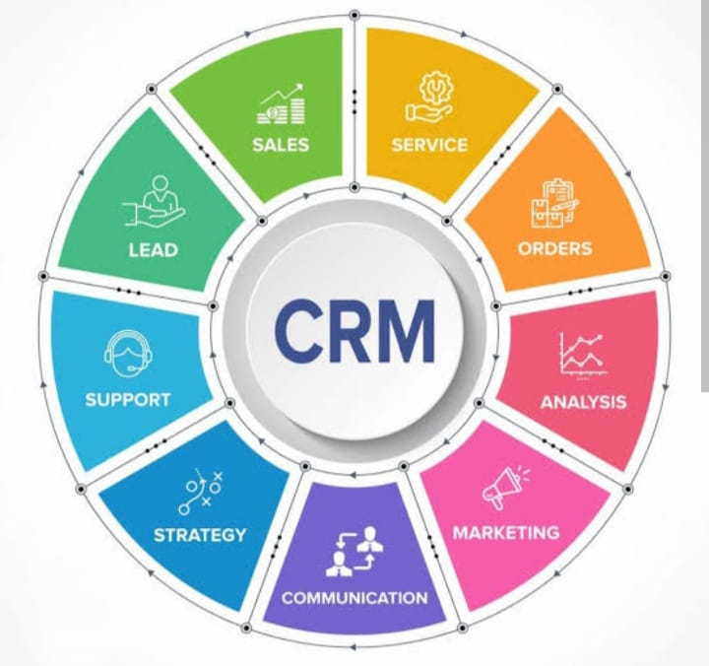

**ARCHITECHER DESIGN**

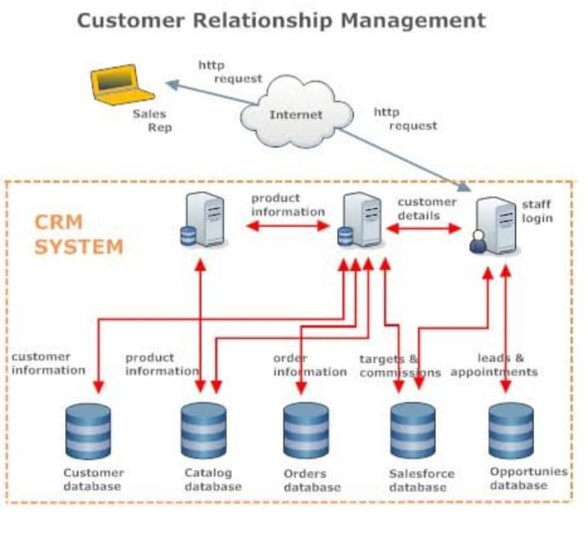

RECORD TYPE

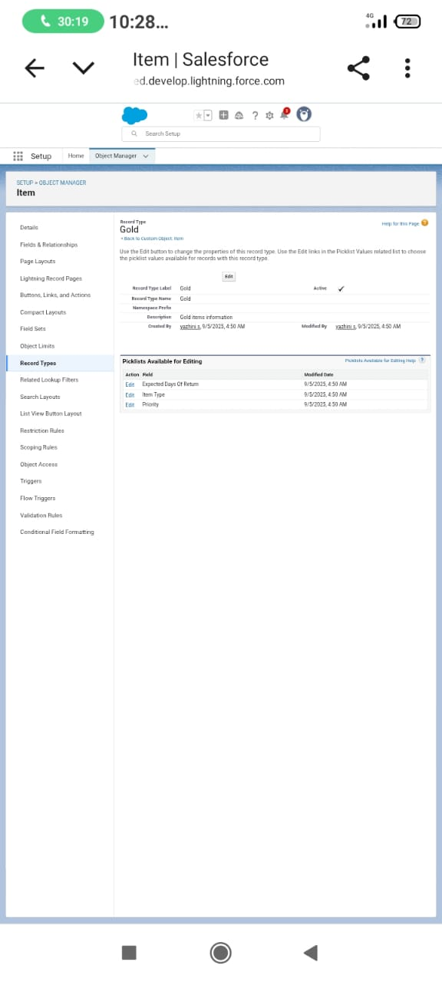

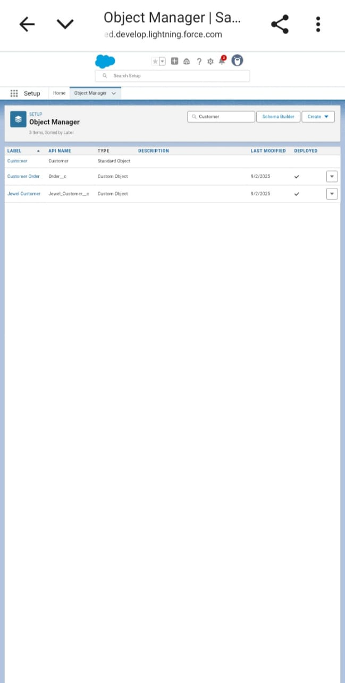

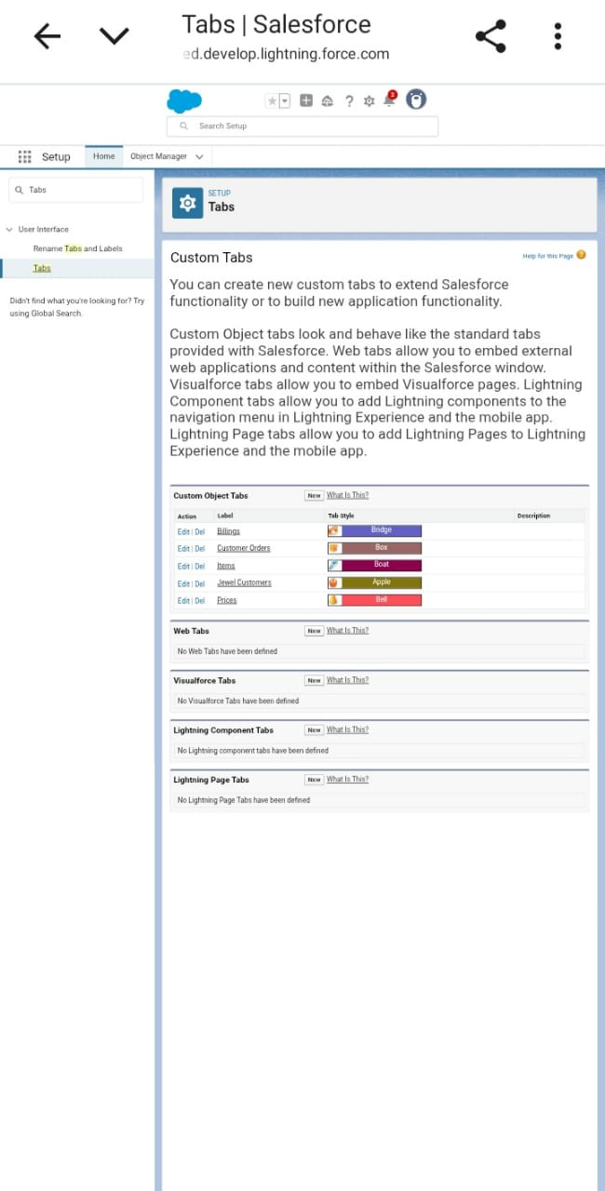

**RECORD PAGE**

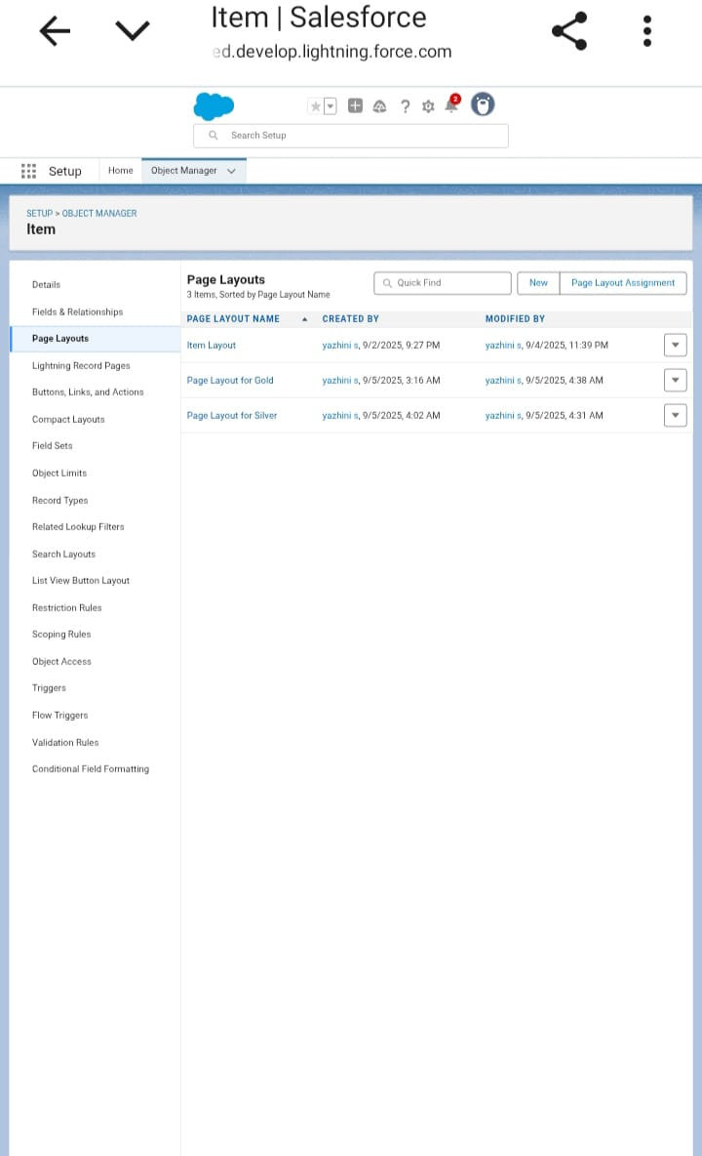

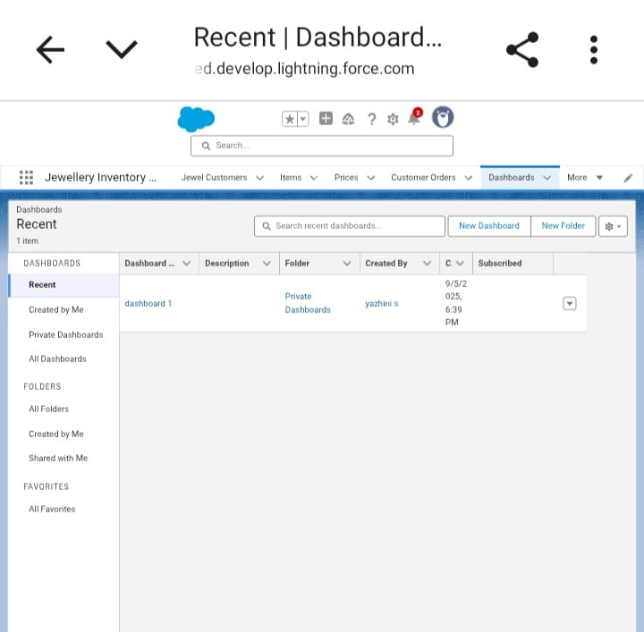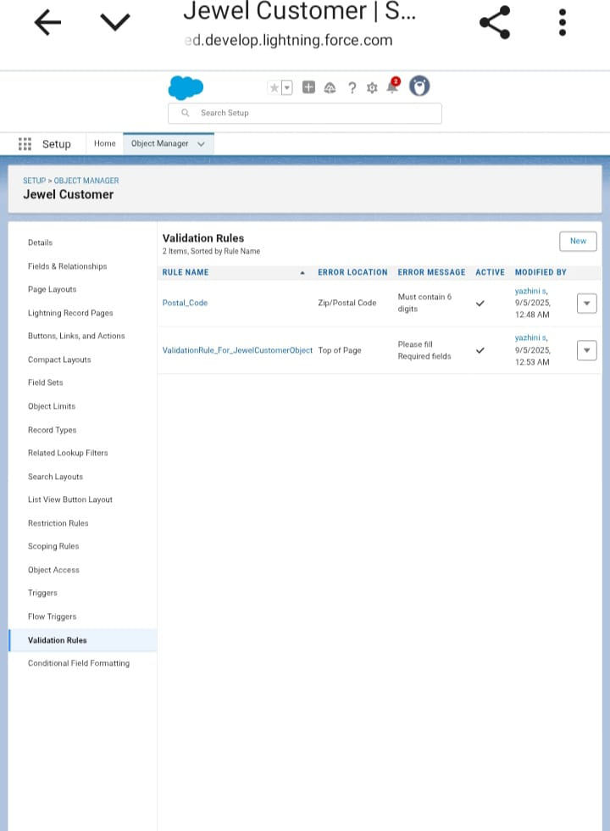

**CONCLUSION**

*The crm jewellery management system plays a vital role in strengthening customer relationship and enhancing business efficiency. It helps jewellery business understsnd customer preference, improve service quality, and increase customer satisfaction. By maintaining accurate records and supporting effectives trust and loyality.*