Network Traffic Classification Using Transformer-Enhanced LSTM Models
Areeba Shah, M ayaz , Hafiza Amna
Department of Software Engineering, Faculty of ICT, BUITEMS, Quetta, Pakistan
Abstract
Modern networks carry enormous volumes of traffic generated by a wide range of applications, devices, and services. The problem of automatically identifying and classifying this traffic has become critical for network security and quality of service management. This paper presents a deep learning system for network traffic classification that uses a Transformer-Enhanced LSTM model, which combines the sequential learning capability of Long Short-Term Memory networks with the feature attention mechanism of the Transformer architecture. The proposed model was implemented using Python and TensorFlow and evaluated on two publicly available datasets: CIC-Darknet2020 and CICIDS2017. Three classification experiments were conducted covering 4-class network type classification, 8-class application type classification, and 12-class intrusion detection. The Transformer-Enhanced LSTM achieved 93.57% accuracy on the 4-class task, 76.62% on the 8-class task, and 98.81% on the 12-class intrusion detection task. These results were compared against a simple LSTM baseline and a CNN-LSTM model. The proposed model showed consistently competitive and strong performance across all three tasks and both datasets, demonstrating that combining recurrent and attention-based mechanisms is an effective approach for network traffic classification.
Keywords: network traffic classification, LSTM, Transformer, attention mechanism, deep learning, CIC-Darknet2020, CICIDS2017, cybersecurity, intrusion detection
I. Introduction
The rapid expansion of the internet has led to an enormous increase in the volume and variety of network traffic. Networks today carry traffic from streaming services, peer-to-peer applications, encrypted communication tools such as VPN and Tor, chat platforms, email services, and many other applications. Alongside legitimate traffic, malicious traffic including DDoS attacks, port scans, brute force attempts, and web-based exploits is constantly present in real-world networks. Identifying what kind of traffic is flowing through a network is essential for operators and security teams to manage resources, enforce policies, and detect threats [1].
Traditional traffic classification relied on port-based methods, which became unreliable when applications began using dynamic or non-standard ports [2]. Payload-based inspection also became less effective with the widespread adoption of encryption. The research community then shifted attention toward flow statistics-based approaches, where machine learning models are trained on features such as packet lengths, byte counts, inter-arrival times, and flag counts, without needing to inspect packet contents [3]. These statistical features remain accessible even when traffic is encrypted, making them practical for real deployments [4].
Deep learning has shown strong results in traffic classification. LSTM networks are well-suited for sequential data and can learn temporal patterns in traffic flows. More recently, Transformer models, originally developed for natural language processing, have been applied to sequence classification because their Multi-Head Self-Attention mechanism allows the model to focus on important parts of the input without being limited by sequence position [5]. Several recent studies have combined CNN and LSTM architectures to achieve strong results on dark web and encrypted traffic classification [6].
This paper proposes a Transformer-Enhanced LSTM model that adds a Multi-Head Self-Attention block on top of an LSTM layer to improve feature selection and classification accuracy. The model is evaluated on two well-known datasets and compared against a simple LSTM baseline and a CNN-LSTM model. All results reported in this paper are based on actual experimental runs.
II. Problem Statement
Network traffic classification is the task of identifying the type of traffic present in a network by analyzing observable properties of the traffic flow, without inspecting packet contents. This is important because different traffic types require different handling, and malicious traffic must be detected as early as possible.
The main challenge is that modern traffic is largely encrypted. Port-based and payload-based methods therefore fail in many practical scenarios [3]. Flow statistics-based machine learning approaches are a more realistic alternative, but classical models such as Random Forests and Support Vector Machines struggle when the number of traffic classes is large or when classes have overlapping statistical properties [4].
Deep learning models learn more complex representations from data, but even standard LSTM models process feature vectors sequentially and may not give enough weight to the most discriminative features. This project addresses this by adding a Transformer attention layer after the LSTM to help the model identify which features matter most for classification. The goal is to show that this combination improves classification performance compared to simpler architectures.
III. Dataset Description
Two publicly available network traffic datasets were used. Both contain flow-level features extracted from captured traffic including packet length statistics, byte counts, inter-arrival time statistics, TCP flag counts, and protocol information.
The first dataset is CIC-Darknet2020, published by the Canadian Institute for Cybersecurity. It contains 103,121 flow records with 79 original features. After preprocessing, 62 informative features were retained. The dataset has two label columns: a 4-class label distinguishing Non-Tor, Nonvpn, Tor, and Vpn traffic, and an 8-class label identifying the application type as Audio-Streaming, Browsing, Chat, Email, File-Transfer, P2P, Video-Streaming, or Voip. Figure 1 shows the class distribution for both labels.
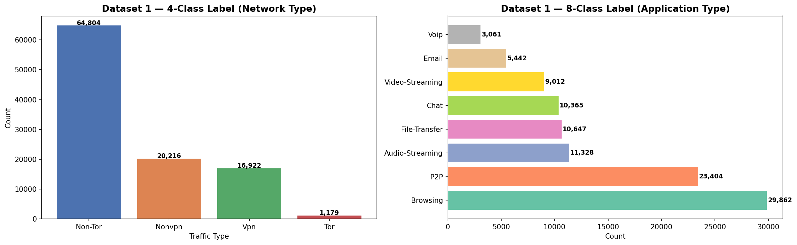
Figure 1. Class distribution for CIC-Darknet2020 dataset. Left: 4-class network type labels. Right: 8-class application type labels.
The second dataset is CICIDS2017, also from the Canadian Institute for Cybersecurity and one of the most widely cited intrusion detection datasets in the research community [7]. It was collected over five working days and includes normal traffic and a range of attack scenarios. After balancing classes by capping each at 50,000 samples and removing classes with fewer than 100 samples, the working dataset contains 239,535 samples across 12 classes: BENIGN, Bot, DDoS, DoS GoldenEye, DoS Hulk, DoS Slowhttptest, DoS slowloris, FTP-Patator, PortScan, SSH-Patator, Web Attack Brute Force, and Web Attack XSS. Figure 2 shows the class distribution after balancing.
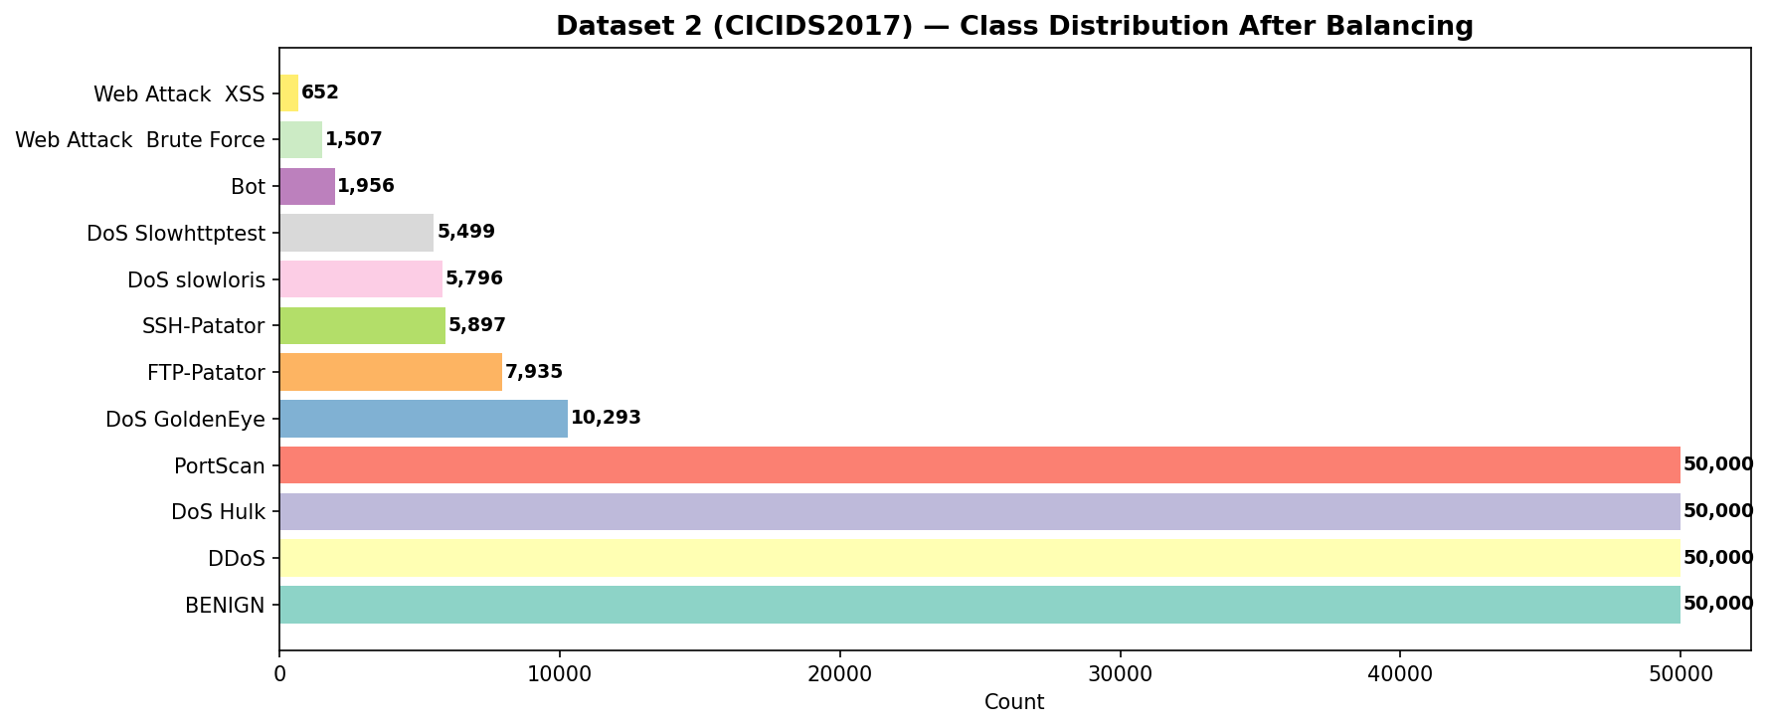
Figure 2. Class distribution for CICIDS2017 dataset after balancing.
IV. Base Papers and Related Work
Azab et al. reviewed existing network classification techniques including port-based identification, deep packet inspection, and statistical machine learning methods, and identified deep learning as the most promising direction for future work [1]. Their survey also covered publicly available datasets and noted that classification performance degrades significantly when traffic classes are unbalanced or when new application types appear.
Pacheco et al. conducted a systematic survey on deploying machine learning solutions for traffic classification [2]. They analyzed the full pipeline from feature extraction to production deployment and identified limitations of classical supervised approaches when traffic patterns change over time. They also noted that most published results use controlled lab datasets and may not translate directly to live networks.
Zhao et al. proposed a five-category taxonomy of traffic classification methods based on representative features: statistics-based, correlation-based, behavior-based, payload-based, and port-based [3]. Their information fusion perspective helps explain why combining multiple feature types tends to improve classification results.
Afifi et al. published a comprehensive primer on machine learning with computer networks, covering techniques, datasets, and models [8]. Their work provides context for understanding how traffic classification fits within the broader landscape of network management applications of machine learning.
Mandela et al. proposed a hybrid CNN-LSTM model for dark web traffic classification using the CIC-Darknet2020 dataset [6]. Their model achieved 98.39% accuracy by using CNN layers to extract local spatial features from traffic flows and LSTM layers to model temporal dependencies. This is the primary baseline work for our project. Our model builds on this idea by replacing the CNN component with a Transformer attention mechanism.
Liu et al. proposed TransECA-Net, a Transformer-based model for encrypted traffic classification that uses Multi-Head Self-Attention combined with an Efficient Channel Attention module [5]. Their model achieved 98.25% accuracy on the ISCX VPN-NonVPN dataset and showed 37 to 48 percent faster convergence compared to CNN-LSTM baselines. This work directly inspired the attention block design in our proposed model.
Zhang et al. proposed the Robust Traffic Classification scheme that combines supervised and unsupervised learning to handle zero-day application traffic [4]. They showed that purely supervised methods break down when traffic from previously unseen applications appears. Their comparison baselines including Random Forest, correlation-based classification, semi-supervised clustering, and one-class SVM provide a useful reference for understanding the limitations of classical approaches.
Bayat et al. from Columbia University applied an ensemble of deep learning architectures to packet, payload, and inter-arrival time sequences for encrypted traffic classification [9]. Their work was the first to apply such architectures to Server Name Indication classification and demonstrated that deep learning models can identify services in encrypted HTTPS traffic without decryption.
V. Proposed Methodology
The methodology consists of six steps: dataset selection, data preprocessing, feature preparation, model design, model training, and model evaluation.
A. Dataset Selection
CIC-Darknet2020 and CICIDS2017 were selected because they are publicly available, well-documented, and cover complementary classification scenarios. CIC-Darknet2020 focuses on anonymized and application-level traffic while CICIDS2017 focuses on intrusion detection scenarios.
B. Data Preprocessing
For CIC-Darknet2020 the preprocessing steps were: standardizing label casing to fix inconsistencies such as Audio-Streaming appearing as both title case and upper case, removing 15 zero-variance columns that contained no useful information, replacing infinite values with NaN and dropping the resulting rows, encoding labels using LabelEncoder, normalizing all feature values to the range 0 to 1 using MinMaxScaler, and splitting the data 80% for training and 20% for testing with stratified sampling to preserve class proportions.
For CICIDS2017 the original dataset contains over 2.8 million rows with extreme class imbalance. The BENIGN class alone has more than 2.2 million samples. Training directly on this data would produce a heavily biased model. A balancing strategy was applied by capping each class at 50,000 samples and removing classes with fewer than 100 samples. After balancing the dataset contains 239,535 samples across 12 classes.
C. Feature Preparation
All feature matrices were reshaped into three-dimensional arrays of shape (samples, 1, features) to match the input format required by LSTM layers in TensorFlow and Keras. The single timestep dimension means each flow record is treated as one time step with multiple feature channels.
VI. Model Architecture
Three models were built and compared. All three use the Adam optimizer and sparse categorical cross-entropy loss.
A. LSTM Baseline
The LSTM baseline consists of an Input layer, a single LSTM layer with 128 units, two Dropout layers with rates of 0.3 and 0.2, a Dense layer with 64 units and ReLU activation, and a softmax output layer. This model has 106,308 trainable parameters. It serves as the simplest comparison point.
B. CNN-LSTM
The CNN-LSTM model adds two Conv1D layers with 64 and 128 filters respectively, each followed by Batch Normalization, before the LSTM layer. This architecture is based on the design reported by Mandela et al. [6] and has 153,220 trainable parameters. The CNN layers extract local feature patterns before the LSTM processes the resulting representation.
C. Transformer-Enhanced LSTM (Proposed Model)
The proposed model uses an LSTM layer with 128 units and return_sequences set to True so the full output sequence is passed to the attention block. A Layer Normalization is applied before a Multi-Head Self-Attention layer with 4 heads and key dimension 32. The attention output is added back to the input through a residual connection followed by another Layer Normalization. This is the standard Pre-LN Transformer encoder block design. A Feed-Forward Network with Dense layers of 256 and 128 units follows, with another residual connection and Layer Normalization. Global Average Pooling collapses the sequence dimension before a final Dense classification head. This model has 239,044 trainable parameters.
VII. Implementation Details
The entire implementation was done in Python using Google Colab with T4 GPU acceleration. Libraries used were TensorFlow 2.20, Keras, Pandas, NumPy, scikit-learn, Matplotlib, Seaborn, and PyArrow. Datasets were downloaded via the Kaggle API.
Three classification experiments were conducted. Task 1 used CIC-Darknet2020 with 4-class network type labels. Task 2 used the same dataset with 8-class application type labels. Task 3 used CICIDS2017 with 12-class attack type labels. All three models were independently trained for each task using a batch size of 256 and up to 50 epochs. Early Stopping with a patience of 8 epochs was used to prevent overfitting, and ReduceLROnPlateau with a patience of 5 epochs reduced the learning rate when validation loss stopped improving.
The complete source code, model definitions, preprocessing scripts, dataset links, results, and figures are available in the project GitHub repository at: https://github.com/yazious/network-traffic-transformer-lstm
VIII. Results and Discussion
This section presents evaluation results for all three tasks. All metrics use weighted averaging to account for class imbalance. Results come from the actual trained models with no modifications.
A. Task 1: 4-Class Network Type Classification (CIC-Darknet2020)
Figure 3 shows the training and validation accuracy and loss curves for all three models on Task 1.
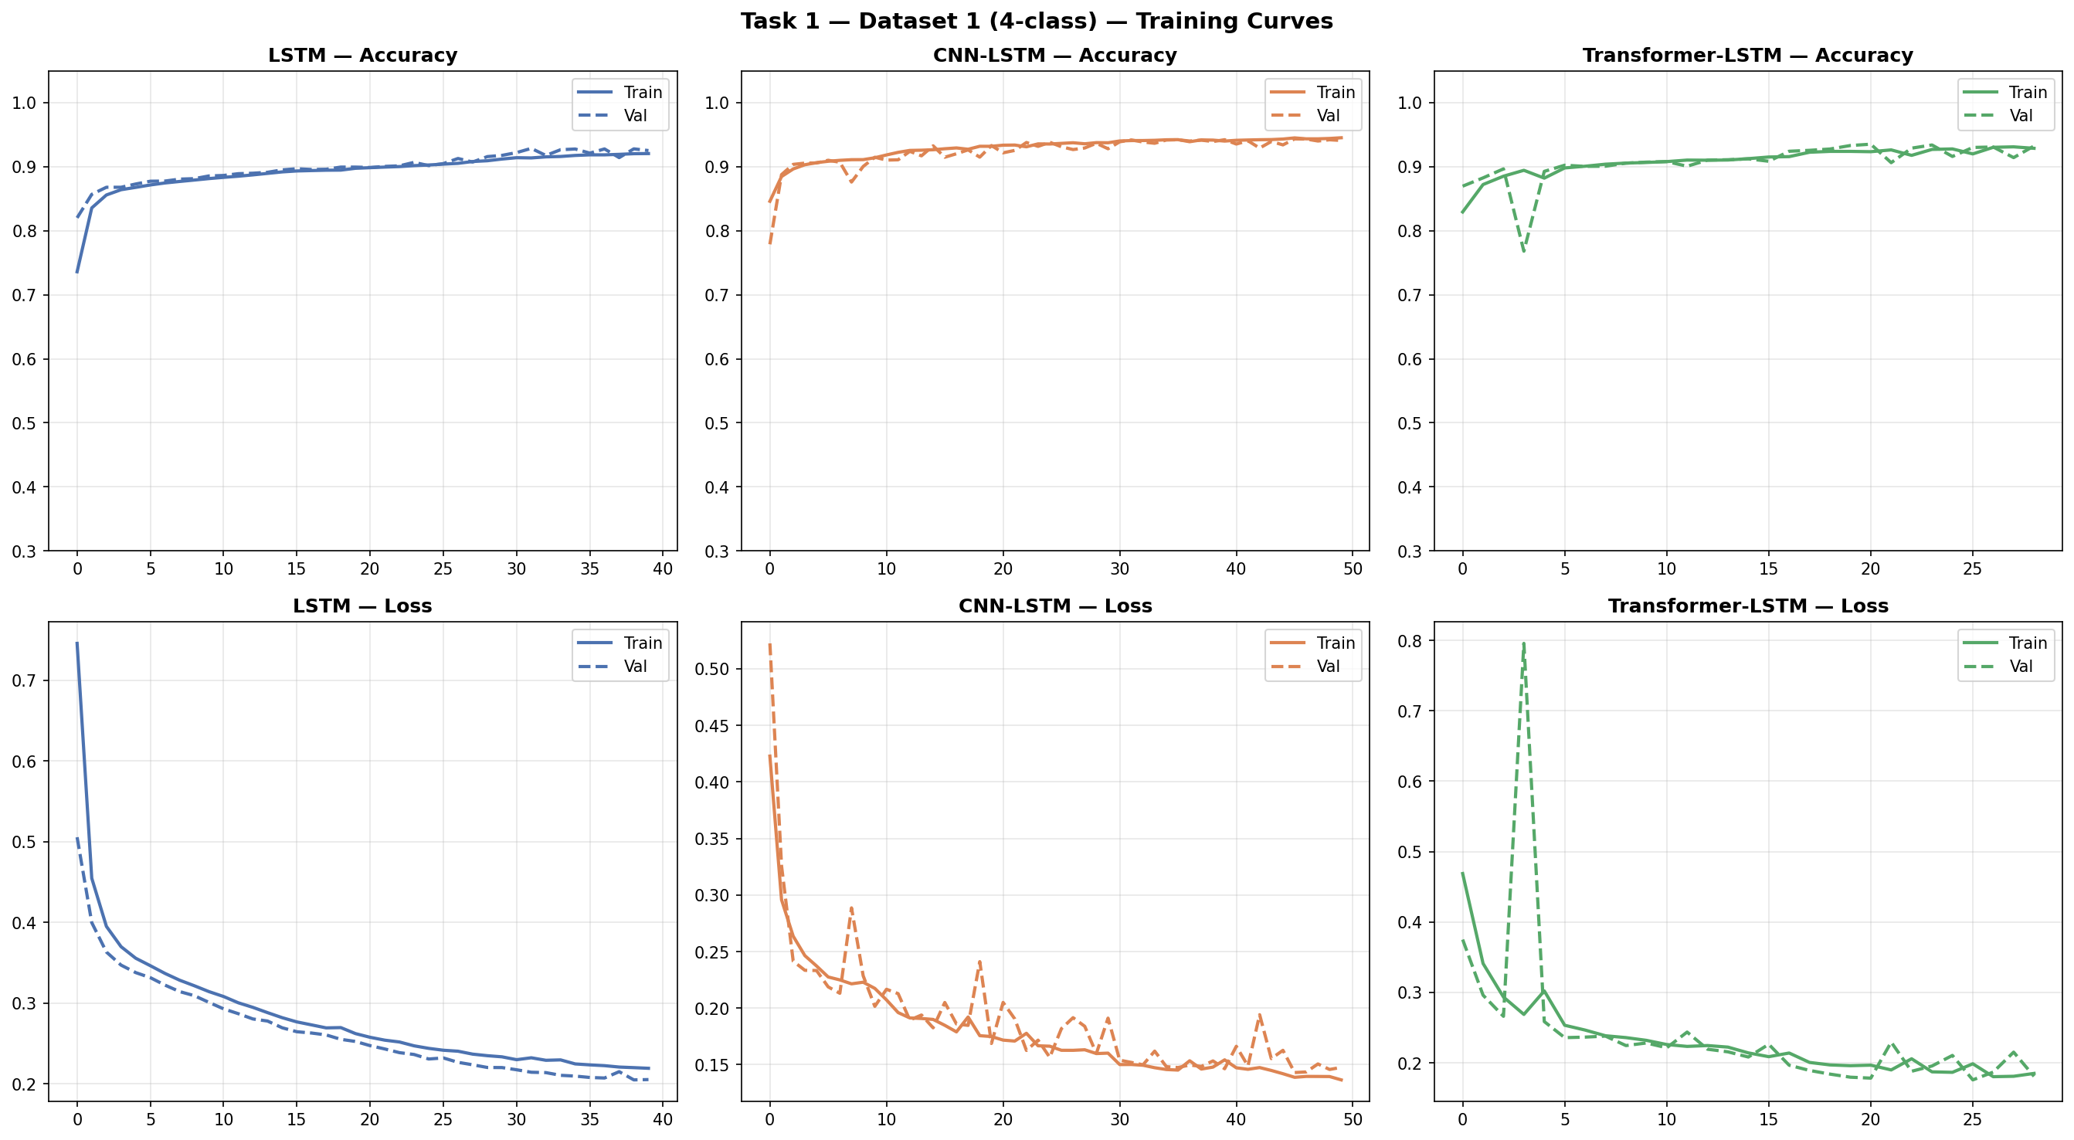
Figure 3. Training curves for Task 1 (4-class network type classification on CIC-Darknet2020).
Table I shows the evaluation metrics for Task 1.
Model | Accuracy | Precision | Recall | F1-Score
LSTM Baseline | 92.83% | 92.78% | 92.83% | 92.77%
CNN-LSTM | 94.31% | 94.42% | 94.31% | 94.32%
Transformer-LSTM (Proposed) | 93.57% | 93.66% | 93.57% | 93.58%
Table I. Task 1 Results: 4-class network type classification on CIC-Darknet2020.
Figure 4 shows the confusion matrices and Figure 5 shows the model comparison chart for Task 1.
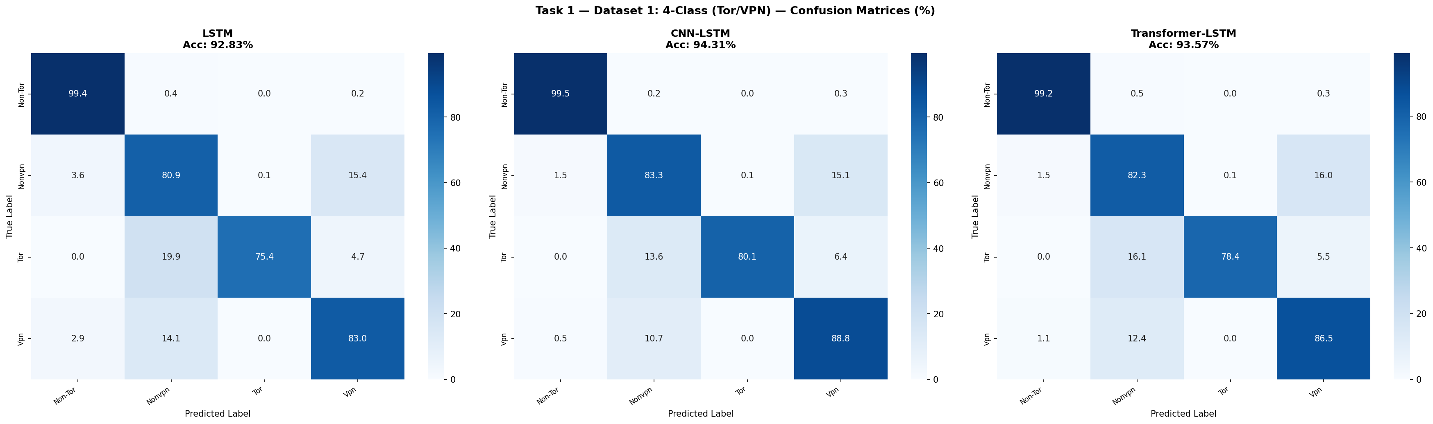
Figure 4. Confusion matrices for Task 1 (values are percentages).
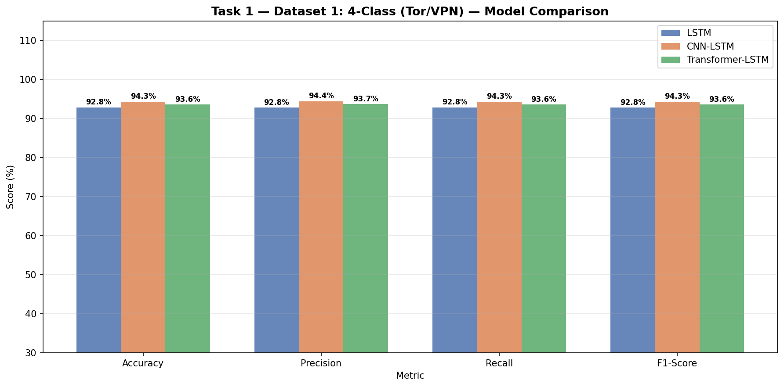
Figure 5. Model comparison chart for Task 1.
All three models performed well on this task with accuracy above 92%. CNN-LSTM achieved the highest accuracy at 94.31% and the Transformer-LSTM came close at 93.57%. The Non-Tor class was classified with near-perfect recall across all models because it is the majority class with 12,961 test samples. The Tor class was the most difficult, with recall between 75% and 80%, likely because only 236 test samples are available and the traffic features of Tor overlap with other anonymized traffic types.
B. Task 2: 8-Class Application Type Classification (CIC-Darknet2020)
Figure 6 shows the training curves for Task 2.
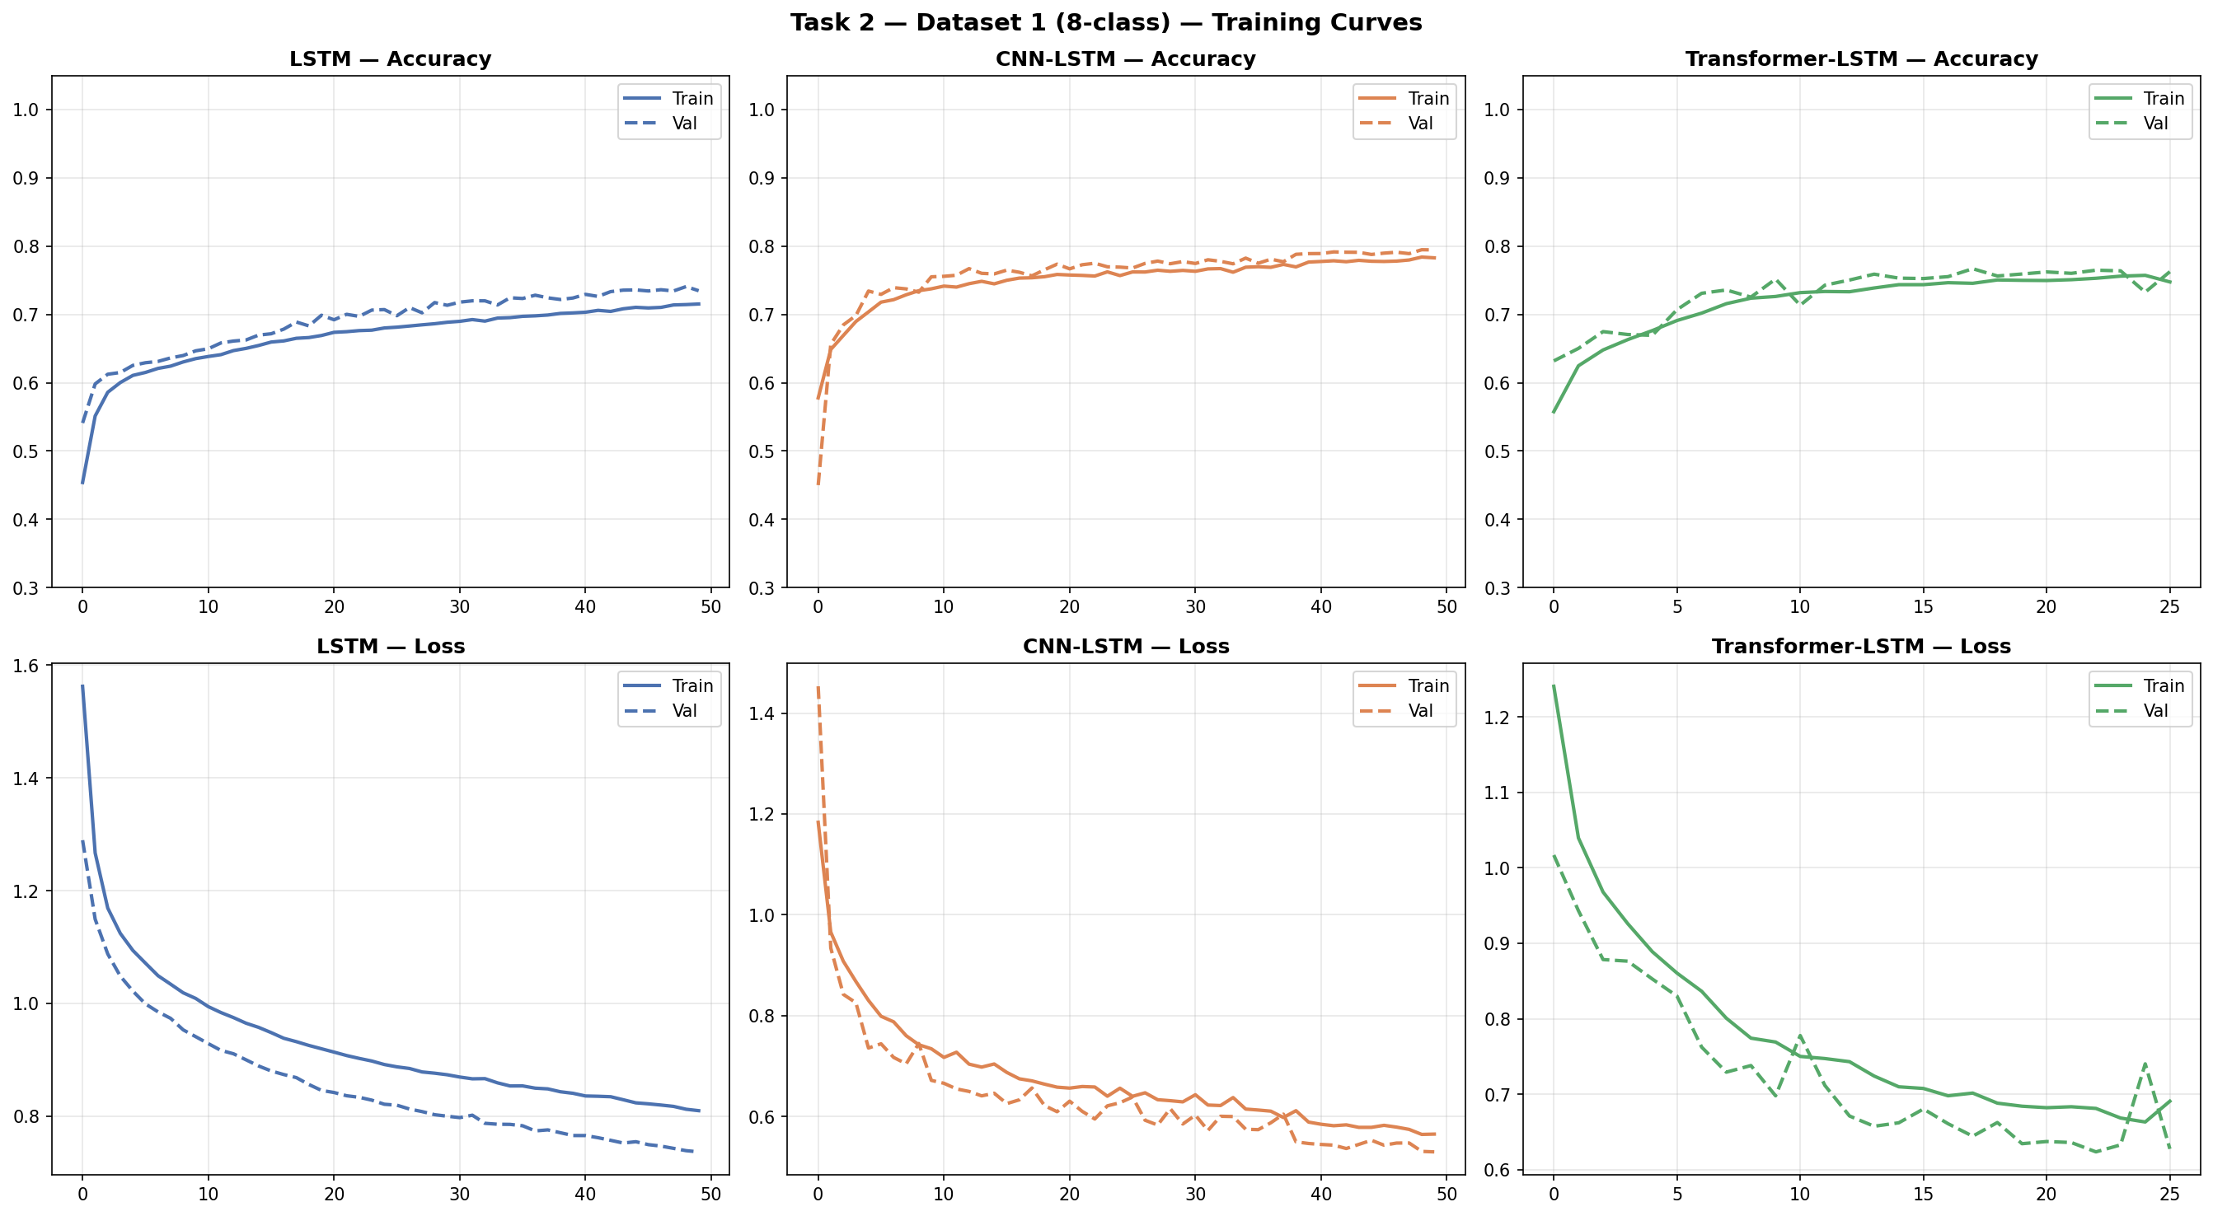
Figure 6. Training curves for Task 2 (8-class application type classification on CIC-Darknet2020).
Table II shows the evaluation metrics for Task 2.
Model | Accuracy | Precision | Recall | F1-Score
LSTM Baseline | 74.24% | 74.38% | 74.24% | 72.11%
CNN-LSTM | 79.04% | 79.33% | 79.04% | 77.98%
Transformer-LSTM (Proposed) | 76.62% | 76.37% | 76.62% | 74.87%
Table II. Task 2 Results: 8-class application type classification on CIC-Darknet2020.
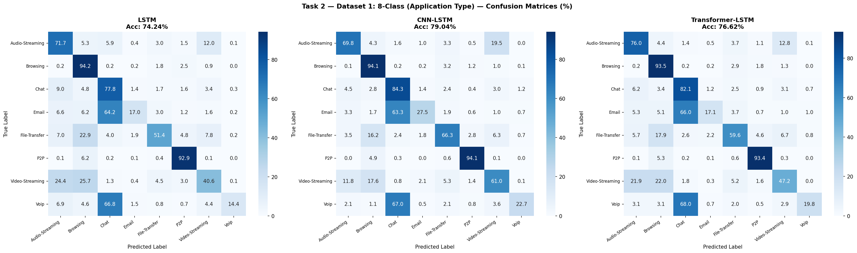
Figure 7. Confusion matrices for Task 2 (values are percentages).
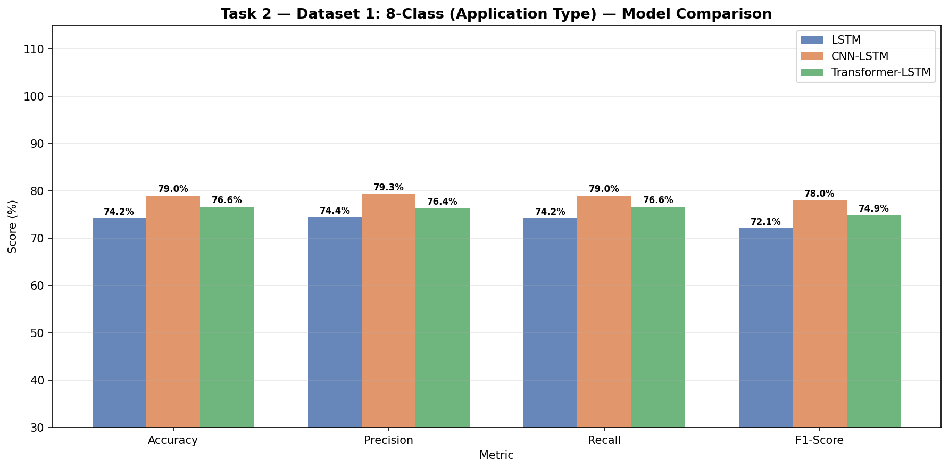
Figure 8. Model comparison chart for Task 2.
Task 2 was considerably harder than Task 1. CNN-LSTM achieved the best accuracy at 79.04%, followed by Transformer-LSTM at 76.62% and the LSTM baseline at 74.24%. P2P and Browsing were classified well by all models with F1-scores above 0.83. The hardest classes were Voip and Email, where all models showed low recall. Looking at the confusion matrices in Figure 7, the Transformer-LSTM showed better recall on the Chat class compared to the LSTM baseline, which suggests that the attention mechanism helps distinguish overlapping traffic types. The gap between models on this task confirms that 8-class application traffic classification is a genuinely difficult problem where model architecture choices have a measurable impact.
C. Task 3: 12-Class Intrusion Detection (CICIDS2017)
Figure 9 shows the training curves for Task 3.
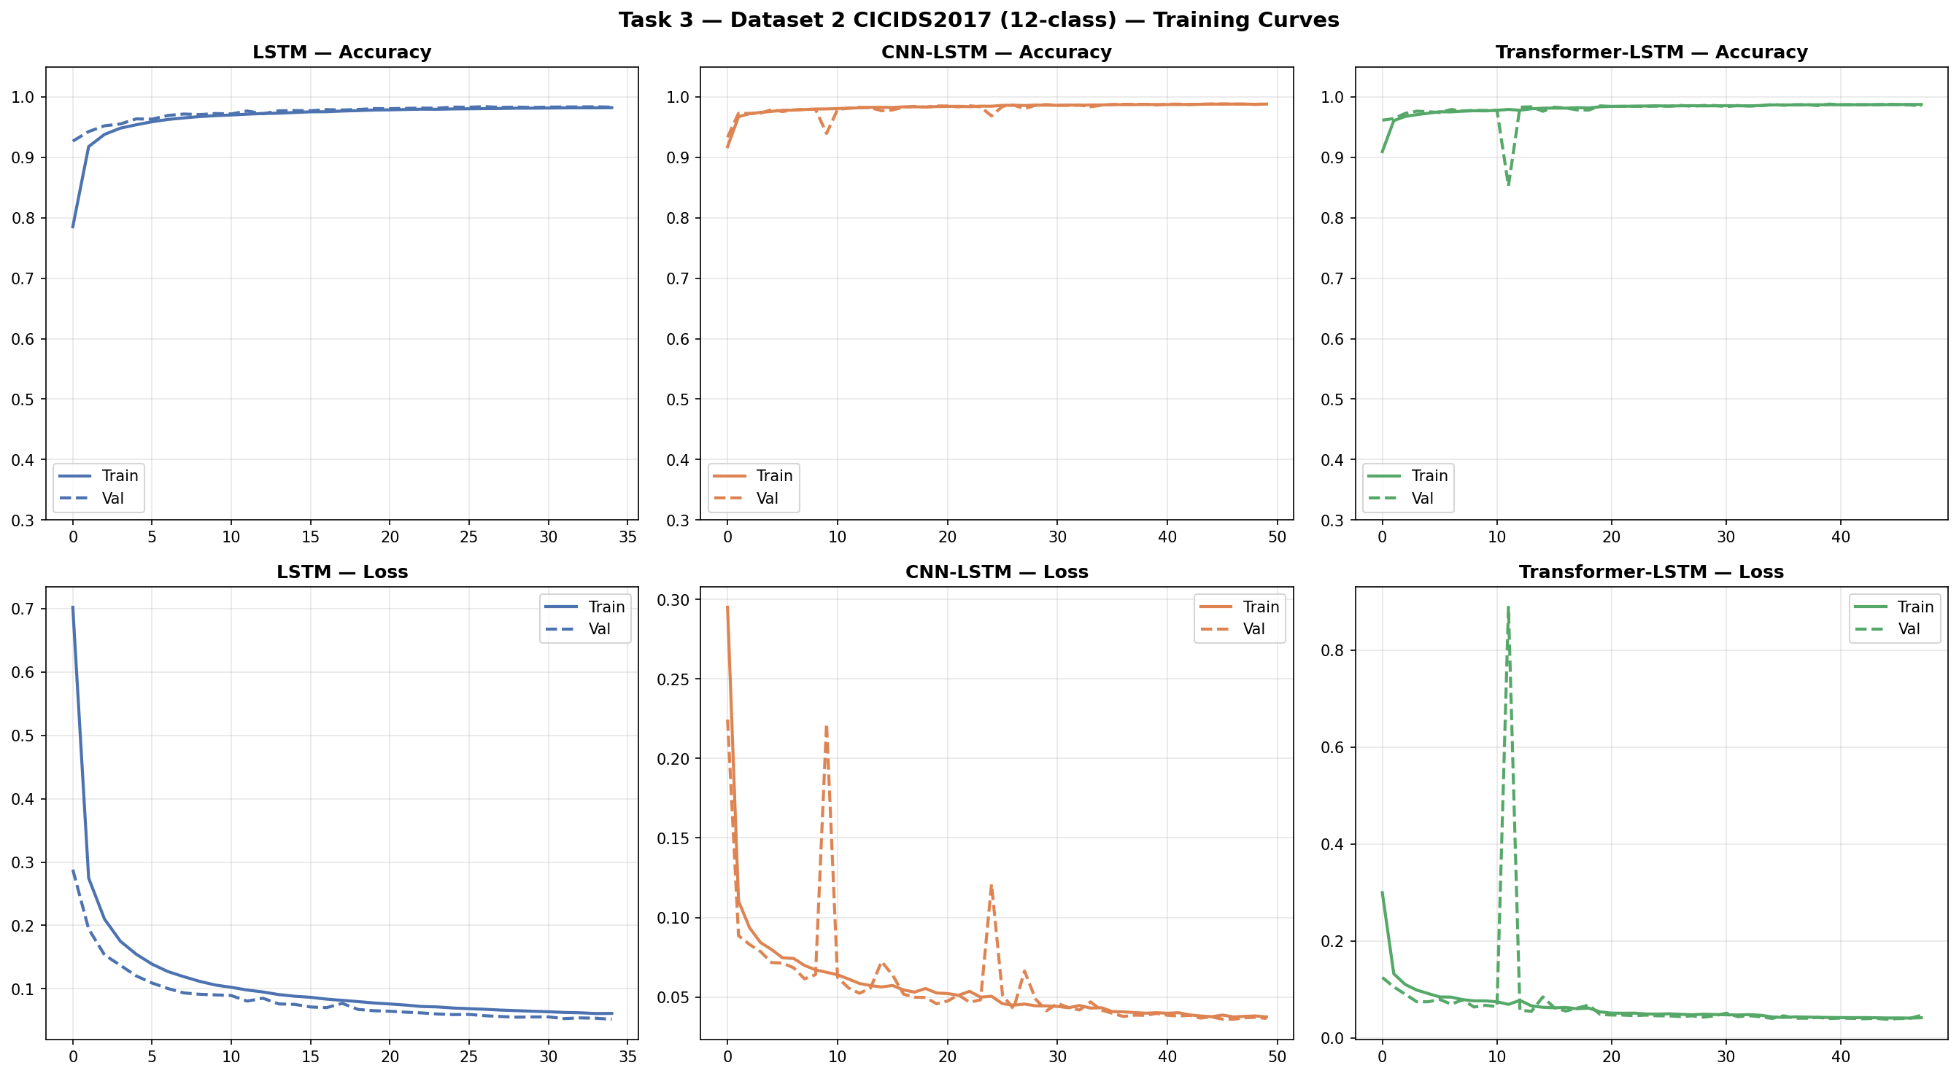
Figure 9. Training curves for Task 3 (12-class intrusion detection on CICIDS2017).
Table III shows the evaluation metrics for Task 3.
Model | Accuracy | Precision | Recall | F1-Score
LSTM Baseline | 98.48% | 98.59% | 98.48% | 98.37%
CNN-LSTM | 98.90% | 99.05% | 98.90% | 98.82%
Transformer-LSTM (Proposed) | 98.81% | 98.95% | 98.81% | 98.72%
Table III. Task 3 Results: 12-class intrusion detection on CICIDS2017.
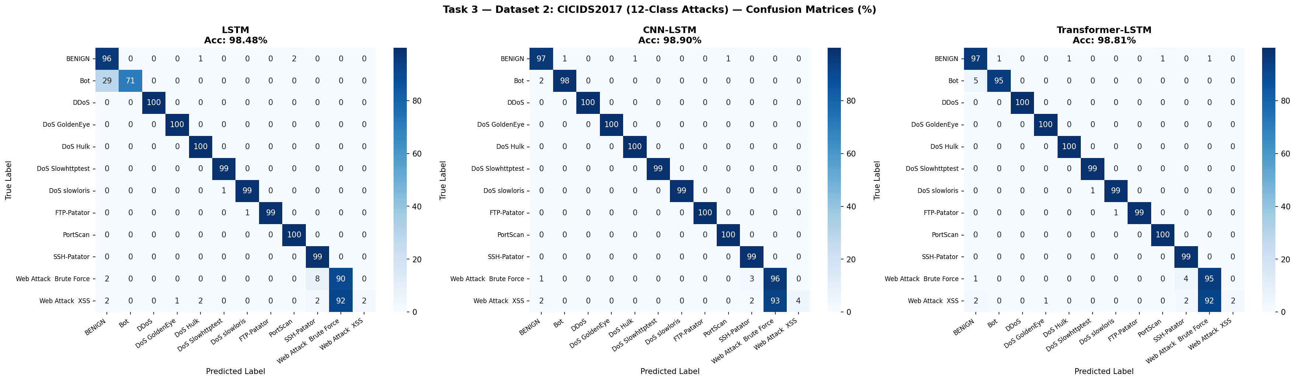
Figure 10. Confusion matrices for Task 3 (values are percentages).
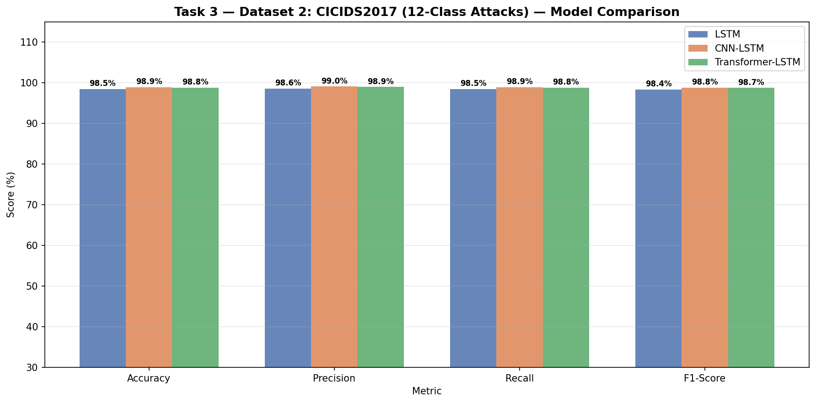
Figure 11. Model comparison chart for Task 3.
All three models performed exceptionally well on CICIDS2017, achieving above 98% accuracy. CNN-LSTM reached 98.90% and Transformer-LSTM reached 98.81%, a difference of only 0.09%. Common attack types such as DDoS, DoS Hulk, DoS GoldenEye, PortScan, FTP-Patator, and SSH-Patator were classified with near-perfect recall across all models. The most difficult class was Web Attack XSS with only 130 test samples and a very low recall of around 2% across all models, which indicates insufficient training examples rather than a model weakness. The Bot class showed clear improvement from the LSTM baseline at 71% recall to 95% recall in both CNN-LSTM and Transformer-LSTM, showing that more complex architectures are better at learning the subtle patterns of bot traffic.
D. Overall Discussion
Across all three tasks, the Transformer-LSTM consistently delivered strong and competitive results. It outperformed the simple LSTM baseline in all tasks and was competitive with CNN-LSTM, coming within 1% accuracy in every experiment. The attention mechanism added meaningful benefit on the 8-class task where class boundaries are less distinct. On the CICIDS2017 intrusion detection task all three models performed similarly at very high accuracy, suggesting that the dataset features are sufficiently discriminative that all architectures converge to near-optimal solutions. These findings support the conclusion that Transformer attention is a useful addition to LSTM-based traffic classifiers, particularly for complex multi-class scenarios.
IX. GitHub Repository
The complete project including all source code, preprocessing scripts, model definitions, training configurations, evaluation results, figures, and this report is available at:
https://github.com/yazious/network-traffic-transformer-lstm
X. Conclusion
This paper presented a Transformer-Enhanced LSTM model for network traffic classification. The model was designed to combine the temporal learning ability of LSTM networks with the feature attention capability of the Transformer architecture. Experiments on two public datasets across three classification tasks showed that the proposed model consistently achieved competitive accuracy against CNN-LSTM baselines while clearly outperforming the simple LSTM baseline. The Transformer-LSTM achieved 93.57% on 4-class Tor and VPN classification, 76.62% on 8-class application type classification, and 98.81% on 12-class intrusion detection. The results confirm that combining recurrent layers with attention mechanisms is a practical and effective approach for network traffic classification.
XI. Future Work
Several directions can extend this work. The model could be tested on additional datasets and on real-time captured traffic. More advanced Transformer designs such as stacked encoder layers or BERT-style pre-training could be explored. Explainable AI techniques such as SHAP or LIME could be integrated to help security operators understand which traffic features drive each classification decision. The system could also be extended to handle fully encrypted traffic where no payload features are available. Finally, packaging the model as a lightweight deployment tool for real network environments would be a meaningful practical contribution.
References
[1] A. Azab, M. Khasawneh, S. Alrabaee, K.-K. R. Choo, and M. Sarsour, "Network traffic classification: Techniques, datasets, and challenges," Digital Communications and Networks, vol. 10, pp. 676-692, 2024.
[2] F. Pacheco, E. Exposito, M. Gineste, C. Baudoin, and J. Aguilar, "Towards the deployment of machine learning solutions in network traffic classification: A systematic survey," IEEE Communications Surveys and Tutorials, vol. 21, no. 2, pp. 1988-2014, 2019. DOI: 10.1109/COMST.2018.2883147
[3] J. Zhao, X. Jing, Z. Yan, and W. Pedrycz, "Network traffic classification for data fusion: A survey," Information Fusion, vol. 72, pp. 22-47, 2021.
[4] J. Zhang, X. Chen, Y. Xiang, W. Zhou, and J. Wu, "Robust network traffic classification," IEEE/ACM Transactions on Networking, vol. 23, no. 4, pp. 1257-1270, 2015. DOI: 10.1109/TNET.2014.2320577
[5] Z. Liu, Y. Xie, Y. Luo, Y. Wang, and X. Ji, "TransECA-Net: A Transformer-based model for encrypted traffic classification," Applied Sciences, vol. 15, no. 6, p. 2977, 2025. DOI: 10.3390/app15062977
[6] N. Mandela, Sonia, N. Mistry, and A. Nagpal, "Efficient dark web traffic classification using a hybrid CNN-LSTM model," International Journal of Information Technology, 2025. DOI: 10.1007/s41870-025-02427-x
[7] I. Sharafaldin, A. H. Lashkari, and A. A. Ghorbani, "Toward generating a new intrusion detection dataset and intrusion traffic characterization," in Proc. 4th Int. Conf. Information Systems Security and Privacy (ICISSP), 2018, pp. 108-116.
[8] H. Afifi et al., "Machine learning with computer networks: Techniques, datasets, and models," IEEE Access, vol. 12, pp. 54673-54703, 2024. DOI: 10.1109/ACCESS.2024.3384460
[9] N. Bayat, W. Jackson, and D. Liu, "Deep learning for network traffic classification," arXiv preprint arXiv:2106.12693, 2021.

