Demo and verification guide: DevSecOps pipeline
Table of Contents

Purpose: verify the project live, step by step, in front of the professor, and justify every technical choice. Demo length: 15 to 20 minutes (part B). Part C is for answering questions.
Version française : GUIDE_DEMO.md
Each step gives: what I do, the command, the expected result and what I say. Every command and expected result was tested on the platform on 9 November 2026.

Part A: Before the demo (10 minutes, alone)

A1. Start the platform
- Start Docker Desktop and wait for the green icon.
- In PowerShell:
cd C:\Users\yasmi\projects\devsecops-pipeline\infra
docker compose up -d
docker start facturation-prod facturation-prod-asis
docker ps --format "{{.Names}} {{.Status}}"
Expected: 5 containers Up: jenkins, sonarqube, mailpit, facturation-prod (fixed code, port 8081) and facturation-prod-asis (vulnerable code, port 8090). SonarQube takes about 2 minutes to start.

A2. Open the browser tabs
Tab | Address | Login
Jenkins | http://localhost:8080 | admin + JENKINS_ADMIN_PASSWORD from infra\.env
SonarQube | http://localhost:9000 | admin + SONAR_ADMIN_PASSWORD from infra\.env
Mailpit (emails) | http://localhost:8025 | none
Also open the project in VS Code (code C:\Users\yasmi\projects\devsecops-pipeline) and a PowerShell terminal in the project folder.

A3. Quick check
curl.exe -s http://localhost:8081/health
curl.exe -s http://localhost:8090/health
Expected: {"status":"ok"} twice. If a container is missing, see part D.

Part B: Demo script

Step 1: The platform is entirely “as code” (1 min)
I show: infra/docker-compose.yml, infra/jenkins/casc.yaml, infra/bootstrap.ps1.
I say: “Nothing was configured by hand. Jenkins, its plugins, credentials, three jobs and the SonarQube server are described in versioned files. One script rebuilds the whole platform on another machine.”

Step 2: The problem: the original pipeline deploys a vulnerable application (3 min)
I show: in Jenkins, the 1-as-is-pipeline job is green. I open Jenkinsfile.asis: four steps, no controls, and a plaintext password (DB_PASSWORD).
I prove the deployed application can be attacked, live, on port 8090:
$alice = 'alice' + '-demo-key' # Alice's demo API key (public test data, see db.py)
# 1) BOLA: Alice reads invoice 3, which belongs to Bob
curl.exe -s -H "X-API-Key: $alice" http://localhost:8090/invoices/3
# 2) SQL injection: Alice gets every customer's invoices
curl.exe -s -H "X-API-Key: $alice" "http://localhost:8090/invoices/search?customer=%25'%20OR%201%3D1%20--"
# 3) Command injection, no authentication
curl.exe -s "http://localhost:8090/admin/ping?host=127.0.0.1;id"
Expected:
- {"id":3,"owner_id":2,"customer":"Poulina Group","amount":99000.0}: Alice reads Bob’s invoice.
- All 3 invoices, including Bob’s (owner_id: 2).
- uid=0(root) gid=0(root): the id command ran as root inside the container.
I say: “This pipeline is green, and it just put into production an application where anyone can run commands as root. That is exactly the problem to solve.”
Expected on screen: the 3 jobs: green / red / green
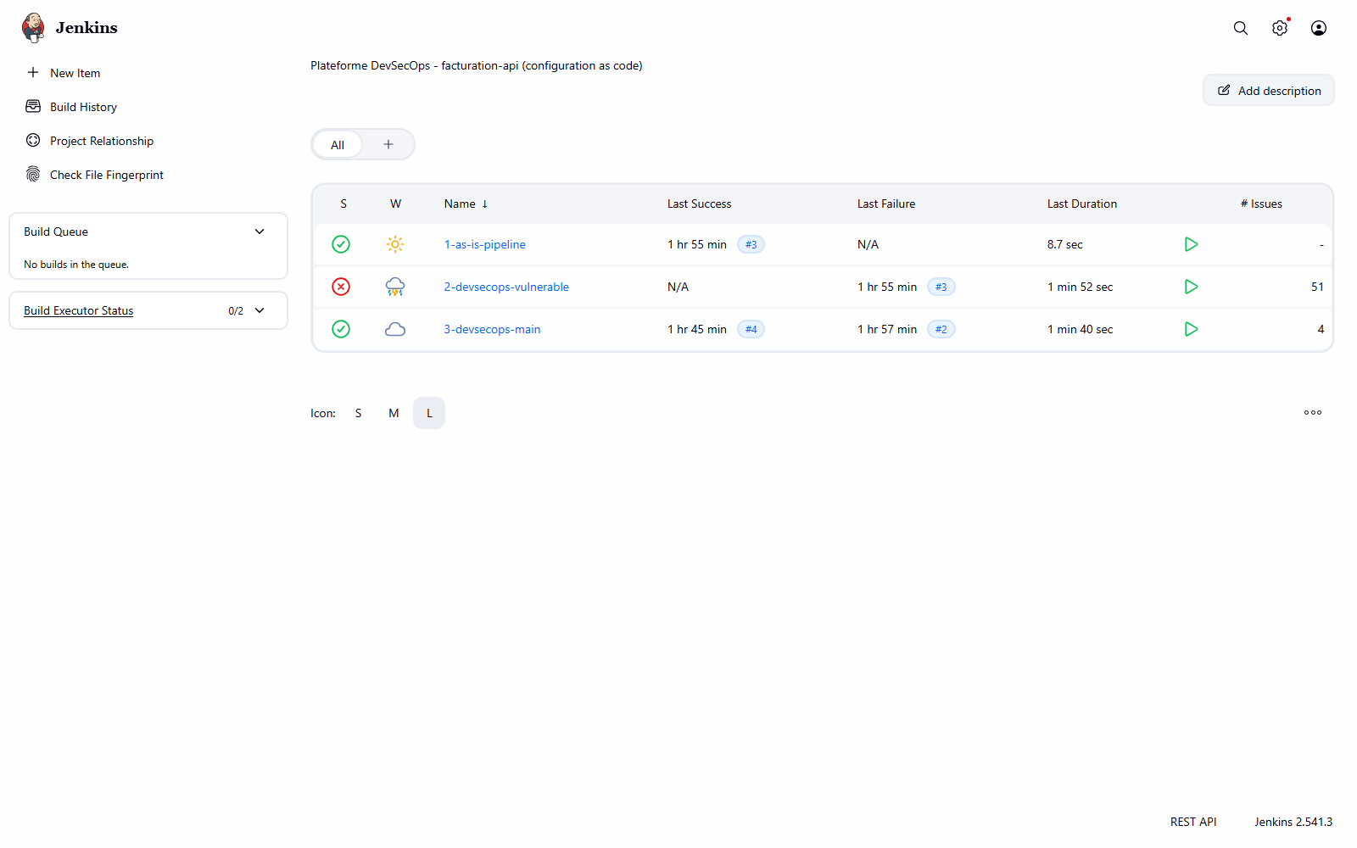

Step 3: The same code through the DevSecOps pipeline is blocked (3 min)
I show: the 2-devsecops-vulnerable job is red.
- Open the job: the Stage View shows the scan stages in red. The deploy_production column never runs.
- Click the last build, then Rapports securite in the left menu.
  - Quality gate tab: BLOCK verdict, per-tool summary (4 secrets, 3 Semgrep, 2 Bandit, 14 dependencies, 114 image, 1 ZAP, SonarQube failed), trend chart, then each finding in detail.
  - ZAP (DAST) tab: High alert Remote OS Command Injection. ZAP found the flaw by attacking the application in staging, not by reading the code.
  - Trivy (image) tab: the CVEs of the outdated base image.
- Optional: Console Output, search for VERDICT : BLOCK.
I say: “The scans keep running even when one fails, so the developer gets the full list in a single run. The security_gate stage makes the final decision and stops the production deploy.”
Expected on screen: job 2 Stage View, production never reached
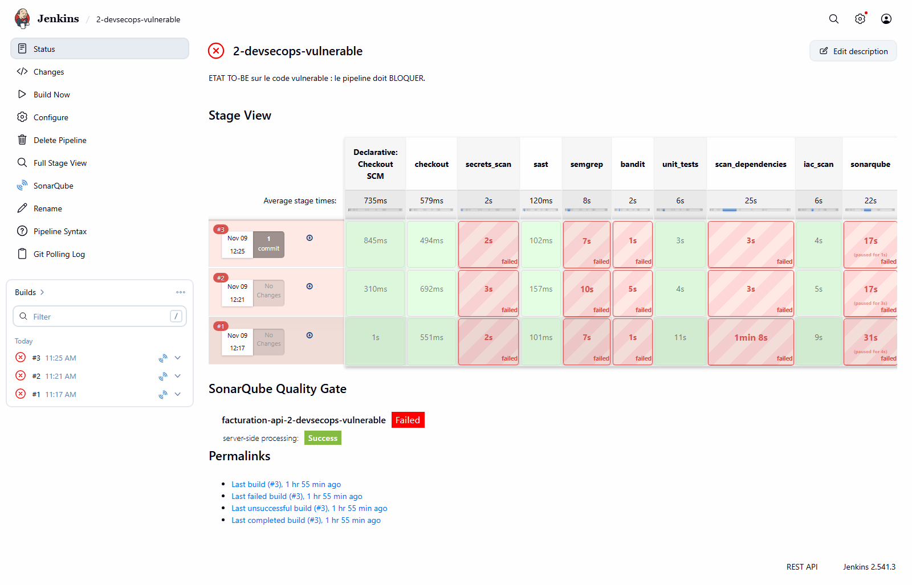
Expected on screen: quality gate report: BLOCK
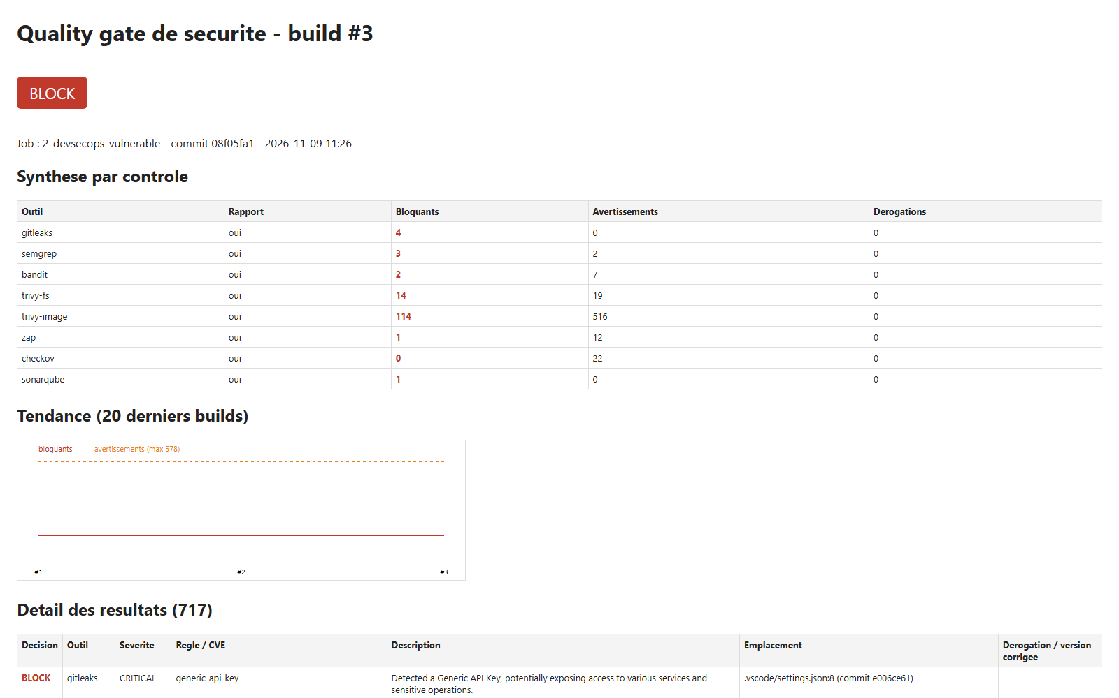
Expected on screen: ZAP report: Remote OS Command Injection (High)
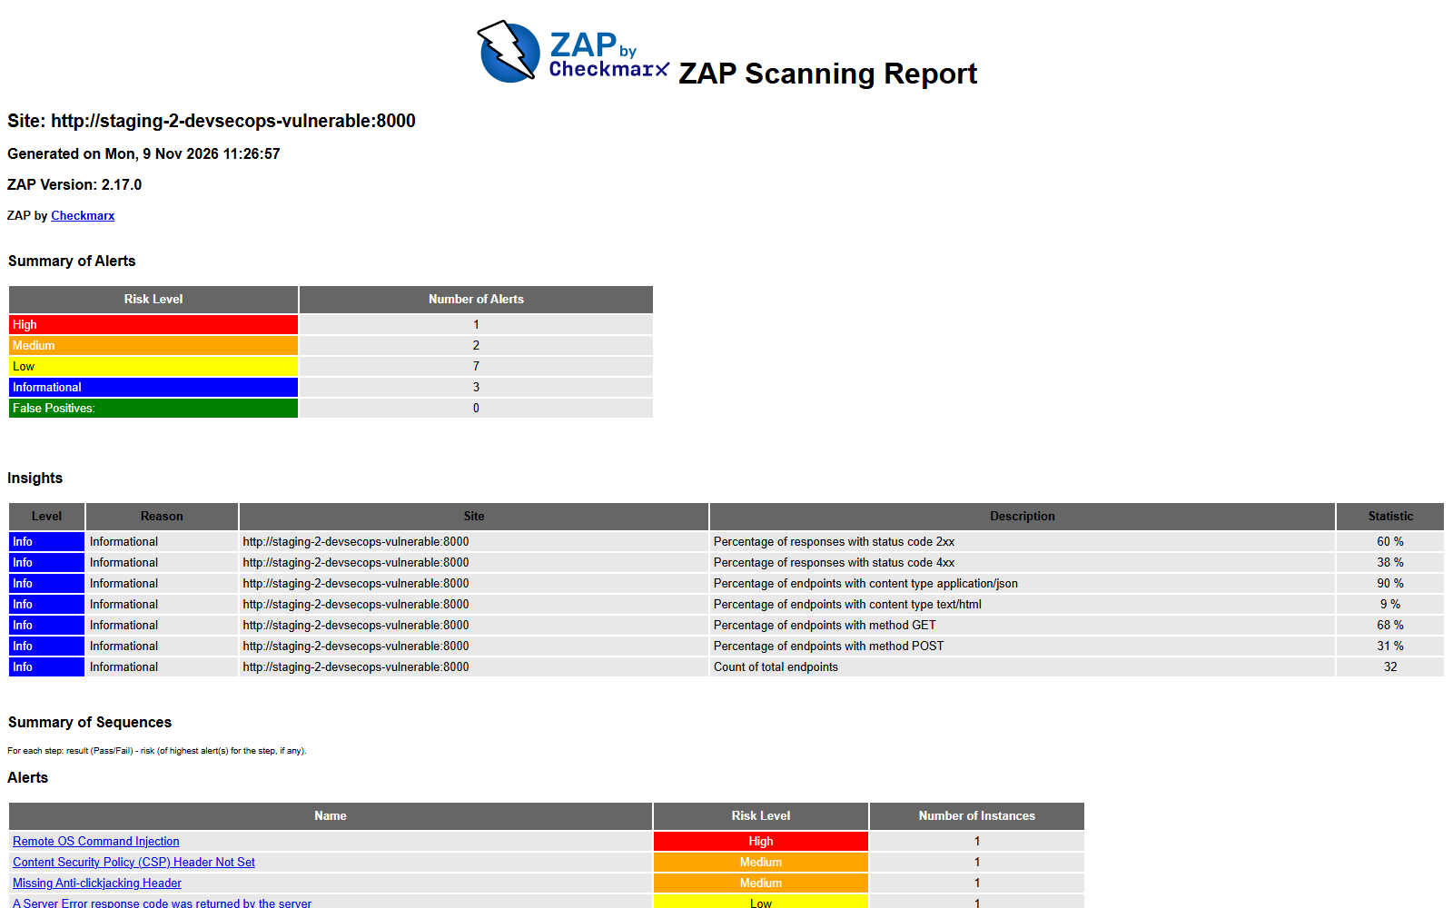

Step 4: The fixed code passes and the attacks fail (3 min)
I show: the 3-devsecops-main job is green all the way to deploy_production. In Rapports securite → Quality gate: PASS verdict, 4 tracked exemptions, 192 warnings (CVEs with no fix available).
I replay the same attacks against the fixed production, port 8081:
$alice = 'alice' + '-demo-key' # Alice's demo API key (public test data, see db.py)
curl.exe -s -o NUL -w "%{http_code}\n" -H "X-API-Key: $alice" http://localhost:8081/invoices/3
curl.exe -s -H "X-API-Key: $alice" "http://localhost:8081/invoices/search?customer=%25'%20OR%201%3D1%20--"
curl.exe -s -o NUL -w "%{http_code}\n" "http://localhost:8081/admin/ping?host=127.0.0.1;id"
Expected: 404 (Bob’s invoice is invisible to Alice), [] (the parameterised query treats the injection as plain text), 404 (the dangerous endpoint no longer exists).
I show the container hardening:
docker inspect facturation-prod --format "user={{.Config.User}} read-only={{.HostConfig.ReadonlyRootfs}} caps-dropped={{.HostConfig.CapDrop}}"
docker inspect facturation-prod-asis --format "user={{.Config.User}} read-only={{.HostConfig.ReadonlyRootfs}}"
Expected: user=10001 read-only=true caps-dropped=[ALL] for the fixed version, and user= read-only=false (so root, writable) for the original.
Expected on screen: job 3 Stage View, all green
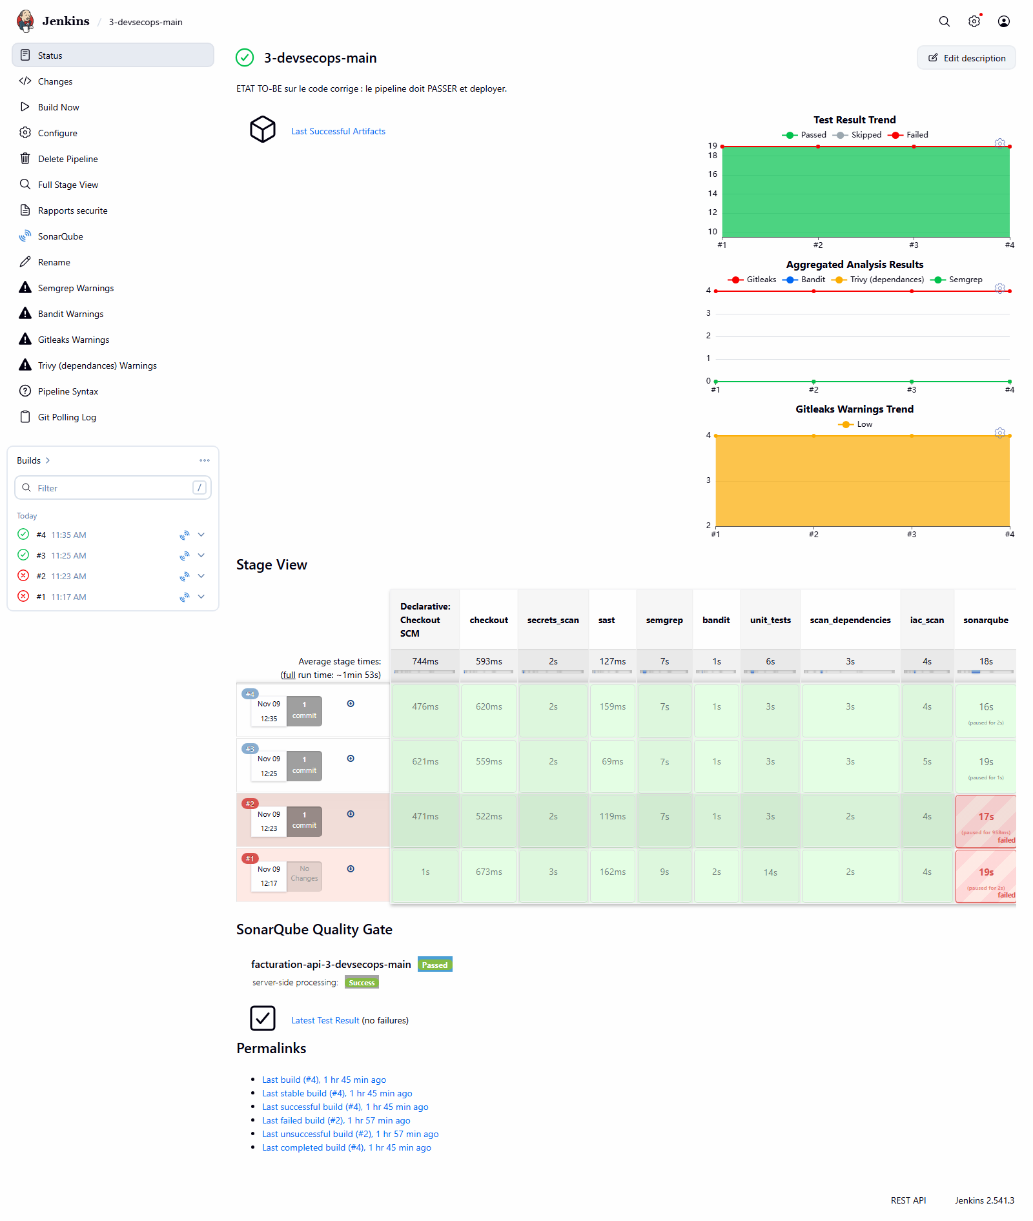
Expected on screen: quality gate report: PASS
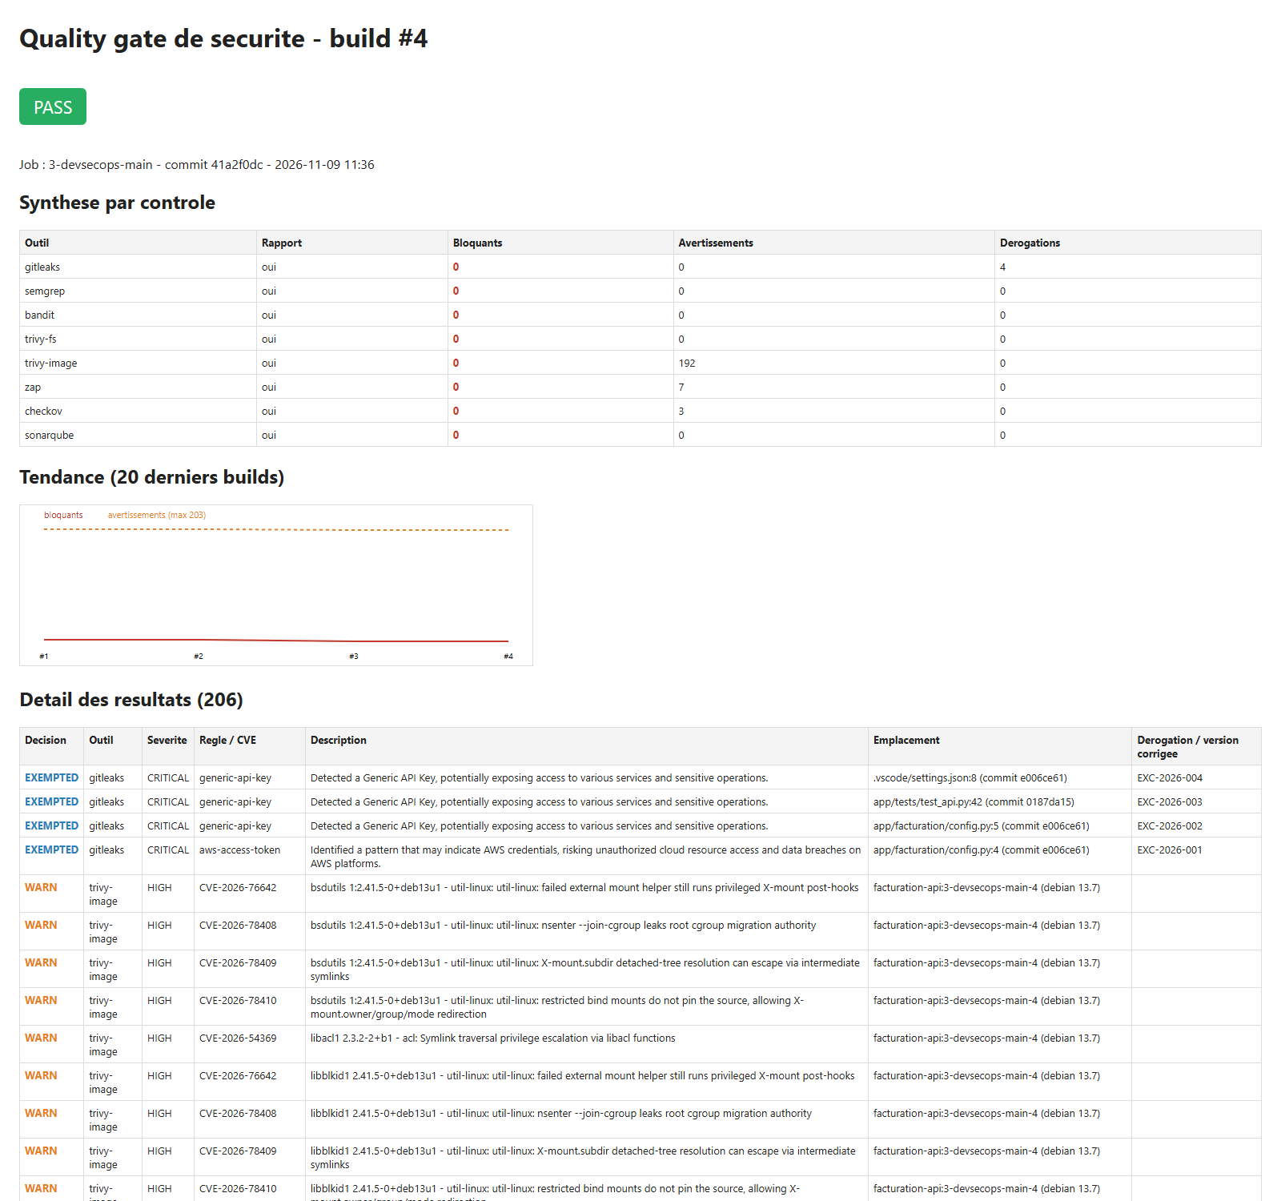

Step 5: Centralisation in SonarQube (2 min)
I show: http://localhost:9000/projects
- facturation-api-2-devsecops-vulnerable: Failed, security rating E, 21 vulnerabilities.
- facturation-api-3-devsecops-main: Passed, rating A, 98.2 % coverage.
- In a project, the Issues tab also shows the Bandit, Semgrep and Gitleaks results imported by the pipeline.
- Quality Gates menu: the “DevSecOps” gate (security rating A, coverage ≥ 80 %).
I say: “SonarQube is the single dashboard. It holds its own analysis and the other tools’ reports. Exemptions are applied before import, so there is one source of truth.”
Expected on screen: SonarQube: rating E vs rating A
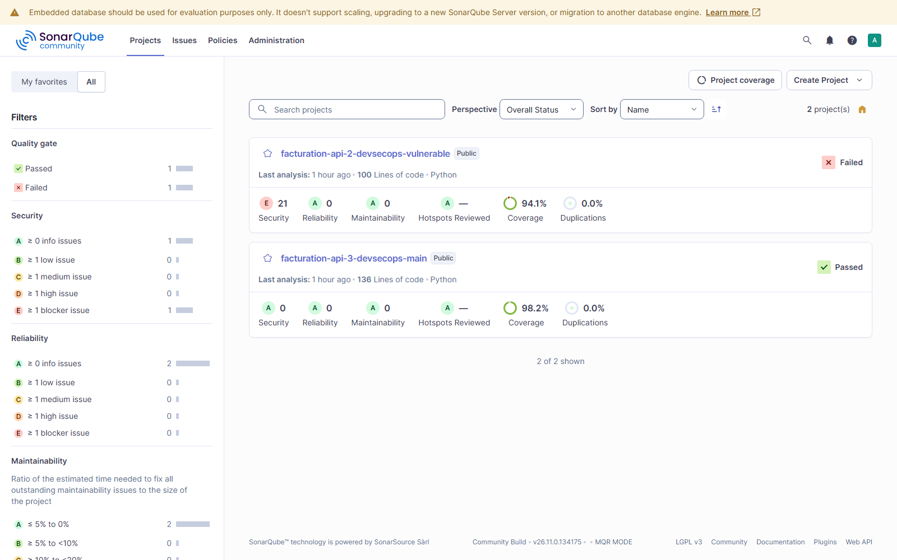

Step 6: Notifications and history (1 min)
I show:
- Mailpit (http://localhost:8025): a [BLOQUE] email listing the blocking findings, and an [OK] … deploye en production email.
- In the Quality gate report: the trend chart. History is also in Jenkins (30 builds kept) and in SonarQube’s Activity tab.
Expected on screen: Mailpit: [BLOQUE] and [OK] emails
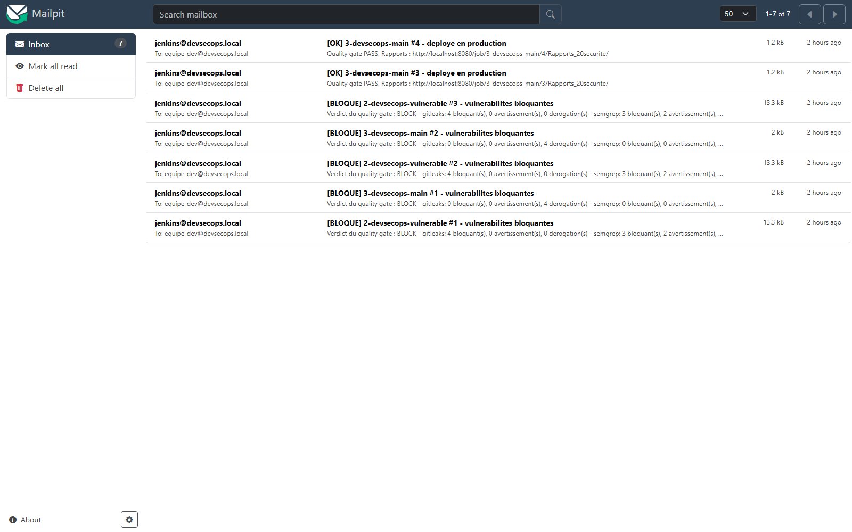
Mailpit: [BLOQUE] and [OK] emails

Step 7: Security on the developer workstation (2 min)
I do: in the terminal, at the project root:
.\.venv\Scripts\Activate.ps1
$k = 'AKIA' + 'Q7XKJ4WZT2MBN5RD' # fake key, split in two so the repo itself holds no key
Set-Content -Encoding ascii app\facturation\aws_demo.py "AWS_ACCESS_KEY_ID = `"$k`""
git add app\facturation\aws_demo.py
git commit -m "ajout config aws"
Expected: Detect hardcoded secrets ... Failed, leaks found: 1. The commit is refused: the secret never left the machine.
Clean up:
git reset -q; Remove-Item app\facturation\aws_demo.py
I also show in VS Code: the recommended extensions (.vscode/extensions.json) and SonarLint connected to the SonarQube server (.vscode/settings.json).
I say: “The hook can be bypassed with --no-verify. That’s why the CI re-runs every check. The workstation speeds up detection; the CI guarantees it.”
Expected on screen: commit refused by the pre-commit hook
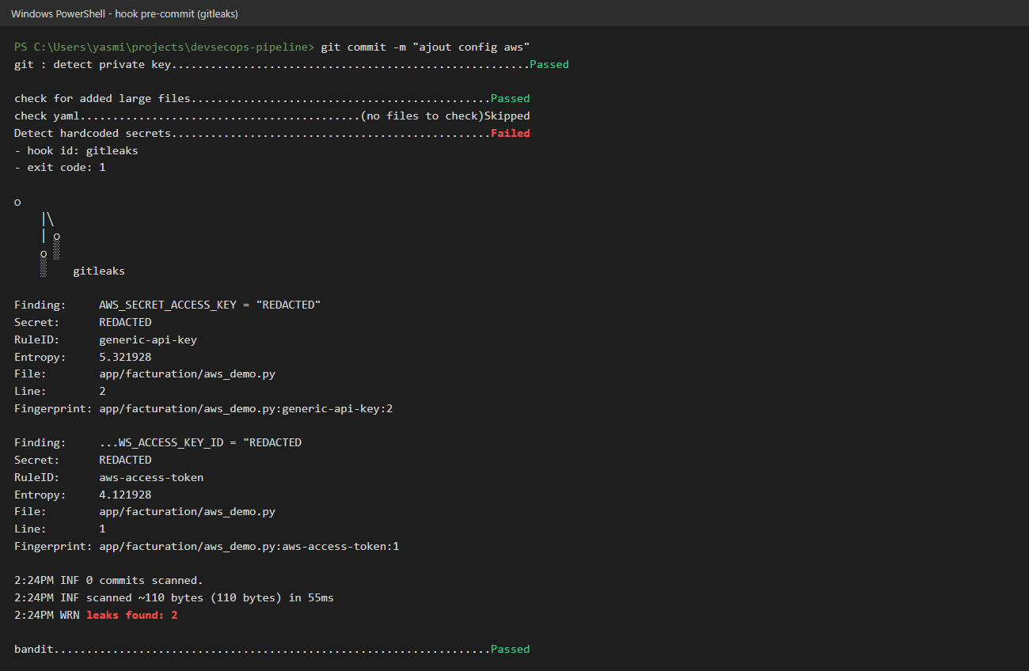

Step 8: Targeted local scan before push (1 min)
powershell -ExecutionPolicy Bypass -File scripts\scan-local.ps1 -Only gitleaks
Expected: [OK] gitleaks bloquants=0 ... derogations=4, VERDICT : PASS. The tools come from the Jenkins image, in the same versions, with the same policy.

Step 9: An expired exemption blocks again automatically (2 min)
I do: in security/exemptions.yml, I change the expiry date of EXC-2026-001 from 2027-05-09 to 2026-11-01, save, then:
powershell -ExecutionPolicy Bypass -File scripts\scan-local.ps1 -Only gitleaks
Expected: Derogation EXC-2026-001 EXPIREE le 2026-11-01 : le resultat redevient bloquant, then VERDICT : BLOCK.
Restore: git checkout -- security\exemptions.yml
I say: “An exemption is never permanent. It has an approver, a ticket and an expiry date. When it expires, the finding blocks again with no human action.”

Step 10: Real time: a vulnerable commit triggers the pipeline and is blocked (5 min, optional)
This is the most convincing demo: one push, no click in Jenkins.
Set-Content -Encoding ascii app\facturation\diagnostic.py "import subprocess`n`n`ndef diagnostic(host):`n return subprocess.run(f`"ping -c 1 {host}`", shell=True)`n"
git add app\facturation\diagnostic.py
git commit -m "ajout diagnostic reseau"
- The pre-commit hook refuses the commit (Bandit, High severity). First safety net.
- I simulate a developer who bypasses the hook: git commit --no-verify -m "ajout diagnostic reseau"
- In Jenkins, within a minute, the 3-devsecops-main job starts by itself (cause: Started by an SCM change).
- About 2 minutes later the build is red: Semgrep and Bandit flag shell=True, deploy_production does not run, and a [BLOQUE] email arrives in Mailpit. Production (port 8081) stays on the healthy version.
- Restore: git revert --no-edit HEAD. The pipeline restarts by itself and turns green.
Note: I checked that the hook blocks this commit. Steps 2 to 5 rely on the same Semgrep and Bandit rules that already block the vulnerable branch. The --no-verify bypass is yours to run during the demo, to show what happens when a developer skips the hook.

Step 11: Pipeline secrets (1 min)
I show:
- Jenkins → Manage Jenkins → Credentials: the sonar-token is stored as a credential. In a build log it shows masked (****).
- git check-ignore -v infra/.env: the password file is excluded from Git.
- Jenkinsfile: no password. Compare with DB_PASSWORD in plaintext in Jenkinsfile.asis.

Conclusion (30 s)
“The same vulnerable code is green in the original pipeline and blocked in the DevSecOps pipeline. The fixed code passes and goes to production hardened. Every decision is automatic, measured and traceable. Accepted limitation: no tool caught the BOLA. The pipeline complements code review; it does not replace it.”

Part C: Why each choice

C1. Architecture and approach
Choice | Why | Rejected alternative
Jenkins | Required by the brief (Jenkins or GitLab), widely used in companies, plugins for SonarQube, HTML reports, email | GitLab CI: excellent, but heavier to host locally and less control over the platform
Docker Compose for the platform | Runs on one PC, rebuilt with one command, no cloud account needed | Virtual machines: slow and not reproducible
Configuration as Code (JCasC + Job DSL) | Reproducible, reviewable platform; no undocumented manual clicks | Manual Jenkins setup: impossible to audit or reproduce
Two branches (vulnerable and main) with the same Jenkinsfile | Proof by comparison: the controls block bad code and let good code through | One branch: only half the proof
A 3rd job running the original pipeline | Measure the as-is state instead of only describing it | Describing it in the report only
A deliberately vulnerable FastAPI app | Small, readable, covers OWASP Top 10 flaws (injection, deserialization, secrets, access control) | An existing demo app: less under control, harder to explain

C2. The tools
Control | Tool | Why this one
Secrets | Gitleaks | Scans the whole Git history, not just the current code. Fast, SARIF output, and the same tool runs as a pre-commit hook.
SAST | Semgrep | Ready-made OWASP rules and easy custom rules. My two rules found the SQL injection and the pickle call that SonarQube Community misses.
SAST | Bandit | Python specialist, with a confidence level per finding, useful to cut false positives.
SAST + central dashboard | SonarQube Community | Required by the brief. Single dashboard, quality gate, history, and imports the other tools’ reports.
SCA + image | Trivy | One tool for dependencies and the image (OS and Python packages). It reports the fixed version, which enables the “block only if a fix exists” rule.
SBOM | Syft (CycloneDX) | Component inventory, in the standard format expected by the EU Cyber Resilience Act.
DAST | OWASP ZAP, API scan mode | Active scan driven by the OpenAPI definition: ZAP knows every endpoint and parameter. The baseline mode is passive and would not have found the command injection.
IaC | Checkov | Covers Dockerfile and Kubernetes with over 1,000 rules.
Email | Mailpit | Local SMTP server: emails are really sent and viewable, without exposing a mail account.
Pinned versions and verified checksum: security tools are targets too. In March 2026 the Trivy GitHub Action tags were compromised. A tag can be moved; a pinned version and a checksum cannot.

C3. Stage order
Choice | Why
Secrets and SAST first | Fastest checks (a few seconds): immediate feedback to the developer.
Semgrep and Bandit in parallel | Independent, so it saves time.
Unit tests with coverage ≥ 80 % | The security tests (test_security.py) are part of the suite: a fixed flaw that comes back breaks the build.
Build after code analysis | No point building an image if the code is already rejected.
DAST on an isolated staging | ZAP really attacks the application, so never in production. The staging container is on an internal network and removed after the build.
catchError on each scan | A red stage doesn’t stop the next ones: the developer sees all problems at once instead of one at a time.
One final security_gate stage | One decision, made on all the reports, with one policy.
deploy_production only if everything passes | That’s what a blocking quality gate means.
Trigger on every commit (polling every minute) | The repository is local, so no webhook is possible. On GitHub/GitLab a webhook would trigger instantly.

C4. Blocking policy
Choice | Why
Policy in a versioned file (policy.yml) applied by one script (gate.py) | Thresholds are reviewed like code, and every tool is judged with the same logic. Changing a threshold leaves a trace in Git.
Every secret blocks | A committed secret must be treated as compromised, whatever its “severity”.
CVSS ≥ 7 threshold (HIGH and CRITICAL) | Common industry threshold: it matches exploitable, high-impact vulnerabilities.
CVE blocks only if a fix exists | Blocking on a CVE with no fix allows no action and stalls the team. These CVEs stay visible as warnings.
Bandit: HIGH with confidence ≥ MEDIUM | Bandit produces low-confidence false positives. Blocking on them causes alert fatigue and pushes people to bypass the tool.
ZAP: High risk | A High alert in staging is a flaw confirmed at runtime.
Checkov non-blocking | 2–4 week observation period to measure noise before blocking. Harden progressively.
Missing report = failure | A broken scanner must never let a build through by default.
SonarQube: security rating A, coverage ≥ 80 % | Custom “DevSecOps” gate, stricter on security than the default gate.

C5. Exemptions
Choice | Why
An exemptions.yml register instead of disabling a rule | Lifts one precise finding (tool, rule, location), not a whole category.
Approver, ticket and justification required | Traceability: who accepted which risk, and why.
Mandatory expiry date | A forgotten exemption would become permanent. On expiry, the finding blocks again (shown in step 9).
Same register applied to SonarQube (SARIF filtering) | One source of truth: without it, SonarQube kept failing on an already accepted risk.
Historical AWS key: exemption after revocation | Deleting the file doesn’t remove the secret from Git history. Revoke the key first, then record the exemption and plan the history rewrite.

C6. Application fixes
Flaw | Fix | Why this fix
SQL injection | Parameterised query | The database gets the data separately from the query, so a quote can no longer change the query.
pickle.loads | JSON + Pydantic schema | pickle can run code during deserialization. JSON carries only data, and Pydantic validates its shape.
shell=True | No shell, validated input, authenticated endpoint | Without a shell, characters like ; or | mean nothing.
MD5 | Salted scrypt | MD5 runs billions of times per second. scrypt is deliberately slow and memory-hungry.
XSS | html.escape | User text is displayed as text, never interpreted as HTML.
BOLA | owner_id filter | Every request checks the invoice belongs to the user. No tool caught it: the fix and test came from code review.
Plaintext secrets | Environment variables | The secret is no longer in the code or the image.
Each flaw | A regression test | If someone reintroduces the flaw, the unit_tests stage fails.

C7. Docker image and deployment
Choice | Why
Base image pinned by digest | A tag (3.12-slim) can change; a digest names exactly the same image, bit for bit.
Multi-stage build | Build tools stay in the build stage: the final image is smaller, with less attack surface.
apt-get upgrade at build time | Even that day’s official image had 2 zlib CVEs fixed in Debian but not yet in the image.
User 10001 (non-root) | If the app is compromised, the attacker is not root (compare with uid=0(root) in step 2).
Read-only filesystem and all capabilities dropped | The attacker can neither modify files nor use Linux privileges.
HEALTHCHECK | Docker knows whether the app answers, not just whether the process runs.
Image SBOM | When a new CVE comes out, you know in seconds whether the image is affected.

C8. Pipeline secrets and developer workstation
Choice | Why
SonarQube token as a Jenkins credential | Masked in logs, never written in the Jenkinsfile.
Passwords generated by bootstrap.ps1 into infra/.env, excluded from Git | No default passwords, nothing sensitive in the repository.
Pre-commit hooks pinned by SHA | Same reason as the tools: an attacker can move a Git tag.
Only fast checks in pre-commit | Developers disable slow hooks. Heavy scans stay in CI.
SonarLint in connected mode | The developer sees exactly the CI’s rules in the IDE.
scan-local.ps1 using the Jenkins image | Same versions and policy as CI: no surprises after the push.

C9. Limitations I acknowledge
- Jenkins can access the host’s Docker socket, which equals root on the machine. In production: ephemeral agents, rootless Docker or Kaniko.
- SonarQube Community does no data-flow analysis for Python, hence the Semgrep rules.
- 192 CVEs with no fix stay as warnings and must be tracked.
- The Jenkins CSP is relaxed to display HTML reports: not for production.
- The tools did not find the BOLA or the XSS: code review is still essential.

Part D: Troubleshooting
Problem | Fix
SonarQube shows “starting” | Wait 2–3 minutes after docker compose up -d.
A facturation-prod* container is missing | In Jenkins, click Build Now on job 1 (port 8090) or job 3 (port 8081).
The job doesn’t start after a commit | Jenkins polls every minute: wait 60 s, or click Build Now.
Forgot a password | Get-Content infra\.env
Rebuild everything from scratch | powershell -ExecutionPolicy Bypass -File infra\bootstrap.ps1
Port 8080 already in use | Close the other application, then docker compose up -d.

