Project report: Securing a CI/CD pipeline (DevSecOps)
Table of Contents

Project: facturation-api, adding automated security controls from the developer workstation to production Date: 9 November 2026 Tools: Jenkins, SonarQube, Gitleaks, Semgrep, Bandit, Trivy, Syft, OWASP ZAP, Checkov, pre-commit, Mailpit
French version: RAPPORT.md

1. Context and objectives
facturation-api is an invoicing REST API (Python 3.12, FastAPI, SQLite), packaged with Docker. It was shipped by a classic “DevOps” Jenkins pipeline: tests, build, deploy, with no security control at all.
Objectives:
- add automated controls to the pipeline: secrets, SAST, SCA, Docker image scan, DAST, plus IaC and SBOM;
- define quality gates that automatically block any critical vulnerability before production;
- equip the developer workstation so flaws are caught before the commit (shift-left);
- produce reports, notifications and a history a third-party team can use;
- document a traceable exemption process.

2. Methodology
- Assessment: map the original pipeline (Jenkinsfile.asis) and its weaknesses.
- Target design: choose one tool per category, the stage order and the blocking policy.
- Reproducible platform: Jenkins + SonarQube + Mailpit in Docker, configured entirely as code (Jenkins Configuration as Code, infra/bootstrap.ps1).
- Proof by comparison: the same DevSecOps pipeline runs on two branches:
  - vulnerable: the original code (as-is), so the pipeline must block;
  - main: the fixed code, so the pipeline must pass and deploy.
- Remediation of each vulnerability, each with a regression test.
- Measurement: every number in this report comes from real Jenkins builds (archived reports).
Three Jenkins jobs are created automatically:
Job | Branch | Jenkinsfile | Purpose
1-as-is-pipeline | vulnerable | Jenkinsfile.asis | baseline: original pipeline
2-devsecops-vulnerable | vulnerable | Jenkinsfile | proves the controls block
3-devsecops-main | main | Jenkinsfile | proves the fixed code passes

3. Analysis of the existing pipeline (as-is)

3.1 Map
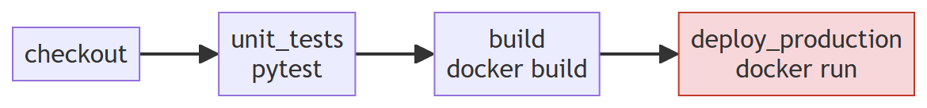
Step | Tool | Security control
CI/CD | Jenkins (declarative pipeline) | none
Dependencies | pip | none (dependencies not checked)
Unit tests | pytest | functional tests only
Build / packaging | Docker | no image scan
Deployment | docker run straight to production | no validation, no staging

3.2 Weaknesses found
# | Weakness | Where | Consequence
W1 | Plaintext secrets in code (AWS key, DB password) | config.py | cloud account compromise; the secret stays in Git history
W2 | No code analysis (SAST) | pipeline | SQL injection, command injection and pickle deserialization shipped to production
W3 | Dependencies not checked (SCA) | requirements.txt | PyJWT 2.3.0, urllib3 1.26.4: known CVEs fixed long ago
W4 | Docker image not scanned, outdated unpinned base (python:3.12.0-slim, Debian 12.2) | Dockerfile | 114 fixable HIGH/CRITICAL CVEs; container runs as root
W5 | Plaintext secret in the pipeline (DB_PASSWORD in the Jenkinsfile) | Jenkinsfile.asis | visible to anyone reading the repo or the logs
W6 | Direct deploy to production with no staging or dynamic testing | pipeline | flaws visible only at runtime go undetected
W7 | No local checks (IDE, pre-commit) | workstation | flaws are found late, so they cost more
W8 | No security reports, alerts or history | pipeline | no visibility, no trend tracking
W9 | Infrastructure as code not checked (privileged container, latest image) | k8s/deployment.yaml | privilege escalation on the cluster
Baseline measurement: the 1-as-is-pipeline job is green and deploys an application with all these flaws to production. That is exactly the problem to solve.

4. Developer-side security (shift-left)

4.1 Secured IDE (VS Code)
.vscode/extensions.json makes VS Code recommend to every developer:
Extension | Role
SonarLint (connected mode) | the same rules as the CI SonarQube, shown live in the editor with an explanation
Semgrep | the same custom rules as the CI (security/semgrep/)
Python, Docker, YAML | language, Dockerfile and manifest support
SonarLint connected mode (.vscode/settings.json) means the developer sees in the IDE exactly what the CI will flag, with the explanation and the suggested fix.

4.2 Pre-commit hooks
.pre-commit-config.yaml blocks the commit on the workstation, before code leaves the machine:
Hook | Detects
gitleaks | secrets in staged files
bandit (-ll) | Python flaws of severity ≥ MEDIUM
detect-private-key | PEM/SSH private keys
check-added-large-files, check-yaml | dumps, binaries, invalid YAML
Design choices:
- each hook repository is pinned by commit SHA (a Git tag can be moved);
- only fast checks run locally (target under 10 s); heavy scans (Trivy, ZAP, SonarQube) stay in CI;
- hooks can be bypassed (--no-verify), which is why the CI re-runs every check. The workstation speeds up detection; the CI guarantees it.

4.3 Targeted local run before push
scripts/scan-local.ps1 runs the same scanners, in the same versions (the Jenkins image) and with the same policy as the CI:
powershell -File scripts\scan-local.ps1 # gitleaks + semgrep + bandit + trivy
powershell -File scripts\scan-local.ps1 -Only semgrep # a single check

4.4 Awareness
Every blocking finding links to an explanation: the custom Semgrep rules cite the CWE, the OWASP Top 10 2025 category and the expected fix; the fixed code carries a comment naming the flaw it fixes (CORRECTIF (CWE-89) : requête paramétrée…); tests/test_security.py documents each attack as an executable test.

5. Automated controls in the pipeline (to-be)

5.1 Final pipeline

5.2 Tools chosen
Control | Tool | Version | Why
Secrets | Gitleaks | 8.30.1 | scans the whole Git history, fast, SARIF output; also runs as a pre-commit hook
SAST | Semgrep | 1.184.0 | ready-made OWASP rules plus custom rules that are easy to write
SAST | Bandit | 1.9.4 | Python specialist (MD5, shell=True, pickle)
SAST + central dashboard | SonarQube Community Build | 26.11 | one dashboard, quality gate, history; imports the other reports
SCA | Trivy (fs) | 0.75.0 | up-to-date vulnerability DB, reports the fixed version
Image scan | Trivy (image) | 0.75.0 | same tool: OS and application packages in the image
DAST | OWASP ZAP (API scan) | stable | active scan driven by the API’s OpenAPI definition
IaC | Checkov | 3.4.3 | Dockerfile + Kubernetes, over 1,000 rules
SBOM | Syft | 1.55.0 | CycloneDX (the format expected by the Cyber Resilience Act)
All tools are installed in the Jenkins image at pinned versions; the Trivy archive is also checksum-verified. Security tools are themselves targets (the Trivy GitHub Action tags were compromised in March 2026).

5.3 Jenkinsfile stages
Stage | Main command | Reports produced
secrets_scan | gitleaks git (full history) | gitleaks.json, .sarif
sast | semgrep ∥ bandit (in parallel) | semgrep.json/.sarif, bandit.json/.sarif/.html
unit_tests | pytest --cov-fail-under=80 | junit.xml, coverage.xml
scan_dependencies | trivy fs + syft | trivy-fs.json/.sarif, sbom-source.cdx.json
iac_scan | checkov | results_json.json
sonarqube | sonar-scanner + waitForQualityGate | SonarQube dashboard
build | docker build + syft | sbom-image.cdx.json
docker_scan | trivy image | trivy-image.json/.html
deploy_staging | isolated container on an internal network | none
dast | zap-api-scan.py (OpenAPI) | zap.json/.html
security_gate | security/gate.py evaluate | security-gate.html/.json, history
deploy_production | only if everything passes | none
On failure. Each scan stage calls gate.py check --tool <tool>: if it finds a blocking result, the stage turns red but the following scans still run (catchError). The developer gets the full list of problems in a single run. The security_gate stage then makes the overall decision and prevents the production deploy.
Trigger. Automatic on every commit (Jenkins polls the repository every minute), with no manual step. The builds in this report show the cause “Started by an SCM change”.

6. Quality gates: blocking thresholds and rationale
The policy is a versioned, reviewed file (security/policy.yml), applied by a single script (security/gate.py) that normalises the results of every tool.
Control | Blocking | Non-blocking (warning) | Rationale
Secrets | every finding | none | a committed secret must be treated as compromised, whatever its “severity”
SAST Semgrep | HIGH, CRITICAL | MEDIUM, LOW | ERROR-level rules match exploitable flaws (injection, RCE)
SAST Bandit | HIGH with confidence ≥ MEDIUM | the rest | Bandit produces low-confidence false positives; this avoids alert fatigue
SCA (Trivy fs) | CRITICAL, HIGH (CVSS ≥ 7.0) if a fix exists | MEDIUM, LOW, and HIGH with no fix | blocking on a CVE with no fix allows no action and stalls the team
Docker image | same as SCA | same | same logic for the base OS packages
DAST ZAP | High risk | Medium, Low, Info | a High alert in staging is an exploitable flaw confirmed at runtime
IaC Checkov | none (observation mode) | everything | 2–4 week observation period to measure noise before blocking
SonarQube | Quality Gate ERROR | none | “DevSecOps” gate: security rating A, reliability ≥ C, coverage ≥ 80 %
Process | missing or unreadable report | none | “missing = failed”: a broken scanner must not let a build through
CVSS v3 mapping: CRITICAL ≥ 9.0; HIGH 7.0–8.9; MEDIUM 4.0–6.9; LOW < 4.0. The threshold is therefore: block from CVSS 7.0 when a fix is available.
Blocking vs non-blocking. Warnings are not ignored: they appear in the HTML report, in SonarQube and in the history. They prepare progressive hardening (for example, making Checkov blocking once its noise is measured).

7. Pipeline secrets management
The pipeline must not reproduce the flaws it is meant to catch:
Before (as-is) | After (to-be)
DB_PASSWORD = 'Sup3rS3cret!2026' in plaintext in the Jenkinsfile | no secret in the Jenkinsfile
none | SonarQube token stored as a Jenkins credential (secret text), injected by withSonarQubeEnv, masked in logs
default admin password | passwords randomly generated by bootstrap.ps1; SonarQube’s admin/admin changed automatically
none | infra/.env file excluded from Git (.gitignore); Jenkins reads it through JCasC (${SONAR_TOKEN})
none | production container: no secret in the image, user 10001, read-only filesystem
Planned evolution: HashiCorp Vault (Jenkins Vault plugin) for short-lived secrets, and OIDC federation to remove static secrets.

8. Reporting, alerting and history
Need | Implementation
JSON report per scan | reports/*.json archived on every build (Jenkins artifacts)
Readable HTML reports | “Rapports securite” tab on each build: consolidated quality gate, ZAP, Trivy image, Bandit
Centralisation | SonarQube: native analysis + import of Bandit (JSON) and Semgrep/Gitleaks (SARIF) results; Warnings NG plugin in Jenkins
Notification | automatic email on every build: [BLOQUE] … listing the blocking findings, or [OK] … deployed to production (Mailpit SMTP server, viewable at http://localhost:8025)
History / trend | (1) security-history/<job>.jsonl: one line per build, chart of the last 20 builds in the HTML report; (2) Warnings NG trend charts; (3) SonarQube Activity tab; (4) 30 builds kept in Jenkins
The consolidated security-gate.html report shows the verdict, a per-tool summary (blocking / warnings / exemptions), the trend chart and the detail of every finding (rule or CVE, location, fixed version or applied exemption).

9. Results

9.1 The three pipelines compared (builds triggered automatically by commit)
Job | Result | Duration
1-as-is-pipeline | ✅ SUCCESS, deploys the vulnerable application | 9 s (warm cache)
2-devsecops-vulnerable | ❌ FAILURE, production blocked | 113 s
3-devsecops-main | ✅ SUCCESS, deployed to production | about 2 min
Cost of security: about 2 minutes per build, of which 37–45 s is DAST. That is well under the 8-minute target for a merge-request pipeline.

9.2 Quality gate results
Control | Vulnerable code | Fixed code
Secrets (Gitleaks) | 4 blocking | 0 (4 tracked exemptions)
SAST Semgrep | 3 blocking, 2 warnings | 0
SAST Bandit | 2 blocking, 7 warnings | 0
SCA Trivy | 14 blocking (33 CVEs in total) | 0
Docker image Trivy | 114 blocking (630 CVEs in total) | 0 blocking, 192 warnings (no fix available)
DAST ZAP | 1 blocking (Remote OS Command Injection), 12 warnings | 0, 7 warnings
IaC Checkov | 22 warnings | 3 warnings
SonarQube | Quality Gate ERROR, security rating E, 21 vulnerabilities | Quality Gate OK, rating A, 0 vulnerabilities, 98.2 % coverage
Verdict | BLOCK, 139 blocking findings | PASS

9.3 Vulnerabilities found and fixed
Flaw | CWE / OWASP | Found by | Fix | Regression test
Plaintext AWS key and password | CWE-798 | Gitleaks, Bandit (B105) | environment variables; keys revoked | secrets gate
SQL injection (f-string) | CWE-89 / A05 Injection | Semgrep (custom rule), Bandit B608 | parameterised query | test_sql_injection_…
pickle deserialization | CWE-502 / A08 | Semgrep (custom rule), Bandit B301 | JSON + Pydantic schema | test_import_rejects_…
Command injection shell=True | CWE-78 / A05 | Semgrep, Bandit B602, ZAP (High, at runtime) | no shell, input validation, authentication | test_command_injection_…
MD5 password hashing | CWE-327 / A04 | Bandit B324, Semgrep | salted scrypt | test_password_is_not_md5
Reflected XSS | CWE-79 / A05 | code review | html.escape | test_xss_is_escaped
BOLA (reading another user’s invoice) | OWASP API1 | no tool, code review | owner_id filter | test_bola_…
Missing security headers | A02 | ZAP | headers middleware | test_security_headers_present
PyJWT 2.3.0, urllib3 1.26.4, jinja2, requests | CVE-2022-29217, CVE-2021-33503… | Trivy fs | removed unused dependencies, upgrades, exact versions | SCA gate
Outdated base image, root container | none | Trivy image, Checkov | recent image pinned by digest, multi-stage, user 10001, apt-get upgrade | image gate
privileged K8s container, latest tag | none | Checkov | hardened securityContext, image by digest, resource limits | none
Key lesson: BOLA and XSS were flagged by no scanner. Automated tools do not understand business logic (“does this invoice belong to this user?”). The pipeline complements code review and penetration testing; it does not replace them.

10. Exemption process
Full detail: docs/PROCEDURE_DEROGATION.md. In short, a blocking finding can only be lifted by an entry in security/exemptions.yml that states the tool, the rule, the exact location, the justification, the approver, the ticket and an expiry date. The gate rejects an incomplete entry, and an expired exemption blocks again. The same register filters the results imported into SonarQube (gate.py filter-sarif), so it is the single source of truth.
Real case from this project: after the code was fixed, Gitleaks still blocked main, because the AWS keys remain in the Git history of the first commit. Handling: revoke the keys, exemptions EXC-2026-001/002 expiring in 6 months, and a planned history rewrite. Two other findings were genuine false positives (EXC-2026-003/004).

11. Difficulties encountered
Difficulty | Solution
SonarQube (Elasticsearch) needs a high vm.max_map_count, unavailable on Docker Desktop/WSL2 | -Dnode.store.allow_mmap=false option
Jenkins could not access the Docker socket (owned by root:root) | group_add: ["0"] in docker-compose (accepted limitation, see §12)
The deleted secret was still detected in Git history | tracked exemption after revocation: a committed secret cannot be “made to disappear”
SonarQube also imported Gitleaks findings covered by an exemption | SARIF filtering by the gate before import
Even today’s Python image had 2 zlib CVEs fixed in Debian but not yet in the official image | apt-get upgrade when building the image
Parameter named branch clashed with the Job DSL branch() method | renamed
HTML reports showed without styling (Jenkins CSP) | CSP relaxed for the lab (not for production: serve reports elsewhere)

12. Limitations and next steps
Accepted lab limitations:
- Jenkins can access the host’s Docker socket, which is equivalent to root on the machine. In production: ephemeral build agents, rootless Docker, Kaniko or BuildKit.
- SonarQube Community does not do data-flow (taint) analysis for Python. Semgrep’s custom rules fill that gap.
- 192 CVEs in the final image have no fix yet and stay as warnings: they must be tracked.
- The Git repository is local (polled every minute). On GitLab or GitHub, a webhook would trigger the build instantly.
Roadmap:
- Image signing (cosign) and admission-time verification in Kubernetes (Kyverno).
- Vault for secrets, OIDC to remove static credentials.
- Dependency-Track: continuous SBOM monitoring (new CVE → automatic ticket with an SLA).
- Make Checkov blocking after the observation period; distroless or Chainguard base image.
- Slack/Teams notifications; Grafana dashboard over the history.
- Authorization tests generated from OpenAPI (Schemathesis) to catch BOLA automatically.

13. Appendices

13.1 Reproducing the project
git clone <repo> ; cd devsecops-pipeline
powershell -ExecutionPolicy Bypass -File infra\bootstrap.ps1 # about 5 min the first time
# Jenkins http://localhost:8080 - SonarQube http://localhost:9000 - Mailpit http://localhost:8025
# (credentials printed by the script, stored in infra\.env)

13.2 Layout
Jenkinsfile DevSecOps pipeline (to-be), commented
Jenkinsfile.asis original pipeline (as-is)
app/ facturation-api (code, tests, Dockerfile)
k8s/deployment.yaml Kubernetes manifest (scanned by Checkov)
security/policy.yml quality gate policy
security/exemptions.yml exemption register
security/gate.py quality gate engine (normalisation, decision, reports, history)
security/semgrep/ custom Semgrep rules
.pre-commit-config.yaml local hooks
.vscode/ extensions and SonarLint/Semgrep settings
infra/ docker-compose, Jenkins image, JCasC, bootstrap
scripts/scan-local.ps1 targeted local run before push
docs/ reports (FR/EN), exemption process, oral preparation, screenshots

13.3 Screenshots
Taken on the running platform (folder docs/captures/).
1. Jenkins: the 3 jobs (green / red / green)
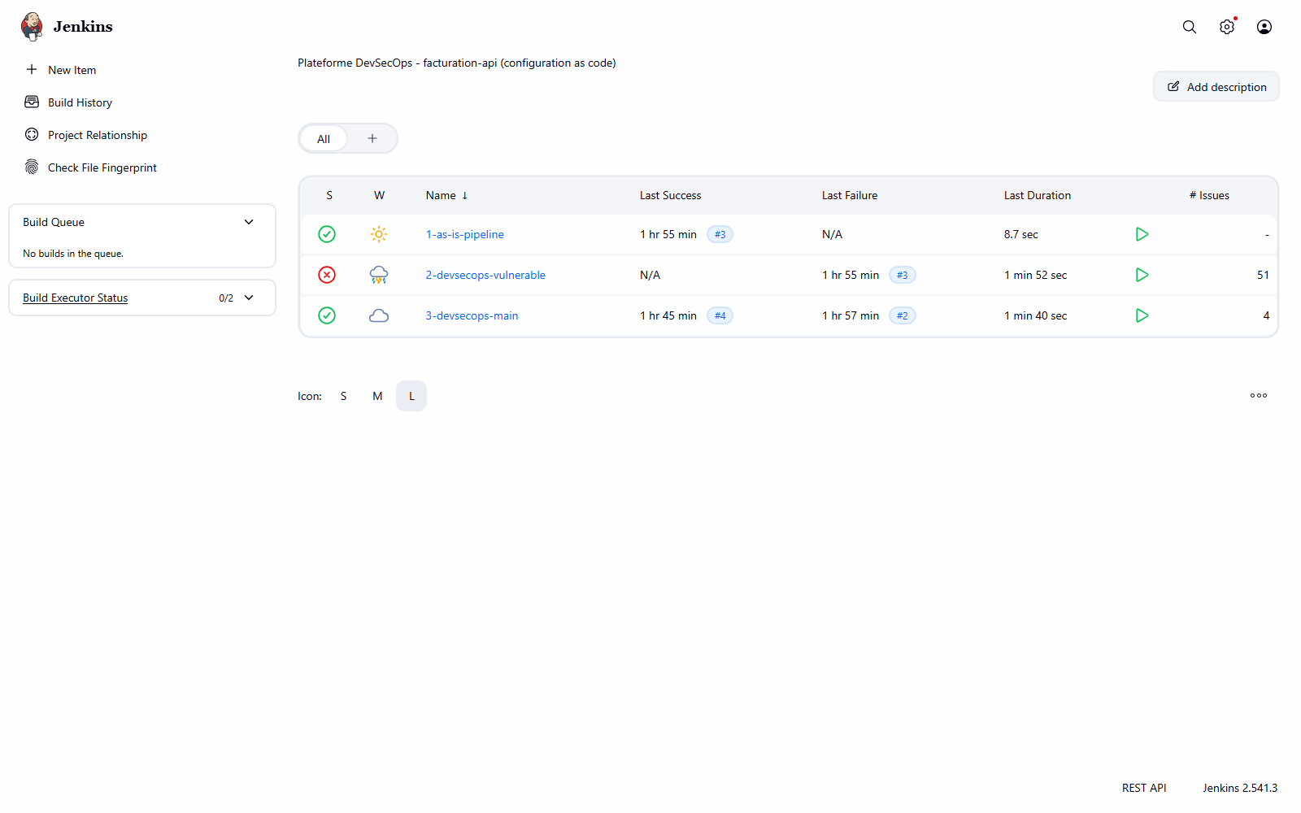
2. Job 2 Stage View: scan stages in red, production never reached
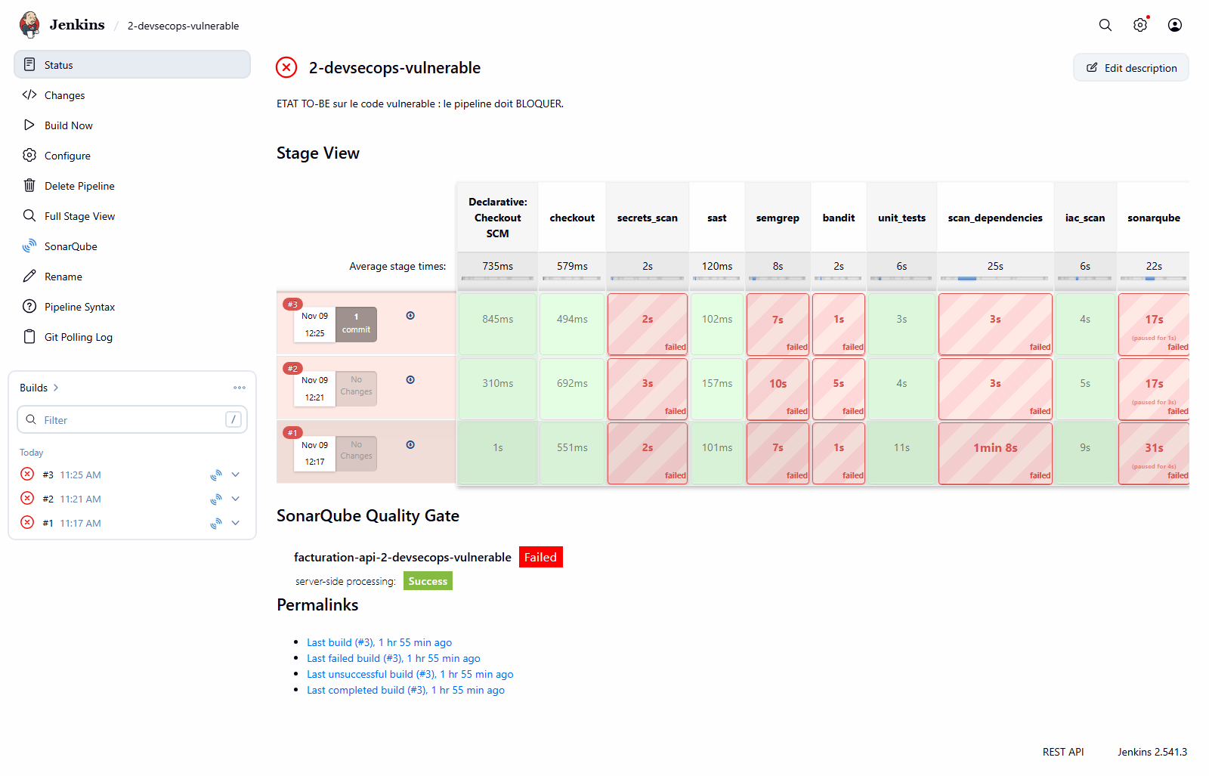
3. Job 3 Stage View: green all the way to deploy_production
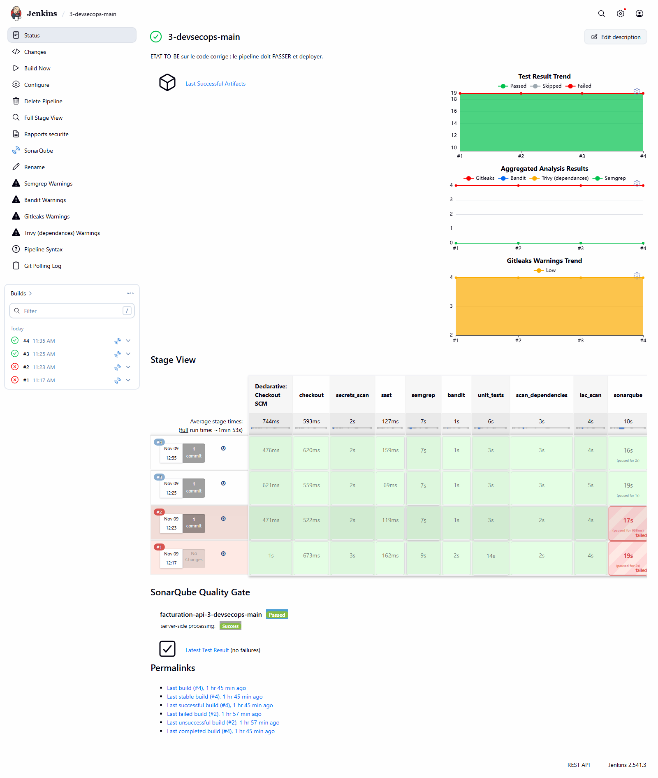
4. Quality gate report, job 2: BLOCK verdict, per-tool summary
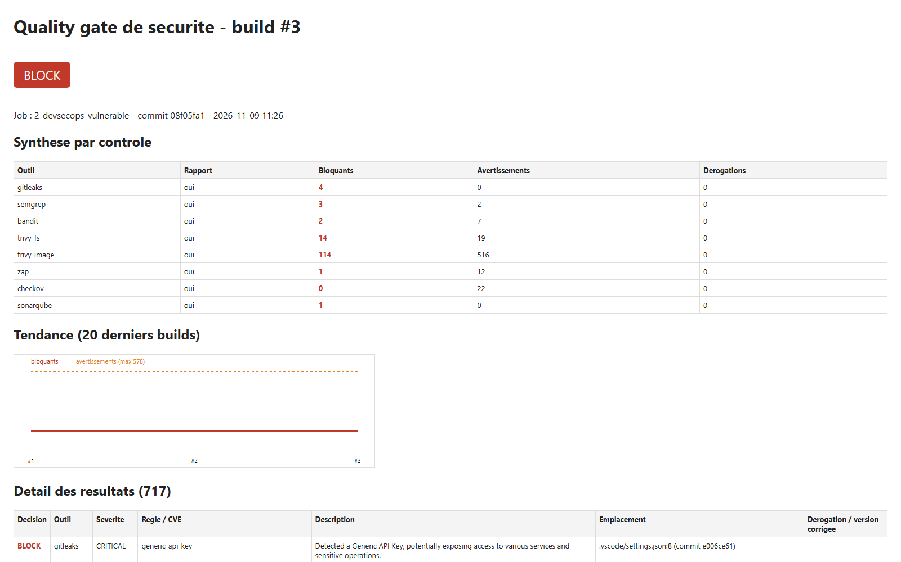
5. Quality gate report, job 3: PASS verdict, exemptions and trend
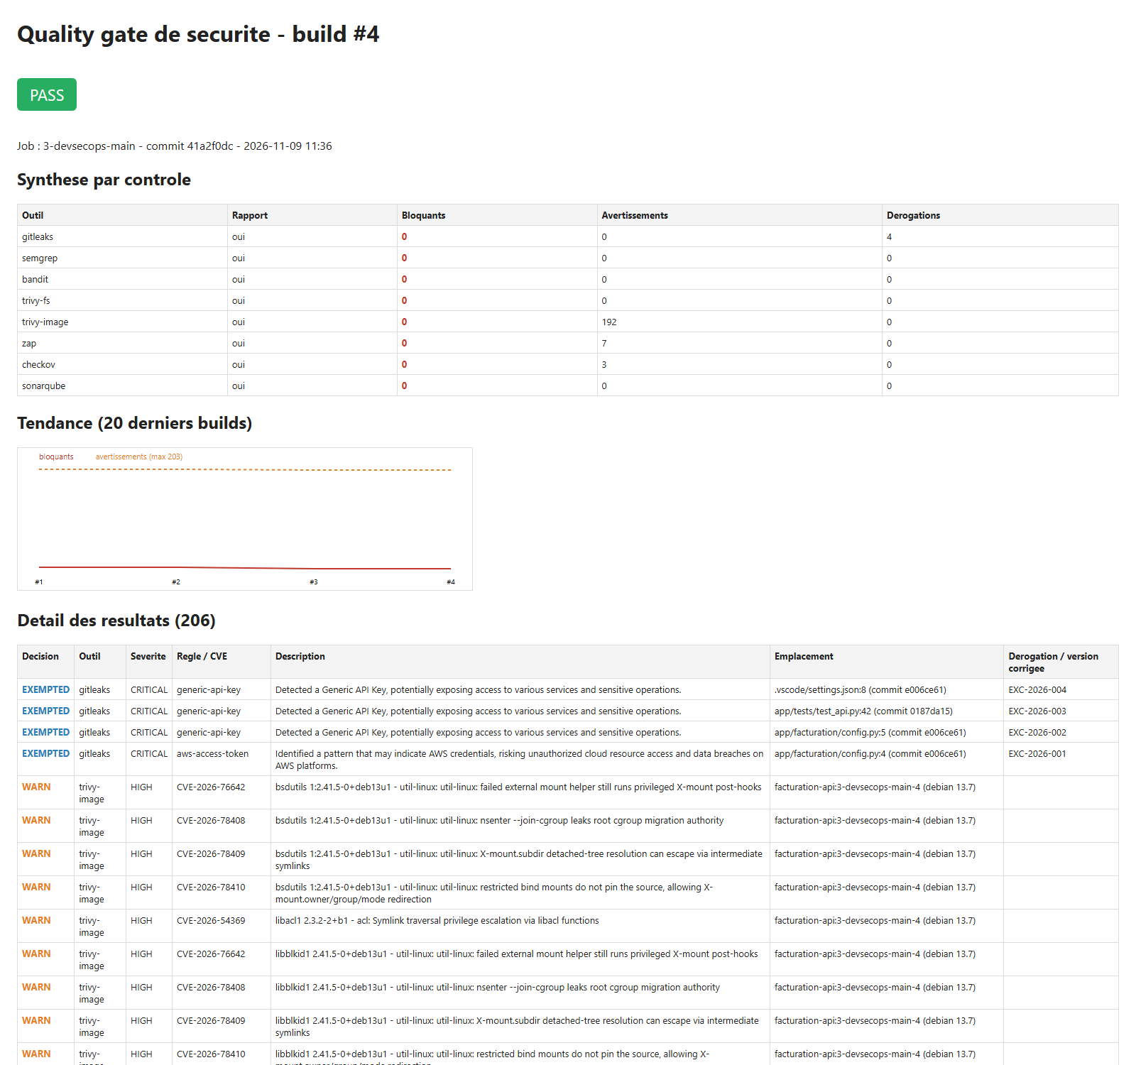
6. ZAP report, job 2: Remote OS Command Injection (High)
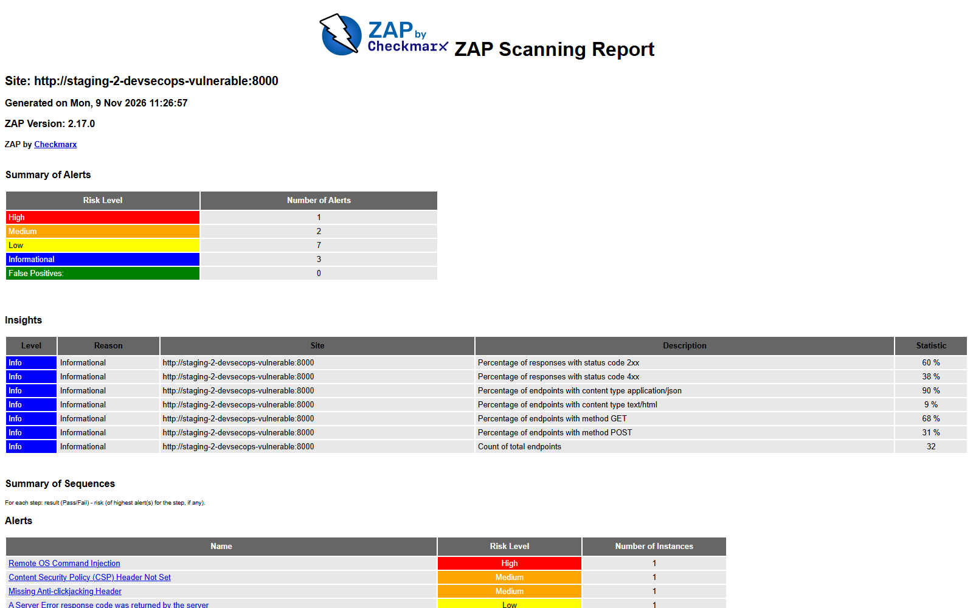
7. Trivy image report, job 2
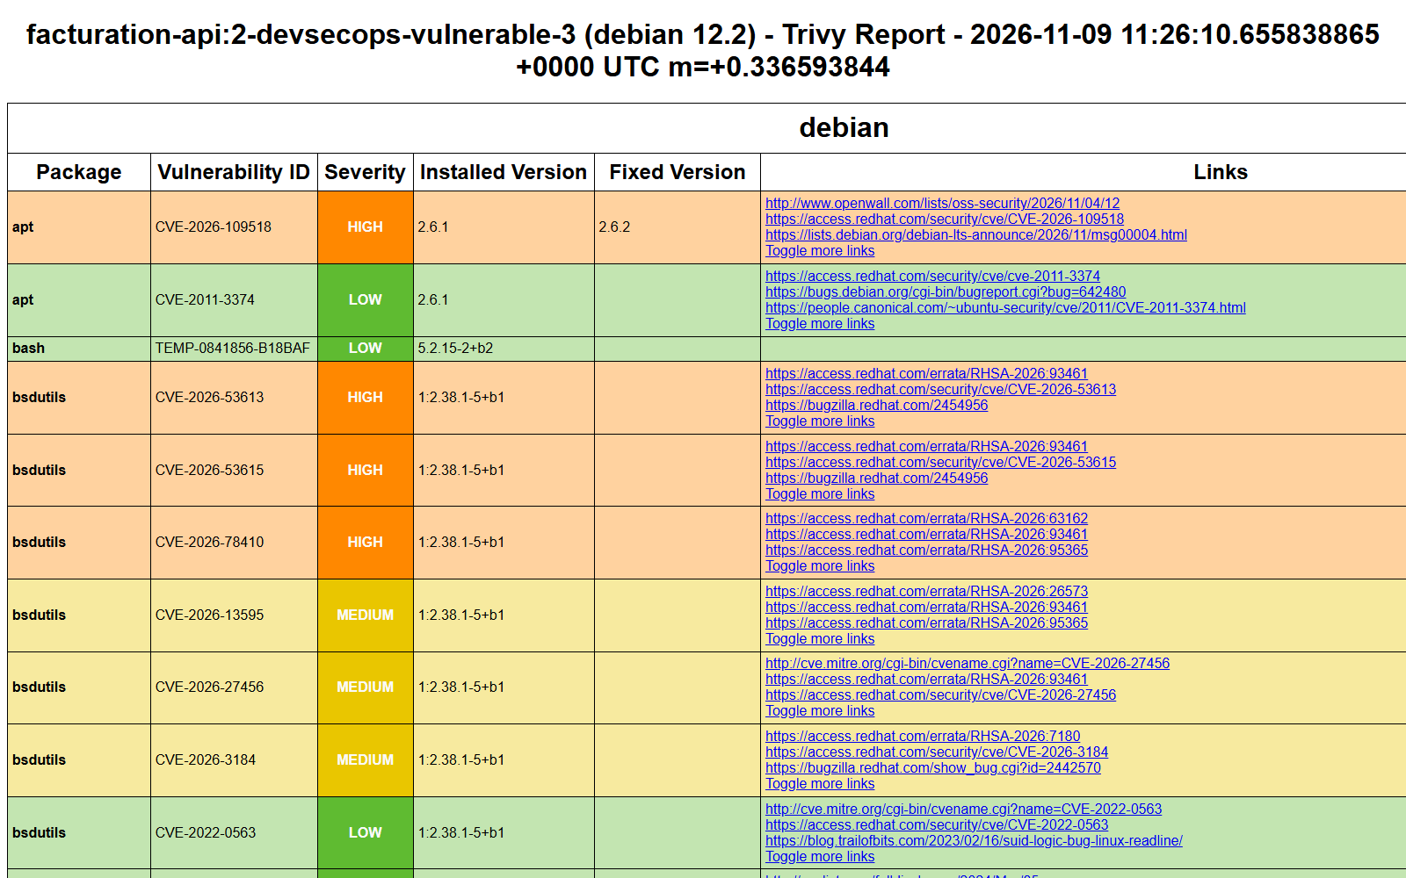
8. SonarQube: both projects (rating E / rating A), then each in detail
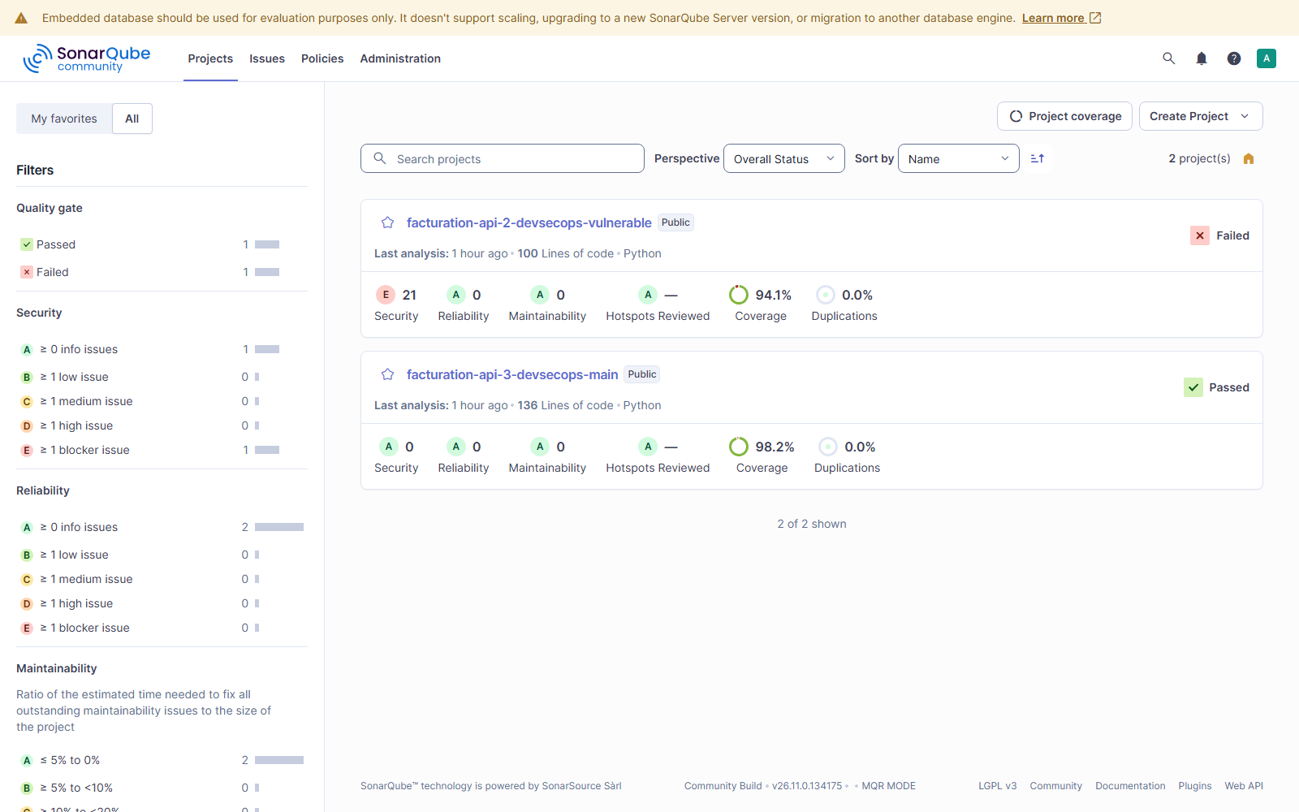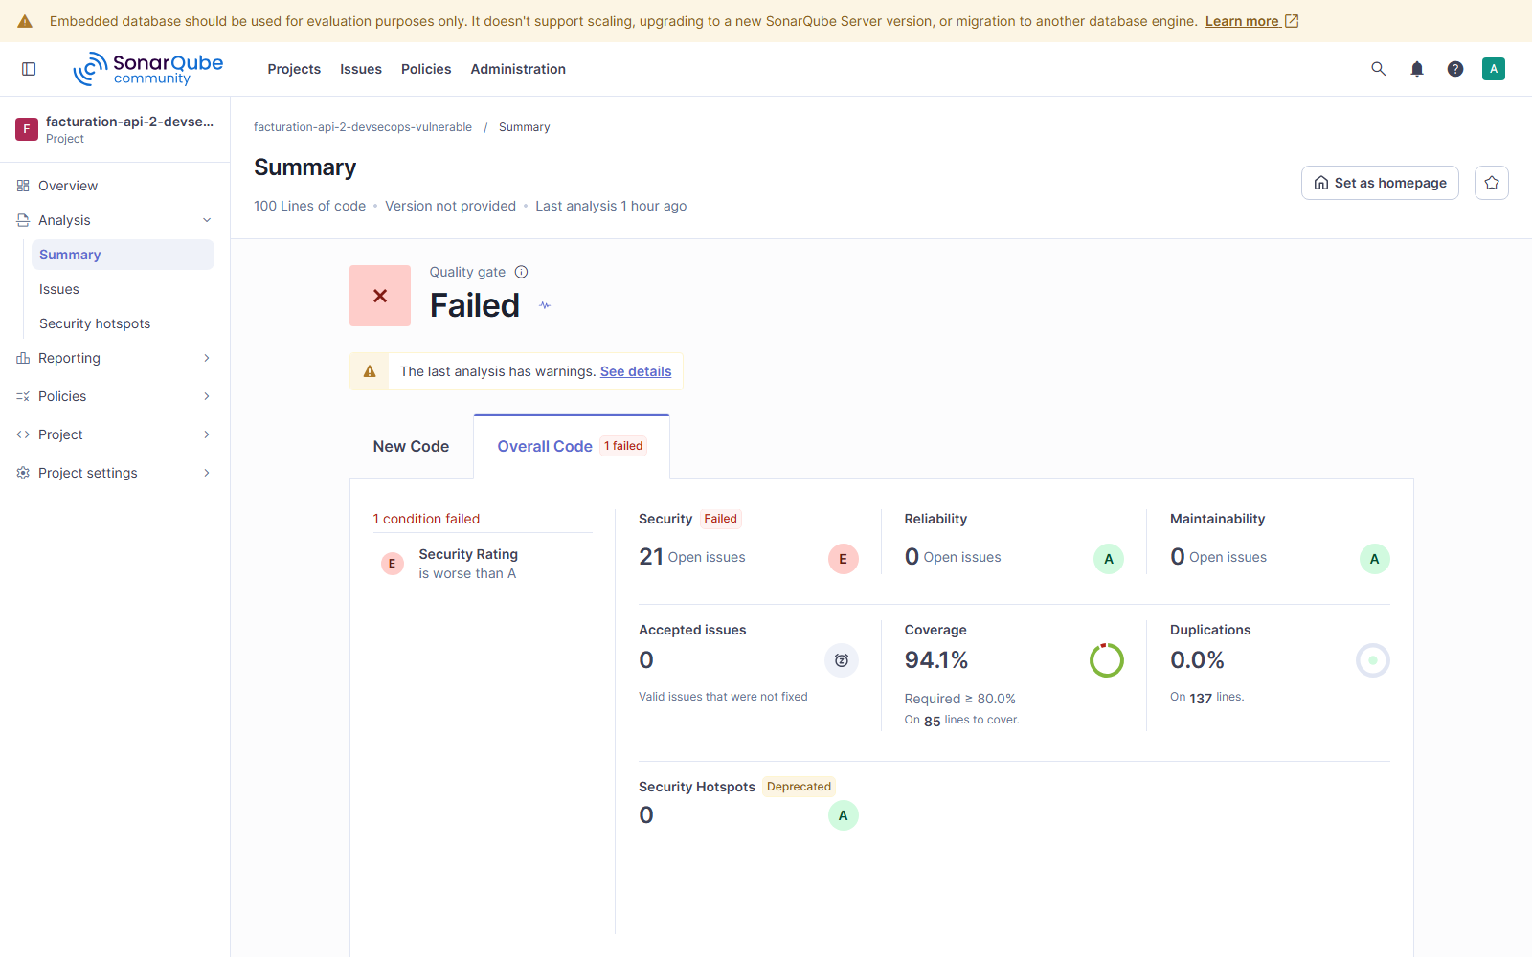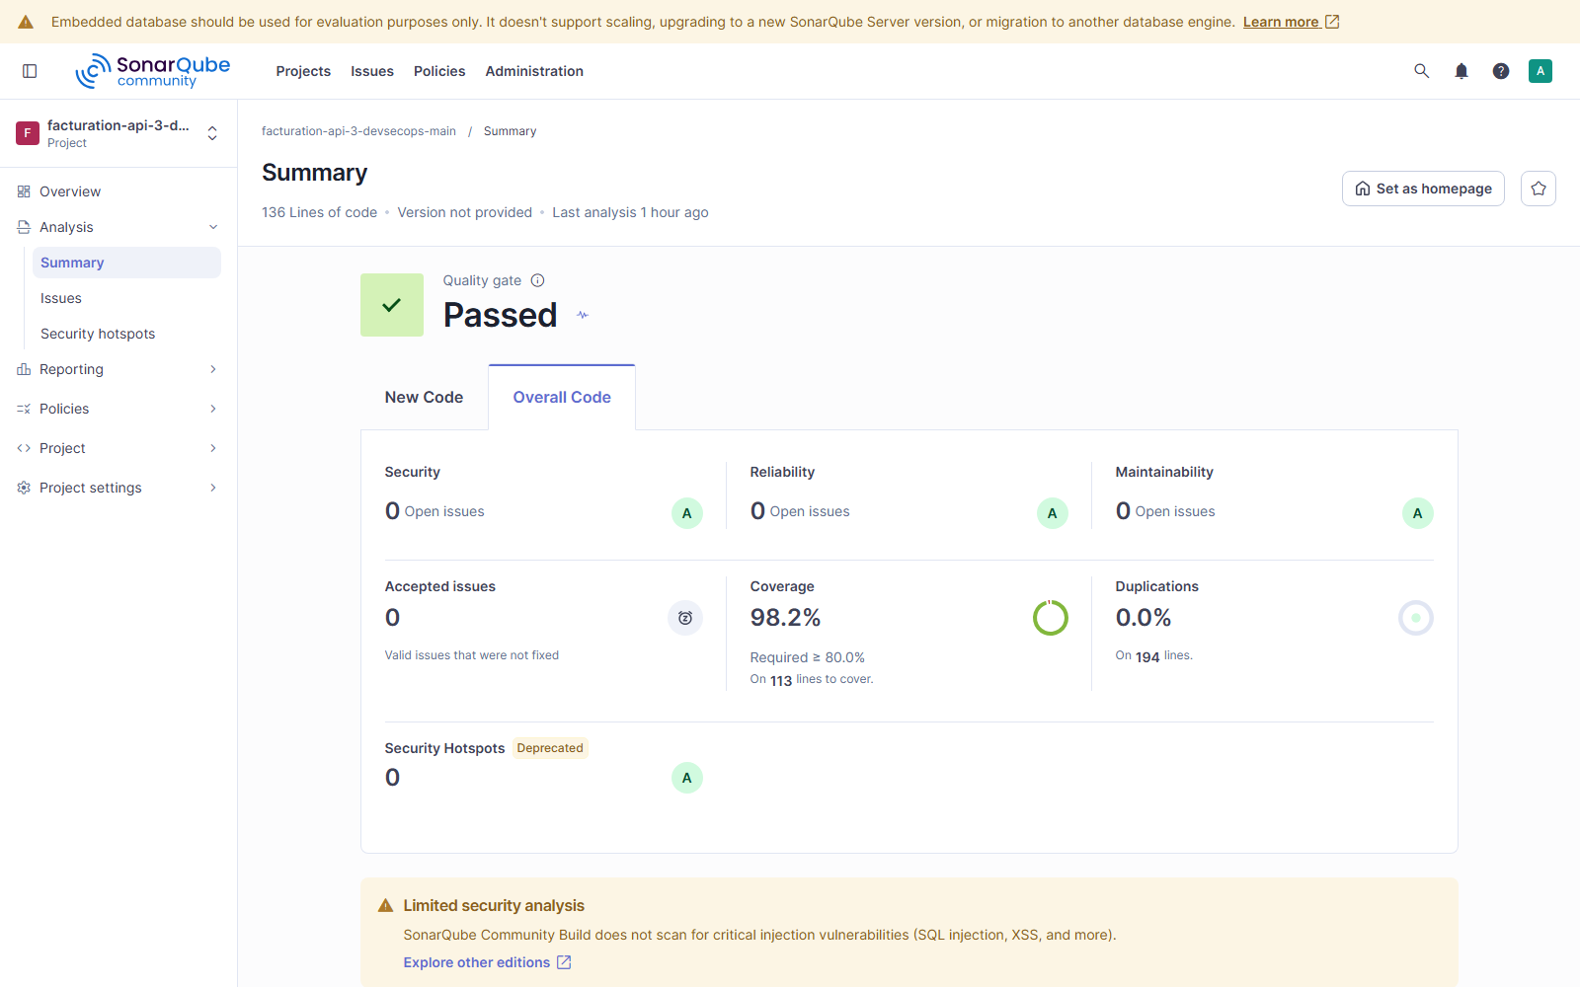
9. Mailpit: [BLOQUE] and [OK] emails
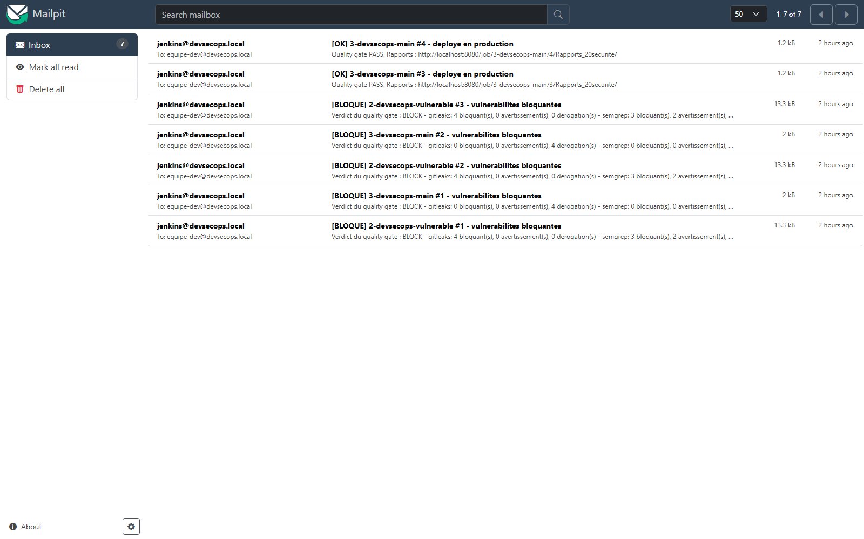
10. Developer workstation: commit refused by the pre-commit hook (Gitleaks, 2 secrets)
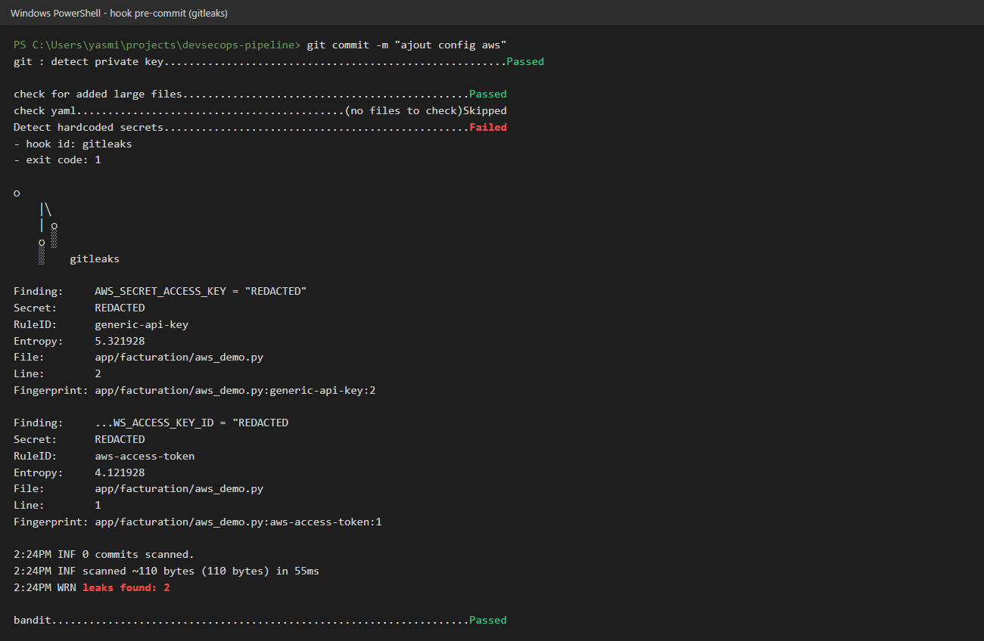
11. Developer workstation: local Semgrep run on the vulnerable branch (SQL injection found by the custom rule)
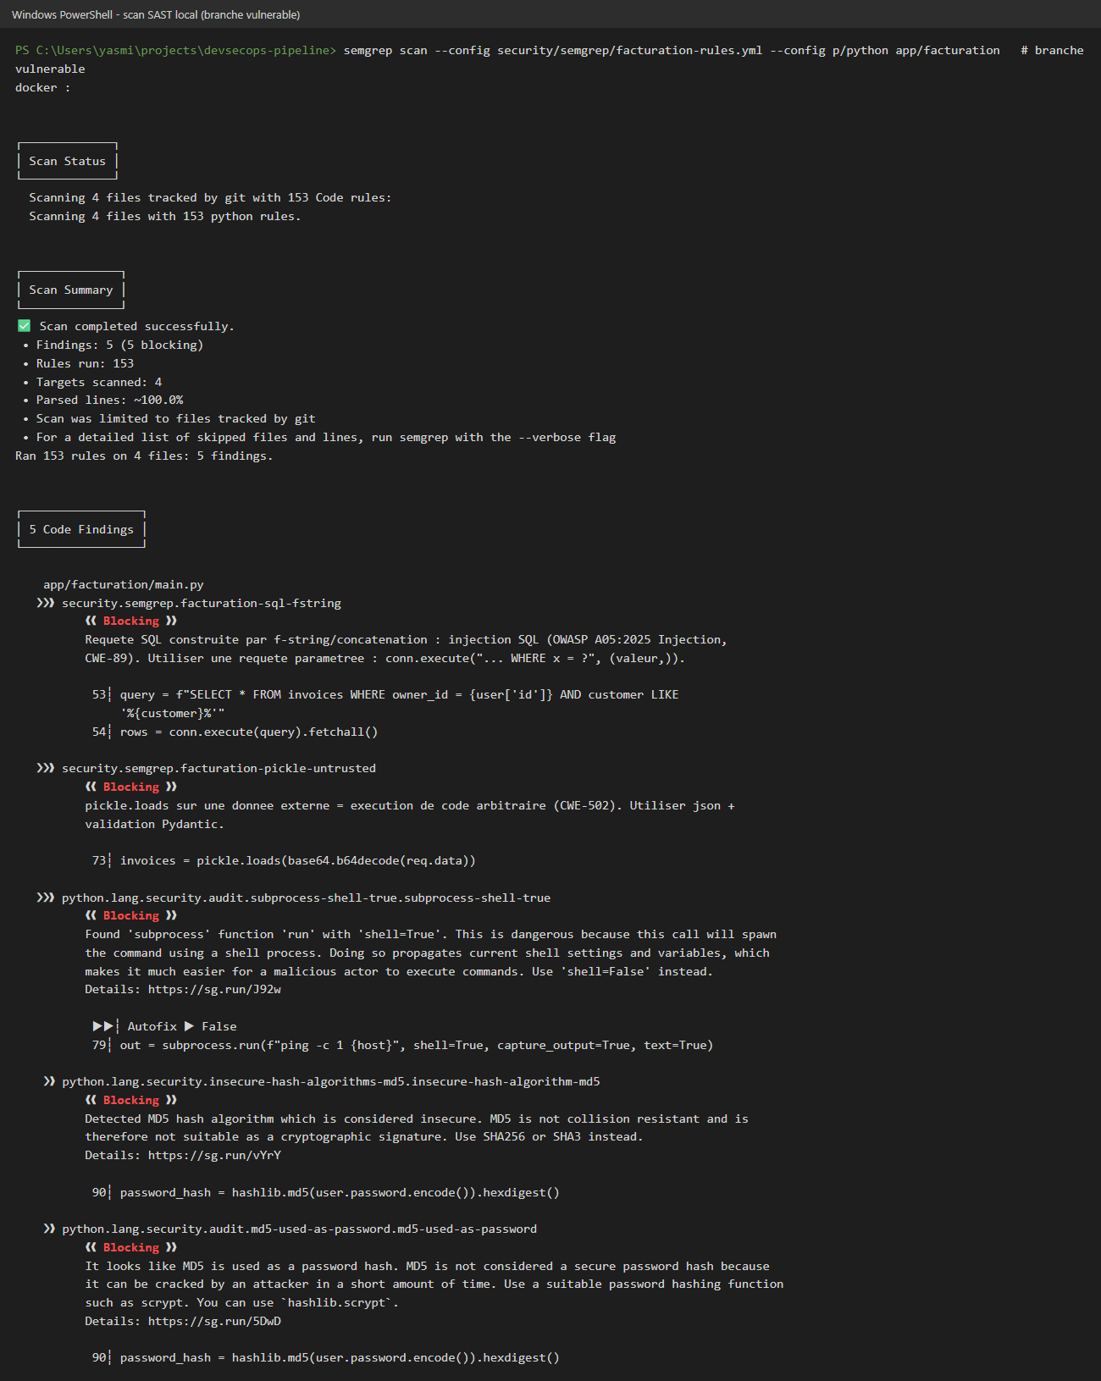
Screenshots 10 and 11 are the real command output, rendered as an image.

