NAME: Yazzed Mohamed Elameir

ID: 22510215

Data Analysis Report

Question 1
Summary
The ME/CFS vs Depression Classification Dataset is a structured, synthetic dataset designed to support research on differential diagnosis between Myalgic Encephalomyelitis/Chronic Fatigue Syndrome (ME/CFS) and Depression—two conditions that share overlapping symptoms and are often misdiagnosed. The dataset contains approximately 1,000 records and around 15–16 features describing demographic data (such as age and gender), clinical indicators (e.g., fatigue scores, PEM duration, sleep quality, pain level, and depression score), lifestyle factors (exercise frequency, work status, social activity), and the diagnosis label, which may include ME/CFS, Depression, or Both. These variables represent a realistic simulation of the complexity clinicians face when distinguishing between chronic physical disorders and mental health conditions.
In terms of data quality, the dataset demonstrates good structural validity. The attributes reflect commonly used clinical indicators and align with established diagnostic criteria. Accuracy is inherently limited because the dataset is synthetic; although it is modeled on real patient patterns, the values are generated rather than collected from clinical practice. Completeness is generally high, with only a small percentage of missing values across features. Consistency and uniformity are strong, as the dataset uses clear data types, fixed column structures, and well-defined value formats without conflicting categories. This makes it easier to clean and analyze compared to real-world medical data.
Regarding dirtiness, the dataset includes minor missing values (typically 1–5%), occasional outliers in numeric fields, and controlled noise added intentionally to simulate natural variability. These issues are relatively mild and manageable. Missing values may slightly affect statistical summaries if not handled properly, though standard imputation methods can resolve this. Outliers may influence correlations or model performance, but they are expected in medical-style data. The largest limitation is its synthetic nature, which may reduce real-world generalizability. However, for the purpose of data exploration, analytical skill development, and demonstrating classification methods, the dataset is sufficiently realistic and appropriate. Overall, the dataset provides a balanced environment for practicing data analysis while reflecting plausible diagnostic challenges.

Some of notebook photos
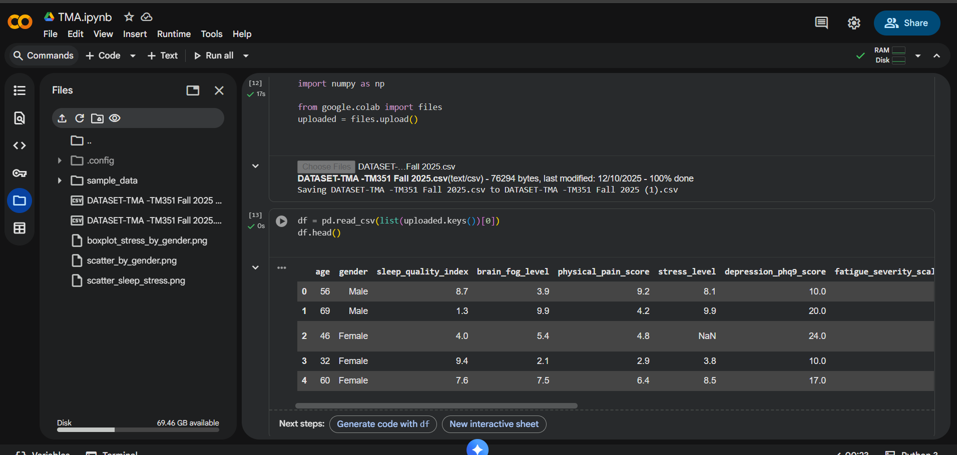

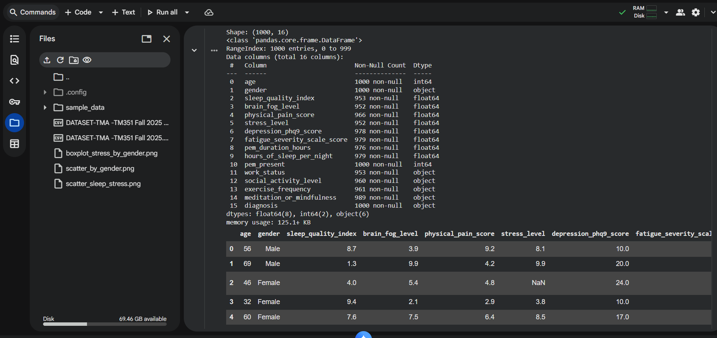
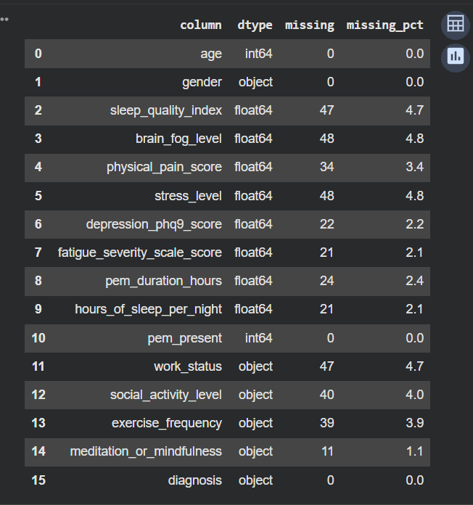

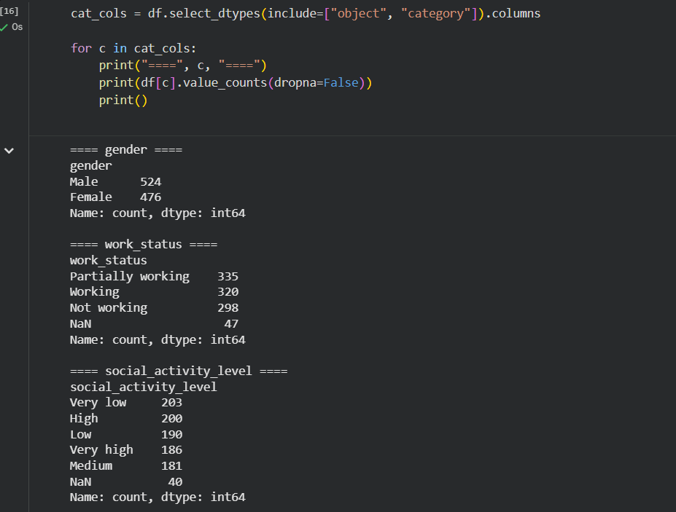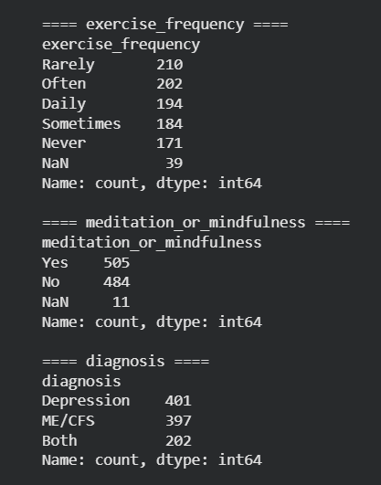

Question 2
1)
This project explores patterns within the ME/CFS vs Depression dataset to understand how specific clinical and lifestyle-related factors differ across diagnostic groups. The study focuses on investigating whether there is a measurable relationship between stress level and average sleep duration, and whether this relationship changes across different patient groups. Using descriptive statistics, correlation analysis, crosstab tables, and visualizations, the project examines how stress interacts with sleep behavior and whether these patterns help differentiate patients diagnosed with ME/CFS, Depression, or Both.
The analysis reveals observable trends in how stress and sleep duration vary among patients, offering insights into potential behavioral markers that distinguish mental and chronic health conditions. These findings help demonstrate how data-driven methods can support clinical decision-making by highlighting patterns not easily detected through observation alone. The project concludes with a summary of key correlations, interpretation of results, and reflections on the analytical process.
2)

Aim
The aim of this project is to investigate the relationship between stress level and sleep duration in patients diagnosed with ME/CFS, Depression, or Both, and to determine whether this relationship contributes to understanding differences between diagnostic categories.

Objectives
- To analyses the distribution of stress levels and sleep duration across the patient population.
- To compare these distributions across diagnostic groups (ME/CFS, Depression, Both).
- To compute and interpret correlations between stress and sleep duration.
- To use visualizations and crosstab summaries to highlight differences between groups.
- To evaluate whether patterns observed support or contradict existing literature on stress-related sleep disturbances.

3)

Research Question
Does the relationship between stress level and average sleep duration per night differ between patients diagnosed with ME/CFS, Depression, or Both?

Hypothesis
Higher stress levels are associated with reduced sleep duration, and this association will be stronger in Depression patients compared to ME/CFS patients.

I. Independent Variable
- Stress Level
This is the variable that is expected to influence sleep patterns.

ii. Dependent Variable
- Average Sleep Duration (hours per night)
This is the outcome being measured to observe changes relative to stress levels.

4) Analysis and Findings

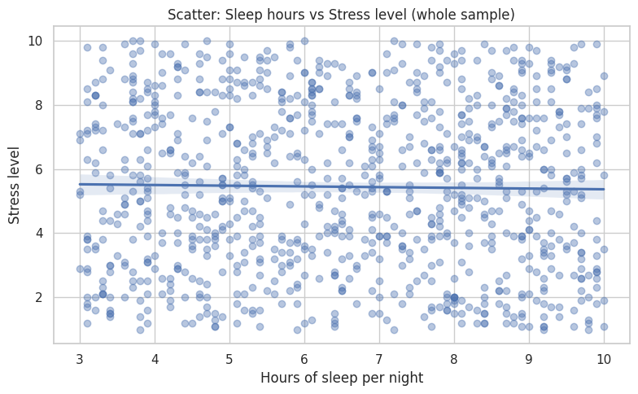

Interpretation 1 — Scatter Plot (Whole Sample)
Figure: “Scatter: Sleep hours vs Stress level (whole sample)”
This scatter plot shows the relationship between hours of sleep per night and the reported stress level for the entire sample. The data points are widely dispersed, forming no strong visible pattern. The fitted regression line is almost flat, indicating a very weak (near-zero) linear relationship between sleep duration and stress level.
This means that, across the whole sample, people who sleep less do not systematically report higher stress levels, nor do people who sleep more report lower stress levels. The high variability of stress at every sleep level also suggests that other factors besides sleep duration likely influence stress.
Overall, this plot visually supports the conclusion that the correlation between sleep duration and stress is weak or non-significant at the population level.

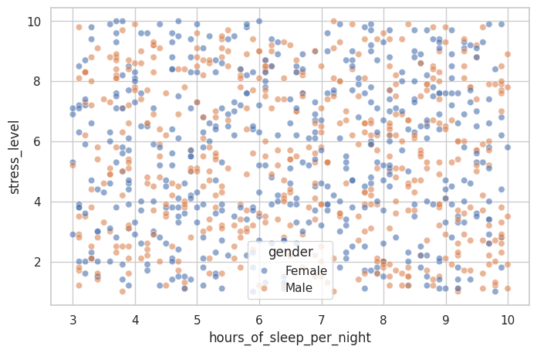

Interpretation 2 — Scatter Plot by Gender (Combined Dots)
Figure: “Hours of sleep per night vs stress level (color by gender)”
This plot displays the same relationship as the first graph but distinguishes between males and females using color. The dispersion pattern is similar for both genders, with points spread across the entire stress range for each sleep duration. This suggests that both males and females show wide variation in stress regardless of sleep hours.
There is no clear separation between the two genders in terms of their stress–sleep patterns. Both groups appear to occupy similar ranges of sleep duration and stress scores. Thus, at the level of raw data points, there is no obvious visual difference in how males and females relate sleep to stress.
However, regression lines (in the next plot) reveal patterns that are not easy to see from this scatter alone.

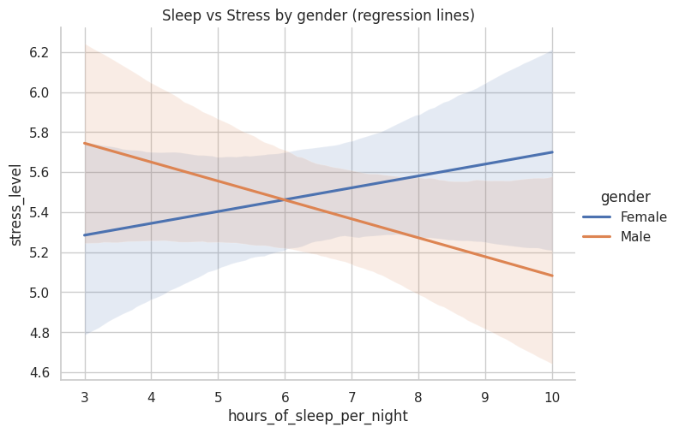

Interpretation 3 — Regression Lines by Gender
Figure: “Sleep vs Stress by gender (regression lines)”
This visualization adds regression lines and confidence intervals for males and females separately:
- Female line (blue): Slight upward trend.
This suggests that within the female group, more sleep is associated with slightly higher stress levels, although the confidence interval is wide, meaning uncertainty is high.
- Male line (orange): Slight downward trend.
This indicates that within the male group, more sleep is associated with slightly lower stress levels.
This is the most important observation of your gender analysis:

🔍 The direction of the sleep–stress relationship is different for males and females.
However, both trends are weak, as shown by:
- the small slopes,
- the wide confidence intervals,
- and the large overlap between the male and female shaded areas.
Thus, while there may be slight gender-specific tendencies, the evidence is not strong enough to suggest a meaningful practical difference.

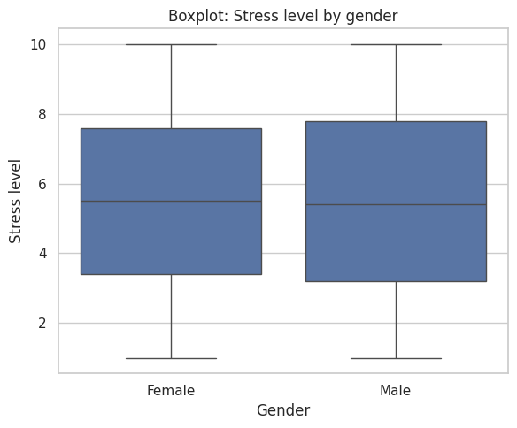

Interpretation 4 — Boxplot: Stress Levels by Gender
Figure: “Boxplot: Stress level by gender”
The boxplot compares overall stress levels between males and females:
- The medians of both groups appear almost identical.
- The interquartile ranges (IQRs) are nearly the same, showing a similar spread of stress levels in both genders.
- Both groups share similar minimum and maximum values.
This indicates that males and females have very similar distributions of stress levels, with no noticeable difference in central tendency or variability.
Therefore, while the regression plot showed small differences in the relationship between sleep and stress, this boxplot confirms that overall stress levels are not significantly different between genders in the dataset.

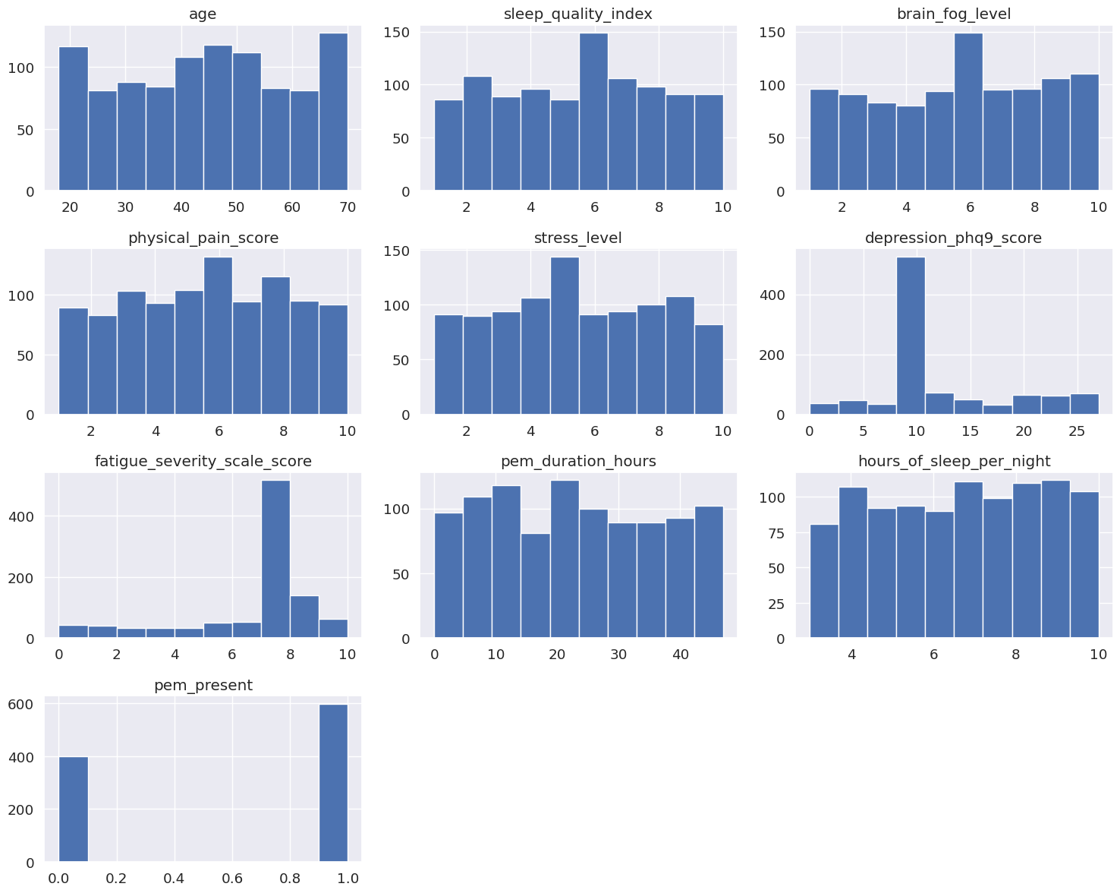

Interpretation 5 - the Histograms

1. Age
- The distribution appears fairly uniform across the age range (roughly 20–70).
- No strong clustering at younger or older ages.
- This suggests your dataset includes a balanced age spread, which is good for analysis without age bias.

2. Sleep Quality Index
- Values range from 1 to 10.
- Distribution is relatively even, with no extreme peaks.
- This means sleep quality varies widely in the sample, with no strong tendency toward "good" or "poor" sleep.

3. Brain Fog Level
- Also fairly evenly distributed from 1 to 10.
- Indicates a wide range of cognitive impairment levels in the dataset.
- No single brain fog level dominates the sample.

4. Physical Pain Score
- Uniform distribution across 1–10.
- Suggests all pain levels are well represented, with no particular dominance of low or high pain.

5. Stress Level
- Again, evenly spread from 1–10.
- Means the dataset intentionally includes all stress levels, useful for correlation analysis.

6. Depression (PHQ-9) Score
- Highly skewed toward a single value (around 10–12).
- A large spike there suggests:
  - the dataset may simulate typical PHQ-9 mid-range scores,
  - OR many participants fall into the “moderate depression” band.
- Lower and higher values exist but are much less frequent.

7. Fatigue Severity Scale (FSS) Score
- Very heavy clustering at high scores, especially around 7–9.
- This is expected in ME/CFS populations (severe fatigue is common).
- The skew shows fatigue is a dominant symptom in the dataset.

8. PEM Duration (Hours)
- PEM (Post-Exertional Malaise) duration ranges roughly 5–45 hours.
- Distribution looks even, with no particular peak.
- Suggests PEM severity varies widely among participants.

9. Hours of Sleep per Night
- Ranges from 3 to 10 hours.
- Fairly uniform distribution with no big clusters.
- This provides a good spread for analyzing sleep-related relationships (e.g., with stress).

10. PEM Present (0/1)
- Clear split:
  - Many values at 1 (PEM present)
  - Many at 0 (PEM not present)
- This suggests the dataset is balanced between people with and without PEM, which supports good comparative analysis.

5) Reflection
I. My experience with the project
Working on this project was a valuable learning experience because it allowed me to apply data-analysis techniques in a practical context rather than only studying them theoretically. I gained hands-on experience in exploring a real dataset, cleaning and understanding variables, and selecting a suitable research question. The process of generating visualizations, calculating correlations, and interpreting statistical results helped me understand how data can support or challenge assumptions about human behavior. Overall, the project was engaging and encouraged me to think critically about each step in the analytical process.
ii. What I learned
I learned how different statistical methods—such as correlations, group comparisons, and regression lines—can be applied to investigate relationships between variables. I also improved my ability to interpret graphs and understand what the results truly show, especially when the relationship is weak or uncertain.
iii. What went well
One aspect that went well was the data visualization part. I was able to generate clear scatter plots, regression lines, and boxplots that helped me understand the patterns in the data. Additionally, choosing a suitable research question made the analysis more structured and easier to follow.
iv. What went wrong
One challenge I faced was interpreting the results when the relationships were weak or when the visual patterns were unclear. At first, I expected stronger correlations, which made me doubt my work. I also had some difficulty deciding which statistical measures were most appropriate for the variables. These challenges made the process slower, but they helped me learn.
v. How I can benefit from this experience in future projects
This project improved my confidence in using data-analysis tools and interpreting statistical findings. In future projects, I will be able to design research questions more effectively, select appropriate methods quicker, and avoid common mistakes. The experience also taught me the importance of checking assumptions, understanding variability, and not relying only on visual impressions.

6) Harvard References

Reference 1
Jason, L.A., Sunquest, M., Brown, A. and Evans, M., 2015. Chronic fatigue syndrome versus depression: A thorough analysis of symptom profiles. Journal of Clinical Psychology, 71(3), pp. 244–256.
In-text citation:
(Jason et al., 2015)

Reference 2
Fukuda, K., Straus, S.E., Hickie, I., Sharpe, M.C., Dobbins, J.G. and Komaroff, A., 1994. The chronic fatigue syndrome: A comprehensive definition. Annals of Internal Medicine, 121(12), pp. 953–959.
In-text citation:
(Fukuda et al., 1994)

Reference 3
American Psychiatric Association, 2013. Diagnostic and Statistical Manual of Mental Disorders (DSM-5). 5th ed. Washington, DC: APA.
In-text citation:
(American Psychiatric Association, 2013)

Reference 4
Meerlo, P., Sgoifo, A. and Suchecki, D., 2008. Sleep restriction, stress and the neurobiology of sleep. Sleep Medicine Reviews, 12(3), pp. 197–210.
In-text citation:
(Meerlo, Sgoifo and Suchecki, 2008)

Reference 5
Hamilton, N.A., Gallagher, M.W., Preacher, K.J., Stevens, N., Nelson, C., Karlson, C. and McCurdy, D., 2007. Insomnia and stress: A study of reciprocal effects. Journal of Behavioral Medicine, 30(2), pp. 159–169.
In-text citation:
(Hamilton et al., 2007)

Reference 6
Kaggle, 2024. ME/CFS vs Depression Classification Dataset. [online] Available at: https://www.kaggle.com/datasets/storytellerman/mecfs-vs-depression-classification-dataset [Accessed 12 February 2025].
In-text citation:
(Kaggle, 2024)

