Sc图（结构图）
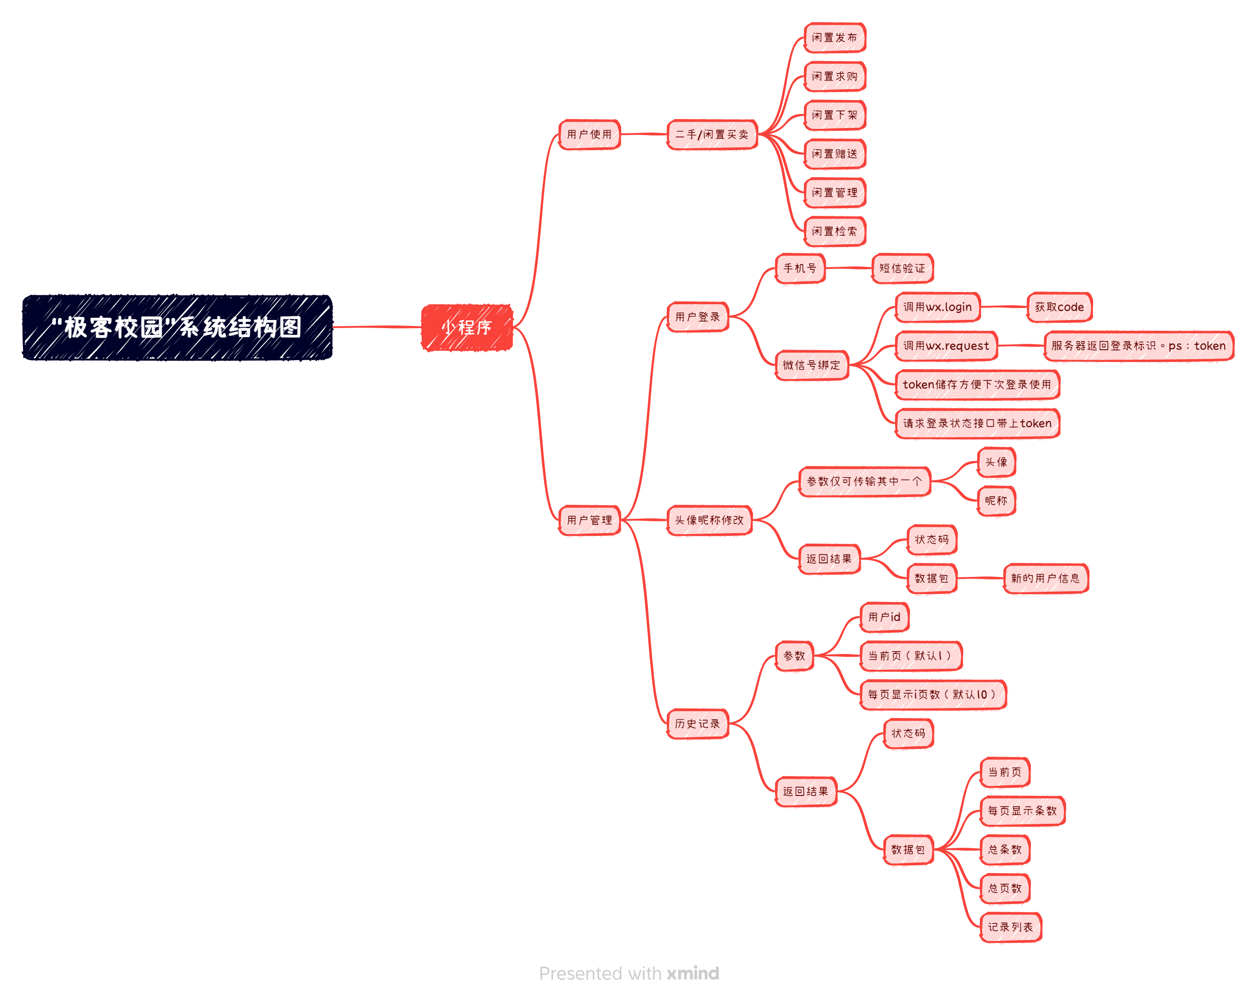
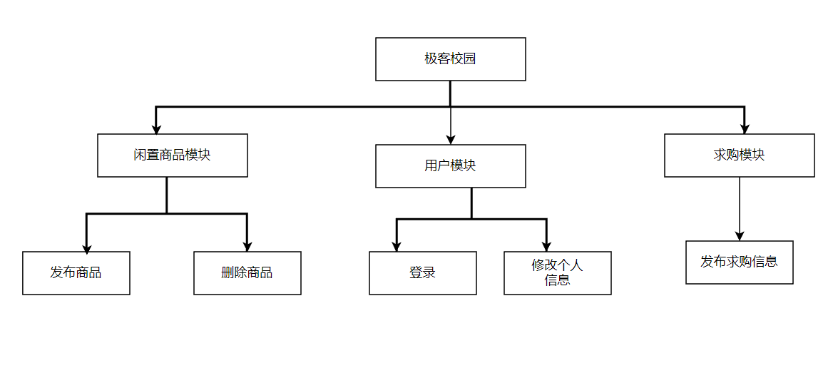
Hipo图（层次图）

类图（无）

模板如下：
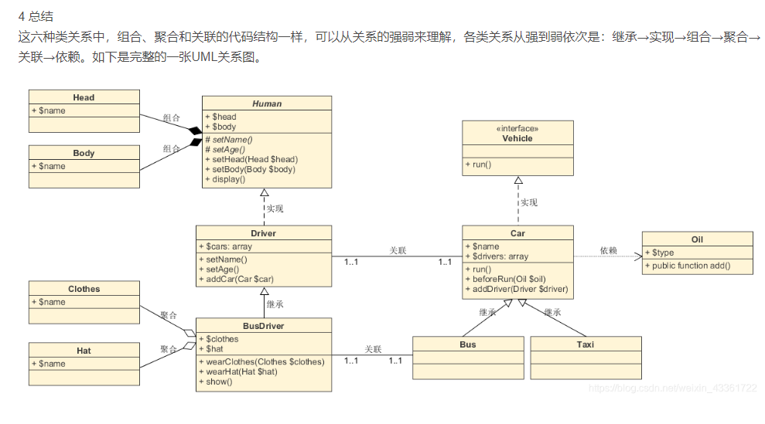
https://blog.csdn.net/weixin_43361722/article/details/112007548?ops_request_misc=&request_id=&biz_id=102&utm_term=%E7%B1%BB%E5%9B%BE&utm_medium=distribute.pc_search_result.none-task-blog-2~all~sobaiduweb~default-9-112007548.nonecase&spm=1018.2226.3001.4187

序列图（时序图）无
模板如下：
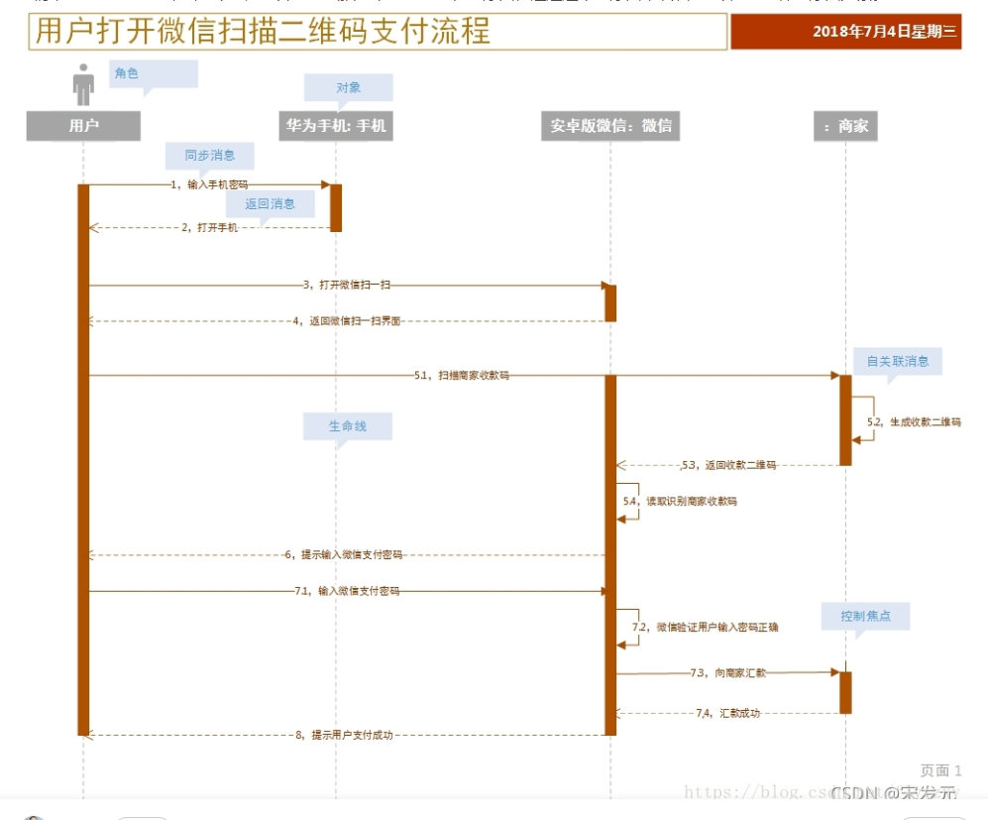
https://blog.csdn.net/u011019141/article/details/121611486?ops_request_misc=%257B%2522request%255Fid%2522%253A%2522166883943816782412539540%2522%252C%2522scm%2522%253A%252220140713.130102334..%2522%257D&request_id=166883943816782412539540&biz_id=0&utm_medium=distribute.pc_search_result.none-task-blog-2~all~top_click~default-2-121611486-null-null.142^v65^pc_rank_34_queryrelevant25,201^v3^control_2,213^v2^t3_esquery_v2&utm_term=%E5%BA%8F%E5%88%97%E5%9B%BE&spm=1018.2226.3001.4187
协作图（无）
模板如下：
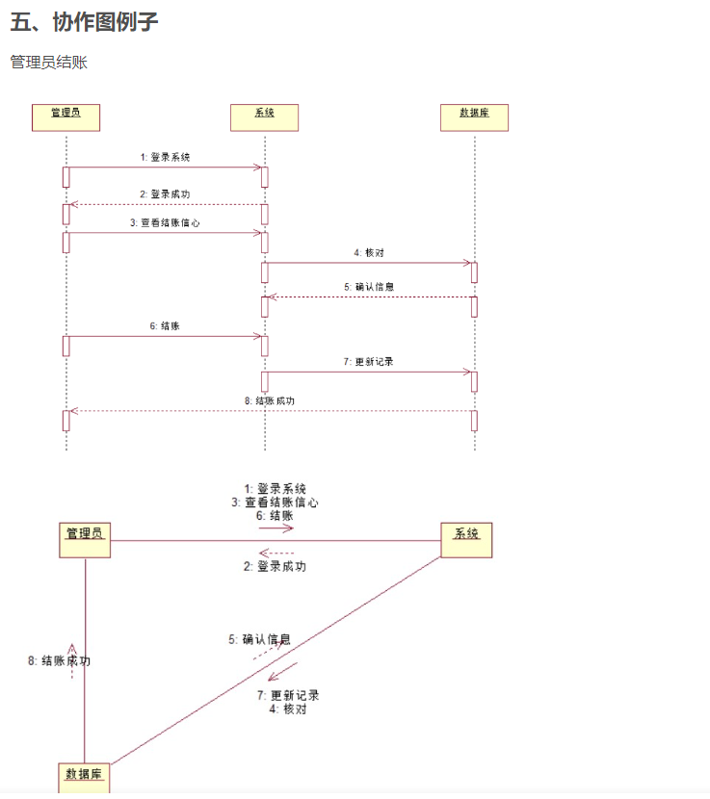

https://blog.csdn.net/neusoft2016/article/details/116195191?ops_request_misc=%257B%2522request%255Fid%2522%253A%2522166883944916782425628236%2522%252C%2522scm%2522%253A%252220140713.130102334..%2522%257D&request_id=166883944916782425628236&biz_id=0&utm_medium=distribute.pc_search_result.none-task-blog-2~all~top_positive~default-1-116195191-null-null.142^v65^pc_rank_34_queryrelevant25,201^v3^control_2,213^v2^t3_esquery_v2&utm_term=%E5%8D%8F%E4%BD%9C%E5%9B%BE&spm=1018.2226.3001.4187

状态图（无）
模板如下
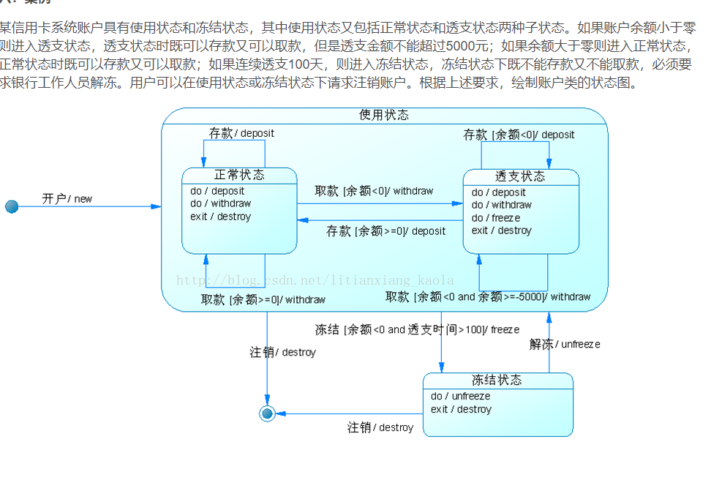
https://blog.csdn.net/litianxiang_kaola/article/details/53945997?ops_request_misc=%257B%2522request%255Fid%2522%253A%2522166883945916782428661250%2522%252C%2522scm%2522%253A%252220140713.130102334..%2522%257D&request_id=166883945916782428661250&biz_id=0&utm_medium=distribute.pc_search_result.none-task-blog-2~all~top_positive~default-1-53945997-null-null.142^v65^pc_rank_34_queryrelevant25,201^v3^control_2,213^v2^t3_esquery_v2&utm_term=%E7%8A%B6%E6%80%81%E5%9B%BE&spm=1018.2226.3001.4187
活动图（无）
模板如下：

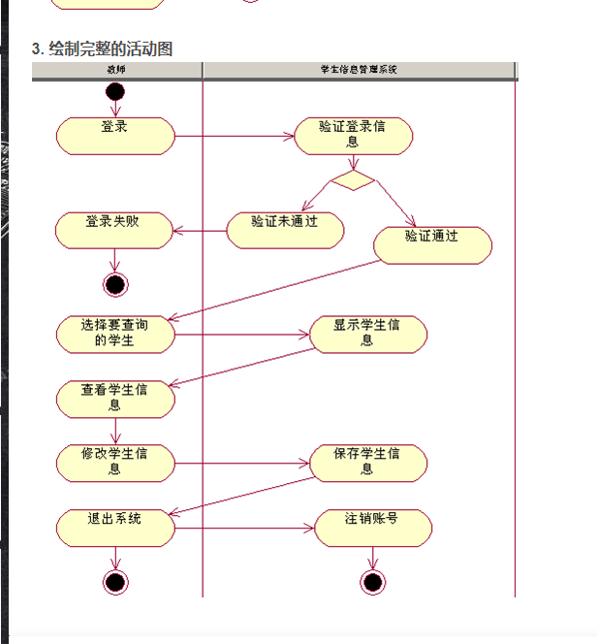
https://blog.csdn.net/mj_ww/article/details/53164679?ops_request_misc=&request_id=&biz_id=102&utm_term=%E6%B4%BB%E5%8A%A8%E5%9B%BE&utm_medium=distribute.pc_search_result.none-task-blog-2~all~sobaiduweb~default-0-53164679.nonecase&spm=1018.2226.3001.4187

