logo 学号 12202400203 序号 42

信息科学与工程学院

**面向对象程序设计课程设计**

|  |  |
| --- | --- |
| 题 目 | 高校人员信息管理系统 |
| 院 系 | 信息科学与工程学院 |
| 专 业 | 计算机科学与技术 |
| 学生姓名 | 袁 博 |
| 学 号 | 12202400203 |
| 指导老师 | 廖 军 |

**二零二二年十一月二十一日**

目录

**1.前言** **3**

一、选题目的及意义 3

二、研究内容及要求 3

**2.系统分析** **4**

一、 需求分析 4

二、 软硬件环境 4

**3.系统概要设计** **5**

一、 系统总体架构设计 5

二、 系统功能模块设计 5

**4.系统详细设计** **6**

一、数据储存的设计与描述 6

二、类的定义 7

**5.系统实现** **8**

一、主要功能界面 8

**6.系统测试** **18**

(1)添加功能 18

(2) 查询功能 18

(3) 编辑功能 19

(4) 删除功能 19

(5) 统计功能 20

(6) 保存功能 20

(7) 读取功能 21

**7.收获及体会** **22**

一、收获 22

二、难点 22

三、 体会 22

**8. 源代码** **23**

**附录：** **23**

1.前言

**一、选题目的及意义**

高校人员信息系统能够使得人员管理管控更加方便，现在很多众多企业都使用飞书、钉钉等自带组织架构进行人员管理的系统对人员进行管理，本高校系统旨在为教职员工学生及校内工作学习人员提供人员管理便利。

一是熟练掌握java程序设计基本语言；二是熟悉各类技术在后期工作编程中的作用并熟练掌握；三是通过具体程序设计将数据库、计算机网络、java设计等串联起来进一步增强综合能力。

**二、研究内容及要求**

（1）通过MySQL数据库创建管理员表、用户信息表、成绩表、科目表等；

（2）普通用户实现登录、退出以及用户相关的功能；

（3）管理员通过MySQL语句实现数据录入、修改、更新和插入以及用户账号管理；

（4）系统通过计软件对录入的数据进行分析统计；

（5）通过访问后台数据库，实现用户对信息的查询；

（6）整个系统是在java应用环境中实现的。

2.系统分析

1. **需求分析**

使用人员类型：教师、实验员、行政人员，教师兼行政人员

具体需要功能：

(1)添加功能：程序能够任意添加上述四类人员的记录，可提供选择界面供用户选择所要添加的人员类别，要求员工的编号要唯一，如果添加了重复编号的记录时，则提示数据添加重复并取消添加。

(2)查询功能：可根据编号、姓名等信息对已添加的记录进行查询，如果未找到，给出相应的提示信息，如果找到，则显示相应的记录信息。

(3)显示功能：可显示当前系统中所有记录，每条记录占据一行。

(4)编辑功能：可根据查询结果对相应的记录进行修改，修改时注意编号的唯一性。

(5)删除功能：主要实现对已添加的人员记录进行删除。如果当前系统中没有相应的人员记录，则提示“记录为空！”并返回操作；否则，输入要删除的人员的编号或姓名，根据所输入的信息删除该人员记录，如果没有找到该人员信息，则提示相应的记录不存。

(6)统计功能：能根据多种参数进行人员的统计。能统计四类人员数量以及总数，统计男、女员工的数量。

(7)保存功能：可将当前系统中各类人员记录存入文件中，存入方式任意。

(8)读取功能：可将保存在文件中的人员信息读入到当前系统中，供用户进行使用。

1. **软硬件环境**

软件环境：

1. 编译器：eclipseide2022.09
2. Jdk版本：1.8
3. 数据库：mysql8.0（数据库管理Navicat16）
4. 界面设计：Windowbuilder editor

3.系统概要设计

1. **系统总体架构设计**

系统包含：教师、实验员、行政人员，教师兼行政人员四类人员，可以进行人员添加、查询、显示、编辑、删除、统计、保存、读取等功能，人员添加需要包含id、姓名、性别、年龄、系别、专业、职称、实验室、职位、政治等方面其中id、姓名、性别、年龄为必填项目。

1. **系统功能模块设计**

(1)添加功能：程序能够任意添加上述四类人员的记录，可提供选择界面供用户选择所要添加的人员类别，要求员工的编号要唯一，如果添加了重复编号的记录时，则提示数据添加重复并取消添加。

通过界面交互，连接数据库存储四类用户信息。

(2)查询功能：可根据编号、姓名等信息对已添加的记录进行查询，如果未找到，给出相应的提示信息，如果找到，则显示相应的记录信息。

通过界面交互根据id、name查询数据库四类用户数据表内是否存在数据。

(3)显示功能：可显示当前系统中所有记录，每条记录占据一行。

显示系统内存储四类人员信息，并通过交互界面显示。

(4)编辑功能：可根据查询结果对相应的记录进行修改，修改时注意编号的唯一性。

通过界面交互，输入相应项目修改相应用户表内的用户数据。

(5)删除功能：主要实现对已添加的人员记录进行删除。如果当前系统中没有相应的人员记录，则提示“记录为空！”并返回操作；否则，输入要删除的人员的编号或姓名，根据所输入的信息删除该人员记录，如果没有找到该人员信息，则提示相应的记录不存。

根据ID或name选择进行删除，并提示是否确认删除

(6)统计功能：能根据多种参数进行人员的统计。能统计四类人员数量以及总数，统计男、女员工的数量。

通过计数sum计算所需人员数据。

(7)保存功能：可将当前系统中各类人员记录存入文件中，存入方式任意。

连接数据库，读取存储为txt

(8)读取功能：可将保存在文件中的人员信息读入到当前系统中，供用户进行使用。

读取txt，连接数据库上传数据。

4.系统详细设计

**一、数据储存的设计与描述**

|  |  |
| --- | --- |
| **字段名** | **存储内容** |
| **Id** | **序号** |
| **Name** | **姓名** |
| **Sex** | **性别** |
| **Age** | **年龄** |
| **Xibu** | **系部** |
| **Zhuanye** | **专业** |
| **Zhicheng** | **职称** |
| **Shiyanshi** | **实验室** |
| **Zhiwu** | **职务** | |
| **Zhengzhi** | **政治面貌** | |

首先设计数据库注册存储字段名及存储内容总共10个字段名如上，其次设计存储表格总共四个：teacher_xingzheng（用于存储教师兼行政人员信息）、teacher（用于存储老师信息）、shiyanyuan（用于存储实验员信息）、xingzheng（用于存储行政人员信息）。

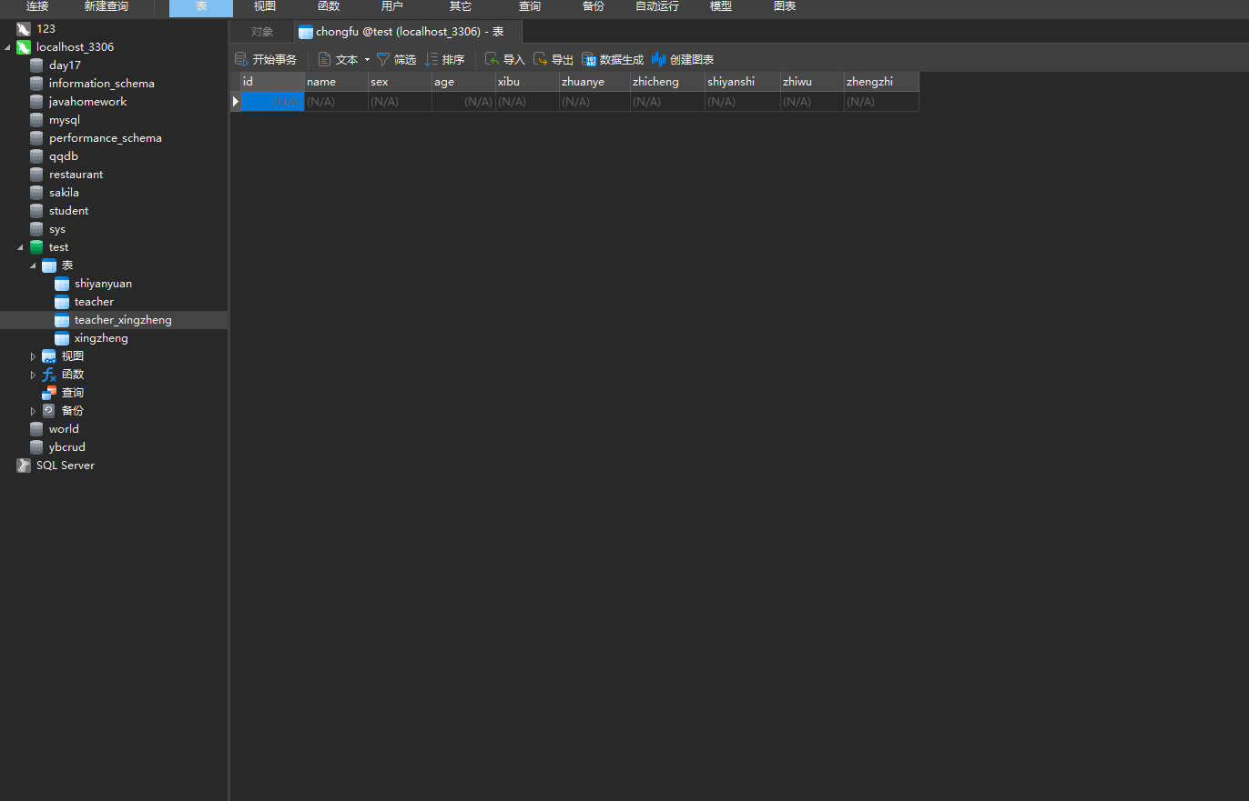

**二、类的定义**

设计java程序设计程序及功能

|  |  |
| --- | --- |
| **类名** | **功能** |
| **Login.java** | **登录界面** |
| **Zhuce.java** | **注册界面** |
| **Accept1.Java** | **操作成功界面** |
| **Baocun.java** | **保存成功界面** |
| **Chaxun.java** | **查询界面** |
| **Chongfu.java** | **数据库内存在相同编号或姓名报错** |
| **Duqu_true.java** | **读取成功界面** |
| **mysql.java** | **读取数据库** | |
| **notexist.java** | **查询用户不存在报错界面** | |
| **notshanchu.java** | **用户不存在报错界面** | |
| **shanchu.java** | **删除id界面** | |
| **Shanchu2.java** | **删除姓名界面** | |
| **Shanchu3.java** | **选择删除id或姓名界面** | |
| **Text.java** | **启动login登录界面** | |
| **Tongji.java** | **统计界面** | |
| **Trueshanchu.java** | **Id已经删除界面** | |
| **Trueshanchu2.java** | **姓名已经删除界面** | |
| **Truexiugai.java** | **修改成功界面** | |
| **Wrong.java** | **操作错画面** | |
| **Wrong2.java** | **操作成功画面** | |
| **Xiugai.java** | **查询后修改界面** | |
| **Xiugai1.java** | **修改内容选择界面** | |
| **Zhuce.java** | **注册界面** | |

5.系统实现

**一、主要功能界面**

通过Windowbuilder editor设计登录主界面：

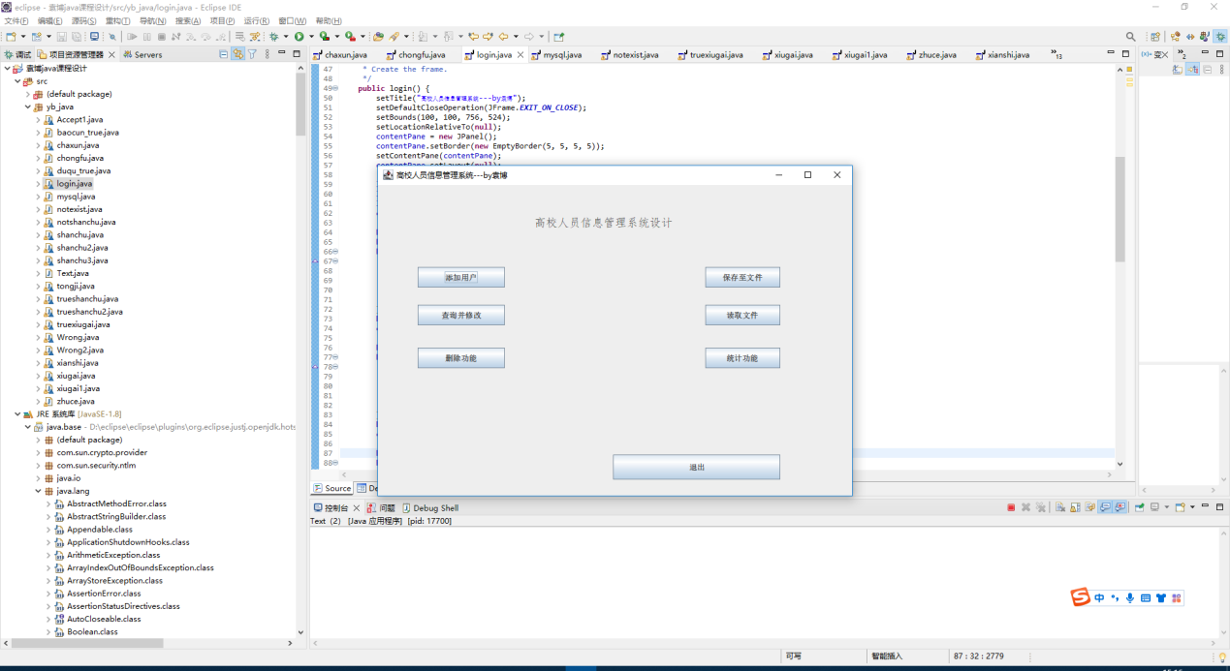设计添加用户跳转注册的界面

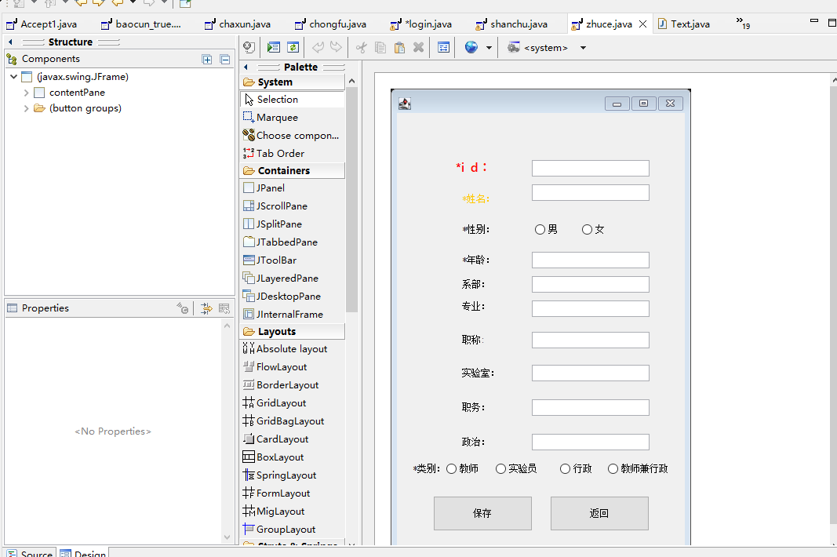设计打开查询的界面

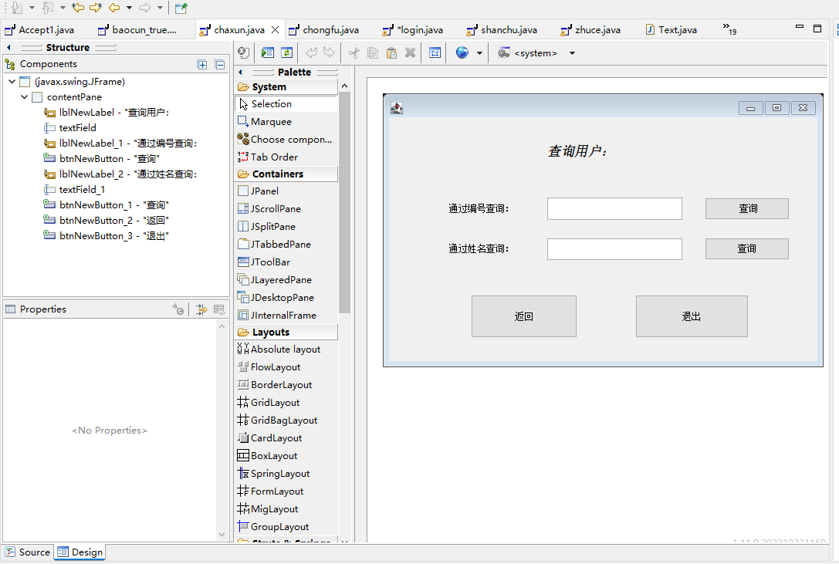设计删除界面

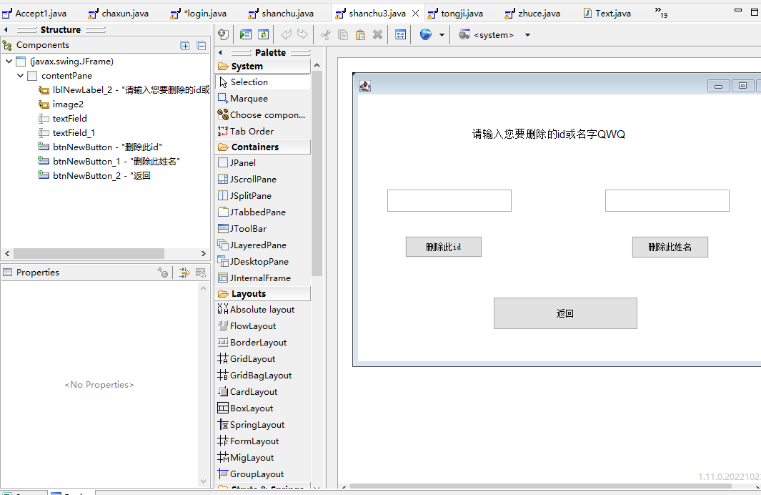

设计统计界面

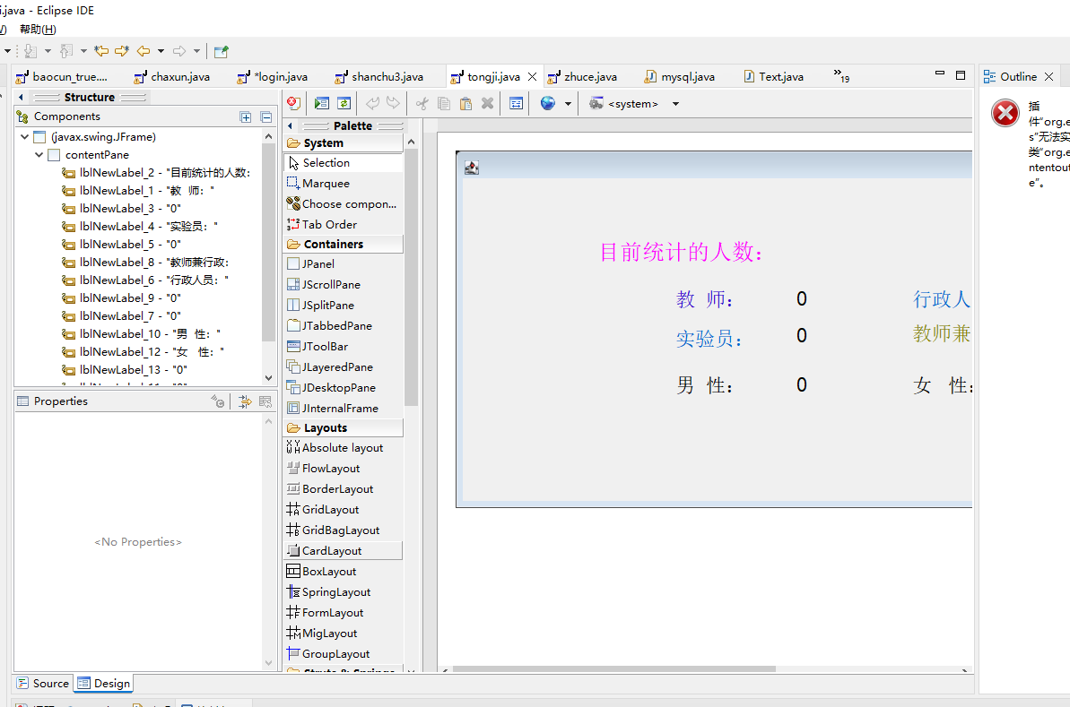

删除界面设计：

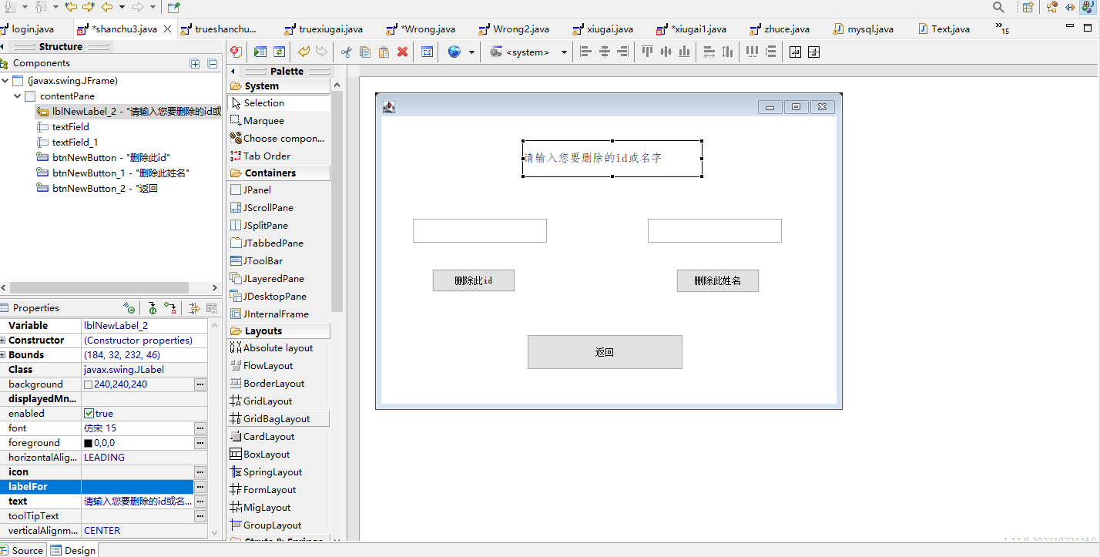

统计界面设计：

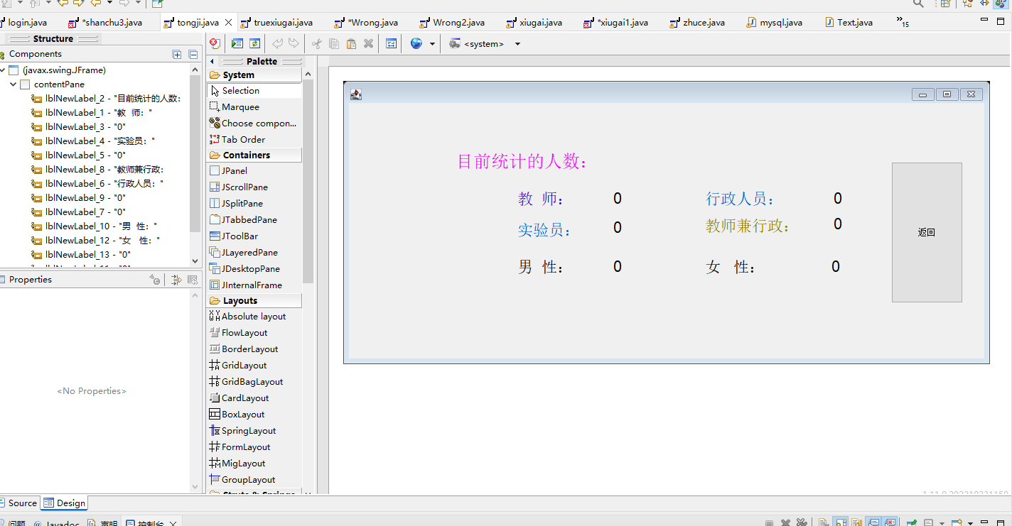**二、查询代码设计**

1. 添加用户设计

四类用户分表存放：在chongfu、teacher、shiyanyuan、xingzheng四张表内分别存放id ,name ,sex,age ,xibu,zhuanye,zhicheng,shiyanshi,zhiwu,zhengzhi等字段。

1. 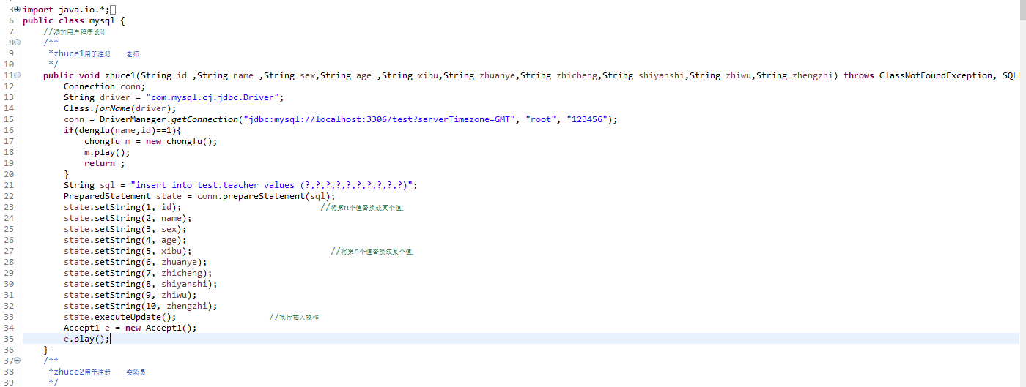查询用户设计

四类用户分表存放因此我们要查询需要根据id或姓名进行查询查找

→查询老师存储数据表为例：sql1-sql4查询四个表姓名sql5-sql8查询四个表id

例子：

String sql1 = "select * from test.teacher where name=?";

PreparedStatement state1 = conn.prepareStatement(sql1); //容器

state1.setString(1, name); //将第n个值替换成某个值

ResultSet re1 = state1.executeQuery(); //上传数据库返回结果集

**if** (re1.next()) {

flag=1;//如果取到了值，fanhui-1;

}

1. 删除用户设计

四类用户分表存放因此我们要删除需要根据id或姓名进行查询查找

→根据id或name删除数据→删除老师存储数据表为例：del1根据姓名删除、del2根据id删除

例子：

根据姓名删除：

String sql = "delete from test.teacher where name = ?";

PreparedStatement state = conn.prepareStatement(sql);

state.setString(1, name);

state.executeUpdate();

根据id删除：

String sq5 = "delete from test.teacher where id = ?";

PreparedStatement state5 = conn.prepareStatement(sq5);

state5.setString(1, id);

state5.executeUpdate();

1. 统计用户设计

根据四类表分别统计：教师、行政人员、实验员、老师兼行政人员及男女性别统计。Count1-4为统计四类人员并返回，count5-6为查四表男女人数。

教师为例统统计代码如下例子：

**public** **int** count1() **throws** ClassNotFoundException, SQLException {

**int** sum=0;

Connection conn;

String driver = "com.mysql.cj.jdbc.Driver";

Class.*forName*(driver);

conn = DriverManager.*getConnection*("jdbc:mysql://localhost:3306/test?serverTimezone=GMT", "root", "123456");

String sql = "select * from test.teacher";

PreparedStatement state = conn.prepareStatement(sql);

ResultSet re1 = state.executeQuery();

**while**(re1.next()){

sum++;

}

**return** sum;

}

男生为例统统计代码如下例子：

public int count5() throws ClassNotFoundException, SQLException {

int sum=0;

Connection conn;

String driver = "com.mysql.cj.jdbc.Driver";

Class.forName(driver);

conn = DriverManager.getConnection("jdbc:mysql://localhost:3306/test?serverTimezone=GMT", "root", "68115tfq");

String sql = "select * from test.teacher_xingzheng";

PreparedStatement state = conn.prepareStatement(sql);

ResultSet re1 = state.executeQuery();

while(re1.next()){

if(re1.getString(3).equals("男"))

sum++;

}

String sql2 = "select * from test.teacher";

PreparedStatement state2 = conn.prepareStatement(sql2);

ResultSet re2 = state2.executeQuery();

while(re2.next()){

if(re2.getString(3).equals("男")){

sum++;

}

}

String sql3 = "select * from test.shiyanyuan";

PreparedStatement state3 = conn.prepareStatement(sql3);

ResultSet re3 = state3.executeQuery();

while(re3.next()){

if(re3.getString(3).equals("男")){

sum++;

}

}

String sql4 = "select * from test.xingzheng";

PreparedStatement state4 = conn.prepareStatement(sql4);

ResultSet re4 = state4.executeQuery();

while(re4.next()){

if(re4.getString(3).equals("男")){

sum++;

}

}

return sum;

}

1. 查询用户设计

分四个表进行查询，以老师表为例依据id或name查询：sql1-4分别对应四个数据表查询。

例子：（通过id）

String sql1 = "select * from test.teacher where id=? ";（更改id为name后可通过name查询）

PreparedStatement state1 = conn.prepareStatement(sql1); //容器

state1.setString(1, id); //将第n个值替换成某个值ֵ

ResultSet re1 = state1.executeQuery(); //上传数据库返回结果集

**if** (re1.next()) {

xiugai m = **new** xiugai(re1.getString(1),re1.getString(2),re1.getString(3),re1.getString(4),re1.getString(5),re1.getString(6),re1.getString(7),re1.getString(8),re1.getString(9),re1.getString(10));

m.play(re1.getString(1),re1.getString(2),re1.getString(3),re1.getString(4),re1.getString(5),re1.getString(6),re1.getString(7),re1.getString(8),re1.getString(9),re1.getString(10));

**return** ;

}

1. 保存及读取用户设计

保存为txt文件：

1. 打开txt文件

FileWriter f=new FileWriter("C:\\Users\\墨云\\Desktop\\1.txt");

f.write("");

f.flush();

f.close();

1. 连接数据库（前面已有：略）
2. 写入过程：

String sql1 = "select * from test.teacher";

PreparedStatement state1 = conn.prepareStatement(sql1); //容器

ResultSet re1 = state1.executeQuery(); //上传数据库返回结果集

String[] p=new String[count1()];

int count=0;

while(re1.next()){

StringBuilder sb=new StringBuilder();

for(int i=1;i<11;i++){

sb.append(re1.getString(i)).append(" ");

}

p[count]=sb.toString();

count+=1;

}

try (BufferedWriter b = new BufferedWriter(new FileWriter("C:\\Users\\墨云\\Desktop\\1.txt",true))) {

for(int i=0;i<p.length;i++){

b.write(p[i]);

b.newLine();

}

} catch (IOException i) {

System.out.println("写入失败");

}

读取txt文件上传至数据库：

try(BufferedReader b=new BufferedReader(new FileReader("C:\\Users\\墨云\\Desktop\\1.txt"))){

String str="";

while ((str = b.readLine()) != null){

String[] p=str.split(" ");

if(denglu(p[1],p[0])==0){

zhuce1(p[0],p[1],p[2],p[3],p[4],p[5],p[6],p[7],p[8],p[9]);

}

}

} catch (IOException e) {

System.out.println("读取失败");

}

1. 修改用户设计

修改的前提是已经查询到

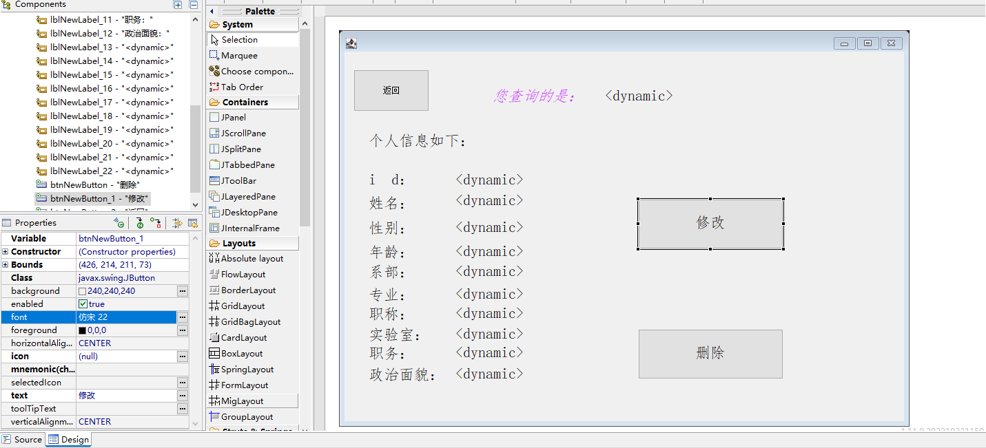选择单项进行修改：

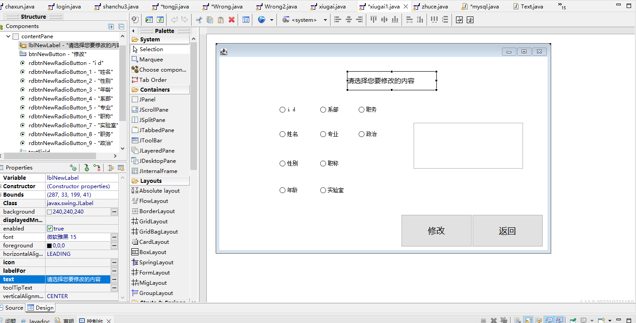以id修改为例：

public void xiugai (String name , String leixing ,String s)throws ClassNotFoundException, SQLException{

try{

Connection conn;

String driver = "com.mysql.cj.jdbc.Driver";

Class.forName(driver);

conn = DriverManager.getConnection("jdbc:mysql://localhost:3306/test?serverTimezone=GMT", "root", "123456");

String sql="";

if(leixing=="id"){

sql = "update test.teacher set id = ? where name= ? ";

}

PreparedStatement state = conn.prepareStatement(sql);

state.setString(1,s);

state.setString(2,name);

state.executeUpdate();

}**catch** (NullPointerException e){

e.printStackTrace();

}

6.系统测试

## (1)添加功能

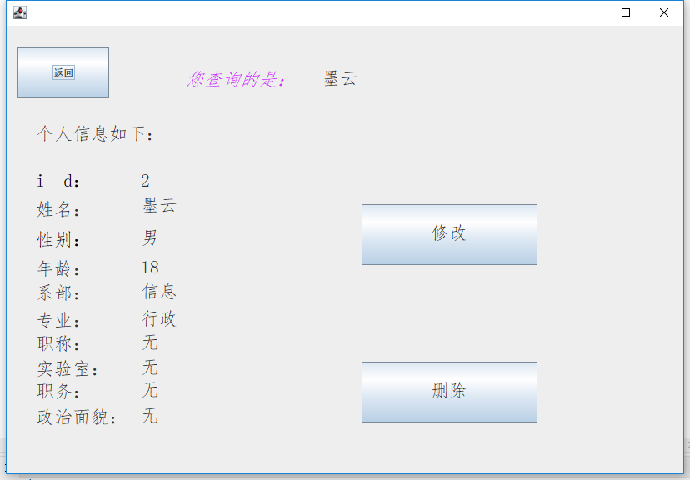

## 查询功能



## 编辑功能

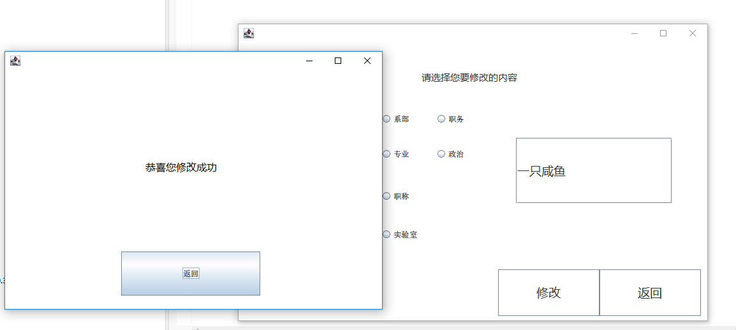

## 删除功能

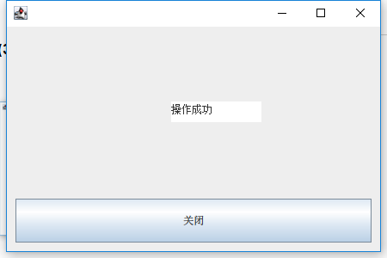

## 统计功能

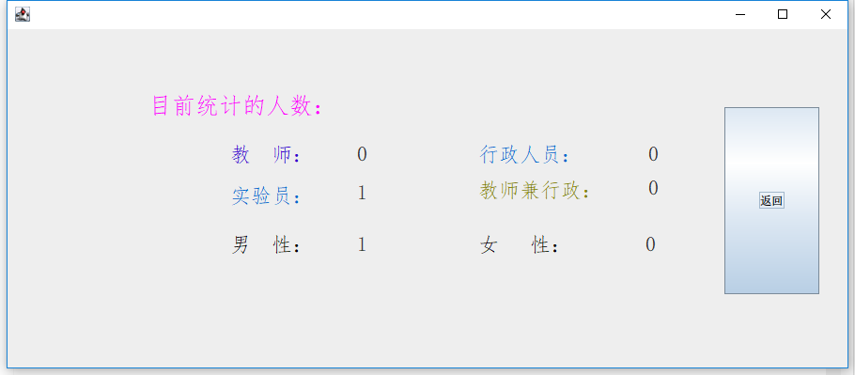

## 保存功能

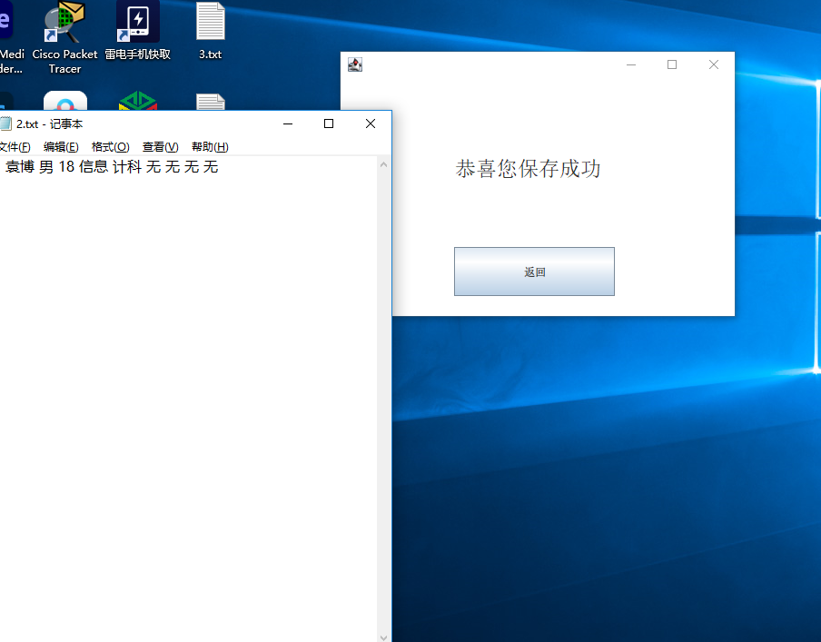

## 读取功能

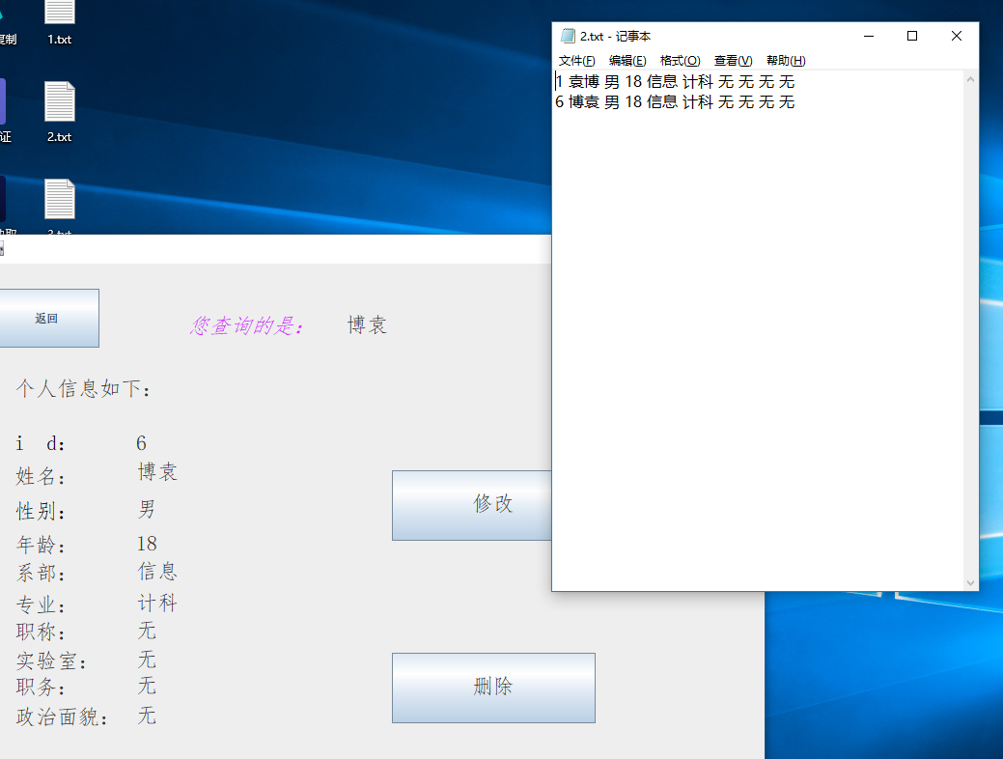

7.收获及体会

一、收获

通过可视化窗口设计，连接MySQL数据库，navicat可视化表，较好实现了管理人员（教师）登录并修改密码，以及对班级学生的信息管理，主界面实现了添加学生信息，修改信息，删除信息，查找信息，查看信息和退出功能。

二、难点

在设计mysql查询语句实现窗口界面和数据库交互的过程中，jar包的增加以及各类的引用一定要细心细致要不很快就容易报错，深切感受到了有些问题就是粗心导致但是一个小错误就可能需要让你从头来过。

1. 体会

通过此次课程设计，我明白细心真的太重要了，单词的拼写还有中英文符号。此外，为了能使程序更加的完善，更加人性化，我也利用了不少的课余时间，查找了各方面的资料，看到一个小型程序能够展示在电脑屏幕上时，感觉自己这段时间的付出是非常值得的，也使我对Java产生了更浓厚的兴趣，对自己的学习以及将来的工作都是有很大的帮助的。

附录源代码：

package yb_java;

import java.io.*;

import java.sql.*;

import java.util.Scanner;

public class mysql {

//添加用户程序设计

/**

*zhuce1用于注册 老师

*/

public void zhuce1(String id ,String name ,String sex,String age ,String xibu,String zhuanye,String zhicheng,String shiyanshi,String zhiwu,String zhengzhi) throws ClassNotFoundException, SQLException {

Connection conn;

String driver = "com.mysql.cj.jdbc.Driver";

Class.forName(driver);

conn = DriverManager.getConnection("jdbc:mysql://localhost:3306/test?serverTimezone=GMT", "root", "123456");

if(denglu(name,id)==1){

chongfu m = new chongfu();

m.play();

return ;

}

String sql = "insert into test.teacher values (?,?,?,?,?,?,?,?,?,?)";

PreparedStatement state = conn.prepareStatement(sql);

state.setString(1, id); //将第n个值替换成某个值ֵ

state.setString(2, name);

state.setString(3, sex);

state.setString(4, age);

state.setString(5, xibu); //将第n个值替换成某个值ֵ

state.setString(6, zhuanye);

state.setString(7, zhicheng);

state.setString(8, shiyanshi);

state.setString(9, zhiwu);

state.setString(10, zhengzhi);

state.executeUpdate(); //执行插入操作

Accept1 e = new Accept1();

e.play();

}

/**

*zhuce2用于注册 实验员

*/

public void zhuce2(String id ,String name ,String sex,String age ,String xibu,String zhuanye,String zhicheng,String shiyanshi,String zhiwu,String zhengzhi) throws ClassNotFoundException, SQLException {

Connection conn;

String driver = "com.mysql.cj.jdbc.Driver";

Class.forName(driver);

conn = DriverManager.getConnection("jdbc:mysql://localhost:3306/test?serverTimezone=GMT", "root", "123456");

if(denglu(name,id)==1){

chongfu m = new chongfu();

m.play();

return;

}

String sql = "insert into test.shiyanyuan values (?,?,?,?,?,?,?,?,?,?)";

PreparedStatement state = conn.prepareStatement(sql);

state.setString(1, id); //将第n个值替换成某个值ֵ

state.setString(2, name);

state.setString(3, sex);

state.setString(4, age);

state.setString(5, xibu); //将第n个值替换成某个值ֵ

state.setString(6, zhuanye);

state.setString(7, zhicheng);

state.setString(8, shiyanshi);

state.setString(9, zhiwu);

state.setString(10, zhengzhi);

state.executeUpdate();

Accept1 e = new Accept1();

e.play();

}

/**

*zhuce3用于注册 行政人员

*/

public void zhuce3(String id ,String name ,String sex,String age ,String xibu,String zhuanye,String zhicheng,String shiyanshi,String zhiwu,String zhengzhi) throws ClassNotFoundException, SQLException {

Connection conn;

String driver = "com.mysql.cj.jdbc.Driver";

Class.forName(driver);

conn = DriverManager.getConnection("jdbc:mysql://localhost:3306/test?serverTimezone=GMT", "root", "123456");

if(denglu(name,id)==1){

chongfu m = new chongfu();

m.play();

return;

}

String sql = "insert into test.xingzheng values (?,?,?,?,?,?,?,?,?,?)";

PreparedStatement state = conn.prepareStatement(sql);

state.setString(1, id); //将第n个值替换成某个值ֵ

state.setString(2, name);

state.setString(3, sex);

state.setString(4, age);

state.setString(5, xibu); //将第n个值替换成某个值ֵ

state.setString(6, zhuanye);

state.setString(7, zhicheng);

state.setString(8, shiyanshi);

state.setString(9, zhiwu);

state.setString(10, zhengzhi);

state.executeUpdate(); //执行插入操作

Accept1 e = new Accept1();

e.play();

}

/**

*zhuce4用于注册 教师兼行政人员

*/

public void zhuce4(String id ,String name ,String sex,String age ,String xibu,String zhuanye,String zhicheng,String shiyanshi,String zhiwu,String zhengzhi) throws ClassNotFoundException, SQLException {

Connection conn;

String driver = "com.mysql.cj.jdbc.Driver";

Class.forName(driver);

conn = DriverManager.getConnection("jdbc:mysql://localhost:3306/test?serverTimezone=GMT", "root", "123456");

if(denglu(name,id)==1){

chongfu m = new chongfu();

m.play();

return;

}

String sql = "insert into test.teacher_xingzheng values (?,?,?,?,?,?,?,?,?,?)";

PreparedStatement state = conn.prepareStatement(sql);

state.setString(1, id); //将第n个值替换成某个值ֵ

state.setString(2, name);

state.setString(3, sex);

state.setString(4, age);

state.setString(5, xibu); //将第n个值替换成某个值ֵ

state.setString(6, zhuanye);

state.setString(7, zhicheng);

state.setString(8, shiyanshi);

state.setString(9, zhiwu);

state.setString(10, zhengzhi);

state.executeUpdate(); //执行插入操作

Accept1 e = new Accept1();

e.play();

}

/*

* 查询四表内id及name

*/

public int denglu(String name, String id) throws ClassNotFoundException, SQLException {

Connection conn;

int flag=0;

String driver = "com.mysql.cj.jdbc.Driver";

Class.forName(driver);

conn = DriverManager.getConnection("jdbc:mysql://localhost:3306/test?serverTimezone=GMT", "root", "123456");

String sql1 = "select * from test.teacher where name=?";

PreparedStatement state1 = conn.prepareStatement(sql1); //容器

state1.setString(1, name); //将第n个值替换成某个值

ResultSet re1 = state1.executeQuery(); //上传数据库返回结果集

if (re1.next()) {

flag=1;//如果取到了值，fanhui-1;

}

String sql2 = "select * from test.shiyanyuan where name=?";

PreparedStatement state2 = conn.prepareStatement(sql2); //容器

state2.setString(1, name); //将第n个值替换成某个值

ResultSet re2 = state2.executeQuery();

if (re2.next()) {

flag=1;//如果取到了值，fanhui-1;

}

String sql3 = "select * from test.xingzheng where name=?";

PreparedStatement state3 = conn.prepareStatement(sql3); //容器

state3.setString(1, name); //将第n个值替换成某个值

ResultSet re3 = state3.executeQuery();

if (re3.next()) {

flag=1;//如果取到了值，fanhui-1;

}

String sql4 = "select * from test.teacher_xingzheng where name=?";

PreparedStatement state4 = conn.prepareStatement(sql4); //容器

state4.setString(1, name); //将第n个值替换成某个值

ResultSet re4 = state4.executeQuery();

if (re4.next()) {

flag=1;//如果取到了值，fanhui-1;

}

String sql5 = "select * from test.teacher where id=?";

PreparedStatement state5 = conn.prepareStatement(sql5); //容器

state5.setString(1, id); //将第n个值替换成某个值

ResultSet re5 = state5.executeQuery(); //上传数据库返回结果集

if (re5.next()) {

flag=1;//如果取到了值，fanhui-1;

}

String sql6 = "select * from test.shiyanyuan where id=?";

PreparedStatement state6 = conn.prepareStatement(sql6); //容器

state6.setString(1, id); //将第n个值替换成某个值

ResultSet re6 = state6.executeQuery();

if (re6.next()) {

flag=1;//如果取到了值，fanhui-1;

}

String sql7 = "select * from test.xingzheng where id=? ";

PreparedStatement state7 = conn.prepareStatement(sql7); //容器

state7.setString(1, id); //将第n个值替换成某个值

ResultSet re7 = state7.executeQuery();

if (re7.next()) {

flag=1;//如果取到了值，fanhui-1;

}

String sql8 = "select * from test.teacher_xingzheng where id=? ";

PreparedStatement state8 = conn.prepareStatement(sql8); //容器

state8.setString(1, id); //将第n个值替换成某个

ResultSet re8 = state8.executeQuery();

if (re8.next()) {

flag=1;//如果取到了值，fanhui-1;

}

if(flag==1)

return 1;

else

return 0;

}

/*

* 删除四表内数据

*

*/

public void del(String name) throws ClassNotFoundException, SQLException {

Connection conn;

String driver = "com.mysql.cj.jdbc.Driver";

Class.forName(driver);

conn = DriverManager.getConnection("jdbc:mysql://localhost:3306/test?serverTimezone=GMT", "root", "123456");

String sql = "delete from test.teacher where name = ?";

PreparedStatement state = conn.prepareStatement(sql);

state.setString(1, name);

state.executeUpdate();

String sq2 = "delete from test.xingzheng where name = ?";

PreparedStatement state2 = conn.prepareStatement(sq2);

state2.setString(1, name);

state2.executeUpdate();

String sq3 = "delete from test.shiyanyuan where name = ?";

PreparedStatement state3 = conn.prepareStatement(sq3);

state3.setString(1, name);

state3.executeUpdate();

String sq4 = "delete from test.teacher_xingzheng where name = ?";

PreparedStatement state4 = conn.prepareStatement(sq4);

state4.setString(1, name);

state4.executeUpdate();

}

public void del2(String name,String id) throws ClassNotFoundException, SQLException {

Connection conn;

String driver = "com.mysql.cj.jdbc.Driver";

Class.forName(driver);

conn = DriverManager.getConnection("jdbc:mysql://localhost:3306/test?serverTimezone=GMT", "root", "123456");

String sql = "delete from test.teacher where name = ?";

PreparedStatement state = conn.prepareStatement(sql);

state.setString(1, name);

state.executeUpdate();

String sq2 = "delete from test.xingzheng where name = ?";

PreparedStatement state2 = conn.prepareStatement(sq2);

state2.setString(1, name);

state2.executeUpdate();

String sq3 = "delete from test.shiyanyuan where name = ?";

PreparedStatement state3 = conn.prepareStatement(sq3);

state3.setString(1, name);

state3.executeUpdate();

String sq4 = "delete from test.teacher_xingzheng where name = ?";

PreparedStatement state4 = conn.prepareStatement(sq4);

state4.setString(1, name);

state4.executeUpdate();

String sq5 = "delete from test.teacher where id = ?";

PreparedStatement state5 = conn.prepareStatement(sq5);

state5.setString(1, id);

state5.executeUpdate();

String sq6 = "delete from test.xingzheng where id = ?";

PreparedStatement state6 = conn.prepareStatement(sq6);

state6.setString(1, id);

state6.executeUpdate();

String sq7 = "delete from test.shiyanyuan where id = ?";

PreparedStatement state7 = conn.prepareStatement(sq7);

state7.setString(1, id);

state7.executeUpdate();

String sq8 = "delete from test.teacher_xingzheng where id = ?";

PreparedStatement state8 = conn.prepareStatement(sq8);

state8.setString(1, id);

state8.executeUpdate();

}

/*

* 统计四类表人数

*/

public int count1() throws ClassNotFoundException, SQLException {

int sum=0;

Connection conn;

String driver = "com.mysql.cj.jdbc.Driver";

Class.forName(driver);

conn = DriverManager.getConnection("jdbc:mysql://localhost:3306/test?serverTimezone=GMT", "root", "123456");

String sql = "select * from test.teacher";

PreparedStatement state = conn.prepareStatement(sql);

ResultSet re1 = state.executeQuery();

while(re1.next()){

sum++;

}

return sum;

}

public int count2() throws ClassNotFoundException, SQLException {

int sum=0;

Connection conn;

String driver = "com.mysql.cj.jdbc.Driver";

Class.forName(driver);

conn = DriverManager.getConnection("jdbc:mysql://localhost:3306/test?serverTimezone=GMT", "root", "123456");

String sql = "select * from test.shiyanyuan";

PreparedStatement state = conn.prepareStatement(sql);

ResultSet re1 = state.executeQuery();

while(re1.next()){

sum++;

}

return sum;

}

public int count3() throws ClassNotFoundException, SQLException {

int sum=0;

Connection conn;

String driver = "com.mysql.cj.jdbc.Driver";

Class.forName(driver);

conn = DriverManager.getConnection("jdbc:mysql://localhost:3306/test?serverTimezone=GMT", "root", "123456");

String sql = "select * from test.xingzheng";

PreparedStatement state = conn.prepareStatement(sql);

ResultSet re1 = state.executeQuery();

while(re1.next()){

sum++;

}

return sum;

}

public int count4() throws ClassNotFoundException, SQLException {

int sum=0;

Connection conn;

String driver = "com.mysql.cj.jdbc.Driver";

Class.forName(driver);

conn = DriverManager.getConnection("jdbc:mysql://localhost:3306/test?serverTimezone=GMT", "root", "123456");

String sql = "select * from test.teacher_xingzheng";

PreparedStatement state = conn.prepareStatement(sql);

ResultSet re1 = state.executeQuery();

while(re1.next()){

sum++;

}

return sum;

}

/*

* 统计男女人数

*/

public int count5() throws ClassNotFoundException, SQLException {

int sum=0;

Connection conn;

String driver = "com.mysql.cj.jdbc.Driver";

Class.forName(driver);

conn = DriverManager.getConnection("jdbc:mysql://localhost:3306/test?serverTimezone=GMT", "root", "123456");

String sql = "select * from test.teacher_xingzheng";

PreparedStatement state = conn.prepareStatement(sql);

ResultSet re1 = state.executeQuery();

while(re1.next()){

if(re1.getString(3).equals("男"))

sum++;

}

String sql2 = "select * from test.teacher";

PreparedStatement state2 = conn.prepareStatement(sql2);

ResultSet re2 = state2.executeQuery();

while(re2.next()){

if(re2.getString(3).equals("男")){

sum++;

}

}

String sql3 = "select * from test.shiyanyuan";

PreparedStatement state3 = conn.prepareStatement(sql3);

ResultSet re3 = state3.executeQuery();

while(re3.next()){

if(re3.getString(3).equals("男")){

sum++;

}

}

String sql4 = "select * from test.xingzheng";

PreparedStatement state4 = conn.prepareStatement(sql4);

ResultSet re4 = state4.executeQuery();

while(re4.next()){

if(re4.getString(3).equals("男")){

sum++;

}

}

return sum;

}

public int count6() throws ClassNotFoundException, SQLException {

int sum=0;

Connection conn;

String driver = "com.mysql.cj.jdbc.Driver";

Class.forName(driver);

conn = DriverManager.getConnection("jdbc:mysql://localhost:3306/test?serverTimezone=GMT", "root", "123456");

String sql = "select * from test.teacher_xingzheng";

PreparedStatement state = conn.prepareStatement(sql);

ResultSet re1 = state.executeQuery();

while(re1.next()){

if(re1.getString(3).equals("女")){

sum++;

}

}

String sql2 = "select * from test.teacher";

PreparedStatement state2 = conn.prepareStatement(sql2);

ResultSet re2 = state2.executeQuery();

while(re2.next()){

if(re2.getString(3).equals("女")){

sum++;

}

}

String sql3 = "select * from test.shiyanyuan";

PreparedStatement state3 = conn.prepareStatement(sql3);

ResultSet re3 = state3.executeQuery();

while(re3.next()){

if(re3.getString(3).equals("女")){

sum++;

}

}

String sql4 = "select * from test.xingzheng";

PreparedStatement state4 = conn.prepareStatement(sql4);

ResultSet re4 = state4.executeQuery();

while(re4.next()){

if(re4.getString(3).equals("女")){

sum++;

}

}

return sum;

}

/*

* 通过id查询

*

*

* sql1是老师

* sql2是实验员

* sql3是行政人员

* sql4是行政人员兼老师

*/

public void chaxun1(String id) throws ClassNotFoundException, SQLException {

Connection conn;

int flag=0;

String driver = "com.mysql.cj.jdbc.Driver";

Class.forName(driver);

conn = DriverManager.getConnection("jdbc:mysql://localhost:3306/test?serverTimezone=GMT", "root", "123456");

String sql1 = "select * from test.teacher where id=? ";

PreparedStatement state1 = conn.prepareStatement(sql1); //容器

state1.setString(1, id); //将第n个值替换成某个值ֵ

ResultSet re1 = state1.executeQuery(); //上传数据库返回结果集

if (re1.next()) {

xiugai m = new xiugai(re1.getString(1),re1.getString(2),re1.getString(3),re1.getString(4),re1.getString(5),re1.getString(6),re1.getString(7),re1.getString(8),re1.getString(9),re1.getString(10));

m.play(re1.getString(1),re1.getString(2),re1.getString(3),re1.getString(4),re1.getString(5),re1.getString(6),re1.getString(7),re1.getString(8),re1.getString(9),re1.getString(10));

return ;

}

String sql2 = "select * from test.shiyanyuan where id=?";

PreparedStatement state2 = conn.prepareStatement(sql2); //容器

state2.setString(1, id); //将第n个值替换成某个值ֵ

ResultSet re2 = state2.executeQuery();

if (re2.next()) {

xiugai m = new xiugai(re2.getString(1),re2.getString(2),re2.getString(3),re2.getString(4),re2.getString(5),re2.getString(6),re2.getString(7),re2.getString(8),re2.getString(9),re2.getString(10));

m.play(re2.getString(1),re2.getString(2),re2.getString(3),re2.getString(4),re2.getString(5),re2.getString(6),re2.getString(7),re2.getString(8),re2.getString(9),re2.getString(10));

return;

}

String sql3 = "select * from test.xingzheng where id=?";

PreparedStatement state3 = conn.prepareStatement(sql3); //容器

state3.setString(1, id); //将第n个值替换成某个值ֵ

ResultSet re3 = state3.executeQuery();

if (re3.next()) {

xiugai m = new xiugai(re3.getString(1),re3.getString(2),re3.getString(3),re3.getString(4),re3.getString(5),re3.getString(6),re3.getString(7),re3.getString(8),re3.getString(9),re3.getString(10));

m.play(re3.getString(1),re3.getString(2),re3.getString(3),re3.getString(4),re3.getString(5),re3.getString(6),re3.getString(7),re3.getString(8),re3.getString(9),re3.getString(10));

return;

}

String sql4 = "select * from test.teacher_xingzheng where id=?";

PreparedStatement state4 = conn.prepareStatement(sql4); //容器

state4.setString(1, id); ///将第n个值替换成某个值ֵ

ResultSet re4 = state4.executeQuery();

if (re4.next()) {

xiugai m = new xiugai(re4.getString(1),re4.getString(2),re4.getString(3),re4.getString(4),re4.getString(5),re4.getString(6),re4.getString(7),re4.getString(8),re4.getString(9),re4.getString(10));

m.play(re4.getString(1),re4.getString(2),re4.getString(3),re4.getString(4),re4.getString(5),re4.getString(6),re4.getString(7),re4.getString(8),re4.getString(9),re4.getString(10));

return;

}

notexist m = new notexist();

m.play();

}

/*

* 通过姓名查询

*

*

* sql1是老师

* sql2是实验员

* sql3是行政人员

* sql4是行政人员兼老师

*/

public void chaxun2(String name) throws ClassNotFoundException, SQLException{

Connection conn;

int flag=0;

String driver = "com.mysql.cj.jdbc.Driver";

Class.forName(driver);

conn = DriverManager.getConnection("jdbc:mysql://localhost:3306/test?serverTimezone=GMT", "root", "123456");

String sql1 = "select * from test.teacher where name=? ";

PreparedStatement state1 = conn.prepareStatement(sql1); //容器

state1.setString(1, name); //将第n个值替换成某个值ֵ

ResultSet re1 = state1.executeQuery(); //上传数据库返回结果集

if (re1.next()) {

xiugai m = new xiugai(re1.getString(1),re1.getString(2),re1.getString(3),re1.getString(4),re1.getString(5),re1.getString(6),re1.getString(7),re1.getString(8),re1.getString(9),re1.getString(10));

m.play(re1.getString(1),re1.getString(2),re1.getString(3),re1.getString(4),re1.getString(5),re1.getString(6),re1.getString(7),re1.getString(8),re1.getString(9),re1.getString(10));

return ;

}

String sql2 = "select * from test.shiyanyuan where name=?";

PreparedStatement state2 = conn.prepareStatement(sql2); //容器

state2.setString(1, name); //将第n个值替换成某个值ֵ

ResultSet re2 = state2.executeQuery();

if (re2.next()) {

xiugai m = new xiugai(re2.getString(1),re2.getString(2),re2.getString(3),re2.getString(4),re2.getString(5),re2.getString(6),re2.getString(7),re2.getString(8),re2.getString(9),re2.getString(10));

m.play(re2.getString(1),re2.getString(2),re2.getString(3),re2.getString(4),re2.getString(5),re2.getString(6),re2.getString(7),re2.getString(8),re2.getString(9),re2.getString(10));

return;

}

String sql3 = "select * from test.xingzheng where name=?";

PreparedStatement state3 = conn.prepareStatement(sql3); //容器

state3.setString(1, name); //将第n个值替换成某个值ֵ

ResultSet re3 = state3.executeQuery();

if (re3.next()) {

xiugai m = new xiugai(re3.getString(1),re3.getString(2),re3.getString(3),re3.getString(4),re3.getString(5),re3.getString(6),re3.getString(7),re3.getString(8),re3.getString(9),re3.getString(10));

m.play(re3.getString(1),re3.getString(2),re3.getString(3),re3.getString(4),re3.getString(5),re3.getString(6),re3.getString(7),re3.getString(8),re3.getString(9),re3.getString(10));

return;

}

String sql4 = "select * from test.teacher_xingzheng where name=?";

PreparedStatement state4 = conn.prepareStatement(sql4); //容器

state4.setString(1, name); //将第n个值替换成某个值ֵ

ResultSet re4 = state4.executeQuery();

if (re4.next()) {

xiugai m = new xiugai(re4.getString(1),re4.getString(2),re4.getString(3),re4.getString(4),re4.getString(5),re4.getString(6),re4.getString(7),re4.getString(8),re4.getString(9),re4.getString(10));

m.play(re4.getString(1),re4.getString(2),re4.getString(3),re4.getString(4),re4.getString(5),re4.getString(6),re4.getString(7),re4.getString(8),re4.getString(9),re4.getString(10));

return;

}

notexist m = new notexist();

m.play();

}

/*

* 保存功能

*/

public void baocun() throws ClassNotFoundException, SQLException{

try{

FileWriter f=new FileWriter("C:\\Users\\墨云\\Desktop\\1.txt");

f.write("");

f.flush();

f.close();

FileWriter f1=new FileWriter("C:\\Users\\墨云\\Desktop\\2.txt");

f1.write("");

f1.flush();

f1.close();

FileWriter f2=new FileWriter("C:\\Users\\墨云\\Desktop\\3.txt");

f2.write("");

f2.flush();

f2.close();

FileWriter f3=new FileWriter("C:\\Users\\墨云\\Desktop\\4.txt");

f3.write("");

f3.flush();

f3.close();

} catch (IOException e) {

e.printStackTrace();

}

Connection conn;

String driver = "com.mysql.cj.jdbc.Driver";

Class.forName(driver);

conn = DriverManager.getConnection("jdbc:mysql://localhost:3306/test?serverTimezone=GMT", "root", "123456");

String sql1 = "select * from test.teacher";

PreparedStatement state1 = conn.prepareStatement(sql1); //容器

ResultSet re1 = state1.executeQuery(); //上传数据库返回结果集

String[] p=new String[count1()];

int count=0;

while(re1.next()){

StringBuilder sb=new StringBuilder();

for(int i=1;i<11;i++){

sb.append(re1.getString(i)).append(" ");

}

p[count]=sb.toString();

count+=1;

}

try (BufferedWriter b = new BufferedWriter(new FileWriter("C:\\Users\\墨云\\Desktop\\1.txt",true))) {

for(int i=0;i<p.length;i++){

b.write(p[i]);

b.newLine();

}

} catch (IOException i) {

System.out.println("写入失败");

}

String sql2 = "select * from test.shiyanyuan";

PreparedStatement state2 = conn.prepareStatement(sql2); //容器

ResultSet re2 = state2.executeQuery(); //上传数据库返回结果集

String[] p2=new String[count2()];

int count2=0;

while(re2.next()){

StringBuilder sb2=new StringBuilder();

for(int i=1;i<11;i++){

sb2.append(re2.getString(i)).append(" ");

}

p2[count2]=sb2.toString();

count2+=1;

}

try (BufferedWriter b2 = new BufferedWriter(new FileWriter("C:\\Users\\墨云\\Desktop\\2.txt",true))) {

for(int i=0;i<p2.length;i++){

b2.write(p2[i]);

b2.newLine();

}

} catch (IOException i) {

System.out.println("写入失败");

}

String sql3 = "select * from test.xingzheng";

PreparedStatement state3 = conn.prepareStatement(sql3); //容器

ResultSet re3 = state3.executeQuery(); //上传数据库返回结果集

String[] p3=new String[count3()];

int count3=0;

while(re3.next()){

StringBuilder sb3=new StringBuilder();

for(int i=1;i<11;i++){

sb3.append(re3.getString(i)).append(" ");

}

p3[count3]=sb3.toString();

count3+=1;

}

try (BufferedWriter b3 = new BufferedWriter(new FileWriter("C:\\Users\\墨云\\Desktop\\3.txt",true))) {

for(int i=0;i<p3.length;i++){

b3.write(p3[i]);

b3.newLine();

}

} catch (IOException i) {

System.out.println("写入失败");

}

String sql4 = "select * from test.teacher_xingzheng";

PreparedStatement state4 = conn.prepareStatement(sql4); //容器

ResultSet re4 = state4.executeQuery(); //上传数据库返回结果集

String[] p4=new String[count4()];

int count4=0;

while(re4.next()){

StringBuilder sb4=new StringBuilder();

for(int i=1;i<11;i++){

sb4.append(re4.getString(i)).append(" ");

}

p4[count4]=sb4.toString();

count4+=1;

}

try (BufferedWriter b4 = new BufferedWriter(new FileWriter("C:\\Users\\墨云\\Desktop\\4.txt",true))) {

for(int i=0;i<p4.length;i++){

b4.write(p4[i]);

b4.newLine();

}

} catch (IOException i) {

System.out.println("写入失败");

}

}

/*

* 读取txt内文件

*/

public void duqu() throws ClassNotFoundException, SQLException{

Connection conn;

String driver = "com.mysql.cj.jdbc.Driver";

Class.forName(driver);

conn = DriverManager.getConnection("jdbc:mysql://localhost:3306/test?serverTimezone=GMT", "root", "123456");

try(BufferedReader b=new BufferedReader(new FileReader("C:\\Users\\墨云\\Desktop\\1.txt"))){

String str="";

while ((str = b.readLine()) != null){

String[] p=str.split(" ");

if(denglu(p[1],p[0])==0){

zhuce1(p[0],p[1],p[2],p[3],p[4],p[5],p[6],p[7],p[8],p[9]);

}

}

} catch (IOException e) {

System.out.println("读取失败");

}

try(BufferedReader b=new BufferedReader(new FileReader("C:\\Users\\墨云\\Desktop\\2.txt"))){

String str="";

while ((str = b.readLine()) != null){

String[] p=str.split(" ");

if(denglu(p[1],p[0])==0){

zhuce2(p[0],p[1],p[2],p[3],p[4],p[5],p[6],p[7],p[8],p[9]);

}

}

} catch (IOException e) {

System.out.println("读取失败");

}

try(BufferedReader b=new BufferedReader(new FileReader("C:\\Users\\墨云\\Desktop\\3.txt"))){

String str="";

while ((str = b.readLine()) != null){

String[] p=str.split(" ");

if(denglu(p[1],p[0])==0){

zhuce3(p[0],p[1],p[2],p[3],p[4],p[5],p[6],p[7],p[8],p[9]);

}

}

} catch (IOException e) {

System.out.println("读取失败");

}

try(BufferedReader b=new BufferedReader(new FileReader("C:\\Users\\墨云\\Desktop\\4.txt"))){

String str="";

while ((str = b.readLine()) != null){

String[] p=str.split(" ");

if(denglu(p[1],p[0])==0){

zhuce4(p[0],p[1],p[2],p[3],p[4],p[5],p[6],p[7],p[8],p[9]);

}

}

} catch (IOException e) {

System.out.println("读取失败");

}

}

/*

* 修改

*/

public void xiugai (String name , String leixing ,String s)throws ClassNotFoundException, SQLException{

try{

Connection conn;

String driver = "com.mysql.cj.jdbc.Driver";

Class.forName(driver);

conn = DriverManager.getConnection("jdbc:mysql://localhost:3306/test?serverTimezone=GMT", "root", "123456");

String sql="";

if(leixing=="id"){

sql = "update test.teacher set id = ? where name= ? ";

}

if(leixing=="name"){

sql = "update test.teacher set name = ? where name= ? ";

}

if(leixing=="sex"){

sql = "update test.teacher set sex = ? where name= ? ";

}

if(leixing=="age"){

sql = "update test.teacher set age = ? where name= ? ";

}

if(leixing=="xibu"){

sql = "update test.teacher set xibu = ? where name= ? ";

}

if(leixing=="zhuanye"){

sql = "update test.teacher set zhuanye = ? where name= ? ";

}

if(leixing=="zhicheng"){

sql = "update test.teacher set zhicheng = ? where name= ? ";

}

if(leixing=="shiyanshi"){

sql = "update test.teacher set shiyanshi = ? where name= ? ";

}

if(leixing=="zhiwu"){

sql = "update test.teacher set zhiwu = ? where name= ? ";

}

if(leixing=="zhengzhi") {

sql = "update test.teacher set zhengzhi = ? where name= ? ";

}

PreparedStatement state = conn.prepareStatement(sql);

state.setString(1,s);

state.setString(2,name);

state.executeUpdate();

}catch (NullPointerException e){

e.printStackTrace();

}

}

}