LLM-Based Antipattern Detection in UML Use Case Models:
A Synthetic Data Generation and Fine-Tuning Approach
Yasser Khan
Department of Electrical Engineering and Computer Science
Florida Atlantic University, Florida, USA
khany2026@fau.edu
Mohamed El-Attar
College of Technological Innovation
Zayed University, Abu Dhabi, United Arab Emirates
Mohamed.El-Attar@zu.ac.ae
Abstract
Antipatterns in UML use case models degrade software design quality and impede communication between stakeholders, yet their detection has received comparatively little automated support. We present a complete pipeline for fine-tuning an LLM to detect the Functional Decomposition via <<include>> relationship antipattern in PlantUML use case diagrams. The pipeline uses Claude Opus, a frontier LLM, to synthesize 194 labeled diagram pairs (each consisting of an antipattern version and its correctly refactored counterpart) across a diverse set of application domains. Qwen2.5-Coder-3B-Instruct, a compact LLM, is then fine-tuned on this dataset using Low-Rank Adaptation (LoRA), achieving 91.0% detection accuracy and an instance-level recall of 0.87 on a held-out, domain-stratified test set. The paper details the full pipeline from synthetic data generation to fine-tuning and evaluation.
Keywords: UML, use case diagrams, antipattern detection, LLM, fine-tuning, synthetic data, PlantUML, LoRA.

Introduction
Unified Modeling Language (UML) use case diagrams are a primary artifact in requirements engineering. They describe the functional scope of a system in terms of actors, use cases, and the relationships between them (<<include>>, <<extend>>, and generalisation). Despite their conceptual simplicity, practitioners regularly introduce structural antipatterns that reduce diagram clarity, misrepresent system behavior, or create maintenance obstacles (Lilly 1999; Anda et al. 2001).
One particularly common antipattern is Functional Decomposition via the include relationship (FD-include) (El-Attar and Miller 2006, 2010): a use case is decomposed into several inclusion use cases that have no direct association with any actor and provide no observable result of their own. Detecting such instances requires understanding both the syntactic structure of the diagram and the semantic intent of the include relationship, a task that benefits from natural language reasoning as well as structural analysis.
Existing approaches to antipattern detection in UML rely primarily on model-checking rules, OCL constraints, or pattern-matching heuristics (Gogolla et al. 2003; Ballis et al. 2008; Fourati et al. 2011). These methods are brittle when diagrams do not conform to an expected representation, and they cannot generalize to novel antipattern types without expert-authored rules. Recent advances in large language models (LLMs) offer an alternative: models trained on sufficiently representative examples can generalize structural reasoning to unseen diagrams.
However, assembling labeled training data for UML antipatterns is expensive and scarce in practice. Published datasets of annotated use case diagrams are small and domain-narrow. We address this bottleneck with a synthetic data generation approach: we use Claude Opus, a state-of-the-art LLM, as a controlled diagram author to produce a large, diverse, and precisely labeled set of diagram pairs. This data is then used to fine-tune Qwen2.5-Coder-3B-Instruct, a compact open-source LLM suitable for deployment in resource-constrained settings.
This paper presents a prompt-engineering framework that instructs an LLM to produce syntactically valid, structurally diverse, and correctly labeled antipattern/refactored PlantUML diagram pairs, together with a structured dataset of 388 annotated training samples spanning 194 distinct application domains with 1–5 antipattern instances per diagram. Building on this data, we fine-tune a 3B-parameter LLM that achieves 91.0% detection accuracy on domain-held-out test samples.
The remainder of this paper is structured as follows. Section 2 reviews relevant background. Section 3 describes the data generation pipeline. Section 4 characterizes the resulting dataset. Section 5 details the fine-tuning configuration. Section 6 presents evaluation results. Section 7 discusses findings and limitations. Section 8 surveys related work. Section 9 concludes.

Background

UML Use Case Diagrams and Antipatterns
A UML use case diagram represents the functional requirements of a system as a set of use cases (ellipses) associated with one or more actors. Three relationship types express dependencies between use cases: the <<include>> relationship indicates that the base use case always incorporates the behavior of the inclusion use case; <<extend>> represents optional behavior that may be inserted at an extension point; and generalisation captures inheritance between actors or between use cases, indicating that one element is a specialized form of another.
Antipatterns in use case models are recurring modeling mistakes that violate the intended semantics of these elements (El-Attar and Miller 2010). This work focuses on FD-include, where a use case is divided into several inclusion use cases that are not directly associated with any actor. Offering no observable result to a user, they represent internal sub-steps rather than independent services. The correct refactoring merges these inclusions back into the base use case. Concretely, an inclusion use case participates in an FD-include instance if and only if: (i) it is included by exactly one base use case; (ii) it has no direct actor association; (iii) it neither includes nor extends any other use case; (iv) it is not extended by any other use case; and (v) it is not involved in any generalisation.

LLMs for Code and Diagram Generation
LLMs have demonstrated strong capabilities in generating structured text conforming to domain-specific syntaxes, including source code, configuration files, and markup languages. PlantUML is a text-based diagram description language; its grammar is sufficiently regular that frontier models can produce syntactically valid diagrams with minimal additional scaffolding. This has been demonstrated in security modeling contexts: ChatGPT-5 has been shown to generate misuse case diagrams directly in PlantUML from textual security requirements (Alzarooni et al. 2026), and ChatGPT has been evaluated for generating STRIDE data flow diagrams, with findings covering syntactic correctness, semantic accuracy, and trust-boundary placement (Alsayegh and El-Attar 2026).
Low-Rank Adaptation (LoRA) (Hu et al. 2022) is a parameter-efficient fine-tuning technique that injects trainable low-rank matrices into each weight matrix of a frozen pre-trained model. With rank $r≪d$, where $d$ is the dimension of the weight matrix, LoRA reduces the number of trainable parameters by orders of magnitude while preserving performance comparable to full fine-tuning.

Data Generation Pipeline

Pipeline Overview
The pipeline takes two inputs. The first is an antipattern specification that names the antipatterns to be instantiated, providing a natural-language description and a refactoring strategy for each. The second is a pool of 194 application domains spanning everyday (e.g. Banking System, Online Store), moderately common (e.g. Tutoring Marketplace, Crowdfunding Platform), and niche domains (e.g. Irrigation Control System, Funeral Service Management System), ensuring the model sees a wide range of domain vocabularies. These inputs drive three pipeline stages: LLM-driven diagram generation, quality review, and training sample packaging, as illustrated in Figure 1.
High-level data generation pipeline.

Prompt Design
Each diagram is generated using a two-part prompt: a system prompt that governs the entire session and remains constant across all diagrams, and a user prompt issued once per domain. The system prompt defines how FD-include instances are identified and counted, what counts as a UML element, the diagram validity rules, the refactoring scope, and the required response format.

FD-include instance definition.
The system prompt instructs Claude to identify FD-include instances using the five criteria defined in Section 2. Each qualifying (base, inclusion) pair constitutes one instance; a base use case with $N$ qualifying inclusions contributes $N$ separate instances. Chain inclusions (A includes B, B includes C) produce two instances, (A, B) and (B, C), since B is simultaneously an inclusion use case for A and a base use case for C. All instances that share the same base use case form an instance group; a diagram in which $k$ base use cases are each decomposed into qualifying inclusions contains $k$ instance groups. Figure 2 shows a Flight Booking System example with two instance groups: Book Flight decomposes into three inclusion use cases (Validate Payment Details, Process Payment, Generate Ticket Confirmation), and Book Flight on Behalf of Customer decomposes into one (Check Seat Availability). All four are FD-include instances and are dropped in the refactored version. The remaining <<include>> from Book Flight on Behalf of Customer to Book Flight is retained because Book Flight is directly associated with an actor and provides an observable result.
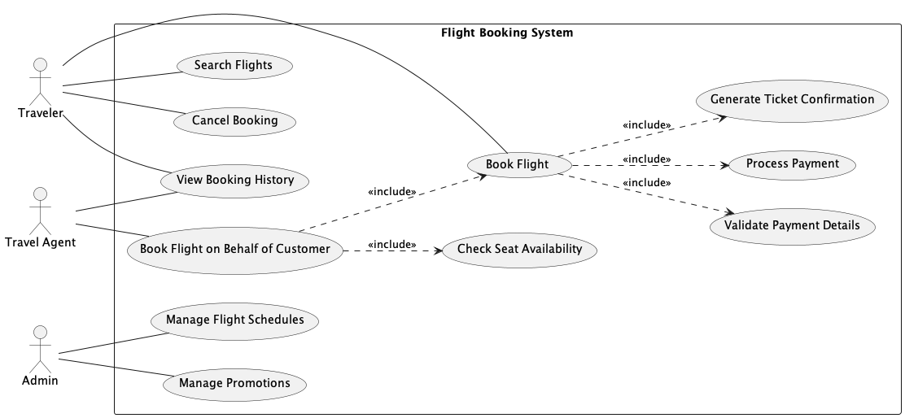  Antipattern: two FD-include instance groups. | 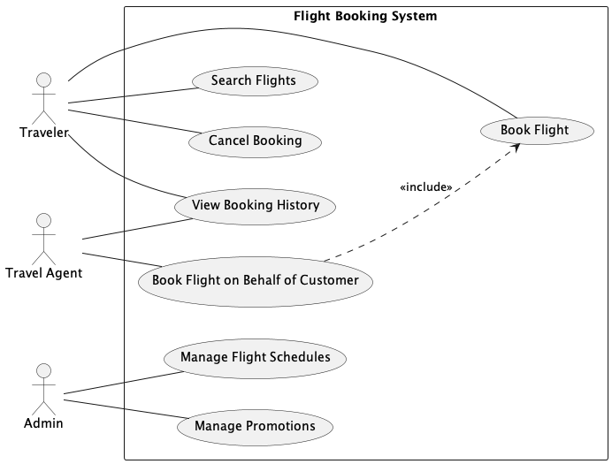  Refactored: all four FD-include instances removed.
Flight Booking System: antipattern and refactored diagrams.

Element definition.
The system prompt defines a UML element as any of four types: actor, use case, <<include>> arrow, or <<extend>> arrow. Diagram size is expressed as a total element count, with the target for each domain drawn from the size tier range. The two tiers in Table 1 are deliberately non-contiguous: small diagrams contain at most one instance group, while medium diagrams are large enough to support up to three. The gap between the tiers ensures structural distinction is preserved regardless of minor count deviations, since Claude may add or omit a few elements to produce a coherent domain model. The ranges therefore serve as target guidelines rather than strict constraints.
Diagram size tiers used during generation.
Size | Element range | Max instance groups
small | 9–13 | 1
medium | 24–30 | 3

Structural validity rules.
Several rules enforce UML correctness. Every model must include a system boundary rectangle enclosing all use cases, with all actors placed outside it. Every use case in both versions must be associated with at least one actor; a use case with no actor association is invalid. Actor-to-use-case associations must be undirected lines, and <<extend>> arrows must point from the extension use case to the base use case.

Refactoring scope.
The system prompt encodes the refactoring strategy supplied in the antipattern specification. The refactored version must be derived strictly from the antipattern version, only elements that participate in FD-include instances may be removed, and no new use cases, actors, or associations may be introduced. This constraint ensures that the two versions are comparable and that the refactored version contains no spurious domain enrichment.

Response format.
The system prompt instructs Claude to produce two PlantUML diagram versions: one with FD-include instances embedded and one with those instances refactored away. It also requires an antipattern detection label, a JSON-formatted structured output recording whether the antipattern is present, which elements are involved in each instance, and a natural-language explanation. The schema is illustrated in Listing 1; refactored versions carry a fixed negative label ("detected": false, empty antipatterns list). Each element is identified by its display name followed by its PlantUML identifier in parentheses (e.g. UC1), enabling a downstream modeling tool to locate and refactor the specific use case without ambiguity.
{
"detected": true,
"antipatterns": [{
"antipattern_name":
"Functional Decomposition: Using the include relationship",
"instance_count": 1,
"instances": [{
"elements": [
"Withdraw Cash (UC1)",
"Validate Account (UC2)"
],
"explanation": "'Validate Account' (UC2) is included by
'Withdraw Cash' (UC1), has no direct actor association
... making it a functional decomposition."
}]
}]
}
The user prompt is issued once per domain and specifies the target domain and a target element count drawn from the size tier range. The Claude Opus 4.6 API is called with this prompt; the response yields a positive sample (the antipattern PlantUML source with its detection label) and a negative sample (the refactored PlantUML source), which are then submitted for manual review. Once approved, each sample is serialized as a conversational training record containing three messages: a fixed system prompt, a user message carrying the PlantUML source, and an assistant message containing the antipattern detection label. Listing [lst:sample] shows a condensed positive sample; the corresponding negative (refactored) sample is identical in structure but with "detected": false and an empty "antipatterns" list.
{
"messages": [
{
"role": "system",
"content": "You are an expert in UML use case diagram analysis..."
},
{
"role": "user",
"content": "Analyze the following PlantUML use case model and
detect if it contains any antipatterns. ......
@startuml
......
@enduml"
},
{
"role": "assistant",
"content": "{ detected: true, .......... }"
}
]
}

Quality Review
Each generated pair is manually reviewed. Despite the detailed prompt constraints, Claude does not always produce fully conformant diagrams; observed issues include use cases with no actor association, violation of the system boundary rule, refactored versions that retain FD-include elements or introduce new use cases absent from the antipattern version, and extension arrows pointing in the wrong direction. When issues are found, the reviewer notes them as free-text descriptions of the specific violations. Those notes are then passed to Claude as part of the user prompt, asking it to regenerate the pair while correcting the identified issues. This loop typically resolves violations within one or two additional attempts.

Dataset Characteristics
The pipeline produced 194 antipattern/refactored pairs spanning as many distinct application domains (85 small, 109 medium), yielding 388 training samples in total. One pair per domain ensures the model generalizes across domain vocabulary rather than memorising domain-specific patterns. Table 2 summarises the structural properties of the generated diagrams.
Structural statistics of the generated diagram dataset.
Metric | Antipattern | Refactored
Samples | 194 | 194
Total elements (mean) | 15.3 | 11.4
Use cases (mean) | 10.2 | 8.2
Actors (mean) | 2.9 | 2.9
Include relationships (mean) | 2.1 | 0.1
Instances per sample (mean) | 1.96 | —
Instances per sample (range) | 1–5 | —
Diagrams with size small | 85 | 85
Diagrams with size medium | 109 | 109
The difference in mean element count between antipattern (15.3) and refactored (11.4) versions directly reflects the refactoring: removing FD-include instances eliminates inclusion use cases and their <<include>> arrows, reducing total elements by approximately 4 per diagram on average. Only 16 of 194 refactored diagrams retain any <<include>> relationships, confirming that the generation pipeline correctly preserves only legitimate includes (those whose inclusion target is associated with an actor or is included by multiple use cases). The antipattern instance distribution (1–5 instances per diagram) provides the model with varied label complexity, including cases where multiple base use cases each decompose into multiple sub-steps.

Fine-Tuning
We apply parameter-efficient fine-tuning (PEFT) to Qwen2.5-Coder-3B-Instruct (Hui et al. 2024), a 3B-parameter LLM from the Qwen2.5-Coder series. Its pretraining corpus includes large quantities of code and structured text, making it well-suited to PlantUML syntax and structured output formatting. Low-Rank Adaptation (LoRA) (Hu et al. 2022) adapters are applied to all attention and feed-forward projection matrices with rank $r=8$ and scaling factor $α=16$, training 0.48% of total parameters. Samples are formatted using the Qwen2.5 chat template with system, user, and assistant turns, with a maximum sequence length of 2048 tokens. The dataset is split into training and test sets using a domain-stratified 80/20 partition, where entire domains (both antipattern and refactored samples) are assigned to either split, ensuring no domain appears in both. This yields 155 training domains (310 samples) and 39 test domains (78 samples). The model is trained for 6 epochs; training loss converged smoothly from above 1.0 to a final value of 0.18, as shown in Figure 3.
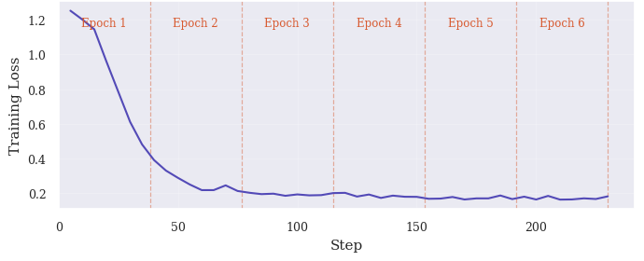
Training loss over 6 epochs.

Evaluation
Test samples are evaluated at two levels: detection and instance. Detection accuracy is the fraction of diagrams for which the model correctly predicts the detected field of the detection label; for positive predictions, the antipattern name is also verified. The model correctly predicted the presence or absence of an antipattern in 71 of 78 test diagrams, yielding a detection accuracy of 91.0%, with the correct antipattern name predicted in all positive cases.
Instance classification compares the predicted instance list against the detection label and assigns TP, TN, FP, and FN counts as follows. A negative sample (refactored diagram) predicted as negative contributes one TN; any instance the model predicts on a negative sample contributes one FP. For a positive sample, each expected instance that the model correctly predicts contributes one TP, each missed instance contributes one FN, and each predicted instance with no match in the expected list contributes one FP. For example, if a positive sample expects two instances and the model predicts two but only one matches, the result is 1 TP, 1 FP, and 1 FN. Matching checks that elements exactly matches the expected list and that the explanation is semantically correct; all results were manually verified to resolve ambiguous cases. Precision, recall, F$​_{1}$, instance classification accuracy, and Matthews Correlation Coefficient (MCC) are derived from these counts. Table 4 reports the results over 126 verified classification outcomes.
Instance-level classification results over 126 outcomes across 78 test samples.
 | Pred. + | Pred. $−$
Actual + | 68 (TP) | 10 (FN)
Actual $−$ | 16 (FP) | 32 (TN)
Instance-level classification results over 126 outcomes across 78 test samples.
Metric | Value
Precision | 0.81
Recall | 0.87
F$​_{1}$ | 0.84
Accuracy | 0.79
MCC | 0.55
In antipattern detection, recall is the more critical metric, since a missed antipattern remains silently in the model whereas a false positive can be dismissed by the modeller on inspection. The model achieves a recall of 0.87, recovering the majority of expected FD-include instances, which is the desirable outcome in this context. Precision at 0.81 reflects some false-positive tendency, as the model occasionally flags an FD-include instance where none was intended, but this is an acceptable trade-off. The MCC of 0.55 confirms a moderate-to-strong positive correlation between predictions and ground truth, despite the modest dataset size.
Manual inspection of the 16 FP and 10 FN instances reveals three recurring FP patterns and two FN patterns. Roughly half of all FPs involve prediction of an FD-include instance whose inclusion-side use case is directly associated with an actor in the diagram, violating the criterion that disqualifies it from FD-include membership. This error is especially consistent when the overlooked actor is a system entity rather than a human role. In two unrelated booking domains a payment use case is simultaneously included by a base use case and directly associated with a Payment Gateway actor, yet the model flags the relationship as FD-include in both cases. This actor-association error persists across both the antipattern and refactored versions of the same domain in three cases, confirming a systematic gap in the model’s actor-association check rather than a stochastic failure. A second FP pattern is extend-for-include confusion, where an <<extend>> relationship is misread as an FD-include instance. A third, less frequent pattern involves structurally unrelated use case pairs: the model asserts an include link between two use cases that share no relationship in the diagram, suggesting occasional hallucination of structural connections. Among FNs, the majority are straightforward omissions in diagrams where other instances in the same diagram were correctly identified, pointing to incomplete structural scanning rather than misclassification of relationship type. One FN involves a chain FD-include where A includes B and B includes C; the second link (B, C) is missed even though the first (A, B) is detected, likely because the intermediate node B plays a dual role as both an inclusion use case and a base use case.

Discussion
The results validate that a frontier LLM can serve as a reliable diagram labeller, as all generated pairs passed manual review, with violations corrected through targeted regeneration, and the structural statistics confirm that refactored versions faithfully remove antipattern elements without introducing spurious additions (16 out of 194 retain legitimate includes, consistent with the prompt intent). The model achieves competitive detection performance with only 3 billion parameters and $<0.5\%$ of its weights updated, confirming that synthetic data generation combined with parameter-efficient fine-tuning enables effective specialisation of a compact LLM at modest computational cost.
The current dataset targets only FD-include; the full antipattern catalogue (El-Attar and Miller 2006, 2010) covers many further types (e.g. FD-extend, Accessing an Extension Use Case), and generalisation to any of these would require repeating the generation and fine-tuning process, or jointly training on multiple antipatterns simultaneously. A second concern is synthetic distribution shift, as Claude Opus exhibits systematic stylistic preferences that may differ from practitioner-authored diagrams, so performance on real-world inputs remains to be evaluated. Generation is also capped at 5 antipattern instance groups per diagram, whereas real-world diagrams may contain more. The FN pattern of incomplete scanning identified in the error analysis suggests performance may degrade further as instance count grows. The model was trained and evaluated exclusively on PlantUML-formatted diagrams, so its applicability to other use case diagram notations or modeling tools remains untested. Finally, 78 test samples across 39 domains yield somewhat unstable metric estimates, and a larger held-out set would provide more reliable performance bounds.
The most immediate extension is broadening the dataset to cover multiple antipattern types simultaneously, working towards a unified model capable of detecting a full antipattern catalogue. Expanding the diagram size range to include larger diagrams would stress-test the model on more complex inputs. Evaluating on a hand-crafted benchmark of real practitioner diagrams would measure how well the model generalizes beyond synthetically generated examples. A natural progression of the task is to move from detection to refactoring, where the model not only identifies antipattern instances but also outputs the corrected diagram.

Related Work
A metric-based approach for antipattern detection in UML designs (Fourati et al. 2011) targets class and sequence diagrams. Their approach detects five antipatterns including Functional Decomposition by computing OO quality metrics such as coupling, cohesion, and complexity, and comparing them against predefined thresholds. While it operates at the UML design level, the approach requires manually defined thresholds. Our approach differs by learning detection from examples rather than from metrics or rules, and targets use case diagrams directly from their PlantUML source.
The most comprehensive catalogue of use case model antipatterns to date (El-Attar and Miller 2010) identifies 26 recurring modeling defects (including FD-include targeted in this work) and codifying them as machine-checkable heuristics within ARBIUM, a supporting tool. Detection in ARBIUM is semi-automated via OCL-style queries; however, refactoring suggestions are made textually and applied by the developer manually. Our work draws on their antipattern taxonomy and takes the next step by replacing the rule-based detector with the model, removing the need for hand-crafted detection rules and enabling operation on plain-text PlantUML sources without a formal model repository.
Subsequent work (Khan and El-Attar 2016) extends the ARBIUM line by automating the refactoring step through model transformations: OCL queries identify antipattern instances, and ATL transformations then apply the prescribed structural repairs. While this fully automates the detect-and-refactor loop for a subset of the catalogued antipatterns, the approach still relies on expert-authored formal rules and operates on structured model repositories rather than textual diagram sources. Our approach is complementary: by training an LLM on labeled diagram pairs, we show that the detection task can be learned from examples alone, without hand-crafted rules.
Early assessments of ChatGPT’s ability to generate UML class diagrams found syntactic and semantic limitations in models of that era (Cámara et al. 2023). More recent studies show frontier models performing markedly better on structured diagram generation tasks (Alzarooni et al. 2026; Alsayegh and El-Attar 2026). Our work builds on this capability but uses it for labeled pair generation rather than description-to-diagram translation.

Conclusion
We have presented an end-to-end pipeline for fine-tuning an LLM to detect the Functional Decomposition antipattern in PlantUML use case diagrams. The pipeline uses Claude Opus as a synthetic diagram author to generate 388 high-quality labeled training samples across 194 application domains, validated through a structured manual review workflow. Qwen2.5-Coder-3B-Instruct, fine-tuned with LoRA on this dataset, achieves 91.0% detection accuracy on a domain-held-out test set, demonstrating that PEFT on LLM-generated synthetic data is an effective strategy for specializing compact models on structured UML reasoning tasks. The pipeline is designed to scale, as additional antipattern types can be added to the configuration and the generation process repeated, extending the detector to new antipattern types without any manual data collection. The dataset, generation scripts, fine-tuning notebook, and evaluation results are publicly available (Khan and El-Attar 2026).
Alsayegh, H., and M. El-Attar. 2026. A Preliminary Exploratory Assessment of ChatGPT to Generating STRIDE Data Flow Diagrams. INSTICC; SciTePress. https://doi.org/10.5220/0014722800004015.
Alzarooni, A., Y. Khan, H. Alsayegh, M. El-Attar, and R. Grati. 2026. Evaluating ChatGPT-5 for Misuse Case Diagram Generation: An Empirical Evaluation. INSTICC; SciTePress. https://doi.org/10.5220/0015014000004015.
Anda, B., D. I. K. Sjøberg, and M. Jørgensen. 2001. “Quality and Understandability in Use Case Models.” Proceedings of the 15th European Conference on Object-Oriented Programming (ECOOP 2001), 402–28.
Ballis, D., A. Baruzzo, and M. Comini. 2008. “A Rule-Based Method to Match Software Patterns Against UML Models.” Electronic Notes in Theoretical Computer Science 219: 51–66. https://doi.org/10.1016/j.entcs.2008.10.034.
Cámara, J., J. Troya, L. Burgueño, and A. Vallecillo. 2023. “On the Assessment of Generative AI in Modeling Tasks: An Experience Report with ChatGPT and UML.” Software and Systems Modeling 22: 781–93. https://doi.org/10.1007/s10270-023-01105-5.
El-Attar, M., and J. Miller. 2006. “Matching Antipatterns to Improve the Quality of Use Case Models.” Proceedings of the 14th IEEE International Requirements Engineering Conference (RE’06). https://doi.org/10.1109/RE.2006.36.
El-Attar, M., and J. Miller. 2010. “Improving the Quality of Use Case Models Using Antipatterns.” Software & Systems Modeling 9 (2): 141–60. https://doi.org/10.1007/s10270-009-0112-9.
Fourati, R., N. Bouassida, and H. B. Abdallah. 2011. “A Metric-Based Approach for Anti-Pattern Detection in UML Designs.” In Computer and Information Science 2011, edited by R. Lee, vol. 364. Springer.
Gogolla, M., J. Bohling, and M. Richters. 2003. “Validation of UML and OCL Models by Automatic Snapshot Generation.” Proceedings of the 6th International Conference on the Unified Modeling Language (UML 2003) (Berlin).
Hu, E. J., Y. Shen, P. Wallis, et al. 2022. “LoRA: Low-Rank Adaptation of Large Language Models.” Proceedings of the International Conference on Learning Representations (ICLR). https://arxiv.org/abs/2106.09685.
Hui, B., J. Yang, Z. Cui, et al. 2024. Qwen2.5-Coder Technical Report. https://arxiv.org/abs/2409.12186.
Khan, Y. A., and M. El-Attar. 2016. “Using Model Transformation to Refactor Use Case Models Based on Antipatterns.” Information Systems Frontiers 18 (1): 171–204. https://doi.org/10.1007/s10796-014-9528-z.
Khan, Y., and M. El-Attar. 2026. Fine-Tuning an LLM for UML Use Case Antipattern Detection [Dataset, Supplementary Materials, and Results]. GitHub. https://github.com/ybakhan/llm-finetuning-uml-antipatterns.
Lilly, S. 1999. “Use Case Pitfalls: Top 10 Problems from Real Projects Using Use Cases.” Proceedings of Technology of Object-Oriented Languages and Systems (TOOLS 30), 174–83.

