Mortle
Functional Specification
Jon Waldow and Aaron Lebahn

Overview
Mortle is a one player game that combines aiming and targeting of a mortar gun and the teleportation of Portal. The object of the game is to get to the exit at right side of the screen starting from the left while navigating around obstacles. It contains multiple levels that the player must progress through.

Scenarios
Scenario 1: Phil
Phil, an experienced computer science major, decides to take a break from his rigorous course work and relax with a game of Mortle. He starts the program and is greeted with a nice welcome screen and presses a key to start off at level one and finds himself at the bottom of the left hand screen. There is a door on the bottom right side of the screen and a series of black squares that block his path. He uses the left and right arrow keys to aim his Mortle. Once he thinks he has the door in his sight, he presses space to fire it. It bounces off some of the blocks and the left side of the screen to land exactly where he started from. Frustrated, Phil re-aims at a different angle and fires again. This time it bounces off some different black squares but lands closer to the door. His Mortle gun is then teleported to the location where his shot landed and he aims once more. This time he fires and hits the door and is whisked to a new level. With all the hard work that it took to make it to level two, Phil decides he needs to start work on his database homework so he hits escape and the game exits and Phil goes on living his life.

Scenario 2: Cyndi Rader
Cyndi is between teaching classes and has some time to kill and nothing kills time more than a game of Mortle. She starts up the game but as being an experienced player, she passes through the first level in one shot. She starts at level two but realizes it is a little more difficult than expected. It turns out that when she hits the celling, the shot loses all momentum and plummets straight to the ground. Now with more practice she realizes that she can use this non-elastic collusion to benefit her and reach her goal sooner. Excited with her new discovery, she forgets about the time and spends the next few hours focusing on Mortle (Yes, this game is so distracting and fun, even Cyndi Rader can’t turn away). She continues until she has beaten all the levels and goes home because all of the day’s classes have ended.

Non Goals
- Make it so people skip their classes
- Editing and creating your own level
- Configure controls
- able to save current level
- not able to solve the meaning of life (it’s just a game)

Mortle State Diagram

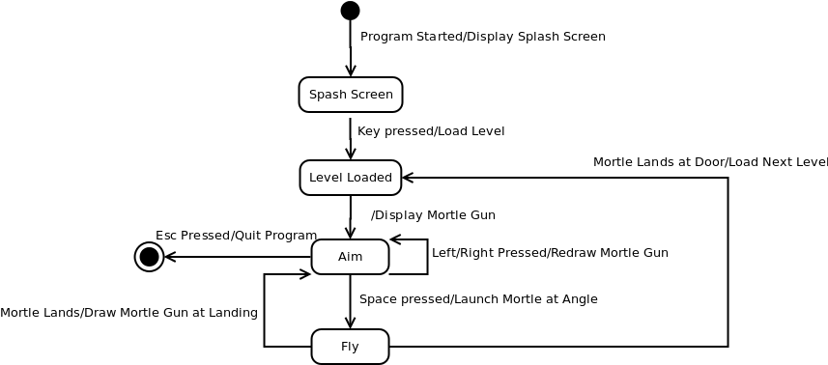

Splash Screen
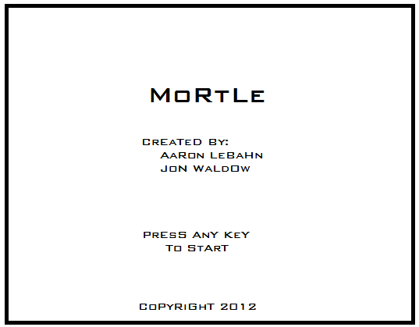

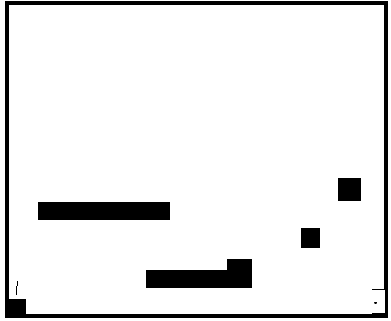
Level Screen

