Classwork 07 – Working with lists

You will find the answer to these questions in **Chapter 4 of the Book “Python Crash Course”.** (**From page 52 to 56)**

**Doing Something After a for Loop**

1. How do you know which lines or statements of code are inside the for-loop?
2. How do you know which lines or statements of code are outside the for-loop?
3. Add a line at the end of the next program, outside of the for loop, that states how much you like pizza. The output should consist of three or more lines about the kinds of pizza you like and then an additional sentence, such as I really love pizza!

pizzas = [“pepperoni”, “cheese lover”, ”vegetables”]

for pizza in pizzas:

print(f“I like {pizza.title()} pepperoni pizza”)

_____________________________________________________________________

_____________________________________________________________________

1. Write the following piece of code in the Python interpreter or in a python file and run it.

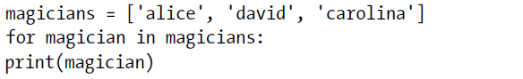

* 1. What error is the Python interpreter throwing?
  2. How do you fix the error?

1. Will the following piece of code throw an error? Which is the value of magician in the last line of code?

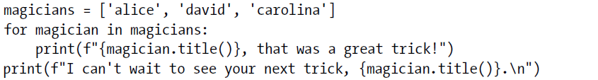

1. Which error will Python interpreter throw with the following piece of code? How do you fix it?

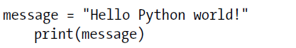

1. Which error will python interpreter throw with the following piece of code? How do you fix it?

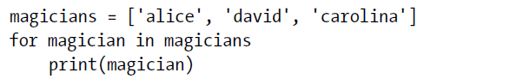

1. 4-2. Animals: Think of at least three different animals that have a common characteristic. Store the names of these animals in a list, and then use a for loop to print out the name of each animal.

_____________________________________________________________________

_____________________________________________________________________

_____________________________________________________________________

1. Modify your program to print a statement about each animal, such as ‘A dog would make a great pet.’
2. Add a line at the end of your program stating what these animals have in common. You could print a sentence such as ‘Any of these animals would make a great pet!’

_____________________________________________________________________

_____________________________________________________________________

_____________________________________________________________________

_____________________________________________________________________

_____________________________________________________________________

_____________________________________________________________________

_____________________________________________________________________

_____________________________________________________________________

**NOTE**: After finish create a python file named “classwork_07” doing the 4-2 task and send it to the teacher.