**Notes about the dataset:**

* Philippine Spotify Daily Top 200 Songs data
* From January 01, 2017 to October 15, 2023

**Research:**

* Taylor Swift pulled out all her songs on Spotify in 2014 “citing Spotify’s low royalties and refusal to make certain songs more expensive to access than others.” [1]
* As soon as she returned to Spotify on June 09, 2017, she immediately charted in the Top 200 occupying 11 spots out of 200.

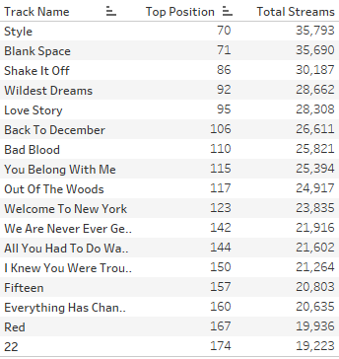

* Taylor never left the charts since April 26, 2019 (1633 days or 4 years 5 months 19 days)

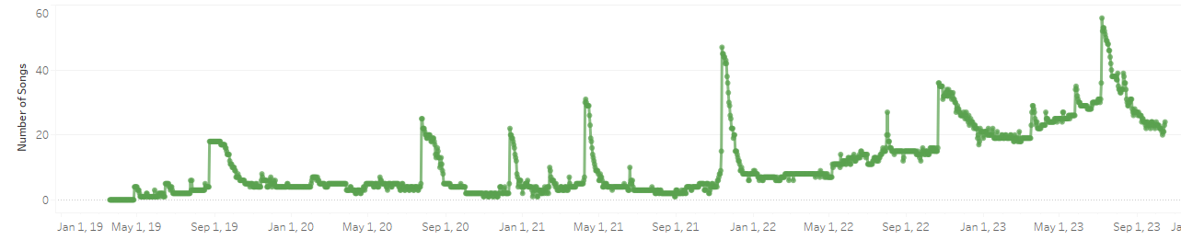

**References**

[1] https://www.vox.com/culture/2017/6/9/15766576/taylor-swift-spotify-streaming-katy-perry